First, download the automated MinGW installer (mingw-get-inst-XYZ.exe) from here: http://sourceforge.net/projects/mingw/files/.
Then run the installer an select to “Download latest repository catalogues”.

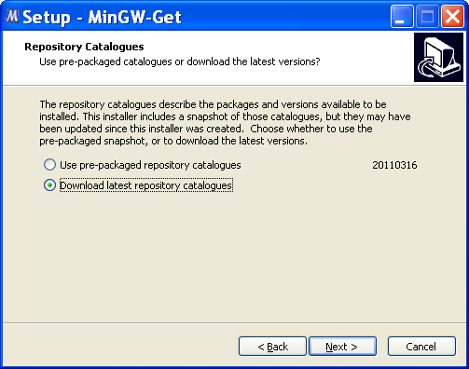

Choose to install into C:\MinGW. All examples bellow assume this default layout.

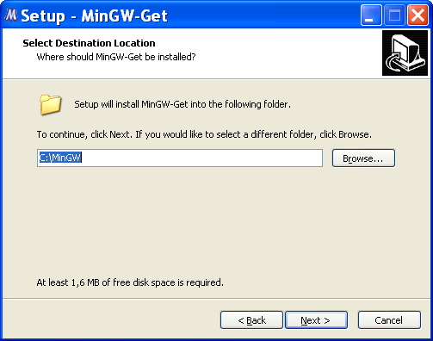

Сhoose components as shown below. MinGW Developer ToolKit includes GNU Autoconf/Automake/LibTool.

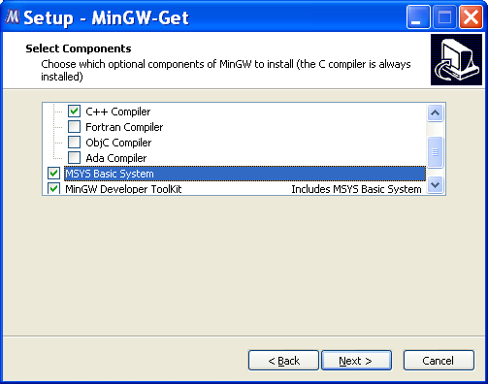

Try to launch “MinGW Shell” from programs menu.
Now you have environment with С++ compiler, make and autotools.

Download and build libxml2 library: ftp://xmlsoft.org/libxml2/libxml2-git-snapshot.tar.gz.

$ mkdir /c/MinGW/build
$ cd /c/MinGW/build
$ tar xvzf /c/soft/mingw/libxml2-git-snapshot.tar.gz
$ cd libxml2-2.7.8/
$ ./configure --prefix=/mingw
$ make && make install

Download and build CppUnit library: http://sourceforge.net/projects/cppunit/files/cppunit/.

$ cd /c/MinGW/build
$ tar xvzf /c/soft/mingw/cppunit-1.12.1.tar.gz
$ cd cppunit-1.12.1/
$ ./configure --prefix=/mingw
$ make && make install

Download and build boost libraries: http://www.boost.org/users/download/

$ cd /c/MinGW/build
$ tar xvzf /c/soft/mingw/boost_1_46_1.tar.bz2
$ cd boost_1_46_1/tools/build/v2
$ sh bootstrap.sh --with-toolset=mingw
$ cd ../../../
$ tools/build/v2/bjam toolset=gcc --with-date_time --with-thread
...
The Boost C++ Libraries were successfully built!
The following directory should be added to compiler include paths:
C:\MinGW\build\boost_1_46_1
The following directory should be added to linker library paths:
C:\MinGW\build\boost_1_46_1\stage\lib

