vncldrnprdz.github.io



**Service Details**

# Programming & Web Development

## Building Functional and User-Friendly Digital Solutions

I design and build digital solutions that range from simple programs to fully functional websites. My experience includes developing applications in **C++** and creating responsive websites using **HTML, CSS, JavaScript, and PHP**. I focus on writing clean code, making designs user-friendly, and ensuring that every project works smoothly across different devices. My approach is to combine problem-solving skills with creativity so that the solutions I create are not only practical but also enjoyable to use.

 Websites and web apps built with HTML, CSS, JavaScript, and PHP.

 C++ programs for problem-solving and application development.

 Responsive, mobile-friendly designs for all devices.

 Database integration and dynamic content management.

 Debugging, optimization, and ongoing technical support.

From small personal projects to larger systems with databases and dynamic content, I can provide development support that adapts to your needs. I value functionality, simplicity, and scalability, so the tools I build can grow and improve alongside your goals.

# Graphic Design

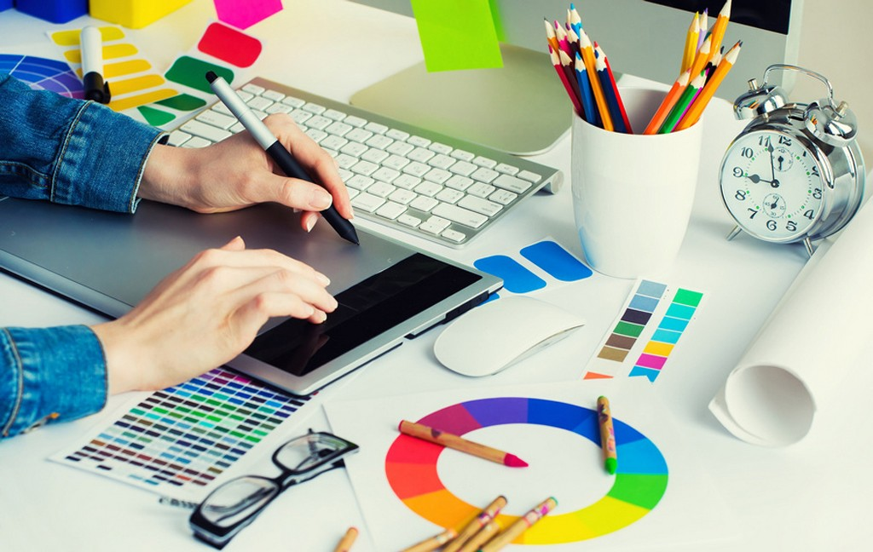

## Creative and Professional Visual Communication

I create designs that are not only visually appealing but also meaningful and effective in communication. With tools like **Adobe Photoshop** and **Adobe Illustrator**, I produce professional-quality graphics for both digital and print media. My work ranges from logos and branding elements to posters, brochures, and social media content. Each design is carefully made to reflect your identity and deliver the right message to your audience.

 Logo, vector, and branding design.

 Social media graphics, posters, and banners.

 Business cards, brochures, and print-ready designs.

 Custom illustrations and creative layouts.

My goal is to provide designs that are clean, modern, and adaptable for different platforms. Whether you need visuals for marketing, business, or personal use, I focus on creating creative outputs that connect with people and leave a lasting impression.

# Photo & Video Editing

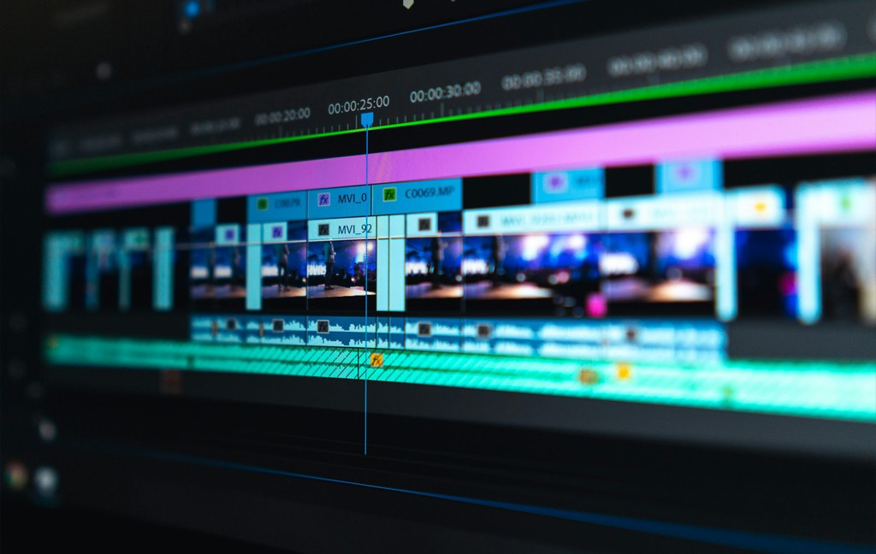

## Enhancing Visuals Through Editing and Production

I enhance photos and videos to make them more professional, engaging, and ready for different purposes. Using tools such as **Filmora**, **Photoshop**, and **Illustrator**, I can edit, retouch, and organize content so that it looks polished and creative. This includes improving image quality, adjusting colors, trimming video clips, and combining elements into seamless presentations.

 Video editing for presentations, events, and online content.

 Photo retouching, manipulation, and enhancement.

 Creative montages, intros, and promotional videos.

 Designing thumbnails, layouts, and motion graphics.

My editing style focuses on clarity and storytelling, making sure that every photo or video highlights its message. Whether it’s for events, online content, or business use, I deliver outputs that bring attention to detail and create a strong visual impact.

# CAD & 3D Modeling

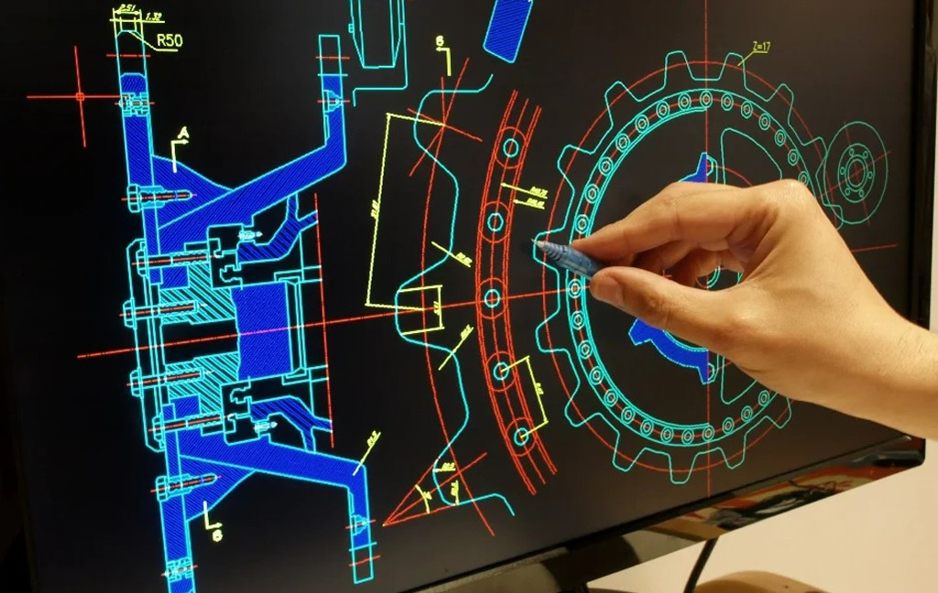

## Precise Drafting and Realistic 3D Visualization

I provide technical drawing and 3D modeling services using **AutoCAD** and **SketchUp**. These tools allow me to create precise plans, models, and visualizations for projects in engineering, architecture, and product design. My work includes drafting layouts, preparing construction-ready plans, and building 3D models that help clients see their concepts more clearly.

 2D drafting and technical drawings in AutoCAD.

 3D modeling and visualization using SketchUp.

 Rendering and presentation of design concepts.

 Modification and improvement of existing designs.

I make sure that designs are both accurate and creative, balancing technical requirements with easy-to-understand visuals. Whether you need a simple drawing, a detailed blueprint, or a 3D rendering, I can deliver solutions that support planning, presentation, and execution.

# Robotics & Microcontrollers

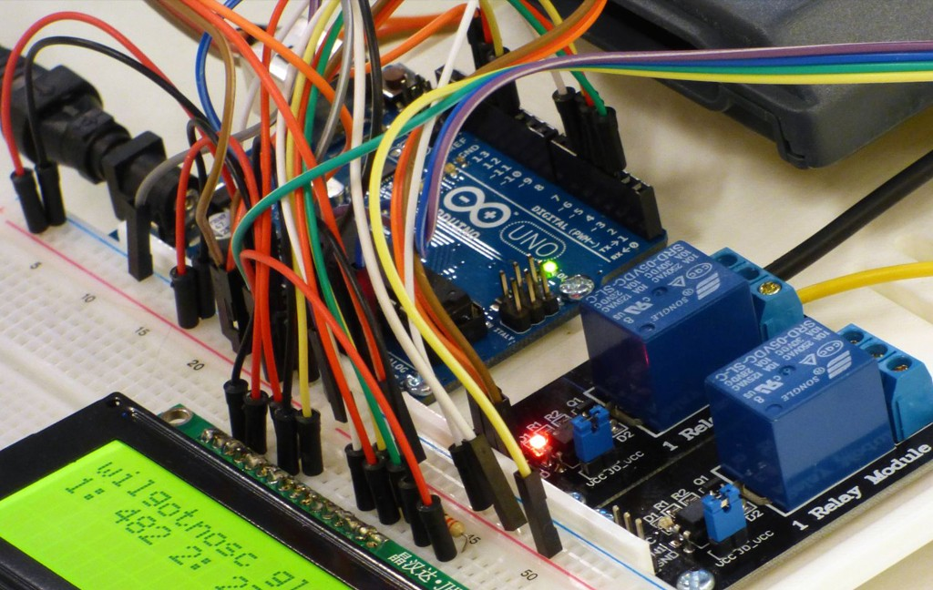

## Innovative Projects with Robotics and IoT

I work with **Arduino** and microcontroller projects to create hands-on solutions that explore automation, sensors, and electronic systems. These projects can be educational prototypes, functional devices, or experiments in robotics and the Internet of Things (IoT). My experience covers coding, circuit design, and integrating different components to make ideas come to life.

 Arduino-based project development.

 Sensor integration and circuit prototyping.

 IoT and automation projects.

 Microcontroller troubleshooting and testing.

I enjoy turning concepts into interactive systems, whether it’s a simple prototype or a more advanced automated project. My goal is to provide designs that are not only functional but also easy to learn from and expand for future development.

# Networking & IT Solutions

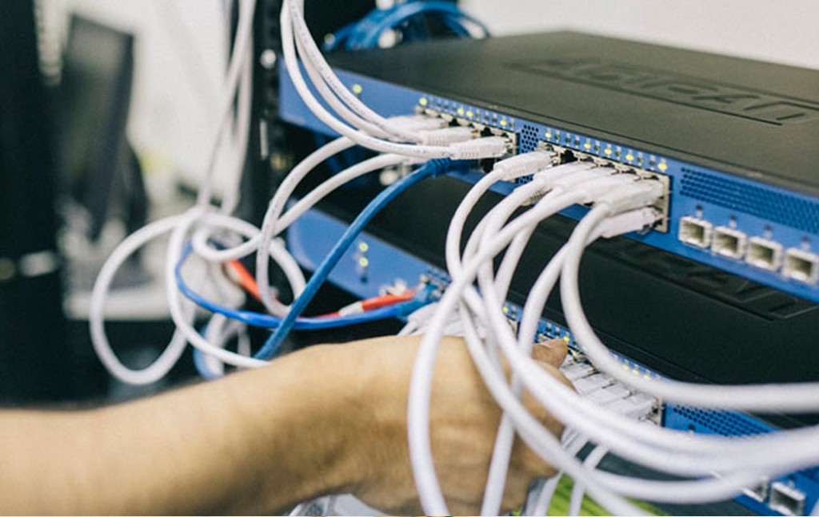

## Reliable Support for Computers and Networks

I provide practical IT support that ensures computers and networks run smoothly. My skills include **LAN setup**, **computer assembly**, software installation, and troubleshooting for both hardware and software issues. I also focus on keeping systems secure, updated, and optimized for everyday use.

 Basic LAN and network setup.

 Computer assembly, installation, and configuration.

 Hardware and software troubleshooting.

 Maintenance and performance optimization.

Whether it’s setting up a small home network, maintaining office computers, or solving technical problems, I aim to deliver solutions that are reliable and easy to manage. My approach is to make technology more accessible so that you can focus on your work without interruptions.

# Laboratory & Electronics

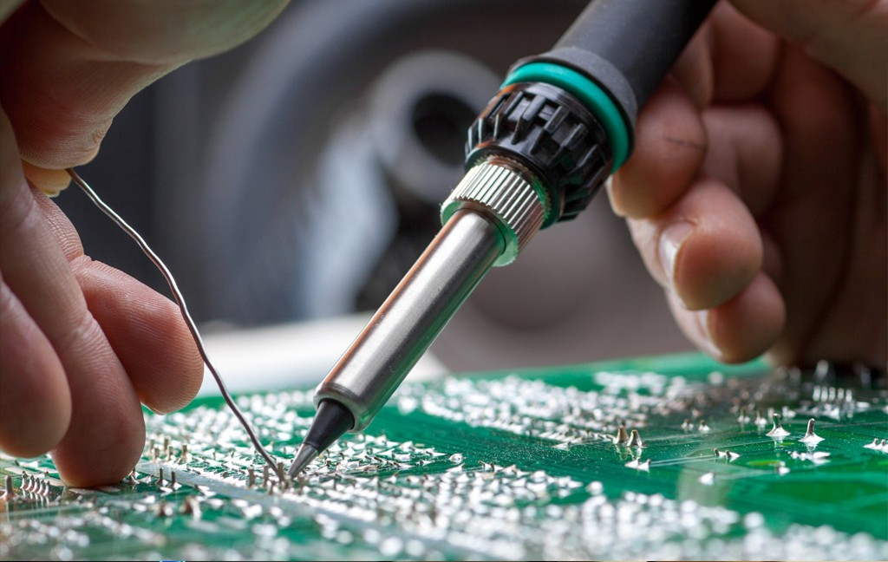

## Hands-On Skills for Electronics and Testing

I have hands-on experience with electronic tools and testing equipment, making me capable of assisting in small-scale projects and experiments. I use instruments like multimeters, soldering irons, and cable testers to build, repair, and analyze circuits. My skills also include working with microcontroller setups for prototypes and practical applications.

 Multimeter testing and circuit analysis.

 Soldering and circuit board assembly.

 Network cable crimping and testing.

 Support for microcontroller-based setups.

I approach every task with precision and care, ensuring that projects are safe, functional, and ready for use. From assembling circuits to testing components, I can support both academic and personal projects that require reliable electronic work.

# Productivity Tools

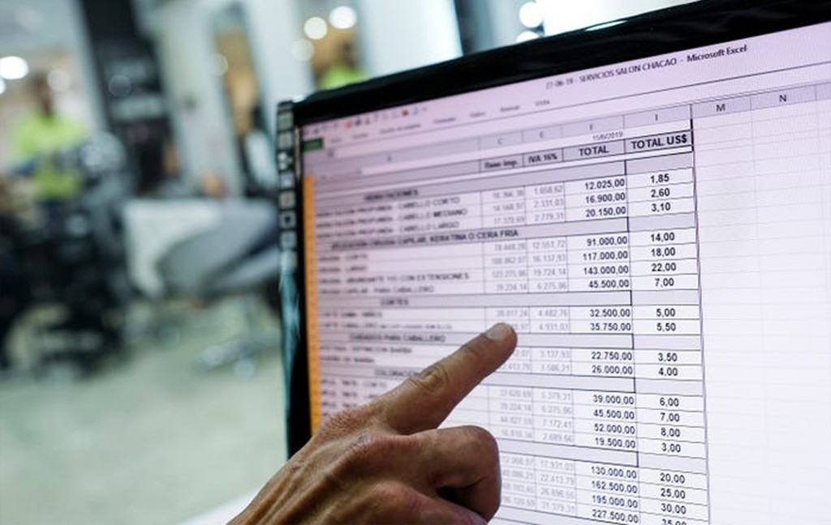

## Boosting Work Efficiency with Office Tools

I support the use of **Microsoft Office** applications such as Word, Excel, and PowerPoint to improve productivity in academic, business, and personal tasks. I can format documents professionally, organize and analyze data, and create engaging presentations that communicate ideas clearly.

 Professional Word document formatting.

 Excel data analysis, charts, and formulas.

 Creative and professional PowerPoint presentations.

 Templates and productivity-enhancing designs.

My focus is to make work easier and more efficient by using the right tools and designs. Whether it’s preparing reports, summarizing data, or designing slides, I can provide outputs that save time, reduce effort, and make your work look more professional.



Have a Question?

 +63 977 749 5601

 [vncldrnprdz@gmail.com](mailto:vatpardito.dev@gmail.com)