**Polytechnic University of the Philippines Department of Computer**

**Engineering**

**Digital Signal Processing**

**CMPE 30244**

MP3

Frequency Response and Passive Filters using Multisim

Submitted by:

Hael Larenz Y. Manalo

Submitted to:

Engr. Jake A. Binuya

Date Submitted:

November 29, 2024

# OBJECTIVES

* To reinforce the concepts behind filter circuits and frequency response
* To reinforce the idea of a phasor
  + To understand and use phasor circuit analysis
* To reinforce the procedure of deriving a transfer function
* To graphically demonstrate the effects of different passive component configurations on different ranges of frequency

# MATERIALS

* The lab assignment (this document)
* Your lab parts
* Printouts (required) of the below documents:
  + Pre-lab analyses
  + Multisim screenshots e-mailed to course e-mail
* Graph paper.

# INTRODUCTION

In this experiment we will analytically determine and measure the frequency response of networks containing resistors, ac sources, and energy storage elements (inductors and capacitors).

Given an input sinusoidal voltage, we will analyze the circuit using the frequency-domain method to determine the phasor of output voltage in the ac steady state. The response function is defined as the ratio of the output and input voltage phasors. It is a function of the input frequency and the values of the circuit elements (resistors, inductors, capacitors).

We start with examples of a few filter circuits to illustrate the concept.

## RC Low-Pass Filter:

Consider the series combination in Fig 1 of the resistor R and the capacitor C, connected to an input signal represented by ac voltage source of frequency .

vin(t) = Vs cos(t + I) (1)

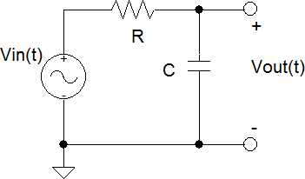

Figure 1  Low-pass filter.

Suppose we are interested in monitoring the voltage across the capacitor. We designate this voltage as the output voltage. We know that it will be a sinusoid of frequency . Thus,

vout(t) = Vo cos(t + o) (2)

We will now determine expressions for the amplitude Vo and the phase angle o. First we convert the network to frequency domain, as shown in Fig. 2.

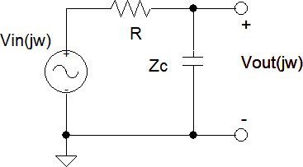

Figure 2  Low-pass filter in frequency domain.

In the above circuit, the voltage source is represented by its phasor and the resistor and capacitor by their impedances. We wish to evaluate the phasor **Vout** for the output sinusoid. Since the three elements are in series, the voltage divider formula can be used and we obtain

**Vout** = [ Zc / (Zc + R) ] **Vin** , (3)

where **Vin** is the phasor of the input voltage. It is given by

**Vin** = VsejI (4)

Zc = 1/jC (5)

The **transfer function** is defined as the output divided by the input. The **frequency response**, **H(jw)**, can be found by manipulation of equation (3),

**H(j****)** = **Vout / Vin** = 1/(1 + jRC) (6)

The product RC has units of the inverse of angular frequency. We define (7) as a characteristic frequency of the network and write the frequency response as (8).

o = 1/RC (7)

**H(j****)** = 1/(1 + j/o) (8)

In other words, we are measuring frequency in units of o (rad/s).

The sinusoid corresponding to the output voltage can be written as

vout(t) = Re{**Vout** ejt} = Re{**H(j****)Vin** ejt} = Re{VsejI ejt/(1+j/o)} (9) vout(t) = {Vs / [1+(/o)2]}cos( t + I  tan1(/o) ) (10)

Returning to the frequency response, **H(j****)** is a complex number. It has a magnitude and phase. Both depend on the frequency, R and C. Thus,

**H(j****)** = H exp(jH) (11)

The magnitude (absolute value) of **H** is a measure of the ratio of the amplitudes of the output and input voltages. It is given by:

H = | **H(j****)** | **=** Vo / Vs = 1/[1+(/o)2]1/2 (12)

On the other hand, the phase angle of **H** measures the difference in the output and input phase angles. It is given by:

O - I = H =  tan1( /o) (13)

The frequency dependence of the magnitude H is plotted in Fig. 3. Note that the x-axis is unitless, the normalized frequency of /o.

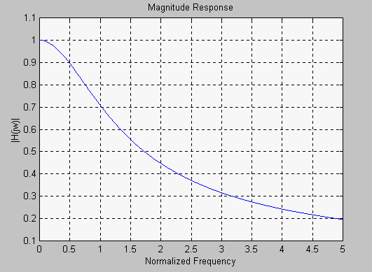

Figure 3  Magnitude frequency response.

From Fig. 3, it is evident that for low frequencies (<<o), H is close to one. In this frequency range, the network allows effective transmission of the input voltage. For >>o, H becomes much less than one. This means that high frequencies do not get transmitted well by the network, but low frequencies are transmitted well. In other words, the network acts as a **low-pass filter**.

The characteristic frequency o is called the **cut-off frequency**. It is defined as the frequency at which H is equal to (1/2)*Hmax. Similarly, the frequency dependence of the phase H is shown in Fig. 4. There is negligible phase shift at very low frequencies and a phase shift approaching 90 at very high frequencies.

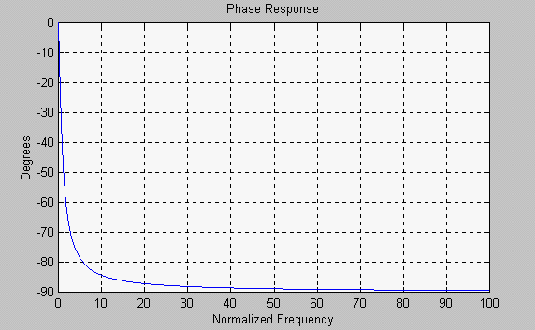

Figure 4  Angle frequency response.

The magnitude and phase plots shown in Fig. 3 and Fig. 4 are plotted using linear scales. However, in electrical circuits, the frequency range may span several decades. For example, in audio amplifiers, the frequency range of interest is 20 Hz to 20,000 Hz. Similarly, the magnitude of the frequency response may vary over several orders of magnitude. Therefore, linear scaled plots are of little use and the frequency response is represented by **Bode Plots.**

In Bode plots, the magnitude H is plotted on the vertical axis, in units of dB, defined by the following equation:

HdB = 20 log H (14)

On the horizontal axis, the frequency is represented on a log scale. On the log scale, the distance between10 and 100 rad/s is equal to that between 100 and 1000 rad/s. This is due to the fact that (log 100  log 10)  (log 1000  log 100) = 1. The distance from 10 to 20 is 30% of the distance between 10 and 100, which can easily inferred since (log 20  log 10) = 0.3.

Fig. 5 shows the Bode plot of the magnitude and phase of the low-pass filter of Fig. 1.

At low frequencies, the value of HdB is close to 0 dB and it is represented by a straight line with zero gradient. **At the cut off frequency HdB drops to**  **3 dB**, and **at frequencies much larger than the cutoff frequency, the response is accurately represented by a straight line with a slope of** **20 dB/decade**. If we extrapolate the two straight lines, they will intersect at the cutoff frequency. The two lines represent the **asymptotic Bode Plots**. The maximum error in asymptotic Bode plot for this case is 3 dB, occurring at the cutoff frequency.

Asymptotic Bode plots are very useful in estimating the magnitude H at any frequency fairly accurately. They are easy to sketch since only straight lines are involved. For example, if we wish to know H at a frequency 100 times larger than the cutoff frequency, we get HdB = 40 dB, which gives H = 0.01, implying that the amplitude of the output voltage at this frequency is 1% of the amplitude of the input voltage.

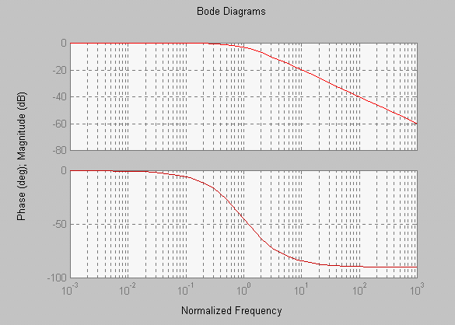

Figure 5  Bode magnitude (top) and phase (bottom) plots.

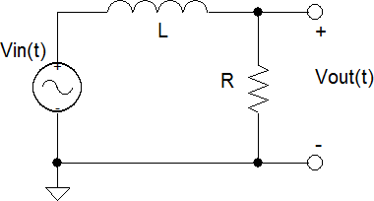When H is smaller than unity, HdB is a negative number. That means the output voltage amplitude is smaller than the input voltage amplitude and the network attenuates the input signal. Such is the case in the passive low-pass filter considered thus far. We will see

later, however, that when active elements such as Op Amps are used, there is usually a net gain and HdB can be a positive number!

One can also design a low-pass filter using an inductor and a resistor, as shown in Fig. 6. It has characteristics very similar to the RC low-pass filter we analyzed above. In the prelab you will look at this example RL circuit.

## RC High-Pass Filter:

Suppose that in the network of Fig. 1, we monitor the output voltage across the resistor as we vary the frequency as shown in Fig. 7.

It can be shown that

**H(j****)** = (j/0)/(1 + j/0) , (15)

Figure 6  RL circuit.

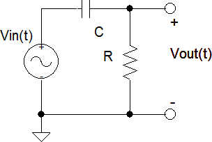

Figure 7  RC high-pass filter.

where 0 = 1/RC.

The Bode plot of this filter is shown in Fig. 8.

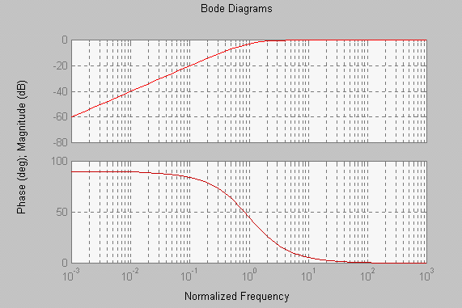

Figure 8  Bode plot of high pass filter.

This circuit acts like a high-pass filter. The asymptotic Bode plot once again is given by two straight lines. For low frequencies, the slope of the line is +20 dB/decade and the 3 dB attenuation point exists at ωo.

A simple passive high-pass filter can also be designed using an inductor and a resistor (see the prelab).

## Band-Pass Filter:

Consider the series combination of a resistor, an inductor, and a capacitor, as shown in Fig. 9.

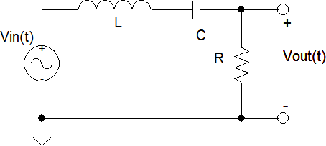

Figure 9  RLC series band-pass circuit.

We will monitor the output voltage across the resistor. In frequency domain, we use the voltage divider formula to obtain the phasor for the output voltage.

**Vout = Vin** {R/[R + j(L  1/C)]} (16) From the above equation, we get the magnitude of the frequency response.

| **H(j****)** | = R/[R2 + (L  1/C)2]1/2 (17)

The magnitude of the frequency response is shown in Fig. 10 for R/L = 1. On the horizontal axis, the frequency has been normalized to o = 1, the resonance frequency given in equation 18.

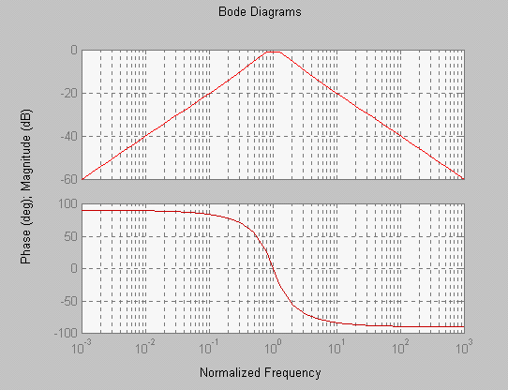

Figure 10  Bode plots for circuit of Fig. 9 with R/L=1.

At very low frequencies, the capacitor has very large impedance, resulting in a low output voltage. Similarly, at very large frequencies, the inductor offers large impedance which results in a drop in the output voltage. However, when the impedances of the capacitor and the inductor cancel each other, the series combination of the two energy-storage elements acts as a short circuit and all the input voltage appears across the resistor (H = 1). This frequency is called the **resonance frequency.**

The resonance frequency is given by

o = (LC)1/2 (18)

It is seen that the network allows efficient transmission of frequencies in the vicinity of the resonance. This is why it is called a band-pass filter.

Apart from the resonance frequency, the filter is also characterized by its **band width** and **Q** (quality factor). The bandwidth and Q are defined as

BW = 2  1 (19)

Q = o / BW, (20)

where 1 and 2 are the two frequencies at which H = (1/2) Hmax. Fig. 11 shows the Bode plot of the band-pass filter for R = 10 , L = 10 mH, and C = 100 F.

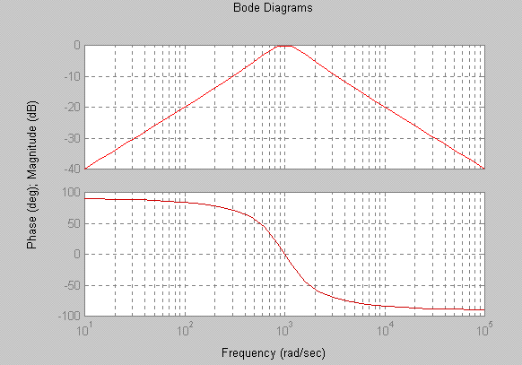

Figure 11  Bode plots for circuit of Fig. 9 with R = 10 , L = 10 mH, C = 100 F.

# PRE-LAB AND QUESTIONS

## Bode Measurements Using Multisim:

1. Using Multisim, one can measure the Bode plot of a given filter. Refer to Fig. 12. This is a simple RC circuit driven by a function generator. The ―XBP1‖ instrument is known as a Bode plotter and (found in the ―Instruments‖ toolbar) applies a sweep of frequencies to the circuit (imagine a function generator inputting a signal with varying frequency as well as varying voltage) then measures the response of the output relative to the input, thus providing a plot of the transfer functions. Note that it is not necessary to set the values of the function generator for the bode plotter to work.

**XBP1**



**XFG1**

**R1**

**1kΩ**

**C1**

**1uF**

Figure 12 – Circuit Setup for Bode Measurement in Multisim

In Fig. 12, we have a resistance of 1kΩ and a capacitance of 1µF. Thus, by (7), ωo = 1,000 rad/s, or

159.16 Hz (ω=2πf). This is verified in Fig. 13. By double-clicking on the Bode plotter and energizing the circuit, the cursor can be adjusted to read roughly -3dB. As can be seen, this attenuation corresponds to value of roughly 159 Hz (and a phase of -45, as seen in Fig. 14).

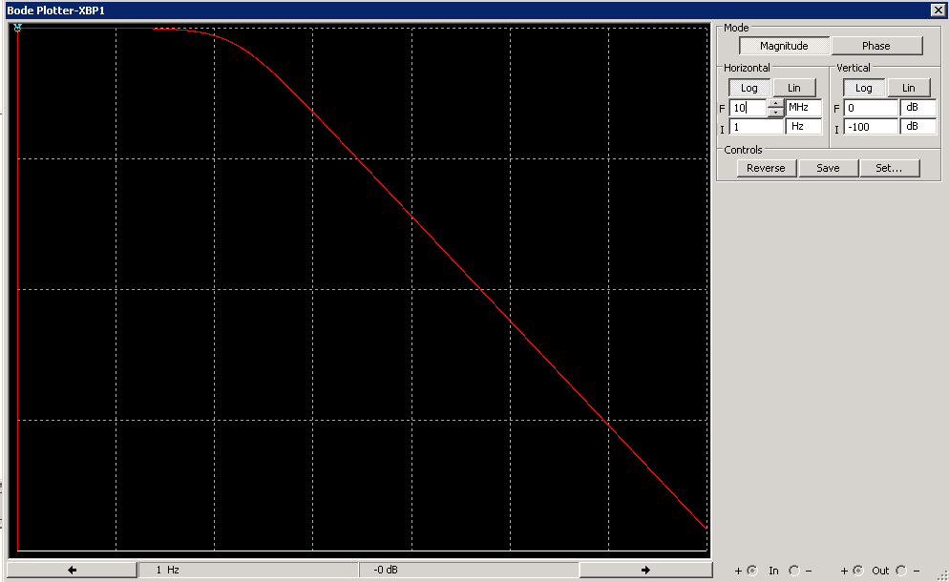

Figure 13 – Bode Magnitude plot created in Multisim.

Note that the phase response can also be obtained simply by changing the Mode to ―Phase.‖

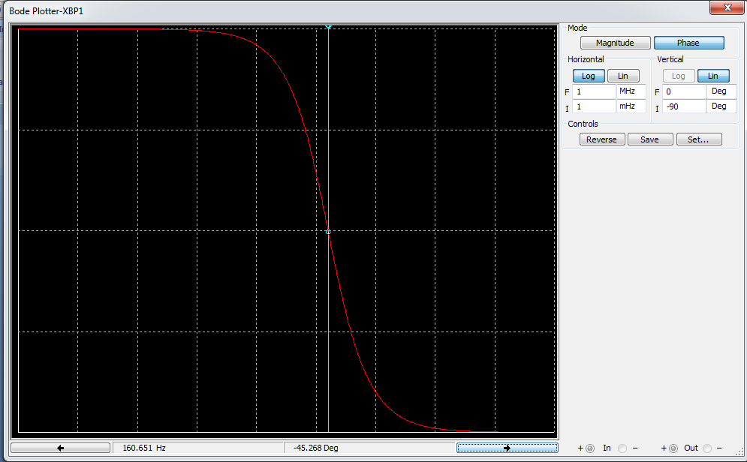

Figure 14 – Bode Phase plot created in Multisim.

1. Build the same circuit as in Fig. 12, but use values of 4kΩ and 500nF for the resistance and capacitance, respectively. Take screenshots of both the magnitude (with the cursor at the -3dB magnitude frequency) and phase plots.

## Low-pass Circuits:

1. Derive the response function { **Vout(j****) / Vin(j****)** } for the low-pass RL circuit in Fig. 15. Calculate the expected value of ωo of this RL circuit if R=100Ω and L=1mH. (Note: Zc = 1/jC; ZL = jL).

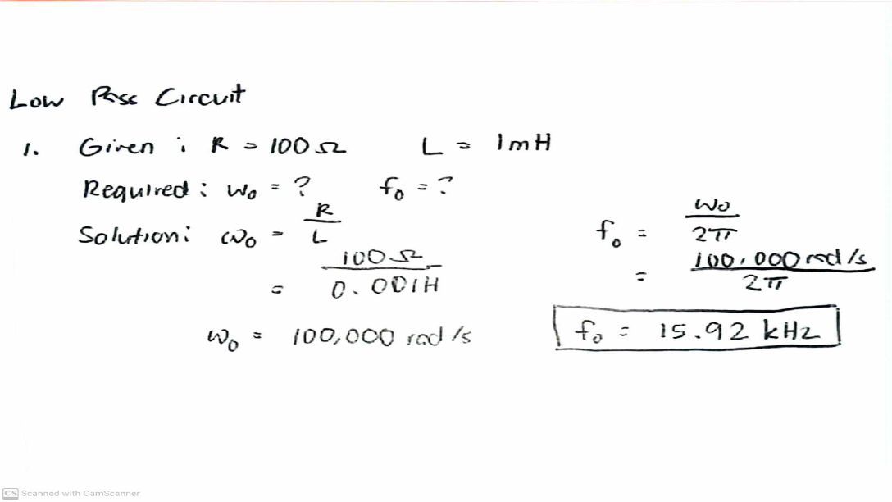

1. Build the circuit in Fig. 15 using values of 100Ω and 1mH for the resistance and inductance, respectively. Measure and take a screenshot of the magnitude response showing

Figure 15  Low-pass RL circuit.

the 3dB frequency. Does this agree with your value from step 1? (Hint: remember that ω is measured in rad/s).

**Based on the AC analysis, the frequency response where the magnitude drops by 3dB is approximately 15.9kHz, which matches the value in step 1.**

1. Do the following:
   1. Calculate the expected value of ωo of this RL circuit if R=100Ω and L=2.2mH.

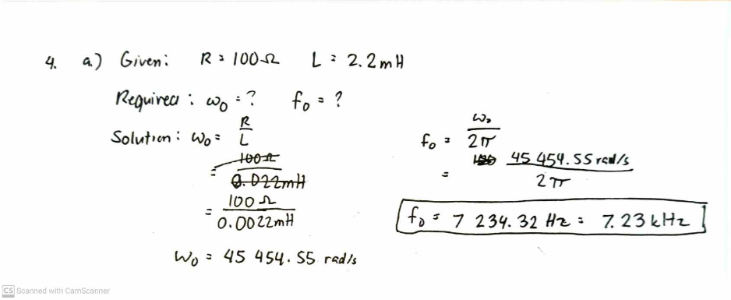

* 1. Build the circuit in Fig. 15 using values R = 100 and L = 2.2mH on your myDAQ breadboard. Connect the input voltage Vin(t) (3Vp-p) to a voltage follower circuit (Fig. 13 Operational Amplifier) and use Vout of the voltage follower as the input to the RL circuit. Display both the input and output of this circuit on the Oscilloscope. Take a screenshot and e-mail to the TA.

* 1. Calculate the Gain (Vout/Vin) at ωo and compare it to the theoretical gain at ωo.

**Based on the result in step b, the Gain 0.707 is true given that 686.598/883.477 is 0.7 which is a particularly close ratio.**

## High-pass Circuits:

1. Derive the response function { **Vout(j****) / Vin(j****)** } for the high-pass RL circuit in Fig. 16. Calculate the expected value of ωo of this RL circuit if R=100Ω and L=1mH.

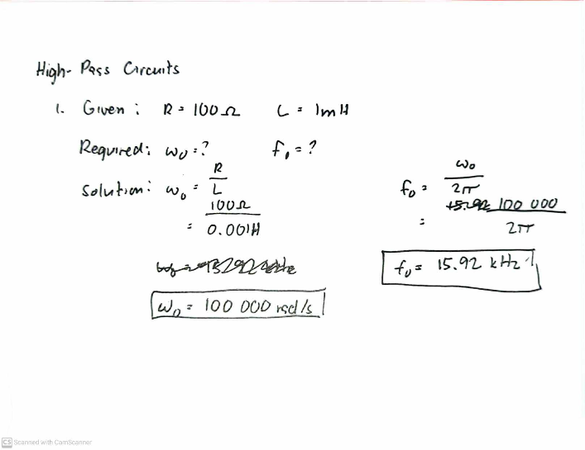

1. Using the same component values as described above, build the circuit of Fig. 16. Measure and take a screenshot of the magnitude response showing the 3dB frequency. Does this agree with your value from step 1?

**Based on the AC analysis of the High-Pass Circuit with the cursor at 3.05 dB, the value 16.03 kHz is close to the computed 15.92kHz frequency at 3dB. Therefore, the value of step 1 agreed with the simulated value of step 2.**

Figure 16  High-pass RL circuit.

## Band-pass Filters:

1. Derive the response function { **Vout(j****) / Vin(j****)** } for the band-pass RLC circuit in Fig. 17. Using

(18) through (20) find ωo, BW, and Q for R=1kΩ, L=1mH, and C=1µF.

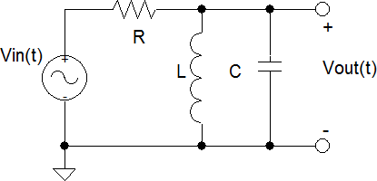

Figure 17  RLC circuit.

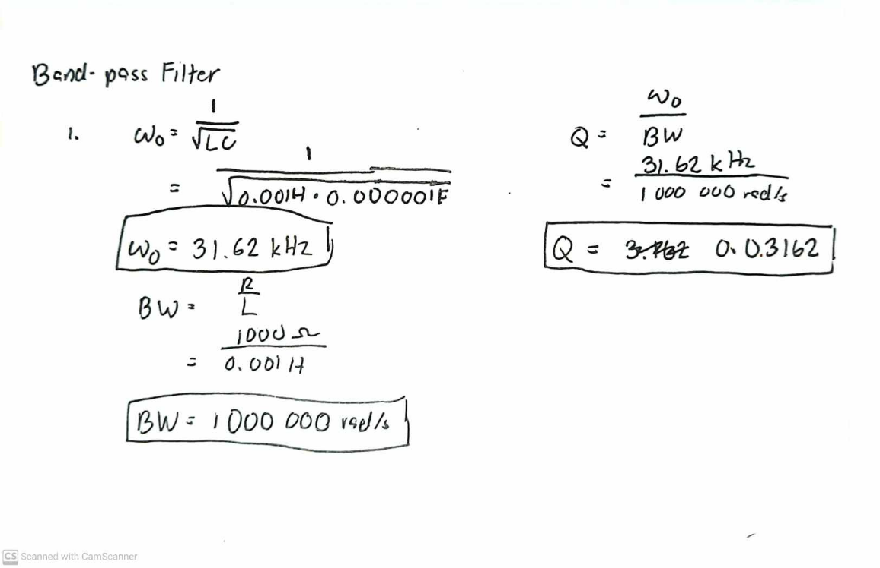

1. Using Multisim, build the circuit in Fig. 17 and measure and take a screenshot of the Bode magnitude plot. Use the cursor to measure ω2 and ω1. Determine the bandwidth of this band pass filter.

**Based on the AC analysis, ω1 is approximately 4.9kJ and ω2 is approximately 5.1kJ, therefore the bandwidth is 5.1kJ – 4.9kJ = 200J.**

## Band-stop Filter:

Often times it is desired to remove a particular or narrow range of frequencies from a signal. For example you may want to remove (notch) the 60 Hz line interference from your signal while allowing all other frequencies to pass through undistorted. One solution to this problem is to design a band-stop filter (also known as a notch filter) to remove the unwanted components. The magnitude response may be considered to be the compliment of the band-pass response. Figure 18 presents the Bode magnitude response of a normalized band-stop filter. Its response function can be expressed as:

**H(j****)** = [(j     (j + ( Q)(j     

□ □ □

where □ and Q are defined in equations (18) and (20), respectively. For the band stop case, □ is also referred to as the notch frequency.

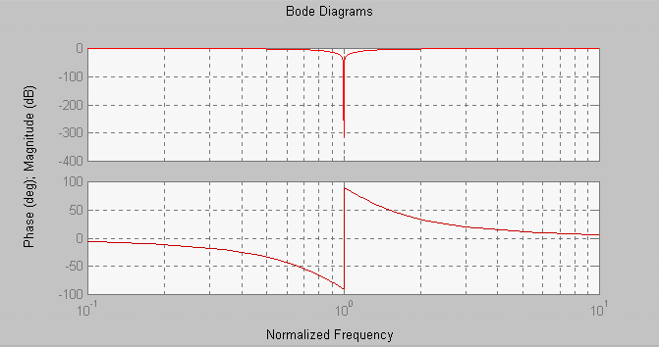

Figure 18  Bode plots for band-stop (notch) filter circuit.

1. Derive the response function { **Vout(j****) / Vin(j****)** } for the band-pass RLC circuit in Fig. 17 (and the same values of for R=1kΩ, L=1mH, and C=1µF as in the band-pass case, **but with the output across the resistor**).

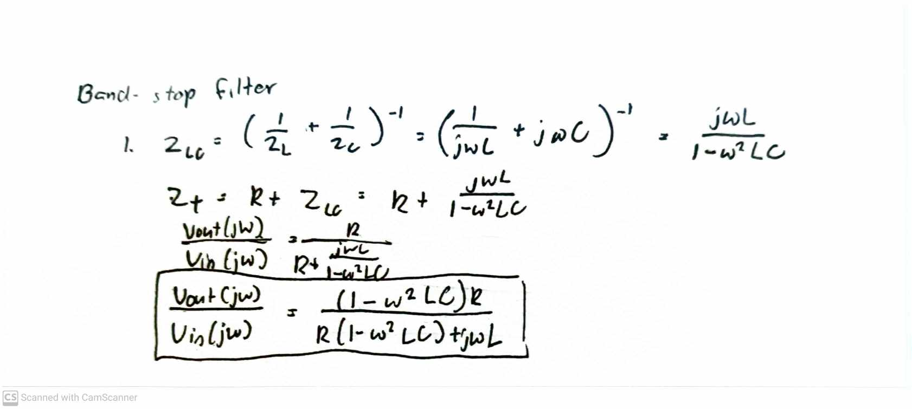

1. Determine the notch frequency □ for this circuit using circuit analysis.

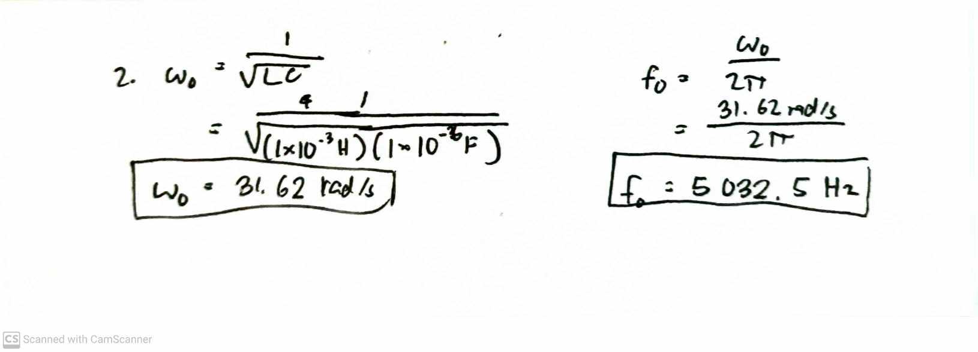

1. Using Multisim, build this circuit in and measure and take a screenshot of the Bode magnitude and phase plots. Use the cursor to measure ω2and ω1. Determine the bandwidth of this band pass filter.

**Based on the AC analysis, ω1 is approximately 4.9kJ and ω2 is approximately 5.1kJ, therefore the bandwidth is 5.1kJ – 4.9kJ = 200J.**

# LAB PROCEDURE AND QUESTIONS

## Low Pass Filter:

1. Build the circuit in Fig. 1. Set R = 2.2 k and C = 0.1 uF . Use a 4-Vpeak sinusoidal voltage for Vin.

1. Determine the cutoff frequency o for this circuit using (7).

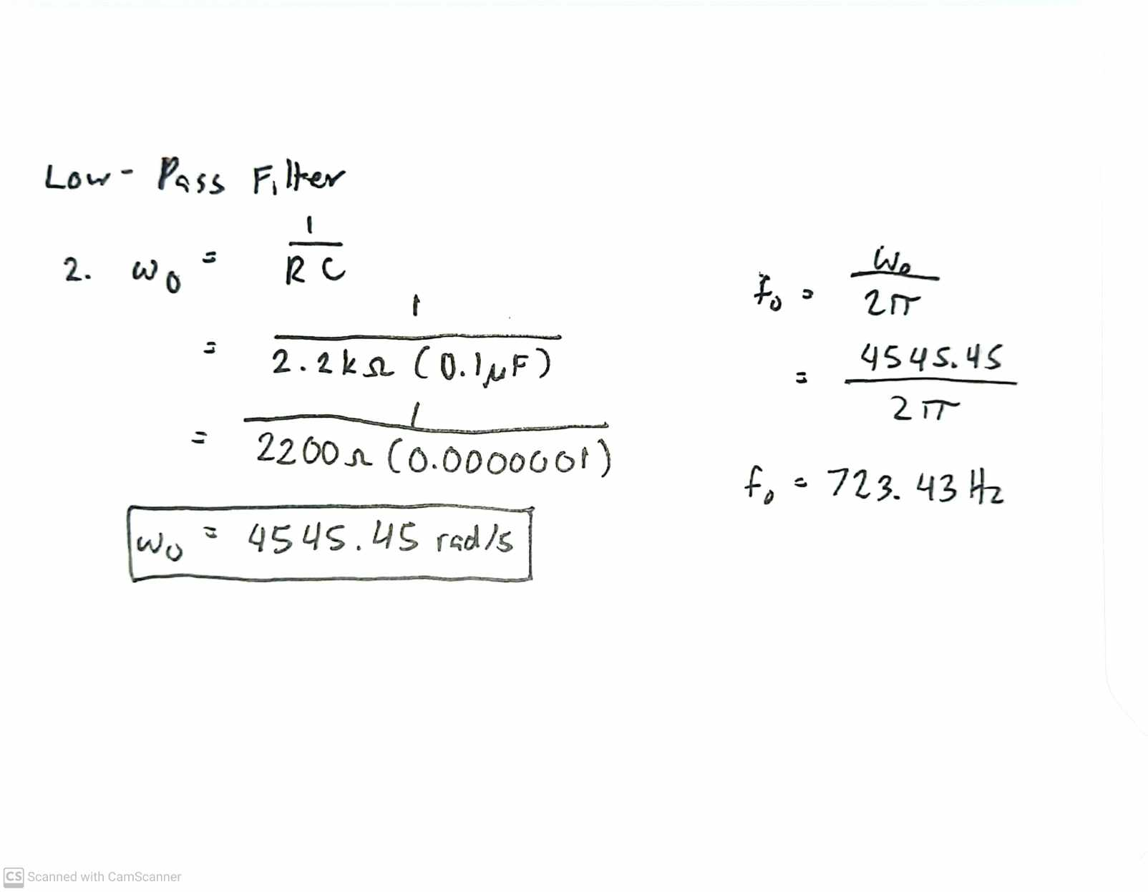

1. Measure Vout (using the AC setting) at the cutoff frequency o. Take 5 data points each above and below the cutoff frequency. Make sure to spread out your frequency values.

1. Draw a plot of HdB vs. frequency for this circuit using the values obtained in step (3). Use Excel or MATLAB to plot the measured values. (Remember that your frequency axis should be logarithmic.) Compare this plot to the theoretical Bode magnitude plot of the circuit. From the plot, estimate the value of o. Does this value agree with that of step (2)? Comment on any differences.

Based on this, the value agrees with that of step 2.

## High Pass Filter:

1. Using the same circuit in Figure 1 monitor the voltage across the resistor (R) instead of the capacitance (C).

1. Repeat steps 2-4 from the low pass exercise above.



Taking data

\

Based on this, the value agrees with the computed w0.

Graph comparison

## Band Pass Filter:

1. Build the circuit in Fig. 17. Set R = 10 k C = 1 uF, and L = 2.2 mH. Use a 4-Vpeak sinusoidal voltage for Vin.

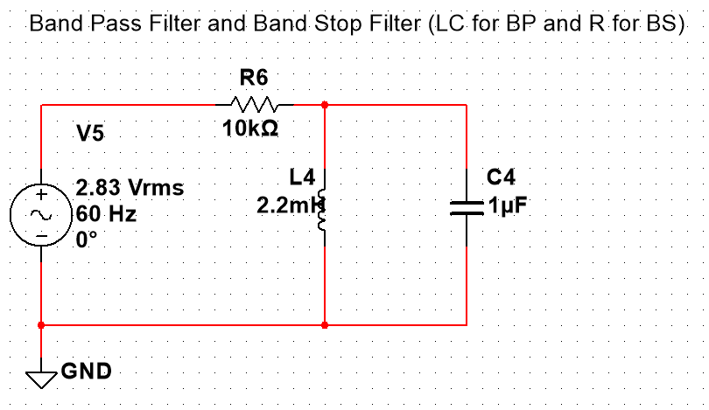

1. Determine the resonant frequency o for this circuit.
2. Measure Vout (using the AC setting) at the resonant frequency o. Take 5 data points each above and below the resonant frequency o. Make sure to spread out your frequency values.
3. Using MATLAB or Excel, draw a plot of HdB vs. frequency for this circuit using the values obtained in step (3). Compare this plot to the theoretical Bode magnitude plot of the circuit. From the plot, estimate the value of □. Does this value agree with that of step (2)? Comment on any differences.
4. From your plot, estimate the bandwidth of this filter.

## Band Stop Filter:

1. Using the same circuit from the band-pass case, monitor the voltage across the resistor (R) instead of the LC branch.
2. Determine the notch frequency □ for this circuit using circuit analysis.
3. Measure Vout (using the AC setting) at the notch frequency o. Take 5 data points each above and below the notch frequency o. Make sure to spread out your frequency values.
4. Draw a plot of HdB vs. frequency for this circuit using the values obtained in step (3). Compare this plot to the theoretical Bode magnitude plot of the circuit. From the plot determine the value of □. Does this value agree with that of step (2)? Comment on any differences.

**Output/Simulation: Conclusion: Recommendation/Reflection:**

**Reference**