**MySpotifyArtistList (MSAL)**

MSAL is a primarily mobile website where you can list your all-time favourite Spotify artist and show it to other. MSAL has 4 main pages:

* List Page: Top 20 Spotify Artist recommendation from the developer. You can add some artist to your own personal favourite page and see the artist details.
* Favourite Page: Your personalized favourite artist page where you can add/remove artist to your favourite page and see the artist details.
* Search Page: Where you can search the name of a spotify artist and you can add it to your favourite page or see the artist details
* Detail Page: See more information about the artist name, and discography (album and tracks)

Link:  
Source code:

MSAL is best viewed in the mobile device, although it can also be viewed in desktop devices.

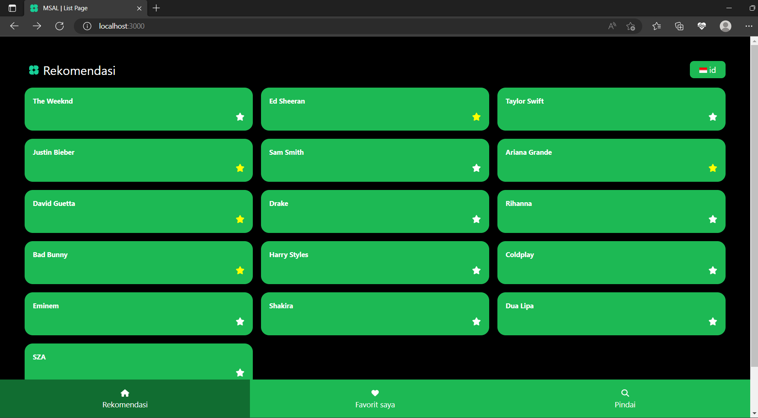

Image 1.0 MSAL on desktop device Image 1.1 MSAL on mobile

**ArtistObject**

The data is fetched to this object by graphql, where the artistName is specified first.

Image 1.1 Artist Object

**Language Option**

MSAL offers two language option: Indonesian and English, to change language, just click on the language button. To apply language changes, react uses Language Context, and get the data from the dictionary.json

Image 2.1 Indonesian mode Image 2.2 English Mode Image 2.3 Change Lang Button

**Homepage (List Page)**

Image 3.1 List Page

List Page have a card component that list all the recommended artist. The star button can be clicked to add that artist to your favorite page. You also can click the card to redirect you the detail page where you can see more about the artist information.

The Navbar is purposely put in the bottom for a better user experience in mobile devices.

Components:

* Layout (Title, ChangeLanguage Button, etc.)
* TitleHeader
* Navbar
* NavbarBtn
* Card Container
* Card Content
* Favorite Button

**Favorite Page**

Image 4.1 Favorite Page

Favorite page is the page that is used to list all user’s favorite artist (marked by the yellow star). Favorite page get and store the data from the local storage, for everytime the user click the star (favorite) button. You can also remove unwanted favorite artist by clicking the star button again, it should disappear from the list.

Image 4.2 Local Storage

Components:

* Layout
* TitleHeader
* Navbar
* NavbarBtn
* ListBox Container
* Card Content
* Favorite Button

**Search Page**

Image 5.1 Search Page

Search Page uses the input element, then change the inputted state. For every change in the input field, MSAL will fetch the data from the spotify graphql using apollo client to search for that artistname.

Image 5.2 Query Used

As per usual, user can add it to their favourite, or see the artist detail

Components:

* Layout
* TitleHeader
* Navbar
* NavbarBtn
* SearchComponent
* ListBox Container
* Card Content
* Favorite Button

**Detail Page**

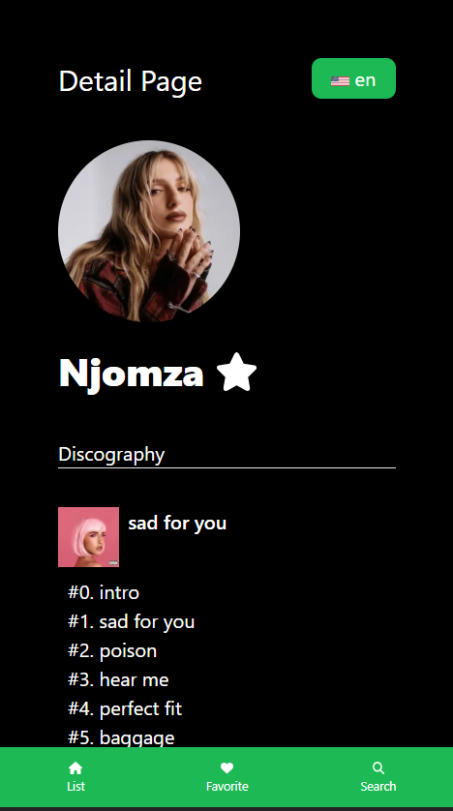

Image 6.1 Detail Page

Detail page have the URL “/detail/{artist-name}”, so user need to click the specified artist to get the right detail page. It consists of artists info, from their image, name, and discography (albums and tracks inside it). The favourite button (star) is also provided for easy access.

Components:

* Layout
* TitleHeader
* Navbar
* Navbarbtn
* ArtistDetail
* ArtistHeader (Artist Image and Name)
* Favorite Button
* Artist Discography (Artist Album and Track)
* Artist Album
* AlbumHeader
* AlbumTracks
* TrackDetail

**BONUS: Light and Dark mode**

Using your browser setting, you can also view the page in light mode