**Problem 6b**

clear; clc;

x = [-1 1 -1 1 -1]; % Present input x(n) in row vector

h = [1 -1 1 -1 1]; % Present impulse response h(n) in row vector

y = conv(x,h); % Convolution function

% Draw output y(n)

stem(y, 'bo');

xlabel('n');

ylabel('y(n) = x(n) * h(n)');

axis([0 10 -6 6]); % Range of n and range of value of y(n)

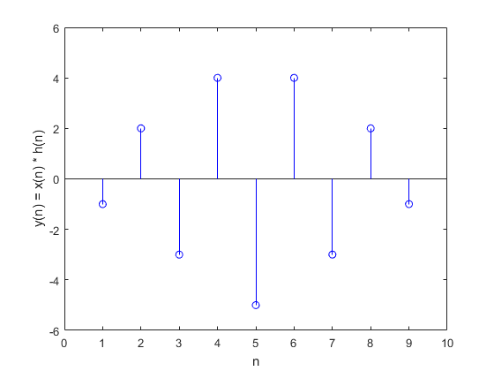

**Figure 1.** The output y(n) drawn by Matlab

**Problem 7**

clear; clc;

t = 0 : pi/50 : 7*pi; % Range of time

Omega = 0.5 * pi; % Omega value

% Draw positive complex exponential

Re_pos = cos(Omega*t);

Im_pos = sin(Omega*t);

subplot(1,2,1);

plot3(t, Re_pos, Im_pos, 'b', 'LineWidth', 2);

ax = gca;

ax.YColor = 'm';

ax.ZColor = 'm';

ax.LineWidth = 2;

ax.GridColor = 'k';

ax.GridLineStyle = ':';

grid;

title('e^{+j\Omegat} (Positive CE)');

xlabel('Time, t', 'Color', 'black', 'rotation', 23);

zlabel('Amplitude in Imaginary axis, Im', 'Color', 'black');

% Draw negative complex exponential

Re_neg = cos(-Omega*t);

Im_neg = sin(-Omega*t);

subplot(1,2,2);

plot3(t, Re_neg, Im_neg, 'r', 'LineWidth', 2);

ax = gca;

ax.LineWidth = 2;

ax.YColor = 'm';

ax.ZColor = 'm';

ax.LineWidth = 2;

ax.GridColor = 'k';

ax.GridLineStyle = ':';

grid;

title('e^{-j\Omegat} (Negative CE)');

xlabel('Time, t', 'Color', 'black', 'rotation', 23);

ylabel('Amplitude in Real axis, Re', 'Color', 'black');

ylh = get(gca,'ylabel');

ylp = get(ylh,'Position');

set(ylh, 'Rotation', -35, 'Position', ylp, 'VerticalAlignment', 'middle', 'HorizontalAlignment', 'right');

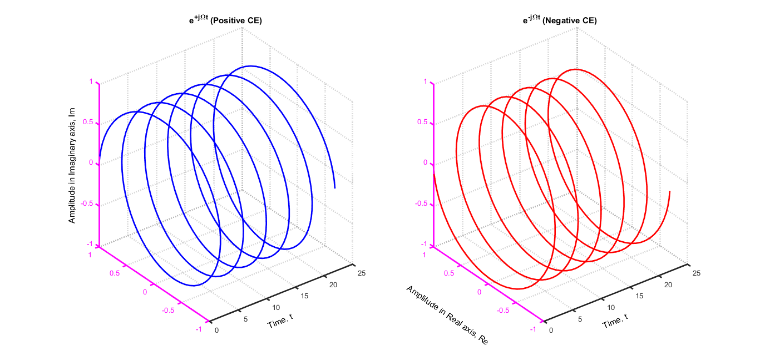

**Figure 2.** The graph of positive and negative complex exponentials