Korea Advanced Institute of Science and Technology

School of Electrical Engineering

EE432 Digital Signal Processing Spring 2018

Student’s Name: Dinh Vu

Student’s ID: 20184187

**Homework 3**

1. **Problem 1**

When the input to an LTI system is

$$x\left(n\right)= {\left(\frac{1}{2}\right)}^{n}u\left(n\right)+2^{n}u\left(-n-1\right)$$

1. Determine the system function $H\left(z\right)$ of the system. Plot the poles and zeros of $H\left(z\right)$, and indicate the ROC

$$X\left(z\right)=\frac{1}{1-\frac{1}{2}z^{-1}}-\frac{1}{1-2z^{-1}}=\frac{-\frac{3}{2}z^{-1}}{\left(1-\frac{1}{2}z^{-1}\right)\left(1-2z^{-1}\right)}, ROC:\frac{1}{2}<\left|z\right|<2$$

$$y\left(n\right)=6{\left(\frac{1}{2}\right)}^{n}u\left(n\right)-6{\left(\frac{3}{4}\right)}^{n}u\left(n\right)$$

$$⇒Y\left(z\right)=6\left(\frac{1}{1-\frac{1}{2}z^{-1}}-\frac{1}{1-\frac{3}{4}z^{-1}}\right)=\frac{-\frac{3}{2}z^{-1}}{\left(1-\frac{1}{2}z^{-1}\right)\left(1-\frac{3}{4}z^{-1}\right)}, ROC:\left|z\right|>\frac{3}{4}$$

$$H\left(z\right)=\frac{Y\left(z\right)}{X\left(z\right)}=\frac{1-2z^{-1}}{1-\frac{3}{4}z^{-1}}=\frac{4\left(z-2\right)}{4z-3}$$

$H\left(z\right)$ has one pole and one zero, $p=\frac{3}{4}=0.75$ and $z=2$ with $ROC: \left|z\right|>\frac{3}{4}$.

The pole and zero of $H\left(z\right)$ are presented in Figure 1.1. The ROC of $H\left(z\right)$ is the gray area.



**Figure 1.1.** Poles and zeros of $H\left(z\right)$

1. Determine the impulse response $h\left(n\right)$ of the system for all values of $n$

$$H\left(z\right)=\frac{1-2z^{-1}}{1-\frac{3}{4}z^{-1}}=\frac{1}{1-\frac{3}{4}z^{-1}}-\frac{2z^{-1}}{1-\frac{3}{4}z^{-1}}, ROC: \left|z\right|>\frac{3}{4}$$

Inverse z-Transform $H\left(z\right)$:

$$h\left(n\right)={\left(\frac{3}{4}\right)}^{n}u\left(n\right)-2{\left(\frac{3}{4}\right)}^{n-1}u\left(n-1\right)$$

1. Write the difference equation that characterizes the system

$$\frac{Y\left(z\right)}{X\left(z\right)}=\frac{1-2z^{-1}}{1-\frac{3}{4}z^{-1}}⇔Y\left(z\right)-\frac{3}{4}z^{-1}Y\left(z\right)=X\left(z\right)-2z^{-1}X\left(z\right)$$

Inverse z-Transform for both sides of the above equation:

$$y\left(n\right)-\frac{3}{4}y\left(n-1\right)=x\left(n\right)-2x\left(n-1\right)⇒y\left(n\right)=\frac{3}{4}y\left(n-1\right)+x\left(n\right)-2x\left(n-1\right)$$

So, the difference equation, characterizing the system is:

$$y\left(n\right)=\frac{3}{4}y\left(n-1\right)+x\left(n\right)-2x\left(n-1\right)$$

1. Is the system stable? Is it causal?

The system is stable because the ROC of $H\left(z\right)$ includes the unit circle in z-plane.

The system is causal because the output $y(n)$ only depends on the delayed sequences and does not depend on the advanced sequences.

1. **Problem 2**
2. Let $r=0.75$ and $ω_{0}=\frac{π}{3}$. Find $b_{0}$ such that $\left|H\left(e^{jπ}\right)\right|=\left|H\left(e^{-jπ}\right)\right|=1$
$$H\left(z\right)=\frac{b_{0}\left(1-e^{jω_{0}}z^{-1}\right)\left(1-e^{-jω_{0}}z^{-1}\right)}{\left(1-re^{jω_{0}}z^{-1}\right)\left(1-re^{-jω_{0}}z^{-1}\right)}$$

$$H\left(e^{jω}\right)=\frac{b_{0}\left[1-e^{j\left(ω_{0}-ω\right)}\right]\left[1-e^{-j\left(ω_{0}+ω\right)}\right]}{\left[1-re^{j\left(ω_{0}-ω\right)}\right]\left[1-re^{-j\left(ω_{0}+ω\right)}\right]}$$

$$\left|H\left(e^{jω}\right)\right|=\left|b_{0}\right|\frac{\left|1-e^{j\left(ω_{0}-ω\right)}\right|\left|1-e^{-j\left(ω_{0}+ω\right)}\right|}{\left|1-re^{j\left(ω_{0}-ω\right)}\right|\left|1-re^{-j\left(ω_{0}+ω\right)}\right|}$$

$$=\left|b_{0}\right|\frac{\sqrt{{\left[1-\cos\left(ω_{0}-ω\right)\right]}^{2}+{\left[\sin\left(ω_{0}-ω\right)\right]}^{2}}\sqrt{{\left[1-\cos\left(ω_{0}+ω\right)\right]}^{2}+{\left[\sin\left(ω_{0}+ω\right)\right]}^{2}}}{\sqrt{{\left[1-r\cos\left(ω_{0}-ω\right)\right]}^{2}+{\left[r\sin\left(ω_{0}-ω\right)\right]}^{2}}\sqrt{{\left[1-r\cos\left(ω_{0}+ω\right)\right]}^{2}+{\left[r\sin\left(ω_{0}+ω\right)\right]}^{2}}}$$

$$=\left|b_{0}\right|\frac{\sqrt{2-2\cos\left(ω_{0}-ω\right)}\sqrt{2-2\cos\left(ω_{0}+ω\right)}}{\sqrt{1+r^{2}-2r\cos\left(ω_{0}-ω\right)}\sqrt{1+r^{2}-2r\cos\left(ω_{0}+ω\right)}}$$

$$For r=0.75, ω_{0}=\frac{π}{3} and ω=π:$$

$$\left|H\left(e^{jπ}\right)\right|=\left|b_{0}\right|\frac{\sqrt{2-2\cos\left(-\frac{2π}{3}\right)}\sqrt{2-2\cos{\frac{4π}{3}}}}{\sqrt{\frac{25}{16}-\frac{3}{2}\cos\left(-\frac{2π}{3}\right)}\sqrt{\frac{25}{16}-\frac{3}{2}\cos{\frac{4π}{3}}}}=\left|b_{0}\right|\frac{\sqrt{3}\sqrt{3}}{\frac{\sqrt{37}}{4}\frac{\sqrt{37}}{4}}=\frac{48}{37}\left|b_{0}\right|$$

$$Because H^{*}\left(e^{jω}\right)=H\left(e^{-jω}\right)⇒\left|H\left(e^{jω}\right)\right|=\left|H^{*}\left(e^{jω}\right)\right|=\left|H\left(e^{-jω}\right)\right|$$

$$Let \left|H\left(e^{jπ}\right)\right|=\left|H\left(e^{-jπ}\right)\right|=1⇔\left|b_{0}\right|=\frac{37}{48}⇔b_{0}=±\frac{37}{48}$$

3. Use Matlab to plot the magnitude response $\left|H\left(e^{jω}\right)\right|$ and the phase response $∠H\left(e^{jω}\right)$ for the range $-π≤ω≤π$. Plot the poles and zeros of $H\left(z\right)$ using Matlab

* Plot the magnitude and phase response of the system

clear; clc;

w = (-1000:1:1000)*pi/1000;

b0 = -37/48;

w0 = pi/3;

r = 0.75;

w1 = w0 - w;

w2 = w0 + w;

H = b0*(1-exp(1j*w1)).*(1-exp(-1j*w2))./((1-r*exp(1j*w1)).*(1-r*exp(-1j*w2)));

magnitudeH = abs(H); phaseH = angle(H);

subplot(2,1,1); plot(w/pi,magnitudeH); grid on;

ylabel('|H(e^j^\omega)|'); title('Magnitude Response');

xlabel('\omega/\pi');

subplot(2,1,2); plot(w/pi,phaseH); grid on;

ylabel('\angleH(e^j^\omega)'); title('Phase Response');

xlabel('\omega/\pi');

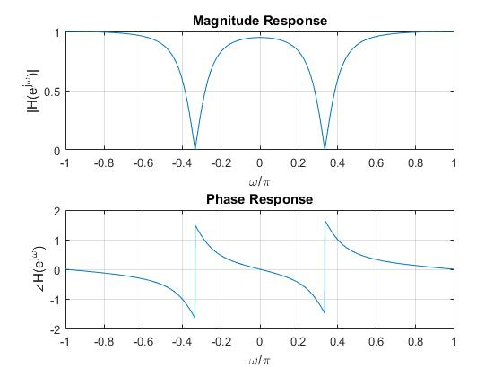

**Figure 2.1.** The magnitude and phase response of the system with $b_{0}=\frac{37}{48},ω_{0}=\frac{π}{3}$ and $r=0.75$

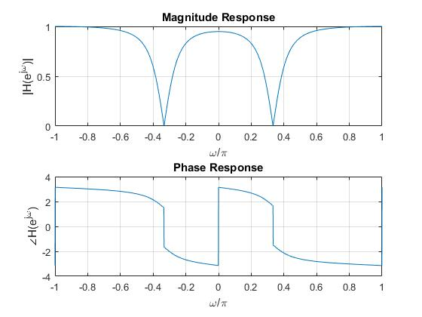

**Figure 2.2.** The magnitude and phase response of the system with $b_{0}=\frac{-37}{48},ω_{0}=\frac{π}{3}$ and $r=0.75$

* Plot the poles and zeros of $H\left(z\right)$

$$H\left(z\right)=\frac{b_{0}\left(1-e^{jω_{0}}z^{-1}\right)\left(1-e^{-jω_{0}}z^{-1}\right)}{\left(1-re^{jω_{0}}z^{-1}\right)\left(1-re^{-jω_{0}}z^{-1}\right)}=b_{0}\frac{1-\left(e^{jω_{0}}+e^{-jω_{0}}\right)z^{-1}+z^{-2}}{1-r\left(e^{jω_{0}}+e^{-jω_{0}}\right)z^{-1}+r^{2}z^{-2}}$$

$$=b_{0}\frac{1-2\cos\left(ω_{0}\right)z^{-1}+z^{-2}}{1-2r\cos\left(ω_{0}\right)z^{-1}+r^{2}z^{-2}}$$

The Figure 2.3 depicts the poles and zeros of $H\left(z\right)$ where $b_{0}=±\frac{37}{48}$.

clear; clc;

% Parameter

b0 = 37/48;

w0 = pi/3;

r = 0.75;

% Polynomial parameter

b = b0*[1 -2*cos(w0) 1];

a = [1 -2*r*cos(w0) r^2];

% Calculating pole

[R, p, C] = residuez(b, a);

% Plot zero-pole

[H1, H2, H3] = zplane(b, a);

set(H1, 'markersize', 10, 'color', 'r');

set(H2, 'markersize', 10, 'color', 'b');

title('Pole-Zero Plot');

text(0.85, -0.1, '1.0');

text(0.01, -0.1, '0');

legend('Zero', 'Pole');

grid on;

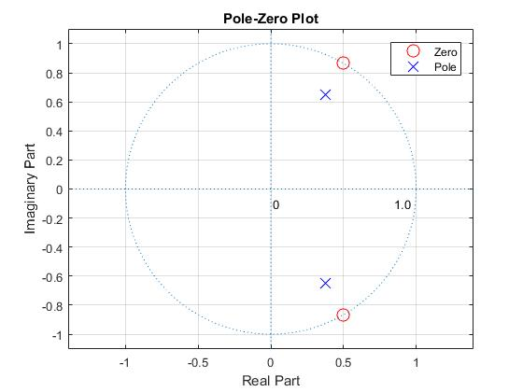

**Figure 2.3.** The poles and zeros of $H\left(z\right)$ for $b_{0}=±\frac{37}{48},ω_{0}=\frac{π}{3}$ and $r=0.75$

1. Now, let $r=0.95$ and $ω_{0}=\frac{π}{3}$. Find $b_{0}$ such that $\left|H\left(e^{jπ}\right)\right|=\left|H\left(e^{-jπ}\right)\right|=1$

$$\left|H\left(e^{jω}\right)\right|=\left|b_{0}\right|\frac{\sqrt{2-2\cos\left(ω_{0}-ω\right)}\sqrt{2-2\cos\left(ω_{0}+ω\right)}}{\sqrt{1+r^{2}-2r\cos\left(ω_{0}-ω\right)}\sqrt{1+r^{2}-2r\cos\left(ω_{0}+ω\right)}}$$

For $r=0.95,ω_{0}=\frac{π}{3}$ and $ω=π$:

$$\left|H\left(e^{jπ}\right)\right|=\left|b_{0}\right|\frac{\sqrt{2-2\cos\left(-\frac{2π}{3}\right)}\sqrt{2-2\cos{\frac{4π}{3}}}}{\sqrt{\frac{761}{400}-\frac{19}{10}\cos\left(-\frac{2π}{3}\right)}\sqrt{\frac{761}{400}-\frac{19}{10}\cos{\frac{4π}{3}}}}=\left|b_{0}\right|\frac{\sqrt{3}\sqrt{3}}{\frac{\sqrt{1141}}{20}\frac{\sqrt{1141}}{20}}=\left|b_{0}\right|\frac{1200}{1141}$$

$$Let \left|H\left(e^{jπ}\right)\right|=\left|H\left(e^{-jπ}\right)\right|=1⇔\left|b_{0}\right|=\frac{1141}{1200}⇔b_{0}=±\frac{1141}{1200}$$

1. Use Matlab to plot the magnitude response $\left|H\left(e^{jω}\right)\right|$ and the phase response $∠H\left(e^{jω}\right)$ for the range $-π≤ω≤π$. Plot the poles and zeros of $H\left(z\right)$ using Matlab

* Plot the magnitude and phase response of the system

clear; clc;

w = (-1000:1:1000)*pi/1000;

b0 = 1141/1200;

w0 = pi/3;

r = 0.95;

w1 = w0 - w;

w2 = w0 + w;

H = b0*(1-exp(1j*w1)).*(1-exp(-1j*w2))./((1-r*exp(1j*w1)).*(1-r*exp(-1j*w2)));

magnitudeH = abs(H);

phaseH = angle(H);

subplot(2,1,1); plot(w/pi,magnitudeH); grid on;

ylabel('|H(e^j^\omega)|'); title('Magnitude Response');

xlabel('\omega/\pi');

subplot(2,1,2); plot(w/pi,phaseH); grid on;

ylabel('\angleH(e^j^\omega)'); title('Phase Response');

xlabel('\omega/\pi');

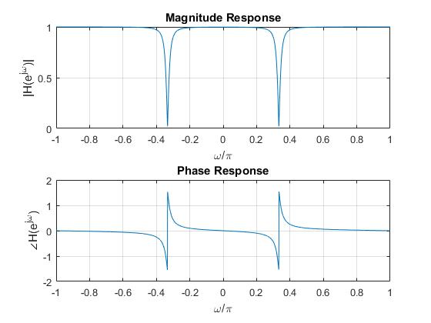

**Figure 2.4.** The magnitude and phase response of the system

with $b_{0}=\frac{1141}{1200},ω_{0}=\frac{π}{3}$ and $r=0.95$

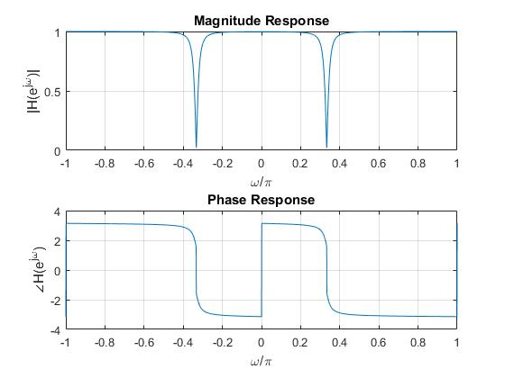

**Figure 2.5.** The magnitude and phase response of the system

with $b_{0}=-\frac{1141}{1200},ω_{0}=\frac{π}{3}$ and $r=0.95$

* Plot the poles and zeros of $H\left(z\right)$

clear; clc;

% Parameter

b0 = 1141/1200;

w0 = pi/3;

r = 0.95;

% Polynomial parameter

b = b0*[1 -2*cos(w0) 1];

a = [1 -2*r*cos(w0) r^2];

% Calculating pole

[R, p, C] = residuez(b, a);

% Plot zero-pole

[H1, H2, H3] = zplane(b, a);

set(H1, 'markersize', 10, 'color', 'r');

set(H2, 'markersize', 10, 'color', 'b');

title('Pole-Zero Plot');

text(0.85, -0.1, '1.0');

text(0.01, -0.1, '0');

legend('Zero', 'Pole');

grid on;

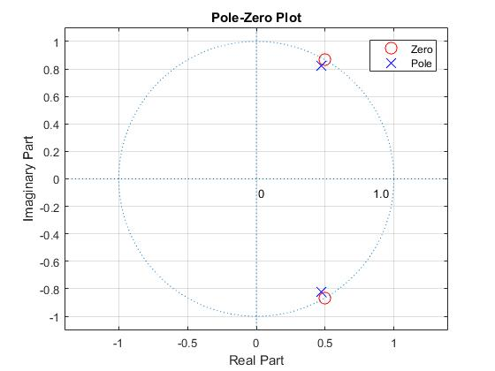

**Figure 2.6.** The poles and zeros of $H\left(z\right)$ for $b_{0}=±\frac{1141}{1200},ω_{0}=\frac{π}{3}$ and $r=0.95$

1. **Problem 3**

Consider a causal linear time-invariant system with system function

$$H\left(z\right)=\frac{\left(1-a^{-1}z^{-1}\right)\left(1-ja^{-1}z^{-1}\right)\left(1+ja^{-1}z^{-1}\right)}{\left(1-az^{-1}\right)\left(1-jaz^{-1}\right)\left(1+jaz^{-1}\right)}$$

Where $a$ is real

1. Write the difference equation that relates the input and the output of this system

$$H\left(z\right)=\frac{\left(1-a^{-1}z^{-1}\right)\left(1-ja^{-1}z^{-1}\right)\left(1+ja^{-1}z^{-1}\right)}{\left(1-az^{-1}\right)\left(1-jaz^{-1}\right)\left(1+jaz^{-1}\right)}=\frac{\left(1-a^{-1}z^{-1}\right)\left(1+a^{-2}z^{-2}\right)}{\left(1-az^{-1}\right)\left(1+a^{2}z^{-2}\right)}$$

$$=\frac{1-a^{-1}z^{-1}+a^{-2}z^{-2}-a^{-3}z^{-3}}{1-az^{-1}+a^{2}z^{-2}-a^{3}z^{-3}}=\frac{Y\left(z\right)}{X\left(z\right)}$$

$$⇒\left(1-az^{-1}+a^{2}z^{-2}-a^{3}z^{-3}\right)Y\left(z\right)=\left(1-a^{-1}z^{-1}+a^{-2}z^{-2}-a^{-3}z^{-3}\right)X\left(z\right)$$

Inverse z-Transform for both sides of the above equation:

$$y\left(n\right)-ay\left(n-1\right)+a^{2}y\left(n-2\right)-a^{3}y\left(n-3\right)=x\left(n\right)-a^{-1}x\left(n-1\right)+a^{-2}x\left(n-2\right)-a^{-3}x\left(n-3\right)$$

$$⇒y\left(n\right)=ay\left(n-1\right)-a^{2}y\left(n-2\right)+a^{3}y\left(n-3\right)+x\left(n\right)-a^{-1}x\left(n-1\right)+a^{-2}x\left(n-2\right)-a^{-3}x\left(n-3\right)$$

1. For what range of values of $a$ is the system stable?

The system always has 3 pole-zero pairs locating in difference sides of the unit circle in z-plane: $\left[\begin{matrix}z_{1}=a^{-1} \\ p_{1}=a\end{matrix}\right],\left[\begin{matrix}z_{2}=ja^{-1} \\ p_{2}=ja\end{matrix}\right],\left[\begin{matrix}z_{3}=-ja^{-1} \\ p_{3}=-ja\end{matrix}\right]$

As long as $\left|a\right|<1$, the system is stable.

1. For $a=\frac{1}{2}$, plot the pole-zero diagram using Matlab and shade the region of convergence

$$H\left(z\right)=\frac{\left(1-2z^{-1}\right)\left(1-2jz^{-1}\right)\left(1+2jz^{-1}\right)}{\left(1-\frac{1}{2}z^{-1}\right)\left(1-\frac{j}{2}z^{-1}\right)\left(1+\frac{j}{2}z^{-1}\right)}=\frac{\left(1-2z^{-1}\right)\left(1+4z^{-2}\right)}{\left(1-\frac{1}{2}z^{-1}\right)\left(1+\frac{1}{4}z^{-2}\right)}$$

$$z_{1}=2,z_{2}=2j,z_{3}=-2j and p_{1}=\frac{1}{2},p_{2}=\frac{j}{2},p_{3}=-\frac{j}{2}$$

clear; clc;

% Parameter

a = 0.5;

r1 = abs(a); r2 = abs(1/a);

r_pole = min(r1, r2);

axis_lim = max(r1, r2) + 0.5;

% Plot the poles

ReP = [a, 0, 0];

ImP = [0, a, -a];

plot(ReP, ImP, 'xr', 'MarkerSize', 7, 'DisplayName', 'Poles');

axis([-axis_lim, axis_lim, -axis_lim, axis_lim]);

axis equal; hold on; grid on;

% Plot the zeros

ReZ = [1/a, 0, 0];

ImZ = [0, 1/a, -1/a];

plot(ReZ, ImZ, 'ob', 'MarkerSize', 7, 'DisplayName', 'Zeros');

hold on;

% Plot the unit circle

[x_unit, y_unit] = circle(0, 0, 1);

plot(x_unit, y_unit, 'k--', 'LineWidth', 1, 'DisplayName', 'Unit circle');

% Plot the pole circle

[x_pole, y_pole] = circle(0, 0, r_pole);

plot(x_pole, y_pole, 'r', 'LineWidth', 1, 'DisplayName', '|z| = 0.5');

[x, y] = circle(0, 0, 2*axis_lim);

h = patch([x,x_pole], [y,y_pole], [0.5 0.5 0.5], 'LineStyle', 'none', 'FaceAlpha', 0.25, 'DisplayName', 'ROC');

legend('show');

xlabel('Re(z)'); ylabel('Im(z)');

title('Problem 3c');

hold off;

%% Inner function

function [xc, yc] = circle(x, y, r)

theta = 0:pi/1000:2*pi;

xc = x + r * cos(theta);

yc = y + r * sin(theta);

end

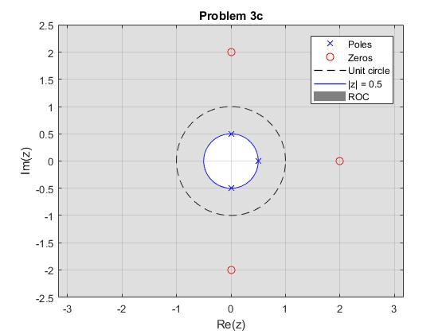

**Figure 3.1.** The pole-zero and ROC graph

1. Find the impulse response $h(n)$ for the system

$$p_{1}=a$$

$$p_{2}=ja=\left\{\begin{aligned}ae^{j\frac{π}{2}} if a≥0 \\ -ae^{-j\frac{π}{2}} if a<0\end{aligned}\right.$$

$$p_{2}=-ja=p_{2}^{*}$$

$$H\left(z\right)=\frac{1-a^{-1}z^{-1}+a^{-2}z^{-2}-a^{-3}z^{-3}}{1-az^{-1}+a^{2}z^{-2}-a^{3}z^{-3}}$$

$$=a^{-6}+\frac{1-a^{-6}+\left(a^{-5}-a^{-1}\right)z^{-1}+\left(a^{-2}-a^{-4}\right)z^{-2}}{\left(1-az^{-1}\right)\left(1-jaz^{-1}\right)\left(1+jaz^{-1}\right)}$$

$$Let K\left(z\right)=\frac{1-a^{-6}+\left(a^{-5}-a^{-1}\right)z^{-1}+\left(a^{-2}-a^{-4}\right)z^{-2}}{\left(1-az^{-1}\right)\left(1-jaz^{-1}\right)\left(1+jaz^{-1}\right)}$$

$$⇒\frac{K\left(z\right)}{z}=\frac{\left(1-a^{-6}\right)z^{2}+\left(a^{-5}-a^{-1}\right)z+a^{-2}-a^{-4}}{\left(z-a\right)\left(z-ja\right)\left(z+ja\right)}=\frac{A_{1}}{z-a}+\frac{A_{2}}{z-ja}+\frac{A_{3}}{z+ja}$$

$$A_{1}=\left(z-a\right){\left.\frac{K\left(z\right)}{z}\right|}_{z=a}=\frac{\left(a^{2}-1\right)\left(a^{4}+1\right)}{2a^{6}}$$

$$A_{2}=\left(z-ja\right){\left.\frac{K\left(z\right)}{z}\right|}_{z=ja}=\frac{\left(1-a^{-6}\right){\left(ja\right)}^{2}+\left(a^{-5}-a^{-1}\right)ja+a^{-2}-a^{-4}}{\left(ja-a\right)\left(ja+ja\right)}$$

$$=\frac{a^{4}-1}{4a^{6}}\left[1+a^{2}+j\left(1-a^{2}\right)\right]=\frac{a^{2}+1}{4a^{6}}\left[a^{4}-1-j{\left(a^{2}-1\right)}^{2}\right]$$

$$Because p_{3}=p_{2}^{*}⇒A_{3}=A_{2}^{*}$$

$$\left|A_{2}\right|=\left|A_{3}\right|=\left|\frac{a^{2}+1}{4a^{6}}\right|\sqrt{{\left(a^{4}-1\right)}^{2}+{\left(a^{2}-1\right)}^{4}}=\frac{a^{2}+1}{4a^{6}}\left|a^{2}-1\right|\sqrt{{\left(a^{2}+1\right)}^{2}+{\left(a^{2}-1\right)}^{2}}$$

$$Let α=∠A_{2}=atan2\left\{-{\left(a^{2}-1\right)}^{2},a^{4}-1\right\}⇒A_{2}=\left|A_{2}\right|e^{jα}$$

$$K\left(z\right)=\frac{A_{1}}{1-az^{-1}}+\frac{A_{2}}{1-jaz^{-1}}+\frac{A_{3}}{1+jaz^{-1}}$$

$$Z^{-1}\left\{K\left(z\right)\right\}=Z^{-1}\left\{\frac{A_{1}}{1-az^{-1}}\right\}+Z^{-1}\left\{\frac{A_{2}}{1-jaz^{-1}}+\frac{A_{3}}{1+jaz^{-1}}\right\}$$

$$Because the system is causal, ROC: \left|z\right|>\left|a\right|⇒Z^{-1}\left\{\frac{A_{1}}{1-az^{-1}}\right\}=A_{1}a^{n}u\left(n\right)$$

Applying the below inverse z-Transform property:

$$Z^{-1}\left\{\frac{A_{k}}{1-p_{k}z^{-1}}+\frac{A_{k}^{*}}{1-p_{k}^{*}z^{-1}}\right\}=2\left|A_{k}\right|r_{k}^{n}\cos\left(β_{k}n+α_{k}\right)u\left(n\right)$$

$$Where A_{k}=\left|A_{k}\right|e^{jα_{k}} and p_{k}=r_{k}e^{jβ_{k}}$$

$$Z^{-1}\left\{\frac{A_{2}}{1-jaz^{-1}}+\frac{A_{3}}{1+jaz^{-1}}\right\}=Z^{-1}\left\{\frac{A_{2}}{1-p_{2}z^{-1}}+\frac{A_{2}^{*}}{1-p_{2}^{*}z^{-1}}\right\}=\left\{\begin{aligned}2\left|A_{2}\right|a^{n}\cos\left(\frac{π}{2}n+α\right)u\left(n\right) if a≥0 \\ 2\left|A_{2}\right|{\left(-a\right)}^{n}\cos\left(-\frac{π}{2}n+α\right)u\left(n\right) if a<0\end{aligned}\right.$$

Finally, there are 2 cases:

$$h\left(n\right)=\left\{\begin{aligned}\frac{1}{a^{6}}δ\left(n\right)+A_{1}a^{n}u\left(n\right)+2\left|A_{2}\right|a^{n}\cos\left(\frac{π}{2}n+α\right)u\left(n\right) if a≥0 \\ \frac{1}{a^{6}}δ\left(n\right)+A_{1}a^{n}u\left(n\right)+2\left|A_{2}\right|{\left(-a\right)}^{n}\cos\left(-\frac{π}{2}n+α\right)u\left(n\right) if a<0\end{aligned}\right.$$

Where:

$$A_{1}=\frac{\left(a^{2}-1\right)\left(a^{4}+1\right)}{2a^{6}}$$

$$\left|A_{2}\right|=\frac{a^{2}+1}{4a^{6}}\left|a^{2}-1\right|\sqrt{{\left(a^{2}+1\right)}^{2}+{\left(a^{2}-1\right)}^{2}}$$

$$α=atan2\left\{-{\left(a^{2}-1\right)}^{2},a^{4}-1\right\}$$

1. Show that the system is an all-pass system, i.e., that the magnitude of the frequency response is a constant. Also, specify the value of the constant.

$$H\left(z\right)=\frac{\left(1-a^{-1}z^{-1}\right)\left(1-ja^{-1}z^{-1}\right)\left(1+ja^{-1}z^{-1}\right)}{\left(1-az^{-1}\right)\left(1-jaz^{-1}\right)\left(1+jaz^{-1}\right)}$$

$$=-a^{-3}z^{-3}\frac{\left(1-az\right)\left(1-jaz\right)\left(1+jaz\right)}{\left(1-az^{-1}\right)\left(1-jaz^{-1}\right)\left(1+jaz^{-1}\right)}=-a^{-3}z^{-3}\frac{\left(1-az\right)\left(1+a^{2}z^{2}\right)}{\left(1-az^{-1}\right)\left(1+a^{2}z^{-2}\right)}$$

$$H\left(e^{jω}\right)=-a^{-3}e^{-j3ω}\frac{\left(1-ae^{jω}\right)\left(1+a^{2}e^{j2ω}\right)}{\left(1-ae^{-jω}\right)\left(1+a^{2}e^{-j2ω}\right)}$$

$$\left|H\left(e^{jω}\right)\right|=\left|-a^{-3}\right|×\left|e^{-j3ω}\right|×\left|\frac{1-ae^{jω}}{1-ae^{-jω}}\right|×\left|\frac{1+a^{2}e^{j2ω}}{1+a^{2}e^{-j2ω}}\right|$$

$$\left|-a^{-3}\right|=\frac{1}{\left|a^{3}\right|}$$

$$\left|e^{-j3ω}\right|=\sqrt{{\left[\cos\left(-3ω\right)\right]}^{2}+{\left[\sin\left(-3ω\right)\right]}^{2}}=1$$

$$\left|\frac{1-ae^{jω}}{1-ae^{-jω}}\right|=\frac{\sqrt{{\left(1-a\cos{ω}\right)}^{2}+{\left(a\sin{ω}\right)}^{2}}}{\sqrt{{\left(1-a\cos{ω}\right)}^{2}+{\left(a\sin{ω}\right)}^{2}}}=1$$

$$\left|\frac{1+a^{2}e^{j2ω}}{1+a^{2}e^{-j2ω}}\right|=\frac{\sqrt{{\left[1+a^{2}\cos\left(2ω\right)\right]}^{2}+{\left[a^{2}\sin\left(2ω\right)\right]}^{2}}}{\sqrt{{\left[1+a^{2}\cos\left(2ω\right)\right]}^{2}+{\left[a^{2}\sin\left(2ω\right)\right]}^{2}}}=1$$

$$Hence, \left|H\left(e^{jω}\right)\right|=\frac{1}{\left|a^{3}\right|}$$

And the system is an all-pass system.

1. Plot the magnitude and phase responses of $H\left(e^{jω}\right)$ with $a=\frac{1}{2}$ for $-π≤ω≤π$ using Matlab

$$H\left(z\right)=\frac{\left(1-a^{-1}z^{-1}\right)\left(1+a^{-2}z^{-2}\right)}{\left(1-az^{-1}\right)\left(1+a^{2}z^{-2}\right)}⇒H\left(e^{jω}\right)=\frac{\left(1-a^{-1}e^{-jω}\right)\left(1+a^{-2}e^{-j2ω}\right)}{\left(1-ae^{-jω}\right)\left(1+a^{2}e^{-j2ω}\right)}$$

$${\left.H\left(e^{jω}\right)\right|}_{a=\frac{1}{2}}=\frac{\left(1-2e^{-jω}\right)\left(1+4e^{-j2ω}\right)}{\left(1-\frac{1}{2}e^{-jω}\right)\left(1+\frac{1}{4}e^{-j2ω}\right)}$$

clear; clc;

w = (-1000:1:1000)*pi/1000;

a = 0.5;

H = (1-1/a*exp(-1j*w)).*(1+1/a^2*exp(-2j*w))./((1-a*exp(-1j*w)).*(1+a^2*exp(-2j*w)));

magnitudeH = abs(H);

phaseH = angle(H);

subplot(2,1,1); plot(w/pi,magnitudeH); grid on;

axis([-1 1 7 9]);

ylabel('|H(e^j^\omega)|'); title('Magnitude Response');

xlabel('\omega/\pi');

subplot(2,1,2); plot(w/pi,phaseH); grid on;

ylabel('\angleH(e^j^\omega)'); title('Phase Response');

xlabel('\omega/\pi');

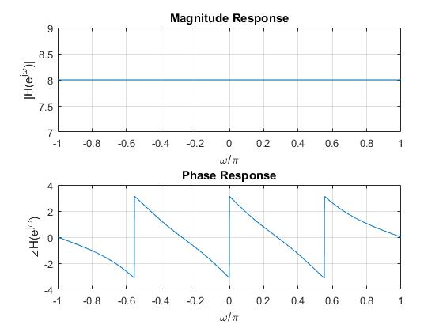

**Figure 3.2.** The magnitude and phase response of the system where $a=\frac{1}{2}$

1. **Problem 4**

Consider a stable LTI system given by

$$H\left(z\right)=\frac{\left(1-9z^{-2}\right)\left(1+\frac{1}{3}z^{-1}\right)}{1-\frac{1}{3}z^{-1}}$$

1. $H\left(z\right)$ can be expressed as a cascade of a minimum-phase system $H_{min}\left(z\right)$ and a unity-gain all-pass system $H_{ap}\left(z\right)$. Determine a choice for $H_{min}\left(z\right)$ and $H_{ap}\left(z\right)$, and specify whether or not they are unique up to a scale factor

$$H\left(z\right)=\frac{\left(1-9z^{-2}\right)\left(1+\frac{1}{3}z^{-1}\right)}{1-\frac{1}{3}z^{-1}}=\frac{\left(1-3z^{-1}\right)\left(1+3z^{-1}\right)\left(1+\frac{1}{3}z^{-1}\right)}{1-\frac{1}{3}z^{-1}}$$

$$=\frac{3\left(\frac{1}{3}-z^{-1}\right)\left(1+3z^{-1}\right)\left(1+\frac{1}{3}z^{-1}\right)}{1-\frac{1}{3}z^{-1}}=-3\left(1+3z^{-1}\right)\left(1+\frac{1}{3}z^{-1}\right)\frac{z^{-1}-\frac{1}{3}}{1-\frac{1}{3}z^{-1}}$$

$$=-9{\left(1+\frac{1}{3}z^{-1}\right)}^{2}\frac{\left(z^{-1}+\frac{1}{3}\right)\left(z^{-1}-\frac{1}{3}\right)}{\left(1+\frac{1}{3}z^{-1}\right)\left(1-\frac{1}{3}z^{-1}\right)}$$

$$H_{1}\left(z\right)=H_{min}\left(z\right)=-9{\left(1+\frac{1}{3}z^{-1}\right)}^{2}$$

$H_{1}\left(z\right)$ is a minimum-phase system because its poles do not exist but its zeros are inside of the unit circle: $z_{1}=z_{2}=-\frac{1}{3}$

$$H_{2}\left(z\right)=H_{ap}\left(z\right)=\frac{\left(z^{-1}+\frac{1}{3}\right)\left(z^{-1}-\frac{1}{3}\right)}{\left(1+\frac{1}{3}z^{-1}\right)\left(1-\frac{1}{3}z^{-1}\right)}$$

$H_{2}\left(z\right)$ is a all-pass system because there are 2 pole-zero pairs, the poles are inside but the zeros are outside of the unit circle.

1. Is the minimum-phase system $H_{min}\left(z\right)$ a FIR system? Explain

$$H_{min}\left(z\right)=-9{\left(1+\frac{1}{3}z^{-1}\right)}^{2}=-{\left(3+z^{-1}\right)}^{2}=-9-6z^{-1}-z^{-2}$$

$$⇒h_{min}\left(n\right)=-9δ\left(n\right)-6δ\left(n-1\right)-δ\left(n-2\right)$$

Obviously, $h_{min}\left(n\right)$ is a FIR.

1. Is the minimum-phase system $H_{min}\left(z\right)$ a generalized linear-phase system? If not, can $H\left(z\right)$ be represented as a cascade of a generalized linear-phase system $H_{lin}\left(z\right)$ and an all-pass system $H_{ap2}\left(z\right)$? If your answer is yes, determine $H_{lin}\left(z\right)$ and $H_{ap2}\left(z\right)$. If your answer is no, explain why such representation does not exist.

$$H_{min}\left(z\right)=-9{\left(1+\frac{1}{3}z^{-1}\right)}^{2}$$

$$⇒H_{min}\left(e^{jω}\right)=-9{\left(1+\frac{1}{3}e^{-jω}\right)}^{2}=-{\left(3+e^{-jω}\right)}^{2}=-9-6e^{-jω}-e^{-j2ω}=-9-6\left(\cos{ω-j\sin{ω}}\right)-\left(\cos{2ω}-j\sin{2ω}\right)=-9-6\cos{ω}-\cos{2ω}+j\left(6\sin{ω}+\sin{2ω}\right)$$

$⇒∠H_{min}\left(e^{jω}\right)=atan2\left(6\sin{ω}+\sin{2ω},-9-6\cos{ω}-\cos{2ω}\right)$ is not linear

Therefore, the minimum-phase system $H_{min}\left(z\right)$ is not a generalized linear-phase system.

$H\left(z\right)$ can be represented as a cascade of a generalized linear-phase system and an all-pass system as below:

$$H\left(z\right)=\frac{\left(1-3z^{-1}\right)\left(1+3z^{-1}\right)\left(1+\frac{1}{3}z^{-1}\right)}{1-\frac{1}{3}z^{-1}}$$

$$=\left[\left(1+3z^{-1}\right)\left(1+\frac{1}{3}z^{-1}\right)\right]\left(\frac{1-3z^{-1}}{1-\frac{1}{3}z^{-1}}\right)$$

$$H_{lin}\left(z\right)=\left(1+3z^{-1}\right)\left(1+\frac{1}{3}z^{-1}\right)$$

$$H_{ap2}\left(z\right)=\frac{1-3z^{-1}}{1-\frac{1}{3}z^{-1}}$$

1. **Problem 5**

Consider the LTI system whose system function is given by

$$H\left(z\right)=\left(1-0.9e^{j0.6π}z^{-1}\right)\left(1-0.9e^{-j0.6π}z^{-1}\right)\left(1-1.25e^{j0.8π}z^{-1}\right)\left(1-1.25e^{-j0.8π}z^{-1}\right)$$

1. Determine all causal system functions that results in the same frequency-response magnitude as $H\left(z\right)$ and for which the impulse responses are real value and of the same length as the impulse response associated with $H\left(z\right)$. There are four different such systems. Identify which system function is minimum phase and which to within a time shift, is maximum phase.



**Figure 5.1.** The zeros of 4 system (a) $H\left(z\right)$, (b) $H_{1}\left(z\right)$, (c) $H_{2}\left(z\right)$ and (d) $H_{3}\left(z\right)$

* System 1:
$$H\left(z\right)=\left(1-0.9e^{j0.6π}z^{-1}\right)\left(1-0.9e^{-j0.6π}z^{-1}\right)\left(1-1.25e^{j0.8π}z^{-1}\right)\left(1-1.25e^{-j0.8π}z^{-1}\right)$$

$$=\left(1-0.9e^{j0.6π}z^{-1}\right)\left(1-0.9e^{-j0.6π}z^{-1}\right)\left(1.25e^{j0.8π}\right)\left(0.8e^{-j0.8π}-z^{-1}\right)\left(1.25e^{-j0.8π}\right)\left(0.8e^{j0.8π}-z^{-1}\right)$$

$$=\left(1-0.9e^{j0.6π}z^{-1}\right)\left(1-0.9e^{-j0.6π}z^{-1}\right){\left(1.25\right)}^{2}\left(z^{-1}-0.8e^{-j0.8π}\right)\left(z^{-1}-0.8e^{j0.8π}\right)$$

$$={\left(1.25\right)}^{2}\left(1-0.9e^{j0.6π}z^{-1}\right)\left(1-0.9e^{-j0.6π}z^{-1}\right)\left(1-0.8e^{-j0.8π}z^{-1}\right)\left(1-0.8e^{j0.8π}z^{-1}\right)\frac{\left(z^{-1}-0.8e^{-j0.8π}\right)\left(z^{-1}-0.8e^{j0.8π}\right)}{\left(1-0.8e^{-j0.8π}z^{-1}\right)\left(1-0.8e^{j0.8π}z^{-1}\right)}$$

$$⇒H_{1}\left(z\right)={\left(1.25\right)}^{2}\left(1-0.9e^{j0.6π}z^{-1}\right)\left(1-0.9e^{-j0.6π}z^{-1}\right)\left(1-0.8e^{-j0.8π}z^{-1}\right)\left(1-0.8e^{j0.8π}z^{-1}\right)$$

* System 2:
$$H\left(z\right)=\left(1-0.9e^{j0.6π}z^{-1}\right)\left(1-0.9e^{-j0.6π}z^{-1}\right)\left(1-1.25e^{j0.8π}z^{-1}\right)\left(1-1.25e^{-j0.8π}z^{-1}\right)$$

$$=0.9e^{j0.6π}\left(\frac{10}{9}e^{-j0.6π}-z^{-1}\right)0.9e^{-j0.6π}\left(\frac{10}{9}e^{j0.6π}-z^{-1}\right)\left(1-1.25e^{j0.8π}z^{-1}\right)\left(1-1.25e^{-j0.8π}z^{-1}\right)$$

$$={\left(0.9\right)}^{2}\left(z^{-1}-\frac{10}{9}e^{-j0.6π}\right)\left(z^{-1}-\frac{10}{9}e^{j0.6π}\right)\left(1-1.25e^{j0.8π}z^{-1}\right)\left(1-1.25e^{-j0.8π}z^{-1}\right)$$

$$={\left(0.9\right)}^{2}\left(1-1.25e^{j0.8π}z^{-1}\right)\left(1-1.25e^{-j0.8π}z^{-1}\right)\left(1-\frac{10}{9}e^{-j0.6π}z^{-1}\right)\left(1-\frac{10}{9}e^{j0.6π}z^{-1}\right)\frac{\left(z^{-1}-\frac{10}{9}e^{-j0.6π}\right)\left(z^{-1}-\frac{10}{9}e^{j0.6π}\right)}{\left(1-\frac{10}{9}e^{-j0.6π}z^{-1}\right)\left(1-\frac{10}{9}e^{j0.6π}z^{-1}\right)}$$

$$⇒H_{2}\left(z\right)={\left(0.9\right)}^{2}\left(1-1.25e^{j0.8π}z^{-1}\right)\left(1-1.25e^{-j0.8π}z^{-1}\right)\left(1-\frac{10}{9}e^{-j0.6π}z^{-1}\right)\left(1-\frac{10}{9}e^{j0.6π}z^{-1}\right)$$

* System 3:

$$H\left(z\right)=\left(1-0.9e^{j0.6π}z^{-1}\right)\left(1-0.9e^{-j0.6π}z^{-1}\right)\left(1-1.25e^{j0.8π}z^{-1}\right)\left(1-1.25e^{-j0.8π}z^{-1}\right)$$

$$=0.9e^{j0.6π}\left(\frac{10}{9}e^{-j0.6π}-z^{-1}\right)0.9e^{-j0.6π}\left(\frac{10}{9}e^{j0.6π}-z^{-1}\right)\left(1.25e^{j0.8π}\right)\left(0.8e^{-j0.8π}-z^{-1}\right)\left(1.25e^{-j0.8π}\right)\left(0.8e^{j0.8π}-z^{-1}\right)$$

$$={\left(0.9\right)}^{2}{\left(1.25\right)}^{2}\left(z^{-1}-\frac{10}{9}e^{-j0.6π}\right)\left(z^{-1}-\frac{10}{9}e^{j0.6π}\right)\left(z^{-1}-0.8e^{-j0.8π}\right)\left(z^{-1}-0.8e^{j0.8π}\right)$$

$$={\left(0.9\right)}^{2}{\left(1.25\right)}^{2}\left(1-\frac{10}{9}e^{-j0.6π}z^{-1}\right)\left(1-\frac{10}{9}e^{j0.6π}z^{-1}\right)\left(1-0.8e^{-j0.8π}z^{-1}\right)\left(1-0.8e^{j0.8π}z^{-1}\right)\frac{\left(z^{-1}-\frac{10}{9}e^{-j0.6π}\right)\left(z^{-1}-\frac{10}{9}e^{j0.6π}\right)\left(z^{-1}-0.8e^{-j0.8π}\right)\left(z^{-1}-0.8e^{j0.8π}\right)}{\left(1-\frac{10}{9}e^{-j0.6π}\right)\left(1-\frac{10}{9}e^{j0.6π}\right)\left(1-0.8e^{-j0.8π}\right)\left(1-0.8e^{j0.8π}\right)}$$

$$⇒H_{3}\left(z\right)={\left(0.9\right)}^{2}{\left(1.25\right)}^{2}\left(1-\frac{10}{9}e^{-j0.6π}z^{-1}\right)\left(1-\frac{10}{9}e^{j0.6π}z^{-1}\right)\left(1-0.8e^{-j0.8π}z^{-1}\right)\left(1-0.8e^{j0.8π}z^{-1}\right)$$

$H_{1}\left(z\right)$ is a minimum-phase system because all its zeros are inside the unit circle.

$H_{2}\left(z\right)$ is a maximum-phase system because all its zeros are outside the unit circle.

1. Determine the impulse response for the system function in part (a)
$$H\left(z\right)=\left(1-0.9e^{j0.6π}z^{-1}\right)\left(1-0.9e^{-j0.6π}z^{-1}\right)\left(1-1.25e^{j0.8π}z^{-1}\right)\left(1-1.25e^{-j0.8π}z^{-1}\right)$$

$$=1+2.5788z^{-1}+3.4975z^{-2}+2.5074z^{-3}+1.2656z^{-4}$$

$$⇒h\left(n\right)=δ\left(n\right)+2.5788δ\left(n-1\right)+3.4975δ\left(n-2\right)+2.5074δ\left(n-3\right)+1.2656δ\left(n-4\right)$$

$$H_{1}\left(z\right)={\left(1.25\right)}^{2}\left(1-0.9e^{j0.6π}z^{-1}\right)\left(1-0.9e^{-j0.6π}z^{-1}\right)\left(1-0.8e^{-j0.8π}z^{-1}\right)\left(1-0.8e^{j0.8π}z^{-1}\right)$$

$$=1.5625+2.8917z^{-1}+3.3906z^{-2}+2.1945z^{-3}+0.81z^{-4}$$

$$⇒h_{1}\left(n\right)=1.5625δ\left(n\right)+2.8917δ\left(n-1\right)+3.3906δ\left(n-2\right)+2.1945δ\left(n-3\right)+0.81δ\left(n-4\right)$$

$$H_{2}\left(z\right)={\left(0.9\right)}^{2}\left(1-1.25e^{j0.8π}z^{-1}\right)\left(1-1.25e^{-j0.8π}z^{-1}\right)\left(1-\frac{10}{9}e^{-j0.6π}z^{-1}\right)\left(1-\frac{10}{9}e^{j0.6π}z^{-1}\right)$$

$$=0.81+2.1945z^{-1}+3.3906z^{-2}+2.8917z^{-3}+1.5625z^{-4}$$

$$⇒h_{2}\left(n\right)=0.81δ\left(n\right)+2.1945δ\left(n-1\right)+3.3906δ\left(n-2\right)+2.8917δ\left(n-3\right)+1.5625δ\left(n-4\right)$$

$$H_{3}\left(z\right)={\left(0.9\right)}^{2}{\left(1.25\right)}^{2}\left(1-\frac{10}{9}e^{-j0.6π}z^{-1}\right)\left(1-\frac{10}{9}e^{j0.6π}z^{-1}\right)\left(1-0.8e^{-j0.8π}z^{-1}\right)\left(1-0.8e^{j0.8π}z^{-1}\right)$$

$$=1.2656+2.5074z^{-1}+3.4975z^{-2}+2.5788z^{-3}+z^{-4}$$

$$⇒h_{3}\left(n\right)=1.2656δ\left(n\right)+2.5074δ\left(n-1\right)+3.4975δ\left(n-2\right)+2.5788δ\left(n-3\right)+δ\left(n-4\right)$$

2. For each of the sequences in part (b), compute and plot the quantity $E\left(n\right)=\sum_{m=0}^{n}{h^{2}\left(m\right)}$ for $0≤n≤5$. Indicate explicitly which plot corresponds to the minimum-phase system.

**Table 5.1.** The energy of each sequence

|  |  |  |  |  |
| --- | --- | --- | --- | --- |
| $$n$$ | $$E\left(n\right)$$ | $$E_{1}\left(n\right)$$ | $$E_{2}\left(n\right)$$ | $$E_{3}\left(n\right)$$ |
| 0 | 1 | 2.44 | 0.66 | 1.6 |
| 1 | 7.65 | 10.8 | 5.47 | 7.89 |
| 2 | 19.88 | 22.3 | 16.97 | 20.12 |
| 3 | 26.17 | 27.11 | 25.33 | 26.77 |
| 4 | 27.77 | 27.77 | 27.77 | 27.77 |
| 5 | 27.77 | 27.77 | 27.77 | 27.77 |

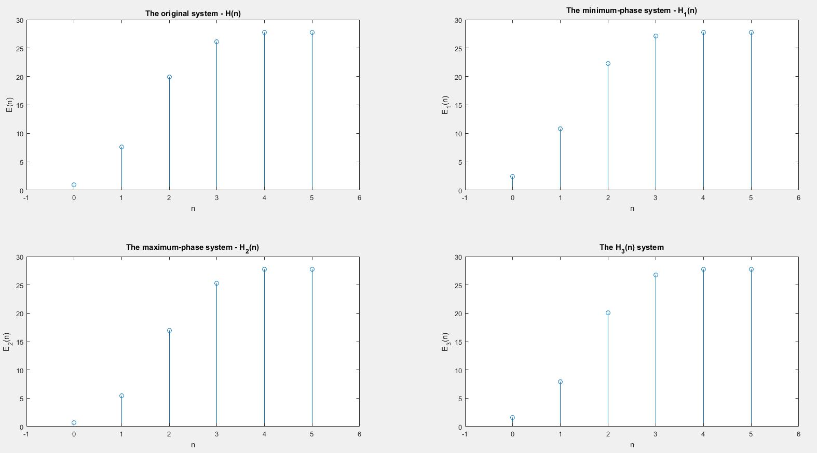

**Figure 5.2.** The quantity of energy in time domain

The plot of $E_{1}\left(n\right)$ corresponds to the minimum-phase system.