Korea Advanced Institute of Science and Technology

School of Electrical Engineering

EE488 Introduction to Machine Learning Spring 2018

Student Name: Dinh Vu

Student ID: 20184187

**Homework 2**

1. **Part 1**
2. **Logistic regression**

$$\log{L(θ)}=\sum_{i=1}^{n}{\log{P\left(y_{i} | x_{i};θ\right)}}=\sum_{i=1}^{n}{y_{i}θ^{T}x_{i}-\log\left(1+e^{θ^{T}x_{i}}\right)}$$

$$J\left(θ\right)=\log{L\left(θ\right)}-Cθ_{j}^{2}=\sum_{i=1}^{n}{\left[y_{i}θ^{T}x_{i}-\log\left(1+e^{θ^{T}x_{i}}\right)\right]}-Cθ_{j}^{2}$$

Using the regularization penalty $-Cθ_{j}^{2}$ where j = {0, 1, 2}, the optimization equation must be solved:

$$\hat{θ}=arg\max_{θ}{J\left(θ\right)}=arg\max_{θ}\left\{\sum_{i=1}^{n}{\left[y_{i}θ^{T}x_{i}-\log\left(1+e^{θ^{T}x_{i}}\right)\right]}-Cθ_{j}^{2}\right\}$$

Take derivative with respect to θ then set to 0:

$$\frac{∂J\left(θ\right)}{∂θ}=\sum_{i=1}^{n}{\left(y_{i}x_{i}-\frac{e^{θ^{T}x_{i}}}{1+e^{θ^{T}x_{i}}}×x_{i}\right)}-2Cθ_{j}=0$$

$$θ_{j}=\frac{1}{2C}\sum_{i=1}^{n}{y_{i}x_{i}-\frac{e^{θ^{T}x_{i}}}{1+e^{θ^{T}x_{i}}}×x_{i}} (1.1)$$

Without regularization penalty, the black decision boundary $θ_{0}+θ_{1}x_{1}+θ_{2}x_{2}=0$ classifies the training data with no training error as shown in Figure 1.1. This decision boundary cut Ox1 at and cut Ox2 at .

First, let regularize only $θ_{0}$. Because C is very large, from (1.1) get that $θ_{0}→0$ then $-\frac{θ_{0}}{θ_{1}}→0$ and $-\frac{θ_{0}}{θ_{2}}→0$. The decision boundary will shift up horizontally and become the red line in Figure 1.1. The training error may be increase to 1.

Second, considering only $θ_{1}$ is regularized. Because of the great value of C and (1.1), $θ_{1}→0$ that mean $-\frac{θ_{0}}{θ_{1}}→∞$, the decision boundary will rotate following the opposite direction of the clockwise and nearly become the blue line in Figure 1.1. The training error may be still equal to zero.



**Figure 1.1.** Regularization penalty

Finally, only take the regularization penalty for $θ_{2}$. Due to the large value of C and equation (1.1), $θ_{2}→0$ that mean $-\frac{θ_{0}}{θ_{2}}→∞$ which causes that the decision boundary will rotate following the clockwise and nearly become the green line in Figure 1.1. In this case, the training error increase rapidly.

1. **Fisher’s Linear Discriminative Analysis (FDA)**
2. *Find the maximum of $J(θ)$ and estimate the projection directions $θ$*

It is required to find $θ=arg\max_{θ}{J(θ)}$

From $\frac{∂J(θ)}{∂θ}=0$, get $θ∝S_{θ}^{-1}\left(m_{2}-m_{1}\right)$

* Mean vector of class:
$$m_{1}=\frac{1}{N_{1}}\sum_{n∈C_{1}}{x_{n}}=\frac{1}{5}\sum_{n∈C_{1}}{x_{n}}=\left[\begin{matrix}3 \\ \frac{18}{5}\end{matrix}\right]$$

$$m_{2}=\frac{1}{N_{2}}\sum_{n∈C_{2}}{x_{n}}=\frac{1}{6}\sum_{n∈C_{2}}{x_{n}}=\left[\begin{matrix}\frac{10}{3} \\ 2\end{matrix}\right]$$

$$m_{2}-m_{1}=\left[\begin{matrix}\frac{1}{3} \\ -\frac{8}{5}\end{matrix}\right]$$

* Between-class covariance matrix:
$$S_{B}=\left(m_{2}-m_{1}\right){\left(m_{2}-m_{1}\right)}^{T}=\left[\begin{matrix}\frac{1}{3} \\ -\frac{8}{5}\end{matrix}\right]{\left[\begin{matrix}\frac{1}{3} \\ -\frac{8}{5}\end{matrix}\right]}^{T}=\left[\begin{matrix}\frac{1}{9} & -\frac{8}{15} \\ -\frac{8}{15} & \frac{64}{25}\end{matrix}\right]$$

* Within-class covariance matrix:

$$S_{θ}=\sum_{n∈C_{1}}{\left(x_{n}-m_{1}\right)}{\left(x_{n}-m_{1}\right)}^{T}+\sum_{n∈C_{2}}{\left(x_{n}-m_{2}\right)}{\left(x_{n}-m_{2}\right)}^{T}=\left[\begin{matrix}\frac{82}{3} & 24 \\ 24 & \frac{116}{5}\end{matrix}\right]$$

Hence: $θ∝S_{θ}^{-1}\left(m_{2}-m_{1}\right)={\left[\begin{matrix}\frac{82}{3} & 24 \\ 24 & \frac{116}{5}\end{matrix}\right]}^{-1}\left[\begin{matrix}\frac{1}{3} \\ -\frac{8}{5}\end{matrix}\right]=\left[\begin{matrix}0.7936 \\ -0.8899\end{matrix}\right]$

$$\max_{θ}{J\left(θ\right)=}\frac{θ^{T}S_{B}θ}{θ^{T}S_{θ}θ}=1.6884$$

* Projection of each data point $x_{n}=θ^{T}x_{n}$

**Table 1.1.** Projection direction of each data point

|  |  |  |  |  |  |
| --- | --- | --- | --- | --- | --- |
| **Data set $(x_{1},x_{2})$** | 1, 2 | 2, 3 | 3, 3 | 4, 5 | 5, 5 |
| **Projection** | -0.9862 | -1.0826 | -0.289 | -1.2752 | -0.4817 |

|  |  |  |  |  |  |  |
| --- | --- | --- | --- | --- | --- | --- |
| **Data set $(x_{1},x_{2})$** | 1, 0 | 2, 1 | 3, 1 | 3, 2 | 5, 3 | 6, 5 |
| **Projection** | 0.7936 | 0.6972 | 1.4908 | 0.6009 | 1.2982 | 0.3119 |

1. *Plot the data samples*

**Table 1.2.** The output $y_{n}$

|  |  |  |  |  |  |
| --- | --- | --- | --- | --- | --- |
| **Data set $(x_{1},x_{2})$** | 1, 2 | 2, 3 | 3, 3 | 4, 5 | 5, 5 |
| **Projection** | -0.9862 | -1.0826 | -0.289 | -1.2752 | -0.4817 |
| $$y_{n}$$ | 1 | 1 | 1 | 1 | 1 |

|  |  |  |  |  |  |  |
| --- | --- | --- | --- | --- | --- | --- |
| **Data set $(x_{1},x_{2})$** | 1, 0 | 2, 1 | 3, 1 | 3, 2 | 5, 3 | 6, 5 |
| **Projection** | 0.7936 | 0.6972 | 1.4908 | 0.6009 | 1.2982 | 0.3119 |
| $$y_{n}$$ | 2 | 2 | 2 | 2 | 2 | 2 |

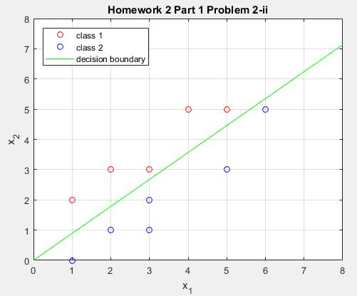

**Figure 1.2.** The decision line of FDA

1. **K-fold cross validation**
2. *LOOCV*

Consider $x_{i}$ is test data point. Size of the training data set is N – 1. In the training set, the number of label 0 and 1 are $N_{y=0}^{(i)}$ and $N_{y=1}^{(i)}$.

According to the given algorithm, the predicted label $\hat{y}=h\left(x\right)=\left\{\begin{aligned}1 if N_{y=0}^{(i)}<N_{y=1}^{(i)} \\ 0 if N_{y=0}^{(i)}>N_{y=1}^{(i)}\end{aligned}\right.$.

$$P\left[y=0\right]=P\left[y=1\right]⇒\frac{N_{y=0}^{(i)}}{N-1}=\frac{N_{y=1}^{(i)}}{N-1}⇒N_{y=0}^{(i)}=N_{y=1}^{(i)}$$

That mean the given algorithm cannot work well in LOOCV model.

1. *K-fold cross validation*
2. **Implementing k-NN algorithm (Matlab Programming)**

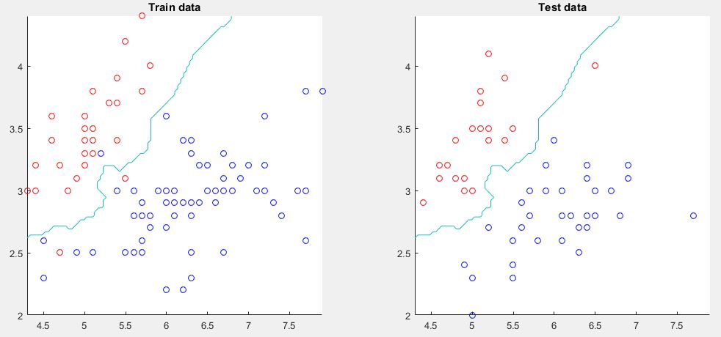

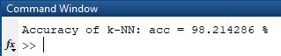

**Figure 1.3.** The decision boundary of k-NN algorithm

The result of implementing k-NN algorithm is depicted in the following Figure 1.3. In order to achieve the highest accuracy, the number of the nearest neighbors k should be an odd number and greater than 1 and less than half of the training data size. Therefore, in the line 5 of main_knn.m file, parameter k is chosen to equal 3 which causes that the accuracy reaches to 98.21 % with the lowest amount of computation.

To programming k-NN algorithm, the distance is calculated by norm 2 and two Matlab functions used: function sort() for searching k nearest training points and function sign() to take major vote.

1. **Part 2**
2. **Linear Discriminative Analysis (LDA)**
3. *Explicit form for f(θ, x)*

* First
$$Because of p\left(B | A\right)=\frac{p\left(A | B\right)p\left(B\right)}{p\left(A\right)},we get$$

$$\ln{\frac{p\left(y=0 | x\right)}{p\left(y=1 | x\right)}}=\ln{\frac{\frac{p\left(x | y=0\right)p\left(y=0\right)}{p\left(x\right)}}{\frac{p\left(x | y=1\right)p\left(y=1\right)}{p\left(x\right)}}}=\ln{\frac{p\left(x | y=0\right)}{p\left(x | y=1\right)}}+\ln{\frac{p\left(y=0\right)}{p\left(y=1\right)}} (2.1)$$

* Second
$$p\left(x | y=0\right)=N\left(μ_{0},Σ_{0}\right)=\frac{1}{{\left(2π\right)}^{\frac{D}{2}}}\frac{1}{{\left|Σ_{0}\right|}^{\frac{1}{2}}}e^{-\frac{1}{2}{\left(x-μ_{0}\right)}^{T}Σ_{0}^{-1}\left(x-μ_{0}\right)}$$

$$p\left(x | y=1\right)=N\left(μ_{1},Σ_{1}\right)=\frac{1}{{\left(2π\right)}^{\frac{D}{2}}}\frac{1}{{\left|Σ_{1}\right|}^{\frac{1}{2}}}e^{-\frac{1}{2}{\left(x-μ_{1}\right)}^{T}Σ_{1}^{-1}\left(x-μ_{1}\right)}$$

$$\ln{\frac{p\left(x | y=0\right)}{p\left(x | y=1\right)}}=\ln\left[{\left|\frac{Σ_{1}}{Σ_{0}}\right|}^{\frac{1}{2}}e^{-\frac{1}{2}{\left(x-μ_{0}\right)}^{T}Σ_{0}^{-1}\left(x-μ_{0}\right)+\frac{1}{2}{\left(x-μ_{1}\right)}^{T}Σ_{1}^{-1}\left(x-μ_{1}\right)}\right] \\ =\frac{1}{2}\ln\left|\frac{Σ_{1}}{Σ_{0}}\right|-\frac{1}{2}{\left(x-μ_{0}\right)}^{T}Σ_{0}^{-1}\left(x-μ_{0}\right)+\frac{1}{2}{\left(x-μ_{1}\right)}^{T}Σ_{1}^{-1}\left(x-μ_{1}\right) (2.2)$$

* Third

Because (1) toss a coin with probability of heads to p and (2) the coin toss result in “head” then y = 1 otherwise y = 0, hence:

$$p\left(y=1\right)=p and p\left(y=0\right)=1-p (2.3)$$

Replace (2.2) and (2.3) to (2.1), we have:

$$\ln{\frac{p\left(y=0 | x\right)}{p\left(y=1 | x\right)}}$$

$$=\frac{1}{2}\ln\left|\frac{Σ_{1}}{Σ_{0}}\right|-\frac{1}{2}{\left(x-μ_{0}\right)}^{T}Σ_{0}^{-1}\left(x-μ_{0}\right)+\frac{1}{2}{\left(x-μ_{1}\right)}^{T}Σ_{1}^{-1}\left(x-μ_{1}\right)+\ln{\frac{1-p}{p}}$$

$$⟹\frac{p\left(y=0 | x\right)}{p\left(y=1 | x\right)}=e^{\frac{1}{2}\ln\left|\frac{Σ_{1}}{Σ_{0}}\right|-\frac{1}{2}{\left(x-μ_{0}\right)}^{T}Σ_{0}^{-1}\left(x-μ_{0}\right)+\frac{1}{2}{\left(x-μ_{1}\right)}^{T}Σ_{1}^{-1}\left(x-μ_{1}\right)+\ln{\frac{1-p}{p}}}=e^{f\left(θ,x\right)}$$

where:

$$f\left(θ,x\right)=\frac{1}{2}{\left(x-μ_{1}\right)}^{T}Σ_{1}^{-1}\left(x-μ_{1}\right)-\frac{1}{2}{\left(x-μ_{0}\right)}^{T}Σ_{0}^{-1}\left(x-μ_{0}\right)+\frac{1}{2}\ln\left|\frac{Σ_{1}}{Σ_{0}}\right|+\ln{\frac{1-p}{p}}$$

$$⟹\frac{1-p\left(y=1 | x\right)}{p\left(y=1 | x\right)}=e^{f\left(θ,x\right)}⟹p\left(y=1 | x\right)=\frac{1}{1+e^{f\left(θ,x\right)}}$$

Finally, $p\left(y=1 | x\right)=\frac{1}{1+e^{f\left(θ,x\right)}}$ is proof

The explicit form for $f\left(θ,x\right)$ is:

$$f\left(θ,x\right)=\frac{1}{2}{\left(x-μ_{1}\right)}^{T}Σ_{1}^{-1}\left(x-μ_{1}\right)-\frac{1}{2}{\left(x-μ_{0}\right)}^{T}Σ_{0}^{-1}\left(x-μ_{0}\right)+\frac{1}{2}\ln\left|\frac{Σ_{1}}{Σ_{0}}\right|+\ln{\frac{1-p}{p}}$$

$$=\frac{1}{2}\left(x^{T}Σ_{1}^{-1}x-x^{T}Σ_{1}^{-1}μ_{1}-μ_{1}^{T}Σ_{1}^{-1}x+μ_{1}^{T}Σ_{1}^{-1}μ_{1}\right)-\frac{1}{2}\left(x^{T}Σ_{0}^{-1}x-x^{T}Σ_{0}^{-1}μ_{0}-μ_{0}^{T}Σ_{0}^{-1}x+μ_{0}^{T}Σ_{0}^{-1}μ_{0}\right)+\frac{1}{2}\ln\left|\frac{Σ_{1}}{Σ_{0}}\right|+\ln{\frac{1-p}{p}}$$

$$=\frac{1}{2}x^{T}\left(Σ_{1}^{-1}-Σ_{0}^{-1}\right)x+\frac{1}{2}\left(-x^{T}Σ_{1}^{-1}μ_{1}-μ_{1}^{T}Σ_{1}^{-1}x+x^{T}Σ_{0}^{-1}μ_{0}+μ_{0}^{T}Σ_{0}^{-1}x\right)+\frac{1}{2}\left(μ_{1}^{T}Σ_{1}^{-1}μ_{1}-μ_{0}^{T}Σ_{0}^{-1}μ_{0}\right)+\frac{1}{2}\ln\left|\frac{Σ_{1}}{Σ_{0}}\right|+\ln{\frac{1-p}{p}}$$

$$=\frac{1}{2}x^{T}\left(Σ_{1}^{-1}-Σ_{0}^{-1}\right)x+\frac{1}{2}\left(-μ_{1}^{T}Σ_{1}^{-1}x-μ_{1}^{T}Σ_{1}^{-1}x+μ_{0}^{T}Σ_{0}^{-1}x+μ_{0}^{T}Σ_{0}^{-1}x\right)+\frac{1}{2}\left(μ_{1}^{T}Σ_{1}^{-1}μ_{1}-μ_{0}^{T}Σ_{0}^{-1}μ_{0}\right)+\frac{1}{2}\ln\left|\frac{Σ_{1}}{Σ_{0}}\right|+\ln{\frac{1-p}{p}}$$

(using ATUB = BTUA)

$$=\frac{1}{2}x^{T}\left(Σ_{1}^{-1}-Σ_{0}^{-1}\right)x-\left(μ_{1}^{T}Σ_{1}^{-1}-μ_{0}^{T}Σ_{0}^{-1}\right)x+\frac{1}{2}\left(μ_{1}^{T}Σ_{1}^{-1}μ_{1}-μ_{0}^{T}Σ_{0}^{-1}μ_{0}\right)+\frac{1}{2}\ln\left|\frac{Σ_{1}}{Σ_{0}}\right|+\ln{\frac{1-p}{p}}$$

1. *The difference and similarity between LDA and logistic regression*

* The similarity:
* Both of models are based on probability of sigmoid function
* The model of LDA proofs the assumption of the linear logistic model
* To find hypothesis space, both of them maximize likelihood
* The decision boundary can be any shape and not necessarily linear separator
* In practice, both of methods often give similar results
* The difference:

**Table 2.1.** The difference between LDA and Logistic Regression

|  |  |  |
| --- | --- | --- |
| **Property** | **Linear Discriminative Analysis** | **Logistic Regression** |
| Assumtion about class | No assumption about the probability of class given data p(Ck|x) | Assume that the probability of class given data p(Ck|x) following sigmoid function |
| Distribution of data | Gaussian | Do not know |
| Optimization | Find parameter θ to maximize the joint likelihood of class and data P(x, Ck) | Find parameter θ to maximize the conditional likelihood of class given data p(Ck|x) |
| Noise | Less robust | More robust |
| Training data | Can process the data without class label | Cannot process the data without class label |
| Amount of data | Require less data than Logistic Regression | Need 30% more than LDA to get equally estimation |
| Hypothesis space | It can be any shape | Tend to find a linear separator is it exist |

1. *Decision boundary*
2. μ0 ≠ μ1 and Σ0 = Σ1 = I

The decision boundary is a linear line.

1. μ0 ≠ μ1 and Σ0 =I, Σ1 = 4I

Where: $x=\left[\begin{matrix}x_{1} \\ x_{2}\end{matrix}\right], μ_{0}=\left[\begin{matrix}μ_{01} \\ μ_{02}\end{matrix}\right], μ_{1}=\left[\begin{matrix}μ_{11} \\ μ_{12}\end{matrix}\right]$

The decision boundary $f\left(θ,x\right)=0→x_{1}^{2}+x_{2}^{2}+Ax_{1}+Bx_{2}+C=0$, where A, B and C are scalar. So it is a circle.

1. μ0 = μ1 = μ and Σ0 =I, Σ1 = 4I

The decision boundary is a circle, similar to the previous b.

$μ_{0}=μ_{1}=\left(0,0\right) and Σ_{0}=\left[\begin{matrix}4 & 1 \\ 1 & 4\end{matrix}\right],Σ_{1}=\left[\begin{matrix}4 & -1 \\ -1 & 4\end{matrix}\right]$

$$f\left(θ,x\right)=\frac{1}{2}x^{T}\left(Σ_{1}^{-1}-Σ_{0}^{-1}\right)x-\left(μ_{1}^{T}Σ_{1}^{-1}-μ_{0}^{T}Σ_{0}^{-1}\right)x+\frac{1}{2}\left(Σ_{1}^{-1}μ_{1}^{2}-Σ_{0}^{-1}μ_{0}^{2}\right)+\frac{1}{2}\ln\left|\frac{Σ_{1}}{Σ_{0}}\right|+\ln{\frac{1-p}{p}}$$

$$=\frac{1}{2}x^{T}\left({\left[\begin{matrix}4 & -1 \\ -1 & 4\end{matrix}\right]}^{-1}-{\left[\begin{matrix}4 & 1 \\ 1 & 4\end{matrix}\right]}^{-1}\right)x+\frac{1}{2}\ln{\frac{\left|\begin{matrix}4 & -1 \\ -1 & 4\end{matrix}\right|}{\left|\begin{matrix}4 & 1 \\ 1 & 4\end{matrix}\right|}}+\ln{\frac{1-p}{p}}$$

$$=\frac{1}{2}x^{T}\left[\begin{matrix}0 & \frac{2}{15} \\ \frac{2}{15} & 0\end{matrix}\right]x+\ln{\frac{1-p}{p}}=\frac{1}{2}\left[\begin{matrix}x_{1} & x_{2}\end{matrix}\right]\left[\begin{matrix}0 & \frac{2}{15} \\ \frac{2}{15} & 0\end{matrix}\right]\left[\begin{matrix}x_{1} \\ x_{2}\end{matrix}\right]+\ln{\frac{1-p}{p}}$$

$$=\frac{2}{15}x_{1}x_{2}+\ln{\frac{1-p}{p}}$$

The decision boundary is $\frac{2}{15}x_{1}x_{2}+\ln{\frac{1-p}{p}}=0⟹x_{2}=\frac{A}{x_{1}}$ where A is scalar. Therefore, the decision boundary is a hyperbolic.

1. **Kernel SVM**

Assuming that we had $\left\{\begin{aligned}k\left(x,z\right)={ϕ\left(x\right)}^{T}ϕ\left(z\right) \\ {ϕ\left(x\right)}_{n}=\frac{1}{\sqrt{n!}}e^{-\frac{x_{i}^{2}}{2}}x_{i}^{n}\end{aligned}\right.$, then $k\left(x,z\right)=e^{-\frac{1}{2}{\left\|x_{i}-z_{i}\right\|}^{2}}$ must be proof.

$${ϕ\left(z\right)}_{n}=\frac{1}{\sqrt{n!}}e^{-\frac{z_{i}^{2}}{2}}z_{i}^{n}$$

$${ϕ\left(x\right)}_{n}{ϕ\left(z\right)}_{n}=\frac{1}{n!}e^{-\frac{1}{2}\left(x_{i}^{2}+z_{i}^{2}\right)}x_{i}^{n}z_{i}^{n}$$

$$k\left(x,z\right)={ϕ\left(x\right)}^{T}ϕ\left(z\right)={ϕ\left(x\right)}_{0}{ϕ\left(z\right)}_{0}+{ϕ\left(x\right)}_{1}{ϕ\left(z\right)}_{1}+{ϕ\left(x\right)}_{2}{ϕ\left(z\right)}_{2}+…+{ϕ\left(x\right)}_{n}{ϕ\left(z\right)}_{n}$$

$$=\frac{1}{0!}e^{-\frac{1}{2}\left(x_{i}^{2}+z_{i}^{2}\right)}x_{i}^{0}z_{i}^{0}+\frac{1}{1!}e^{-\frac{1}{2}\left(x_{i}^{2}+z_{i}^{2}\right)}x_{i}^{1}z_{i}^{1}+\frac{1}{2!}e^{-\frac{1}{2}\left(x_{i}^{2}+z_{i}^{2}\right)}x_{i}^{2}z_{i}^{2}+…+\frac{1}{n!}e^{-\frac{1}{2}\left(x_{i}^{2}+z_{i}^{2}\right)}x_{i}^{n}z_{i}^{n}$$

$$=e^{-\frac{1}{2}\left(x_{i}^{2}+z_{i}^{2}\right)}\left[1+x_{i}z_{i}+\frac{{\left(x_{i}z_{i}\right)}^{2}}{2!}+\frac{{\left(x_{i}z_{i}\right)}^{3}}{3!}+…+\frac{{\left(x_{i}z_{i}\right)}^{n}}{n!}\right]$$

$$=e^{-\frac{1}{2}\left(x_{i}^{2}+z_{i}^{2}\right)}e^{x_{i}z_{i}} (Taylor series)$$

$$=e^{-\frac{x_{i}^{2}+z_{i}^{2}-2x_{i}z_{i}}{2}}=e^{-\frac{1}{2}{\left(x_{i}-z_{i}\right)}^{2}}=e^{-\frac{1}{2}{\left\|x_{i}-z_{i}\right\|}^{2}}$$

1. **Kernel SVM**
2. *Soft-margin linear SVM with trade-off factor of C = 0.1*

Corresponding to Figure 4 because the decision boundary is linear and does not separate two classes strictly, which is the case C is small and more errors are allowed.

1. *Soft-margin linear SVM with trade-off factor of C = 10*

This case is for Figure 3 because the decision boundary is linear and separates two class more strictly than in Figure 4, caused by the greater value of C.

1. *Hard-margin kernel machine with $k\left(x,z\right)=x.z+{(x.z)}^{2}$*

The decision boundary of quadratic kernel $f\left(x\right)=\sum_{i}{α_{i}\left(x_{i}x+{\left(x_{i}x\right)}^{2}\right)+b}=0$. Because $f(x)$ is a second order function of x, the decision boundary can be ellipse or hyperbolic. Hence this kernel is for the hyperbolic curve in Figure 5.

1. *Hard-margin kernel machine with $k\left(x,z\right)=e^{-\frac{1}{4}{\left\|x-z\right\|}^{2}}$*

The decision function $f\left(x\right)=\sum_{i}{α_{i}e^{-β{\left\|x_{i}-x\right\|}^{2}}}+b$. If β is very large, then kernel value is small which causes hard classification with the lack of support vectors. Hence it cannot classify many circle point in the middle Figure 1.

1. *Hard-margin kernel machine with $k\left(x,z\right)=e^{-4{\left\|x-z\right\|}^{2}}$*

Corresponding to Figure 6. Explanation is similar to the previous iv, it can be said that if β is big, there are more support vectors.

1. **Kernel SVM (Matlab Programming)**

The decision boundary, data samples and accuracy is presented in Figure 2.1 below. The source code is in folder kernel_svm.

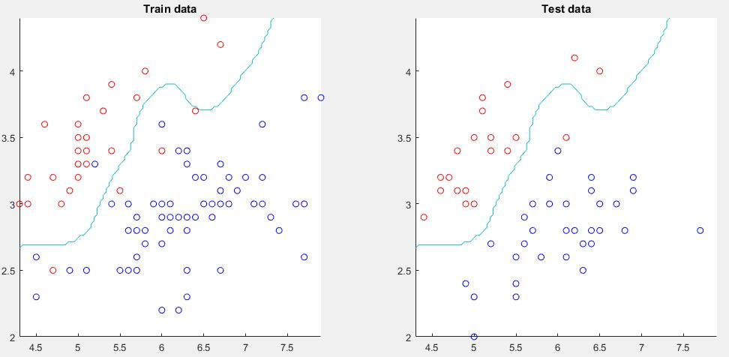

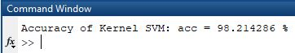

**Figure 2.1.** The result of implementing SVM using RBF kernel

To get highest accuracy with lowest execution time, the chosen number of iterations equals to 500, parameter λ = 1 and the covariance of Gaussian distribution σ = 0.2