Korea Advanced Institute of Science and Technology

School of Electrical Engineering

EE488 Introduction to Machine Learning Spring 2018

Student’s Name: Dinh Vu

Student’s ID: 20184187

**Homework 3**

1. **PART 1**
2. **K-NN**
3. **Problem 1-i**

Because

$$P\left(θ,θ_{n} | x,x_{n}\right)=P\left(θ | x\right)P\left(θ_{n} | x_{n}\right)$$

$$⇒P\left(θ=ω_{l},θ_{n}=ω_{l} | x,x_{n}\right)=P\left(ω_{l} | x\right)P\left(ω_{l} | x_{n}\right)$$

The error rate can be express as:

$$P\left(θ≠θ_{n} | x,x_{n}\right)=P\left(e | x,x_{n}\right)=1-\sum_{l=1}^{C}{P\left(θ=ω_{l},θ_{n}=ω_{l} | x,x_{n}\right)}=1-\sum_{l=1}^{C}{P\left(ω_{l} | x\right)P\left(ω_{l} | x_{n}\right)} (1.1)$$

1. **Problem 1-ii**

Bayes error rate is defined as below:

$$P^{*}\left(e | x\right)=1-\max_{θ∈Ω}{P\left(ω_{m} | x\right)}=1-P\left(ω_{m} | x\right)⇒P\left(ω_{m} | x\right)=1-P^{*}\left(e | x\right)$$

The sum of squares can be divided into 2 parts as follows:

$$\sum_{i=1}^{C}{P^{2}\left(ω_{i} | x\right)}=P^{2}\left(ω_{m} | x\right)+\sum_{i≠m}{P^{2}\left(ω_{i} | x\right)}={\left[1-P^{*}\left(e | x\right)\right]}^{2}+\sum_{i≠m}{P^{2}\left(ω_{i} | x\right)} (1.2)$$

$$In order to find lower bound of\sum_{i=1}^{C}{P^{2}\left(ω_{i} | x\right)}, the minimum value of\sum_{i≠m}{P^{2}\left(ω_{i} | x\right)}$$

$$must be determined while satifying the below condition:$$

$$\sum_{l=1}^{C}{P\left(ω_{i} | x\right)}=1⇔P\left(ω_{m} | x\right)+\sum_{l≠m}{P\left(ω_{i} | x\right)}=1$$

$$⇔\sum_{l≠m}{P\left(ω_{i} | x\right)}=1-P\left(ω_{m} | x\right)=P^{*}\left(e | x\right)$$

According to Bunyakovsky for $C-1$ elements:

$$\left(\sum_{i=1}^{C-1}{1^{2}}\right)×\left[\sum_{i≠m}{P^{2}\left(ω_{i} | x\right)}\right]≥{\left[\sum_{i≠m}{1×P\left(ω_{i} | x\right)}\right]}^{2}$$

$$⇔\left(C-1\right)\sum_{i≠m}{P^{2}\left(ω_{i} | x\right)}≥{\left[\sum_{i≠m}{P\left(ω_{i} | x\right)}\right]}^{2}=P^{*2}\left(e | x\right)$$

$$⇔\sum_{i≠m}{P^{2}\left(ω_{i} | x\right)}≥\frac{P^{*2}\left(e | x\right)}{C-1}$$

$$So, min\left[\sum_{i≠m}{P^{2}\left(ω_{i} | x\right)}\right]=\frac{P^{*2}\left(e | x\right)}{C-1} if only if$$

$$P\left(ω_{1} | x\right)=P\left(ω_{2} | x\right)=⋯=P\left(ω_{m-1} | x\right)=P\left(ω_{m+1} | x\right)=⋯=P\left(ω_{C} | x\right)=\frac{P^{*}\left(e | x\right)}{C-1}=\frac{1-P\left(ω_{m} | x\right)}{C-1}=\frac{1-S}{C-1}$$

1. **Problem 1-iii**

Therefore, from $\left(1.2\right)$:

$$\sum_{i=1}^{C}{P^{2}\left(ω_{i} | x\right)}≥{\left[1-P^{*}\left(e | x\right)\right]}^{2}+\frac{P^{*2}\left(e | x\right)}{C-1} (1.3)$$

$$Hence, the lower bound of \sum_{i=1}^{C}{P^{2}\left(ω_{i} | x\right)} in term of P^{*}\left(e | x\right) is:$$

$${\left[1-P^{*}\left(e | x\right)\right]}^{2}+\frac{P^{*2}\left(e | x\right)}{C-1}$$

1. **Problem 1-iv**

Because when the size of training data is infinite, the nearest neighbor of x will be itself, so:

$$P\left(e | x,x_{n}\right)=P\left(e | x,x\right)=P\left(e | x\right)$$

$$P\left(ω_{l} | x_{n}\right)=P\left(ω_{l} | x\right)$$

Replace to $(1.1)$:

$$P\left(e | x\right)=1-\sum_{l=1}^{C}{P^{2}\left(ω_{l} | x\right)}⇒\sum_{l=1}^{C}{P^{2}\left(ω_{l} | x\right)}=1-P\left(e | x\right)$$

Replace to $(1.3)$:

$$1-P\left(e | x\right)≥{\left[1-P^{*}\left(e | x\right)\right]}^{2}+\frac{P^{*2}\left(e | x\right)}{C-1}⇔P\left(e | x\right)≤1-{\left[1-P^{*}\left(e | x\right)\right]}^{2}-\frac{P^{*2}\left(e | x\right)}{C-1}$$

$$⇔P\left(e | x\right)≤1-\left[1-2P^{*}\left(e | x\right)+P^{*2}\left(e | x\right)\right]-\frac{P^{*2}\left(e | x\right)}{C-1}$$

$$⇔P\left(e | x\right)≤2P^{*}\left(e | x\right)-P^{*2}\left(e | x\right)-\frac{P^{*2}\left(e | x\right)}{C-1}$$

$$⇔P\left(e | x\right)≤2P^{*}\left(e | x\right)-\frac{C}{C-1}P^{*2}\left(e | x\right)$$

Conclusion, the upper bound of the error rate in term of Bayes error rate is:

$$2P^{*}\left(e | x\right)-\frac{C}{C-1}P^{*2}\left(e | x\right)$$

1. **Bayesian Statistic**
2. **Problem 2-i**

Prior: $θ\sim Beta\left(α_{0},β_{0}\right)$

Observe data $D=\left\{0,0,1,0,1,1,1\right\}$, there are $y=4$ one-labels and 3 one-labels. The data size is $n=7$.

$$P\left(θ | D\right)\sim P\left(D | θ\right)P\left(θ\right)$$

$$\sim \left(\begin{matrix}7 \\ 4\end{matrix}\right)θ^{4}{\left(1-θ\right)}^{3}\frac{Γ\left(α_{0}+β_{0}\right)}{Γ\left(α_{0}\right)Γ\left(β_{0}\right)}θ^{α_{0}-1}{\left(1-θ\right)}^{β_{0}-1}$$

$$\sim θ^{4+α_{0}-1}{\left(1-θ\right)}^{3+β_{0}-1}=θ^{3+α_{0}}{\left(1-θ\right)}^{2+β_{0}}$$

$$P\left(θ | D\right)=Beta(α_{0}+4,β_{0}+3)$$

$$P\left(x=1 | D\right)=\int_{0}^{1}{P\left(x=1 | θ\right)P\left(θ | D\right)dθ}=\int_{0}^{1}{θP\left(θ | D\right)}dθ=E\left[θ|D\right]=\frac{4+α_{0}}{7+α_{0}+β_{0}}$$

1. **Problem 2-ii**

Prior $μ\sim N\left(μ_{0},\frac{1}{r_{0}}\right)$, so:

$$P\left(μ\right)=\frac{1}{\sqrt{2π×\frac{1}{r_{0}}}}exp\left[-\frac{{\left(μ-μ_{0}\right)}^{2}}{2×\frac{1}{r_{0}}}\right]=\sqrt{\frac{r_{0}}{2π}}exp\left[-\frac{r_{0}{\left(μ-μ_{0}\right)}^{2}}{2}\right]$$

According Bayes Rule:

$$P\left(μ | D\right)=\frac{P\left(D | μ\right)P\left(μ\right)}{P\left(D\right)}$$

Because given data $D=\left\{x_{1},x_{2},…,x_{n}\right\}$ from Gaussian distribution with mean $μ$ and known variance $σ^{2}$:

$$P\left(x_{i} | μ,σ^{2}\right)=N\left(μ,σ^{2}\right)=\frac{1}{\sqrt{2πσ^{2}}}exp\left[-\frac{{\left(x_{i}-μ\right)}^{2}}{2σ^{2}}\right]$$

Therefore:

$$P\left(D | μ\right)=P\left(D | μ,σ^{2}\right)=\prod_{i=1}^{n}{P\left(x_{i} | μ,σ^{2}\right)}={\left(\frac{1}{\sqrt{2πσ^{2}}}\right)}^{n}exp\left[-\frac{1}{2σ^{2}}\sum_{i=1}^{n}{{\left(x_{i}-μ\right)}^{2}}\right]$$

Since $P\left(D\right)$ is constant: $P\left(μ | D\right)∝P\left(D | μ\right)P\left(μ\right)$

$$⇒P\left(μ | D\right)∝{\left(\frac{1}{\sqrt{2πσ^{2}}}\right)}^{n}exp\left[-\frac{1}{2σ^{2}}\sum_{i=1}^{n}{{\left(x_{i}-μ\right)}^{2}}\right]\sqrt{\frac{r_{0}}{2π}}exp\left[-\frac{r_{0}{\left(μ-μ_{0}\right)}^{2}}{2}\right]$$

$$⇒P\left(μ | D\right)∝exp\left[-\frac{1}{2σ^{2}}\sum_{i=1}^{n}{{\left(x_{i}-μ\right)}^{2}}-\frac{r_{0}{\left(μ-μ_{0}\right)}^{2}}{2}\right]$$

$$Let r=\frac{1}{σ^{2}}$$

$$⇒P\left(μ | D\right)∝exp\left[-\frac{1}{2}r\sum_{i=1}^{n}{{\left(x_{i}-μ\right)}^{2}}-\frac{r_{0}{\left(μ-μ_{0}\right)}^{2}}{2}\right]$$

$$⇒P\left(μ | D\right)∝exp\left[-\frac{1}{2}\left(r\sum_{i=1}^{n}{{\left(x_{i}-μ\right)}^{2}}+r_{0}{\left(μ-μ_{0}\right)}^{2}\right)\right]=exp\left\{-\frac{1}{2}\left[r\sum_{i=1}^{n}{\left(x_{i}^{2}-2x_{i}μ+μ^{2}\right)}+r_{0}\left(μ^{2}-2μμ_{0}+μ_{0}^{2}\right)\right]\right\}$$

$$P\left(μ | D\right)∝exp\left\{-\frac{1}{2}\left[r\sum_{i=1}^{n}{\left(-2x_{i}μ+μ^{2}\right)}+r_{0}\left(μ^{2}-2μμ_{0}\right)\right]\right\}=exp\left[-\frac{1}{2}\left(-2rμ\sum_{i=1}^{n}{x_{i}}+nrμ^{2}+r_{0}μ^{2}-2r_{0}μμ_{0}\right)\right]$$

$$Let S=\sum_{i=1}^{n}{x_{i}}$$

$$P\left(μ | D\right)∝exp\left\{-\frac{1}{2}\left[\left(r_{0}+nr\right)μ^{2}-2μ\left(r_{0}μ_{0}+rS\right)\right]\right\}$$

$$P\left(μ | D\right)∝exp\left\{-\frac{1}{2}\left(r_{0}+nr\right)\left[μ^{2}-2μ\frac{r_{0}μ_{0}+rS}{r_{0}+nr}+{\left(\frac{r_{0}μ_{0}+rS}{r_{0}+nr}\right)}^{2}\right]\right\}$$

$$P\left(μ | D\right)∝exp\left\{-\frac{1}{2}\left(r_{0}+nr\right){\left(μ-\frac{r_{0}μ_{0}+rS}{r_{0}+nr}\right)}^{2}\right\}$$

$$Finally, P\left(μ | D\right)=N\left(\frac{r_{0}μ_{0}+rS}{r_{0}+nr},\frac{1}{r_{0}+nr}\right)$$

$$Where r=\frac{1}{σ^{2}} and S=\sum_{i=1}^{n}{x_{i}}$$

1. **Problem 2-iii**

$$Prior: P\left(μ,γ\right)\sim Normal-gamma distribution$$

According to Bayes Rule:

$$P\left(μ,γ | D\right)=\frac{P\left(μ,γ\right)P\left(D | μ,γ\right)}{P\left(D\right)}$$

Since $μ$ and $γ$ are conditionally dependent variables: $P\left(μ,γ\right)=P\left(γ\right)P\left(μ | γ\right)$

$P(D)$ is constant, so: $P\left(μ,γ | D\right)∝P\left(γ\right)P\left(μ | γ\right)P\left(D | μ,γ\right) (2.1)$

$$γ\sim Gamma\left(α,β\right)⇒P\left(γ\right)=\frac{1}{Γ\left(α\right)}β^{α}γ^{α-1}exp\left(-βγ\right)$$

$$\left.μ\right|γ\sim N\left(μ_{0},\frac{1}{γ_{0}γ}\right)⇒P\left(μ | γ\right)=\frac{1}{\sqrt{2π×\frac{1}{γ_{0}γ}}}exp\left[-\frac{{\left(μ-μ_{0}\right)}^{2}}{2×\frac{1}{γ_{0}γ}}\right]=\sqrt{\frac{γ_{0}γ}{2π}}exp\left[-\frac{γ_{0}γ}{2}{\left(μ-μ_{0}\right)}^{2}\right]$$

$$\left.x_{i}\right|μ,γ\sim N\left(μ,\frac{1}{γ}\right)⇒P\left(x_{i} | μ,γ\right)=\frac{1}{\sqrt{2π×\frac{1}{γ}}}exp\left[-\frac{{\left(x_{i}-μ\right)}^{2}}{2×\frac{1}{γ}}\right]=\sqrt{\frac{γ}{2π}}exp\left[-\frac{γ}{2}{\left(x_{i}-μ\right)}^{2}\right]$$

$$⇒P\left(D | μ,γ\right)=\prod_{i=1}^{n}{P\left(x_{i} | μ,γ\right)}={\left(\frac{γ}{2π}\right)}^{\frac{n}{2}}exp\left[-\frac{γ}{2}\sum_{i=1}^{n}{{\left(x_{i}-μ\right)}^{2}}\right]$$

Therefore, from $(2.1)$:

$$P\left(μ,γ | D\right)∝γ^{α-1}exp\left(-βγ\right)γ^{\frac{1}{2}}exp\left[-\frac{γ_{0}γ}{2}{\left(μ-μ_{0}\right)}^{2}\right]γ^{\frac{n}{2}}exp\left[-\frac{γ}{2}\sum_{i=1}^{n}{{\left(x_{i}-μ\right)}^{2}}\right]$$

$$P\left(μ,γ | D\right)∝γ^{α+\frac{n}{2}-\frac{1}{2}}e^{-βγ}exp\left\{-\frac{γ}{2}\left[γ_{0}{\left(μ-μ_{0}\right)}^{2}+\sum_{i=1}^{n}{{\left(x_{i}-μ\right)}^{2}}\right]\right\}$$

$$\sum_{i=1}^{n}{{\left(x_{i}-μ\right)}^{2}}=\sum_{i=1}^{n}{\left(x_{i}^{2}-2x_{i}μ+μ^{2}\right)}=\sum_{i=1}^{n}{x_{i}^{2}}-2μ\sum_{i=1}^{n}{x_{i}}+nμ^{2}$$

$$Let \overline{x}=\frac{1}{n}\sum_{i=1}^{n}{x_{i}}, S=\sum_{i=1}^{n}{x_{i}^{2}}$$

$$P\left(μ,γ | D\right)∝γ^{α+\frac{n}{2}-\frac{1}{2}}e^{-βγ}exp\left\{-\frac{γ}{2}\left[γ_{0}\left(μ^{2}-2μμ_{0}+μ_{0}^{2}\right)+S-2nμ\overline{x}+nμ^{2}\right]\right\}$$

$$⇒P\left(μ,γ | D\right)∝γ^{α+\frac{n}{2}-\frac{1}{2}}e^{-βγ}exp\left\{-\frac{γ}{2}\left[\left(n+γ_{0}\right)μ^{2}-2μ\left(n\overline{x}+μ_{0}γ_{0}\right)+γ_{0}μ_{0}^{2}+S\right]\right\}$$

$$⇒P\left(μ,γ | D\right)∝γ^{α+\frac{n}{2}-\frac{1}{2}}e^{-βγ}exp\left\{-\frac{γ}{2}\left(n+γ_{0}\right)\left[μ^{2}-2μ\frac{n\overline{x}+μ_{0}γ_{0}}{n+γ_{0}}+{\left(\frac{n\overline{x}+μ_{0}γ_{0}}{n+γ_{0}}\right)}^{2}\right]\right\}$$

$$⇒P\left(μ,γ | D\right)∝γ^{α+\frac{n}{2}-\frac{1}{2}}e^{-βγ}exp\left\{-\frac{γ}{2}\left(n+γ_{0}\right){\left(μ-\frac{n\overline{x}+μ_{0}γ_{0}}{n+γ_{0}}\right)}^{2}\right\}$$

Finally:

$$P\left(μ,γ | D\right)=\frac{β^{α}\sqrt{n+γ_{0}}}{Γ\left(α\right)\sqrt{2π}}γ^{α+\frac{n}{2}-\frac{1}{2}}e^{-βγ}e^{-\frac{\left(n+γ_{0}\right)γ}{2}{\left(μ-\frac{n\overline{x}+μ_{0}γ_{0}}{n+γ_{0}}\right)}^{2}}$$

$$P\left(μ,γ | D\right)=Normal-Gamma(mean=\frac{n\overline{x}+μ_{0}γ_{0}}{n+γ_{0}},variance=\frac{1}{n+γ_{0}},α,β)$$

1. **Problem 2-iv**

Exponential family: $P\left(x | η\right)=h\left(x\right)g\left(η\right)e^{η^{T}u\left(x\right)}$

Conjugate prior: $p\left(η | x,ν\right)=f\left(x,ν\right){g\left(η\right)}^{ν}e^{νη^{T}x}$

* Poisson distribution

$$P\left(x | λ\right)=\frac{λ^{x}e^{-λ}}{x!}=\frac{1}{x!}e^{x\ln{λ}}e^{-λ}=\frac{1}{x!}e^{-λ}e^{x\ln{λ}}$$

$$η=\ln{λ}, u\left(x\right)=x, h\left(x\right)=\frac{1}{x!}, g\left(η\right)=e^{-e^{η}}$$

Conjugate prior:

$$p\left(η | x,ν\right)=f\left(x,ν\right){g\left(η\right)}^{ν}e^{νη^{T}x}=f\left(x,ν\right)e^{-λν}e^{νx\ln{λ}}=f\left(x,ν\right)λ^{νx}e^{-λν}$$

$$=f\left(x,ν\right)λ^{νx}e^{-νλ}∝Gamma\left(α,β\right)$$

Where: $α=1+νx, β=ν$

* Multinomial distribution

$$P\left(x_{1},x_{2},…,x_{K} | μ,N\right)=\frac{N!}{x_{1}!x_{2}!…x_{K}!}\prod_{k=1}^{K}{μ_{k}^{x_{k}}}=\frac{N!}{x_{1}!x_{2}!…x_{K}!}\prod_{k=1}^{K}{e^{x_{k}\ln{μ_{k}}}}$$

$$=\frac{N!}{x_{1}!x_{2}!…x_{K}!}exp\left(\sum_{k=1}^{K}{x_{k}\ln{μ_{k}}}\right)=\frac{N!}{x_{1}!x_{2}!…x_{K}!}exp\left({\left[\begin{matrix}\ln{μ_{1}} \\ ⋮ \\ \ln{μ_{K}}\end{matrix}\right]}^{T}\left[\begin{matrix}x_{1} \\ ⋮ \\ x_{K}\end{matrix}\right]\right)$$

$$η=\left[\begin{matrix}\ln{μ_{1}} \\ ⋮ \\ \ln{μ_{K}}\end{matrix}\right], u\left(x\right)=\left[\begin{matrix}x_{1} \\ ⋮ \\ x_{K}\end{matrix}\right], h\left(x\right)=\frac{N!}{x_{1}!x_{2}!…x_{K}!}, g\left(η\right)=1$$

Conjugate prior:

$$p\left(η | x,ν\right)=f\left(x,ν\right){g\left(η\right)}^{ν}e^{νη^{T}x}=f\left(x,ν\right)exp\left\{ν{\left[\begin{matrix}\ln{μ_{1}} \\ ⋮ \\ \ln{μ_{K}}\end{matrix}\right]}^{T}x\right\}$$

$$=f\left(x,ν\right)\prod_{k=1}^{K}{μ_{k}^{νx_{k}}}∝Dir\left(μ,α\right)$$

Where: $α_{k}=1+νx_{k}$

* Laplace distribution

$$P\left(x | μ,b\right)=\frac{1}{2b}e^{-\frac{\left|x-μ\right|}{b}}=\frac{1}{2b}e^{-\frac{1}{b}\left|x-μ\right|}$$

$$η=-\frac{1}{b}, u\left(x\right)=\left|x-μ\right|, h\left(x\right)=1, g\left(η\right)=-\frac{η}{2}$$

Conjugate prior:

$$p\left(η | x,ν\right)=f\left(x,ν\right){g\left(η\right)}^{ν}e^{νη^{T}x}=f\left(x,ν\right){\left(-\frac{η}{2}\right)}^{ν}e^{ν\left(-\frac{1}{b}\right)x}=f\left(x,ν\right){\left(\frac{1}{2b}\right)}^{ν}e^{-\frac{νx}{b}}=f\left(x,ν\right){\left(\frac{1}{2}\right)}^{ν}b^{-ν}e^{-\frac{νx}{b}}∝Inverse_Gamma\left(α,β\right)$$

Where: $α=1+ν, β=νx$

* Dirichlet distribution

$$Where α_{0}=\sum_{k=1}^{K}{α_{k}}$$

$$P\left(x | α\right)=\frac{Γ\left(α_{0}\right)}{Γ\left(α_{1}\right)Γ\left(α_{2}\right)…Γ\left(α_{K}\right)}\prod_{k=1}^{K}{x_{k}^{α_{k}-1}}=\frac{Γ\left(α_{0}\right)}{Γ\left(α_{1}\right)Γ\left(α_{2}\right)…Γ\left(α_{K}\right)}\prod_{k=1}^{K}{x_{k}^{-1}}\prod_{k=1}^{K}{x_{k}^{α_{k}}}$$

$$=\frac{Γ\left(α_{0}\right)}{Γ\left(α_{1}\right)Γ\left(α_{2}\right)…Γ\left(α_{K}\right)}\prod_{k=1}^{K}{x_{k}^{-1}}exp\left(\sum_{i=1}^{K}{α_{k}\ln{x_{k}}}\right)$$

$$=\frac{Γ\left(α_{0}\right)}{Γ\left(α_{1}\right)Γ\left(α_{2}\right)…Γ\left(α_{K}\right)}\prod_{k=1}^{K}{x_{k}^{-1}}exp\left({\left[\begin{matrix}α_{1} \\ ⋮ \\ α_{K}\end{matrix}\right]}^{T}\left[\begin{matrix}\ln{x_{1}} \\ ⋮ \\ \ln{x_{K}}\end{matrix}\right]\right)$$

$$η=\left[\begin{matrix}α_{1} \\ ⋮ \\ α_{K}\end{matrix}\right], u\left(x\right)=\left[\begin{matrix}\ln{x_{1}} \\ ⋮ \\ \ln{x_{K}}\end{matrix}\right], h\left(x\right)=\prod_{k=1}^{K}{x_{k}^{-1}}, g\left(η\right)=\frac{Γ\left(\sum_{k=1}^{K}{η_{k}}\right)}{\prod_{k=1}^{K}{Γ\left(η_{k}\right)}}$$

Conjugate prior:

$$p\left(η | x,ν\right)=f\left(x,ν\right){g\left(η\right)}^{ν}e^{νη^{T}x}=f\left(x,ν\right){\left[\frac{Γ\left(\sum_{k=1}^{K}{η_{k}}\right)}{\prod_{k=1}^{K}{Γ\left(η_{k}\right)}}\right]}^{ν}exp\left\{ν{\left[\begin{matrix}α_{1} \\ ⋮ \\ α_{K}\end{matrix}\right]}^{T}x\right\}$$

$$=f\left(x,ν\right){\left[\frac{1}{B\left(α\right)}\right]}^{ν}exp\left(\sum_{k=1}^{K}{νx_{k}α_{k}}\right)∝CD\left(α | x,ν\right)∝{\left[\frac{1}{B\left(α\right)}\right]}^{ν}exp\left(\sum_{k=1}^{K}{νx_{k}α_{k}}\right)$$

* Gamma distribution

$$P\left(x | a,b\right)=\frac{1}{Γ\left(a\right)}b^{a}x^{a-1}e^{-bx}=\frac{b^{a}}{Γ\left(a\right)}e^{\left(a-1\right)\ln{x}}e^{-bx}=\frac{b^{a}}{Γ\left(a\right)}exp\left[\left(a-1\right)\ln{x}-bx\right]$$

$$=\frac{b^{a}}{Γ\left(a\right)}exp\left({\left[\begin{matrix}a-1 \\ -b\end{matrix}\right]}^{T}\left[\begin{matrix}\ln{x} \\ x\end{matrix}\right]\right)$$

$$η=\left[\begin{matrix}a-1 \\ -b\end{matrix}\right], u\left(x\right)=\left[\begin{matrix}\ln{x} \\ x\end{matrix}\right], h\left(x\right)=1, g\left(η\right)=\frac{b^{a}}{Γ\left(a\right)}$$

Conjugate prior (with known shape a):

$$p\left(η | x,ν\right)=f\left(x,ν\right){g\left(η\right)}^{ν}e^{νη^{T}x}=f\left(x,ν\right){\left[\frac{b^{a}}{Γ\left(a\right)}\right]}^{ν}exp\left\{ν{\left[\begin{matrix}a-1 \\ -b\end{matrix}\right]}^{T}x\right\}$$

$$=f\left(x,ν\right){\left[\frac{1}{Γ\left(a\right)}\right]}^{ν}b^{aν}e^{ν\left(a-1\right)x-vbx}∝b^{aν}e^{-vxb}∝Gamma\left(α,β\right)$$

Where: $α=1+aν$, $β=νx$

**Table 1.1.** Summary of exponential family distributions and their conjugate prior

|  |  |  |  |  |  |
| --- | --- | --- | --- | --- | --- |
| **Distribution** | $$η$$ | $$u\left(x\right)$$ | $$h\left(x\right)$$ | $$g\left(η\right)$$ | **Conjugate prior** |
| Poisson | $$\ln{λ}$$ | x | $$\frac{1}{x!}$$ | $$e^{{-e}^{η}}$$ | Gamma |
| Multinomial | $$\left[\begin{matrix}\ln{μ_{1}} \\ ⋮ \\ \ln{μ_{K}}\end{matrix}\right]$$ | $$\left[\begin{matrix}x_{1} \\ ⋮ \\ x_{K}\end{matrix}\right]$$ | $$\frac{N!}{x_{1}!x_{2}!…x_{K}!},$$ | 1 | Dirichlet |
| Laplace |  |  | 1 | $$-\frac{η}{2}$$ | Inverse Gamma |
| Dirichlet | $$\left[\begin{matrix}α_{1} \\ ⋮ \\ α_{K}\end{matrix}\right]$$ | $$\left[\begin{matrix}\ln{x_{1}} \\ ⋮ \\ \ln{x_{K}}\end{matrix}\right]$$ | $$\prod_{k=1}^{K}{x_{k}^{-1}}$$ | $$\frac{Γ\left(\sum_{k=1}^{K}{η_{k}}\right)}{\prod_{k=1}^{K}{Γ\left(η_{k}\right)}}$$ | Unknown |
| Gamma | $$\left[\begin{matrix}a-1 \\ -b\end{matrix}\right]$$ | $$\left[\begin{matrix}\ln{x} \\ x\end{matrix}\right]$$ | 1 | $$\frac{b^{a}}{Γ\left(a\right)}$$ | Gamma |

1. **Decision Theory**

$$y\sim Bernoulli\left(\frac{1}{2}\right)⇒P\left(y\right)={\left(\frac{1}{2}\right)}^{y}{\left(1-\frac{1}{2}\right)}^{1-y}=\frac{1}{2}⇒P\left(y=1\right)=P\left(y≠1\right)=\frac{1}{2}$$

$$P\left(x | y=1\right)\sim Bernoulli\left(p\right); P\left(x | y≠1\right)\sim Bernoulli\left(q\right)$$

$$P\left(x=1 | D\right)=P\left(x=1 | y=1\right)P\left(y=1 | D\right)+P\left(x=1 | y≠1\right)P\left(y≠1 | D\right)=P\left(x=1 | y=1\right)P\left(y=1\right)+P\left(x=1 | y≠1\right)P\left(y≠1\right)=\frac{1}{2}p^{1}{\left(1-p\right)}^{0}+\frac{1}{2}q^{1}{\left(1-q\right)}^{0}=\frac{1}{2}\left(p+q\right)$$

$$P\left(x=0 | D\right)=1-\frac{1}{2}\left(p+q\right)$$

Expected loss or risk based on zero-one loss:

$$R=\sum_{x=0}^{1}{P\left(x | D\right)P\left(x≠ω_{m} | D\right)}=P\left(x≠ω_{m} | D\right)\sum_{x=0}^{1}{P\left(x | D\right)}$$

$$=\left[1-P\left(x=ω_{m} | D\right)\right]\left[P\left(x=0 | D\right)+P\left(x=1 | D\right)\right]=1-P\left(x=ω_{m} | D\right)$$

Where: $ω_{m}$ is the major probable class.

* Case 1: $p+q>1⇒P\left(x=1 | D\right)>\frac{1}{2}⇒P\left(x=1 | D\right)>P\left(x=0 | D\right)$. The major probable class is $x=1$.

Expected loss or risk:

$$R=1-P\left(x=ω_{m} | D\right)=1-P\left(x=1 | D\right)=1-\frac{1}{2}\left(p+q\right)$$

* Case 2: $0<p+q<1⇒P\left(x=0 | D\right)>\frac{1}{2}⇒P\left(x=0 | D\right)>P\left(x=1 | D\right)$. The most probable class is $x=0$.

Expected loss or risk:

$$R=1-P\left(x=ω_{m} | D\right)=1-P\left(x=0 | D\right)=\frac{1}{2}\left(p+q\right)$$

1. **Implementing Backpropagation Algorithm (Matlab Programming Assignment)**

Figure 4.1 and Figure 4.2 displays the test accuracy and the performance of each epoch. In the feed-forward process, the chosen activation function is sigmoid function. For the back-propagation, the derivative components are calculated in two for-loops which presents to layer. All weights of each layer are updated concurrently by matrix operations.

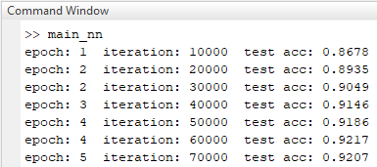

**Figure 4.2.** Test accuracy

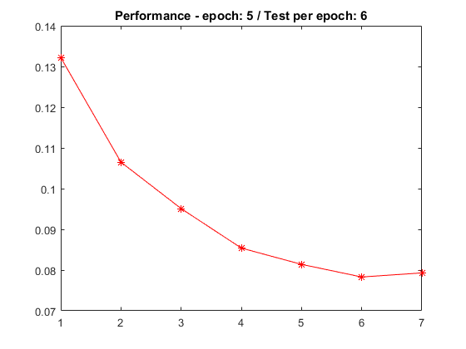

**Figure 4.1.** Performance each epoch

1. **Recurrent Neural Network**
2. **Problem 5-i**

$$h^{(1)}=f_{θ}\left(h^{\left(0\right)},x^{\left(1\right)}\right)=\tanh\left(Ux^{\left(1\right)}+Wh^{\left(0\right)}+b\right)$$

$$h^{(2)}=f_{θ}\left(h^{\left(1\right)},x^{\left(2\right)}\right)=\tanh\left(Ux^{\left(2\right)}+Wh^{\left(1\right)}+b\right)=\tanh\left(Ux^{\left(2\right)}+W\tanh\left(Ux^{\left(1\right)}+Wh^{\left(0\right)}+b\right)+b\right)$$

$$h^{(3)}=f_{θ}\left(h^{\left(2\right)},x^{\left(3\right)}\right)=\tanh\left(Ux^{\left(3\right)}+Wh^{\left(2\right)}+b\right)=\tanh\left(Ux^{\left(3\right)}+W\tanh\left(Ux^{\left(2\right)}+Wh^{\left(1\right)}+b\right)+b\right)=\tanh\left(Ux^{\left(3\right)}+W\tanh\left(Ux^{\left(2\right)}+W\tanh\left(Ux^{\left(1\right)}+Wh^{\left(0\right)}+b\right)+b\right)+b\right)$$

…

$$h^{\left(τ\right)}=\tanh\left(Ux^{\left(τ\right)}+W\tanh\left(Ux^{\left(τ-1\right)}+W\tanh\left(Ux^{\left(τ-2\right)}+W\tanh\left(Ux^{\left(τ-3\right)}+…+W\tanh\left(Ux^{\left(1\right)}+Wh^{\left(0\right)}+b\right)+…+b\right)+b\right)+b\right)+b\right)$$

1. **Problem 5-ii**

Cross entropy:

$$L=-\sum_{t}{\sum_{i}{y_{i}^{\left(t\right)}\log{{\hat{y}}_{i}^{\left(t\right)}}}}$$

Where:

$${\hat{y}}^{\left(t\right)}=softmax\left(o^{\left(t\right)}\right); o^{\left(t\right)}=Vh^{\left(t\right)}+c; h^{\left(t\right)}=\tanh\left(Ux^{\left(t\right)}+Wh^{\left(t-1\right)}+b\right)$$

$$Let L^{\left(t\right)}=y_{i}^{\left(t\right)}\log{{\hat{y}}_{i}^{\left(t\right)}}$$

$$∇_{V}L=\frac{∂L}{∂V}=\frac{∂}{∂V}\left(-\sum_{t}{\sum_{i}{y_{i}^{\left(t\right)}\log{{\hat{y}}_{i}^{\left(t\right)}}}}\right)=-\sum_{t}{\sum_{i}{\frac{∂}{∂V}\left(y_{i}^{\left(t\right)}\log{{\hat{y}}_{i}^{\left(t\right)}}\right)}}=-\sum_{t}{\sum_{i}{\frac{∂L}{∂o_{i}^{\left(t\right)}}}}\frac{∂o_{i}^{\left(t\right)}}{∂V}$$

$$\frac{∂L}{∂o_{i}^{\left(t\right)}}=\frac{∂L}{∂L^{\left(t\right)}}×\frac{∂L^{\left(t\right)}}{∂o_{i}^{\left(t\right)}}=1×y_{i}^{\left(t\right)}\left({\hat{y}}_{i}^{\left(t\right)}-1\right)=y_{i}^{\left(t\right)}\left({\hat{y}}_{i}^{\left(t\right)}-1\right)$$

$$\frac{∂o_{i}^{\left(t\right)}}{∂V}=\frac{∂}{∂V}\left(Vh_{i}^{\left(t\right)}+c\right)=h_{i}^{\left(t\right)}$$

$$\frac{∂L}{∂V}=-\sum_{t}{\sum_{i}{y_{i}^{\left(t\right)}\left({\hat{y}}_{i}^{\left(t\right)}-1\right)h_{i}^{\left(t\right)}}}=\sum_{t}{\sum_{i}{y_{i}^{\left(t\right)}\left(1-{\hat{y}}_{i}^{\left(t\right)}\right)h_{i}^{\left(t\right)}}}=\sum_{t}{y^{\left(t\right)}}diag\left(1-{\hat{y}}^{\left(t\right)}\right){\left(h^{\left(t\right)}\right)}^{T}=\sum_{t}{\left(∇_{o^{\left(t\right)}}L\right){\left(h^{\left(t\right)}\right)}^{T}}$$

$$∇_{W}L=\frac{∂L}{∂W}=\sum_{t}{\sum_{i}{\frac{∂L}{∂h_{i}^{\left(t\right)}}\frac{∂h_{i}^{\left(t\right)}}{∂W}}}=\sum_{t}{diag\left(I-h^{\left(t\right)}{\left(h^{\left(t\right)}\right)}^{T}\right)\left(∇_{h^{\left(t\right)}}L\right){\left(h^{\left(t-1\right)}\right)}^{T}}$$

1. **Problem 5-iii**

$$f_{θ}\left(h^{\left(0\right)},x^{\left(1\right)}\right)=\tanh\left(Ux^{\left(1\right)}+Wh^{\left(0\right)}+b\right)$$

$$f_{θ}\left(h^{\left(1\right)},x^{\left(2\right)}\right)=\tanh\left(Ux^{\left(2\right)}+Wh^{\left(1\right)}+b\right)=\tanh\left(Ux^{\left(2\right)}+W\tanh\left(Ux^{\left(1\right)}+Wh^{\left(0\right)}+b\right)+b\right)$$

$$f_{θ}\left(h^{\left(2\right)},x^{\left(3\right)}\right)=\tanh\left(Ux^{\left(3\right)}+Wh^{\left(2\right)}+b\right)=\tanh\left(Ux^{\left(3\right)}+W\tanh\left(Ux^{\left(2\right)}+Wh^{\left(1\right)}+b\right)+b\right)=\tanh\left(Ux^{\left(3\right)}+W\tanh\left(Ux^{\left(2\right)}+W\tanh\left(Ux^{\left(1\right)}+Wh^{\left(0\right)}+b\right)+b\right)+b\right)$$

…

$$f_{θ}\left(h^{\left(τ\right)},x^{\left(τ\right)}\right)=\tanh\left(Ux^{\left(τ\right)}+W\tanh\left(Ux^{\left(τ-1\right)}+W\tanh\left(Ux^{\left(τ-2\right)}+W\tanh\left(Ux^{\left(τ-3\right)}+…+W\tanh\left(Ux^{\left(1\right)}+Wh^{\left(0\right)}+b\right)+…+b\right)+b\right)+b\right)+b\right)$$

1. **PART 2**

The results of PCA (Matlab Programming Assignment) are shown in Table 2.1 – 2.2 and Figure 2.1 – 2.4. Table 2.1 presents reconstruction error in each case k = 5, 50, 200 and 500. The top 5 principal components (PCs) are displayed from Figure 2.1 to Figure 2.4. Table 2.2 presents specifically the prediction about emotion of each test image in 4 cases of k.

**Table 2.1.** Reconstruction Error

|  |  |  |  |  |
| --- | --- | --- | --- | --- |
| **k** | 5 | 50 | 200 | 500 |
| **Reconstruction Error** | 2.1290 × 106 | 2.5866 × 105 | 4.0246 × 10-22 | 3.9890 × 10-22 |

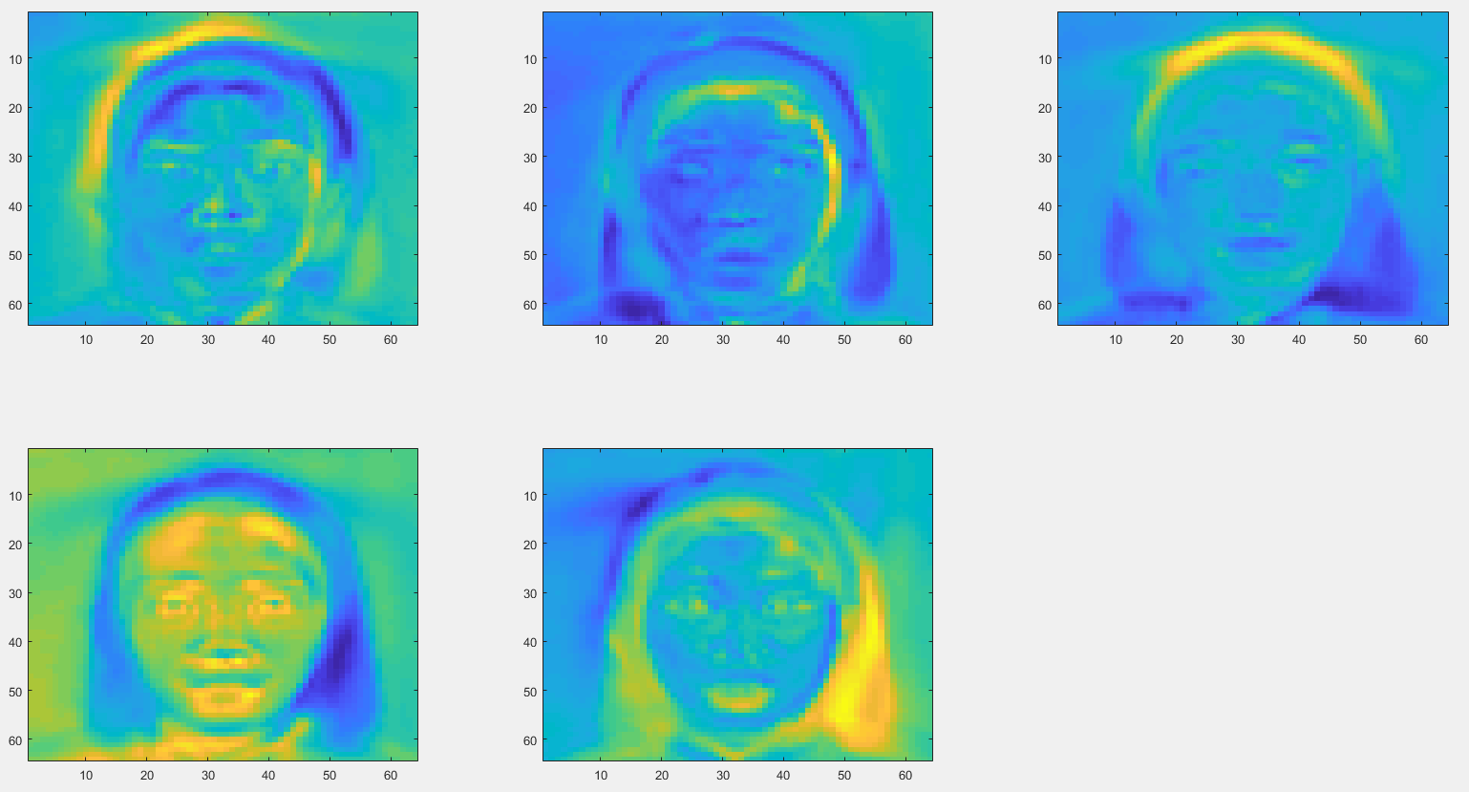

**Figure 2.1.** The top 5 PCs with k = 5

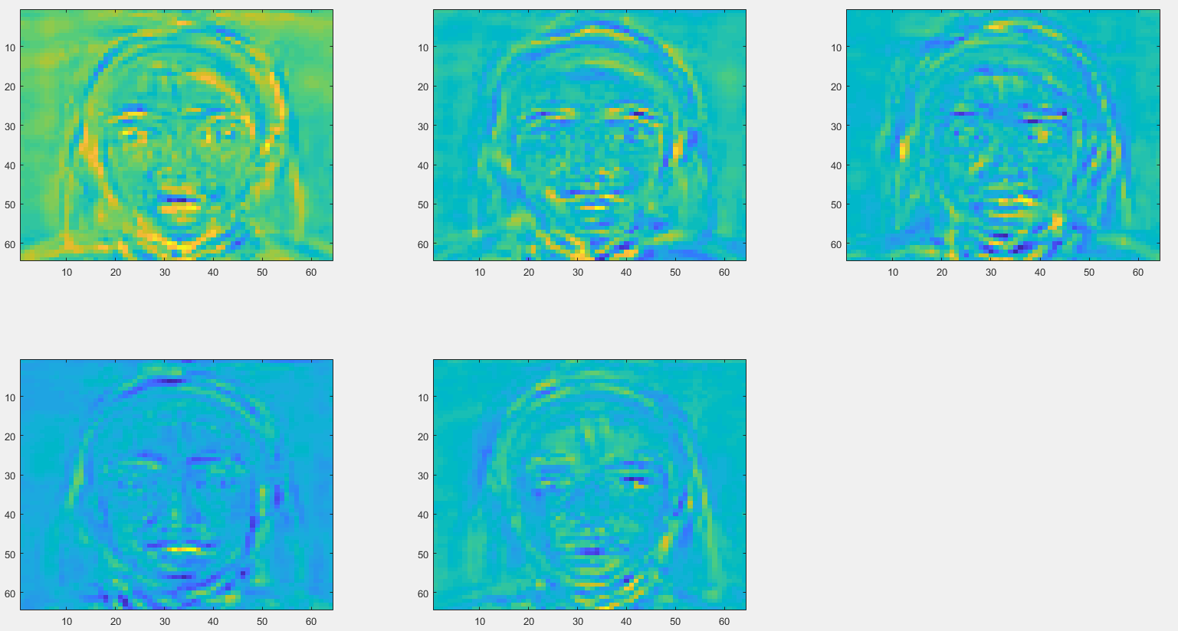

**Figure 2.2.** The top 5 PCs with k = 50

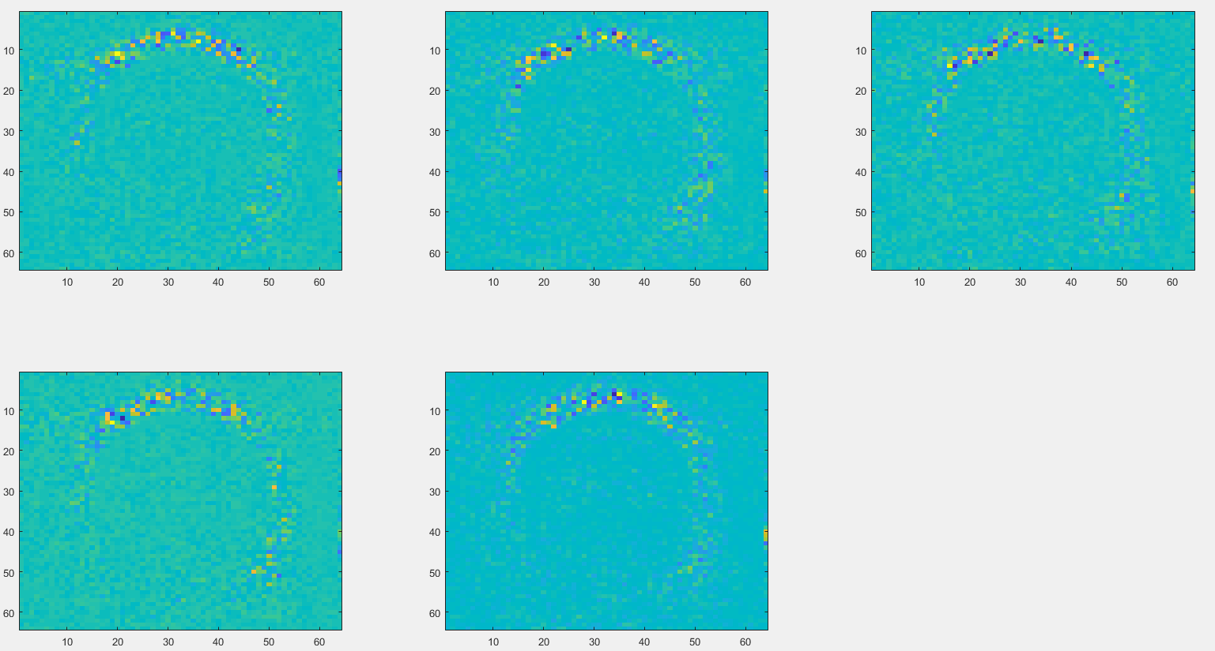

**Figure 2.3.** The top 5 PCs with k = 200

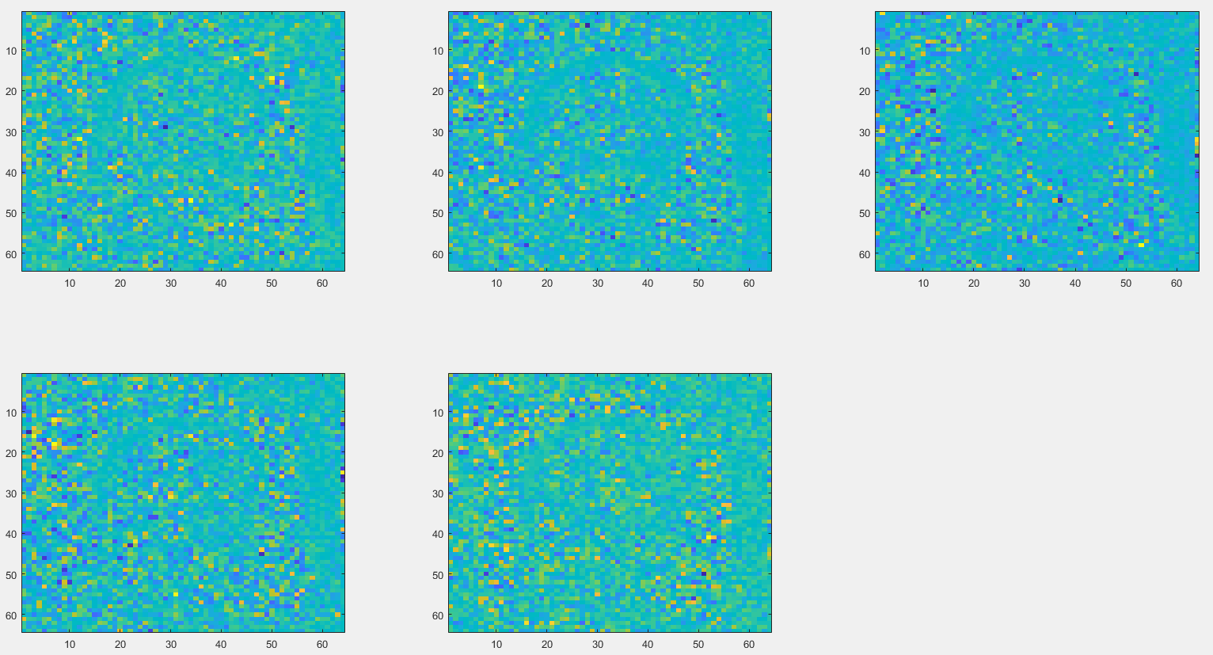

**Figure 2.4.** The top 5 PCs with k = 500

**Table 2.2.** The prediction results about emotion

|  |  |  |  |  |  |  |
| --- | --- | --- | --- | --- | --- | --- |
| **ID of test image** | **k** | | | | **Human eyes** | **Incorrect** |
| **5** | **50** | **200** | **500** |
| 1 | 7 | 18 | 18 | 18 | Not exist | All |
| 2 | 3 | 3 | 3 | 3 |  |  |
| 3 | 5 | 5 | 5 | 5 |  |  |
| 4 | 9 | 9 | 9 | 9 |  |  |
| **ID of test image** | **k** | | | | **Human eyes** | **Incorrect** |
| **5** | **50** | **200** | **500** |
| 5 | 14 | 14 | 14 | 14 |  |  |
| 6 | 19 | 19 | 19 | 19 |  |  |
| 7 | 22 | 21 | 22 | 22 | 21, 22 |  |
| 8 | 28 | 27 | 27 | 27 | 27, 28 |  |
| 9 | 30 | 30 | 30 | 30 |  |  |
| 10 | 35 | 35 | 35 | 35 |  |  |
| 11 | 36 | 36 | 36 | 36 |  |  |
| 12 | 44 | 44 | 44 | 44 |  |  |
| 13 | 46 | 46 | 46 | 46 |  |  |
| 14 | 48 | 49 | 49 | 49 | 49 | k = 5 |
| 15 | 52 | 52 | 52 | 52 |  |  |
| 16 | 55 | 55 | 55 | 55 |  |  |
| 17 | 56 | 55 | 55 | 55 | 55, 56 |  |
| 18 | 57 | 57 | 57 | 57 |  |  |
| 19 | 67 | 67 | 67 | 67 |  |  |
| 20 | 57 | 67 | 67 | 67 | 67 | k = 5 |
| 21 | 68 | 68 | 68 | 68 |  |  |
| 22 | 68 | 68 | 68 | 68 |  |  |
| 23 | 78 | 79 | 79 | 79 | 78, 79 |  |
| 24 | 77 | 81 | 81 | 81 | 81 | k = 5 |
| 25 | 73 | 83 | 83 | 83 | 83 | k = 5 |
| 26 | 85 | 85 | 85 | 85 |  |  |
| 27 | 94 | 94 | 94 | 94 | 92 | All |
| 28 | 94 | 92 | 92 | 92 | 92 | k = 5 |
| 29 | 93 | 94 | 94 | 94 | 93, 94 |  |
| 30 | 98 | 96 | 96 | 96 | 96 | k = 5 |
| 31 | 100 | 100 | 100 | 100 |  |  |
| 32 | 100 | 100 | 100 | 100 |  |  |
| 33 | 101 | 101 | 101 | 101 |  |  |
| 34 | 113 | 113 | 113 | 113 |  |  |
| 35 | 103 | 108 | 108 | 108 | 108 | k = 5 |
| 36 | 116 | 116 | 115 | 115 | 115 | k = 5, 50 |
| 37 | 118 | 118 | 118 | 118 |  |  |
| 38 | 119 | 119 | 119 | 119 | 119, 120 |  |
| 39 | 125 | 125 | 124 | 124 | 124, 125 |  |
| 40 | 129 | 129 | 129 | 129 |  |  |
| 41 | 137 | 134 | 134 | 134 | 134 | k = 5 |
| 42 | 144 | 140 | 140 | 140 | 140 |  |
| 43 | 144 | 144 | 144 | 144 |  |  |
| 44 | 144 | 144 | 144 | 144 |  |  |
| 45 | 145 | 145 | 145 | 145 |  |  |
| 46 | 148 | 148 | 148 | 148 |  |  |
| **ID of test image** | **k** | | | | **Human eyes** | **Incorrect** |
| **5** | **50** | **200** | **500** |
| 47 | 154 | 149 | 149 | 149 | 149 | k = 5 |
| 48 | 154 | 154 | 154 | 154 | 150 | All |
| 49 | 151 | 151 | 152 | 152 | 152 | k = 5, 50 |
| 50 | 154 | 154 | 154 | 154 |  |  |

Generally, all cases predict correctly about the face of person in the test images. However, the emotion prediction of the case k = 200 and 500 are the best. While the case k = 5 gives us the worst emotion prediction. There are 3 test images that all cases of k predicts emotion wrong and their ID equals to 1, 27 and 48. Conclusion, the PCA algorithm operates very well on face recognition but in emotion detection, it required improvement.