|  |  |  |  |
| --- | --- | --- | --- |
| 3Documents | Progress | Reporting | Enterprise |
| * + [Smart drawings](https://www.plangrid.com/features/smart-plan-viewer/)   + [BIM](https://www.plangrid.com/features/bim/)   + [Documents](https://www.plangrid.com/features/construction-document-control/)   + [Workflows](https://www.plangrid.com/features/workflows/)   + [Submittals](https://www.plangrid.com/features/submittals/)   + [Automatic Submittal Log](https://www.plangrid.com/features/automatic-submittal-log/)   + [Advanced RFIs](https://www.plangrid.com/features/rfis/)   + [Instant sync](https://www.plangrid.com/features/cloud-software/) | * + [Markups](https://www.plangrid.com/features/markups-and-measurements/)   + [Tasks](https://www.plangrid.com/features/tasks/)   + [Punch Lists](https://www.plangrid.com/features/punch-list-app/)   + [Sheet compare](https://www.plangrid.com/features/sheet-compare/)   + [Photos & videos](https://www.plangrid.com/features/photos/)   + [Project Hub](https://www.plangrid.com/features/project-hub/) | * + [Field reports](https://www.plangrid.com/features/field-reports/)   + [PDF reports](https://www.plangrid.com/features/reporting/)   + [As-builts](https://www.plangrid.com/features/as-built-drawings/) | * + [Admin console](https://www.plangrid.com/features/admin-console/)   + [Security](https://www.plangrid.com/security/)   + [Connect](https://www.plangrid.com/features/plangrid-connect/)   + [Integrations](https://www.plangrid.com/integrations/)   + [Workspaces](https://www.plangrid.com/features/workspaces/)   + Subscription |

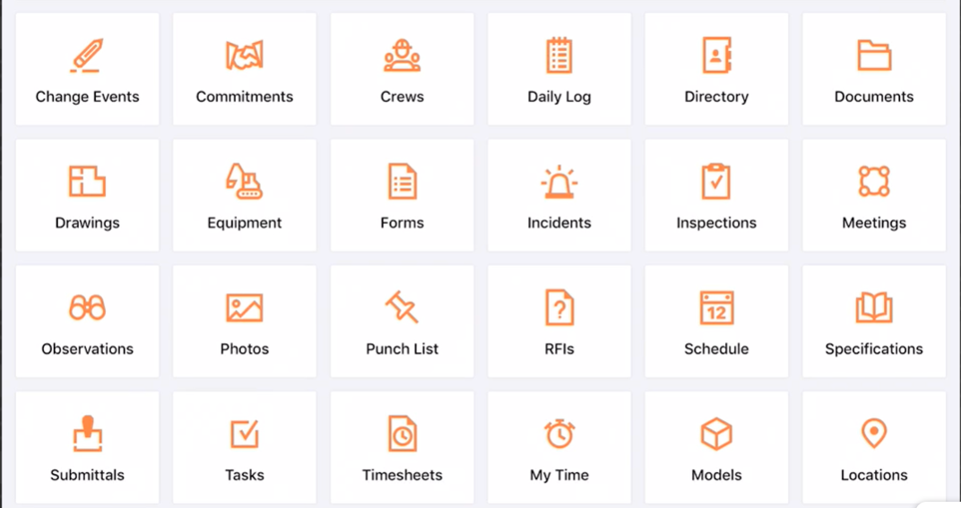

MVP

Device types – Web, Tablet and Mobile

1. Users, groups, role, permission mapping
2. Punch list – Defect tracking
   1. Ticket custom form generation
3. Dashboard
4. User metrics
5. Plan viewing - image markup
6. Task management, scheduling
7. Checklists
8. Instant messaging & notifications
9. Report template generation and exporting data
10. Statistics
11. Working offline
12. App billing and subscriptions (Maintenance)

Additional features

1. Pre constructions
   1. Pre qualification
   2. Bid management
2. Estimates & Cost tracking and accounting
3. Box/Dropbox/OneDrive sync
4. Revit Plugin
5. BIM viewer
6. Workflow management
7. API access
8. Single sign-on (SSO)
9. API support
10. Training programs

Resources

1. <https://www.buildxact.com/features/cost-tracking-software/>
2. <https://www.fieldwire.com/pricing/>
3. <https://www.buildxact.com/>
4. <https://www.procore.com/>
5. Plangrid
6. CoContruct
7. Bluebeam

Modules

1. User management

- groups

- roles

- permissions

2. Plans

3. Projects

4. Documents, pictures and videos management

- Sheet compares

5. Third party management

- penalty clause

6. Tasks

-Calendar view

7. Punch list

- Image markup

- Custom forms

8. Report templates

9. Reports and Charts

10. Alerts

11. Notifications

1. Email & SMS

12. Chat

13. Workflows

14. Advanced RFIs

15. Project Hub

User geolocation tracking

16. Subscription

Themes

<https://demos.creative-tim.com/vue-now-ui-dashboard-pro/?_ga=2.16031476.331593876.1602796985-1616048344.1602796985#/>

<https://www.creative-tim.com/product/buy/bundle/vuejs-bundle>

**Architecture**

CMSProMicroService

Queue

CMSProReportsGateway

Service

CMSProReportstService

CMSProDMGateway

Service

CMSProSubscriptionGateway

Service

CMSProGateway

Service

CMSProSubsrciptionService

CMSProNotificationService

CMSProDocumentManagementService