Team 207 Project Technical Report to the 2026

International Rocket Engineering Competition

Lucas Ignacio Freyre Cancela, Felipe Ranftl, Fabrizio Iezzi, Justina Kamiya, Santiago Ponte, Tomas Gomez Crovetto, Valentin Neme, Tomas J. Manzella, Ivan Marzeniuk, Tomas Wickham, Martina Parera, Marco Beretta
ITBA Rocketry Team
Instituto Tecnológico de Buenos Aires, Ciudad Autónoma de Buenos Aires, C1004, Argentina



Abstract/Executive summary

Aconcagua is ITBA Rocketry's 30.000 ft AGL COTS Single-Stage submission for the 2026 IREC. Building on the team's 2025 IREC entry, the design priorities for Aconcagua were: (1) mass optimization of composite structures and bulkheads through quantitative safety-factor analysis, (2) ease of field assembly, (3) use of previously unused internal volume, and (4) repeatable in-house composite manufacturing.

The rocket is 2.95 m long and weighs 34.2 kg at lift-off, and is propelled by an Aerotech O5500X motor to a predicted apogee of 30.679 ft. It departs the rail at 45 m/s with an acceleration of 25.1 g and reaches a maximum speed of 628 m/s. Aconcagua is divided into three easy to disassemble sections: Nosecone, Payload Bay and Fincan joined by aluminum Radial-Axial (RADAX) bulkheads and Glass Fibre Reinforced Polymer (GFRP) field joints.

All composite components are manufactured in-house: the 5:1 Von Karman Nosecone and Boattail are hand-laminated GFRP; the body tubes are winded GFRP with a [±30/±30/90] hoop reinforced layup; the four 1.1 caliber semispan fins are vacuum-bagged Carbon Fibre Reinfornces Polymer (CFRP) using a β=20° aeroelastically tailored AR1 stacking sequence. A 6061 T-6 Aluminum center Ring and a mass-optimized, 5-axis machined and Finite Element Method (FEM) validated Motor bulkhead transfer the load generated by the impulse of the motor to the airframe. RADAX joints carry bending moments with less deformation than radial bolt joints, enabling mass reduction in the airframe.

Aeroelastic stability, also known as fin flutter, was assessed using a custom Classic Lamination Theory (CLT) and Supersonic piston theory finite element solver, yielding a worst case scenario Safety Factor of 2.41 at maximum flight velocity, complying with DTEG 8.2.2

The avionics combines COTS components such as two RRC3, a Featherweight GPS and a TeleMega with an SRAD computer that provides live telemetry to a ground station that feeds a Graphic User Interface (GUI), each powered independently. The three GPS send its instantaneous position to an automatic antenna-tracking ground station. Dual-event recovery releases the drogue at apogee through two Raptor CO2 charges, activated each by a different RRC3 and at 1200 AGL ft a Piranha line cutter releases the three ring-mechanism, extracting the main from the Parachute Opening Device (POD) and inflating it.

The payload is a 3U scientific experiment designed to study and quantify the effects of launch-induced acceleration and vibrations on the performance of a custom designed infusion pump. A microfluidic flow sensor is used to evaluate flow rate stability, focusing on the occurrence of undesired boluses and air bubbles during flight. The results aim to inform the design of reliable fluid delivery systems for future microfluidic and cell culture applications.

Testing performed includes: compression and micrographic validation of in-house GFRP/CFRP tubes; bonded-joint shear tests on anodized-aluminum-to-GFRP interfaces; recovery ground tests including pop-off separation and electronics arming verification per DTEG 6.13.4; functional and endurance testing of both avionics bays; and ground baseline characterization of the payload flow system for in-flight comparison.

Introduction

A: Academic program

The ITBA Rocketry Team is a student organization from the Instituto Tecnológico de Buenos Aires, based in the Autonomous City of Buenos Aires, Argentina. Founded in August 2022, the team aims to provide students with hands-on experience in aerospace technologies as an extracurricular activity.

B: Stakeholders

The primary stakeholder of the project is the Instituto Tecnológico de Buenos Aires, which provides financial support and essential resources to ensure the team’s success in competition. Additionally, our faculty advisor, Prof. Patricio Hernán Pedreira, has played a pivotal role in the project. As a professor of Heat Transfer and Fluid Dynamics, his expertise and guidance have been invaluable, significantly contributing to the team’s development and achievements. Another key group of stakeholders includes the companies and institutions that sponsor and support the project. These external partners have provided both financial and technical assistance, including supplies, tools, specialized knowledge, and industry mentorship. Their contributions have been crucial in advancing the team’s capabilities. Finally, the members of the ITBA Rocketry Team themselves are fundamental stakeholders. Their dedication, teamwork, and relentless pursuit of innovation have transformed this project from a challenging ambition into a tangible reality.

C: Team Structure and Management Strategy

The ITBA Rocketry Team operates under a hierarchical structure, with a team director serving as both the team lead and project manager. Additionally, a community management coordinator is responsible for communications with stakeholders. The full team structure is illustrated in Figure 1.
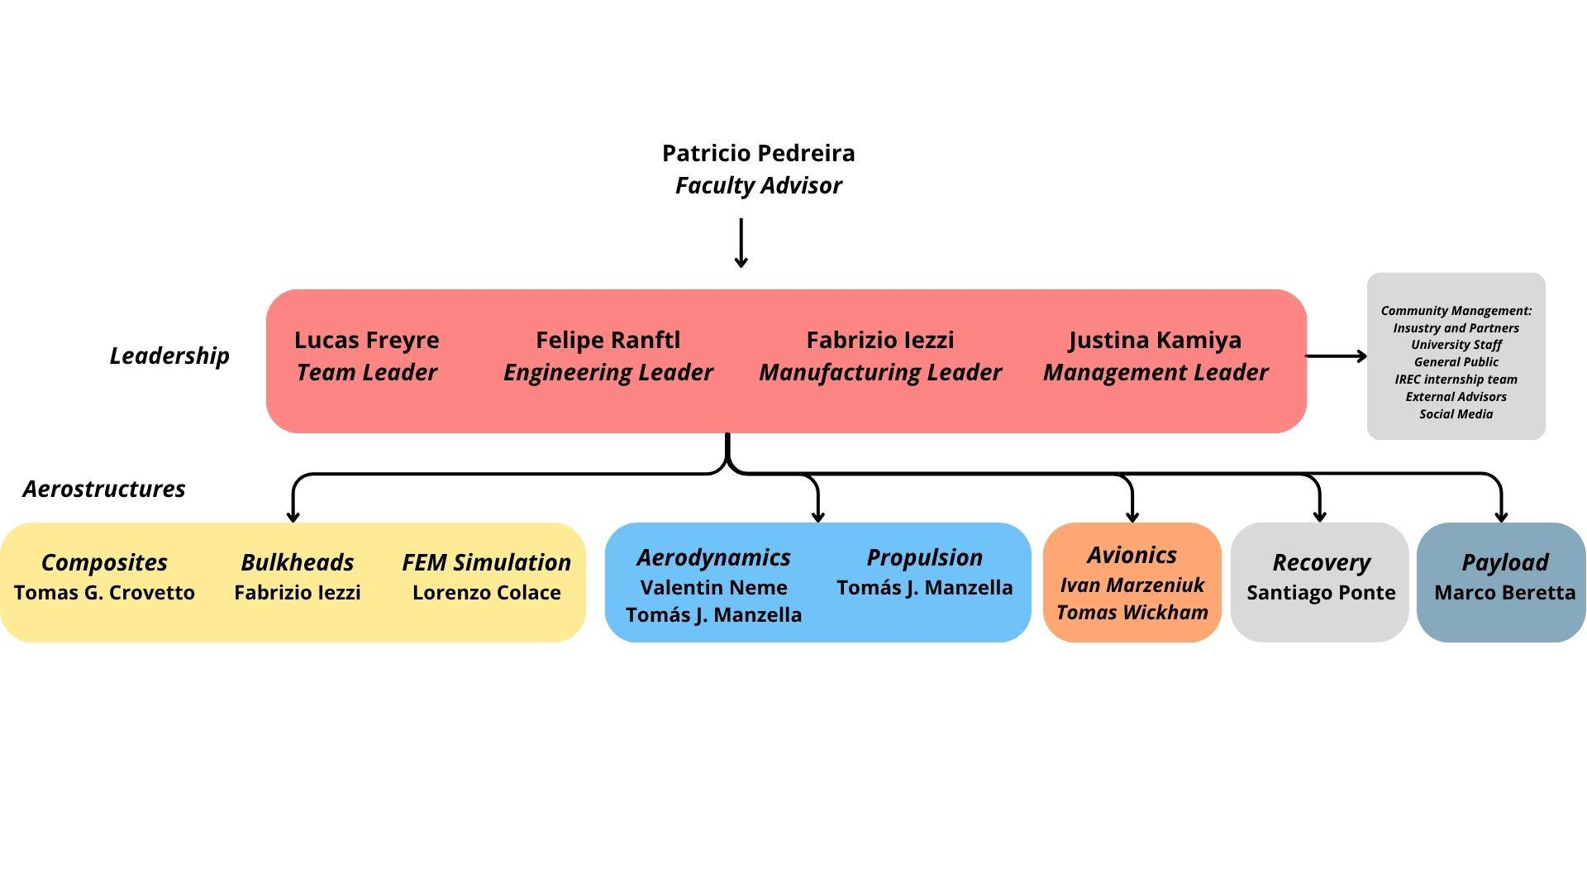
Fig. 1: 2025/2026 Team Structure

The management strategy consisted in dividing the project in clearly defined stages in time, defining milestones, revisions and deadlines for each subteam. An Excel spreadsheet with all tasks and progress status was used to track the teams and a Gantt made with Jira by Atlassian (see Fig. 2) was constantly updated to provide the team with clear visibility of upcoming deadlines. The design stages are: Design, Purchases, Manufacturing, Integration and Testing. A Flow chart served as a guide to each team to point out what to do next. The workflow is presented in Fig. 3:
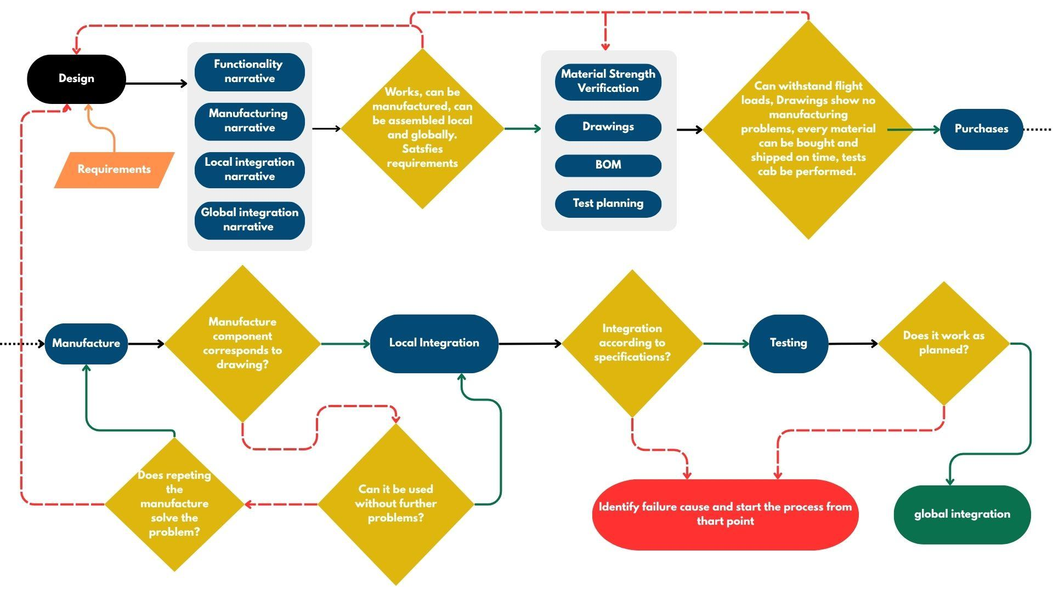
Fig. 2: Sub teams work flow

For the purchases an excel sheet is used where every team member can upload an item and then the purchase responsible continuously updates the status of the item. This provides clarity and traceability of the budgetspent, allows to assess the cashflow and establish a proven supply chain..

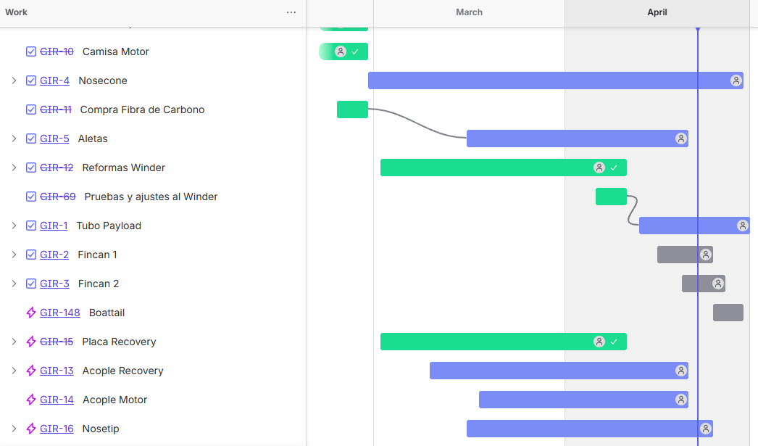
Fig. 3: Gantt made with Jira

The technical report was prepared by each subteam leader with assistance from their team members. The team leader and advisors improved coherency and improved the overall structure of the report. Constant feedback between both parties improved the balance between technical details and briefness.

System Architecture Overview

A: Overview
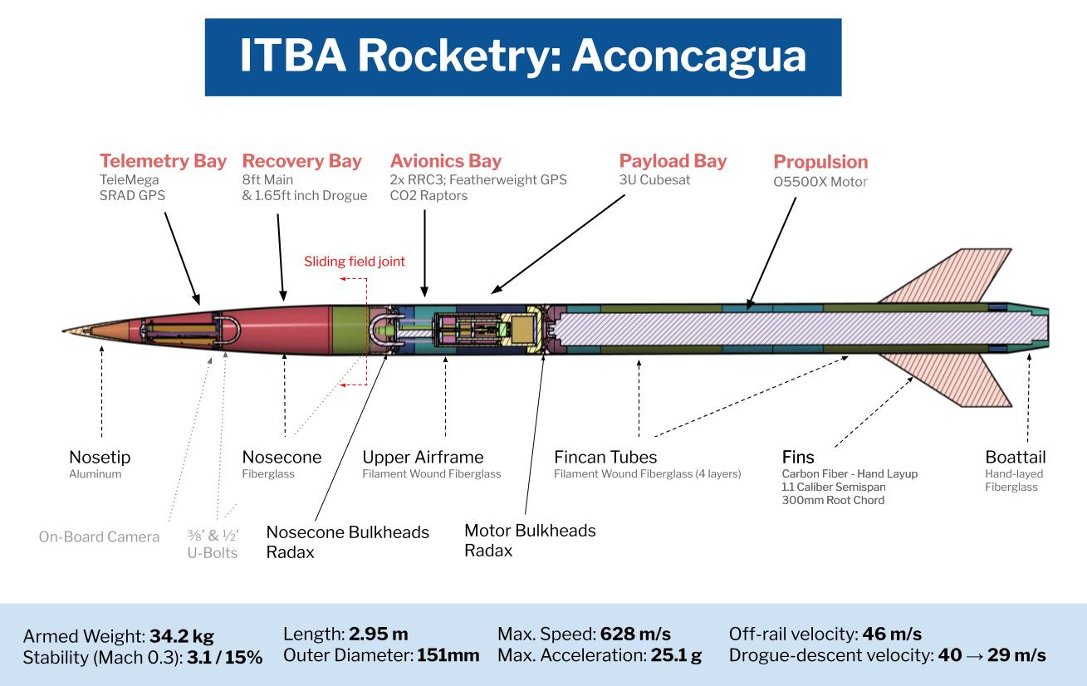
Fig 4: Section view of Aconcagua
Aconcagua is composed of six main subsystems: aero-structures, propulsion, avionics, telemetry, recovery, and payload. Figure 4 presents a sectional view of the fully integrated vehicle, illustrating the physical arrangement of these subsystems.
From a structural standpoint, the vehicle is divided into three primary assemblies: the nosecone, the upper airframe, and the fincan (see Appendix F “Aconcagua Top Level” for the rocket interfaces).
Starting from the forward end, the nosecone assembly houses the nosetip, telemetry subsystem, as well as part of the recovery system. The nosetip is structurally connected to the internal avionics structure, which provides mounting for flight electronics and transmits loads to the surrounding composite shell. Within this section, recovery components are anchored to a ⅜’ U-Bolt.
At the interface between the nosecone and the upper airframe, separation is achieved through a sliding field joint secured during flight by nylon shear pins. At apogee, the shear pins are cut, allowing relative motion between both sections and enabling deployment of the recovery system.
The upper airframe serves as the central structural segment of the vehicle. It houses the avionics subsystem, payload module and provides the main load transfer path between the forward and aft sections. It integrates a ½’ U-Bolt for recovery attachment and connects the avionics and payload bay through bolted joints. The airframe structure is bonded to the bulkheads and mechanically reinforced to transfer axial and bending loads.
The fincan constitutes the aft structural assembly and integrates the propulsion subsystem. The Aerotech O5500X solid rocket motor is mounted to a motor bulkhead assembly, which acts as the primary thrust transfer structure. Loads generated during propulsion are transmitted from the motor through the bulkhead into the airframe. The fincan also incorporates an internal coupler and structural reinforcements to maintain alignment and stiffness.
Aerodynamic stabilization is achieved through a set of four fins mounted on the fincan. At the aft end, a boattail is incorporated to reduce base drag and improve overall aerodynamic efficiency.
The propulsion subsystem is based on a commercial off-the-shelf solid rocket motor (O5500), selected to provide sufficient total impulse to reach the target apogee while maintaining controlled ascent dynamics and structural compatibility with the airframe.
The avionics subsystem is responsible for flight state detection, recovery system actuation, and position tracking. Two redundantly powered RRC3 altimeters are used to detect apogee and trigger deployment events. These devices activate the primary and secondary recovery systems, including Raptor deployment mechanisms at apogee and a Piranha line cutter at 1200 ft, ensuring redundancy and mission reliability.
The telemetry subsystem is dedicated to data acquisition and transmission to the ground station. It includes a TeleMega V7.0 unit and a SRAD data acquisition board, which collect and transmit real-time flight data. This information is used by the ground station for monitoring, antenna tracking, and visualization through a graphical user interface. An onboard camera is also included to record flight footage for post-flight analysis.
The recovery subsystem is distributed across the nosecone and is designed to ensure safe descent and vehicle retrieval. It is mechanically linked to the U-Bolts located in the Telemetry Bay and Avionics Bay and is triggered by the avionics system based on flight conditions.
Finally, the 3U payload module is located within the upper airframe and houses an experiment aimed at characterizing flow behavior within an in-house developed infusion pump.
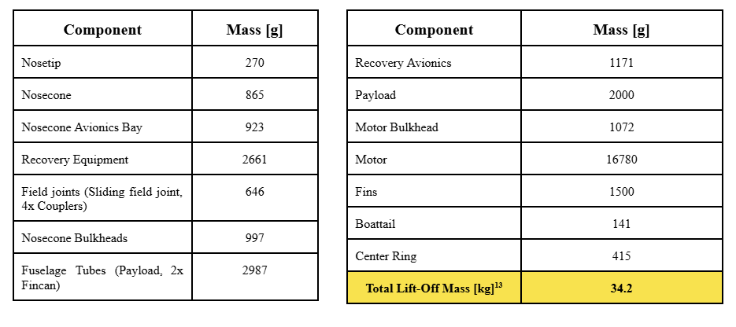Table 1: Mass Budget. Glue, paint and bolt mass were also considered for the total lift-off mass.
The mass budget of Aconcagua is presented in Table 1.

B: Propulsion

Aconcagua 's propulsion is achieved via a COTS solid motor. For the selection process, several category ‘O’ motors were considered, with a total impulse between 20000 and 31000 Ns, due to the need for moderately high thrust. Furthermore, AeroTech and Cesaroni Technology Inc. were considered as potential suppliers, in view of their proven reliability on past competitions.
The aforementioned restrictions yielded a set of five viable motors for Aconcagua. Table 2 below lists the main characteristics of each of the motors. In order to select the most appropriate one, each candidate was evaluated through OpenRocket and RasAero simulations considering the following aspects:

- The capability of reaching the target altitude of 30000 ft, and the resulting mass and size constraints flexibility.
- The rocket’s overall flight dynamics, especially its maximum acceleration, maximum speed, rail departure velocity and stability margin evolution throughout the entirety of the flight. These parameters had to remain within the limits established by the competition requirements.
- Motor availability from the manufacturers, in order to assure correct and in-time delivery.

Supplier | Motor Designation | Total Impulse [Ns] | Total Mass [kg] | Diameter [mm] | Estimated Apogee [ft] | Maximum Mach N. | Maximum Acceleration [m/s^2] | Rail Departure Velocity [m/s]
AeroTech | O5500X | 21395 | 16.783 | 98 | 30679 | 1.906 | 248 | 46
Cesaroni Technology | 21062O3400 | 21041 | 16.842 | 98 | 27557 | 1.725 | 145 | 37.5
 | 30795O25000 | 30907 | 23.558 | 132 | 33399 | 2.716 | 849 | 81.6
 | 29920O3700 | 29956 | 31.350 | 161 | 29393 | 1.675 | 79.9 | 24.6
 | 30600O5800 | 30615 | 26.368 | 161 | 38618 | 2.090 | 108 | 31.8
Table 2. Simulation results for the COTS motors considered in the selection process. All cases were configured with a launch altitude of 2120 ft, 6° of rail inclination, 2kg of payload, and no wind.

The AeroTech O5500X was selected as Aconcagua’s propulsion system, as it provides the best overall balance between flight performance and design flexibility, and has a proven flight heritage within the 30K COTS category.

C: Aero-Structures

C.1 Flight Loads Model
C.11 Flight Loads Model
In order to optimize the structural mass of Aconcagua, the team developed a mathematical flight loads model to replace empirical safety factors with physics based load inputs. Two classes of loads were considered. Aerodynamic loads lateral forces on the nosecone, fins, and boattail arising from the gust-induced angle of attack, with drag coefficients from OpenRocket, plus a fuselage lateral pressure force characterised by the coefficient lateral Cd obtained from OpenFOAM CFD simulations of the full vehicle at the design wind speed of 36 km/h gusts. Dynamic inertia loads longitudinal inertia from axial acceleration, lateral inertia from the translational side-acceleration, and rotational inertia from the pitching angular acceleration from the fins were considered. Axial compression from thrust and rotational resistance from angular acceleration complete the load set.
Three flight conditions were evaluated to identify the governing case at each station: max-q , max-qa, and max-av. When the rocket travels at a non-zero angle of attack, the aerodynamic lift coefficients of the nosecone, boattail, and fins generate transverse shear forces within the fuselage which in turn produce internal bending moments; it was necessary to evaluate each flight stage independently to identify the critical condition. The loads were used as boundary conditions for the FEM simulation and optimisation of bulkheads. The governing internal forces at the three primary structural stations under the max-qa were taken into consideration for the design process. Full derivation including shear force and bending moment diagrams is presented in Appendix K.

C.2 Nosetip
The nose tip is machined from 6061-T6 aluminum (see Figure 5) and defines the leading-edge geometry of the vehicle, ensuring aerodynamic continuity with the nosecone. Structurally, it serves as the primary attachment point for recovery loads, transferring forces from the nosecone to the internal structure during deployment. Additionally, it integrates an access interface for the TeleMega and SRAD avionics, enabling rapid apogee measurement and battery servicing. FEM analysis of the main deployment shock taken entirely by the nosetip revealed a SF of 19.3 (see Appendix K). Material selection and dimension were defined considering mass, manufacturability and integration simplicity.

Figure 5: Nosetip CAD

C.3 Nosecone
Aconcagua’s nosecone follows a 5:1 Von Karman profile (see Fig. 6), selected to minimize wave drag during transonic and supersonic flight. Its internal volume enables packing of a parachute system with 120 mm of diameter and 500mm of longitude.
A sensitivity analysis in OpenRocket showed a 3% (~1000 ft) apogee variation for lengths between 500 mm and 1000 mm, and 2% across different profiles. Since the recovery system is housed within the nosecone, the length was set to 800 mm, corresponding to the second-best aerodynamic performance. This trade-off prioritizes system integration over marginal aerodynamic gains: 500 mm are allocated to the recovery system based on supplier-provided packed dimensions, while the remaining volume accommodates a structural bulkhead with a U-bolt for nosecone recovery.
The tip diameter was defined as the minimum required to integrate Molex connectors for battery charging and data access to the TeleMega system. The ogive transitions into a 1.2-caliber cylindrical section that interfaces with the recovery bay via a 1-caliber sliding field joint, compliant with DTEG 8.5.1.1.
Due to geometric complexity, the nosecone is manufactured via hand lay-up over a 3D-printed female mold. Fiberglass was selected for its low dielectric losses, ensuring reliable telemetry transmission from SRAD and TeleMega systems, unlike carbon fiber and aluminum, which significantly attenuate RF signals.
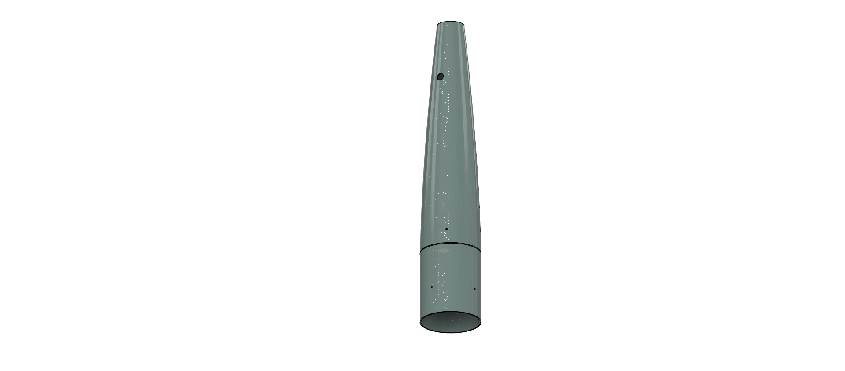
Fig. 6: Nosecone CAD (left); Nosecone Mold (right)

C.4 Avionics Bulkhead
The avionics bulkhead (see Fig. 7) serves as the primary structural interface for the nosecone assembly, transferring recovery loads from drogue and main deployment while providing attachment points for the U-bolt and nosecone avionics. The loads travel from the cord to the U-Bolt, Avionics Plate, Avionics Bulkhead and then to the Nosecone. The connection is made by means of a ring, bonded to the bay with resin. The avionics plate (see Fig. 7) incorporates two mounting points to the ring and two additional reinforced points for a ⅜ inch U-bolt, which serves as attachment point for the parachute system.
Shock simulations predicted a peak load of 3.2 kN (see Appendix I) under a worst-case drogue deployment at a lateral velocity of 100 m/s. The glued joint was dimensioned using the maximum shear stress of the EA 120 HP bonding agent, obtained by standard ASTM D5868 (see Appendix B.I.2) and resulted in a SF of 41.
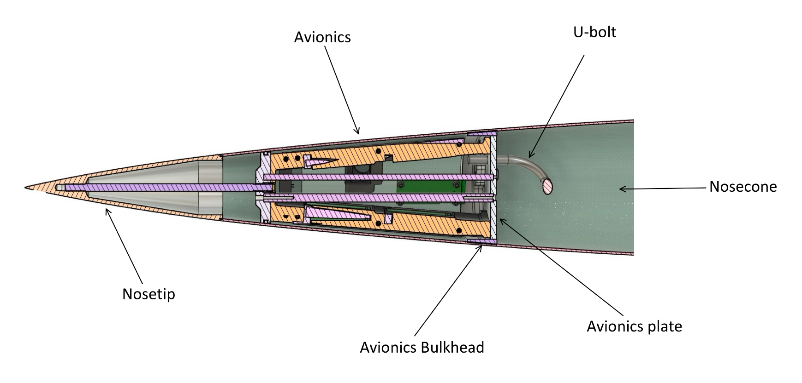
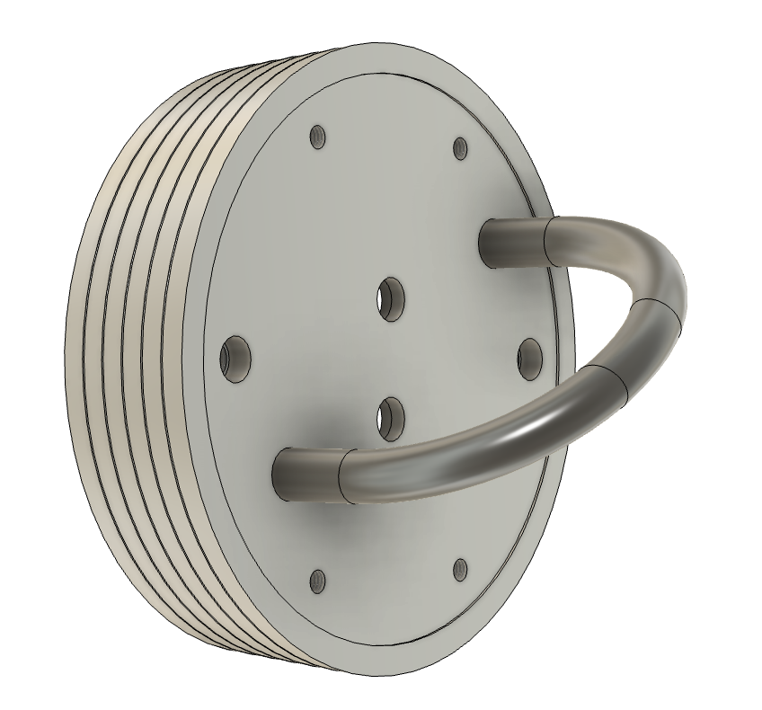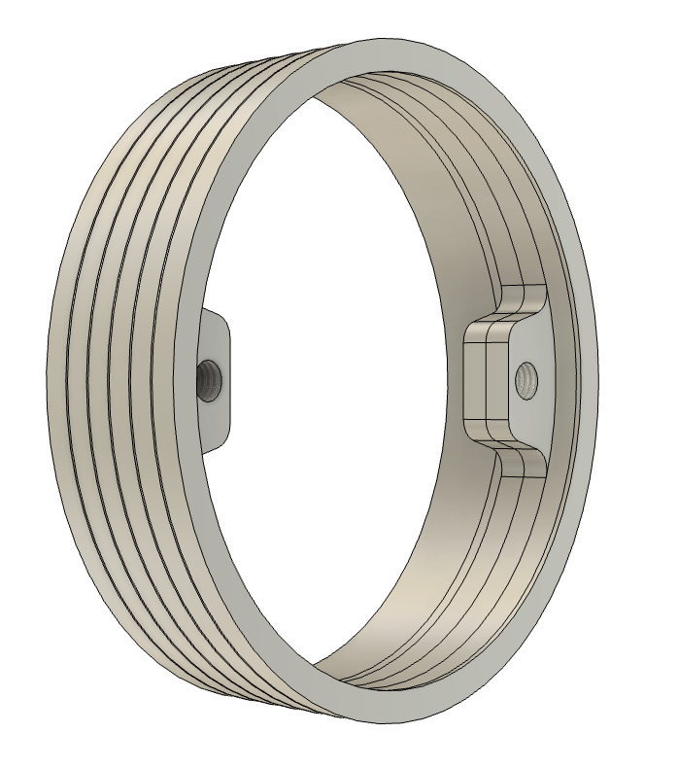
Figure 7: Section view of the nosecone (top); Avionics plate, BH and U-Bolt assembled (bottom)

C.5 Payload Bulkhead
Figure 8 shows the payload bulkhead assembly. It features a sliding field joint bonded to the recovery bay using Loctite E-120HP adhesive. The sliding field joint is connected to the nosecone with nylon shear pins. A fixed field joint is bonded to the aft end
Radax and radial bulkheads were considered for the design. Compared to conventional radial fastener joints, RADAX joints (see Fig. 9) increase axial stiffness by a factor of at least three by introducing angled fasteners that generate preload, enabling load transfer through friction and reducing compliance associated with bolt shear and joint clearance. The Load Program and transition to RADAX joint allowed the team to optimize the weight of the male and female bulkheads, resulting in 560 g and 460 g.
An aluminum plate, the recovery plate, serves as a mounting plate for the payload and includes a connection point for a ½ inch U-Bolt. This plate is placed in a 5.5 mm gap between the two bulkhead parts, which are then bolted together. The bulkheads are connected using six equally spaced grade 12.9 steel radial bolts.
Recovery loads are transferred through the U-Bolt, recovery plate, Male Recovery Bulkhead and finally to the airframe and female Recovery Bulkhead. The maximum stress on both Bulkheads considering recovery and flight loads is below 50 MPa according to FEM analysis detailed in Appendix K, resulting in a safety factor of 5 for the bulkheads.
The specific joint located within the nosecone is designed as a sliding joint. Unlike the bonded couplers, this interface, lubricated with grease, allows for a clean separation between the nosecone and the rest of the rocket at apogee.
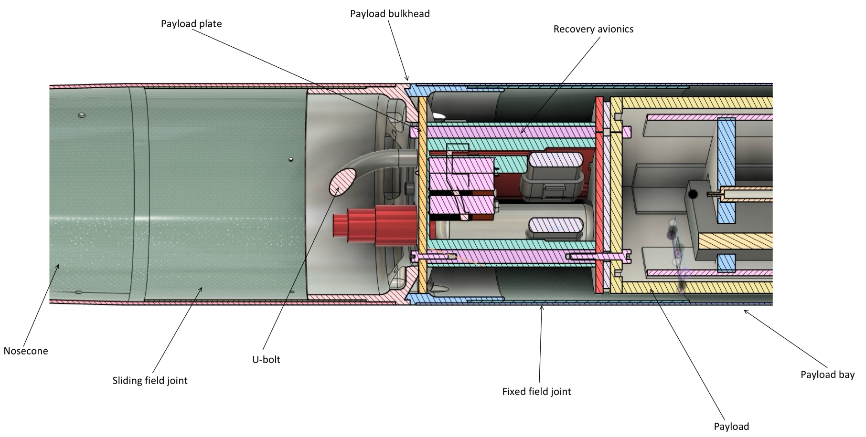
Fig. 8: Section view of Recovery Bulkhead

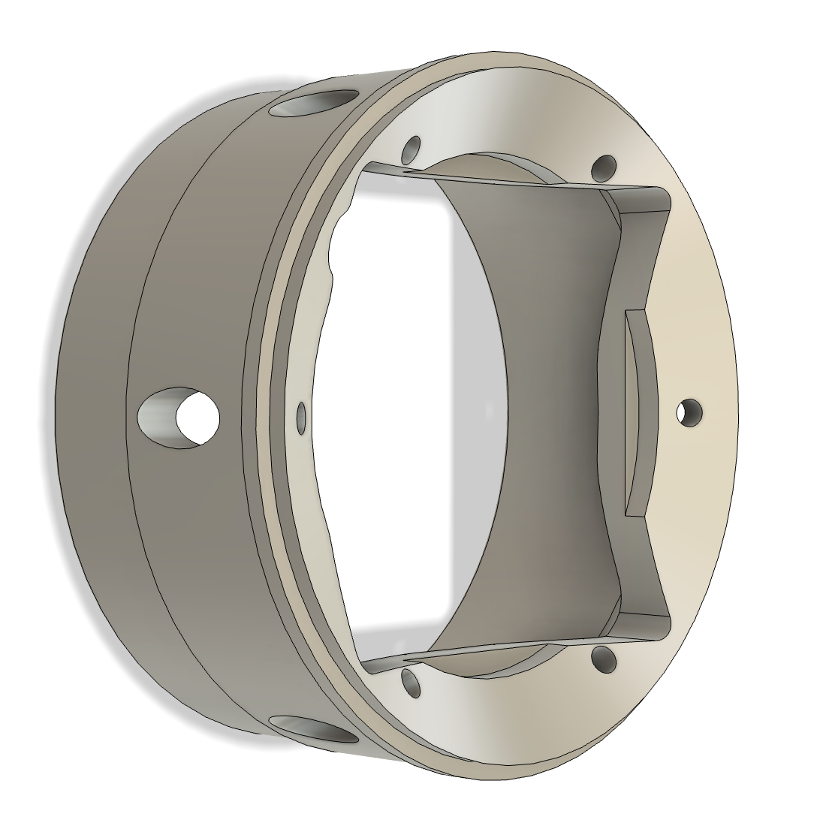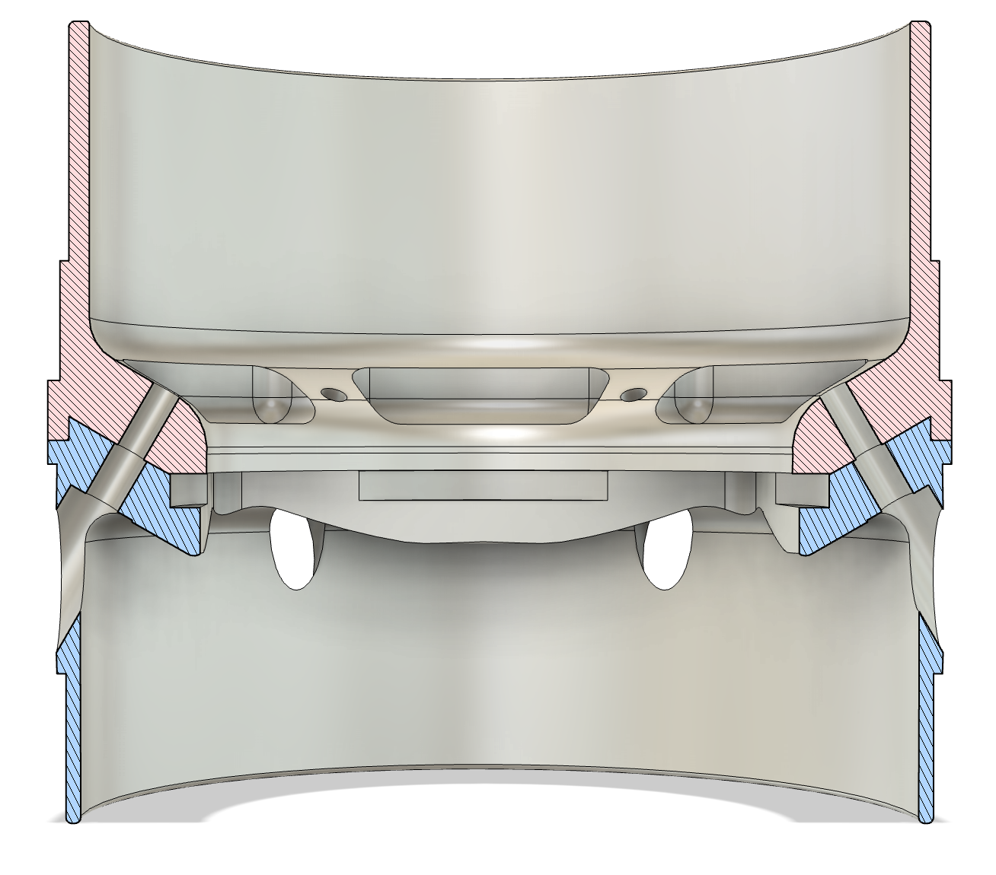
Fig. 9: Female Nosecone BH (left); Nosecone BH assembled (right)

C.6 Body Tubes
The airframe of the Aconcagua rocket consists of three 151 mm outer diameter body tubes. These components are manufactured in-house using a filament winding process, which allows customization of fiber orientation, and therefore tube properties. The Payload tube and Fincan tubes are presented in Fig. 10. Two Fincan tubes joined internally and externally by carbon fibre make up the motor bay structure. Compression testing under ASTM D5449 revealed the tubes resist up to 80 kN (see Appendix B.I), resulting in a SF of 4 regarding 20 kN of compressive flight loads estimated by the team´s load program. Fuselage tubes were also FEM validated (see Appendix K), obtaining matching results between simulation and testing, which provides further certainty of obtained results. GFRP- Aluminum Glued joints testing showed a 15 MPa resistance of the joint (see Appendix B.I). Applying the mentioned value to dimension the glued joints under traction results in a minimum SF of 7 corresponding to the coupling between male Motor Bulkhead and Fincan.
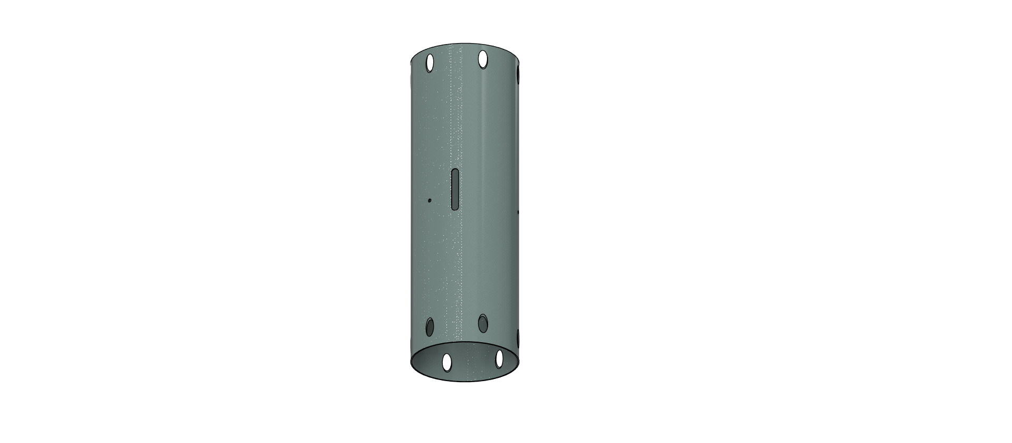
Fig. 10: Payload Tube (left); Fincan tubes (Right)
Because of the motor length, two tubes had to be manufactured due to the size restriction imposed by the curing oven. The layup consists of five layers of GFRP with the layup: [±30° / ±30° / 90°]. It is based on an optimization of Pionero’s eight layer layup [±30° / 2x ±45° / ±30°], validated through the compression test mentioned. The first four layers are wound at the lowest angle achievable by the teams filament winder to provide resistance against compressive axial loads. Besides, the 30 degree layers provide shear resistance, present in moment loads. The final external layer is wound at a 90° (Hoop) orientation to provide significant radial stiffness and produce a 10% improvement in compressive resistance. Determination

C.7 Field joints
The airframe sections are joined using five field joints (couplers) manufactured from GFRP. These components are produced through a hand lay-up process using a 0/90° woven fabric to provide radial and longitudinal stiffness to the rocket joints. All joints are bonded using Loctite E-120HP, a high-performance structural epoxy adhesive selected for its strength, durability, and environmental resistance.

C.8 Motor Bulkhead
The engine bulkhead is secured using a fixed-field joint, which serves as the primary structural interface for transmitting thrust loads from the engine to the rocket structure. This field joint is bonded to the fincan using a high-performance Loctite structural adhesive. For additional visual reference, see Figure 11. Because the thrust and moment loads are transmitted through contact of the bulkheads, the Radax design achieves a more uniform distribution to the male motor Bulkhead, thereby reducing localized stress peaks. This configuration provides a safety factor of 5.3 under the motor thrust load, according to FEM simulations detailed in Appendix K. Due to the development of a new load calculation program, we were able to adjust the safety factor, allowing us to reduce the weight compared to the previous year's design. Through design iterations, the use of three beams was implemented, which allowed us to significantly reduce weight without sacrificing the safety factor. Notably, in 2025 the engine bulkhead weighed 3067 grams, while the current design weighs 1072 grams, a reduction of 1995 grams.
Additionally, the tubular interface section incorporates a precision-machined tapered profile, which ensures concentric alignment of the engine within the fuselage.
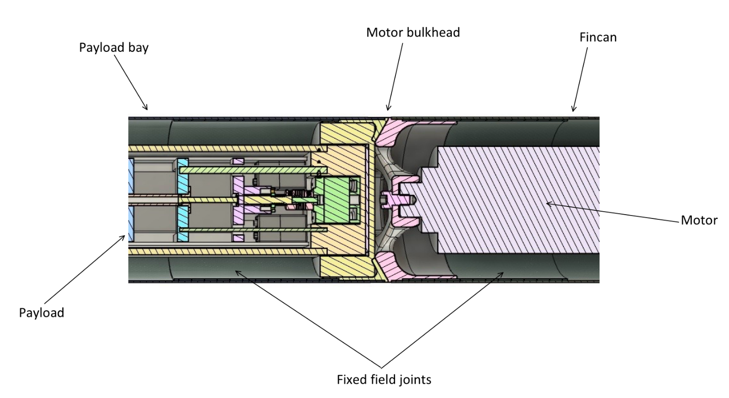
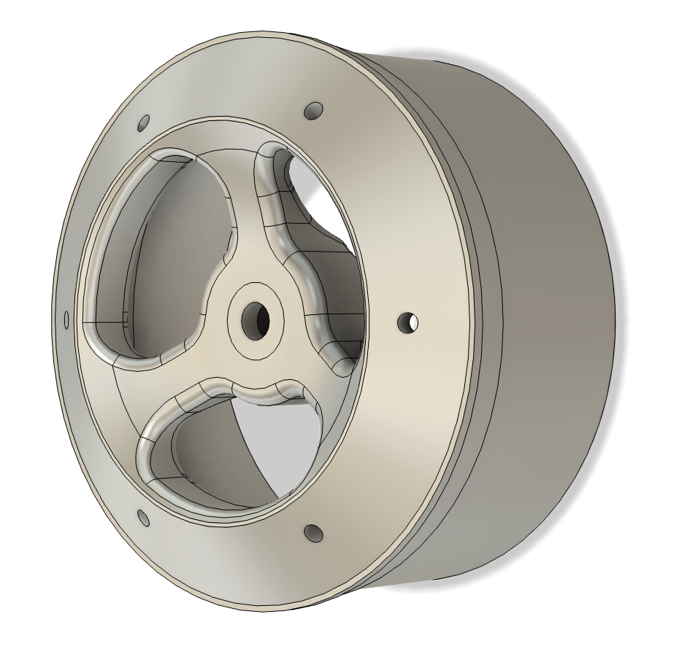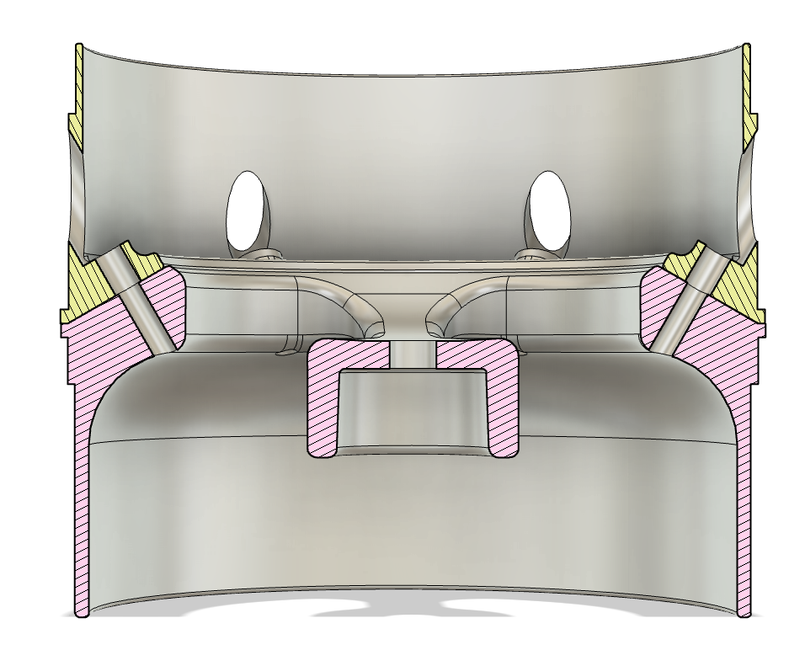

Figure 11: Section view of the joint between Upper Airframe and Motor Bulkhead (Top); Male Motor Bulkhead (Bottom Left); Section view of Motor Bulkheads joined (Bottom Right)

C.9 Center Ring
The center ring was fabricated from 6061-T6 aluminum. Below the motor bulkhead, the glued center ring serves two critical functions. Structurally, it is responsible for bearing the aerodynamic loads generated by the rocket's fins during ascent. Functionally, it ensures precise alignment of the lower section of the motor relative to the airframe during mounting. To achieve this, the contact interfaces between the motor casing and center ring are machined with a conical profile, facilitating self-centering. The conical profile allows compensation for any dimensional tolerances in the motor casing. To minimize weight while maintaining structural integrity, material was selectively removed from non-load-bearing regions, particularly around bolt holes and stress-concentrating surfaces. For a detailed view, refer to Figure 12.
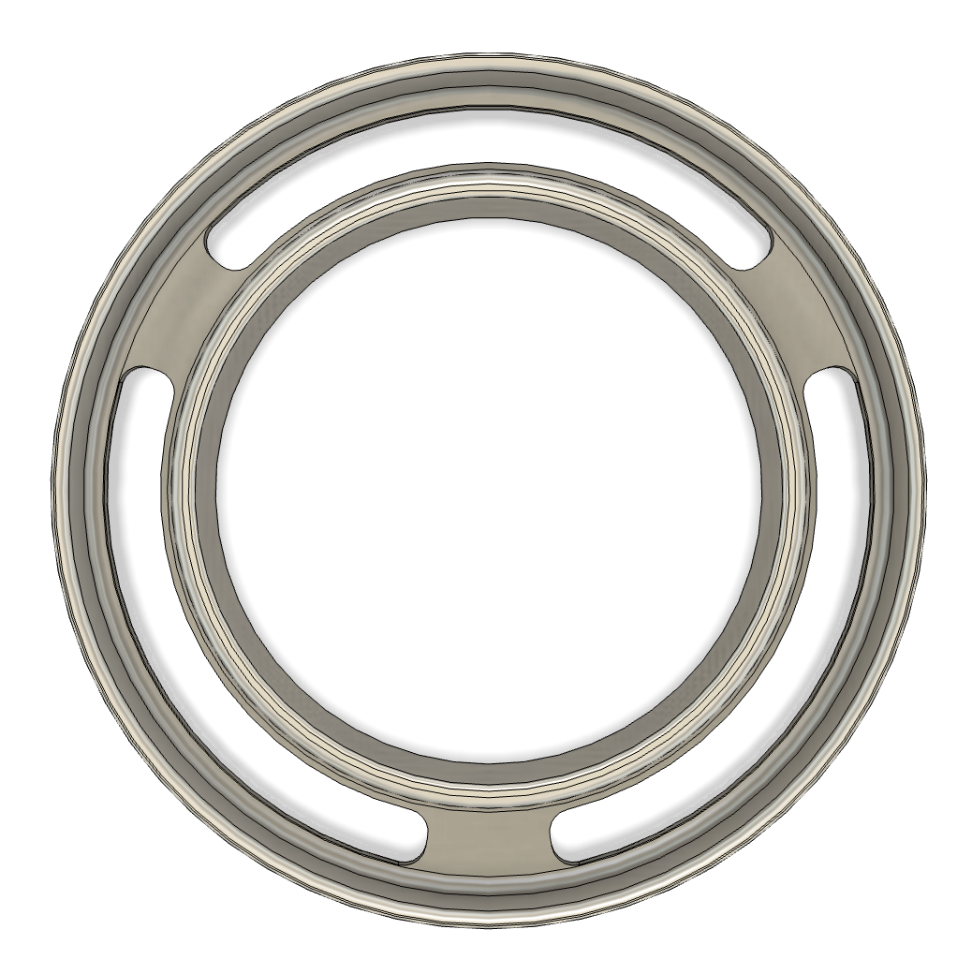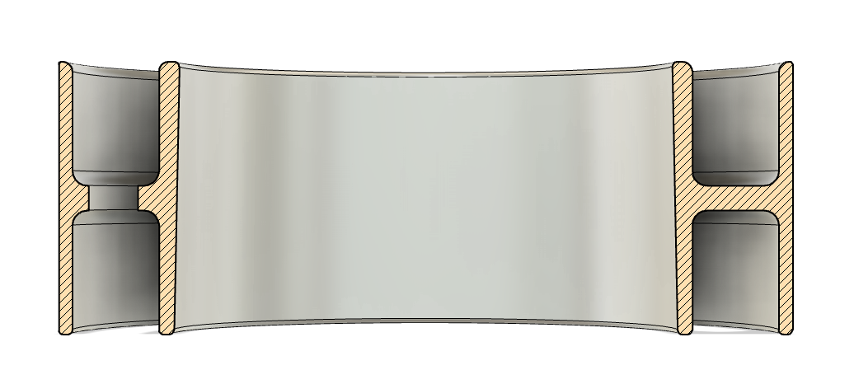
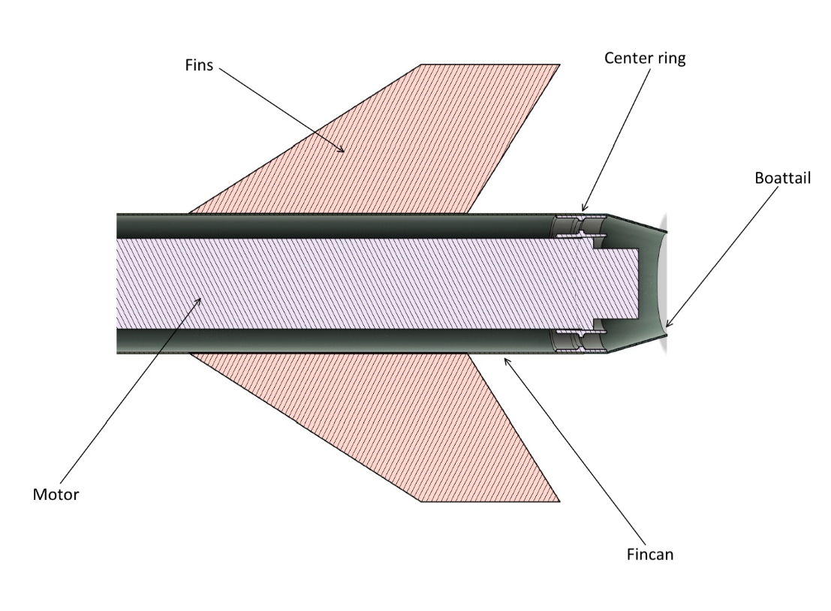
Fig. 12: Section view of the Fincan; Center Ring

C.10 Boattail
The boattail was manufactured with a hand lay-up process, using 0/90° GFRP fabric. However, to ensure coupling with the centering ring, an external mold was employed. It is glued to the Center Ring with EA-120-HP epoxy adhesive.

C.11 Fins
The CFRP fins for the Aconcagua are manufactured in-house using a vacuum bagging lamination process. The stacking sequence is the AR1 with aeroelastic tailoring at β=20°. Material selection was based on weight and obtaining a 1.5 Fin flutter SF. CFRP fins allow to reduce 1 kg of mass compared to aluminum and was chosen due to this fact despite higher cost, lower G and harder manufacturing. This is justified by the mass optimization goal of the project.

D: Flight Dynamics

D1: Low Order Modelling and Design Approach
The aerodynamic design process for Aconcagua was started considering two complementary low-order simulation tools: OpenRocket and RASAero II. Above Mach 0.8, where RASAero II tended to overestimate wave drag onset. Therefore OpenRocket was used as the primary design tool.
The primary design criteria governing the low-order iteration are shown in Table 3. Stability was assessed using the Barrowman method as implemented in OpenRocket. The stability margin was evaluated at liftoff, burnout, and apogee to identify any critical flight phase (see Appendix G.5 for the diagram of stability across flight).
Property | Value | Unit
Static Stability | 2 - 4 | dimensionless
Rail departure velocity | 40 | m/s
Apogee | ~30000 | ft
Table 3: Primary Design Criteria in low-order iteration
The design was guided by the following properties which had the greatest impact on apogee (See Table 4):
Parameter | Variation that produces 1k ft apogee difference | Value that reduces apogee in 500 ft | Value that increases apogee in 500 ft
Mass [kg] | 2 | Δ Mass = -1 | Δ Mass = 1
Rugosity [micrometers] | 16 | 14 | 27
Fin thickness [mm] | 1.5 | 8.3 | 6.7
Rocket diameter [mm] | 4 | 148.5 | 153
Table 4: OpenRocket sensitivity analysis
Gaining insight on the apogee difference of each variable allowed the team to perform improvements from the 2025 IREC project that resulted in a 5500ft apogee increase (18% of the target apogee). Mass was reduced by 7 kg, with an apogee gain of 3500 ft. Rugosity was improved from rough, around 30 micrometers, to one micrometer through improvements in painting and polishing. The apogee increase is from around 2000ft. The rocket diameter was reduced from 158 mm to 151mm, gaining around 2000ft of apogee. Fin thickness had to be increased from 4 mm to 7,5 mm to satisfy a 1.5 Fin Flutter SF, reducing apogee in around 2300ft

D.2 Fin calculations
The fin structural and aerodynamic analysis builds upon the converged low-order geometry. It provides the quantitative evidence required to justify the chosen layup, validate the flight envelope, and establish the baseline drag polar used in the trajectory simulation.
Three complementary analyses are presented in the subsections that follow: a laminate-level estimation of the CFRP in-plane elastic properties using Classical Lamination Theory (D.2.1) and a closed-form prediction of the flutter and divergence velocities of the fin (D.2.2). The outputs of these analyses define the stiffness inputs (D.2.1), structural margins, and drag references against which the higher-fidelity CFD results will be compared in Progress Report 3.

D.2.1 CFRP theoretical in-plane properties estimation

The aerodynamic fin panels of Aconcagua are manufactured from a T700 12K carbon-fibre / epoxy (LY1564) hybrid laminate designed to balance high bending stiffness, torsional stability, and aeroelastic tailorability. The material and laminate properties were derived analytically using Classical Lamination Theory (CLT) in combination with Halpin–Tsai micromechanical models and implemented in a Python script. The resulting stiffness characterisation feeds directly into the aeroelastic flutter solver described in Section D.2.2. The properties are derived and calculated in Appendix G. The percentage of volume fibre and porosity needed for the calculations were obtained from micrographic analysis of carbon fibre coupons fabricated in-house (see Appendix B.I.3). A summary of the results is presented next.
The stacking sequence chosen was the AR1 All-rounder, modified through aeroelastic tailoring to improve thetorsional stiffness and in-plane G value:
[+65/−25 / 20₂ / +65/−25 / 20 / +65/−25 / 20₂]ₛ
The properties obtained for the in-plane shear and torsional stiffness are summarized in Table 5. The shear modulus used in the flutter analysis Gxy = 15.03 GPa is derived from CLT applied to the laminate ABD matrix, with constituent properties from manufacturer datasheets — see Appendix G

Property | β = 0° (standard) | β = 20° (tailored) | Unit
In-plane shear modulus, G_xy | 13.25 | 15.03 | GPa
Torsional stiffness (flutter driver), D_66 | 292.40 | 289.93 | N·m
Table 5: Laminate-level in-plane and bending stiffness properties computed by CLT (h = 6.0 mm, AR1 layup, Vₜ = 0.50). In-plane constants derived from A⁻¹ inversion; D-matrix from thickness-cubed integration. β = 20° column is used as input to the flutter solver in Section D.2.2.
Further properties are tabulated in Section Appendix G.

D.2.2 Fin Flutter Velocity and Divergence Velocity

The aeroelastic stability of the Aconcagua fin was assessed through a dedicated p-k flutter solver that couples Classical Lamination Theory (CLT) shell mechanics with second-order supersonic piston theory aerodynamics. Unlike a quasi-steady approximation, the p-k method tracks complex eigenvalues p² = eig(q·Q(k) − Ω²_c) iterating the reduced frequency k = Im(p)·b_ref/U to convergence at each dynamic pressure step, and separately evaluates quasi-static divergence from the k = 0 aerodynamic stiffness matrix. The analysis uses the CLT bending stiffness matrix characterised for the tailored β = 20° CFRP layup in Section D.2.1 and covers all supersonic flight conditions extracted from the OpenRocket trajectory simulation. The physical model and full derivation are presented in Appendix G.2.

Results

The solver was executed across all 246 supersonic flight points spanning Mach 1.05–1.85 and altitudes of 256–5 236 m. Descent is not considered, since parachute deployment limits velocity to below 30 m/s. All 246 flight points are aeroelastically stable with respect to both dynamic flutter and quasi-static divergence.

Dynamic flutter — identified by the real part of a p-k eigenvalue crossing zero from below — is not detected at any flight point: V₟ₗᵤₜₜₑr = ∞ across the entire supersonic envelope. This is a direct consequence of two synergistic wash-out mechanisms. The 57.4° leading-edge sweep produces geometric wash-out: for a swept-back surface deflecting upward, the chordwise slope ∂w/∂x is predominantly negative for the first bending mode, generating a restoring pressure that opposes further deformation. The β = 20° tailored CFRP layup introduces material wash-out through the bending–torsion coupling term D₁₆ = 13.05 N·m (Section D.2.1): upward bending induces nose-down tip twist, reducing the local angle of attack and the aerodynamic excitation driving the instability. The aerodynamic damping matrix Q₁ is negligible in the modal basis (‖Q₁‖_F / ‖Q₀‖_F < 10⁻³), confirming that mode-coalescence flutter is physically suppressed for this planform and layup.

Quasi-static divergence — governed by the positive eigenvalues of the frequency-normalised aerodynamic stiffness matrix B̂ = diag(1/ω)·Q₀·diag(1/ω) — sets the governing stability limit. Table 6 summarises the divergence speed (V_div), flight speed (V_flight), and velocity margin (V_div / V_flight) at representative Mach numbers spanning the supersonic envelope.
Mach | Altitude [m] | V_flight [m/s] | V_div [m/s] | V_div / V_flight
1.63 | 710 | 550.0 | 1 457 | 2.65
1.73 | 837 | 582.8 | 1 466 | 2.52
1.82 | 1 060 | 613.1 | 1 483 | 2.42
1.85 ¹ | 1 179 | 619.9 | 1 491 | 2.41
Table 6: Divergence speed V_div, flight speed V_flight, and velocity margin at representative Mach numbers along the powered-ascent trajectory (worst-case q per Mach band). Altitudes increase monotonically with Mach, consistent with the ascending flight path. ¹ Worst-case flight point (maximum dynamic pressure along the full trajectory). Dynamic flutter is not detected at any point (V_flutter = ∞).

The divergence speed V_div increases slightly from 1 426 m/s at Mach 1.05 to 1 491 m/s at the worst-case condition (Mach 1.85, 1 179 m). This modest increase with Mach reflects the decreasing air density with altitude along the powered-ascent trajectory, which raises the velocity corresponding to a given critical dynamic pressure. Simultaneously, the flight speed rises from 355 m/s to 620 m/s, so the velocity margin narrows monotonically from 4.0× to 2.41×. Fig. 13 shows the aeroelastic velocity envelope across the supersonic flight corridor; Fig. 14 shows the p-k damping history at the critical flight condition confirming that all structural modes remain stable throughout.

[ FIGURE PLACEHOLDER — Fig. 13 — Aeroelastic velocity envelope: V_div (blue dashed) and V_flight (black solid) vs Mach number. Paste: results/velocity_envelope.png ]

Fig. 13: Aeroelastic velocity envelope — divergence speed V_div (blue dashed) and flight speed V_flight (black solid) vs Mach number. Green shading marks the safe operating corridor. Dynamic flutter is not detected (V_flutter = ∞). Worst-case margin of 2.41× at Mach 1.85.

[ FIGURE PLACEHOLDER — Fig. 14 — p-k damping history at critical condition (Mach 1.85). Paste: results/pk_damping.png ]

Fig. 14: p-k damping history at the critical flight condition (Mach 1.85, h = 1 179 m, g_struct = 0.01). Growth rate γ = Re(p) [rad/s] vs dynamic pressure q [kPa] for all six structural modes. All modes remain stable (γ < 0) throughout the q-sweep. The vertical dotted line marks the flight dynamic pressure.

The complete stability envelope and physical interpretation are presented in Appendix G.3.

E: Avionics, Mission Control and Ground Support Equipment

E.1 Overview:
Avionics and mission control are responsible for overseeing and coordinating all onboard rocket systems: activation of deploy, telemetry and GPS signal. These functions are divided in two bays: the nosecone bay and the recovery bay. In total the rocket counts three COTS Altimeters and two COTS GPS. An SRAD flight computer is implemented both as an altimeter and GPS to feed data to a GUI for live telemetry data. Also, a fully automatic ground station was designed to follow the rocket in-flight, capturing the GPS signal, eliminating human error.
A mind map of the function of Avionics in Aconcagua is presented in Fig. 15.

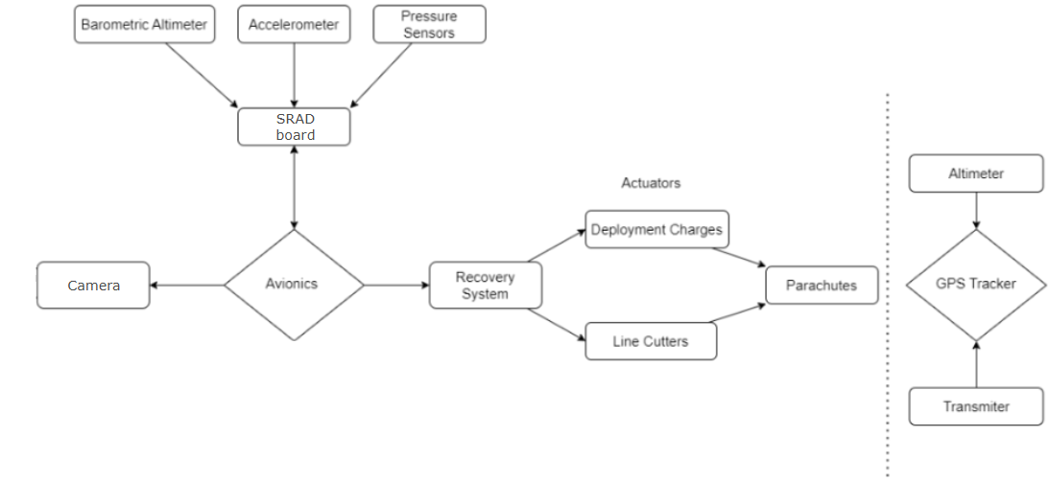
Fig. 15: Mind Map of avionics functions in Aconcagua

E.2 On board hardware and mechanical design
For this year's iteration, the avionics system was redesigned to streamline integration across all vehicle sections. Based on the selected COTS hardware, the architecture was divided into two distinct bays: one located within the nosecone and another integrated into a shared payload bay. The Recovery setup required a Bay in the Payload compartment to activate the Raptors, but placing all of the avionics in that bay would imply an increase in rocket length, while leaving dead space in the nosecone. Therefore, the necessary avionics to trigger the recovery sequence was placed in a bay as compact as possible to keep the tubes shorter, minimizing drag and weight. The rest of the avionics was placed in a secondary bay in the nosecone, focusing on efficient space usage.
The distribution of electronic devices across bays is shown in Table 6:
Nosecone Bay | Recovery Bay
- SRAD flight computer  - TeleMega (Altimeter and GPS)  - Onboard Camera | - 2x RRC3 Altimeters  - Featherweight GPS  - 2x Raptor CO2 devices
Table 6: Components on each avionics bay (Nosecone and Recovery)
The assembled bay can be seen in Fig. 16
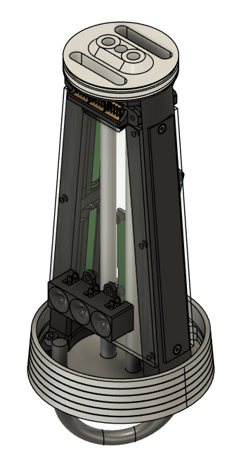
1
2
3
4
5
6
7
8
Fig. 16: Nosecone bay assembled without electronics (left); Section view (right)
Fig. 16 shows the rods, that act as the only structural elements of the bay, not transmitting flight loads to the 3D printed structure. 6061 T6 Aluminum was used for the load-bearing components because of its machinability in comparison to composites and strength relative to 3D printing filament. PETG was used in non structural elements because of the adjustable weight given by the infill and simplicity to manufacture complex geometries such as the 3D structure of the bay. Also, PETG has, unlike PLA, a transition temperature high enough to stay solid in spite of the heating of the nosecone. Delrin was used for the upper plate because of its RF transparency to avoid interference with the TeleMega Antenna in the upper plate, while still being able to withstand the load of the nosetip.
The structural sizing of the structure was driven by the peak launch acceleration and the shock cord deployment loads. As a redundancy measure, the assembly is mechanically supported by a threaded rod connected to the nose tip, ensuring retention even under worst-case load scenarios.
The recovery bay CAD and BOM are shown in Fig. 17:
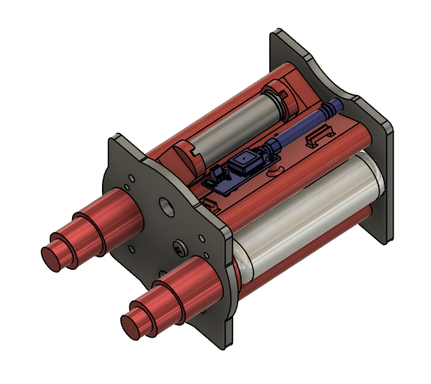
1
3
4
7
6
Fig. 17: Recovery Bay CAD

The selection process for the COTS components and estimated battery duration is summarized in the following table (see Table 7.)

Component | Function | Selection motive | Powered by | Estimated battery duration (hours)
RRC3 | Altimeter, Recovery event Trigger | Previous experience | 9V Battery | 17
Featherweight | GPS | Previous experience | 18650 Battery | 7
TeleMega | Altimeter & GPS | Live Telemetry and completeness | 18650 Battery | 7
SRAD flight computer | Altimeter & GPS; Telemetry | - | 18650 Battery | 7
Table 7: Selection process of avionics components

The connections of the rocket’s electronics are shown in the Fig. 18:
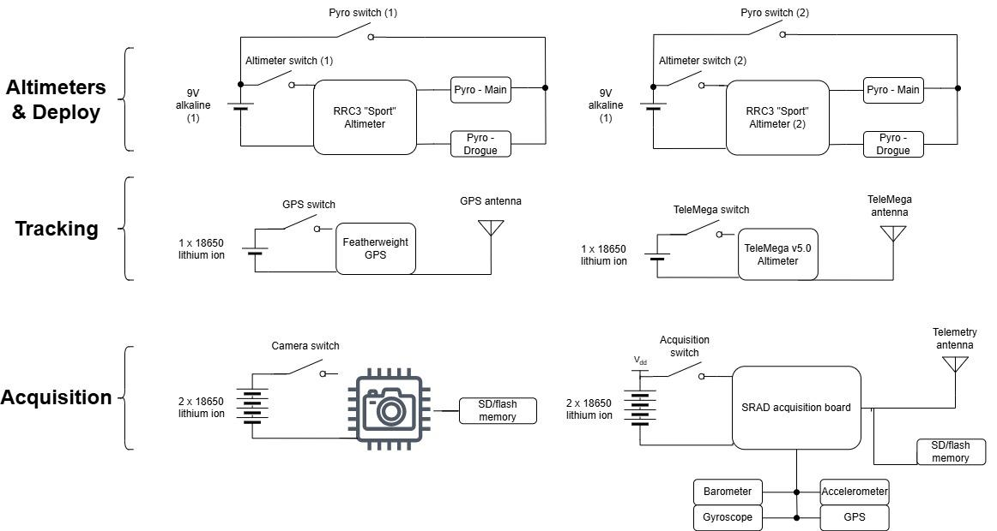
Figure 18: Electronic Connections of Aconcagua

E.3 SRAD flight computer & acquisition board:
The flight computer design is focused on the ability to collect, store, and enable the transmission of environmental data, such as pressure, temperature, and rocket altitude. For construction and design memory of the SRAD flight computer see Appendix H.

E.4 Ground station:
The ground station is designed to receive and process telemetry data and GPS tracking information from an airborne platform. It is composed of three primary subsystems: SRAD board telemetry, Telemega telemetry and GPS Tracking. Each subsystem plays a distinct role in ensuring reliable communication and tracking during flight operations.

The Telemega subsystem is a redundant version of the COTS GPS one but it uses a Yagi antenna, capable of keeping the communication up to a 20 km distance with the rocket.

The ground station integrates all subsystems through a central computer that acts as the primary interface for telemetry data. The computer receives the data from the SRAD board and this information can be visualized, stored, or used in real-time flight monitoring. Meanwhile, two smartphones handle Telemega and GPS tracking independently via Bluetooth, ensuring redundancy in tracking capabilities.

E.6 Antenna Tracking System:
A ground-based antenna tracking system was developed to maintain a high-gain directional link between the ground station and the rocket during flight. Given the narrow beamwidth of the Yagi antenna, accurate and continuous alignment is critical to avoid significant signal attenuation.
The system was designed under three main constraints:
- Low computational complexity (embedded implementation on a microcontroller)
- Low latency (real-time tracking requirement)
- Robustness to limited and potentially noisy telemetry data
To satisfy these requirements, the tracking system was designed using a feedforward geometric approach. Instead of correcting the antenna orientation based on measured signal strength or actuator feedback, the pointing direction is computed directly from the relative position between the rocket and the ground station.
This design choice eliminates the need for a control loop, reducing system complexity and computational requirements. As a result, the system achieves low latency and deterministic behavior, which are critical for real-time tracking applications. The specific antenna tracking method used is detailed in section Appendix H

F: Recovery

F.1 Overview of the recovery systems:
The recovery system is responsible for bringing the rocket safely back to the ground. The recovery bay is integrated within the nosecone, directly above the recovery bulkhead. Both drogue and main parachutes are stowed in this compartment, with the latter packed in a dedicated deployment bag. The nosecone and recovery bulkhead are connected via a 1-caliber composite coupler inserted into the nosecone and secured in flight by four 4-40 × 5/16” nylon shear pins installed in the recovery bulkhead.

The drogue is connected through a 10 ft, 5300 lb–rated Kevlar line incorporating a three-ring release mechanism and protected by a bag. This configuration provides high mechanical advantage (200:1) while ensuring drogue-phase loads are carried exclusively by the drogue line, isolating the main parachute from initial loads. The line diagram at this phase can be observed in Figure 19.

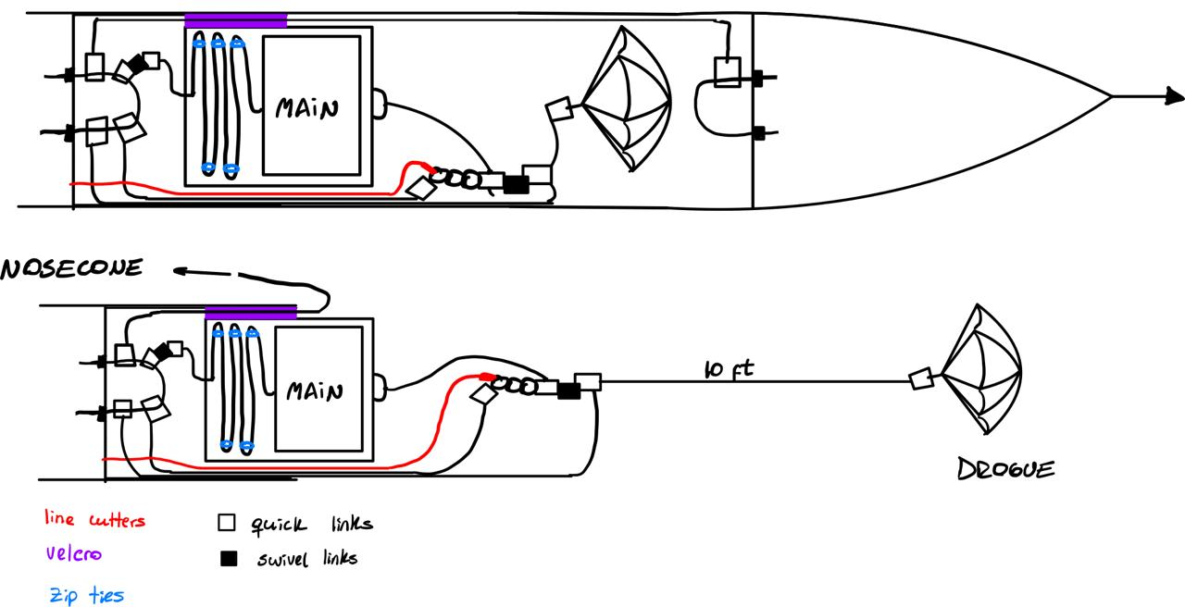
Fig. 19. Line diagram at drogue parachute descent

F.2 Decoupling system:
At apogee, the recovery sequence initiates when 33 g and a redundant 45 g CO₂ cartridges pressurize the compartment (see Appendix I for the CO2 mass estimation) and therefore break the shear the pins, separating the nosecone from the airframe. The vehicle then divides into two primary sections: the forward section, containing avionics and recovery hardware, and the aft section, housing payload and propulsion systems. The drogue parachute is immediately expelled and inflated by the internal pressure of the compartment, reducing descent rate to approximately 29 m/s at the moment of main parachute deployment. The system is designed assuming up to 100 m/s horizontal velocity at drogue deployment to ensure safe operation under worst-case lateral conditions. Main suspension lines are temporarily restrained using rubber bands to prevent premature line deployment and minimize entanglement risk during descent, as well as the usage of two swivel links for the same purpose. The Raptor devices are joined to the payload plate which is linked directly to the recovery bulkhead as shown in Figure 17.

At 1200 ft AGL, two independent COTS flight computers (both RRCC3) redundantly activate Piranha line cutters, releasing the three-ring system and extending the drogue line by 25 ft. This extension extracts the main deployment bag via a 5 ft linking cord, initiating main inflation and load transfer. Progressive-failure shear zip ties are integrated into the main line to dissipate opening shock. Final descent occurs at approximately 7 m/s until landing.

F.3 Parachutes:
The drogue parachute is a 1.65 ft elliptical CD 2.2 canopy manufactured in Argentina by Aerorriging, a company that supplies parachutes for both civilian and military applications. Its design is similar to the parachutes used in the IREC 2023 rocket, which were purchased from Rocketman. The drogue is deployed at apogee and is expected to provide a descent rate of 29 m/s. It is connected to the rocket through a 10 ft 5300 lb rated Kevlar shock-chord, as well as two 25 kN rated quick links and a 23 kN Petzl swivel link to prevent its entanglement. At last, a three-ring device connects the whole linkage to the rocket’s ½ U-Bolt, and will later provide the proper separation towards the main parachute descent stage.

The main parachute is an 8-foot elliptical CD 2.2 canopy , also manufactured by Aerorigging and is the same design utilized in the IREC 2025 rocket. It is protected by a POD (Parachute Opening Device) to secure its safe release. The resulting descent rate of the main parachute is expected to be of approximately 7 m/s The linkage consists of a 10 ft 5300 lb rated Kevlar shock-chord, connected to two 25 kN rated quick links and a 23 kN Petzl swivel link to prevent its entanglement as well. The linkage to the rocket’s body is obtained through a ½ U-Bolt.

Shock Loads calculation
Both descent rates come from empirical calculations and diverse softwares, such as Fruity Chutes’ own simulator. The opening forces for both the drogue and main parachute deployments were obtained through a Python based deployment simulation program developed in house (see Appendix I). In both cases, worst case scenarios are deliberately adopted as inputs: for the drogue, this translates to a high lateral velocity at apogee, while for the main, a total velocity at deployment higher than nominally expected was assumed. The simulation models the shock cord as an elastic element responsible for dissipating the difference in kinetic energy present in the rocket's components immediately prior and after each deployment event. The program allowed us to establish the minimum specifications required to achieve an acceptable safety factor. The obtained values are summarized and compared to the maximum allowable forces in Table 8.

Component | Real force (kN) | Permitted force (kN) | Safety factor
Drogue 10 ft shock-chord | 5.8 | 23.5 | 4.03
Main 10 ft shock-chord | 15.6 | 23.5 | 1.51
Drogue swivel link | 5.8 | 23 | 3.95
Main swivel link | 15.6 | 23 | 1.48
Drogue quick links | 5.8 | 25 | 4.29
Main quick links | 15.6 | 25 | 1.60
Table 8: Safety Factor of Recovery components

G: Payload

G.1 Overview
The payload consists of a 3U, 2 kg scientific experiment designed to investigate the performance of a custom designed syringe infusion pump under the dynamic conditions of a rocket launch. Infusion pumps are widely used medical devices employed in both clinical treatments and biological experimentation where precise and controlled fluid delivery is needed. Prior studies have examined the effects of vibration [1] and pressure changes [2] on infusion pump performance independently, however the combined high-g acceleration environment of a rocket launch at µL/min flow rates remains uncharacterized experimentally. These effects are evaluated using a microfluidic flow sensor that continuously monitors the flow rate throughout the mission. Particular attention is given to the occurrence of sudden increases in flow rate (boluses) and the generation of air pockets within the fluid line, as both phenomena negatively impact flow stability and represent critical failure modes in infusion-based systems.

The mission aims to provide insight into design strategies for precise fluid delivery systems in high acceleration and vibration environments; enabling future payload teams to carry out more ambitious experiments reliably in areas such as cell culture or microfluidics. The infusion pump is presented in Fig 20:
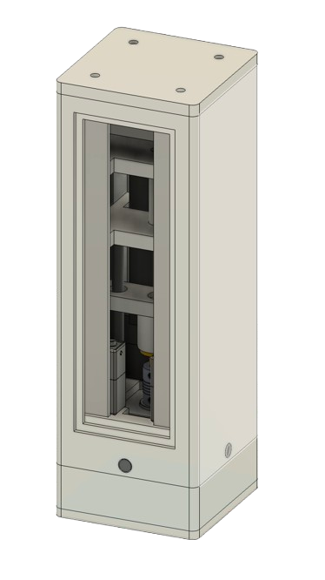
Fig 20. Payload CAD Design and Assembled Design

G.2 Experiment overview
The experiment is designed to evaluate the performance of the infusion system by continuously monitoring the flow rate between launch and apogee. Distilled water is driven from a syringe by a linear actuator and directed through two sensors before being collected in a sealed reservoir. This configuration enables real-time measurement of flow behavior throughout the mission, allowing deviations from the expected flow profile to be identified and analyzed.

G.3 Mechanical design
Building on the experience from the 2025 IREC, the Payload team designed a new chassis to support a similar experimental setup. The main goal of this payload is to provide a repeatable and improvable model of an infusion pump which goes under the stipulated flight conditions.
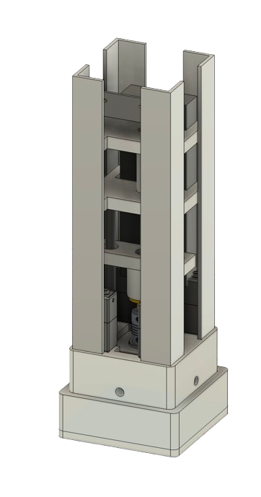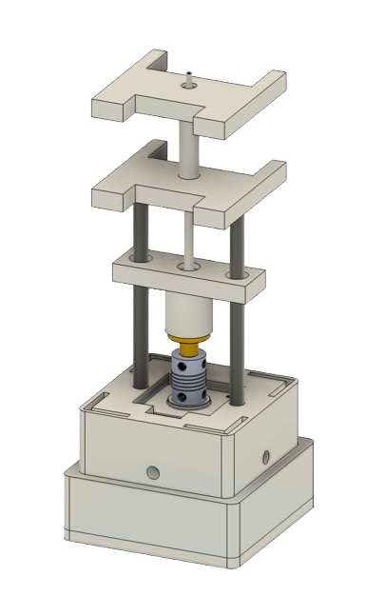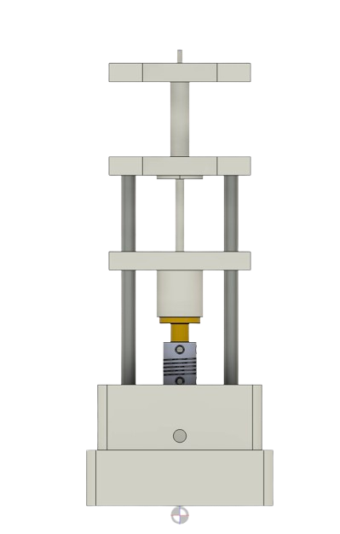
Transverse plates
L-brackets

Linear actuation system
Linear guides
NEMA 17 motor
Rigid shaft coupling
Lead screw
Linear carriage
Plunger
Syringe
Fig. 21: Internal structure of the Payload

The internal structure (see Fig. 21) is composed of four vertical structural members (25 mm x 25 mm x 1.2 mm) connected by a series of transverse plates, forming a rigid frame. These components are assembled using M5 bolts at each interface. The structure transmits axial forces from the upper sections of the payload to the base. The spacing and distribution of the transverse plates are determined based on the required syringe length to achieve the 1.6 ml working volume, ensuring adequate constraint points for internal components. This configuration was designed to work in compression.

As visible in Fig. 21 , a central linear actuation system is integrated along the main axis of the payload. This system consists of a stepper motor located at the base, to a lead screw that drives a linear carriage in the vertical direction. The guidance of the moving component is achieved through the linear guides structure.
3D printing was chosen for the structure because of manufacturing simplicity, low costs and low structural requirements. Components subjected to higher mechanical loads, such as the L-brackets, are from aluminum to provide structural rigidity while minimizing weight. Additionally, two types of polystyrene (PS) are used to dampen the vibrations from the flight: for the superior interface, expanded PS, and for the inferior one, rigid PS.

G.4 Electronics and software
The electronics architecture is centered around an ESP 32s, which serves as the main control unit for the payload. It is responsible for coordinating sensor acquisition, motor control, and data logging throughout the mission.

An external Allen switch is used to arm the Payload electronics. Launch detection is performed using an accelerometer (ADXL345), which continuously monitors acceleration. Upon detecting 15g or greater for over 0.5 seconds, the microcontroller transitions the system from a dormant state to active operation, initiating the experiment. The actuation system is driven by a DRV8825, which controls the NEMA 17 stepper motor. Both the SLF3S-0600F and the ADXL345 interface with the ESP32 using the I²C communication protocol. Experimental data, including flow sensor measurements, air-in-line detector signals, and accelerations, are recorded using a MicroSD Module connected via SPI. The block-diagram of the electronics is presented in Fig. 22. For information about the flow system, power system and IR Air Bubble Measurement see Appendix J

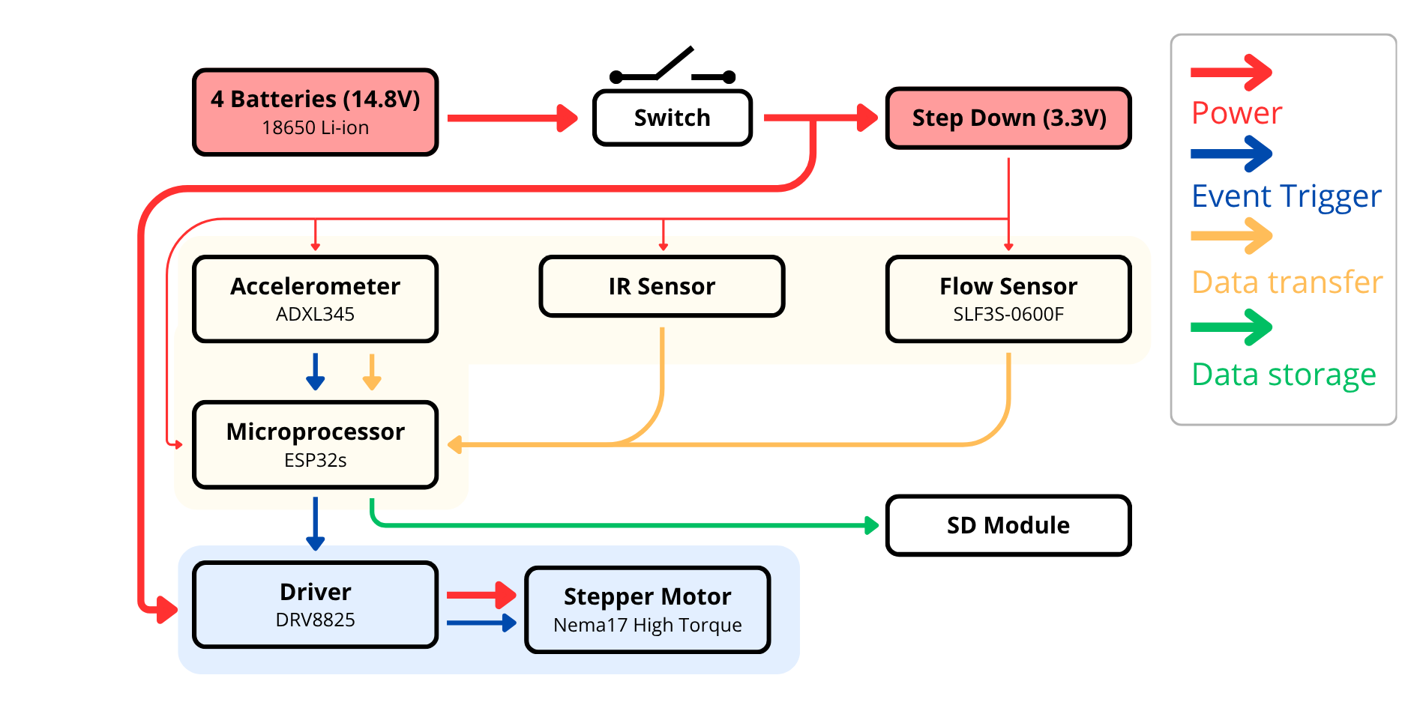
Fig. 22: Payload Electronics Block-Diagram

Mission Concept of Operations Overview

Fig. 23 shows the mission concept of operations of the Aconcagua.

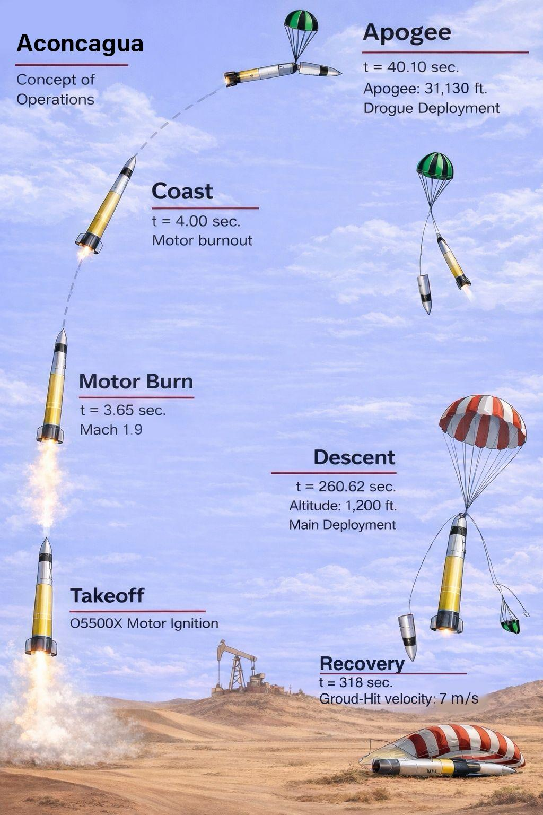
Fig. 23: Mission CONOPS

The Mission concept of operations Actions and Phases are listed in Table 9:

Phase Number | Phase Designation | Actions during Phase
1 | Preflight | All systems are verified to be in the OFF state, including switches for ejection charges and other critical avionics. The ejection charges are assembled. All batteries are checked for full charge and the electronics sled is assembled. The whole rocket structure is assembled and all screws are checked for correct tightness. Finally, the motor is integrated into the rocket.
2 | Launch Rail Integration | The rocket is slid onto the launch rail. The electronics are turned on and the rail is raised and locked.
3 | System Checks | All electronic systems are checked for correct functionality. All non essential personnel are cleared from the area, the ejection arming pull-pin is removed and the ignition charge is installed inside the motor.
4 | Ignition (t+0.0 s) | Once authorisation has been given to launch, the ignition sequence begins. The ignitor is  activated and the motor commences burning.
5 | Liftoff (t+0.06 s) | The rocket starts ascending, guided by the launch rail. The motor smoke gives confirmation. The TeleMega, Featherweight and SRAD send its location to the ground station to initiate automatic antenna tracking. The payload is triggered by the accelerometer and starts the experiment.
6 | Launch Rail Departure (t+0.34 s) | The rocket departs the launch rail, with a velocity of 46 m/s and a static stability margin of 2 calibers
7 | Boost (t+0.34 s - t+4.0s) | The motor burns for 4.0s. The rocket reaches a velocity of 619.9 m/s and the  motor stops burning at an altitude of 653 m
8 | Coast (t+3.56 s - t+40.1 s) | The rocket coasts for 36.5 s.
9 | Apogee and Drogue Parachute Deployment (t+40.1 s) | Once one of the flight computers detects apogee it ignites one of the CO2 charges and deploys the drogue parachute.
10 | Drogue Descent (t+40.1s - t+260.62 s) | The rocket descends with a velocity of 29 m/s.
11 | Main Parachute Deployment (t+260.62) | When one of the flight computers detects an altitude of 1200 ft it triggers the Piranha line cutter and deploys the main parachute.
12 | Main Descent (t+260.62 - t+318 s) | The rocket descents with a velocity of 7 m/s.
13 | Touchdown (t+318 s) | The rocket hits the ground with a safe speed. The first part to hit the ground is the Nosecone, followed by the Boattail and then the payload tube. The Altimeters start emitting sound signals to be found by the recovery team.
14 | Recovery | A recovery team is sent to locate the rocket using the received GPS data. Once found the electronics are turned off and the rocket is taken back to the judges for post flight evaluation.
Table 9: Phases and actions of the Concept of Operations

Conclusions and Lessons Learned

Pionero (2025 IREC Submission) flight Outcome vs Goals:
The state of every recovery element should be carefully checked before launch. The recovery system was the failure cause of Pionero. Pictures and videos of the recovery assembly showed a damaged shock cord that was overseen by the team. For that reason this year a verification step of recovery material was added to the assembly sequence. Another lesson learned is that low rail-departure velocities and high wind speeds can lead to high deviations from nominal expected flight path. Pionero’s rail-departure velocity was about 20 m/s with a 5 m/s average wind speed and high velocity wind gusts which results in subpar stability. The angle deviation of approximately 25° with respect to the vertical, as checked with OpenRocket, is believed to have produced a telemetry measured 2000 ft (18%) decrease in apogee. An improvement that could avoid this situation in the future is a go - no go protocol for launching at given windspeeds. The team is expected to evaluate the maximum permissible wind speed for a successful mission, and based on that information decide to proceed with the launch. Furthermore, with Pionero the team lost GPS signal because of a frequency collision with another team. That caused uncertainty about the location of the rocket which complicated the recovery. Obtaining a confirmed GPS lock is now considered a top priority for the team. This routine is also added to the checklist as a go no go event.

Aconcagua (2026 IREC Submission) design and manufacturing phase lessons:
Changing the category to 30k COTS brought a new set of challenges. Mass optimization is crucial to reach 30000 ft. Associated with this goal comes the problem of mass optimization which drives Safety Factors to decrease, that intern calls for a specific knowledge of the loads present in conjunction with simulation and testing. Not knowing the load state during flight means no optimization can be done. Composites simulation present an added difficulty at checking result validity because of their anisotropic nature. From the limitations learned a long- term project will be proposed to improve composite simulation and mechanical testing capabilities.
With supersonic speeds fin flutter becomes a problem, since regular calculations such as Martin’s formula predict flutter for 10k ft fins. Lowering their semispan from one caliber could impact negatively on rocket stability since fins often lie within the shock wave cone of the nosecone. Furthermore apogee is sensitive to fin semispan, therefore a trade took place between fin thickness and mass reduction to maintain the desired apogee.

Team management & Knowledge transfer strategies:
During this iteration the leadership team noticed that new members lacked training in manufacturing skills and the machinery available at ITBA's workshop. For recruitment, the best practice was to onboard new members as interns on small projects, giving more responsibilities to the strongest interns until they become full team members. An improvement opportunity for the next iteration is to have former team and subteam leaders guide their successors through their first months, providing a general project perspective from an experienced member. Video tutorials of every process are being produced to teach future generations. Team and subteam leaders are announced two months before the next iteration begins, allowing them to develop new technologies, process improvements and to observe their predecessors' work during the learning phase.

Acknowledgments

Appendix A: System weights, measures, and performance data

a. Basic Rocket Vehicle Information
Parameter | Value
1. Number of stages | 1 (single-stage)
2. Length | 2.95 m (9.68 ft)
3. Airframe diameter | 151 mm (5.94 in) outer diameter
4. Number of fins | 4
5. Fin semi-span | 160 mm (1.06 caliber)
6. Fin tip chord | 150 mm
7. Fin root chord | 300 mm
8. Fin thickness | 7.5 mm
9. Weight on launch rail | 34.2 kg (73.0 lb)
10. Propellant weight | 9.8 kg (21.56 lb)
11. Empty motor case / structure weight | 7.0 kg (15.44 lb)
12. Payload weight | 2.0 kg (4.41 lb)
13. Liftoff weight | 34.2 kg (73.0 lb)
14. Center of pressure | 1798 mm
15. Center of gravity (at liftoff) | 2254 mm
16. Launch rail length | 5.18 m (17 ft) — IREC-provided rail for the solids category, per IREC Range Standard Operating Procedures
Table A1: Basic rocket vehicle information.

b. Propulsion Information
Parameter | Value
1. Motor type | Solid (APCP AeroTech Propellant X™)
2. COTS or SRAD | COTS
3. COTS manufacturer and designation | AeroTech / RCS Rocket Motor Components — O5500X-PS (98 mm DMS)
4. Motor letter classification | O
5. Average thrust | 5,514.6 N (1,239.7 lbf)
6. Total impulse | 21,384 N·s (4,808 lbf·s)
7. Motor burn time | 4.03 s
Table A2: Propulsion information.

c. Predicted Flight Data
Parameter | Value
1. Liftoff thrust-to-weight ratio | 22.64
2. Rail departure velocity | 45 m/s (148 ft/s)
3. Minimum static margin | 3
4. Maximum acceleration | 25.1 g (246 m/s²)
5. Maximum velocity | 628 m/s (Mach 1.85)
6. Fin flutter velocity | 1,491 m/s (worst-case condition at Mach 1.85, 1,179 m altitude — see Section D). Velocity margin V_fl/V_flight = 2.41×
7. Target apogee | 30,000 ft AGL (competition class)
8. Predicted apogee | 30,679 ft AGL
Table A3: Predicted flight data.

d. Flight Profile Graph
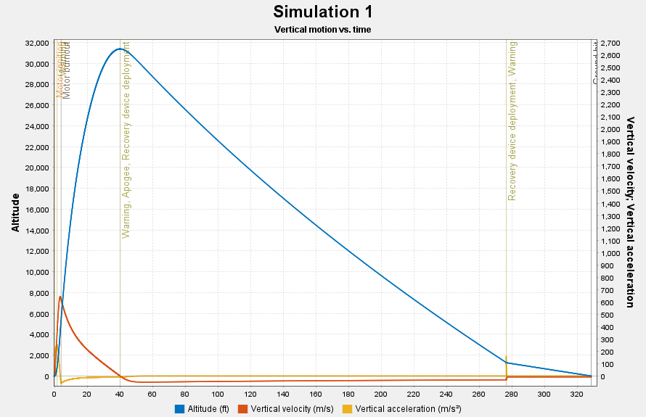
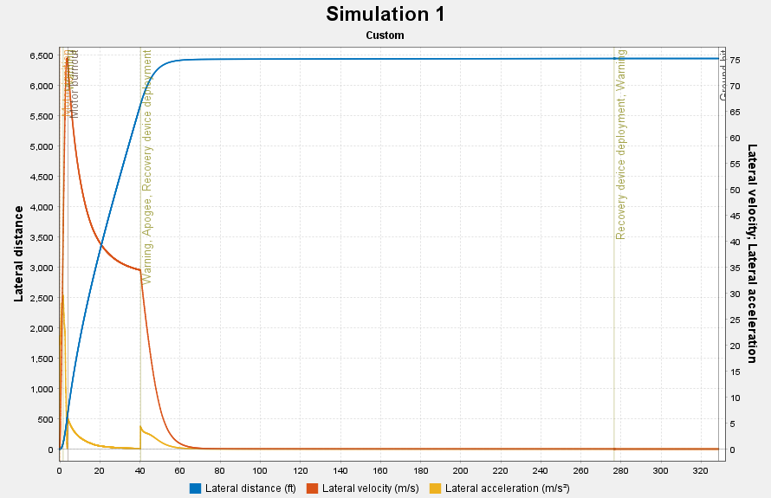

e. Recovery Information
1. Altimeters used
Altimeter | Type
PerfectFlite RRC3 #1 — primary recovery | i. COTS
PerfectFlite RRC3 #2 — redundant recovery | ii. Redundant (also COTS)
Altus Metrum TeleMega — telemetry / GPS / altitude backup | COTS (not recovery-event triggering)
SRAD flight computer — telemetry / data acquisition | SRAD (not recovery-event triggering)
Table A4: Altimeters used.
2. Drogue parachute information
Parameter | Value
Manufacturer / model | Aerorigging (Argentina)
Canopy type and diameter | "1.65-foot elliptical Cd 2.2 canopy." 1.65 ft (0.5 m)
i. Primary deployment charge | 33 g CO₂ cartridge in Tinder Rocketry Raptor #1, fired by RRC3 #1
ii. Backup deployment charge | 45 g CO₂ cartridge in Tinder Rocketry Raptor #2, fired by RRC3 #2
iii. Deployment altitude | Apogee (≈30,679 ft AGL predicted)
iv. Descent rate | 29 m/s
Table A5: Drogue parachute information.
3. Main parachute information
Parameter | Value
Manufacturer / model | Aerorigging (Argentina)
Canopy type and diameter | "8-foot elliptical Cd 2.2 canopy." 8 ft (2.44 m)
i. Primary deployment charge | Tinder Rocketry Piranha line cutter #1 (severs three-ring restraint line), fired by RRC3 #1
ii. Backup deployment charge | Tinder Rocketry Piranha line cutter #2, fired by RRC3 #2 (independent flight computer per DTEG §6.1.5.1)
iii. Deployment altitude | 1,200 ft AGL
iv. Descent rate | 7 m/s (23.0 ft/s)
Table A6: Main parachute information.
4. Parachute shock cords
Parameter | Value
Drogue shock cord | 10 ft (3.05 m) Kevlar, rated 5,300 lb (23.6 kN)
Main shock cord | 10 ft (3.05 m) Kevlar, rated 5,300 lb (23.6 kN)
Table A7: Parachute shock cords.
5. Mechanical links
Parameter | Value
Drogue quick links (×2) | Stainless steel, rated 25 kN (5,620 lb) each
Drogue swivel link | Petzl, rated 23 kN (5,170 lb)
Main quick links (×2) | Stainless steel, rated 25 kN (5,620 lb) each
Main swivel link | Petzl, rated 23 kN (5,170 lb)
U-bolts | ⅜ in (forward, recovery bulkhead → drogue) and ½ in (aft, payload bulkhead → main)
Three-ring release mechanism | Connects drogue line to main extraction
Table A8: Mechanical links.

Appendix B — Project Test Report
a. Recovery System Testing
This appendix documents the testing performed on Aconcagua's recovery system in accordance with DTEG sections 6.13–6.16, and includes a figure and supporting text describing the dual redundancy of recovery system electronics as required by R&R 2.6.2.9.2(a). Sub-sections follow the order prescribed by the R&R: Recovery System (DTEG 6.13), Ground Test Demonstration (DTEG 6.13.4), Flight Test Demonstration (DTEG 6.13.5), Dual Redundancy of Recovery Electronics, Stored-Energy Devices (DTEG 6.14), Arming Devices (DTEG 6.15), and Arming Device Verification (DTEG 6.16).
Building on the 2025 IREC recovery failure of Pionero attributed in Section "Conclusions and Lessons Learned" to a damaged shock cord that was overlooked during assembly the ITBA Rocketry Team has adopted a verification-first approach to the Aconcagua recovery system. All ground tests described below will be completed prior to the Video Flight Readiness Review, and video evidence will be linked in Progress Report 3 in accordance with DTEG 6.13.4.3.

A: Recovery System [DTEG 6.13]

A.1 Overview
Aconcagua implements a single-separation, dual-event recovery architecture integrated within the nosecone section, directly above the recovery bulkhead. Both drogue and main parachutes are stowed in this compartment, with the latter packed in a dedicated deployment bag (POD). The nosecone and recovery bulkhead are connected via a 1-caliber composite coupler secured by four 4-40 × 5/16" nylon shear pins installed in the recovery bulkhead, compliant with DTEG 8.7.
The apogee event is initiated by redundant Raptor CO₂ cartridges (33 g primary, 45 g backup) activated by independent RRC3 flight computers; pressurization shears the nylon pins and expels the drogue. The main event is initiated at 1,200 ft AGL by redundant Piranha line cutters, also activated by independent RRC3 flight computers, which sever the restraint on a three-ring release mechanism. The three-ring system extends the drogue line by 25 ft, extracting the main from its POD via a 5 ft linking cord. Progressive-failure shear zip ties dissipate opening shock.

A.2 Compliance Statement
All recovery ground tests were conducted at test locations operating in compliance with the rules, regulations, and best practices of the local authorities (DTEG 6.13.1). Ground test facilities were made available through the ITBA workshop.
In accordance with DTEG 6.13.3, all recovery ground tests described in Section B shall be completed prior to the Video Flight Readiness Review, and in any case prior to flight.

A.3 Architecture Summary Table
Event | Trigger | Energetic Device
Apogee separation | RRC3 #1 → Raptor #1 (primary)RRC3 #2 → Raptor #2 (redundant) | 33 g CO₂ (primary)45 g CO₂ (redundant)
Drogue deployment | Pressurization from CO₂ event | Passive expelled by internal pressure
Main release at 1,200 ft AGL | RRC3 #1 → Piranha #1 (primary)RRC3 #2 → Piranha #2 (redundant) | Tinder Piranha cutter #1Tinder Piranha cutter #2
Table B1: Recovery event, trigger, and energetic device summary. All four RRC3 outputs are independent per DTEG 6.9.1 and 6.1.5.1.

B: Ground Test Demonstration [DTEG 6.13.4]
Four ground tests cover the recovery system mechanisms per DTEG 6.13.4.1: (B.1) CO₂ separation pop test primary and redundant charges; (B.2) Piranha line cutter test primary and redundant devices; (B.3) RRC3 flight computer functional verification under simulated flight conditions per DTEG 6.13.4.2; and (B.4) integrated electronics arming and recovery-bay functional verification. Video documentation of each test will be linked in Progress Report 3 per DTEG 6.13.4.3.

B.1 CO₂ Separation Pop Test
B.1.1 Objective
Verify that each Raptor CO₂ cartridge, fired independently by its assigned RRC3 flight computer, (i) generates sufficient airframe overpressure to shear all four 4-40 × 5/16" nylon shear pins at the nosecone/recovery-bay interface, (ii) fully separates the forward section, and (iii) expels the packed drogue parachute without damage to the parachute, shock cord, avionics plate, or U-bolt attachment.
B.1.2 Test Setup
The fully integrated nosecone section, recovery bay, and payload-tube stub are assembled as for flight, with the drogue parachute packed into its Nomex-protected stowage volume, the 10 ft 5,300 lb-rated Kevlar shock cord folded per the flight layout, and the three-ring release mechanism connected to the ½" U-bolt on the recovery plate. The assembly is supported horizontally on foam saddles to avoid constraining separation. The forward section is loosely tethered to a fixed anchor via a safety line sized to arrest the nosecone after no more than 3 m of travel, preventing damage on hard surfaces.
The primary RRC3 is powered through its dedicated 9 V alkaline battery and armed via its flight arming switch; the redundant RRC3 is kept unpowered during this run. The Raptor #1 CO₂ device is installed with its 33 g cartridge, e-match inserted, and initiator leads connected to the primary RRC3 drogue output channel. To trigger the test, the RRC3 is placed in its deployment-test mode (the standard procedure documented in the PerfectFlite RRC3 user manual), which commands the drogue output for the configured duration; this substitutes the in-flight apogee trigger with a ground-commandable equivalent while exercising the identical firing path.
Video is captured from two viewpoints: an axial view along the separation plane (to verify pin shear and parachute deployment) and a lateral view (to verify separation velocity and confirm no shrapnel from the cartridge or cartridge housing). The test area is cleared to a minimum of 5 m (beyond the tethered travel distance) in all directions.

B.1.3 Charge Sizing Justification
Cartridge sizing followed Raptor's manufacturer guidance for the compartment volume between the recovery bulkhead and the base of the nosecone, cross-checked against the shear load required to fail all four 4-40 × 5/16" nylon shear pins simultaneously. The use of 33 g for primary and 45 g for redundant is calculated: the primary charge is sized for nominal shear plus a 1.3× margin, while the redundant charge is oversized to guarantee separation even if the primary charge underperforms (e.g., partial release, cold-temperature CO₂ delivery delay). Because the primary and redundant firings are sequential in the RRC3 default configuration (apogee + backup delay), the redundant charge acts on an already-partially-pressurized volume in the event of primary underperformance, and the larger mass ensures authority over any friction or partial pin engagement remaining.

B.1.4 Test Procedure
- B.1.4.1 — Verify assembly per the General Assembly checklist (Appendix E). Confirm drogue packing, shear pin installation, shock cord routing, and three-ring configuration.
- B.1.4.2 — Install Raptor #1 with 33 g cartridge. Insert e-match. Connect initiator leads to primary RRC3 drogue output with leads shunted until the final connection step.
- B.1.4.3 — Clear test area. Confirm camera operation. Connect the primary RRC3 battery.
- B.1.4.4 — Arm primary RRC3 via its external switch using the arming key from a distance ≥1 m (per DTEG 6.15.3 the in-flight requirement is 100 mm, but ground test standoff is increased for safety).
- B.1.4.5 — Command RRC3 deployment-test mode. Observe and record the event.
- B.1.4.6 — Safe the system: disarm RRC3, remove battery, verify any unfired backup channels are unpowered. Inspect hardware.
- B.1.4.7 — Repeat B.1.4.1–B.1.4.6 for the redundant firing: install Raptor #2 with 45 g cartridge, use redundant RRC3, primary RRC3 unpowered.
B.1.5 Success Criteria
- All four shear pins are fully sheared without airframe damage.
- Forward section separates cleanly from the recovery bay; separation distance ≥1 m within 500 ms of firing signal.
- Drogue parachute is fully expelled from the stowage volume.
- No thermal damage to the parachute, shock cord, Nomex protection, or avionics plate.
- Three-ring release mechanism remains intact and correctly configured for the subsequent main-release event.
- RRC3 altimeter reports the commanded firing event in its post-test data download.

B.2 Piranha Line Cutter Test
B.2.1 Objective
Verify that each Tinder Rocketry Piranha line cutter, fired independently by its assigned RRC3 flight computer, severs the three-ring release restraint line cleanly and within a time window compatible with the main deployment sequence, such that the three-ring mechanism releases and the main parachute is extracted from its POD. This test directly satisfies DTEG 6.1.5.1 by demonstrating redundant devices activated by independent flight computers, and DTEG 6.1.5.2 by using two physically separate Piranha units rather than dual initiators in a single device.
B.2.2 Test Setup
The three-ring release mechanism is assembled with its release line routed through the Piranha under test and terminated to match the flight configuration. A calibrated weight simulating the drogue-phase line tension (~1 kN representative of nominal three-ring advantage applied to the drogue load at main-release altitude) is suspended from the three-ring output so that the release line is tensioned equivalently to flight. The main parachute is packed in its POD with the linking cord connected as in flight. The POD is loosely tethered to prevent it from leaving the test area once released.
The RRC3 under test is powered via its 9 V battery and configured in deployment-test mode to drive its main output channel, which is wired to the Piranha e-match. A camera is positioned to capture the cut event; a second camera captures the subsequent POD extraction and main parachute inflation (in the test, inflation is gravity-driven only no forward airspeed is simulated).

B.2.3 Test Procedure
- B.2.3.1 — Assemble three-ring release mechanism per the Recovery checklist. Route the release line through the Piranha body.
- B.2.3.2 — Pack main parachute into POD. Connect linking cord to three-ring output.
- B.2.3.3 — Apply calibrated tension to the three-ring via suspended weight. Confirm the release line carries the tension.
- B.2.3.4 — Connect Piranha e-match leads to the RRC3 main output channel with leads shunted until the final step.
- B.2.3.5 — Clear area. Confirm cameras. Connect RRC3 battery.
- B.2.3.6 — Arm the RRC3. Command deployment-test mode on the main output. Observe and record.
- B.2.3.7 — Safe and inspect. Measure cut time from high-speed footage.
- B.2.3.8 — Repeat B.2.3.1–B.2.3.7 for the redundant Piranha driven by the redundant RRC3.
B.2.4 Success Criteria
- Release line is fully severed within 100 ms of firing signal.
- Three-ring release mechanism activates and releases the POD linking cord.
- The main parachute is extracted from the POD without snagging or line entanglement.
- Piranha body remains intact with no fragmentation.
- No damage to adjacent recovery hardware (shock cord, swivel links, U-bolts).

B.3 RRC3 Functional Verification — Vacuum Chamber
B.3.1 Objective
Per DTEG 6.13.4.2, sensor electronics must be functionally tested at the atmospheric conditions under which deployment triggers occur. This test verifies that both RRC3 flight computers, in their final flight configuration (with e-match outputs replaced by low-current indicator LEDs for safety), correctly detect (i) apogee from the simulated Aconcagua ascent profile and (ii) the 1,200 ft AGL main-deployment threshold during the simulated descent. The launch-site reference elevation is 2,920 ft MSL per DTEG 6.3.2.
B.3.2 Test Setup
Both RRC3 computers are installed in the recovery avionics bay exactly as for flight same orientation, same mounting hardware, same 9 V battery type. The drogue and main firing outputs on both RRC3s are disconnected from the Raptor and Piranha e-matches and instead connected to indicator LEDs with appropriate current-limiting resistors; this allows the firing events to be observed visually and logged by the chamber camera without any energetic risk. The avionics bay is placed inside a bell-jar vacuum chamber equipped with a calibrated pressure transducer and a programmable vacuum pump.
The pressure profile is generated to match the Aconcagua trajectory: starting at the Midland launch-site pressure (~946 hPa at 890 m MSL equivalent of 2,920 ft MSL), the chamber is evacuated (reaching the pressure equivalent of 30,679 ft apogee), held briefly to simulate apogee, then re-pressurized at a rate matching the drogue descent to the main-deployment altitude (pressure equivalent of 2,920 + 1,200 = 4,120 ft MSL, approximately 875 hPa). The re-pressurization continues past the main-deployment threshold to confirm the main output fires at the correct altitude.
The RRC3 deployment configuration is set to apogee for the drogue channel and 1,200 ft AGL for the main channel, matching the flight configuration. Data is captured via (i) RRC3 post-test flight data download, (ii) chamber pressure transducer log, and (iii) video of the LED indicators with synchronized timestamp.

B.3.3 Test Procedure
- B.3.3.1 — Replace e-match outputs on both RRC3s with indicator LEDs. Verify LED illumination with a bench power supply at each output.
- B.3.3.2 — Install both RRC3s in the recovery avionics bay. Power both units, confirm nominal beep sequences.
- B.3.3.3 — Program chamber pressure profile based on the OpenRocket Aconcagua simulation.
- B.3.3.4 — Seal chamber. Start the pressure profile. Record video.
- B.3.3.5 — Observe apogee drogue LED firing; continue re-pressurization; observe main LED firing at the 1,200 ft AGL threshold.
- B.3.3.6 — Return to ambient. Power down. Download flight data from both RRC3s.
- B.3.3.7 — Compare: commanded altitude profile vs. each RRC3's logged altitude; expected trigger altitudes vs. actual LED fire times.
B.3.4 Success Criteria
- Apogee detection altitude within ±50 ft of the programmed apogee peak for both RRC3s.
- Main deployment trigger within ±50 ft of 1,200 ft AGL for both RRC3s.
- No false triggers during ascent or at intermediate altitudes.
- Both RRC3 post-test data downloads succeed and show consistent altitude profiles.

B.4 Integrated Electronics Arming and Functional Test
B.4.1 Objective
Verify end-to-end functionality of the Recovery Bay avionics per DTEG 6.13.4: arming switch operation, RRC3 power-up and beep sequence, independent battery verification, continuity through to the Raptor and Piranha initiators (with charges absent), and correct beep-code reporting of armed state. This test also serves as a rehearsal of the Arming checklist (Appendix E).
B.4.2 Test Setup
The recovery bay is fully assembled in flight configuration, with Raptor devices and Piranha cutters installed but with no CO₂ cartridges and no e-matches inserted into the energetic receptacles. Initiator leads are instead connected to a continuity test rig that measures resistance through each firing circuit in real time, recording whether the RRC3 closes the firing switch when commanded. Both 9 V RRC3 batteries and the 18650 Featherweight GPS battery are installed.
B.4.3 Test Procedure
- B.4.3.1 — Execute the Arming checklist (Appendix E) step by step. Time the procedure.
- B.4.3.2 — Verify each RRC3 reports its configured deployment altitudes via beep code (PerfectFlite RRC3 standard beep convention).
- B.4.3.3 — Trigger the deployment-test mode on each RRC3 output in sequence (primary drogue, primary main, redundant drogue, redundant main). Verify continuity closure on the test rig.
- B.4.3.4 — Verify that arming the primary RRC3 does not affect the redundant RRC3's state, and vice versa.
- B.4.3.5 — Execute the Preflight Off-nominal checklist (disarming procedure) and verify all channels return to safe state.
B.4.4 Success Criteria
- Both RRC3s power up cleanly, report correct deployment configuration via beep code.
- All four firing channels close continuity when commanded.
- Arming actions on one bus do not propagate to the other bus (confirmed electrical isolation per DTEG 6.9.1).
- Disarming procedure returns all channels to safe state.
- Full Arming checklist complete within 10 minutes.

C: Flight Test Demonstration [DTEG 6.13.5]
DTEG 6.13.5.1 states that a flight test demonstration is recommended and may be required by flight safety personnel in the case of an unusual or untested recovery approach. Aconcagua's recovery architecture CO₂-actuated separation with a reefed main parachute released by a line cutter mechanism uses individually well-established COTS components (RRC3 flight computer, Tinder Rocketry Raptor CO₂ ejection, Tinder Rocketry Piranha line cutter, three-ring release) in a configuration that is conventional within the high-power rocketry community. It is not considered an unusual or untested recovery approach, furthermore it is the configuration used by this team in previous years (apart from the CO2 ejection).
For this reason, and given budgetary constraints limiting the team's ability to conduct a full-scale test flight of the Aconcagua airframe with its flight motor, no dedicated flight test demonstration is planned prior to IREC. The ground test campaign described in Section B including pop testing of both CO₂ charges, cut testing of both Piranha cutters, vacuum chamber verification of both RRC3 flight computers, and integrated electronics verification provides the testing evidence base in contrast to a flight test.
The ITBA Rocketry Team additionally notes that the 2025 and 2024 IREC submission (Pionero and Lanin) provide flight heritage for the team's general recovery design philosophy, though with documented lessons learned (see the main report's Conclusions section). The Aconcagua recovery design specifically addresses the Pionero failure mode by (i) adding a verification step for recovery material condition in the assembly checklist, (ii) maintaining a fully redundant electronics architecture, and (iii) adopting CO₂ ejection in place of black-powder ejection that reduces thermal exposure risk to the shock cord.

D: Dual Redundancy of Recovery Electronics [R&R 2.6.2.9.2(a)]
Aconcagua's recovery electronics architecture satisfies DTEG 6.9.1 (completely independent and redundant arming switches, sensors/flight computers, power supplies, redundant energetics, and electric initiators), 6.10 (COTS flight computer requirements), 6.1.5 (redundant line cutters on independent flight computers), and 6.17 (permitted battery chemistries).

D.1 Redundancy Block Diagram
The redundancy block diagram is presented in Fig. B.C.1

Fig. B.C.1: Redundancy Block Diagram

D.2 Component Breakdown
D.2.1 Primary Bus
- Flight computer: PerfectFlite RRC3 "Sport" #1 (COTS, DTEG 6.10.1 compliant).
- Power: 9 V alkaline battery #1, dedicated to RRC3 #1, metal casing compliant with DTEG 6.17.2.3.
- Arming switch: Pyro switch #1 (single-pole, externally actuatable per DTEG 6.15.1). Independent of the redundant bus per DTEG 6.9.2.
- Drogue output: RRC3 #1 drogue channel → e-match → Raptor #1 CO₂ device (33 g cartridge).
- Main output: RRC3 #1 main channel → e-match → Piranha line cutter #1.
D.2.2 Redundant Bus
- Flight computer: PerfectFlite RRC3 "Sport" #2 (COTS).
- Power: 9 V alkaline battery #2, dedicated to RRC3 #2, physically separate from battery #1.
- Arming switch: Pyro switch #2, physically separate single-pole device.
- Drogue output: RRC3 #2 drogue channel → e-match → Raptor #2 CO₂ device (45 g cartridge).
- Main output: RRC3 #2 main channel → e-match → Piranha line cutter #2.
Note that the Featherweight GPS (18650-powered, independent switch per DTEG 4.2.3) and TeleMega (18650-powered, nosecone bay independent altitude backup and GPS) are treated as GPS/tracking redundancy rather than recovery-event redundancy, and are described separately in Section E of the main report.

D.3 Compliance Mapping
Requirement | Requirement Text (abbreviated) | Aconcagua Implementation
DTEG 6.9.1 | Independent, redundant arming switches, flight computers, power supplies, energetics, and initiators. | 2 pyro switches, 2 RRC3s, 2 × 9 V batteries, 2 CO₂ cartridges, 2 Piranha cutters, 4 independent e-matches (one per firing channel).
DTEG 6.9.2 | A dual-pole switch does not satisfy redundant arming. | Two physically separate single-pole pyro switches are installed, each on its own bus. No DPDT is used.
DTEG 6.10.1 | At least one redundant subsystem uses a COTS flight computer. | Both RRC3 units are COTS (PerfectFlite). Requirement exceeded.
DTEG 6.10.2 | A COTS flight computer serves as the official altitude logger per R&R 2.5. | RRC3 #1 is designated as the official altitude logger. TeleMega altitude data is available as backup per R&R 2.8.1.4.
DTEG 6.10.3 | A COTS flight computer fires primary or redundant energetic system. | Both primary and redundant energetic chains are fired by COTS RRC3 units.
DTEG 6.1.5.1 | Redundant line cutter devices, activated by independent flight computers. | Two Tinder Rocketry Piranha cutters, activated by RRC3 #1 and RRC3 #2 respectively.
DTEG 6.1.5.2 | Dual initiators in a single device do not satisfy redundancy. | Two physically separate Piranha units are used, not one Piranha with two e-matches.
DTEG 6.17 | Permitted battery chemistries; LiPo prohibited. | 9 V alkaline (metal case) for each RRC3 per 6.17.2.3. 18650 Li-Ion (cylindrical metallic casing) per 6.17.2.4 for Featherweight and TeleMega. No LiPo used.
DTEG 4.2.3 | COTS GPS switched and powered independently of flight computer. | Featherweight GPS has its own switch and 18650 battery, independent of both RRC3s.
Table B2: Recovery electronics compliance mapping.

D.4 Safety Critical Wiring Statement
All wiring on both recovery buses complies with DTEG 6.12 and the safety critical wiring guidelines of DTEG Appendix B. In particular: all airborne wiring is stranded, insulated, 22 AWG or lower numerical gauge; cable management and strain relief are provided at all connections to prevent disconnection under expected launch loads; wiring is labeled or color-coded to distinguish the primary and redundant subsystems; electrical connectors are not used as structural elements, with daughterboards mechanically supported per DTEG 6.12.3.3; and twisted-wire splices and wire nuts are not used on flight-essential connections. All wire terminations will be pull-tested and visually inspected prior to final integration per DTEG Appendix B.

E: Stored-Energy Devices — Energetic Device Safing and Arming [DTEG 6.14]

E.1 Inventory of Stored-Energy Devices
Aconcagua's recovery system contains four stored-energy devices governed by DTEG 6.14, in addition to the solid propulsion system which is governed by DTEG 5 separately. All four recovery energetics are of the pyrogen-plus-pressure-vessel class per DTEG 6.14.5.
Device | Class (DTEG 6.14.5) | Function
Raptor CO₂ #1 (33 g cartridge + pyro actuator) | Pyrogen (small qty) + charged pressure vessel | Primary airframe separation at apogee
Raptor CO₂ #2 (45 g cartridge + pyro actuator) | Pyrogen (small qty) + charged pressure vessel | Redundant airframe separation at apogee
Piranha cutter #1 (pyrogen) | Pyrogen (small qty in non-shrapnel device) | Primary main release at 1,200 ft AGL
Piranha cutter #2 (pyrogen) | Pyrogen (small qty in non-shrapnel device) | Redundant main release at 1,200 ft AGL
Table B3: Stored-energy devices in Aconcagua's recovery system.

E.2 Safing/Arming State Table
Device Class | Non-Energetic | Made Safe | Armed
Raptor CO₂ device (cartridge + pyro actuator) | CO₂ cartridge not installed; e-match not connected; actuator leads shunted. | CO₂ cartridge installed; e-match connected to RRC3 output; arming pyro switch OFF and RRC3 unpowered (two events required: switch ON + RRC3 firing signal). | Pyro switch ON, RRC3 powered and in flight-ready state (only the RRC3 firing signal is needed to actuate).
Piranha line cutter (pyrogen) | E-match not inserted into cutter body; leads shunted. | E-match inserted and leads connected to RRC3 main output; arming pyro switch OFF and RRC3 unpowered. | Pyro switch ON, RRC3 powered (only the RRC3 firing signal at 1,200 ft AGL is needed to actuate).
Table B4: Safing/arming states per DTEG 6.14.5 convention.

E.3 Transition Procedure Summary
The non-energetic to made-safe transition occurs during final assembly in the team's workspace at the launch site: CO₂ cartridges are installed in the Raptor devices, e-matches are inserted into both Raptors and both Piranhas, and all initiator leads are connected to the appropriate RRC3 output channels. The arming pyro switches remain in the OFF position and the RRC3 batteries remain disconnected until the made-safe → armed transition.
The made-safe to armed transition occurs only at the pad, with the rocket installed on the launch rail in vertical position, under the direction of IREC personnel per DTEG 6.14.4. The arming crew member climbs the 10-foot stepladder provided in the solids area, inserts the arming key into each pyro switch through the external access port in the recovery bay wall, and rotates the key from SAFE to ARMED. The Featherweight GPS switch is armed during the same visit. Arming is verified per Section G before the crew descends.
The reverse (armed to made-safe) procedure is executed in the event of a launch abort or if arming occurs and launch is subsequently cancelled. Both arming keys are rotated back to SAFE, and the rocket is removed from the rail for inspection and disassembly of the energetics.

E.4 Pyrogenic Material Inventory
Per DTEG 6.14.6, the team will not bring amounts of pyrogenic materials to the IREC greater than the amount required for ground testing and the competition flight. The inventory for Midland is:
- 2 × Raptor CO₂ cartridges for flight (33 g primary, 45 g redundant), plus 2 × spare cartridges of each size for on-site pop testing as permitted by DTEG 6.13.4.3.
- 2 × Piranha cutters for flight, plus 2 × spare cutters for contingency.
- E-matches: 4 for flight (one per firing channel), plus 8 × spares for on-site pop tests and contingency.

F: Arming Devices [DTEG 6.15]

F.1 Arming Hardware
Each recovery bus is armed via a dedicated pyro switch mounted to the recovery avionics structure, accessed through an external port in the airframe skin. The switches are keyed single-pole devices (one key per switch, kept in the possession of the arming crew during arming). Two physically separate switches are used one per bus satisfying DTEG 6.9.2.

F.2 Compliance with DTEG 6.15 Requirements
F.2.1 Externally Actuatable ( 6.15.1)
Both pyro switches are externally actuatable via keys inserted through airframe ports. The keys are the standard tools provided with the switches.
F.2.2 ( 6.15.3)
The arming keys have a handle-to-shank length that, when fully inserted through the airframe port, places the crew member's hand and head no closer than 100 mm to the airframe skin. This is verified by measurement during the Arming checklist rehearsal described in Section B.4.
F.2.3 Operable with PPE ( 6.15.4)
The Arming checklist was rehearsed with the arming crew. The pyro switch keys are gripped and rotated without removing PPE. No adjustments to tool handles were required.
F.2.4 Clocking Relative to Energetic Discharge Path ( 6.15.5)
The two arming ports are located far from the separation plane and from any energetic discharge path. The separation plane is at the nosecone–recovery bay interface; the two arming ports are located on the recovery bay tube at positions that, in the event of an inadvertent separation during arming, would not place the crew member in the path of ejected hardware.
F.2.5 Ladder Reachability ( 6.15.6)
Aconcagua is competing in the single-stage solids category, where rockets are supported approximately 2 ft above the ground on the launch rail and 10-foot stepladders are provided. The arming ports are located on the recovery bay, which is positioned forward of the payload bay with the recovery bay located roughly between 5.0 ft and 6.0 ft from the base, the arming ports are at approximately 7.0 ft – 8.0 ft above ground level when the rocket is on the rail. This is comfortably within the reach of a crew member on a 10-foot stepladder.

G: Arming Device Verification [DTEG 6.16]

G.1 Verification Method
Each RRC3 flight computer reports its armed state via an audible beep pattern following the standard PerfectFlite RRC3 convention: on power-up, the unit emits a series of beeps reporting (i) battery voltage, (ii) stored apogee from the previous flight if present, and (iii) the configured deployment altitudes. Once the self-test is complete, a continuous steady beep sequence indicates the unit is armed and ready for flight. The beep pattern audibly differs between armed and disarmed states, allowing the arming crew to confirm state without visual contact with the avionics bay.

G.2 Compliance with DTEG 6.16 Requirements
G.2.1 ( 6.16.1)
The RRC3 beepers are audibly loud enough to be heard at 1 m from the airframe under quiet conditions.
G.2.2 Noise + Wind Conditions ( 6.16.2)
The RRC3 beep pattern has a discrete tonal character at approximately 2–3 kHz that is distinguishable from broadband wind noise even at the 76 dBA + 20 mph wind combination specified by DTEG 6.16.2. Arming verification was rehearsed on a bench with a portable speaker generating noise calibrated to 76 dBA at the listener's position. In those conditions the armed-state beep pattern was reliably distinguished from the disarmed-state beep pattern.

H: Test Artifact Index
Consolidated index of video links and supporting data for all ground tests described in this sub-section, in support of DTEG 6.13.4.3. All links will remain publicly accessible from the date of Progress Report 3 submission through at least two years after Technical Report submission per R&R 2.6.2.2.
Reference | Description | Link Location
B.1 Primary | Raptor 33 g CO₂ pop test (primary bus) | To be completed in Progress Report 3
B.2 Primary | Piranha line cutter test (primary bus) | To be completed in Progress Report 3
B.3 | Vacuum chamber RRC3 functional test — pressure profile, LED events, altimeter logs | To be completed in Progress Report 3
B.4 | Integrated electronics arming and functional test | To be completed in Progress Report 3
Table B5: Recovery system testing artifact index.

I: Mechanical Tests

I.1 Composite Tube Compression Testing (ASTM D5449)
Composite airframe tubes were experimentally characterized under axial compression to validate structural performance, quantify failure behavior, and correlate analytical predictions with physical response. Testing was conducted in accordance with ASTM D5449.

I.1.1 Test Objective
The objective of this test was to:
- Determine the ultimate compressive load capacity of the filament-wound composite tubes
- Quantify stiffness and failure behavior under axial loading
- Validate analytical predictions derived from laminate theory and structural models
- Establish statistical confidence in the manufacturing process

I.1.2 Specimen Description
Test specimens consisted of filament-wound composite tubes representative of the flight hardware, manufactured using identical materials, layup, and curing processes.
- Outer diameter: 152 mm
- Inner diameter: 148 mm
- Length: 212 mm
- Layup configuration: : [±30° / ±30° / 90°]
- Fiber: Glass Fiber 1100 TEX
- Matrix: Dipreg 52 Epoxy Resin
All specimens were visually and dimensionally inspected prior to testing. Measured geometric tolerances were within:
- Diameter: 0.1 mm
- Thickness: 0.5 mm
No critical defects (macroscopic voids, delaminations, or fiber misalignment) were observed.

I.1.3 Test Setup
Compression tests were performed using a calibrated universal testing machine under displacement control.
- Machine: Instron 3382
- Load cell: 100 kN (calibrated, ±0.5% accuracy)
- Displacement rate: 1,3 mm/min
- Boundary condition: axial compression between parallel platens
Alignment was verified prior to each test to minimize eccentric loading.

I.1.4 Test Procedure
Each specimen was loaded monotonically in axial compression until failure. Load and displacement were recorded at a sampling rate of 500Hz.
A total of n = 3 specimens were tested.
Failure modes were documented visually and through post-test inspection.

I.1.5 Results

The results of the test are presented in Table I.1:

Specimen | Max Load (kN) | Av. Stress (Mpa) | Failure Mode
1 | 71.4 | 98.5 | Matrix Crack
2 | 84.5 | 111.7 | Buckling
3 | 98.17 | 129.7 | Buckling
Table I.1: ASTM D5449 Test Results
Statistical Summary:
- Mean maximum load: 84.7 kN
- Standard deviation: 10.9 kN
- Coefficient of variation: 12.9 %

I.1.6 Graphical Results
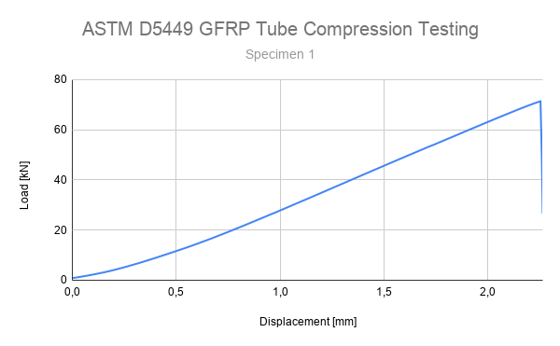
Fig. I.1: ASTM D5449 Compression test of GFRP tube; Specimen 1
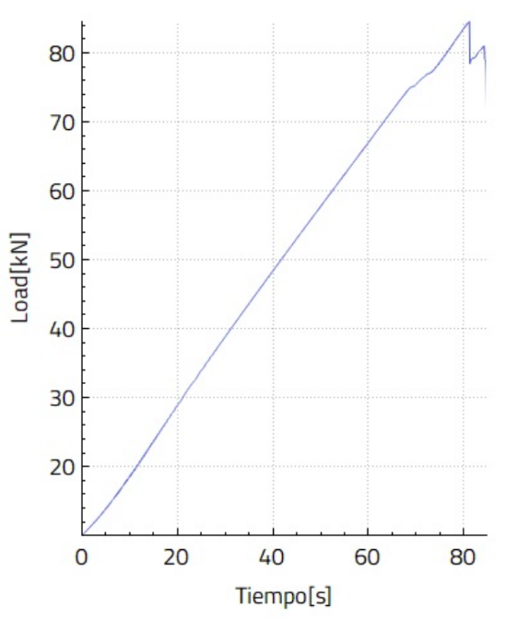

Time [s]
Fig. I.2: ASTM D5449 Compression test of GFRP tube; Specimen 2
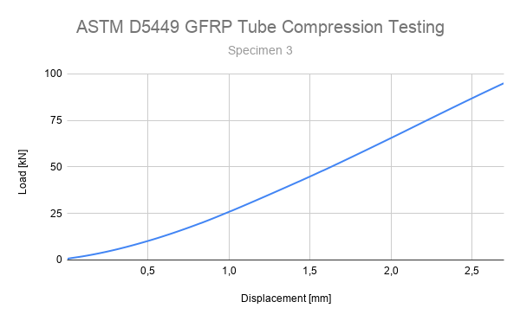
Fig. I.3: ASTM D5449 Compression test of GFRP tube; Specimen 3

I.1.7 Failure Analysis
Failure occurred through Buckling and Matrix cracking, characterized by:
Buckling:
- Fiber microbuckling initiation
- Elastic buckling in the mid region of the tube: Initial geometry recovered when unloaded
- Delamination in buckling zone
Matrix crack:
- Sudden failure; Loud matrix crack noise
The failure method indicates that fibers can withstand further compression. Stiffeners in the middle section of the tube or other technique should be considered to obtain a matrix crack failure, optimizing the fiber’s properties usage.
Big dispersion, around 13.9% in load indicates uncertainty in test method or material properties, which has to be considered for the next iteration’s optimization process.

I.1.8 Correlation with Analytical Model
Experimental results were compared against predictions from analytical and numerical models from Appendix K:
Parameter | Analytical Value | Experimental Value | Error
Max. Load [kN] | 80 | 84.7 | 5.8%
Table I.2: Correlation between analytical and experimental values of the ASTM D5449 compression test of GFRP tubes
The experimental mean deviates by 5.8% from predicted values.
This level of agreement is considered acceptable by the team for a first iteration of both tests, but it is planned to improve the reliability through improvement of the compression setup and detailed revision of literature on FEM simulation of composites.

I.1.9 Engineering Interpretation
The results demonstrate that:
- A predminantely linear behaviour was observed until at least 80% of the load (Specimen 2)
- Failure occurs according to two different mechanisms: Buckling or matrix cracking
- Failure values occur with a deviation of 15 kN
- The design maintains a safety factor of 4 relative to maximum expected flight loads

I.1.10 Conclusion
Results validate the structural design, demonstrating that the airframe meets load requirements with a safety factor of 4 under worst-case conditions.
The correlation between analytical predictions and experimental results, combined with a variability of 13.9% and identified failure modes, provides confidence in the structural integrity during flight. For future iterations and further optimization other tests should be performed such as a bending moment test and glued joint resistance to bending moments test. Also, lower dispersion in failure load results is desirable, preferably in the order of 1 kN to provide more certainty about test results.

I.2 Adhesive Bond Lap Shear Testing (ASTM D5868)
Adhesively bonded joints between aluminum couplers and composite airframe tubes were experimentally characterized under shear loading to evaluate bond strength, identify failure mechanisms, and validate joint design assumptions. Testing was conducted in accordance with ASTM D5868.

I.2.1 Test Objective
The objective of this test was to:
- Determine the lap shear strength of the adhesive bond between aluminum and composite substrates
- Evaluate the effectiveness of the surface preparation and bonding process
- Identify dominant failure modes (adhesive, cohesive, or substrate failure)
- Assess manufacturing consistency and repeatability of bonded interfaces

I.2.2 Specimen Description
Test specimens consisted of single-lap joints representative of the interface between aluminum couplers and composite tubes used in the flight vehicle. All specimens were manufactured using identical materials and bonding procedures.
- Composite substrate: 200g/m² Glass fiber
- Aluminum substrate: Aluminum 6061 T6
- Adhesive: Loctite EA 120 HP
- Overlap length: 25.4 mm
- Bond width: 25 mm
- Adhesive thickness: 0.18 mm
Surface preparation was performed prior to bonding and included:
- Aluminum: Sandblasting + Pickling + Anodizing
- Composite: Abrasion + Solvent Cleaner
Bonding was carried out under controlled conditions:
- Cure temperature: 80°C
- Cure time: 5 h
- Applied pressure: 1 atm
All specimens were visually inspected prior to testing. No visible defects such as macroscopic voids, incomplete wetting, or misalignment were observed.

I.2.3 Test Setup
Lap shear tests were performed using a calibrated universal testing machine under tensile loading.
- Machine: Instron 3382
- Load cell: 100 kN (±0.5% accuracy)
- Loading configuration: single-lap shear fixture
- Crosshead speed: 13 mm/min
Specimens were mounted to minimize bending effects inherent to single-lap configurations, ensuring consistent load application across the bonded area.

I.2.4 Test Procedure
Each specimen was loaded in tension under displacement control until failure. Load and displacement were continuously recorded at a sampling rate of 500 Hz.
A total of n = 7 specimens were tested to obtain a preliminary estimate of variability.
Failure modes were documented visually and through post-test inspection of fracture surfaces.

I.2.5 Results
The results of the test are presented in Table I.3.
# | Specimen Label | Width [mm] | Thickness [mm] | Maximum Load [N] | Maximum Tensile Stress [N/mm²]
1 | AZI1 | 25.00 | 25.30 | 6886.18 | 10.89
2 | AZI2 | 25.00 | 25.40 | 7245.72 | 11.41
3 | AZI3 | 25.00 | 25.10 | 7459.99 | 11.89
4 | AZI4 | 25.00 | 25.30 | 7477.48 | 11.82
5 | AZI5 | 25.00 | 25.40 | 7664.79 | 12.07
6 | AZI6 | 25.00 | 25.50 | 7192.16 | 11.28
7 | AZI7 | 25.00 | 25.50 | 7246.87 | 11.37
Table I.3: ASTM D5868 Lap shear test results; Sandblasted, pickled and anodized 6061 T6 Aluminum and GFRP joint.
Statistical Summary:
- Mean maximum stress: 11.5 MPa
- Standard deviation: 0.4 MPa
- Coefficient of variation: 3.48 %

I.2.6 Graphical Results
Results of Specimens 1 to 7 are presented in Fig. I.4
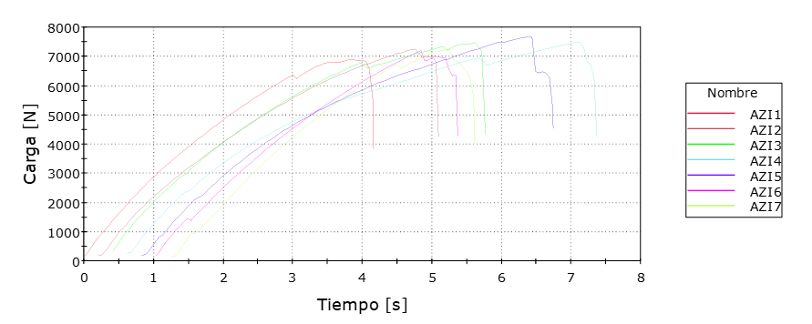

Time
Load

Name
Fig. I.4: ASTM D5868 Lap shear test results; Sandblasted, pickled and anodized 6061 T6 Aluminum and GFRP joint.

I.2.7 Failure Analysis
Failure occurred through fibre-tear failure, characterized by:
- Failure of composite adhesion between matrix and fibres
This indicates that the joint performance is governed by the adhesion property of the composite.
Variability in failure load of approximately 3.48% suggests moderate sensitivity to surface preparation, adhesive thickness control, or curing conditions.

I.2.8 Engineering Interpretation
The results indicate that:
- The bonded joint sustains shear stresses up to 11.5 MPa
- The dominant failure mode suggests that adhesion between epoxy matrix and fibre is the main cause of failure.
- The joint provides a minimum safety factor of 5.3 relative to expected operational loads

I.2.9 Conclusion
Lap shear testing confirms that the adhesive joints between aluminum couplers and composite tubes meet the structural requirements for the intended mission profile.
Future work includes investigating the cause of fibre-tear failure and improving fibre-matrix adhesion to improve joint performance.

1.3

Appendix C- Hazard analyses:

This appendix presents a hazard analysis for Aconcagua addressing hazardous material handling, transportation and storage of energetics, and other aspects of the design that pose potential hazards to operating personnel. Hazards are grouped by category: (A) energetic devices; (B) solid motor handling and transport; (C) battery handling; and (D) CO₂ cartridge handling. The format follows the example matrix on the ESRA website.

A: Energetic Devices and Pyrogenic Materials
Hazard | Possible Causes | Risk of Mishap and Rationale | Mitigation Approach | Risk after Mitigation
e-match ignition during installation | Static discharge to leads; stray current from test equipment; lead shorting against battery terminals. | An unshunted e-match firing near the installer can cause hand burns and ear damage; surprise reaction can cause secondary injury (e.g., fall from ladder). | E-match leads kept shunted until the final connection step; no multimeter applied to leads; arming switch verified OFF and battery disconnected before initiator leads attached; safety glasses worn. | Low
Unintended Raptor CO₂ actuation during arming | Pyro switch closes before the flight computer is in flight-ready state | Inadvertent Raptor actuation propels the nosecone with sufficient force to injure nearby personnel via impact, blast pressure, or cold-jet exposure. | CO₂ cartridges installed only at the pad with the rocket vertical and IREC personnel present per DTEG 6.14.4; pyro switches in SAFE during installation; flight computers unpowered until arming; personnel cleared from the airframe forward sector during arming. | Low
Piranha cutter actuation | Pyro switch closed prematurely; e-match firing under stray current; mechanical damage to Piranha body. | Small pyrogen quantity in non-shrapnel device, but actuation near hands could cause minor burns and severs any line currently routed through the cutter. | Piranha e-matches shunted until final assembly; Piranhas installed only after both flight computers confirmed unpowered; restraint line not routed through Piranha until final pad arming; safety glasses worn. | Low
Pyrogen quantity exceeding DTEG 6.14.6 limits | Bringing more pyrogens to the IREC than required for flight + on-site testing; improper transport packaging. | Regulatory non-compliance, potential confiscation, increased fire/explosion exposure during travel and storage. | Inventory restricted per Appendix B E.4 (2 flight Raptors, 2 spare cartridges, 2 flight Piranhas, 2 spare Piranhas, 4 + 8 e-matches, 2 motor igniters); inventory verified before transport; storage in approved containers separated from ignition sources. | Low
Spent e-match or pyro residue mishandling | Hot residue contact after firing; assumption that fired devices are inert when partial pyrogen remains. | Burns from hot residue; ignition of nearby flammable material (Nomex parachute protector, packaging). | Minimum 5-minute wait before handling; visual inspection for unburned pyrogen; disposal in metal containers; workspace kept clear of flammable debris. | Low
Table C1: Hazard analysis energetic devices and pyrogenic materials.

B: Solid Motor Handling, Transportation, and Storage
Hazard | Possible Causes | Risk of Mishap and Rationale | Mitigation Approach | Risk after Mitigation
ignition of solid propellant during handling | Flame, spark, or static discharge near exposed grain; mechanical impact; autoignition temperature exposure; igniter inserted prematurely. | Ignition of an O-class motor outside its case produces violent deflagration with severe burns, blast injury, and projectile risk; potentially fatal at close range. | Reload kit opened only in clean, ventilated workspace with no ignition sources within 5 m; no smoking, no open flame, no static-generating activity; assembly performed by FoR or designated certified member per AeroTech instructions; igniter installed only at the pad after vehicle is vertical per DTEG 5.7. | Low
Hangfire / partial ignition / live propellant in recovered case | Delayed ignition; incomplete burn leaving residual propellant; failure to ignite. | Approach to unfired or partially-fired motor risks delayed ignition; live propellant in recovered case poses ignition hazard during disassembly. | Range officials notified immediately on misfire; minimum hold time per Range SOP observed before approach (typically 60 minutes for solids); recovered case treated as live until verified empty by FoR; disassembly performed in workspace with case soaked in water if residue observed. | Low
Motor exhaust inhalation | Proximity to motor at ignition; downwind exposure; post-flight handling of sooted case. | APCP exhaust contains aluminum oxide, hydrochloric acid, carbon monoxide, particulates; causes respiratory irritation; chronic exposure has long-term effects. | Personnel cleared to IREC-prescribed minimum safe distance before ignition | Low
Table C2: Hazard analysis solid motor handling, transportation, and storage.

C: Battery Handling and Electrical Hazards
Hazard | Possible Causes | Risk of Mishap and Rationale | Mitigation Approach | Risk after Mitigation
18650 lithium-ion thermal runaway | Cell short-circuit (terminal contact with metal); mechanical damage; over-charging; over-discharge; charging with mismatched chemistry charger. | Thermal runaway produces vented hot electrolyte, flame, possible cell rupture; adjacent cells can cascade; burns and toxic gas inhalation. | Cells inspected before each use for casing damage, swelling, terminal corrosion; damaged cells retired; stored in cell-specific holders or insulated cases; charging only with chemistry-matched charger on non-flammable surface, never unattended overnight; lithium-rated fire extinguisher within reach; battery transport in fire-rated cases. | Low
9 V battery shorting | Battery terminals contact metal in pocket or tool tray; e-match leads bridging terminals during installation. | 9 V alkaline shorting heats the cell and adjacent objects; can cause minor burns and fire any e-match in contact with the leads. | 9 V batteries stored with terminal caps installed; battery connected to RRC3 only at the assembly stage when no e-matches are also being handled; polarity checked before connection; no metal tools near battery during connection. | Low
Table C3: Hazard analysis battery handling and electrical hazards.

D: Compressed Gas (CO₂ Cartridge) Handling
Hazard | Possible Causes | Risk of Mishap and Rationale | Mitigation Approach | Risk after Mitigation
CO₂ cartridge thermal overpressure | Cartridge stored above 50 °C; cartridge near heat source; airframe under direct sun for extended time on the pad. | Cartridge rupture without controlled venting produces high-velocity fragments and a violent expansion event; severe injury risk at close range. | Cartridges stored in shaded containers until use; airframe shaded on the pad; installed cartridges not exposed to direct sun for prolonged periods of time; cartridge inspection for corrosion or dent damage before installation. | Low
Cartridge actuation during installation | Drop or impact damaging the seal; pyro actuator fired during handling; cross-threading damaging the seal. | Sudden CO₂ discharge in close proximity causes cold-jet exposure , eye injury from particulates. | Cartridges installed only after Raptor pyro actuator confirmed unpowered; installation by trained recovery-team member; safety glasses and long sleeves worn; workspace clear of other personnel | Low
Table C4: Hazard analysis compressed gas (CO₂ cartridge) handling.

Appendix D- Risk assessment

Hazard | Possible Causes | Risk of Mishap and Rationale | Mitigation Approach | Risk of Injury after Mitigation
Rocket deviates from the nominal flight path, comes in contact with personnel at high speed. | -Overstability with high cross winds  -Unstable rocket | Medium; An out of  control rocket is extremely  dangerous but  the probability of it  hitting someone is  greatly reduced by distancing  all personnel  from the launch site | -Designing the rocket with high rail departure velocity and stability under 2 calibers at liftoff.  -A go- no go wind check before flight sets the maximum wind speed at 5 m/s, which is not enough to tilt the rocket in an angle of 25° as checked per simulation in OpenRocket. | Low
Recovery system fails, rocket  comes in  contact with personnel | -Event triggering altimeter unpowered  -Event triggering altimeter fails  - Cable connecting altimeter and e-match gets cut  - Shear pins do not break  - Pressure loss in the recovery bay  - Shock cord gets cut | High; A rocket in a ballistic trajectory is extremely dangerous. Failure to deploy is one of the most common rocketry failures | - Recovery electronics power testing before flight  - Cable joint inspection. Check for sharp edges and poor welds.  - Altimeter functionality testing before flight  - Pop-off test to check if shear pins break, nominal pressure in the bay and if cables get cut. | Medium
Recovery system partially  deploys, rocket  comes in contact with personnel | - Lines get tangled up  - Parachutes don´t inflate | Medium: A rocket out of control is dangerous, but if the recovery system is partially deployed, an individual can recognize the rocket and dodge it. | - Recovery equipment arming and mounting sequence is implemented  - Parachute opening test at near flight condition speed to check proper unfolding of main and drogue. | Low
Recovery system deploys during assembly or prelaunch, causing injury | - Altimeter fails | High: A team member could fall of the stair if working on the rocket. The nosecone could strike personnel or a team member, causing possible injury. | - Recovery system armed on pad.  - Testing of both COTS event triggering flight computers.  - Inform team members of the risk. | Low
Main parachute deploys  at or near  apogee, rocket or payload  drifts to highway(  s) | - Three Ring system fails  - Main line is tensioned at or near apogee | Medium: An incoming rocket in a highway is dangerous and could cause an accident. Risk is lowered by the distance from launch site to any highway and by launching in a low highway density zone. Also, a 7 m/s descent rate gives time for drivers to dodge the rocket. | -Three Ring system testing at Parachute inflation test  -Main line is tied together with zip ties and rubber bands to prevent low tensions from releasing the parachute from the POD. | Low
Rocket does not ignite  when command  is given (“hang fire”),  but does ignite when  the team approaches  to troubleshoot | -Defective igniter  - Incorrect wiring | High: The rocket igniting with team members nearby could cause severe burns. | - Ask the organization to power off the line to the igniter once the team approaches.  - Inform team members of the risk. | Low
Rocket falls from the  launch rail during pre  launch preparations,  causing injury | -Rail Button failure  -Launch rail incorrectly held to the ground | Medium: The rocket weighs 33kg and therefore it can be held or pushed away by any team member if aware of the situation. | - Rigidization of rail buttons joint with glass fiber and resin.  - Check stability of the rocket once mounted on the rail  - Inform every member of the risk and telling them to be aware. | Low
Table D1: Risk assessment Matrix

Appendix E – Checklists

General Assembly
Process | Team | Responsible | Complete
Assemble Payload | Payload | Marco Beretta
Payload Preintegration Check | Payload | Marco Beretta
Assemble Recovery Electronics | Avionics | Ivan Marzeniuk
Assemble Raptor Deploy device | Recovery | Santiago Ponte
Recovery Bay Preintegration Check | Avionics | Tomas Wickham
Integrate Raptor to Recovery Bay | Avionics | Ivan Marzeniuk
Recovery Bay -Payload Integration | Leadership | Felipe Ranftl
Assemble Nosecone avionics bay | Avionics | Ivan Marzeniuk
Nosecone avionics preintegration check | Avionics | Tomas Wickham
Nosecone Avionics Integration | Avionics | Ivan Marzeniuk
Recovery equipment assembly | Recovery | Santiago Ponte
Recovery equipment integration | Recovery | Santiago Ponte
Nosecone - Payload Bay integration | Leadership | Fabrizio Iezzi
Integrate Center Ring to Fincan | Bulkheads | Fabrizio Iezzi
Assembly Motor | Propulsion | Fabrizio Iezzi
Integrate Motor to Fincan | Bulkheads | Fabrizio Iezzi
Integrate Fincan and Payload Can | Leadership | Fabrizio Iezzi
Prefilght Nominal | Leadership | Lucas Freyre
Preflight Off-nominal | Leadership | Lucas Freyre
Launch nominal | Leadership | Lucas Freyre
Launch off-nominal | Leadership | Lucas Freyre
Recovery nominal | Leadership | Lucas Freyre
Recovery off-nominal | Leadership | Lucas Freyre

Assemble Payload
Step | Team | Task | Responsible | Complete
1.1 | Payload | Connect circuit board to NEMA 17, SLF3S-0600F, batteries, switch, IR LED and IR phototransistor | Marco Beretta
1.2 | Payload | Insert NEMA 17 into the Motor Base | Marco Beretta
1.3 | Payload | Fix NEMA motor with the motor plate using 4xM3 screws | Marco Beretta
1.4 | Payload | Connect Rigid shaft coupling to the motor by using two M5 Allen screws | Marco Beretta
1.5 | Payload | Insert Linear Guides into the motor base holes. | Marco Beretta
1.6 | Payload | Join Lead Screw and linear carriage with 4 M3 Bolts | Marco Beretta
1.7 | Payload | Screw Lead screw with linear carriage into motor. | Marco Beretta
1.8 | Payload | Fix the PCB onto the L-brackets with 4 M3 bolts | Marco Beretta
1.9 | Payload | Fix the two battery packs onto the front and back pair of L-brackets with 2 M3 bolts each | Marco Beretta
1.10 | Payload | Fix the plate that holds the flow sensor onto the front pair of L-brackets with 4 M3 bolts | Marco Beretta
1.11 | Payload | Insert the back pair of L-brackets into the motor base | Marco Beretta
1.12 | Payload | Load the syringe with distilled water | Marco Beretta
1.13 | Payload | Insert the syringe into the middle transversal plate and lock it in place | Marco Beretta
1.14 | Payload | Connect the tubing to the syringe, passing it through the top transversal plate and then connect it to the IR sensor, and flow sensor | Marco Beretta
1.15 | Payload | Push the syringe plunger until the fluid channel has liquid going through the flow sensor and 1.6ml are left in the syringe | Marco Beretta
1.16 | Payload | Screw both plates holding the syringe to the already placed L-brackets with M3 bolts and fix the plunger to the linear carriage | Marco Beretta
1.17 | Payload | Connect the collector to the fluid line tubbing | Marco Beretta
1.18 | Payload | Fix the IR sensor to the top plate with 4 M3 bolts | Marco Beretta
1.19 | Payload | Insert the front pair of L-brackets into the motor base | Marco Beretta
1.20 | Payload | Fix the flow sensor into the plate designed to hold it | Marco Beretta
1.21 | Payload | Fix the collector to the corresponding L-bracket | Marco Beretta
1.22 | Payload | Load the ballast in the bottom of the motor base and close the hatch with 4 M3 bolts | Marco Beretta
1.23 | Payload | Slide the shell in and fix it with 4 M5 bolts | Marco Beretta

Payload Preintegration Check
Step | Team | Task | Responsible | Complete
2.1 | Payload | Check continuity | Marco Beretta
2.2 | Payload | Check connections are properly joined | Marco Beretta
2.3 | Payload | Check proper adjusting of the shell bolts. | Marco Beretta
2.4 | Payload | Check functionality performing a complete test | Marco Beretta
2.5 | Payload | Check connections to the switches | Marco Beretta
2.6 | Payload | Check continuity by turning on and off through switches | Marco Beretta

Assemble Recovery Electronics
Step | Team | Task | Responsible | Complete
3.1 | Avionics | Secure batteries and connectors in place and connect power sources | Ivan Marzeniuk
3.2 | Avionics | Mount and secure the two RRC3 units and the Featherweight to the sled | Ivan Marzeniuk
3.3 | Avionics | Assemble the wiring harness, incorporating the deployment charges and switches | Tomas Wickham

Assemble Raptor Deploy device
Step | Team | Task | Responsible | Complete
4.1 | Recovery | Lube the Dual Charge Cup with the supplied lube | Santiago Ponte
4.2 | Recovery | Remove the protective plastic cover from the E-match | Santiago Ponte
4.3 | Recovery | Slide one of the small black O-rings over the wire and up to the E-match head | Santiago Ponte
4.4 | Recovery | Seal the e-matches using potting putty and O-ring seals | Santiago Ponte
4.5 | Recovery | Fill the supplied Powder Measure Vial to the line with 4F black powder | Santiago Ponte
4.6 | Recovery | Carefully add the pyro powder to the prepped charge cup, tap to settle powder if needed. Use one of the supplied "Red Dots" to seal the pyro in the Charge Cup. Press firmly to make sure the red dot sticks properly. | Santiago Ponte
4.7 | Recovery | Use supplied lube and a cotton swab to completely lube the inside of the Pyro Housing, including the grooves. | Santiago Ponte
4.8 | Recovery | Twist all 4 wires together and insert them into the Pyro Housing. | Santiago Ponte
4.9 | Recovery | Pull the Charge Cup only to the mouth of the Pyro Housing. | Santiago Ponte
4.10 | Recovery | Install the return spring onto the Puncture Piston. | Santiago Ponte
4.11 | Recovery | Hold the spring and use it to push the Puncture Piston and the Charge Cup assembly until the Charge Cup is completely seated (gently pull wires as needed) | Santiago Ponte
4.12 | Recovery | Screw on the Mounting Cap onto the Pyro Housing. | Santiago Ponte
4.13 | Recovery | Install the CO2 cartridge. | Santiago Ponte

Recovery Bay Preintegration Check
Step | Team | Task | Responsible | Complete
5.1 | Avionics | Verify that all bolts and fasteners are properly tightened and secured | Ivan Marzeniuk
5.2 | Avionics | Inspect the structural integrity of the sled for cracks, deformations, or any signs of damage | Ivan Marzeniuk
5.3 | Avionics | Verify that all batteries are correctly positioned and firmly secured in their mounts | Tomas Wickham
5.4 | Avionics | Inspect all wiring connections, including components, batteries, switches, connectors, and e-matches | Tomas Wickham
5.5 | Avionics | Power on the system for a final functional check of all avionics and telemetry | Tomas Wickham

Integrate Raptor to Avionics Bay
Step | Team | Task | Responsible | Complete
6.1 | Avionics | Install the RAPTOR mounting caps onto the recovery flange plate | Ivan Marzeniuk
6.2 | Avionics | Prepare the puncture piston assembly with assembly lube and install the return spring | Ivan Marzeniuk
6.3 | Avionics | Mount the pyro housing and secure the E-matches using potting putty and O-ring seals | Ivan Marzeniuk
6.4 | Avionics | Wire and connect the E-matches to the RRC3 altimeters for deployment activation | Tomas Wickham
6.5 | Avionics | Load the charge cups with the required black powder and secure the red dot seals | Ivan Marzeniuk
6.6 | Avionics | Thread and secure the CO2 cartridges ( 35g) into the RAPTOR assembly | Ivan Marzeniuk

Recovery Bay - Payload Integration
Step | Team | Task | Responsible | Complete
7.1 | Integration | Place the PS upper plate on top of the payload shell | Felipe Ranftl
7.2 | Integration | Join the Payload shell to the avionics bay rods with 4x Allen M6 bolts | Felipe Ranftl
7.3 | Integration | Connect Payload to the Allen switches | Felipe Ranftl
7.4 | Integration | Connect Recovery Bay to the Allen Switches | Felipe Ranftl
7.5 | Integration | Slide joined Payload and recovery bay into the square hole of the recovery female bulkhead, matching the two integration lines marked on the recovery plate and female recovery Bulkhead. | Felipe Ranftl

Assemble Nosecone Avionics Bay
Step | Team | Task | Responsible | Complete
8.1 | Avionics | Bolt the 3D printed sled to the plate using 4x M4 bolts | Ivan Marzeniuk
8.2 | Avionics | Pass the aluminum rods through the sled and bolt them to both the plate and the top plate using M6 bolts | Ivan Marzeniuk
8.3 | Avionics | Place the 18650 Li-ion batteries into the covers and secure the covers to the sled, ensuring the cells are properly housed in their compartments | Ivan Marzeniuk
8.4 | Avionics | Mount the components to the acrylic plates: Secure the camera, SRAD antenna, and switches using M4 bolts; secure the TeleMega and SRAD units using M3 bolts | Ivan Marzeniuk
8.5 | Avionics | Secure the acrylic plates to the sled using 6x M3 bolts for each plate | Ivan Marzeniuk
8.6 | Avionics | Secure the two Molex connector assemblies to the sled using M3 bolts | Tomas Wickham
8.7 | Avionics | Complete circuit wiring by connecting all components, batteries, Molex connectors, and switches | Tomas Wickham
8.8 | Avionics | Install the 3/8" U-bolt to the bottom plate | Ivan Marzeniuk
8.9 | Avionics | Secure the avionics assembly to the avionics ring (bonded to the nosecone) using M8 bolts | Ivan Marzeniujk

Nosecone Avionics Preintegration Check
Step | Team | Task | Responsible | Complete
9.1 | Avionics | Verify all bolts from steps 8.1–8.9 are properly tightened (M3, M4, M6, M8) and no hardware is missing or damaged | Tomas Wickham
9.2 | Avionics | Inspect all components (TeleMega, SRAD, camera, antenna, battery covers, Molex assemblies) for physical damage, cracks, or misalignment | Tomas Wickham
9.3 | Avionics | Power on the avionics bay using the switches and confirm both the SRAD and TeleMega boards boot correctly with no error indicators | Tomas Wickham
9.4 | Avionics | Verify two-way communication between TeleMega and the ground station; confirm telemetry data is being received correctly | Tomas Wickham
9.5 | Avionics | Verify SRAD unit communication is established and functioning with the ground station | Tomas Wickham
9.6 | Avionics | Check battery voltage levels on all 18650 Li-ion cells and confirm they are within the required range for flight | Tomas Wickham
9.7 | Avionics | Perform a mechanical pull test on all Molex connector assemblies and wiring harness connections to confirm they resist light mechanical stress without disconnecting | Tomas Wickham
9.8 | Avionics | Tug-test all individual wire connections and solder joints throughout the circuit to ensure no loose or intermittent connections | Tomas Wickham
9.9 | Avionics | Confirm all switches operate correctly (open/close circuit as expected) and are secured in their mounted position | Tomas Wickham
9.10 | Avionics | Perform a final visual inspection of the complete avionics bay assembly before nosecone integration | Tomas Wickham

Nosecone Avionics Integration
Step | Team | Task | Responsible | Complete
10.1 | Integration | Insert Assembled Nosecone avionics bay into the Nosecone matching the lines in the nosecone and avionics plate. | Felipe Ranftl
10.2 | Integration | Join Avionics plate and Avionics Bulkhead using 2x M8 Allen bolts | Felipe Ranftl

Recovery Equipment Assembly
Step | Team | Task | Responsible | Complete
11.1 | Recovery | Verify the drogue parachute is properly contained in its bag. | Santiago Ponte
11.2 | Recovery | Verify the main parachute is properly contained in its POD. | Santiago Ponte
11.3 | Recovery | Mount the 3-ring device’s shear chord through both line cutter’s orifices. Leave the other end of the line cutter’s loose for further connection | Santiago Ponte
11.4 | Recovery | Restrain the 10 ft main parachute shock chord with shear zip ties at the designated intervals so it stays packed during boost. | Santiago Ponte
11.5 | Recovery | Attach the main parachute shock chord to the main parachute on one end. Then connect the other end to a quick-link - swivel link - quick link. | Santiago Ponte
11.6 | Recovery | Attach the drogue parachute to a quick link. Connect that quick link to the 10 ft drogue shock chord on one end. | Santiago Ponte
11.7 | Recovery | On the other end of the drogue shock chord, connect it to a quick-link - swivel link - quick link. | Santiago Ponte
11.8 | Recovery | Engage the last drogue-system quick-link to the 3-ring device, aswell as the 5 ft shock chord. Connect that 5 ft shock chord to the main parachute’s POD. | Santiago Ponte
11.9 | Recovery | Attach the free end of the three ring device to a quick-link - by-pass shock chord - quick link. | Santiago Ponte
11.10 | Recovery | Connect the quick-link next to the 10 ft drogue shock-chord to a 20 ft shock-chord. The loose end of the latter shall be connected to another quick-link. | Santiago Ponte
11.11 | Recovery | Prepare the spare 20 ft nosecone shock-chord by connecting both its ends to 2 different quick links. | Santiago Ponte
11.12 | Recovery | Pack the nosecone shock-chord and the POD-drogue quick-link shock chords with elastic bands. Compact both as much as possible. | Santiago Ponte

Recovery Integration
Step | Team | Task | Responsible | Complete
12.1 | Recovery | Connect the main quick-link to the rocket’s U-Bolt. | Santiago Ponte
12.2 | Recovery | Connect the last vinculating drogue line quick-link to the rocket’s U-Bolt. | Santiago Ponte
12.3 | Recovery | Connect the loose 20 ft drogue’s system’s quick-link to the rocket’s U-Bolt | Santiago Ponte
12.4 | Recovery | Connect the spare quick-link - 20 ft shock chord - quick-link to the rocket’s U-Bolt on one end, and to the nosecone’s U-Bolt on the other. | Santiago Ponte
12.5 | Recovery | Connect the line cutters to the avionic’s bay. | Santiago Ponte

Nosecone - Payload Bay Integration
Step | Team | Task | Responsible | Complete
11.1 | Integration | Slide the nosecone into the sliding field joint. | Felipe Ranftl
11.2 | Integration | Match the lines on nosecone and male recovery bulkhead | Felipe Ranftl
11.3 | Integration | Join female and male recovery bulkhead with 6x M6 x 20 Bolts | Felipe Ranftl

Motor Assembly
Step | Team | Task | Responsible | Complete
12.1 | Propulsion | Glue grains to the liner at least 24 hours before launch following the manufacturer instructions | Fabrizio Iezzi
12.2 | Propulsion | Assembly de motor following the manufacturer instructions | Fabrizio Iezzi
12.3 | Propulsion | Tighten the nuts using an appropriate tool and verify that all components are correctly positioned | Fabrizio Iezzi

Integrate Center Ring to Fincan
Step | Team | Task | Responsible | Complete
13.1 | Integration | Position the motor inside the fin-can, ensuring that the motor flange properly fits into the motor bulkhead | Fabrizio Iezzi
13.2 | Integration | Install the motor centering ring and secure it to the fuselage | Fabrizio Iezzi
13.3 | Integration | Insert and tighten the screw in the motor bulkhead to secure the motor to the rocket. | Fabrizio Iezzi

Integrate Fincan and Payload Can
Step | Team | Task | Responsible | Complete
15.1 | Integration | Mount the Payload Bay and Nosecone in one ITBA Rocketry Stand, and the fincan in another one | Felipe Ranftl
15.2 | Integration | Mate motor bulkhead cones and turn the payload bay until assembly lines drawn on both cans are aligned. | Felipe Ranftl
15.3 | Integration | Join Male and Female Bulkheads using 6x M6x20 Allen Bolts | Felipe Ranftl

Preflight Nominal
Step | Team | Task | Responsible | Complete
16.1 | Launch | Carry the rocket to the launch pad | Lucas Freyre
16.2 | Launch | Install rocket on the rail | Felipe Ranftl
16.3 | Launch | Lift launch rail | Felipe Ranftl
16.4 | Launch | Climb with the stair to the Payload Bay where the Allen switches are located | Felipe Ranftl
16.5 | Launch | Turn on 2 RRC3 COTS flight computers (4 Allen switches) | Felipe Ranftl
16.6 | Launch | Wait to hear both sound signals. | Felipe Ranftl
16.7 | Launch | Turn on Featherweight GPS (1 Allen Switch) | Felipe Ranftl
16.8 | Launch | Wait to hear both sound signals. | Felipe Ranftl
16.9 | Launch | Turn on Payload Power supply | Felipe Ranftl
16.10 | Launch | Wait to hear sound signal | Felipe Ranftl
16.11 | Launch | Climb with the stairs to the nosecone where the Allen switches are located | Felipe Ranftl
16.12 | Launch | Turn on SRAD flight computer | Felipe Ranftl
16.13 | Launch | Wait to hear the buzzer. | Felipe Ranftl
16.14 | Launch | Turn on TeleMega COTS flight computer. | Felipe Ranftl
16.15 | Launch | Wait to hear the buzzer. | Felipe Ranftl
16.16 | Launch | Turn on the on-board camera. | Felipe Ranftl
16.17 | Launch | Communicate with the ground Station and check its tracking functionality by facing it in the opposite direction of the rocket. | Lucas Freyre
16.18 | Launch | Check receiving GPS signal from the Featherweight and TeleMega | Ivan Marzeniuk
16.19 | Launch | Non essential personnel clear the area | Lucas Freyre
16.20 | Launch | Motor igniter is connected and inserted into the motor | Felipe Ranftl
16.21 | Launch | Area is cleared | Lucas Freyre

Preflight Off-Nominal
Step | Team | Task | Responsible | Complete
17.1 | Launch | Remove motor igniter | Felipe Ranftl
17.2 | Launch | Turn off Payload bay switches | Felipe Ranftl
17.3 | Launch | Turn off Nosecone Bay switches | Felipe Ranftl
17.4 | Launch | Lower Rail | Felipe Ranftl
17.5 | Launch | Remove rocket from rail | Felipe Ranftl

Launch Nominal
Step | Team | Task | Responsible | Complete
18.1 | - | Motor Ignition | -
18.2 | Tracking | Track rocket through automatic ground station. Check if switching to manual mode is necessary. | Tomas Wickham
18.3 | Tracking | Track rocket through Featherweight App | Ivan Marzeniuk
18.4 | Tracking | Track rocket with binoculars | Lucas Freyre

Launch Off-Nominal
Step | Team | Task | Responsible | Complete
19.1 | All | Take cover until given all clear to approach rocket or rocket wreckage | Lucas Freyre
19.2 | Launch | Turn off all switches if possible | Felipe Ranftl
19.3 | Launch | Disconnect ejection charges if necessary | Felipe Ranftl
19.4 | Launch | Remove possible damaged batteries | Felipe Ranftl

Recovery Nominal
Step | Team | Task | Responsible | Complete
20.1 | Recovery | Turn off flight computers (2x RRC3, SRAD flight computer, TeleMega) | Ivan Marzeniuk
20.2 | Recovery | Turn off camera, payload experiment and Featherweight GPS | Ivan Marzeniuk
20.3 | Recovery | Verify all ejection charges are empty. If not disconnect ejection charges | Ivan Marzeniuk
20.4 | Recovery | Take rockets to judges for post flight evaluation | Lucas Freyre

Recovery Off-Nominal
Step | Team | Task | Responsible | Complete
21.1 | Recovery | Turn off flight computers (2x RRC3, SRAD flufh computer, TeleMega) | Ivan Marzeniuk
21.2 | Recovery | Turn off camera, payload experiment and Featherweight GPS | Ivan Marzeniuk
21.3 | Recovery | Remove possible damaged batteries | Ivan Marzeniuk
21.4 | Recovery | Recover the rocket and any possible debris | Ivan Marzeniuk
21.5 | Recovery | If a flight computer still works take it to the judges for post flight evaluation. | Lucas Freyre

Appendix F – Engineering drawings

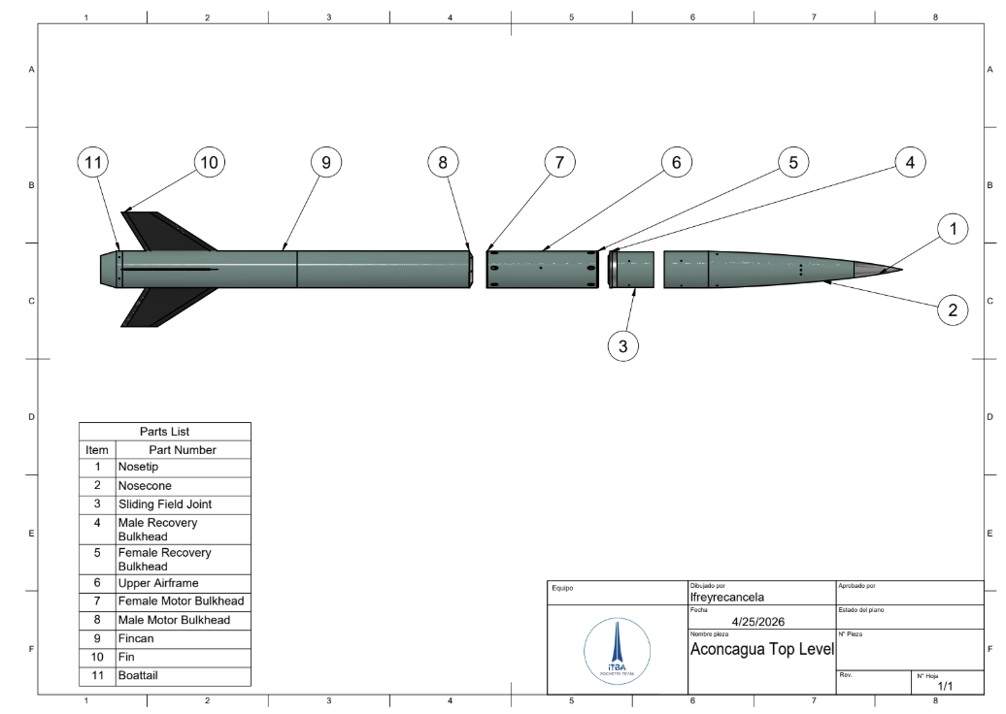
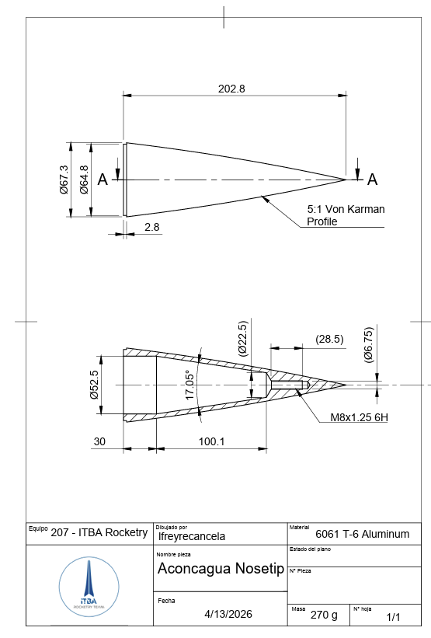
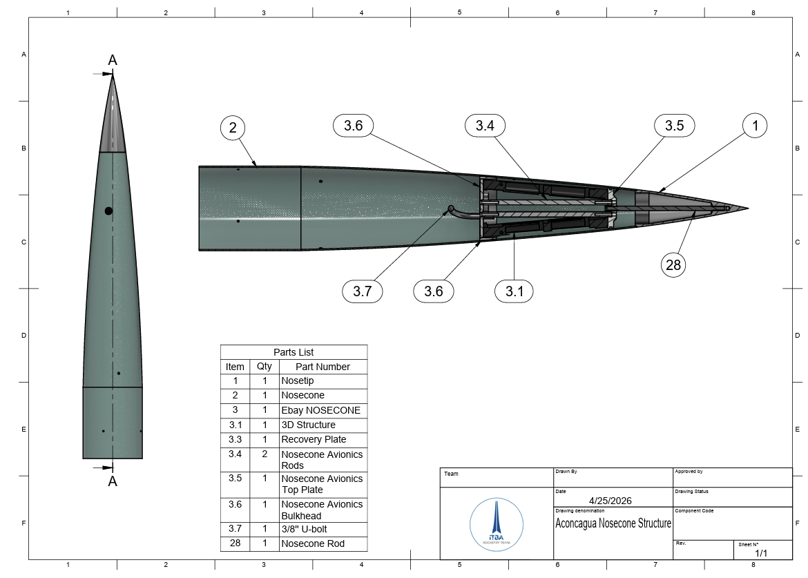
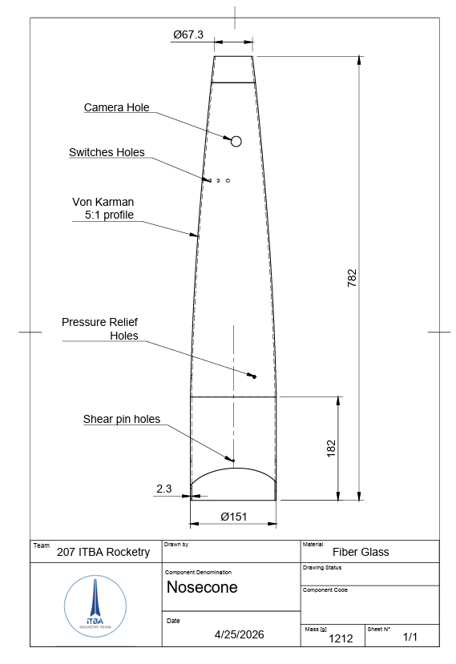
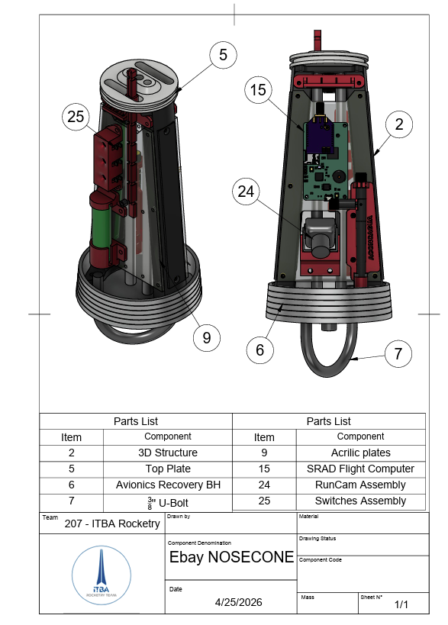
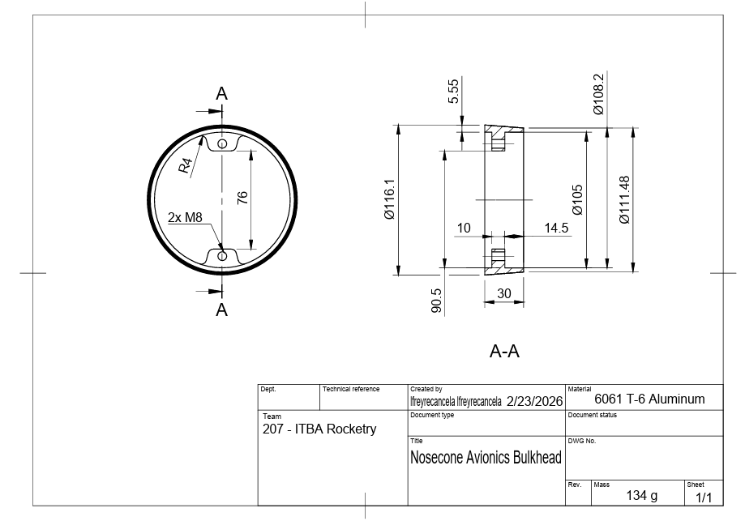
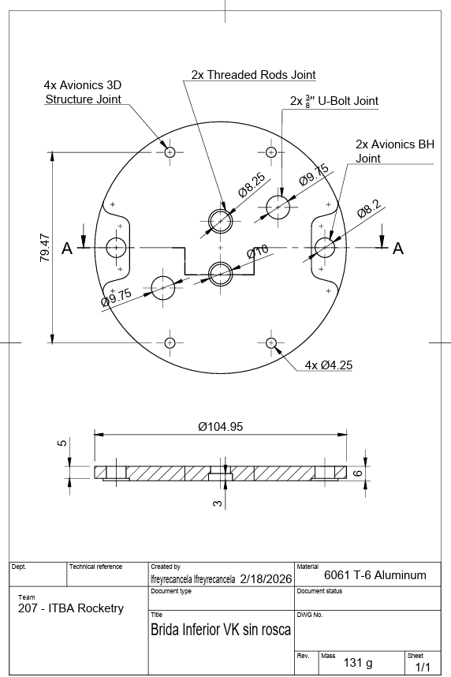
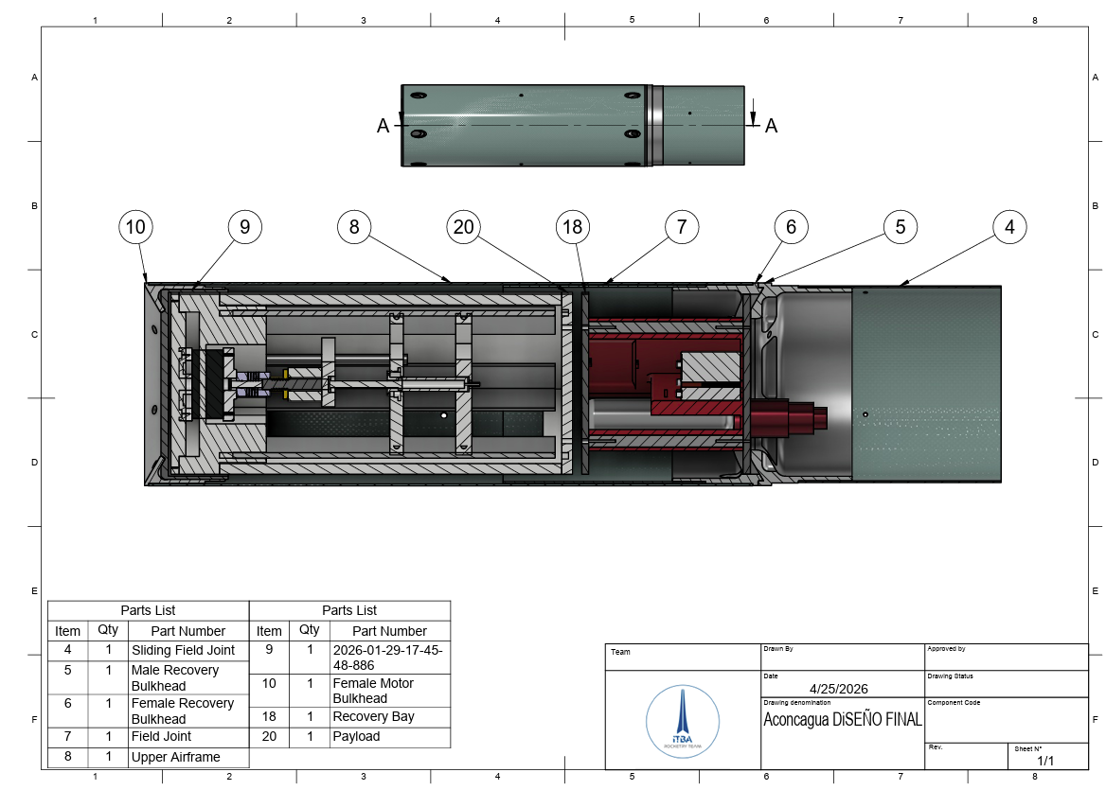
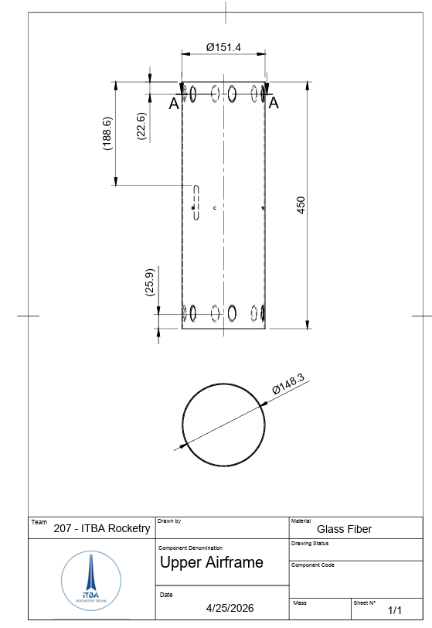
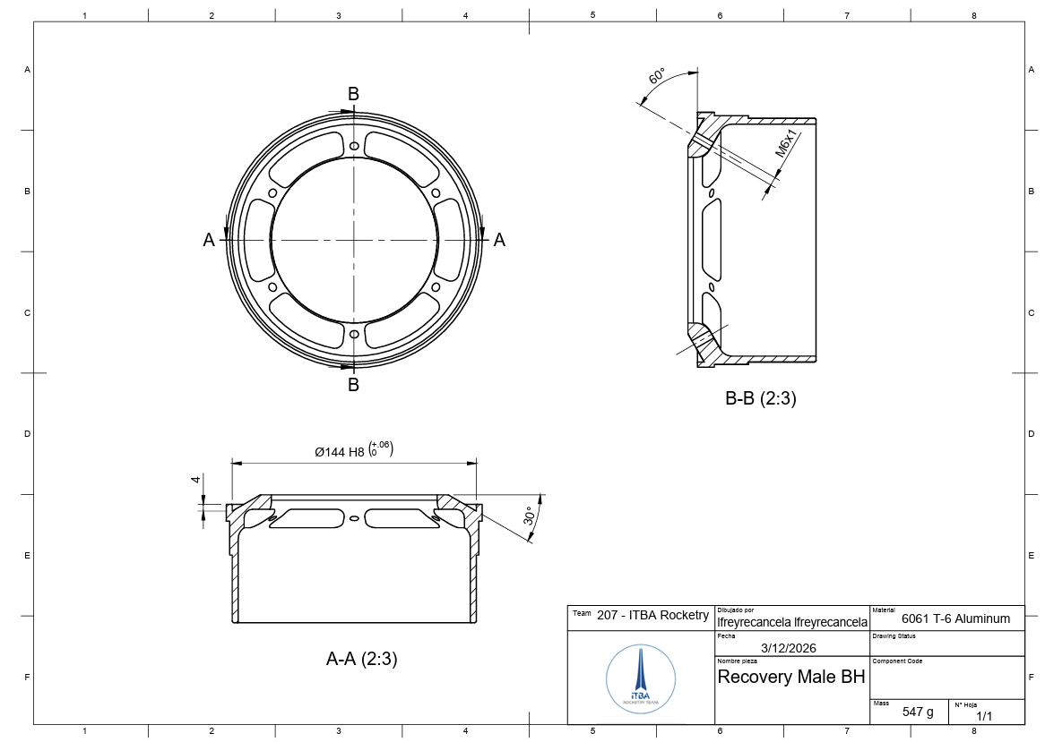
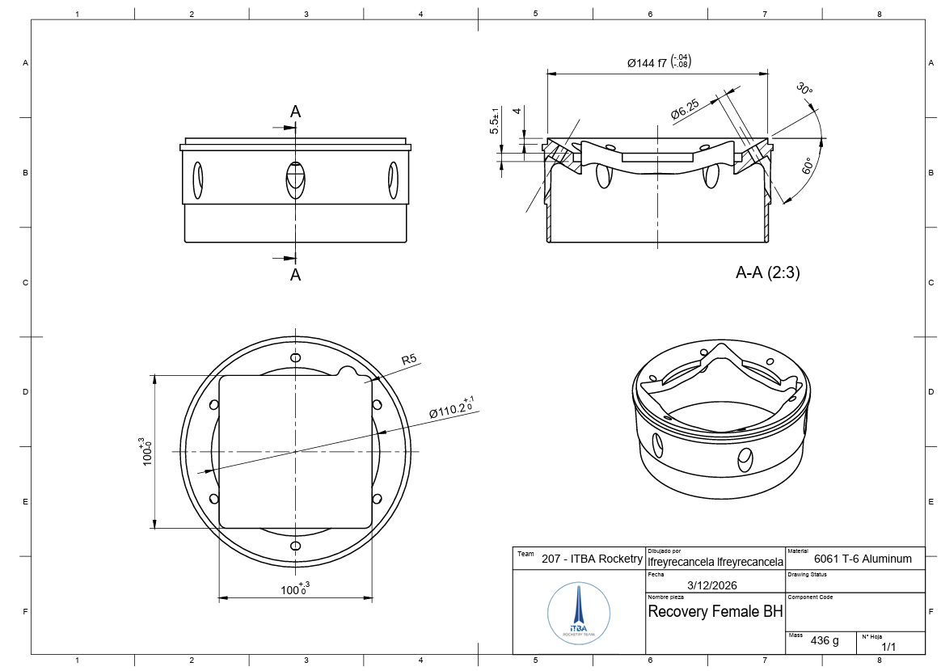

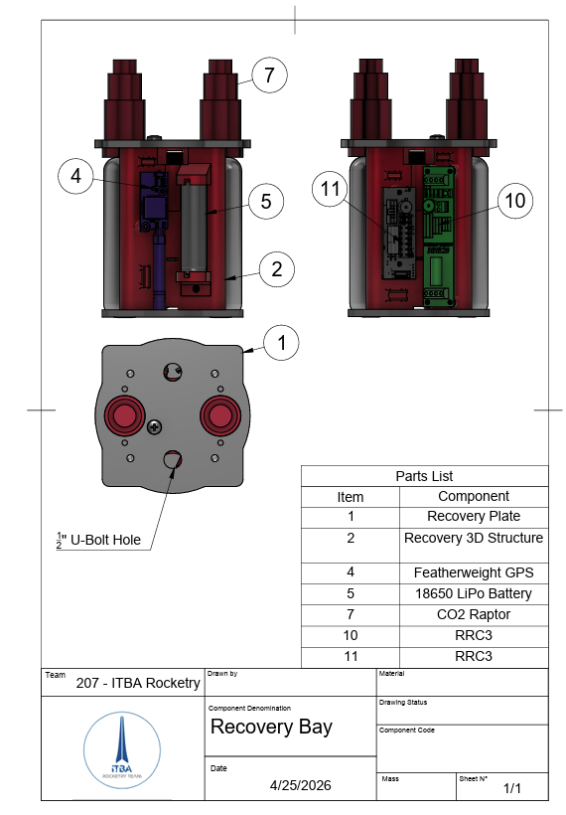

LiIon
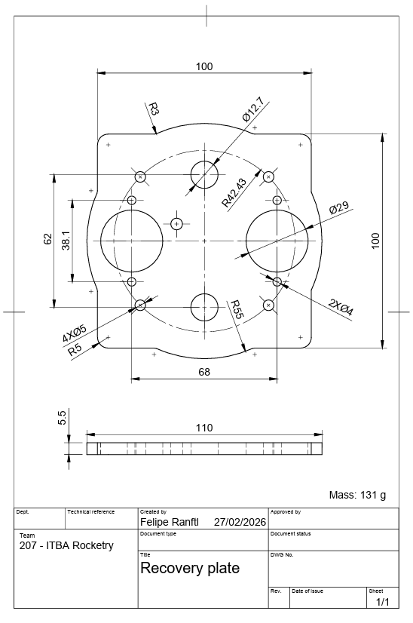
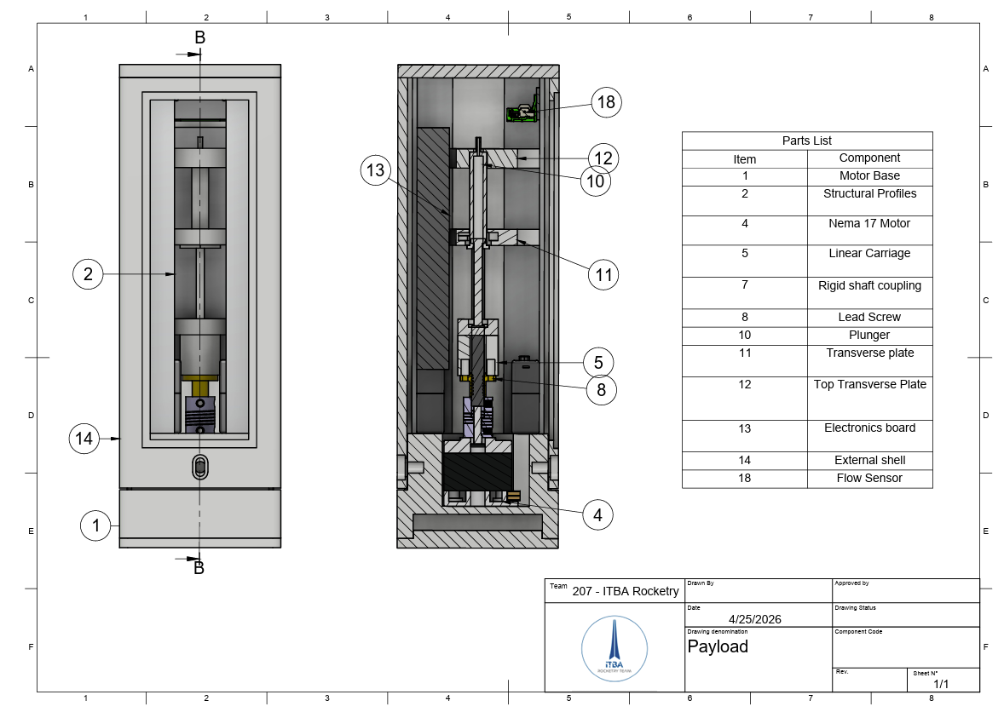

Appendix G: Aerodynamics Complements

G.1 CFRP theoretical in-plane properties estimation - Continuation and further properties
Constituent material properties and micromechanics
The UD lamina elastic constants were computed from constituent moduli using the Rule of Mixtures (ROM) for fibre-dominated properties and the Halpin–Tsai semi-empirical model for matrix-dominated properties, at a nominal fibre volume fraction V_{f} = 0.50. The Halpin–Tsai reinforcement parameter was set to ξ = 2 for transverse modulus E₂ and ξ = 1 for in-plane shear modulus G₁₂, consistent with the standard recommendations for cylindrical fibres (Halpin & Tsai, 1969). The governing equations are:
E₁ = E_f1·V_f + E_m·(1−V_f) = 116.75 GPa
ν₁₂ = ν_f·V_f + ν_m·(1−V_f) = 0.275
E₂ = E_m·(1 + ξ·η₂·V_f) / (1 − η₂·V_f) = 7.215 GPa, η₂ = (E_f2/E_m − 1)/(E_f2/E_m + ξ)
G₁₂ = G_m·(1 + ξ·η_G·V_f) / (1 − η_G·V_f) = 3.454 GPa
The hybrid laminate employs two distinct fabric architectures. The first is CARBONODB300, a non-crimp fabric (NCF) biaxial ply with ±45° fibre orientation and an areal weight of 300 g/m², for which UD elastic constants apply directly (no crimp penalty). Each physical ±45° pair comprises two independently stacked single plies of thickness t_{B} = 0.167 mm each. The second fabric is CARBONOGA90R, a plain-weave 0°/90° fabric with an areal weight of 302 g/m² and a crimp knockdown factor k_{c} = 0.92 applied to its in-plane moduli (Naik & Shembekar, 1992). Because the woven ply is balanced (equal 0° and 90° tow content), its effective moduli reduce to E_{1,w} = E_{2,w} = ½(E₁ + E₂)× k_{c} = 57.024 GPa, with Poisson ratio ν_{12,w} = 2ν₁₂ E₂/ (E₁ + E₂) = 0.032 (Jones, 1999 §2). The ply-level elastic constants and thicknesses are summarised in Table G1.

Property | Symbol | Value | Method | Reference
Fibre axial modulus | E_f1 | 230.0 GPa | Manufacturer data | TorayCA T700
Fibre transverse modulus | E_f2 | 15.0 GPa | Manufacturer data | TorayCA T700
Fibre shear modulus | G_f12 | 27.0 GPa | Manufacturer data | TorayCA T700
Fibre Poisson ratio | ν_f | 0.20 | Manufacturer data | TorayCA T700
Matrix elastic modulus | E_m | 3.5 GPa | Manufacturer data | LY1564 epoxy
Matrix Poisson ratio | ν_m | 0.35 | Manufacturer data | LY1564 epoxy
UD axial modulus | E_1 | 116.75 GPa | Rule of mixtures | Eq. (D.1)
UD transverse modulus | E_2 | 7.215 GPa | Halpin–Tsai (ξ=2) | Halpin & Tsai (1969)
UD in-plane shear modulus | G_12 | 3.454 GPa | Halpin–Tsai (ξ=1) | Halpin & Tsai (1969)
UD Poisson ratio | ν_12 | 0.275 | Rule of mixtures | Eq. (D.2)
UD ply thickness (DB300) | t_B | 0.167 mm | FAW / (2 V_f ρ_f) | areal weight
UD ply thickness (GA90R) | t_W | 0.336 mm | FAW / (V_f ρ_f) | areal weight
Woven ply axial modulus (crimp-corrected) | E_1ᵂ | 57.024 GPa | 0.5(E_1+E_2)×k_c | Naik & Shembekar (1992)
Woven ply Poisson ratio | ν_12ᵂ | 0.032 | 2ν_12 E_2/(E_1+E_2) | Jones (1999) §2
Crimp knockdown factor | k_c | 0.92 | Plain-weave correlation | Naik & Shembekar (1992)
Table G1 Constituent and UD ply-level elastic properties (T700 12K / Epoxy LY1564, Vₜ = 0.50). Unscaled ply thicknesses from areal-weight formula t = FAW / (Vₜ×ρₜ).
Stacking sequence — AR1 all-rounder architecture
The laminate follows the AR1 (All-Rounder) half-stack architecture, which interleaves NCF biaxial pairs and woven plies to achieve a balanced combination of in-plane shear stiffness and bending rigidity. The 11-entry half-stack is:
[±45ᴏᴄᶠ / 0ₚ / 0ₚ / ±45ᴏᴄᶠ / 0ₚ / ±45ᴏᴄᶠ / 0ₚ / 0ₚ]
where ±45ᴏᴄᶠ denotes an NCF ±45° pair (two singles, +45° above −45° within the sub-stack) and 0ₚ denotes a single 0°/90° woven ply. Applying the symmetric boundary condition produces the full 22-ply laminate:
[±45ᴏᴄᶠ / 0₂ₚ / ±45ᴏᴄᶠ / 0ₚ / ±45ᴏᴄᶠ / 0₂ₚ]ₛ
yielding 12 DB300 NCF single plies and 10 GA90R woven plies. The as-manufactured nominal ply thicknesses (0.167 mm for DB300 singles and 0.336 mm for GA90R layers) are scaled proportionally to reach the target laminate thickness h = 6.0 mm (scale factor 1.120), giving scaled thicknesses of 0.187 mm and 0.376 mm respectively. The symmetric stacking sequence guarantees B = 0 by construction; the numerical residual from CLT integration is max |B_{ij}| ≤ 2 × 10⁻¹⁰ N (relative error < 4 × 10⁻¹⁵, well within machine precision).
Classical Lamination Theory — A-matrix and in-plane engineering constants
The in-plane stiffness matrix A is assembled by integrating the transformed reduced stiffness matrix Q̄ through the laminate thickness:
A_ij = Σₖ Q̄_ij⁾ᵏⁿ · Δzₖ
where k sums over all plies. For the reference β = 0° configuration, the balanced symmetric stacking (equal ±45° ply counts, symmetric about the mid-plane) enforces A₁₆ = A₂₆ = 0, so the in-plane response fully decouples bending/stretching from shear. In-plane engineering constants are extracted by inverting the 3×3 in-plane matrix (reducing to the uncoupled 2×2 plus scalar for the orthotropic case):
E_x = 1 / (h·a_11), E_y = 1 / (h·a_22), G_xy = 1 / (h·a_66), ν_xy = −a_12 / a_11
where a = A⁻¹ is the compliance matrix. For the balanced β = 0° laminate, the A-matrix has A₁₁ = A₂₂ = 294.33 MN/m, A₁₂ = 71.13 MN/m, A₆₆ = 79.48 MN/m, yielding E_{x} = E_{y} = 46.19 GPa, G_{xy} = 13.25 GPa, and ν_{xy} = 0.242.
Aeroelastic tailoring — global β-rotation (Weisshaar, 1981)
A uniform tailoring angle β = 20° is applied to all plies in the laminate. Under this global rotation the stacking sequence becomes:
[(±45+20)ᴏᴄᶠ / 20₂ₚ / (±45+20)ᴏᴄᶠ / 20ₚ / (±45+20)ᴏᴄᶠ / 20₂ₚ]ₛ
= [+65/−25 / 20₂ / +65/−25 / 20 / +65/−25 / 20₂]ₛ
The β-rotation breaks the strict balance condition of the NCF ±45° pairs in the laminate-axis frame (the woven 0°/90° plies, being quasi-isotropic, are insensitive to in-plane rotation). As a result, the A-matrix acquires non-zero shear coupling terms A₁₆ = +15.82 MN/m, A₂₆ = −15.82 MN/m, and the apparent in-plane constants from A⁻¹ shift to E_{x} = E_{y} = 41.85 GPa, G_{xy} (apparent) = 15.03 GPa, and ν_{xy} (apparent) = 0.313.
The dominant aeroelastic effect of the β-rotation acts through the D-matrix bending stiffness rather than the A-matrix in-plane stiffness. The z-offset asymmetry within each NCF ±45° pair generates a non-zero bending–torsion coupling coefficient D₁₆. At β = 20° this term evaluates to D₁₆ = 13.05 N·m, compared to 20.87 N·m at β = 0°; the rotation optimises the coupling polarity to produce aerodynamic wash-out for the 57.4° aft-swept fin planform. Physically, D₁₆ couples spanwise bending curvature κ_{xx} to the twisting moment M_{xy}: when aerodynamic loading deflects the tip upward, the non-zero D₁₆ induces a nose-down twist that reduces the local angle of attack and, consequently, the aerodynamic load driving the instability. This mechanism is additive to the geometric wash-out produced by the leading-edge sweep, and the combined effect is quantified in the flutter analysis of Section D.2.2.
The stabilising range for an aft-swept fin with Λ = 57.4° is 0° < β < 45°, with the wash-out effectiveness peaking near β ≈ 30° (peak D₁₆ magnitude). The design choice of β = 20° is a conservative selection that preserves acceptable torsional stiffness D₆₆ = 289.93 N·m (1.5 % reduction from the β = 0° reference) while providing meaningful β-induced tailoring. Laminate-level properties for both the standard (β = 0°) and tailored (β = 20°) configurations are summarised in Table G2.

Property | β = 0° (standard) | β = 20° (tailored) | Unit
In-plane engineering constants (from A⁻¹)
Longitudinal in-plane modulus, E_x | 46.19 | 41.85 | GPa
Transverse in-plane modulus, E_y | 46.19 | 41.85 | GPa
In-plane shear modulus, G_xy | 13.25 | 15.03 | GPa
In-plane Poisson ratio, ν_xy | 0.242 | 0.313 | —
In-plane shear coupling, A_16 / t | 0 | +2.64 | GPa
Bending stiffness matrix (from D-matrix integration)
Spanwise bending stiffness, D_11 | 839.98 | 815.61 | N·m
Chordwise bending stiffness, D_22 | 839.98 | 869.28 | N·m
Bending–torsion stiffness, D_12 | 267.14 | 264.67 | N·m
Torsional stiffness (flutter driver), D_66 | 292.40 | 289.93 | N·m
Bend–twist coupling, D_16 | 20.87 | 13.05 | N·m
Table G2 Laminate-level in-plane and bending stiffness properties computed by CLT (h = 6.0 mm, AR1 layup, Vₜ = 0.50). In-plane constants derived from A⁻¹ inversion; D-matrix from thickness-cubed integration. β = 20° column is used as input to the flutter solver in Section D.2.2.
Laminate symmetry verification
Symmetric laminate construction enforces B = 0 analytically; the CLT integration yields a residual max |B_{ij}| = 1.76 × 10⁻¹⁰ N against a reference scale D₆₆/h = 4.83 × 10⁴ N, giving a relative error of 3.65 × 10⁻¹⁵ — comfortably within double-precision machine epsilon (~2 × 10⁻¹⁶). The symmetric construction also ensures absence of extension–bending coupling in service, consistent with a load-bearing panel that must not exhibit parasitic bending under in-plane loads.

G.2 Physical Model for Fin Flutter

Structural model
The fin planform was discretised into a structured mesh of 288 four-node Mindlin–Reissner (Q4) shell elements on a 24 × 12 grid, yielding 325 nodes and 1 950 total degrees of freedom. Each node carries six degrees of freedom: three translational and three rotational. The element stiffness formulation incorporates the full 3 × 3 CLT bending stiffness matrix D as the anisotropic bending constitutive contribution, while an isotropic-equivalent membrane and transverse shear model is derived from the in-plane shear modulus D₆₆. Selective reduced integration is applied to prevent shear locking: membrane and bending contributions employ 2 × 2 Gauss quadrature, and the shear term uses 1 × 1 quadrature. A lumped diagonal mass matrix is assembled from element area, shell thickness, and material density. The 25 root-chord nodes are fully clamped (all six DOFs suppressed), reducing the active system to 1 800 free degrees of freedom. The resulting Q4 mesh is shown in Fig.G1.

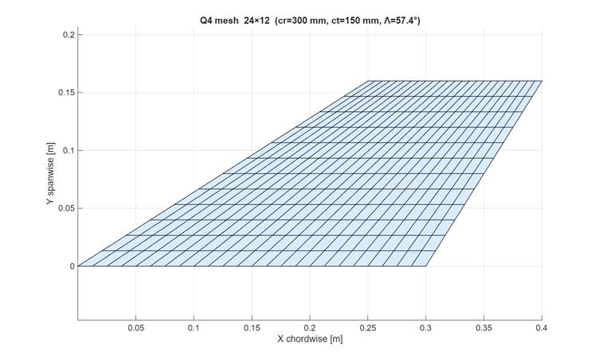
Fig. G1 Q4 finite element mesh of the Aconcagua fin (24 × 12 elements, Λ = 57.4°, cᵣ = 300 mm, cₜ = 150 mm, b = 160 mm).

Modal analysis
The natural frequencies and mass-normalised mode shapes are extracted from the generalised eigenvalue problem (K − ω²M)Φ = 0 applied to the reduced system via LAPACK direct factorisation, with spurious near-zero eigenvalues filtered by a relative threshold of 10⁻¹⁰ times the spectral range. The six lowest natural frequencies and their modal characters are summarised in Table G3, and the first four mode shapes are shown in Fig. G2.

Mode | Frequency [Hz] | Modal character
1 | 174.62 | First spanwise bending — dominant tip displacement, root fixed
2 | 437.72 | Second spanwise bending — one node interior to span
3 | 986.29 | Third bending / first torsional coupling
4 | 1075.10 | Combined bending–torsion, higher-order spanwise
5 | 1664.02 | Fourth bending / higher torsional content
6 | 2051.10 | Fifth bending / coupled chordwise–spanwise
Table G3 Natural frequencies of the clamped CFRP fin (6.0 mm T700/epoxy, β = 20° layup, Λ = 57.4°).
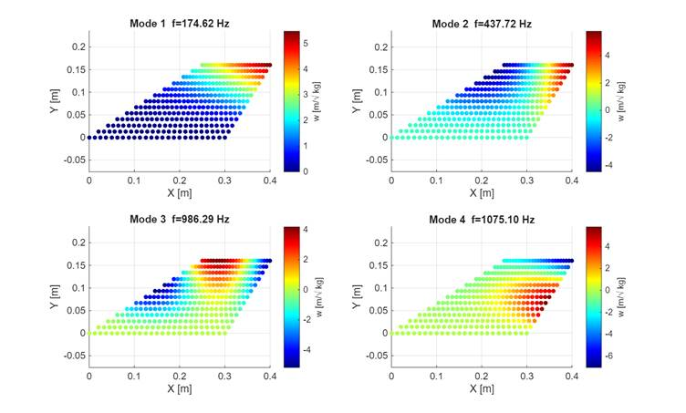
Fig. G2 First four mode shapes of the clamped fin. Colour map shows out-of-plane displacement magnitude (mass-normalised, m/√kg).
The fundamental bending mode at 174.62 Hz corresponds to first-order cantilever bending with maximum tip displacement and zero displacement at the root. The frequency ratio between modes 1 and 2 is 2.51, reflecting a well-separated modal spectrum. This separation is aerodynamically significant: mode-coalescence flutter — the classical bending–torsion coupling mechanism producing exponentially growing oscillations — requires two modes to approach the same frequency as dynamic pressure increases. The wide inter-mode spacing in Aconcagua's fin reduces susceptibility to this mechanism across the entire supersonic envelope.

Aerodynamic model
Aerodynamic loading is modelled using linearised second-order supersonic piston theory (Lighthill, 1953; Ashley & Zartarian, 1956), valid for M > 1. The pressure perturbation on the fin surface is:
p = (2q∞/β) (∂w/∂x + (1/U) ∂w/∂t),
where β = √(M²− 1) is the supersonic compressibility factor and w is the out-of-plane surface displacement. The generalised aerodynamic force (GAF) matrix Q(k) is computed for seven reduced frequencies k ∈ {0, 0.01, 0.05, 0.1, 0.2, 0.5, 1.0}. The quasi-steady matrix Q_{avg} is the real part of the mean of Q(k) over the unsteady points (k > 0), and the static matrix Q₀ ≡ Q(0) is retained for the divergence computation.
For the low-aspect-ratio planform (AR ≈ 0.5), the free-stream Mach number is used throughout the GAF computation, consistent with the Jones (1946) low-AR limit and standard practice in rocket fin flutter assessment (Garrick & Reed, 1981). The GAF matrix is computed at the worst-case flight condition — the point of maximum dynamic pressure along the trajectory: Mach = 1.846, q∞ = 209 827 Pa, h = 1 179 m, at t = 3.4 s after launch. The normalised GAF matrix is applied across all 246 supersonic flight points to evaluate local stability margins.

Stability analysis methodology
The aeroelastic stability of the fin is assessed by the p-k method applied in modal coordinates. Structural damping is included via a complex stiffness matrix Ω²_c = diag(ω_n²·(1 + i·g_s)) with a structural loss factor g_s = 0.01, which regularises the undamped system so that all modes begin with Re(p) < 0 at q = 0 and flutter onset is identified by the first zero-crossing of Re(p) from below.

The generalised aerodynamic force matrix is decomposed as Q(k) = Q₀ + i·k·Q₁, which is exact for piston theory (pressure is linear in ∂w/∂x and ∂w/∂t). The quasi-steady matrix Q₀ ≡ Re(Q(k = 0)) is the real part of the k = 0 generalised aerodynamic force; Q₁ = Im(Q(k₂))/k₂ is the aerodynamic damping slope extracted at k₂ = 0.01. Critically, Q(k) is used without symmetrisation: the physical off-diagonal coupling Qᵢⱼ = ∫φᵢ·(∂φⱼ/∂x) dA ≠ Qⱼᵢ represents the aerodynamic work done by mode j on mode i through chordwise slope, and symmetrising with (Q + Qᴴ)/2 destroys this cross-coupling and produces spurious eigenvalues.

At each dynamic pressure step q, the p-k iteration proceeds as follows. An effective aerodynamic matrix Q_eff = q·(Q₀ + i·k·Q₁) is formed at the current reduced frequency k = mean(Im(p))·b_ref/U. The eigenvalue problem p² = eig(Q_eff − Ω²_c) is solved for complex eigenvalues λᵢ, and the physical positive-frequency branch is selected as pᵢ = √λᵢ with Im(pᵢ) ≥ 0. Mode tracking across q steps uses greedy minimum complex-distance assignment to prevent mode-order crossings. The iteration repeats until |k_new − k_old| < 10⁻⁸. Flutter is identified as the first q at which any Re(pᵢ) crosses zero from below. The p-k sweep covers 150 steps from q = 0 to 4× the local flight dynamic pressure.

For the divergence analysis, the frequency-normalised aerodynamic stiffness matrix B̂ = diag(1/ω_n)·Q₀·diag(1/ω_n) is constructed at k = 0. Its real eigenvalues λ̂ᵢ give the per-mode divergence dynamic pressures q_div,ᵢ = 1/λ̂ᵢ. A positive λ̂ᵢ indicates a finite divergence pressure in that mode; a negative value indicates aerodynamically stabilising loading. The critical divergence speed is V_div = √(2·q_div/ρ), where q_div = 1/max(λ̂ᵢ > 0). The velocity margin at each flight point is V_div/V_flight = √(q_div/q_∞).

For the Aconcagua fin, the aerodynamic damping slope Q₁ is negligible in the modal basis (‖Q₁‖_F/‖Q₀‖_F < 10⁻³). This reflects the physics of the low-aspect-ratio (AR ≈ 0.53) swept planform: the dominant piston-theory contribution to the modal forces is the quasi-steady chordwise slope ∂w/∂x rather than the unsteady inertial term ∂w/∂t. As a consequence, the p-k k-iteration has negligible effect and the instability mechanism is quasi-static (divergence), not dynamic (flutter). The two wash-out mechanisms described in Section D.2.1 — geometric sweep and material D₁₆ coupling — ensure that all B̂ eigenvalues at the critical flight condition remain below the divergence threshold, as demonstrated in Appendix G.3.

G.3 Further Fin Flutter results analysis

The stability margin as a function of Mach number, expressed as the dynamic pressure ratio SM = q_div/q_∞, is shown in Fig. G3. The minimum margin is SM = 5.79× at Mach 1.85, equivalent to the velocity margin of 2.41× cited in Section D.2.2. The margin increases monotonically to SM = 33.1× at Mach 1.05, confirming robust stability throughout the powered-ascent corridor.

[ FIGURE PLACEHOLDER — Fig. G3 — Stability envelope (SM vs Mach, 246 supersonic points). Paste: results/velocity_envelope.png ]

Fig. G3: Aeroelastic stability envelope across 246 supersonic flight points. Stability margin SM = q_div/q_flight (dynamic pressure ratio). Dynamic flutter is not detected (V_flutter = ∞); the governing instability is quasi-static divergence. Minimum SM = 5.79× at the worst-case condition (Mach 1.85).

The B̂ eigenvalue spectrum at the critical flight condition (Mach 1.85, q_∞ = 209 827 Pa) reveals that four of the six structural modes carry negative eigenvalues (aerodynamically stiffening). Two modes carry positive eigenvalues: λ̂₁ = 8.23 × 10⁻⁷ Pa⁻¹ and λ̂₂ = 3.49 × 10⁻⁸ Pa⁻¹, corresponding to critical divergence dynamic pressures of 1 214 438 Pa and 28 680 000 Pa respectively, both far above the maximum flight dynamic pressure of 209 827 Pa. The governing divergence limit is set by mode 1 at 5.79× the worst-case flight condition.

[ FIGURE PLACEHOLDER — Fig. G4 — B-hat eigenvalue spectrum at critical condition (Mach 1.85). Paste: results/b_hat_eigenvalues.png or equivalent figure ]

Fig. G4: Divergence eigenvalue spectrum B̂ = diag(1/ω)·Q₀·diag(1/ω) at the critical flight condition (Mach 1.85). Positive bars indicate finite divergence dynamic pressures; negative bars indicate aerodynamically stabilising modes. Only modes 1 and 2 carry positive eigenvalues, both with critical pressures far exceeding the maximum flight dynamic pressure.

Physical interpretation

The decreasing velocity margin with Mach number (Table 6, Fig. 13) reflects the increasing dynamic pressure as the vehicle accelerates while climbing. Despite this trend, the margin remains well above unity throughout because the swept planform and composite tailoring produce two synergistic stabilising mechanisms.

The first is geometric aerodynamic wash-out from the 57.4° leading-edge sweep. As the fin deflects upward, the swept planform causes the local angle of attack to decrease toward the tip. In piston theory terms, the chordwise slope ∂w/∂x is predominantly negative for the first bending mode of a swept-back surface, producing a pressure distribution that opposes further deformation and contributes net positive stiffness to the aeroelastic system. This geometric effect is additive across all dynamic pressure levels.

The second is material wash-out from the bending–torsion coupling term D₁₆ = 13.05 N·m of the tailored β = 20° CFRP layup (Section D.2.1). The non-zero D₁₆ couples bending curvature κₓₓ to twisting moment Mₓᵧ such that upward bending induces nose-down twist, reducing the effective angle of attack at the tip and diminishing the aerodynamic excitation that drives divergence. The dominance of negative B̂ eigenvalues in Fig. G4 directly confirms this effect: the wash-out coupling converts what would otherwise be destabilising aerodynamic stiffness into net restoring stiffness for four of the six structural modes.

The combination of the two wash-out mechanisms ensures that the Aconcagua fin achieves a minimum divergence velocity of 1 491 m/s — 2.41× the maximum flight speed — at the worst-case dynamic pressure condition. The velocity margin ranges from 4.0× at the onset of the supersonic regime to 2.41× at peak dynamic pressure. No dynamic flutter is detected at any flight point (V_flutter = ∞): the p-k growth-rate history shown in Fig. 14 confirms that all modal damping rates remain negative throughout the full dynamic pressure sweep at the critical condition. The design is therefore robust against aeroelastic instability throughout the entire powered and coasting flight phases.

G.5 Nosecone Aerodynamic Heating Analysis

Because Aconcagua will achieve higher velocities and apogee altitudes than previous iterations, understanding the thermal loads during flight is critical. Specifically, the teams responsible for the fuselage and avionics require this information to evaluate the structural stability between the resin and fiberglass components, and to ensure that 3D-printed parts and internal electronics are not compromised by excessive heat.

Methodology

The study utilizes the Unsteady Finite Volume Method (FVM) to evaluate internal heat conduction, complemented by aerodynamic heating theories, solved using MATLAB. The approach relies on an axisymmetric analysis, allowing for accurate modeling of compressible flows and shock waves at a reduced computational cost.

Fluid and Shock Wave Modeling

The surrounding airflow is modeled using compressibility theory and ideal gas assumptions. Free-stream properties are derived from the rocket's flight trajectory simulated with OpenRocket (altitude and velocity over time), combined with the International Standard Atmosphere (ISA) model for air pressure and temperature, and finally Sutherland’s Law as well as the ideal gas equation for viscosity and density, respectively.
The transition to the supersonic regime is simplified to occur at a Mach number of 1. In the subsonic regime, the fluid dynamics are modeled as an isentropic compression without energy losses. In the supersonic regime, an oblique shock wave forms ahead of the nosetip, causing an entropy jump and a reduction in stagnation pressure. Because the stagnation point lies on the axis of symmetry, the shock wave is locally normal at the exact tip, allowing the use of Rayleigh's Pitot tube equation to determine stagnation pressure.

Heat Transfer Analysis

To accurately predict convective heat transfer, the analysis is divided by flight regime and geometric region as follows:
- Subsonic Regime: Heat flux is calculated using Eckert's Reference Enthalpy Method. Air properties are obtained through isoentropic relations, paired with a Newtonian expansion model, which assumes the fluid expands from the stagnation point laterally after losing its normal momentum component.
- Supersonic Regime - Region 1 (0 to 20 mm): In this critical leading-edge zone, the shock wave is assumed to be separated from the tip’s surface, and approximately normal. The Fay-Riddell theory is explicitly applied to calculate the stagnation point heat flux caused by oxygen molecule dissociation. Outside the exact tip, the Eckert method, paired with Newtonian expansion, is implemented considering the shock wave discontinuity.
- Supersonic Regime - Region 2 (20 to 200 mm): To optimize computational efficiency, this region is approximated as a perfect cone. The Taylor-Maccoll theory is applied to resolve the oblique shock wave and the corresponding pressure and temperature jumps. Local properties at the boundary layer edge are subsequently calculated, and the Eckert method is used again to determine convective heat flux.
Radiation heat transfer is altogether neglected. Finally, both the interior cavity of the nosetip and the interface between it and the fuselage are assumed heatsinks, to obtain the maximum heating scenario for the neighbouring components.

Meshing and Numerical Resolution

The FVM is solved employing an axisymmetric mesh, making use of a cut-cell technique to faithfully represent the Von Karman curve. A major challenge in Unsteady FVM is numerical stability, as the time step is strictly limited by the mesh's cell size, defined by the physical restriction:
$Δt<\frac{Δy^{2}}{2α}$
Because adapting a structured mesh to a curved profile generates exceptionally small surface cut-cells, the allowable time step could drop by several orders of magnitude. To solve this, a fusion logic was implemented: surface cells with a volume smaller than 50% of the nominal volume are merged with their lower neighbors, maintaining a stable time step throughout the simulation. Internal heat conduction is resolved using an explicit calculation model for Fourier's equation.

Results and Conclusions

The maximum internal temperature recorded during the flight simulation reached 357.2 K. The peak aerodynamic heat flux was observed to be under 900 kW/m². The heat flux transferred to the side resting against the composite material was practically insignificant.

The simulation results indicate a clear thermal evolution: initially, the hypersonic ascent generates significant positive heat flux due to air compression and viscous effects. However, once the maximum velocity peak has passed, and the rocket decelerates, altitude increases and surrounding air density decreases, these heating mechanisms dissipate, leading to convective cooling.
Thermal mapping revealed that the foremost region of the nosetip (0 to 20 mm) sustains higher temperatures compared to the rest of the cone. This phenomenon occurs because the airflow remains laminar in this specific portion throughout the entire flight, which drastically reduces the outward heat flux.
Furthermore, the simulation showed a discrete downward jump in heat flux at the 20 mm mark during supersonic flight. This is attributed to the transition from the detached shock wave model to the Taylor-Maccoll conical model, the latter predicting a lower adiabatic wall temperature.
Ultimately, the analysis confirms that the maximum temperatures reached at the composite interface are relatively low. Therefore, the aerodynamic heating of the nosetip does not pose a threat to the structural integrity or the avionics components.

G.6 Complementary Stability analysis

The stability curve across fligh is shown in Fig. G5.1:

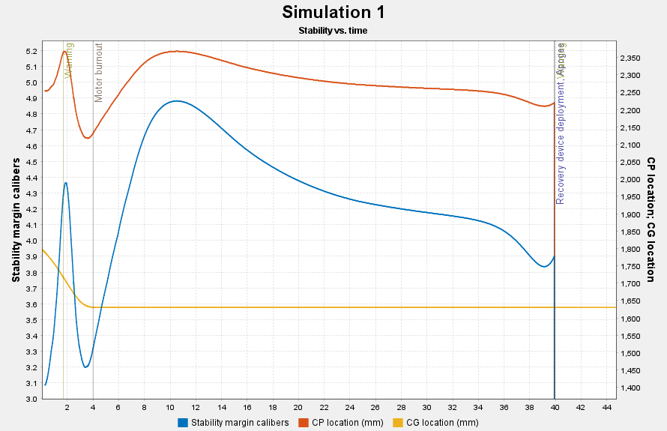
Fig. G.5.1: Aconcagua Stability across flight

Fig. G5.2 shows the angle of attack across flight, which is practically null until T+30s independent of wind conditions, according to OpenRocket simulations performed.

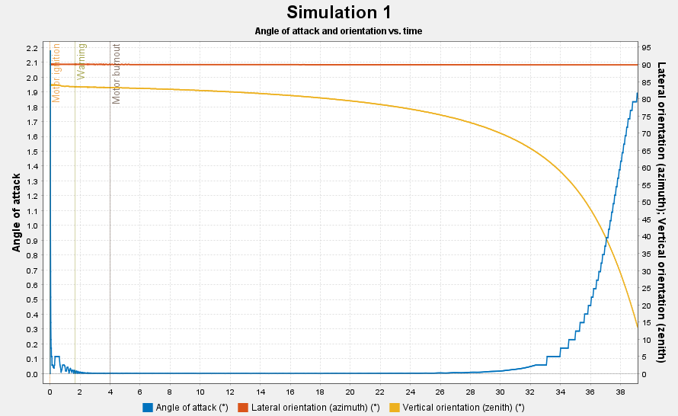
Fig. G.5.2: Aconcagua angle of attack across flight

Figure G5.1 shows that Aconcagua has a minimum stability of approximately 3 at rod clearance and a maximum value of almost 5 ten seconds after launch. Since the angle of attack is insignificant at that time point, overstability is not concerning regarding a change of direction in Aconcagua. The static margin at liftof is 15.7%, while the maximum stability is 23,7% at T+10s, complying with IREC DTEG

Appendix H: Avionics, Mission Control and Ground Station Complements

H.1 SRAD data acquisition board design

The RP2040 was selected as the main microcontroller. With two ARM M0+ cores running at 133MHz and the flexibility it offers in assigning functions to each pin, along with its high availability, it becomes the most convenient option for the development of this computer. It was proposed that the microcontroller communicate with all its peripherals via a single I2C bus, thus simplifying the board connections and providing the system with communication fast enough to meet the data acquisition needs (320kHz).

To measure, store, and communicate the rocket’s current altitude, the computer features two dedicated sensors: a BMP280 pressure sensor, chosen for its reliability and communication versatility; and a GNSS module, the U-blox SAM-M8Q, capable of measuring altitude by connecting to satellites from more than one system, with a maximum update rate of 18 Hz.

By combining information from three different sources and calculation methods, the goal is to obtain altitude data ’as accurately as possible’, improving the altitude calculation based on pressure-only sensors. Likewise, it was preferred not to place full responsibility for this measurement on the GNSS module, in order to add redundancy and reliability to the system. After the flight, we intend to have a better comprehension of the rocket dynamics during the ascent using the collected data from multiple sensors of different technologies. These data will be used for future analysis and simulations. Inertial measurements are carried out with an ICM-9250-type IMU, a 9-axis motion tracking device, which consists of a three-axis accelerometer, gyroscope, and magnetometer. It is capable of returning acceleration and angular velocity measurements at a maximum rate of 8 kHz.

Although the minimal RP2040 design requires the use of up to 128Mb of flash memory, which is capable of storing telemetry data for the entire flight time, for simplicity in data extraction, the computer was equipped with the option of inserting a micro SD card for data storage. The main idea here is that the processor builds data packets to be stored on the SD memory as a “csv,” and only uses its flash memory to store backup data, intermediate information required for packet assembly, or simply as a transmission buffer to the SD memory. Considering a desired data saving and transmission rate of approximately 10Hz, and taking into account that the packets consist of 12 fields of 6 bytes each, the maximum estimated storage time is 4 hours, which is more than enough for a typical flight duration. The PCB design was developed around the peripheral communication system with the RP2040. The base used was the design provided by Raspberry Pi for implementing circuits using the RP2040 microcontroller. Taking into account the minimum designs required by the component manufacturers, a layout was designed with a modular organization to ensure greater efficiency and simplify board testing. Since I²C is used as the communication protocol between peripherals and the 𝜇𝐶, two channels, SDA and SCL, are used. To ensure proper bus operation, pull-up resistors were placed on both channels near each module. These ensure that the lines remain high, allowing the communication speed to meet the previously specified value.

H.2 Telemetry & communication system

This section presents the wireless communication system used for real-time telemetry transmission from the rocket to the ground station. It discusses the hardware setup, antenna configuration, and key performance challenges such as signal propagation and link stability during flight.

The telemetry and communication system for the rocket is built around two Digi XBee-PRO S3B RF modules, operating in the 902–928 MHz ISM band with software-selectable channels. This system provides a robust wireless link between the onboard transmitter and the ground-based receiver, enabling real-time monitoring of critical flight data.
The onboard module transmits using a 2 dBi dipole antenna, offering a balanced radiation pattern that is ideal for mobile applications like rocketry, where orientation can change rapidly during ascent and descent. On the ground station side, a high-gain 12 dBi Yagi directional antenna is employed. This significantly improves link margin and reception sensitivity, particularly important as the rocket ascends to a maximum altitude of 3.5 kilometers and may reach a horizontal distance of up to 1 kilometer.

One of the key challenges in this setup is maintaining a stable link throughout the dynamic flight profile. The dipole antenna’s omnidirectional pattern offers coverage during rapid attitude changes, but its relatively low gain could limit effective range without the assistance of the high-gain Yagi on the ground. Accurate aiming of the Yagi antenna is essential, especially as it has a narrower beamwidth; manual or mechanical tracking may be required to keep the antenna aligned with the rocket during flight. Another consideration is Fresnel zone clearance. At a frequency around 915 MHz, the first Fresnel zone radius at maximum altitude can exceed several meters. Since the environment is flat and open, obstructions are unlikely, but awareness of this factor helps in evaluating possible signal degradation.

In addition to the electrical circuit and communication system, a backend system developed in Go for processing and distributing flight telemetry data received from the rocket was designed. The system implements a robust solution for real-time acquisition, processing, and distribution of critical data to a web interface using the WebSocket protocol. The system was designed with a modular architecture that enables a clear separation of responsibilities and facilitates maintenance and scalability. This architecture comprises five main components that work together to ensure the integrity and availability of telemetry data.
1) The serial communication module (serial.go) forms the core of the system, establishing and maintaining the connection with the XBee module. It processes incoming telemetry messages, logs all received data with precise timestamps, and detects connection losses to notify the system.
2) The web controller (controller.go) implements an HTTP server that manages WebSocket connections, providing endpoints for real-time data streaming. This component also enforces CORS (Cross-Origin Resource Sharing) policies to ensure secure connections from the web interface and retains the functionality to send commands, although it is currently commented out.
3) The broadcast system (broadcast.go) implements a publish/subscribe pattern that allows efficient data distribution to multiple clients connected simultaneously. This component dynamically manages subscriptions and ensures that all clients receive data in a synchronized manner.
4) The data models (model.go) define the necessary structures to represent flight telemetry, specifying the exact format of expected messages. These models remain compatible with legacy systems to ensure a smooth transition from previous implementations.
5) The testing utility (serial_tester.go) provides tools to verify parser functionality without requiring a real connection to the XBee module, supporting development and debugging of the system. For reference of the flow diagram of the rocket telemetry system.
The telemetry data acquisition and distribution follow a well-defined flow that ensures data integrity and reliability. The system starts by establishing a serial connection with the XBee module configured at 115200 baud, with standard parameters: 8 data bits, no parity, and one stop bit. Once connected, the system enters a continuous data-reading loop. Data is read byte-by-byte from the serial port and stored in a temporary buffer until a line-ending character is detected. Each complete message is immediately logged with a timestamp, providing full traceability of all communications.

Message processing is critical for extracting useful information. The system verifies that each message contains exactly 66 characters, corresponding to 11 fields of 6 characters each. These fields represent data sent from the rocket, including mission time, packet number, rocket status, altitude, inclination, GPS coordinates (latitude, longitude, altitude), acceleration, temperature, and battery voltage. We rely on the native CRC-16 error checking of the XBee S3B module for messages received with errors; such messages are discarded. The system includes a connection error detection mechanism that continuously monitors the time since the last message was received. If more than 4 seconds pass without receiving data, an error notification is generated to alert of communication loss.
Data is distributed to web clients through a WebSocket server that exposes the /system_status endpoint. The server implements origin checks for security and maintains persistent connections with web clients. The broadcast system ensures each new client is automatically subscribed to the data stream and receives real-time updates packaged in JSON format. System security was carefully considered during design. Strict CORS settings are applied to limit connections to specific, authorized origins. Additionally, the WebSocket server performs origin verification before accepting new connections, ensuring only authorized clients can access the data stream. Error handling was designed to allow recovery from connection failures and parsing errors, ensuring continued system operation under adverse conditions. The system has been optimized to handle multiple simultaneous connections using goroutines, Go’s native concurrency model. Mutexes are used to prevent race conditions when accessing the serial port, ensuring data integrity. Serial data reading and log writing are performed using buffers to maximize I/O efficiency.

H.3 Antenna tracking

The tracking algorithm receives the position of both the antenna and the rocket in a common three-dimensional reference frame:
Antenna position: (xₐ, yₐ, zₐ)
Rocket position: (xᵣ, yᵣ, zᵣ)
From these two vectors, the system computes the relative displacement from the antenna to the rocket, also referred to as the line-of-sight vector:
d = rᵣ − rₐ
whose Cartesian components are:
dₓ = xᵣ − xₐ
dᵧ = yᵣ − yₐ
d_z = zᵣ − zₐ
This formulation was selected because the tracking problem is fundamentally directional: the antenna must point along the vector that joins the ground station to the rocket. Expressing the problem in terms of the relative displacement vector makes the computation independent of the absolute position of the system, as long as both positions are defined in the same coordinate frame.

The antenna orientation is defined by two angles:
Azimuth (φ), representing rotation in the horizontal plane
Elevation (θ), representing vertical inclination
These angles are obtained from the components of the line-of-sight vector as:
φ = atan2(dᵧ, dₓ)
θ = atan2(d_z, √(dₓ² + dᵧ²))
The azimuth angle is calculated from the projection of the line-of-sight vector onto the horizontal plane. The use of the atan2 function ensures correct quadrant identification and avoids ambiguity when dₓ is close to zero.
The elevation angle is computed using the horizontal distance √(dₓ² + dᵧ²), which corresponds to the magnitude of the projection of the line-of-sight vector onto the ground plane. This allows the vertical angle to be referenced to the local horizon, which is the physically meaningful quantity for antenna pointing.
This formulation is standard for line-of-sight tracking systems and provides a direct mapping from Cartesian position measurements to angular coordinates.

Once the target azimuth and elevation are computed, the angles are converted from radians to degrees and mapped to the servo motors that actuate the antenna mount.
Since standard hobby servos operate over a bounded angular range from 0° to 180°, while the computed angles are centered around zero, an angular offset is applied before commanding the actuators:
Servo azimuth command = φ + 90°
Servo elevation command = θ + 90°
This linear mapping was chosen because it is simple to implement and preserves a direct correspondence between the calculated pointing angle and the actuator command.
To protect the mechanical system and ensure valid actuator operation, the commands are saturated within the servo limits:
0° ≤ command ≤ 180°
This guarantees that the tracking system remains within the physical range of the actuators even under extreme position inputs.

The main advantage of this approach is its simplicity. By directly computing the antenna pointing direction from the rocket position, the system avoids the need for iterative correction or signal-based optimization. This reduces computational burden and allows the algorithm to run with minimal latency, which is especially valuable in a real-time embedded system.
However, this strategy also introduces limitations. Since the control is purely geometric and feedforward, the final antenna orientation depends entirely on the accuracy and timeliness of the position data. As a result, the system is sensitive to:
Position estimation errors
Telemetry latency
Servo backlash and mechanical misalignment
Despite these limitations, the selected approach provides a robust and practical solution for a first implementation of a real-time antenna tracker. Future improvements may include measurement filtering, predictive compensation for communication delays, and closed-loop correction based on signal strength or actuator feedback.

Appendix I: Recovery Complements

I.1 CO2 Calculations

CO₂ Ejection Charge Sizing
The rocket performs tube separation at apogee using a RAPTOR CO₂ ejection device manufactured by Tinder Rocketry. The device punctures a CO₂ cartridge via a black-powder-driven piston, releasing pressurized gas into the parachute bay to separate the airframe sections. The amount of CO₂ required is determined from the ideal gas law, following the methodology outlined below.

Separation Force
The total force that the CO₂ pressure must overcome consists of two contributions: the combined shear force of the nylon shear pins and the shear resistance of the bonded bulkhead interface. The shear pin contribution is given by
F_{pins} = N · F_{pin} (1)
where N is the number of shear pins (4), and F_{pin} is the shear load per nylon 5/16” pin (350 N, representative value for HPR nylon shear pins). The bulkhead bond resistance is estimated from
F_{bond} = τ · A_{bond} = τ · π · d · w (2)
where τ is the epoxy shear strength (12 MPa, structural epoxy), d is the internal airframe diameter (145 mm), and w is the bond bead width (5 mm calibre). The total separation force is
F_{sep} = F_{pins} + F_{bond} (3)
Evaluating Eqs. (1)–(3) with the parameters above F_{pins}, F_{bond} and F_{sep} can be obtained.

Required CO₂ Pressure
The gauge pressure that the CO₂ gas must supply across the bulkhead face area to produce the required separation force is
P_{CO₂} = F_{sep} / A_{BH} (4)
where A_{BH} is the cross-sectional area of the bulkhead (πd²/4 = 165.13 cm² for d = 145 mm).

Atmospheric Conditions at Apogee
The apogee altitude is approximately 30000 ft AGL; the temperature is expected to be near to -50°C
P_{atm} = 26.44 kPa, T_{CO₂} = -50.0°C (223.1 K) (5)
The CO₂ gas is assumed to reach thermal equilibrium with the surrounding air at deployment. The absolute pressure inside the parachute bay required for separation is therefore P_{abs} = P_{CO₂} + P_{atm}.

Parachute Bay Volume
The parachute bay is modelled as a cylinder of internal diameter d and length L. Its volume is
V_{P} = A_{BH} · L (6)
With L = 500 mm, this gives V_{P} = 8256 cm³ (503.8 in³).

CO₂ Mass from the Ideal Gas Law
The number of moles of CO₂ required to fill the parachute bay at the absolute separation pressure is found from the ideal gas law:
n_{CO₂} = P_{abs} · V_{P} / (R · T_{CO₂}) (7)
where R = 8.314 J·mol⁻¹·K⁻¹ is the universal gas constant. Converting moles to mass:
M_{CO₂} = n_{CO₂} · MW_{CO₂} (8)
where MW_{CO₂} = 44.01 g·mol⁻¹. Evaluating Eqs. (7)–(8) with the above values:
n_{CO₂} = 0.477 mol
M_{CO₂} = 0.477 mol × 44.01 g·mol⁻¹ = 21.01 g

Cartridge Selection
The ideal-gas calculation yields a minimum required CO₂ mass of 21,01 g to achieve separation at an apogee of 30000 ft AGL. A safety factor must be applied on top of this theoretical minimum to account for gas leakage past seals, thermal losses, and manufacturing variability in the shear pin strength. The deployment system carries two RAPTOR CO₂ devices. The first one counts with a 33 g cartridge (1.57 safety factor) and the redundant one counts with a 45 g cartridge (2.14 safety factor).

Appendix J: Payload Complements

J.1 Flow system
The selection of components was guided by the choice of flow sensor, which established the target flow rate that was to be achieved by the infusion pump. Due to their availability and ease to source, Sensirion sensors were selected. In particular, the SLF3S-0600F (See Fig. J1) was chosen over the SLF3S-1300F and LD20-2600B due to its higher accuracy at low flow rates and its reusability, respectively.

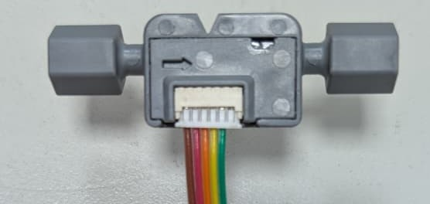
Fig. J1: Flow sensor

This selection constrained the interface to adapters with a 1/4″-28 UNF flat-bottom thread (See Fig. J2), which in turn limited the tubing outer diameter (OD) to either 1/16″ or 1/8″. Tubing with 1/8″ OD and 1/16″ inner diameter (ID) was selected due to its widespread availability and ease of procurement. Transparent FEP tubing was used to enable the implementation of an SRAD air-in-line detector based on infrared (IR) transmission. Flangeless FlushNuts were chosen to connect the flow sensor to the tubing, allowing for a more compact design by eliminating the threaded head that most adapters have. Standard Luer adapters compatible with 1/16″ ID tubing were used to connect the syringe to the system. Distilled water is used to reduce the risk of residue accumulation and ensure reliable operation of the flow sensor.

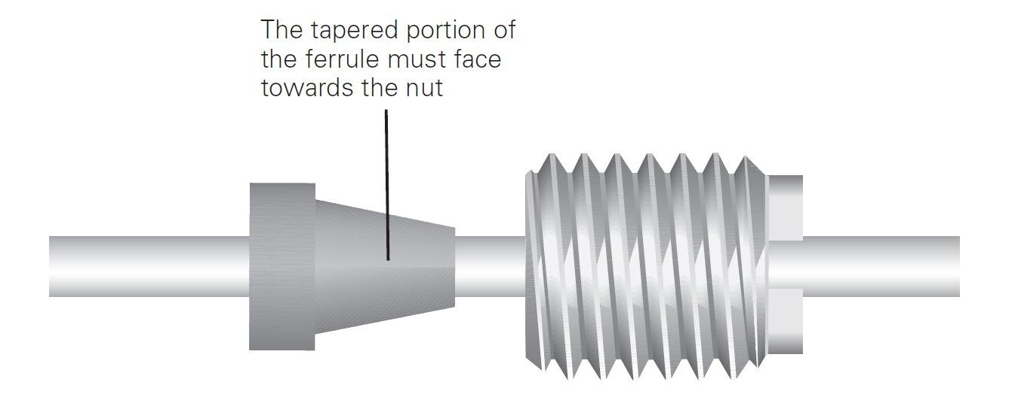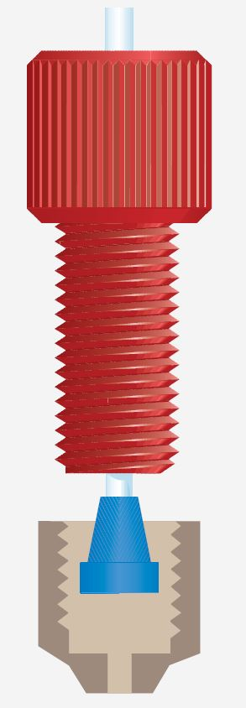
Fig. J2: FEP Tubes Adapters

The system flow rate is described by:

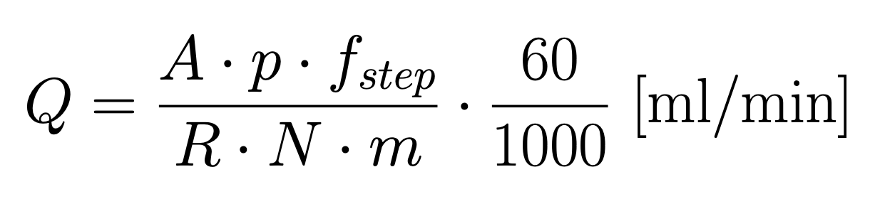

Q → Flow rate [mm3\s → uL/min]
A → Syringe cross section area [mm2] (3 ml syringe has 58,9 mm2)
p → Lead screw pitch [mm] (1 mm)
fstep → Step frequency for the stepper motor [Hz]
R → Stepper reduction
N → Number of steps the motor has
m → Number of microsteps

Given that the flow sensor exhibits its lowest relative error at flow rates below 2000 μL/min, all component combinations were evaluated to ensure operation within this range. A 3 mL syringe was selected over a 1 mL alternative despite its larger cross-sectional area, as its shorter length allowed the payload to meet the 3U volume constraints. For similar spatial limitations, a stepper motor with a reduction stage was not implemented, although it would have provided greater flexibility in achieving the desired flow range; this limitation was partially mitigated through the use of microstepping. The smallest commercially available lead screw pitch was selected to maximize linear resolution. A ball screw was initially considered to minimize backlash; however, it was ultimately not used due to size constraints. The actuation system employs a high-torque NEMA 17 stepper motor with 200 steps per revolution. To reduce pulsatile flow effects, the step frequency was empirically determined to be greater than 1000 Hz. Taking all of these considerations into account, the system was configured to deliver a nominal flow rate of approximately 1100 μL/min.

Based on the estimated interval between launch and apogee, an operating time of 60 seconds was selected. This results in a required working volume of approximately 1.6 ml to be carried by the syringe. For redundancy, the system is capable of accommodating up to 2 ml without modifications to the design.

A repurposed vial with self-sealing rubber septum is used as the collection container for the distilled water downstream of both sensors. Two needles are employed, one serves as the fluid inlet, while the other acts as a vent, allowing air to escape selectively through a hydrophobic membrane. The needles are fixed in place using silicone adhesive to prevent displacement and maintain sealing integrity.

J.2 Power system
18650 lithium-ion cells were selected. 9V batteries were discarded because their limited current delivery made them unsuitable for reliable system operation. The superior current output and higher capacity of the 18650 were the drivers for this decision.

Four 18650 cells are connected in series, providing a nominal voltage of 14.8 V for the motor. A step-down regulator is used to derive a stable 3.3 V supply for the logic system. While in a dormant state, the system draws approximately 90 mA, increasing to 1 A during active operation for the 60 seconds after launch. Considering a 18650 cell has a nominal capacity of 2600 mAh and based on the average current consumption, the system achieves an estimated operational lifetime of approximately 29 hours, exceeding the minimum operational lifetime of 4 hours, established as an internal design requirement.

J.3 IR Air Bubble Measurement

Inspired by the optical sensing principles employed in pulse oximeters, an air-in-line detector was developed. An IR LED (See Fig. J3) emits light through the tubing, with an IR-sensitive phototransistor positioned opposite to it. The phototransistor modulates the current through resistor R2 as a function of the incident light intensity. This configuration enables the detection of air pockets within the tubing, as variations in the optical properties of air and liquid produce measurable changes in the transmitted light intensity. Detection is achieved by measuring the voltage across resistor R2, with the presence of air in the line producing a decrease in the measured voltage. The acquired data is stored on the onboard SD card and will later be compared with the flow sensor measurements to validate the experimental detector. Given the known flow rate and the spatial separation between the IR detector and the SLF3S-0600S sensor, the expected time delay between signals can be used to assess detection accuracy.

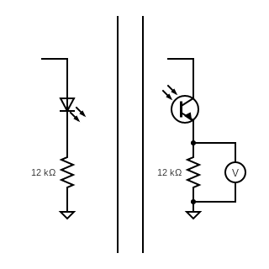
3.3V
3.3V

R1
R2
Fig. J3: IR Bubble detection device

A dedicated housing was designed to fix the components and tubing in position, while also serving to shield the system from ambient light during testing. The housing is mounted to the top structural plate of the payload (see Fig. J4).

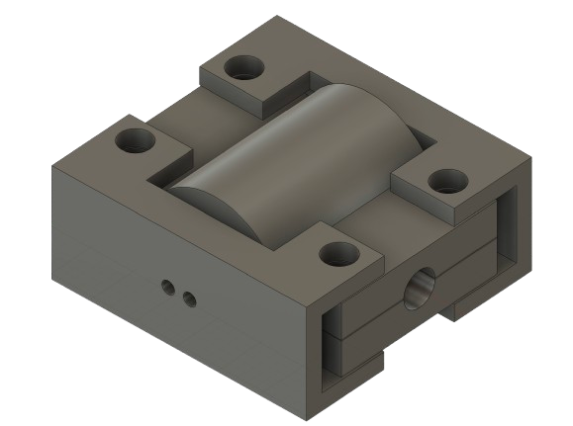
Fig. J4: IR Bubble detection mounting device

The payload is placed in a tip up orientation to ensure that in the case an air pocket forms, it will naturally migrate towards the exit port and be detected by the sensors.

Appendix K: Flight Loads Model and FEM Validation

K.1 Introduction
This appendix presents the mathematical flight loads model developed for Aconcagua and the Finite Element Method (FEM) validation of its aluminium bulkheads. The loads model follows the methodology established by Newlands, Heywood, and Lee in Rocket Vehicle Loads and Airframe Design (AspireSpace Technical Papers, 2016), adapted where appropriate to reflect Aconcagua's supersonic flight envelope and CFD-derived lateral aerodynamic data obtained from OpenFOAM simulations. The FEM analysis was conducted in ANSYS Mechanical, with each bulkhead evaluated independently under the worst-case combined loading identified by the mathematical model.
The purpose of this analysis was twofold. First, it provides quantitative load inputs axial force, lateral shear, and bending moment at each structural station replacing conservative rule-of-thumb estimates with physics-based values. Second, it allows the team to reduce structural safety factors toward analytically validated minima, directly supporting the mass optimization objective described in Section C of the main report.

K.2 Vehicle Discretisation and Inertia Model
The vehicle was discretised into a series of lumped-mass stations along its longitudinal axis, measured from the nosecone tip (x = 0). Each bay was assigned its component masses, centre of mass, and axial moment of inertia contribution. The total lift-off mass at the time of analysis was 30.87 kg over a total length of 2.85 m. The aerodynamic reference parameters used throughout the model are listed in Table K.1.

Parameter | Symbol | Value
Reference diameter | D_ref | 151 mm
Reference area | A_ref | 0.0246 m²
Total axial drag coefficient | C_dt | 0.80
Nosecone profile | — | Von Kármán 5:1 (Ogive)
Nosecone CP from nose | x_CP,nose | 454.4 mm
Nosecone lateral lift (max-qa) | L_nose | 87.35 N
Number of fins | N | 4
Fin semi-span | S | 120 mm
Fin root chord | C_R | 270 mm
Fin tip chord | C_T | 110 mm
Fin CP from nose | x_CP,fins | 2,616.0 mm
Fin lateral lift (max-qa) | L_fins | 247.62 N
Boattail lower diameter | D_bt | 110 mm
Boattail CP from nose | x_CP,bt | 2,784.2 mm
Boattail lateral lift (max-qa) | L_bt | 40.99 N
Table K.1: Aerodynamic reference parameters and lifting surface data.
The moment of inertia of each component about the vehicle centre of gravity was computed using the parallel-axis theorem:
I_total = Σ [ I_cm,i + m_i · (x_i − x_CG)² ]
where I_cm,i is the self-inertia of component i about its own centroid, m_i its mass, x_i its axial centre of mass position, and x_CG the vehicle's instantaneous centre of gravity. The CG position varies during motor burn as propellant is consumed; the model evaluates it at each of the three critical flight conditions defined in Section K.3. The vehicle mass breakdown used in the model is presented in Table K.2.

Bay / Component | x_CM from nose [mm] | Mass [kg] | Inertia [kg·mm²]
Avionics (Nosecone bay) | 325 | 2.093 | 3,524,678
Recovery | 720 | 4.000 | 3,259,486
Nosecone composite shell | 802 | 0.400 | 269,420
Avionics bulkhead | 350 | 0.093 | 150,639
Bulkhead 1 | 980 | 0.627 | 258,993
Payload | 1,155 | 2.000 | 437,490
Bay 2 composite | 1,155 | 0.839 | 183,527
Motor Bulkhead (×2) | 1,330 | 0.357 (×2) | 30,586 (×2)
Fincan composite | 1,971 | 2.016 | 244,564
Motor | 2,101 | 16.800 | 3,843,314
Centering rings (×3) | 1,680 – 2,380 | 0.260 (×3) | variable
Boattail | 2,790 | 0.143 | 194,849
TOTAL | 1,622.7 (CG at liftoff) | 30.87 | —
Table K.2: Vehicle mass distribution used in the load model. Positions measured from nosecone tip.

K.3 Critical Flight Case Selection
Rather than evaluating loads at a single design point, the model was applied to three candidate flight conditions that are known to produce local maxima in aerodynamic loading. Each was identified from the OpenRocket trajectory simulation. Following Newlands et al., the maximum potential aerodynamic load occurs at the maximum of the product q·|dC_L/dα|, where q is the dynamic pressure and dC_L/dα is the combined lift-curve slope of all lifting surfaces. Three distinct candidates emerge from this criterion, each governing a different structural quantity:

–max-q — Maximum dynamic pressure. Occurs near motor burnout (t ≈ 4.0 s, V ≈ 800 m/s) when dynamic pressure q = ½ρV² is at its peak. At this condition no lateral wind is applied, so the angle of attack is minimal. This case governs axial aerodynamic forces but produces the lowest bending moment of the three cases.
–max-qa — Maximum dynamic pressure with lateral wind. Applies the same maximum dynamic pressure as max-q but simultaneously imposes the design wind speed of 36 km/h (10 m/s), generating a gust-induced angle of attack on the vehicle. The combination of high q and non-zero α produces the maximum aerodynamic side-load and, consequently, the maximum internal bending moment at every structural station. This case was identified as the governing design condition for bulkhead sizing.
–max-av — Maximum vertical acceleration. Corresponds to the instant of peak motor thrust on the O5500X thrust curve, occurring early in the powered flight phase. At this point the motor is producing its maximum thrust of 7,749 N significantly above the average thrust of 5,514 N while the vehicle mass is still close to its launch value. Although the vehicle has not yet reached high speed and dynamic pressure is therefore well below its maximum, the combination of peak thrust and high vehicle mass produces the largest axial compressive load in the airframe. This case governs the axial compression analysis of the motor bulkhead and fincan.

The design gust velocity of 10 m/s is consistent with the NASA sharp-edged gust specification of 9 m/s described by Newlands et al., rounded conservatively. The angle of attack induced by the lateral wind component is:
α = arctan( U_wind / V_vehicle )
where U_wind is the lateral wind velocity and V_vehicle the vehicle's instantaneous axial speed. Table K.3 summarises the governing parameters for all three cases.

Parameter | max-q | max-qa (Governing) | max-av
Dynamic pressure q [Pa] | 338,817 | 338,744 | 99,829
Angle of attack α [rad] | 0.01250 | 0.01249 | 0.02443
Axial acceleration a_z [m/s²] | 22.90 | 15.86 | 299.41
Lateral acceleration a_x [m/s²] | 273.38 | 272.94 | 307.63
Air density ρ [kg/m³] | 1.059 | 1.057 | 1.198
Lateral drag coefficient C_dv | 0.2096 | 0.2096 | 0.2096
Vehicle speed V_vert [m/s] | 799.97 | 800.52 | 409.35
Wind speed V_wind [km/h] | 36 | 36 | 36
Motor thrust T [N] | 2,042 | 2,032 | 7,749
CG from nose [mm] | 1,569.8 | 1,915.7 | 1,692.0
Table K.3: Flight case parameters. max-qa governs bending moment at all structural stations.
It is noteworthy that the max-qa case produces a higher bending moment than max-q despite having nearly identical dynamic pressure. This occurs because the CG position at the max-qa condition (x_CG = 1,915.7 mm) is significantly further aft than at max-q (x_CG = 1,569.8 mm), a consequence of propellant mass consumed during the burn between the two conditions. The longer moment arm between the nosecone aerodynamic centre of pressure (x_CP = 454.4 mm) and the aft CG amplifies the pitching moment generated by the nosecone lateral lift, yielding higher internal bending moments throughout the airframe despite the same dynamic pressure.

K.4 Mathematical Loads Model
The loads model calculates the internal forces and moments at any cross-section of the airframe by treating the rocket as a free body and applying Newton's second law to each sub-section forward of the cut. The approach follows the framework of Newlands et al., extended to include a CFD-derived lateral body force and the rotational inertia loads arising from angular acceleration. Five load types are considered.

K.4.1 Axial Loads — Thrust and Drag
The axial compressive force in the airframe arises from the net difference between motor thrust and aerodynamic drag, distributed according to the inertial load of each mass station. The total aerodynamic drag force acting on the vehicle is:
F_drag = q · C_dt · A_ref
where q is the dynamic pressure, C_dt the total axial drag coefficient (0.80), and A_ref the reference cross-sectional area (0.0246 m²). The internal axial force R_z(x) at any station x, evaluated by summing over all components forward of x, is:
R_z(x) = Σ m_i · a_z − T + F_drag,forward(x)
where the summation runs over all mass stations forward of x, a_z is the vehicle axial acceleration, T the motor thrust (applied only aft of the motor bulkhead), and F_drag,forward(x) the drag contribution of components forward of x. Negative values indicate axial compression.

K.4.2 Lateral Loads — Aerodynamic Lift Forces
The lateral aerodynamic forces arise from the gust-induced angle of attack and are concentrated at the centres of pressure of the three lifting surfaces: nosecone, fins, and boattail. Each is treated as a discrete point load following Newlands et al., since the fuselage body between them generates negligible lift at the angles of attack considered (α < 1.5°). The normal force on each lifting surface is:
L_i = q · A_ref · (dC_N/dα)_i · α
where (dC_N/dα)_i is the normal force coefficient slope of surface i, evaluated at the relevant Mach number using OpenRocket aerodynamic data. The boattail contributes a stabilising (negative) lateral force.

K.4.3 CFD-Derived Lateral Body Force
In addition to the concentrated lifting surface loads, the team's model includes a lateral pressure force arising from the wind acting directly on the cylindrical fuselage body. This term, characterised by the lateral drag coefficient C_dv, was obtained from OpenFOAM CFD simulations of the full rocket geometry at the design wind condition (details are presented in the Aerodynamics appendix). The lateral body force is:
F_lateral,body = q · C_dv · A_ref
At the max-qa condition, C_dv = 0.2093, giving a lateral body force contribution that is superimposed on the discrete surface loads when computing the internal shear force distribution. This approach departs from the standard Newlands et al. framework, which treats the body as non-lifting, and produces a more conservative (higher) shear force along the fuselage.

K.4.4 Longitudinal and Lateral Inertia Loads
During powered flight, both the axial acceleration a_z and the lateral acceleration a_x create inertial load reactions distributed along the airframe. The longitudinal inertia load of the sub-body forward of station x is:
F_inertia,z(x) = Σ m_i · a_z (summed over all i forward of x)
and the lateral inertia load is:
F_inertia,x(x) = Σ m_i · a_x (summed over all i forward of x)
where a_x is obtained by dividing the net lateral aerodynamic force by the total vehicle mass.

K.4.5 Rotational Inertia Loads — Angular Acceleration
The aerodynamic pitching moment about the CG, produced by the asymmetric lift distribution during the gust event, causes the vehicle to pitch as the fins restore zero angle of attack. This angular acceleration generates additional transverse inertia loads on mass stations located at a distance from the CG. The pitching angular acceleration is:
α̈ = M_aero / I_total
where M_aero is the net aerodynamic pitching moment about the CG (computed from the lift forces and their moment arms relative to the CG at the relevant flight condition) and I_total is the total vehicle moment of inertia about the CG, calculated via the parallel-axis theorem as described in Section K.2. The transverse inertia load on mass station i, located at distance r_i from the CG, is:
F_rot,i = m_i · α̈ · r_i
This term is significant for the heavy motor (16.8 kg) located approximately 478 mm aft of the CG at the max-qa condition.

K.4.6 Internal Shear Force and Bending Moment
The internal shear force R_x(x) and bending moment M_y(x) at any cross-section x are obtained by summing all forces and moments forward of that section. Taking positive lateral forces in the wind direction and positive moments as nose-up:
R_x(x) = Σ L_i + F_lateral,body − Σ F_inertia,x,i − Σ F_rot,i
M_y(x) = Σ L_i·(x − x_CP,i) − Σ F_inertia,x,i·(x − x_i) − Σ F_rot,i·(x − x_i)
The model was evaluated at every mass station and at the locations of all four aluminium bulkheads, which constitute the primary load transfer interfaces. Three stations were selected for FEM input: Bulkhead 1 at the nosecone/payload interface (x = 980 mm), the Motor Bulkhead at the payload/fincan interface (x = 1,330 mm), and a mid-fincan reference section (x = 2,125 mm) used to verify the load path toward the fins.

K.5 Loads Model Results
The internal forces and bending moments were computed for all three flight cases at each structural station. Table K.4 presents results for the governing max-qa condition. The sign convention follows structural analysis practice: R_z negative indicates axial compression; R_x positive indicates lateral shear in the wind direction; M_y negative indicates hogging bending.

Station | x from nose [mm] | R_z Axial [N] | R_x Shear [N] | M_y Bending [N·m]
Nosecone/Payload interface | 980 | −3,290.1 | 146.5 | −1,334.7
Motor bulkhead | 1,330 | −2,085.1 | 147.6 | −1,413.0
Mid-fincan reference section | 2,125 | −2,399.5 | 151.4 | −1,825.7
Table K.4: Internal forces and bending moments at structural stations — max-qa case (governing bending).
For completeness, Table K.5 presents the results for the max-av case, which governs the axial compressive load:

Station | x from nose [mm] | R_z Axial [N] | R_x Shear [N] | M_y Bending [N·m]
Payload Bulkhead | 980 | −10,358.4 | 84.0 | −769.4
Motor Bulkhead | 1,330 | −10,946.5 | 84.5 | −814.7
Mid-fincan reference | 2,125 | −16,871.9 | 86.4 | −1,053.1
Table K.5: Internal forces and bending moments at structural stations — max-av case (governing axial compression).
The governing loads for structural design were taken as the envelope of both cases: the axial compressive forces from max-av (peak motor thrust, highest axial acceleration) and the bending moments from max-qa were applied simultaneously to each bulkhead in the FEM analysis. This conservative combination represents the structural demand that would arise if the vehicle simultaneously experienced its worst compressive loading and its worst bending loading, even though these two conditions occur at different points in the flight trajectory.

K.6 Finite Element Method Validation — ANSYS Mechanical
K.6.1 Analysis Overview
All four aluminium bulkheads were validated independently using ANSYS Mechanical static structural analysis. The components analysed were: (1) the Nosecone Avionics Bulkhead, (2) the Recovery Male Bulkhead, (3) the Recovery Female Bulkhead, and (4) the Motor Bulkhead . All components are machined from 6061-T6 aluminium alloy. Material properties are listed in Table K.6.

Property | Value | Source
Material | 6061-T6 Aluminium Alloy | MMPDS / ASM Handbook
Young's modulus E | 68.9 GPa | ANSYS material library
Poisson's ratio ν | 0.33 | ANSYS material library
Yield strength σ_y | 270 MPa | MMPDS
Ultimate tensile strength σ_u | 310 MPa | MMPDS
Density ρ | 2,700 kg/m³ | ANSYS material library
Table K.6: Material properties applied to all FEM models.
K.6.2 Mesh Strategy
All bulkheads were meshed using tetrahedral elements (SOLID187), which are well-suited to the complex curved geometries of the 5-axis machined components. A globally refined mesh was applied with local element size reduction at all stress-concentrating features: fillet radii at the RADAX joint contact faces, bolt hole perimeters, and thickness transitions. The refinement strategy followed ANSYS best practices for tetrahedral meshing of thin-walled rotational structures, with element size set to approximately one-fifth of the local wall thickness at critical cross-sections. Mesh quality was verified by monitoring maximum element skewness (target < 0.85) and minimum orthogonal quality (target > 0.15). The motor bulkhead mesh is shown in Figure K.1.
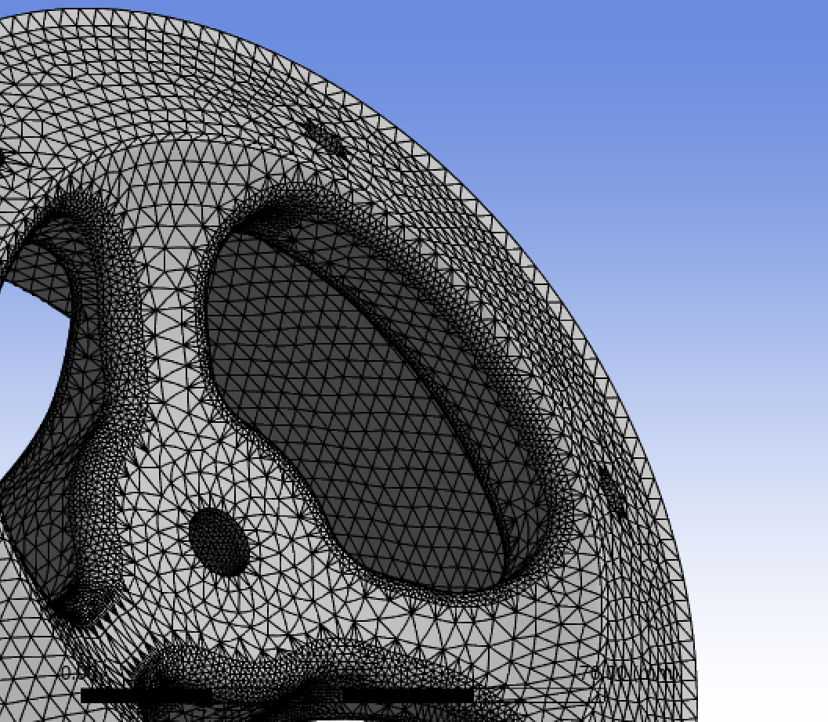
Figure K.1: Tetrahedral mesh with local refinement at RADAX contact face, bolt holes, and thickness transitions.
K.6.3 Boundary Conditions
Boundary conditions were applied to replicate the physical constraints of each bulkhead in its assembled configuration. Two constraint types were used consistently across all models:

–Frictionless support on the seating face: The face of each bulkhead that seats against its mating component was assigned a frictionless support condition. In ANSYS Mechanical, this constrains displacement normal to the face while permitting free in-plane displacement and rotation. This correctly replicates the physical bearing contact condition the face can push but not pull without artificially restraining in-plane deformation.
–Cylindrical support at bolt holes: Each bolt hole was assigned a cylindrical support, constraining radial displacement while leaving axial and tangential directions free. This represents the bolt as a radial pin bearing on the hole wall, avoiding the artificial stress concentrations that would result from a fully fixed hole. The tangential freedom allows the hole to deform slightly under load as it physically would.

No symmetry conditions were applied; each bulkhead was modelled in its complete 360° geometry to correctly capture any asymmetric stress distributions arising from the bolt pattern geometry and the non-axisymmetric bending load.

K.6.4 Applied Loads
The load inputs for each bulkhead were derived from the loads model results of Section K.5, enveloping the max-av and max-qa cases as described. The governing load for the recovery bulkheads was the parachute deployment shock load, which exceeds the flight aerodynamic loads at the nosecone/payload station:

–Motor Bulkhead: Axial compressive force R_z = 10,946.5 N (max-av: peak thrust condition, governing axial compression) applied as a distributed pressure on the thrust plate face. Bending moment M_y = 1,413.0 N·m (max-qa, governing bending) applied as a force couple on the mating RADAX faces.
–Recovery Bulkheads (Male and Female): The peak drogue deployment shock load of 3.2 kN (described in Section C.3 of the main report) was applied as a tensile axial force at the U-bolt attachment point, with the bulkhead reaction face constrained by the frictionless support boundary condition.
–Nosecone Avionics Bulkhead: The drogue deployment peak force of 3.2 kN was applied at the ⅜" U-bolt holes and reacted through the ring bond interface to the nosecone structure. The flight aerodynamic loads (R_z = 3,290.1 N, M_y = 1,334.7 N·m) were also applied and confirmed to produce lower stresses than the recovery case.

K.7 FEM Results
K.7.1 Male Motor Bulkhead
The motor bulkhead carries the full motor thrust and bending moment into the airframe via the RADAX joint. The RADAX angled contact geometry distributes load across the bearing face, reducing peak stress compared to a conventional flat radial joint as described in Section C.4. The von Mises stress distribution is shown in Figure K.2.
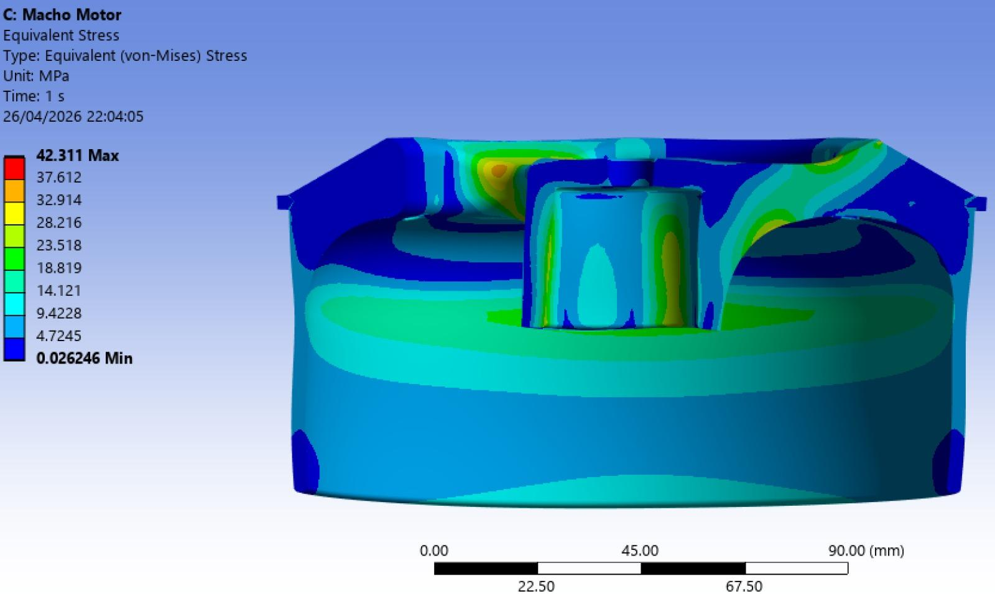
Figure K.2: Von Mises stress distribution under combined thrust (R_z = 10,946.5 N) and bending (M_y = 1,413.0 N·m). Material: 6061-T6 aluminium.

Parameter | Value
Applied axial force R_z | 10,946.5 N (compression — max-av, peak thrust)
Applied bending moment M_y | 1,413.0 N·m (max-qa)
Maximum von Mises stress σ_vM | 42.31 MPa
Material yield strength σ_y | 270 MPa
Safety factor SF = σ_y / σ_vM | 6.38
Location of peak stress | Weight reduction radius
Table K.7: Motor bulkhead FEM results summary.
The stress distribution confirms that the RADAX contact geometry produces a more uniform stress field across the bearing face, consistent with the analytical prediction of Section C.4. The minimum safety factor of 5.3 is achieved at the location of peak stress noted above.
K.7.2 Male Motor Bulkhead
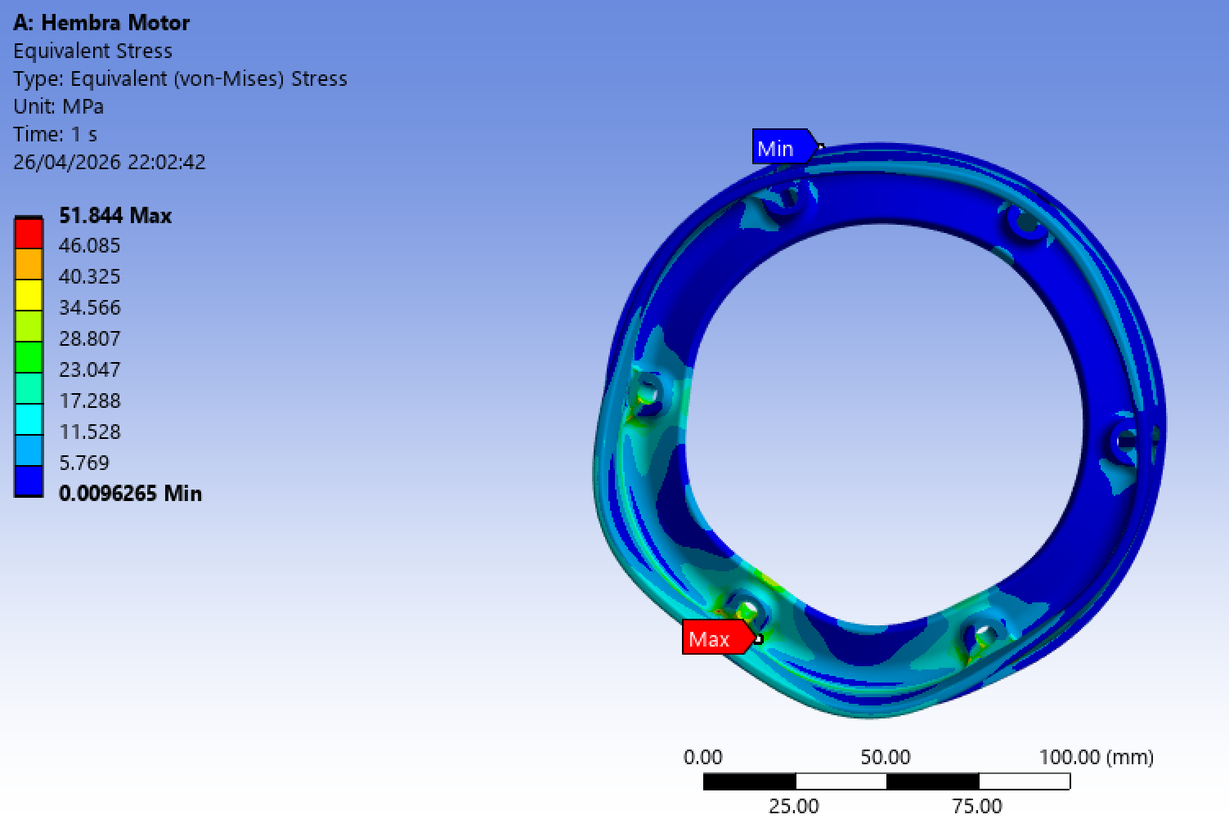
Figure K.3: Von Mises stress distribution Material: 6061-T6 aluminium.

Parameter | Value
Maximum von Mises stress σ_vM | 51.84 MPa
Material yield strength σ_y | 270 MPa
Safety factor SF = σ_y / σ_vM | 5.2
Location of peak stress | Rigidity transition from wall to radax surface
Table K.8: Recovery male bulkhead FEM results summary.
K.7.3 Recovery Male Bulkhead
The recovery male bulkhead transfers the parachute deployment shock load from the U-bolt through the recovery plate to the airframe. The governing load is the drogue deployment peak force of 3.2 kN. The von Mises stress distribution is shown in Figure K.4.
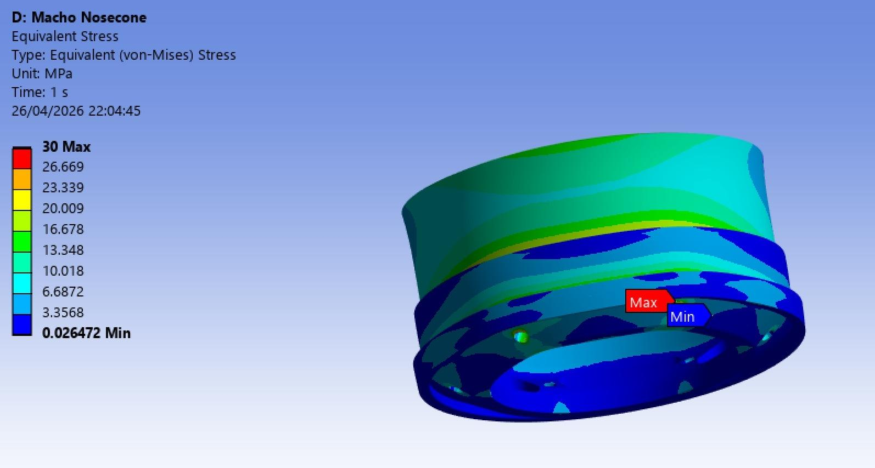
Figure K.4: Von Mises stress distribution . Material: 6061-T6 aluminium.

Parameter | Value
Maximum von Mises stress σ_vM | 30 MPa
Material yield strength σ_y | 270 MPa
Safety factor SF = σ_y / σ_vM | 9
Location of peak stress | Rigidity transition from wall to radax surface
Table K.9: Recovery male bulkhead FEM results summary.

K.7.4 Recovery Female Bulkhead
The recovery female bulkhead is the mating half of the RADAX joint at the nosecone/payload interface, loaded in the opposite sense to the male bulkhead. The von Mises stress distribution is shown in Figure K.5.
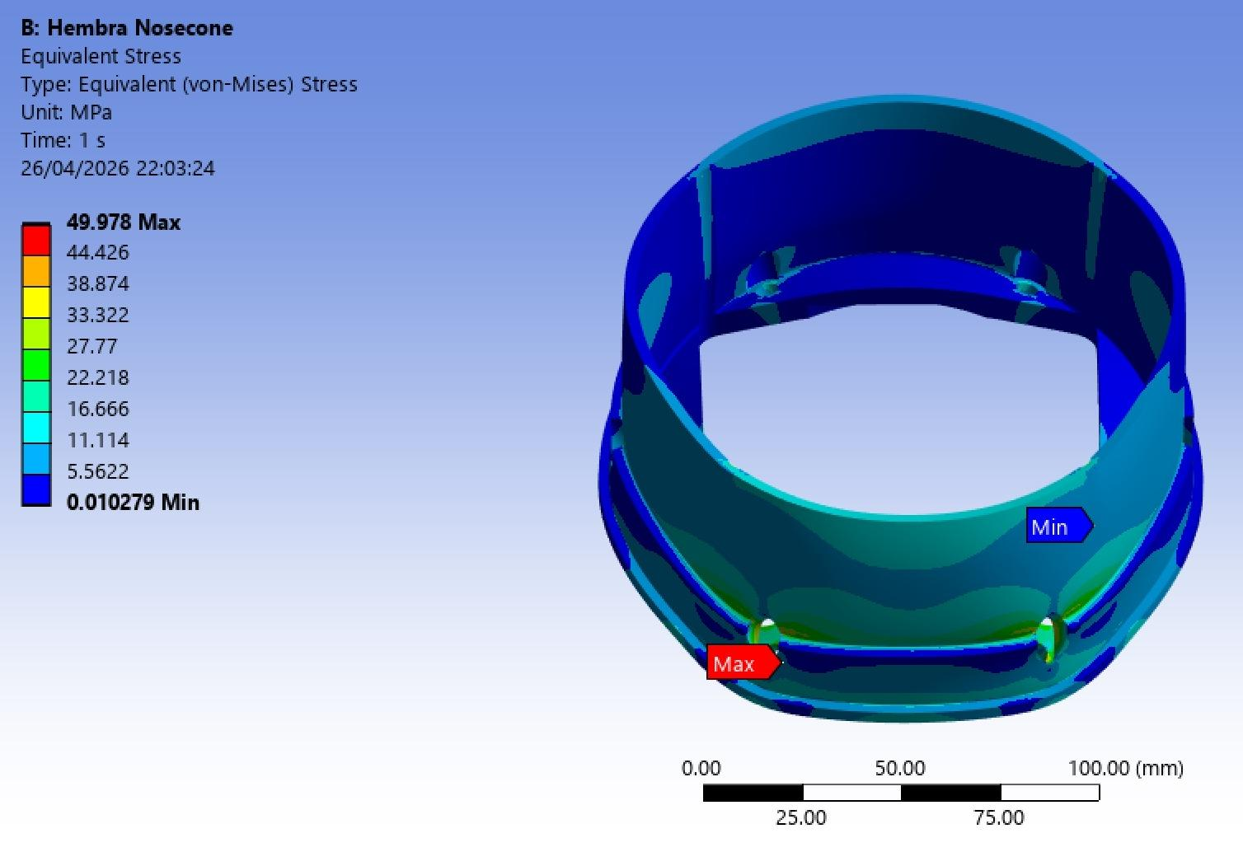
Figure K.5: Von Mises stress distribution under combined deployment load and flight loads at nosecone/payload station. Material: 6061-T6 aluminium.

Parameter | Value
Maximum von Mises stress σ_vM | 49.978 MPa
Material yield strength σ_y | 270 MPa
Safety factor SF = σ_y / σ_vM | 5.4
Location of peak stress | Rigidity transition
Table K.10: Recovery female bulkhead FEM results summary.

K.8 Summary
Table K.11 summarises the safety factors obtained across all four bulkheads. The minimum safety factor of 5.0 for the recovery bulkheads and 5.3 for the motor bulkhead confirm that all primary structural interfaces of Aconcagua comply with design requirements with substantial margin. The analysis confirms that the governing load case for all recovery-path bulkheads is parachute deployment shock rather than aerodynamic flight loads, validating the design approach of Section C.

Bulkhead | Governing Load Case | Max σ_vM [MPa] | SF
Recovery Male BH | Deployment + flight loads | 30 | 9
Recovery Female BH | Deployment + flight loads | 49.9 | 5.4
Male Motor BH | Peak thrust + bending envelope (max-av / max-qa) | 42.1 | 6.38
Female Motor BH | Peak thrust + bending envelope (max-av / max-qa) | 51.84 | 5.2

Table K.11: Safety factor summary for all FEM-validated bulkheads.

The combined loads model and FEM validation methodology provides a complete and traceable derivation chain from the physical flight environment to the boundary conditions applied in each finite element model, replacing conservative empirical safety factors with analytically justified values and enabling the mass optimization described in the main report.

K.9 Composite Tube FEM Validation
Composite tubes were validated separately using NX and taking as load reference twice the maximum axial compression produced by the motor thrust, 13 kN. This method was used as it was previously validated by the team in previous iterations. The result plot in Fig. K6 shows the ply failure index of the composite tube. The resulting SF is 3.87, the inverse of the ply failure index. The sudden increase in the ply failure index in the edge of the tube requires further analysis.

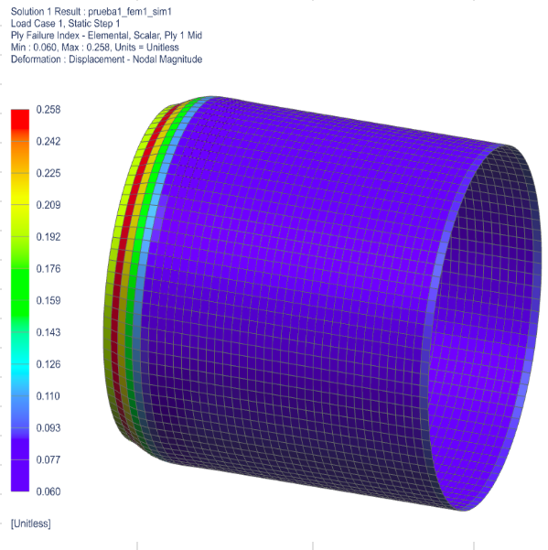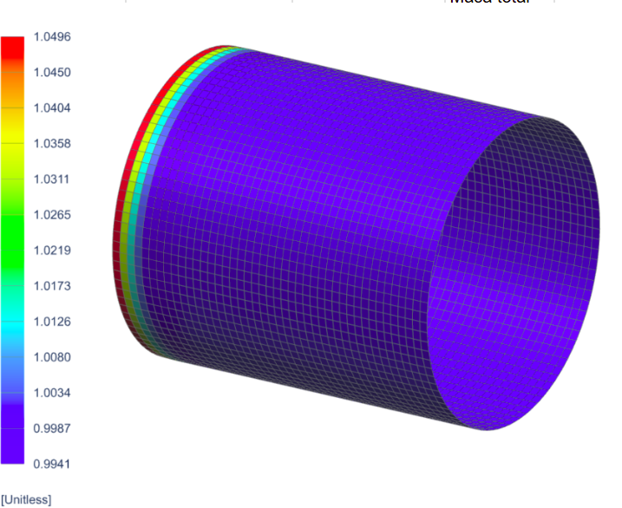
Figure K6: Composite Tube FEM validation under compressive loads; Load of 13kN (left); Load of 80kN (right)

To validate the compression testing performed. Another FEM simulation was performed under 80kN of compression, load under which tubes failed in the mechanical test. Ply failure index results are shown in the right figure of Fig. K6.
A SF of 4 results if the maximum compressive load of the test is compared to the maximum load indicated by the loads program.

K. 5 Integrated Validation of Structural Design

The objective of this section is to integrate all testing and simulation performed to validate the structural integrity of Aconcagua during flight.

The summarized results of material testing results are presented in table K12:

Test | Compression test of fuselage tubes | Adhesive bond Lap Shear Test | Micrographic analysis
Standard | ASTM D5449 | ASTM D5868 | Self-established
Property | Failure Load of GFRP Fuselage Tubes | EA 120 HP Maximum shear stress for Aluminum - GFRP Joints | % Vf, % Porosity
Mean value | 84.7 kN | 11.5 MPa | 65% Vf  5% Porosity
Standard deviation | 10.9 kN | 0.4 MPa
Coefficient of variability | 12.9% | 3.48% | Not calculated
Table K12: Summarized results of material testing for Aconcagua

The dimensioning of glued joints is presented in table K13, using the shear stress obtained in Table K12.

Component | Joint surface area [mm^2] | Maximum Shear Stress N/[mm^2) | Load at theoretical failure [kN] | Maximum Load [kN] | SF
Avionics Bulkhead | 10758 | 11,5 | 124 | 3.2 | 41
Payload Can - Recovery BH | 14914 | 11,5 | 172 | 10 | 17
Payload Can - Motor BH | 18116 | 11,5 | 208 | 10 | 21
Fincan 1 - Motor BH | 4649 | 11,5 | 53 | 10 | 5
Fincan Coupler | 6,95E+04 | 11 | 764 | 10 | 76
Table K13: Dimensioning of GFRP - 6061 T6 Aluminum joints bonded with Loctite EA 120 HP .

References

[1] Hong, K. Y., Kim, Y. Y., Yoo, S. Y., Lee, J.-H., Kim, D. K., and Min, J.-J., "Simulation Study on Flow Rate Accuracy of Infusion Pumps in Vibration Conditions During Emergency Patient Transport," Journal of Clinical Monitoring and Computing, published online 6 Nov. 2020.
doi: 10.1007/s10877-020-00588-7

[2] Lopez, P. E., King, B. R., Goss, P. W., and Chockalingam, G., "Bubble Formation Occurs in Insulin Pumps in Response to Changes in Ambient Temperature and Atmospheric Pressure but Not as a Result of Vibration," BMJ Open Diabetes Research and Care, Vol. 2, No. 1, 2014, p. e000036.
doi: 10.1136/bmjdrc-2014-000036

[3] R. Newlands, M. Heywood, and A. Lee, "Rocket Vehicle Loads and Airframe Design," AspireSpace Technical Papers, 2016. [Online]. Available: http://www.aspirespace.org.uk/downloads/Rocket%20vehicle%20loads%20and%20airframe%20design.pdf

Team Leader, Mechanical Engineering, lfreyrecancela@itba.edu.ar
Engineering Leader, Mechanical Engineering, franftl@itba.edu.ar
Manufacturing Leader, Mechanical Engineering, fiezzi@itba.edu.ar
Recovery Sub-Team Leader, Mechanical Engineering, sponte@itba.edu.ar
Composites Sub-Team Leader, Mechanical Engineering, tgomezcrovetto@itba.edu.ar
Aerodynamics Sub-Team Co-Leader, Mechanical Engineering, vnemegabriel@itba.edu.ar
Aerodynamics Sub-Team Co-Leader, Mechanical Engineering, tmanzella@itba.edu.ar
Avionics Sub-Team Co-Leader, Mechanical Engineering, imarzeniuk@itba.edu.ar
Avionics Sub-Team Co-Leader, Electronic Engineering, twickham@itba.edu.ar
Payload Sub-Team Leader, Bioengineering, maberetta@itba.edu.ar
Payload Sub-Team Structures Designer, Mechanical Engineering, marparera@itba.edu.ar
Administrative Leader, Mechanical Engineering, jkamiya@itba.edu.ar
Taking 20 micrometers as base value
Taking 7.5 mm as base value
Taking 151 mm as base value
This value corresponds to the mean value of the maximum load, presented in Table I1
The value corresponds to a ply failure index of 1, as simulated through FEM analysis.
Three different surface preparations were tested. This configuration provided 10% more shear resistance than the second best preparation, which used oxsalic acid for the anodizing instead of phosphoric acid
This case correspond to the joint between the male motor Bulkhead and FWD Fincan
All flight altitudes are expressed in feet AGL, while all other quantities are in SI units.

