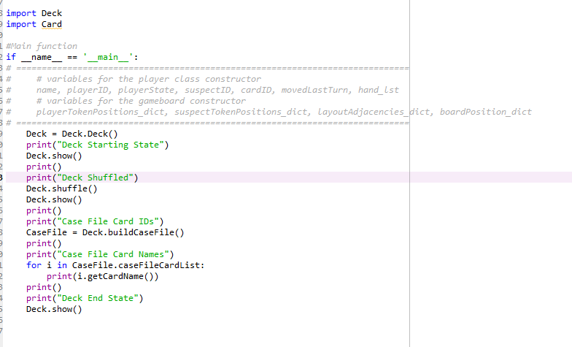

Python Output:

Deck Starting State

Card Name: Rope | Card ID: 0

Card Name: Lead Pipe | Card ID: 1

Card Name: Knife | Card ID: 2

Card Name: Wrench | Card ID: 3

Card Name: Candlestick | Card ID: 4

Card Name: Revolver | Card ID: 5

Card Name: Colonel Mustard | Card ID: 6

Card Name: Miss Scarlet | Card ID: 7

Card Name: Professor Plum | Card ID: 8

Card Name: Mr. Green | Card ID: 9

Card Name: Mrs. White | Card ID: 10

Card Name: Mrs. Peacock | Card ID: 11

Card Name: Study | Card ID: 12

Card Name: Library | Card ID: 13

Card Name: Conservatory | Card ID: 14

Card Name: Hall | Card ID: 15

Card Name: Billiard Room | Card ID: 16

Card Name: Ball Room | Card ID: 17

Card Name: Lounge | Card ID: 18

Card Name: Dining Room | Card ID: 19

Card Name: Kitchen | Card ID: 20

Deck Shuffled

Card Name: Miss Scarlet | Card ID: 7

Card Name: Study | Card ID: 12

Card Name: Billiard Room | Card ID: 16

Card Name: Lounge | Card ID: 18

Card Name: Mrs. White | Card ID: 10

Card Name: Lead Pipe | Card ID: 1

Card Name: Hall | Card ID: 15

Card Name: Professor Plum | Card ID: 8

Card Name: Mr. Green | Card ID: 9

Card Name: Mrs. Peacock | Card ID: 11

Card Name: Revolver | Card ID: 5

Card Name: Conservatory | Card ID: 14

Card Name: Library | Card ID: 13

Card Name: Dining Room | Card ID: 19

Card Name: Wrench | Card ID: 3

Card Name: Knife | Card ID: 2

Card Name: Ball Room | Card ID: 17

Card Name: Candlestick | Card ID: 4

Card Name: Kitchen | Card ID: 20

Card Name: Rope | Card ID: 0

Card Name: Colonel Mustard | Card ID: 6

Case File Card IDs

Murderer Card ID: 7

Murder Room Card ID: 16

Murder Weapon Card ID: 1

Case File Card Names

Lead Pipe

Miss Scarlet

Billiard Room

Deck End State

Card Name: Study | Card ID: 12

Card Name: Lounge | Card ID: 18

Card Name: Mrs. White | Card ID: 10

Card Name: Hall | Card ID: 15

Card Name: Professor Plum | Card ID: 8

Card Name: Mr. Green | Card ID: 9

Card Name: Mrs. Peacock | Card ID: 11

Card Name: Revolver | Card ID: 5

Card Name: Conservatory | Card ID: 14

Card Name: Library | Card ID: 13

Card Name: Dining Room | Card ID: 19

Card Name: Wrench | Card ID: 3

Card Name: Knife | Card ID: 2

Card Name: Ball Room | Card ID: 17

Card Name: Candlestick | Card ID: 4

Card Name: Kitchen | Card ID: 20

Card Name: Rope | Card ID: 0

Card Name: Colonel Mustard | Card ID: 6