1. **<User> Add Goal**

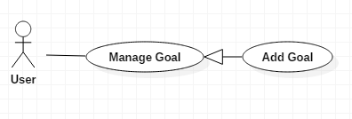

|  |  |  |  |
| --- | --- | --- | --- |
| **USE CASE – UC_0** | | | |
| **Use Case No.** | 0 | **Use Case Version** | 1.0 |
| **Use Case Name** | Add goal | | |
| **Author** | TungPT | | |
| **Date** | 07/10/2018 | **Priority** | Normal |
| **Actor:**   * User   **Summary:**   * This use case allows the user to add goal.   **Goal:**   * Add a goal while add the habit.   **Triggers:**   * User click on “Add goal” button.   **Preconditions:**   * Guest must login.   **Post Conditions:**   * **Success:** System shows “Successful to add a goal!” message. * **Fail:** System shows “Failed to add a goal!” message.   **Main Success Scenario:**   |  |  |  | | --- | --- | --- | | Step | Actor Action | System Response | | 1 | User click on “Add goal” button. | The system request information in form:   * Goal period: select input * Set your goal: input text | | 2 | User click on “Save” button | - That goal will be added. |   **Alternative:**   |  |  |  | | --- | --- | --- | | No | Actor Action | System Response | | 1 | User click on “Cancel” button. | - Close this form. |   **Exceptions:**   |  |  |  | | --- | --- | --- | | No | Cause | System Response | | 1 | None of any goal was selected | Shows “Failed to add a goal!” message. |   **Relationships:**  N/A  **Business Rules:**   * The goal name must be under 255 characters and not null. * After adding goal success. The user returns menu list habit page. | | | |

*Table 0 – Add goal specification*

1. **<User> Delete Goal**

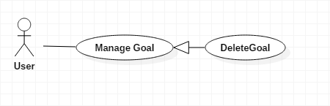

|  |  |  |  |
| --- | --- | --- | --- |
| **USE CASE – UC_0** | | | |
| **Use Case No.** | 0 | **Use Case Version** | 1.0 |
| **Use Case Name** | Delete goal | | |
| **Author** | TungPT | | |
| **Date** | 07/10/2018 | **Priority** | Normal |
| **Actor:**   * User   **Summary:**   * This use case allows the user to delete goal.   **Goal:**   * Delete a goal from the goal.   **Triggers:**   * User click on “Delete goal” button.   **Preconditions:**   * Guest must login.   **Post Conditions:**   * **Success:** System shows “Successful to delete a goal!” message. * **Fail:** System shows “Failed to delete a goal!” message.   **Main Success Scenario:**   |  |  |  | | --- | --- | --- | | Step | Actor Action | System Response | | 1 | User click on “Delete goal” button. | Shows a form to ask user want to delete goal. | | 2 | User click on “Save” button | - That goal will be deleted. |   **Alternative:**   |  |  |  | | --- | --- | --- | | No | Actor Action | System Response | | 1 | User click on “Cancel” button. | - Close this form. |   **Exceptions:**   |  |  |  | | --- | --- | --- | | No | Cause | System Response | | 1 | None of any goal was selected | Shows “Failed to add a goal!” message. |   **Relationships:**  N/A  **Business Rules:**   * When a user deleted a goal, this goal will be hidden. * The information of the goal is deleted to the local. | | | |

*Table 0 – Delete goal specification*

1. **<User> Edit Goal**

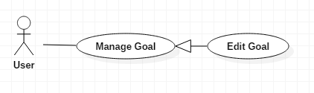

|  |  |  |  |
| --- | --- | --- | --- |
| **USE CASE – UC_0** | | | |
| **Use Case No.** | 0 | **Use Case Version** | 1.0 |
| **Use Case Name** | Edit goal | | |
| **Author** | TungPT | | |
| **Date** | 07/10/2018 | **Priority** | Normal |
| **Actor:**   * User   **Summary:**   * This use case allows the user to edit goal.   **Goal:**   * Edit a goal from the goal.   **Triggers:**   * User click on “Edit goal” button.   **Preconditions:**   * Guest must login.   **Post Conditions:**   * **Success:** System shows “Successful to edit a goal!” message. * **Fail:** System shows “Failed to edit a goal!” message.   **Main Success Scenario:**   |  |  |  | | --- | --- | --- | | Step | Actor Action | System Response | | 1 | User click on “Edit goal” button. | The system request information in form:   * Goal period: select input * Set your goal: input text | | 2 | User click on “Save” button | - That goal will be edit. |   **Alternative:**   |  |  |  | | --- | --- | --- | | No | Actor Action | System Response | | 1 | User click on “Cancel” button. | - Close this form. |   **Exceptions:**   |  |  |  | | --- | --- | --- | | No | Cause | System Response | | 1 | None of any goal was selected | Shows “Failed to edit a goal!” message. |   **Relationships:**  N/A  **Business Rules:**   * The goal name must be under 255 characters and not null. * The information of Goal is sent to the server. * After Edit goal success. The user will return to the menu list habit page. | | | |

*Table 0 – Delete goal specification*