**Use Case Diagram**

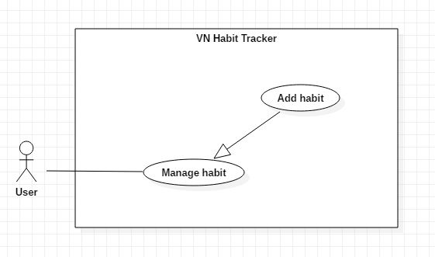

*Figure 3- <User>Add habit*

**Use Case Specification**

|  |  |  |  |
| --- | --- | --- | --- |
| **USE CASE – UC_01** | | | |
| **Use Case No.** | 01 | **Use Case Version** | 1.0 |
| **Use Case Name** | Add habit | | |
| **Author** | TuyenNQ | | |
| **Date** | 27/09/2018 | **Priority** | Normal |
| **Actor:**   * User   **Summary:**   * This use case allows the user to add a new habit.   **Goal:**   * Add a new habit from the schedule.   **Triggers:**   * User click on “Add habit” button.   **Preconditions:**   * Guest must login.   **Post Conditions:**   * **Success:** System shows “Successful to add a new habit!” message. * **Fail:** System shows “Failed to add a new habit!” message.   **Main Success Scenario:**   |  |  |  | | --- | --- | --- | | Step | Actor Action | System Response | | 1 | User click on “Add habit” button. | The system request information in form:   * Habit name: input text * Habit type: input text * Habit color: select button * Habit goal: select option * Set a target: date time | | 2 | User click on “Save” button | - System shows “Successful to add a new habit” message |   **Alternative:**   |  |  |  | | --- | --- | --- | | No | Actor Action | System Response | | 1 | User click on “Cancel” button. | - Close this form. |   **Exceptions:**   |  |  |  | | --- | --- | --- | | No | Cause | System Response | | 1 | User add an existed habit in the application | Show message to notify user this habit is existed. | | 2 | User add new fail | System shows “Failed to add a new habit!” message. |   **Relationships:**  N/A  **Business Rules:**   * The habit’s name must be under 255 characters and not null. * After adding habit success. The user returns menu list habit page. | | | |

*Table 13 – Add habit specification*

* + 1. <User> Archive habit

**Use Case Diagram**

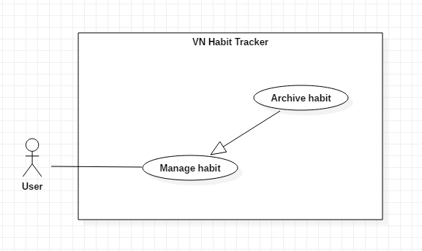

*Figure 4 - <User> Archive habit*

**Use Case Specification**

|  |  |  |  |
| --- | --- | --- | --- |
| **USE CASE – UC_02** | | | |
| **Use Case No.** | 02 | **Use Case Version** | 1.0 |
| **Use Case Name** | Delete habit | | |
| **Author** | TuyenNQ | | |
| **Date** | 27/09/2018 | **Priority** | Normal |
| **Actor:**   * User   **Summary:**   * This use case allows the user to delete habit.   **Goal:**   * Delete a habit from the schedule.   **Triggers:**   * User click on “Archive habit” button.   **Preconditions:**   * Habit is existed.   **Post Conditions:**   * **Success:** System shows “Successful to delete a habit!” message. * **Fail:** System shows “Failed to delete a habit!” message.   **Main Success Scenario:**   |  |  |  | | --- | --- | --- | | Step | Actor Action | System Response | | 1 | User click on “Archive habit” button. | Shows a form to ask user want to delete habit. | | 2 | User click on “Yes” button | - That habit will be deleted. |   **Alternative:**   |  |  |  | | --- | --- | --- | | No | Actor Action | System Response | | 1 | User click on “Cancel” button. | - Close this form. |   **Exceptions:**   |  |  |  | | --- | --- | --- | | No | Cause | System Response | | 1 | None of any habit was selected | Shows “Failed to delete a habit!” message. |   **Relationships:**  N/A  **Business Rules:**   * When a user delete a habit, this habit will be hidden. * The information of the habit is deleted from the local. | | | |

*Table 14 – Archive habit specification*

* + 1. <User> Edit habit

**Use Case Diagram**

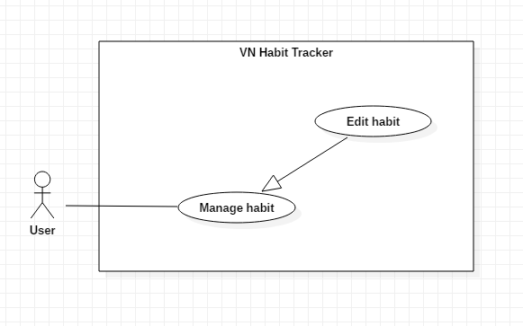

*Figure 5 - <User> Edit habit*

**Use Case Specification**

|  |  |  |  |
| --- | --- | --- | --- |
| **USE CASE – UC_03** | | | |
| **Use Case No.** | 03 | **Use Case Version** | 1.0 |
| **Use Case Name** | Edit habit | | |
| **Author** | TuyenNQ | | |
| **Date** | 27/09/2018 | **Priority** | Normal |
| **Actor:**   * User   **Summary:**   * This use case allows the user to edit a habit.   **Goal:**   * Edit habit when user input.   **Triggers:**   * User click on “Edit habit” button.   **Preconditions:**   * Guest must login. * The habit is existed.   **Post Conditions:**   * **Success:** System shows “Successful to edit a habit!” message. * **Fail:** System shows “Failed to edit a habit!” message.   **Main Success Scenario:**   |  |  |  | | --- | --- | --- | | Step | Actor Action | System Response | | 1 | User click on “Edit habit” button. | The system request information in form:   * Habit name: input text * Habit type: input text * Habit color: select button * Habit goal: select option * Set a target: date time | | 2 | User click on “OK” button | - The system validates the information and shows confirmation message. | | 3 | User click on “YES” button | -System shows “Successful to edit a habit!” message. |   **Alternative:**   |  |  |  | | --- | --- | --- | | No | Actor Action | System Response | | 1 | User click on “Cancel” button. | - Close this form. |   **Exceptions:**   |  |  |  | | --- | --- | --- | | No | Cause | System Response | | 1 | The field is blank | The system shows “Must not be blank!” message. | | 2 | System edit habit fail | System shows “Failed to edit a habit!” message. | |  |  |  |   **Relationships:**  N/A  **Business Rules:**   * The habit’s name must be under 255 characters and not null. * The information of Habit is sent to the server. * After Edit habit success. The user will return to the menu list habit page. | | | |

**Use Case Specification**

|  |  |  |  |
| --- | --- | --- | --- |
| **USE CASE – UC_04** | | | |
| **Use Case No.** | 04 | **Use Case Version** | 1.0 |
| **Use Case Name** | View habit | | |
| **Author** | TuyenNQ | | |
| **Date** | 27/09/2018 | **Priority** | Normal |
| **Actor:**   * User   **Summary:**   * This use case allows the user to view all habit are added.   **Goal:**   * View habit when user want to see their added habit.   **Triggers:**   * User click on “View habit” button. * User click on “Login habit” button.   **Preconditions:**   * Guest must login. * The habit is existed.   **Post Conditions:**   * **Success:** System shows all habit are added. * **Fail:** User can’t see their added habit.   **Main Success Scenario:**   |  |  |  | | --- | --- | --- | | Step | Actor Action | System Response | | 1 | User click on “View habit” button.  User click on “Login” button | The system show information in form:   * Habit name: text * Habit description: text * Habit color * Habit goal: text * Habit time: date time | | 2 | User click on “View habit” button | - The system validates the request and shows the added habit. |   **Exceptions:**   |  |  |  | | --- | --- | --- | | No | Cause | System Response | | 1 | There are no existed habit | The system shows nothing | | 2 | System login habit fail | System shows “Please reconfirm your password!” message. | |  |  |  |   **Relationships:**  N/A  **Business Rules:**   * The habit’s information must be existed first. * The information of Habit is sent to the server. * After View habit successfully. The user will see the list of all habit. | | | |

**Use Case Specification**

|  |  |  |  |
| --- | --- | --- | --- |
| **USE CASE – UC_05** | | | |
| **Use Case No.** | 05 | **Use Case Version** | 1.0 |
| **Use Case Name** | Set notification | | |
| **Author** | TuyenNQ | | |
| **Date** | 27/09/2018 | **Priority** | Normal |
| **Actor:**   * User   **Summary:**   * This use case allows the user to set the notification.   **Goal:**   * Set notification for a habit.   **Triggers:**   * User click on “Set notification” button.   **Preconditions:**   * Guest must login. * User click on “Edit habit” button. * User click on “Add habit” button. * The habit is existed.   **Post Conditions:**   * **Success:** Mobile devices will show the pop-up with sound. * **Fail:** Nothing will be showed.   **Main Success Scenario:**   |  |  |  | | --- | --- | --- | | Step | Actor Action | System Response | | 1 | User click on “Set notification” button. | The system request information in form:   * Habit name: text * Habit description: text * Habit time: date time * Snooze length * Sound | | 2 | User click on “OK” button | - The system validates the request and shows the added information. | | 3 | User click on “Yes” button | System shows “Successful to edit a habit!” message. |   **Alternative:**   |  |  |  | | --- | --- | --- | | No | Actor Action | System Response | | 1 | User click on “Cancel” button. | - Close this form. |   **Exceptions:**   |  |  |  | | --- | --- | --- | | No | Cause | System Response | | 1 | The field is blank | The system shows “Must not be blank!” message. | | 2 | System fail to set notification | System shows “Failed to set notification!” message. | |  |  |  |   **Relationships:**  N/A  **Business Rules:**   * The habit must be existed first. * After set notification successfully. The user will see the notification of the habit when time comes. | | | |

**Use Case Specification**