**Problem 1:**

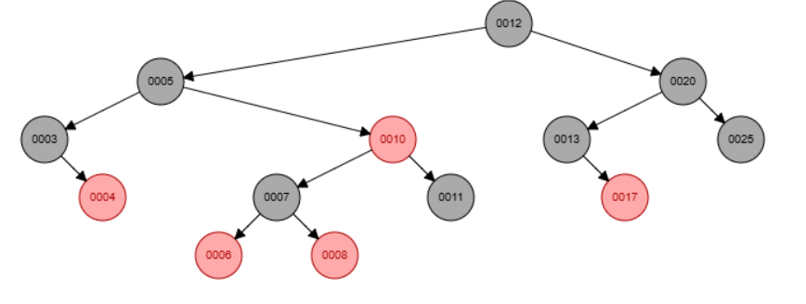

Insert 1

Insert 15

Insert 18

Insert 9

**Problem 2:**

1. Given the following “Red-Black tree”, indicate the color of each node with letter R or B.

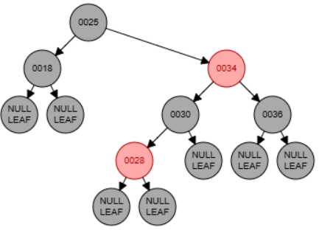

1. Insert the key 29.

