1. **What is the adjacency matrix of the graph G = (V,E) displayed below**

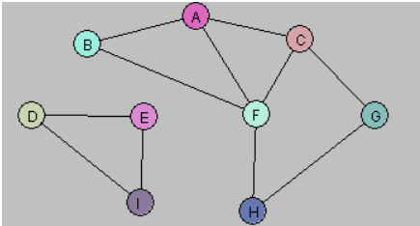

|  |  |  |  |  |  |  |  |  |  |
| --- | --- | --- | --- | --- | --- | --- | --- | --- | --- |
|  | **A** | **B** | **C** | **D** | **E** | **F** | **G** | **H** | **I** |
| **A** | 0 | 1 | 1 | 0 | 0 | 1 | 0 | 0 | 0 |
| **B** | 1 | 0 | 0 | 0 | 0 | 1 | 0 | 0 | 0 |
| **C** | 1 | 0 | 0 | 0 | 0 | 1 | 1 | 0 | 0 |
| **D** | 0 | 0 | 0 | 0 | 1 | 0 | 0 | 0 | 1 |
| **E** | 0 | 0 | 0 | 1 | 0 | 0 | 0 | 0 | 1 |
| **F** | 1 | 1 | 1 | 0 | 0 | 0 | 0 | 1 | 0 |
| **G** | 0 | 0 | 1 | 0 | 0 | 0 | 0 | 1 | 0 |
| **H** | 0 | 0 | 0 | 0 | 0 | 1 | 1 | 0 | 0 |
| **I** | 0 | 0 | 0 | 1 | 1 | 0 | 0 | 0 | 0 |

1. **Create a Java program to find all components of a graph given the adjacency matrix through DFS. Test your program on the above graph.**

See the source code in packagelesson12.lab

1. **Create a Java program to find all components of a graph given the adjacency matrix through BFS. Test your program on the above graph**

See the source code in packagelesson12.lab