**Question 1:**

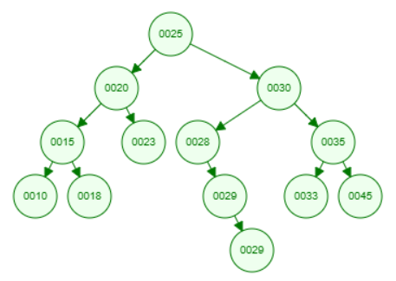

**Question 2:**

1. **Delete 30**

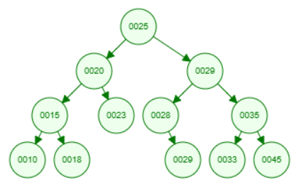

1. **Delete 25**

1. **Delete 28**

**Question 3:**

1. **Preorder traversal**

25, 20, 15, 10, 18, 23, 30, 28, 29, 29, 35, 33, 45

1. **Postorder traversal**

10, 18, 15, 23, 20, 29, 29, 28, 33, 45, 35, 30, 25

1. **Inorder traversal**

10, 15, 18, 20, 23, 25, 28, 29, 29, 30, 33, 35, 45

**Question 4:** Write a recursive function to

1. (a) Count the nodes of a BST
2. (b) Count the leaves of a BST
3. Create a mirror image of the BST

See the source code in class: **lesson9.lab.binarySearchTree.BinarySearchTree**