PageSpeed and Rich Results Test baseline for DrK-care – 14oct2026

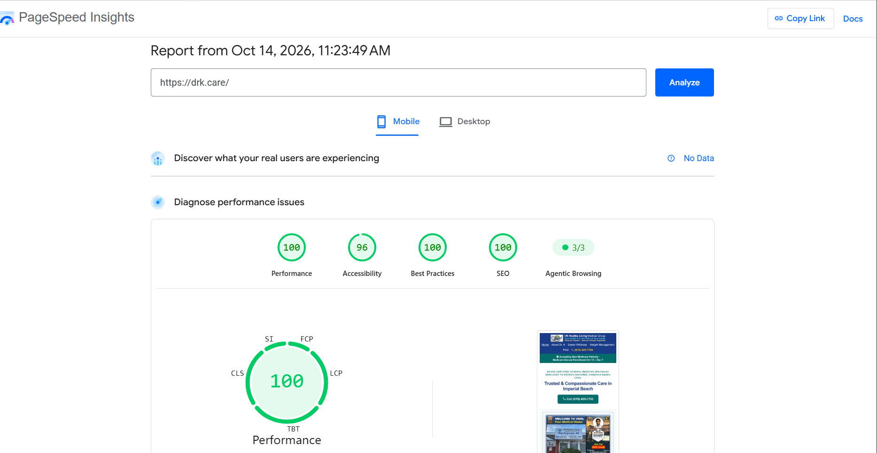
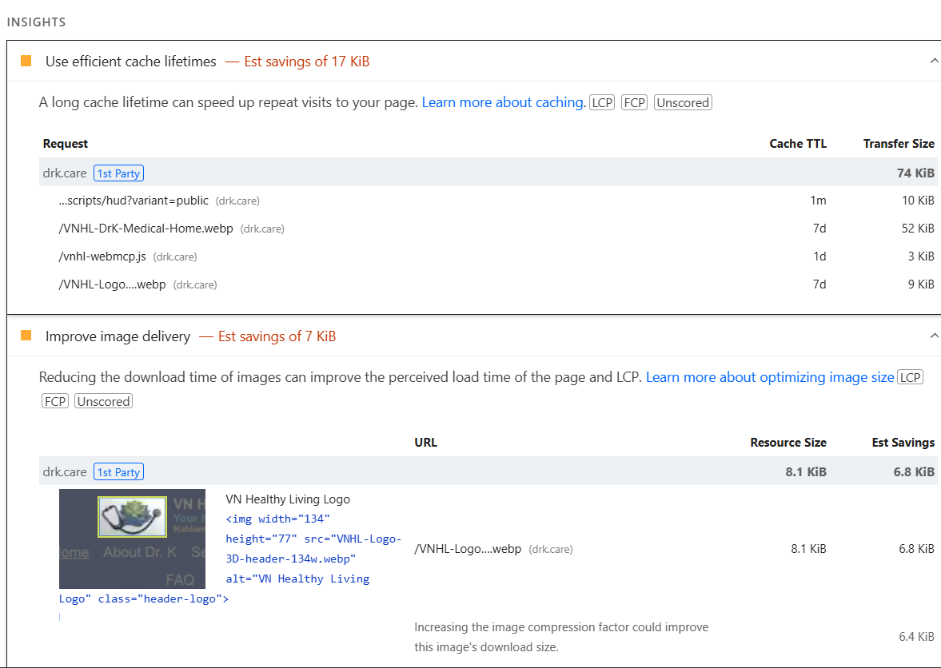
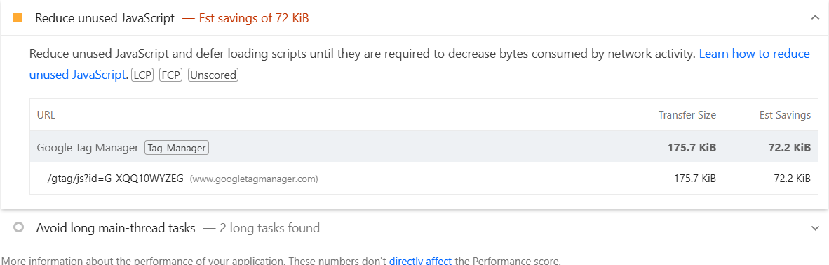


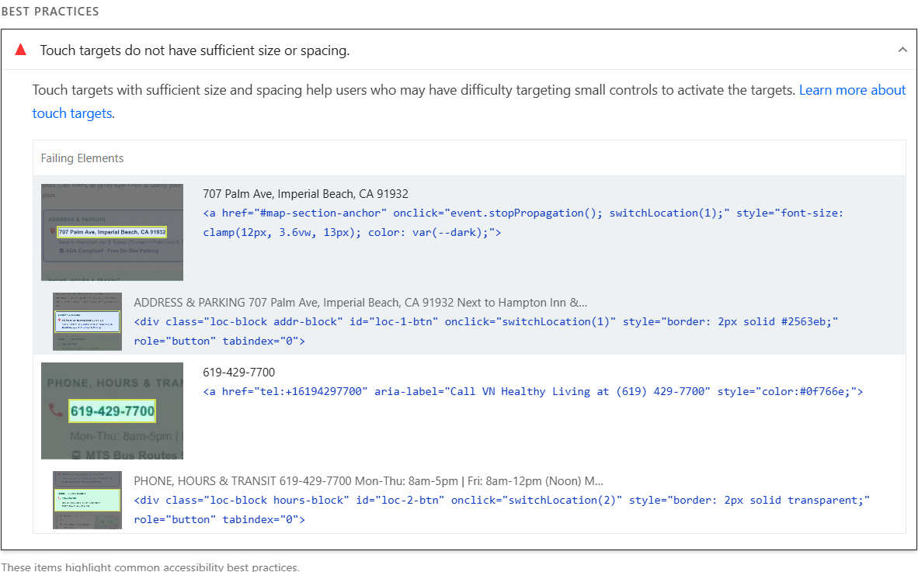

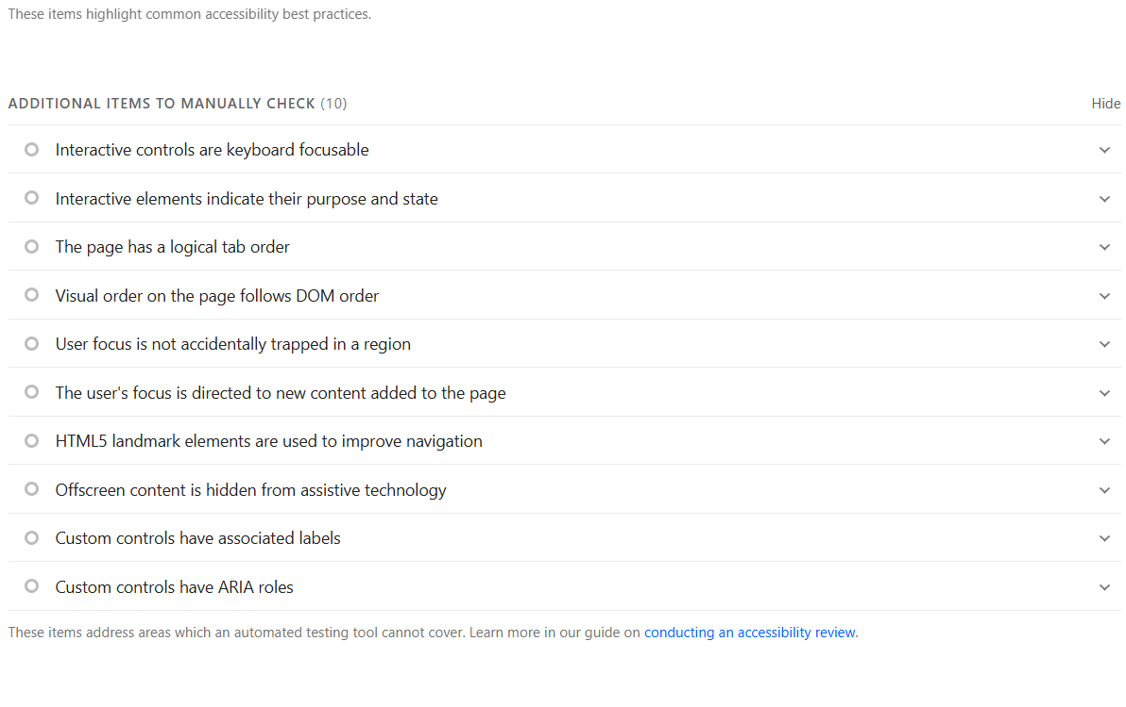

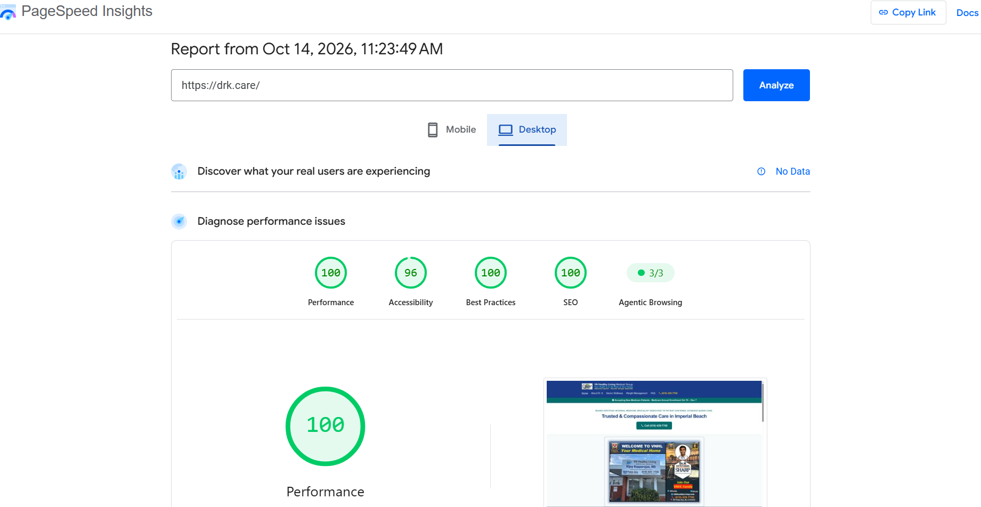

Discover what your real users are experiencing
No Data

Diagnose performance issues

100
Performance

96
Accessibility

100
Best Practices

100
SEO

3/3
Agentic Browsing

100FCP+10LCP+25TBT+30CLS+25SI+10Performance
Values are estimated and may vary. The performance score is calculated directly from these metrics.See calculator.
0–4950–8990–100
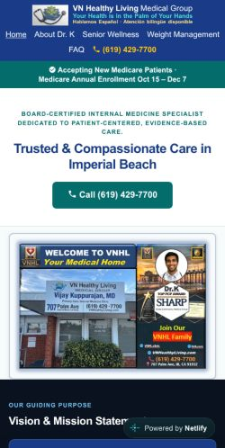
MetricsExpand view
First Contentful Paint
0.8 s
Largest Contentful Paint
1.2 s
Total Blocking Time
40 ms
Cumulative Layout Shift
0.003
Speed Index
0.9 s
- Captured at Oct 14, 2026, 11:23 AM CDT
- Emulated Moto G Power with Lighthouse 13.5.0
- Single page session
- Initial page load
- Slow 4G throttling
- Using HeadlessChromium 153.0.8010.36 with lr
View Treemap
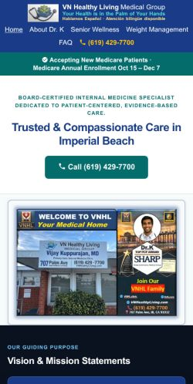
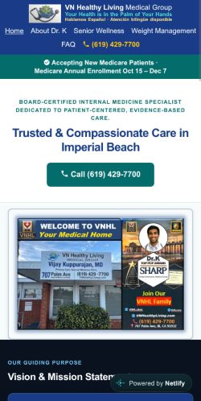
Show audits relevant to:AllFCPLCPTBTCLS
Insights
Use efficient cache lifetimes Est savings of 17 KiB
A long cache lifetime can speed up repeat visits to your page. Learn more about caching.LCPFCPUnscored
Request | Cache TTL | Transfer Size
drk.care  1st party |  | 74 KiB
…scripts/hud?variant=public  (drk.care) | 1m | 10 KiB
/VNHL-DrK-Medical-Home.webp  (drk.care) | 7d | 52 KiB
/vnhl-webmcp.js  (drk.care) | 1d | 3 KiB
/VNHL-Logo….webp  (drk.care) | 7d | 9 KiB
Improve image delivery Est savings of 7 KiB
Reducing the download time of images can improve the perceived load time of the page and LCP. Learn more about optimizing image sizeLCPFCPUnscored
 | URL | Resource Size | Est Savings
drk.care  1st party |  | 8.1 KiB | 6.8 KiB
VN Healthy Living Logo  <img width="134" height="77" src="VNHL-Logo-3D-header-134w.webp" alt="VN Healthy Living Logo" class="header-logo"> | /VNHL-Logo….webp  (drk.care) | 8.1 KiB | 6.8 KiB
 | Increasing the image compression factor could improve this image's download size. |  | 6.4 KiB
Layout shift culprits
Layout shifts occur when elements move absent any user interaction. Investigate the causes of layout shifts, such as elements being added, removed, or their fonts changing as the page loads.CLSUnscored
Element | Layout shift score
Total | 0.003
Powered by Netlify  <div class="nl-wrap"> | 0.003
Optimize DOM size
A large DOM can increase the duration of style calculations and layout reflows, impacting page responsiveness. A large DOM will also increase memory usage. Learn how to avoid an excessive DOM size.Unscored
Statistic | Element | Value
Total elements |  | 182
DOM depth | div > div.card-title > svg.ico > use  <use href="#i-scale"> | 10
Most children | body > svg > defs  <defs> | 12
LCP breakdown
Each subpart has specific improvement strategies. Ideally, most of the LCP time should be spent on loading the resources, not within delays.LCPUnscored
Subpart | Duration
Time to first byte | 20 ms
Resource load delay | 190 ms
Resource load duration | 90 ms
Element render delay | 60 ms
Welcome to VNHL, your medical home: Dr. Vijay Kuppurajan, Sharp Top PCP Award, …
<img srcset="VNHL-DrK-Medical-Home-614w.webp 614w, VNHL-DrK-Medical-Home.webp 691w" sizes="(max-width: 650px) 100vw, 614px" src="VNHL-DrK-Medical-Home.webp" alt="Welcome to VNHL, your medical home: Dr. Vijay Kuppurajan, Sharp Top PCP Aw…" class="banner-image" width="691" height="486" fetchpriority="high">
3rd parties
3rd party code can significantly impact load performance. Reduce and defer loading of 3rd party code to prioritize your page's content.Unscored
3rd party | Transfer size | Main thread time
Google Tag Manager  tag-manager | 176 KiB | 137 ms
/gtag/js?id=G-XQQ10WYZEG  (www.googletagmanager.com) | 176 KiB | 137 ms
Google Analytics  analytics | 1 KiB | 0 ms
/g/collect?v=…  (www.google-analytics.com) | 1 KiB | 0 ms
These insights are also available in the Chrome DevTools Performance Panel - record a trace to view more detailed information.
Diagnostics
Reduce unused JavaScript Est savings of 72 KiB
Reduce unused JavaScript and defer loading scripts until they are required to decrease bytes consumed by network activity. Learn how to reduce unused JavaScript.LCPFCPUnscored
URL | Transfer Size | Est Savings
Google Tag Manager  tag-manager | 175.7 KiB | 72.2 KiB
/gtag/js?id=G-XQQ10WYZEG  (www.googletagmanager.com) | 175.7 KiB | 72.2 KiB
Avoid long main-thread tasks 2 long tasks found
Lists the longest tasks on the main thread, useful for identifying worst contributors to input delay. Learn how to avoid long main-thread tasksTBTUnscored
URL | Start Time | Duration
Google Tag Manager  tag-manager |  | 174 ms
/gtag/js?id=G-XQQ10WYZEG  (www.googletagmanager.com) | 2,957 ms | 102 ms
/gtag/js?id=G-XQQ10WYZEG  (www.googletagmanager.com) | 3,059 ms | 72 ms
More information about the performance of your application. These numbers don't directly affect the Performance score.
Passed audits (19)
Show
Document request latency
Your first network request is the most important. Reduce its latency by avoiding redirects, ensuring a fast server response, and enabling text compression.LCPFCPUnscored
- Avoids redirects
- Server responds quickly (observed 19 ms)
- Applies text compression
Duplicated JavaScript
Remove large, duplicate JavaScript modules from bundles to reduce unnecessary bytes consumed by network activity.LCPFCPUnscored
Font display
Consider setting font-display to swap or optional to ensure text is consistently visible. swap can be further optimized to mitigate layout shifts with font metric overrides.Unscored
Forced reflow
A forced reflow occurs when JavaScript queries geometric properties (such as offsetWidth) after styles have been invalidated by a change to the DOM state. This can result in poor performance. Learn more about forced reflows and possible mitigations.Unscored
INP breakdown
Start investigating how to improve INP by looking at the longest subpart.Unscored
LCP request discovery
Optimize LCP by making the LCP image discoverable from the HTML immediately, and avoiding lazy-loadingLCPUnscored
- LCP resources should not use loading=lazy
- fetchpriority=high applied
- Request is discoverable in initial document
Welcome to VNHL, your medical home: Dr. Vijay Kuppurajan, Sharp Top PCP Award, …
<img srcset="VNHL-DrK-Medical-Home-614w.webp 614w, VNHL-DrK-Medical-Home.webp 691w" sizes="(max-width: 650px) 100vw, 614px" src="VNHL-DrK-Medical-Home.webp" alt="Welcome to VNHL, your medical home: Dr. Vijay Kuppurajan, Sharp Top PCP Aw…" class="banner-image" width="691" height="486" fetchpriority="high">
Legacy JavaScript
Polyfills and transforms enable older browsers to use new JavaScript features. However, many aren't necessary for modern browsers. Consider modifying your JavaScript build process to not transpile Baseline features, unless you know you must support older browsers. Learn why most sites can deploy ES6+ code without transpilingLCPFCPUnscored
Network dependency tree
Avoid chaining critical requests by reducing the length of chains, reducing the download size of resources, or deferring the download of unnecessary resources to improve page load.LCPUnscored
Maximum critical path latency: 271 ms
Initial Navigation
https://drk.care
- 271 ms, 13.34 KiB
Preconnected origins
preconnect hints help the browser establish a connection earlier in the page load, saving time when the first request for that origin is made. The following are the origins that the page preconnected to.
no origins were preconnected
Preconnect candidates
Add preconnect hints to your most important origins, but try to use no more than 4.
No additional origins are good candidates for preconnecting
Render-blocking requests
Requests are blocking the page's initial render, which may delay LCP. Deferring or inlining can move these network requests out of the critical path.LCPFCPUnscored
Optimize viewport for mobile
Tap interactions may be delayed by up to 300 ms if the viewport is not optimized for mobile.Unscored
head > meta
<meta name="viewport" content="width=device-width, initial-scale=1.0, viewport-fit=cover">
Minify CSS
Minifying CSS files can reduce network payload sizes. Learn how to minify CSS.LCPFCPUnscored
Minify JavaScript
Minifying JavaScript files can reduce payload sizes and script parse time. Learn how to minify JavaScript.LCPFCPUnscored
Reduce unused CSS
Reduce unused rules from stylesheets and defer CSS not used for above-the-fold content to decrease bytes consumed by network activity. Learn how to reduce unused CSS.LCPFCPUnscored
Avoids enormous network payloads Total size was 264 KiB
Large network payloads cost users real money and are highly correlated with long load times. Learn how to reduce payload sizes.Unscored
URL | Transfer Size
Google Tag Manager  tag-manager | 176.4 KiB
/gtag/js?id=G-XQQ10WYZEG  (www.googletagmanager.com) | 176.4 KiB
drk.care  1st party | 87.2 KiB
/VNHL-DrK-Medical-Home.webp  (drk.care) | 52.2 KiB
https://drk.care | 13.3 KiB
…scripts/hud?variant=public  (drk.care) | 10.3 KiB
/VNHL-Logo….webp  (drk.care) | 8.8 KiB
/vnhl-webmcp.js  (drk.care) | 2.6 KiB
Google Analytics  analytics | 0.8 KiB
/g/collect?v=…  (www.google-analytics.com) | 0.8 KiB
User Timing marks and measures
Consider instrumenting your app with the User Timing API to measure your app's real-world performance during key user experiences. Learn more about User Timing marks.Unscored
JavaScript execution time 0.2 s
Consider reducing the time spent parsing, compiling, and executing JS. You may find delivering smaller JS payloads helps with this. Learn how to reduce Javascript execution time.TBTUnscored
URL | Total CPU Time | Script Evaluation | Script Parse
Google Tag Manager  tag-manager | 178 ms | 101 ms | 64 ms
/gtag/js?id=G-XQQ10WYZEG  (www.googletagmanager.com) | 178 ms | 101 ms | 64 ms
drk.care  1st party | 171 ms | 14 ms | 5 ms
https://drk.care | 93 ms | 4 ms | 2 ms
…scripts/hud?variant=public  (drk.care) | 77 ms | 10 ms | 3 ms
Unattributable | 70 ms | 4 ms | 0 ms
Unattributable | 70 ms | 4 ms | 0 ms
Minimizes main-thread work 0.4 s
Consider reducing the time spent parsing, compiling and executing JS. You may find delivering smaller JS payloads helps with this. Learn how to minimize main-thread workTBTUnscored
Category | Time Spent
Script Evaluation | 121 ms
Style & Layout | 100 ms
Other | 88 ms
Script Parsing & Compilation | 69 ms
Parse HTML & CSS | 19 ms
Garbage Collection | 17 ms
Rendering | 10 ms
Avoid non-composited animations
Animations which are not composited can be janky and increase CLS. Learn how to avoid non-composited animationsCLSUnscored
Image elements have explicit width and height
Set an explicit width and height on image elements to reduce layout shifts and improve CLS. Learn how to set image dimensionsCLSUnscored
96
Accessibility
These checks highlight opportunities to improve the accessibility of your web app. Automatic detection can only detect a subset of issues and does not guarantee the accessibility of your web app, so manual testing is also encouraged.
Best practices
Touch targets do not have sufficient size or spacing.
Touch targets with sufficient size and spacing help users who may have difficulty targeting small controls to activate the targets. Learn more about touch targets.
Failing Elements
707 Palm Ave, Imperial Beach, CA 91932
<a href="#map-section-anchor" onclick="event.stopPropagation(); switchLocation(1);" style="font-size: clamp(12px, 3.6vw, 13px); color: var(--dark);">
ADDRESS & PARKING 707 Palm Ave, Imperial Beach, CA 91932 Next to Hampton Inn &…
<div class="loc-block addr-block" id="loc-1-btn" onclick="switchLocation(1)" style="border: 2px solid #2563eb;" role="button" tabindex="0">
619-429-7700
<a href="tel:+16194297700" aria-label="Call VN Healthy Living at (619) 429-7700" style="color:#0f766e;">
PHONE, HOURS & TRANSIT 619-429-7700 Mon-Thu: 8am-5pm | Fri: 8am-12pm (Noon) M…
<div class="loc-block hours-block" id="loc-2-btn" onclick="switchLocation(2)" style="border: 2px solid transparent;" role="button" tabindex="0">
These items highlight common accessibility best practices.
Additional items to manually check (10)
Show
Interactive controls are keyboard focusable
Custom interactive controls are keyboard focusable and display a focus indicator. Learn how to make custom controls focusable.Unscored
Interactive elements indicate their purpose and state
Interactive elements, such as links and buttons, should indicate their state and be distinguishable from non-interactive elements. Learn how to decorate interactive elements with affordance hints.Unscored
The page has a logical tab order
Tabbing through the page follows the visual layout. Users cannot focus elements that are offscreen. Learn more about logical tab ordering.Unscored
Visual order on the page follows DOM order
DOM order matches the visual order, improving navigation for assistive technology. Learn more about DOM and visual ordering.Unscored
User focus is not accidentally trapped in a region
A user can tab into and out of any control or region without accidentally trapping their focus. Learn how to avoid focus traps.Unscored
The user's focus is directed to new content added to the page
If new content, such as a dialog, is added to the page, the user's focus is directed to it. Learn how to direct focus to new content.Unscored
HTML5 landmark elements are used to improve navigation
Landmark elements (<main>, <nav>, etc.) are used to improve the keyboard navigation of the page for assistive technology. Learn more about landmark elements.Unscored
Offscreen content is hidden from assistive technology
Offscreen content is hidden with display: none or aria-hidden=true. Learn how to properly hide offscreen content.Unscored
Custom controls have associated labels
Custom interactive controls have associated labels, provided by aria-label or aria-labelledby. Learn more about custom controls and labels.Unscored
Custom controls have ARIA roles
Custom interactive controls have appropriate ARIA roles. Learn how to add roles to custom controls.Unscored
These items address areas which an automated testing tool cannot cover. Learn more in our guide on conducting an accessibility review.
Passed audits (24)
Hide
[aria-*] attributes match their roles
Each ARIA role supports a specific subset of aria-* attributes. Mismatching these invalidates the aria-* attributes. Learn how to match ARIA attributes to their roles.
[aria-hidden="true"] is not present on the document <body>
Assistive technologies, like screen readers, work inconsistently when aria-hidden="true" is set on the document <body>. Learn how aria-hidden affects the document body.
[role]s have all required [aria-*] attributes
Some ARIA roles have required attributes that describe the state of the element to screen readers. Learn more about roles and required attributes.
[role] values are valid
ARIA roles must have valid values in order to perform their intended accessibility functions. Learn more about valid ARIA roles.
[aria-*] attributes have valid values
Assistive technologies, like screen readers, can't interpret ARIA attributes with invalid values. Learn more about valid values for ARIA attributes.
[aria-*] attributes are valid and not misspelled
Assistive technologies, like screen readers, can't interpret ARIA attributes with invalid names. Learn more about valid ARIA attributes.
Image elements have [alt] attributes
Informative elements should aim for short, descriptive alternate text. Decorative elements can be ignored with an empty alt attribute. Learn more about the alt attribute.
[user-scalable="no"] is not used in the <meta name="viewport"> element and the [maximum-scale] attribute is not less than 5.
Disabling zooming is problematic for users with low vision who rely on screen magnification to properly see the contents of a web page. Learn more about the viewport meta tag.
button, link, and menuitem elements have accessible names
When an element doesn't have an accessible name, screen readers announce it with a generic name, making it unusable for users who rely on screen readers. Learn how to make command elements more accessible.
ARIA attributes are used as specified for the element's role
Some ARIA attributes are only allowed on an element under certain conditions. Learn more about conditional ARIA attributes.
[aria-hidden="true"] elements do not contain focusable descendents
Focusable descendents within an [aria-hidden="true"] element prevent those interactive elements from being available to users of assistive technologies like screen readers. Learn how aria-hidden affects focusable elements.
Elements use only permitted ARIA attributes
Using ARIA attributes in roles where they are prohibited can mean that important information is not communicated to users of assistive technologies. Learn more about prohibited ARIA roles.
Background and foreground colors have a sufficient contrast ratio
Low-contrast text is difficult or impossible for many users to read. Learn how to provide sufficient color contrast.
Document has a <title> element
The title gives screen reader users an overview of the page, and search engine users rely on it heavily to determine if a page is relevant to their search. Learn more about document titles.
<frame> or <iframe> elements have a title
Screen reader users rely on frame titles to describe the contents of frames. Learn more about frame titles.
<html> element has a [lang] attribute
If a page doesn't specify a lang attribute, a screen reader assumes that the page is in the default language that the user chose when setting up the screen reader. If the page isn't actually in the default language, then the screen reader might not announce the page's text correctly. Learn more about the lang attribute.
<html> element has a valid value for its [lang] attribute
Specifying a valid BCP 47 language helps screen readers announce text properly. Learn how to use the lang attribute.
Links are distinguishable without relying on color.
Low-contrast text is difficult or impossible for many users to read. Link text that is discernible improves the experience for users with low vision. Learn how to make links distinguishable.
Links have a discernible name
Link text (and alternate text for images, when used as links) that is discernible, unique, and focusable improves the navigation experience for screen reader users. Learn how to make links accessible.
No element has a [tabindex] value greater than 0
A value greater than 0 implies an explicit navigation ordering. Although technically valid, this often creates frustrating experiences for users who rely on assistive technologies. Learn more about the tabindex attribute.
Heading elements appear in a sequentially-descending order
Properly ordered headings that do not skip levels convey the semantic structure of the page, making it easier to navigate and understand when using assistive technologies. Learn more about heading order.
Skip links are focusable.
Including a skip link can help users skip to the main content to save time. Learn more about skip links.
Document has a main landmark.
One main landmark helps screen reader users navigate a web page. Learn more about landmarks.
Deprecated ARIA roles were not used
Deprecated ARIA roles may not be processed correctly by assistive technology. Learn more about deprecated ARIA roles.
Not applicable (38)
Hide
[accesskey] values are unique
Access keys let users quickly focus a part of the page. For proper navigation, each access key must be unique. Learn more about access keys.Unscored
Elements with role="dialog" or role="alertdialog" have accessible names.
ARIA dialog elements without accessible names may prevent screen readers users from discerning the purpose of these elements. Learn how to make ARIA dialog elements more accessible.Unscored
ARIA input fields have accessible names
When an input field doesn't have an accessible name, screen readers announce it with a generic name, making it unusable for users who rely on screen readers. Learn more about input field labels.Unscored
ARIA meter elements have accessible names
When a meter element doesn't have an accessible name, screen readers announce it with a generic name, making it unusable for users who rely on screen readers. Learn how to name meter elements.Unscored
ARIA progressbar elements have accessible names
When a progressbar element doesn't have an accessible name, screen readers announce it with a generic name, making it unusable for users who rely on screen readers. Learn how to label progressbar elements.Unscored
Elements with an ARIA [role] that require children to contain a specific [role] have all required children.
Some ARIA parent roles must contain specific child roles to perform their intended accessibility functions. Learn more about roles and required children elements.Unscored
[role]s are contained by their required parent element
Some ARIA child roles must be contained by specific parent roles to properly perform their intended accessibility functions. Learn more about ARIA roles and required parent element.Unscored
Elements with the role=text attribute do not have focusable descendents.
Adding role=text around a text node split by markup enables VoiceOver to treat it as one phrase, but the element's focusable descendents will not be announced. Learn more about the role=text attribute.Unscored
ARIA toggle fields have accessible names
When a toggle field doesn't have an accessible name, screen readers announce it with a generic name, making it unusable for users who rely on screen readers. Learn more about toggle fields.Unscored
ARIA tooltip elements have accessible names
When a tooltip element doesn't have an accessible name, screen readers announce it with a generic name, making it unusable for users who rely on screen readers. Learn how to name tooltip elements.Unscored
ARIA treeitem elements have accessible names
When a treeitem element doesn't have an accessible name, screen readers announce it with a generic name, making it unusable for users who rely on screen readers. Learn more about labeling treeitem elements.Unscored
Buttons have an accessible name
When a button doesn't have an accessible name, screen readers announce it as "button", making it unusable for users who rely on screen readers. Learn how to make buttons more accessible.Unscored
The page contains a heading, skip link, or landmark region
Adding ways to bypass repetitive content lets keyboard users navigate the page more efficiently. Learn more about bypass blocks.Unscored
<dl>'s contain only properly-ordered <dt> and <dd> groups, <script>, <template> or <div> elements.
When definition lists are not properly marked up, screen readers may produce confusing or inaccurate output. Learn how to structure definition lists correctly.Unscored
Definition list items are wrapped in <dl> elements
Definition list items (<dt> and <dd>) must be wrapped in a parent <dl> element to ensure that screen readers can properly announce them. Learn how to structure definition lists correctly.Unscored
ARIA IDs are unique
The value of an ARIA ID must be unique to prevent other instances from being overlooked by assistive technologies. Learn how to fix duplicate ARIA IDs.Unscored
No form fields have multiple labels
Form fields with multiple labels can be confusingly announced by assistive technologies like screen readers which use either the first, the last, or all of the labels. Learn how to use form labels.Unscored
<html> element has an [xml:lang] attribute with the same base language as the [lang] attribute.
If the webpage does not specify a consistent language, then the screen reader might not announce the page's text correctly. Learn more about the lang attribute.Unscored
Input buttons have discernible text.
Adding discernable and accessible text to input buttons may help screen reader users understand the purpose of the input button. Learn more about input buttons.Unscored
<input type="image"> elements have [alt] text
When an image is being used as an <input> button, providing alternative text can help screen reader users understand the purpose of the button. Learn about input image alt text.Unscored
Form elements have associated labels
Labels ensure that form controls are announced properly by assistive technologies, like screen readers. Learn more about form element labels.Unscored
Lists contain only <li> elements and script supporting elements (<script> and <template>).
Screen readers have a specific way of announcing lists. Ensuring proper list structure aids screen reader output. Learn more about proper list structure.Unscored
List items (<li>) are contained within <ul>, <ol> or <menu> parent elements
Screen readers require list items (<li>) to be contained within a parent <ul>, <ol> or <menu> to be announced properly. Learn more about proper list structure.Unscored
The document does not use <meta http-equiv="refresh">
Users do not expect a page to refresh automatically, and doing so will move focus back to the top of the page. This may create a frustrating or confusing experience. Learn more about the refresh meta tag.Unscored
<object> elements have alternate text
Screen readers cannot translate non-text content. Adding alternate text to <object> elements helps screen readers convey meaning to users. Learn more about alt text for object elements.Unscored
Select elements have associated label elements.
Form elements without effective labels can create frustrating experiences for screen reader users. Learn more about the select element.Unscored
Cells in a <table> element that use the [headers] attribute refer to table cells within the same table.
Screen readers have features to make navigating tables easier. Ensuring <td> cells using the [headers] attribute only refer to other cells in the same table may improve the experience for screen reader users. Learn more about the headers attribute.Unscored
<th> elements and elements with [role="columnheader"/"rowheader"] have data cells they describe.
Screen readers have features to make navigating tables easier. Ensuring table headers always refer to some set of cells may improve the experience for screen reader users. Learn more about table headers.Unscored
[lang] attributes have a valid value
Specifying a valid BCP 47 language on elements helps ensure that text is pronounced correctly by a screen reader. Learn how to use the lang attribute.Unscored
<video> elements contain a <track> element with [kind="captions"]
When a video provides a caption it is easier for deaf and hearing impaired users to access its information. Learn more about video captions.Unscored
autocomplete attributes are used correctly
The autocomplete attribute values must be valid and correctly applied for screen readers to function correctly. Learn more about valid autocomplete values.Unscored
Elements with role="none" or role="presentation" do not have conflicts
There are certain cases where the semantic role of an element with role="none" or role="presentation" does not resolve to none or presentation. To ensure the element remains removed from the accessibility tree, you should not add any global ARIA attributes to the element or make it focusable. Learn more about presentation role conflict.Unscored
SVG elements with an img role have an accessible text alternative
Ensures SVG elements with an img, graphics-document or graphics-symbol role have an accessible text alternative. Learn more about SVG alt text.Unscored
Tables have different content in the summary attribute and <caption>.
The summary attribute should describe the table structure, while <caption> should have the onscreen title. Accurate table mark-up helps users of screen readers. Learn more about summary and caption.Unscored
All heading elements contain content.
A heading with no content or inaccessible text prevent screen reader users from accessing information on the page's structure. Learn more about headings.Unscored
Uses ARIA roles only on compatible elements
Many HTML elements can only be assigned certain ARIA roles. Using ARIA roles where they are not allowed can interfere with the accessibility of the web page. Learn more about ARIA roles.Unscored
Image elements do not have [alt] attributes that are redundant text.
Informative elements should aim for short, descriptive alternative text. Alternative text that is exactly the same as the text adjacent to the link or image is potentially confusing for screen reader users, because the text will be read twice. Learn more about the alt attribute.Unscored
Identical links have the same purpose.
Links with the same destination should have the same description, to help users understand the link's purpose and decide whether to follow it. Learn more about identical links.Unscored
100
Best Practices
Trust and Safety
Ensure CSP is effective against XSS attacks
A strong Content Security Policy (CSP) significantly reduces the risk of cross-site scripting (XSS) attacks. Learn how to use a CSP to prevent XSSUnscored
Description | Directive | Severity
`script-src` directive is missing. This can allow the execution of unsafe scripts. | script-src | High
Missing `object-src` allows the injection of plugins that execute unsafe scripts. Consider setting `object-src` to `'none'` if you can. | object-src | High
Use a strong HSTS policy
Deployment of the HSTS header significantly reduces the risk of downgrading HTTP connections and eavesdropping attacks. A rollout in stages, starting with a low max-age is recommended. Learn more about using a strong HSTS policy.Unscored
Description | Directive | Severity
No `preload` directive found | preload | Medium
Mitigate DOM-based XSS with Trusted Types
The require-trusted-types-for directive in the Content-Security-Policy (CSP) header instructs user agents to control the data passed to DOM XSS sink functions. Learn more about mitigating DOM-based XSS with Trusted Types.Unscored
Description | Severity
No `Content-Security-Policy` header with Trusted Types directive found | High
Browser Compatibility
Baseline Features
Lists web features used on the page and their Baseline status as of 2026-09-17. Learn more about Baseline.Unscored
Web-features | Baseline Status | Source
Unattributable
background-clip-text | Limited Availability | about:srcdoc:-1:-2
referrer-policy | Widely Available (2021-09-20)
request-animation-frame | Widely Available (2015-07-29) | about:srcdoc:101:26
Google Tag Manager
tag-manager
ua-client-hints | Limited Availability | /gtag/js?id=G-XQQ10WYZEG:846:121  (www.googletagmanager.com)
scrollend | Newly Available (2025-12-12) | /gtag/js?id=G-XQQ10WYZEG:331:105  (www.googletagmanager.com)
drk.care
1st party
fetch-priority | Newly Available (2024-10-29) | https://drk.care:-1:-2
text-wrap | Newly Available (2024-10-17) | https://drk.care:-1:-2
text-wrap-balance | Newly Available (2024-05-13) | https://drk.care:-1:-2
outline | Widely Available (2023-03-27) | https://drk.care:-1:-2
focus-visible | Widely Available (2022-03-14) | https://drk.care:-1:-2
color-scheme | Widely Available (2022-02-03) | …scripts/hud?variant=public:464:24  (drk.care)
not | Widely Available (2021-01-21) | https://drk.care:-1:-2
clip-path | Widely Available (2021-01-21) | …scripts/hud?variant=public:464:24  (drk.care)
text-underline-offset | Widely Available (2020-11-19) | https://drk.care:-1:-2
webp | Widely Available (2020-09-16) | https://drk.care:-1:-2
intersection-observer | Widely Available (2019-03-25) | https://drk.care:1179:44
grid | Widely Available (2017-10-17) | https://drk.care:-1:-2
flexbox | Widely Available (2015-09-30) | https://drk.care:-1:-2
Passed audits (13)
Show
Uses HTTPS
All sites should be protected with HTTPS, even ones that don't handle sensitive data. This includes avoiding mixed content, where some resources are loaded over HTTP despite the initial request being served over HTTPS. HTTPS prevents intruders from tampering with or passively listening in on the communications between your app and your users, and is a prerequisite for HTTP/2 and many new web platform APIs. Learn more about HTTPS.
Avoids deprecated APIs
Deprecated APIs will eventually be removed from the browser. Learn more about deprecated APIs.
Avoids third-party cookies
Third-party cookies may be blocked in some contexts. Learn more about preparing for third-party cookie restrictions.
Allows users to paste into input fields
Preventing input pasting is a bad practice for the UX, and weakens security by blocking password managers.Learn more about user-friendly input fields.
Avoids requesting the geolocation permission on page load
Users are mistrustful of or confused by sites that request their location without context. Consider tying the request to a user action instead. Learn more about the geolocation permission. Also consider using the <geolocation> element.
Avoids requesting the notification permission on page load
Users are mistrustful of or confused by sites that request to send notifications without context. Consider tying the request to user gestures instead. Learn more about responsibly getting permission for notifications.
Displays images with correct aspect ratio
Image display dimensions should match natural aspect ratio. Learn more about image aspect ratio.
Serves images with appropriate resolution
Image natural dimensions should be proportional to the display size and the pixel ratio to maximize image clarity. Learn how to provide responsive images.
Page has the HTML doctype
Specifying a doctype prevents the browser from switching to quirks-mode. Learn more about the doctype declaration.
Properly defines charset
A character encoding declaration is required. It can be done with a <meta> tag in the first 1024 bytes of the HTML or in the Content-Type HTTP response header. Learn more about declaring the character encoding.
No browser errors logged to the console
Errors logged to the console indicate unresolved problems. They can come from network request failures and other browser concerns. Learn more about this errors in console diagnostic audit
No issues in the Issues panel in Chrome Devtools
Issues logged to the Issues panel in Chrome Devtools indicate unresolved problems. They can come from network request failures, insufficient security controls, and other browser concerns. Open up the Issues panel in Chrome DevTools for more details on each issue.
Page has valid source maps
Source maps translate minified code to the original source code. This helps developers debug in production. In addition, Lighthouse is able to provide further insights. Consider deploying source maps to take advantage of these benefits. Learn more about source maps.Unscored
Not applicable (4)
Show
Redirects HTTP traffic to HTTPS
Make sure that you redirect all HTTP traffic to HTTPS in order to enable secure web features for all your users. Learn more.Unscored
Ensure proper origin isolation with COOP
The Cross-Origin-Opener-Policy (COOP) can be used to isolate the top-level window from other documents such as pop-ups. Learn more about deploying the COOP header.Unscored
Mitigate clickjacking with XFO or CSP
The X-Frame-Options (XFO) header or the frame-ancestors directive in the Content-Security-Policy (CSP) header control where a page can be embedded. These can mitigate clickjacking attacks by blocking some or all sites from embedding the page. Learn more about mitigating clickjacking.Unscored
Detected JavaScript libraries
All front-end JavaScript libraries detected on the page. Learn more about this JavaScript library detection diagnostic audit.Unscored
100
SEO
These checks ensure that your page is following basic search engine optimization advice. There are many additional factors Lighthouse does not score here that may affect your search ranking, including performance on Core Web Vitals. Learn more about Google Search Essentials.
Additional items to manually check (1)
Hide
Structured data is valid
Run the Structured Data Testing Tool to validate structured data. Learn more about Structured Data.Unscored
Run these additional validators on your site to check additional SEO best practices.
Passed audits (9)
Show
Page isn’t blocked from indexing
Search engines are unable to include your pages in search results if they don't have permission to crawl them. Learn more about crawler directives.
Document has a <title> element
The title gives screen reader users an overview of the page, and search engine users rely on it heavily to determine if a page is relevant to their search. Learn more about document titles.
Document has a meta description
Meta descriptions may be included in search results to concisely summarize page content. Learn more about the meta description.
Page has successful HTTP status code
Pages with unsuccessful HTTP status codes may not be indexed properly. Learn more about HTTP status codes.
Links have descriptive text
Descriptive link text helps search engines understand your content. Learn how to make links more accessible.
Links are crawlable
Search engines may use href attributes on links to crawl websites. Ensure that the href attribute of anchor elements links to an appropriate destination, so more pages of the site can be discovered. Learn how to make links crawlable
Image elements have [alt] attributes
Informative elements should aim for short, descriptive alternate text. Decorative elements can be ignored with an empty alt attribute. Learn more about the alt attribute.
Document has a valid hreflang
hreflang links tell search engines what version of a page they should list in search results for a given language or region. Learn more about hreflang.
Document has a valid rel=canonical
Canonical links suggest which URL to show in search results. Learn more about canonical links.
Not applicable (1)
Show
robots.txt is valid
If your robots.txt file is malformed, crawlers may not be able to understand how you want your website to be crawled or indexed. Learn more about robots.txt.Unscored
3/3
Agentic Browsing
These checks ensure high-quality, browsable websites for AI agents and validate the correctness of WebMCP integrations. This category is still under development and subject to change.
Passed audits (3)
Show
Accessibility tree is well-formed All audits passed
A well-formed accessibility tree helps AI agents to navigate and interact with the page.
Cumulative Layout Shift 0.003
Cumulative Layout Shift measures the movement of visible elements within the viewport. Learn more about the Cumulative Layout Shift metric.
llms.txt follows recommendations
If your llms.txt file does not follow recommendations, large language models may not be able to understand how you want your website to be crawled or used for training. The llms.txt file should be a Markdown file containing at least one H1 header. Learn more about the llms.txt audit.
Not applicable (4)
Show
WebMCP form coverage
Consider adding WebMCP annotations to the forms listed below. This helps AI agents identify and interact with these forms more reliably.Unscored
WebMCP tools registered
Lists the WebMCP tools registered at the time of analysis.Unscored
WebMCP schemas are valid
Valid WebMCP schemas are required for AI agents to understand and interact with tools correctly. Please fix any errors or warnings reported by the browser.Unscored
ai-catalog.json schema is valid
Valid ai-catalog.json manifests are required for autonomous AI agents and registries to discover and verify your resources. Learn more about the ARD specification.Unscored
More on PageSpeed InsightsWhat's newDocumentationLearn about Web PerformanceAsk questions on Stack OverflowMailing list
Related ContentUpdatesWeb FundamentalsCase StudiesPodcasts
ConnectTwitterYoutube
ChromeFirebaseAll products
Terms and Privacy Policy
For details, see the Google Developers Site Policies.

