B09.2405 Data Analysis and Modeling for Managers

Data Analysis Project

BUSINESS SCHOOL RANKINGS BY U.S. NEWS

Introduction
Every year, U.S. News reports the ranking of the top business schools in the nation, along with various data associated with the incoming and graduating MBA classes of each school. This data project examines how U.S. News determines the 1998 rankings for the top 50 business schools. Specifically, I am investigating the relationship between the overall ranking and 7 chosen variables, namely “Academic ranking”, “Recruiter’s ranking”, “Student ranking”, “Placement success’, “GMAT”, “GPA” and “Salary”. The data for this project were obtained from the web site: http://www4.usnews.com/usnews/edu/beyond/gradrank/mba/gdmbas1.htm.

General Statistics
Before I start to build a model for the overall rankings, here are some general statistics that are associated with the top 50 business schools:

Descriptive Statistics
Variable N Mean Median TrMean StDev SE Mean
GMAT 50 637.60 633.00 636.89 27.41 3.88
GPA 50 3.3008 3.3000 3.2982 0.1170 0.0165
Salary 50 64552 64250 64099 8786 1243

Variable Minimum Maximum Q1 Q3
GMAT 590.00 712.00 614.75 660.50
GPA 3.1000 3.5900 3.2000 3.4000
Salary 51255 88000 55937 71150

The scatter plots for the overall ranking versus each predictor variable are shown on the next page. The plots indicate that there is a correlation between the overall ranking and all the 7 variables. As expected, the overall ranking is directly proportional to the individual rankings. And the lower the overall rankings, the higher the test scores and starting salaries.
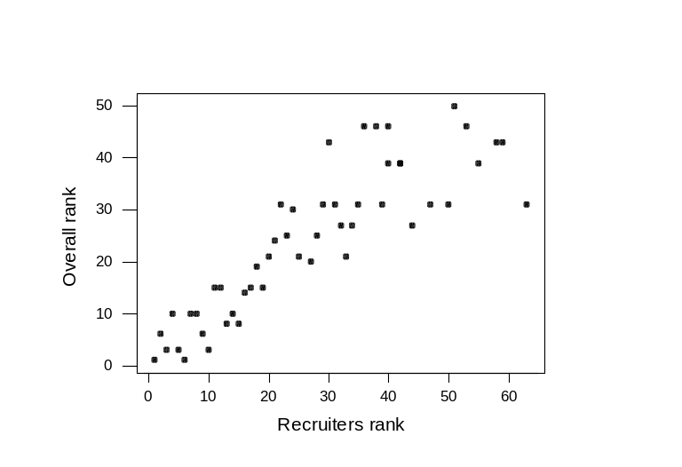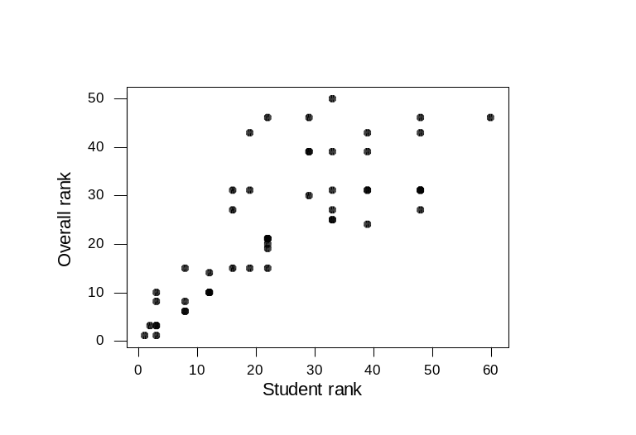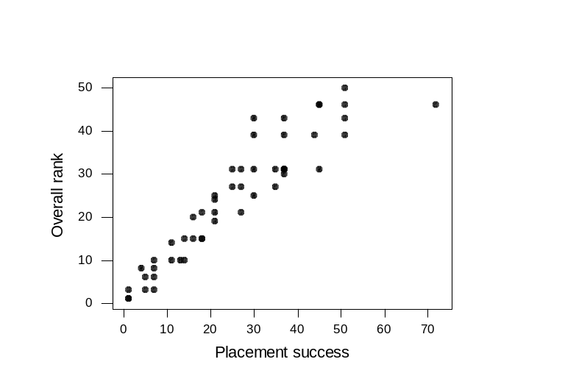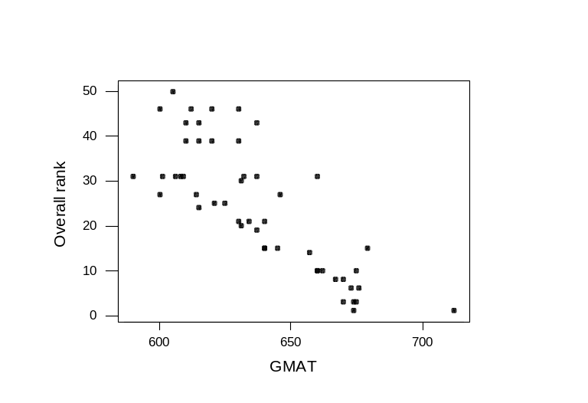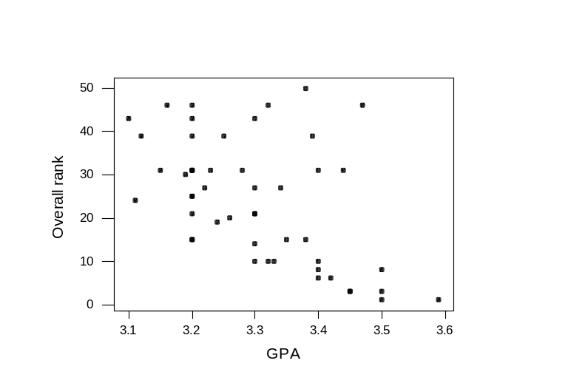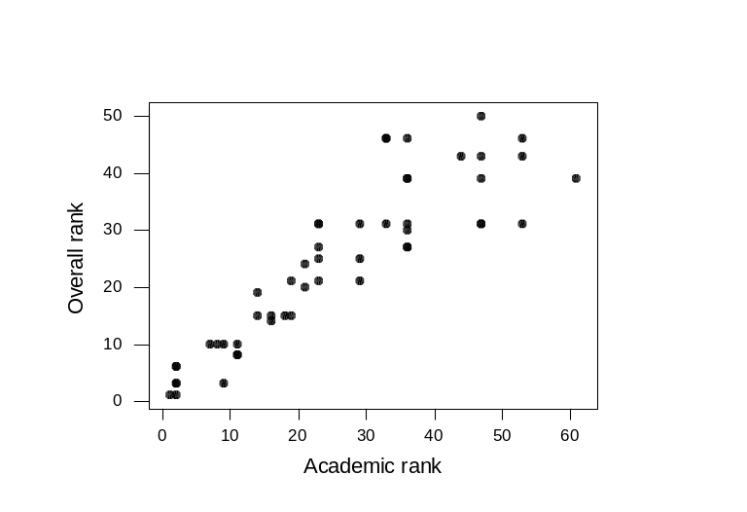

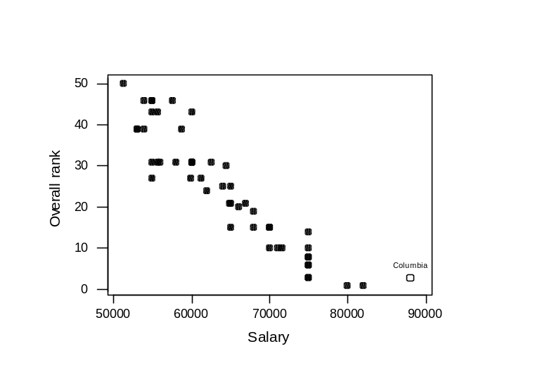
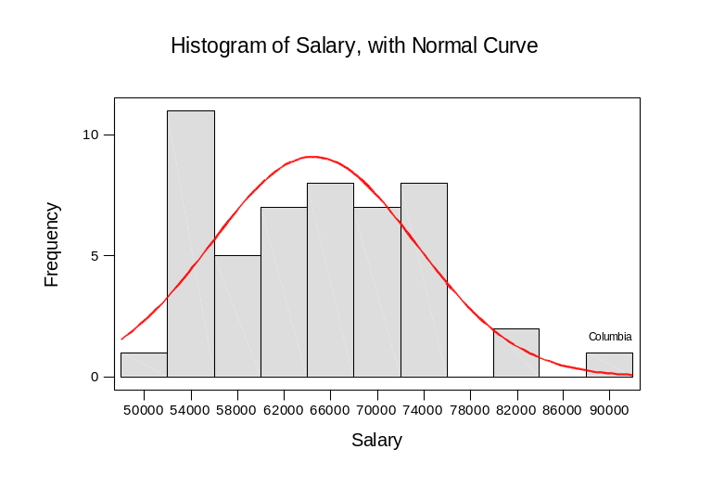 It is interesting to note that Columbia has an unusually high starting salary, which falls outside of the range where most of the data are (see histogram). At the same time, we know that the ranking for Columbia has jumped several places from 1997 to 1998. In building a model for the overall ranking data, I am trying to understand how U.S. News weights the different measures. Therefore, the model should help to explain the sudden jump in Columbia’s status in 1998.

Multiple regression models

Multiple regression using top 50 schools and 7 predictor variables
The overall ranking data were first modeled using all 50 schools and 7 predictor variables. However, the assumption of constant variance is violated in this case, as shown below by the structured pattern in the residual versus fitted value plot. This is not surprising, considering that all the above scatter plots indicate a larger spread of data as the overall ranking of the school decreases.
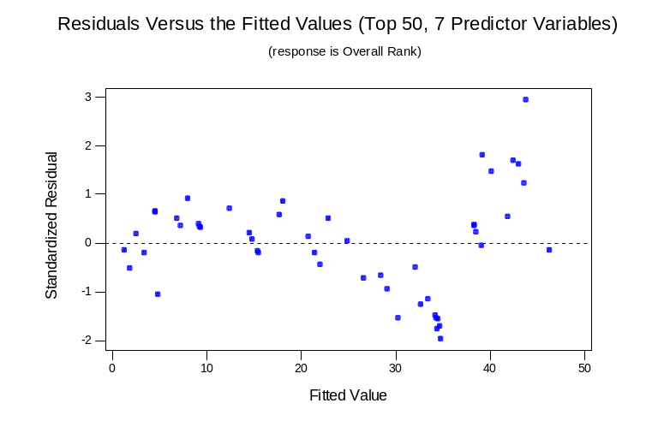
In order to correct the heteroscedasticity, a log-log model was considered. Logging the individual rankings, however, did not provide the desired results. The data actually became more skewed after the transformation, as shown in the histograms below (using “Academic ranking” as an example). In fact, the only variable that may require a log transformation is “Salary”, since the data have a long right tail. Nonetheless, attempts to build a model by logging all the predictor variables or just the “Salary” variable alone were not successful in correcting the non-constant variance problem.
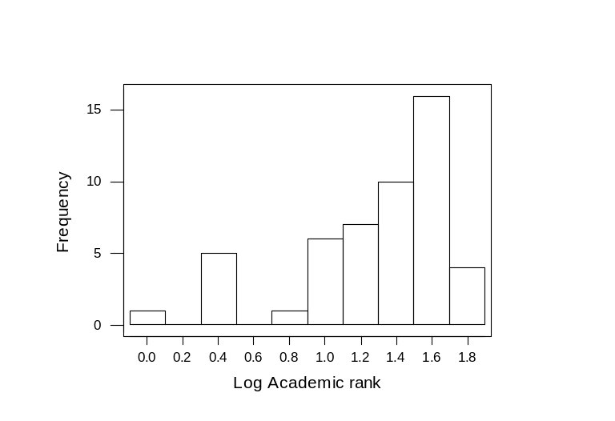
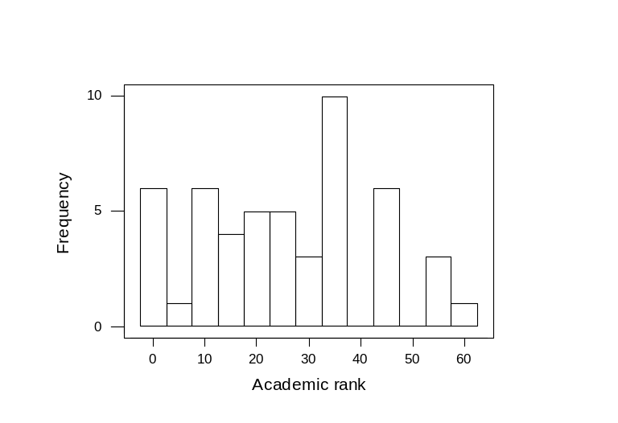

Multiple regression using top 25 schools and 7 predictor variables
Since the scatter plots for the individual variables suggest that there is a lot less variability in the data for the lower ranked schools, I decided to rebuild a model using a subset of the data. Modeling only the top 25 schools proves to give more satisfactory results than modeling the top 30 or 35 schools in terms of getting homoscedasticity. The Minitab regression analysis is presented on the next page. Results show that while the overall correlation is strong (F value of 326), variables “GMAT”, “GPA”, and “Salary” can be eliminated because they all have low t-statistics and high tail probabilities. Although the p-value for “GPA” does suggest statistical significance at a 0.05 level, it has much less predicting power than the remaining 4 ranking variables (as do “GMAT and “Salary). Moreover, the VIF values suggest that there exists some collinearity in the model. Therefore, using only the ranking variables will simplify the regression model and reduce the extra sources of variability.

Regression Analysis (25 schools, 7 predictor variables)

Overall rank = 30.2 + 0.192 Academic rank + 0.164 Recruiters rank
+ 0.155 Students rank + 0.279 Placement success + 0.0085 GMAT
- 7.76 GPA -0.000110 Salary

Predictor Coef StDev T P VIF
Constant 30.21 16.60 1.82 0.085
Academic 0.19232 0.05505 3.49 0.003 8.6
Recruite 0.16450 0.04249 3.87 0.001 5.3
Students 0.15459 0.05062 3.05 0.007 11.4
Placemen 0.27894 0.04714 5.92 0.000 5.7
GMAT 0.00853 0.02218 0.38 0.705 10.2
GPA -7.761 3.530 -2.20 0.041 7.0
Salary -0.00011006 0.00006114 -1.80 0.089 5.6

S = 0.7994 R-Sq = 99.2% R-Sq(adj) = 98.9%

Analysis of Variance

Source DF SS MS F P
Regression 7 1460.38 208.63 326.46 0.000
Residual Error 18 11.50 0.64
Total 25 1471.88

Source DF Seq SS
Academic 1 1262.97
Recruite 1 12.98
Students 1 129.79
Placemen 1 49.04
GMAT 1 0.09
GPA 1 3.44
Salary 1 2.07

Unusual Observations
Obs Academic Overall Fit StDev Fit Residual St Resid
23 23.0 21.000 22.572 0.515 -1.572 -2.57R

R denotes an observation with a large standardized residual

Multiple regression using top 25 schools and 4 predictor variables
The multiple regression was rerun using the 4 ranking predictor variables. The results are shown below. The correlation between the overall ranking and the four predictors is very strong, with a 99% R² value. Similarly, the F-value and tail probability of 447 and 0.000, respectively, show that the null hypothesis of no correlation should be strongly rejected. The individual t- and p-values are now all acceptable, and the variance inflation factor for each predicting variable is below 10, indicating that the previous problem of multicollinearity has been eliminated.
The regression equation is given by:
Overall rank = 0.206 + 0.205 Academic rank + 0.147 Recruiters rank
+ 0.237 Student rank + 0.336 Placement success

The coefficients suggest that the individual rankings are weighted slightly differently to obtain the overall U.S. News ranking. Normalizing the 4 coefficients give the following weights of measures: 22% for academic rank, 16% for recruiters’ rank, 26% for student rank, and 36% for placement success.
Recall that Columbia has experienced a sudden jump in overall ranking this year and that its reported starting salary is unusually high. It is believed that U.S. News determines the placement success by taking into account the starting salary, along with other parameters such as how many and when the MBA graduates receive their job offers. Since the regression model suggests that U.S. News weights the placement success most heavily, it is not surprising that Columbia gets an unusually high ranking in 1998.

Regression Analysis (25 schools, 4 predictor variables)

The regression equation is
Overall rank = 0.206 + 0.205 Academic rank + 0.147 Recruiters rank
+ 0.237 Student rank + 0.336 Placement success

Predictor Coef StDev T P VIF
Constant 0.2057 0.3599 0.57 0.574
Academic 0.20514 0.05656 3.63 0.002 7.1
Recruite 0.14654 0.04591 3.19 0.004 4.9
Students 0.23684 0.03394 6.98 0.000 4.0
Placemen 0.33641 0.04335 7.76 0.000 3.8

S = 0.9024 R-Sq = 98.8% R-Sq(adj) = 98.6%

Analysis of Variance

Source DF SS MS F P
Regression 4 1454.78 363.70 446.61 0.000
Residual Error 21 17.10 0.81
Total 25 1471.88

Source DF Seq SS
Academic 1 1262.97
Recruite 1 12.98
Students 1 129.79
Placemen 1 49.04

Regression diagnostics were run to look for outliers, leverage points and influence points. The criteria for identifying these points are based on a standardized residual of >⏐2.5⏐, a leverage value (Hi) of > 2.5x(4+1)/26 = 0.481 (note that several schools have identical rankings, therefore, there are a total of 26 schools in the top 25 category), and a Cook value of >1. The regression diagnostics results show that outliers, leverage points or influence points are absent in this data set.

Regression Diagnostics

School Overall rank SRES HI COOK

Harvard 1 -0.97433 0.152522 0.034170
Stanford 1 -1.04198 0.157089 0.040468
Columbia 3 -1.91800 0.183180 0.164997
MIT 3 -1.39550 0.126168 0.056235
UPenn 3 -0.52629 0.109638 0.006821
Northwestern 6 1.00798 0.144422 0.034301
U of Chicago 6 0.60739 0.205994 0.019143
Dartmouth 8 0.46822 0.137651 0.006999
UCLA 8 0.32956 0.149431 0.003816
Duke 10 0.43933 0.082983 0.003493
UCBerkeley 10 1.14998 0.270214 0.097932
U Michigan 10 0.42696 0.167301 0.007325
Darden 10 1.37948 0.118968 0.051393
NYU 14 1.88024 0.083015 0.064010
Carnegie 15 -0.57575 0.113717 0.008506
NCarolina 15 0.02087 0.133920 0.000013
Texas 15 -0.90375 0.249053 0.054176
Yale 15 0.47437 0.263433 0.016096
Cornell 19 1.21652 0.154455 0.054067
Rochester 20 1.14879 0.183656 0.059381
Emory 21 -0.11265 0.313355 0.001158
Indiana 21 -0.41753 0.243136 0.011200
USC 21 -1.41669 0.344681 0.211128
Purdue 24 0.15523 0.411052 0.003363
Ohio State 25 -0.17605 0.241516 0.001974
Vandebilt 25 -1.54847 0.259447 0.168007

The assumptions for the regression model were checked. First, the residuals were shown to be a normal distributed, as shown in the normal probability plot. Second, the proof for homoscedasticity was deemed acceptable. Although the overall residual versus fitted value plot still shows a slight degree of structured pattern, it is a much improved version than the that originally obtained by the model using all 50 schools and 7 predictors. The individual residual versus predicting variable plots (on next page) shows a lack of pattern in the data, and therefore further confirms that the assumption of constant variance is not violated. The other assumptions concerning time series data and subgroups are not applicable for this set of data.

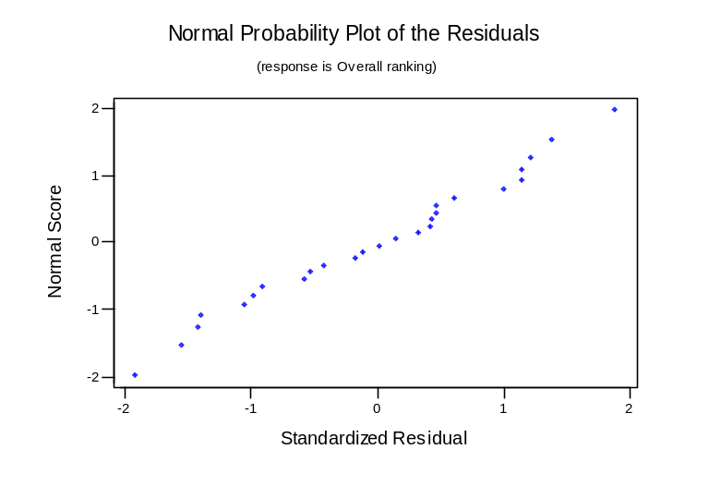
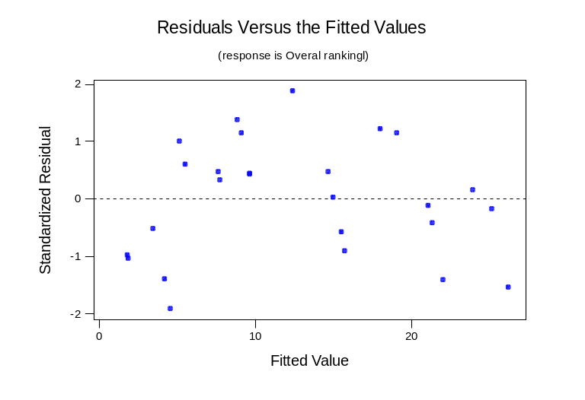
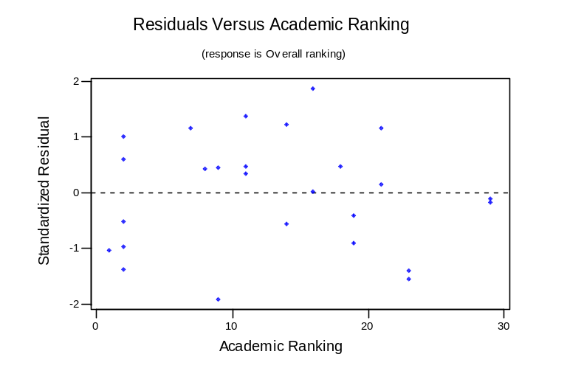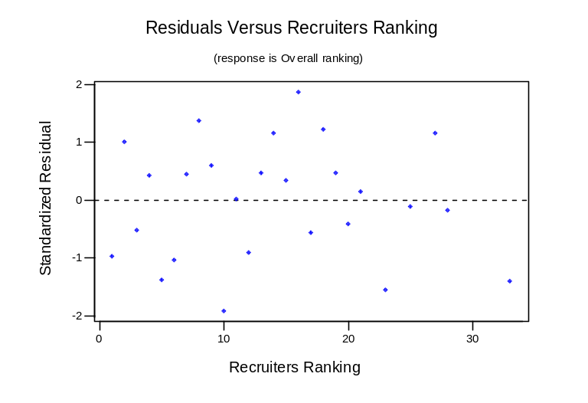
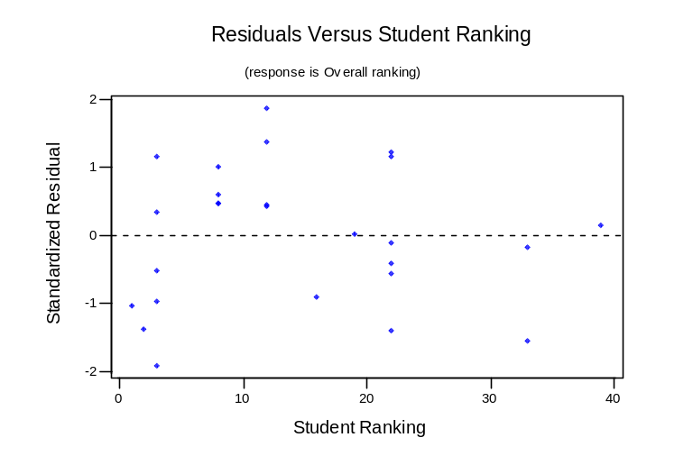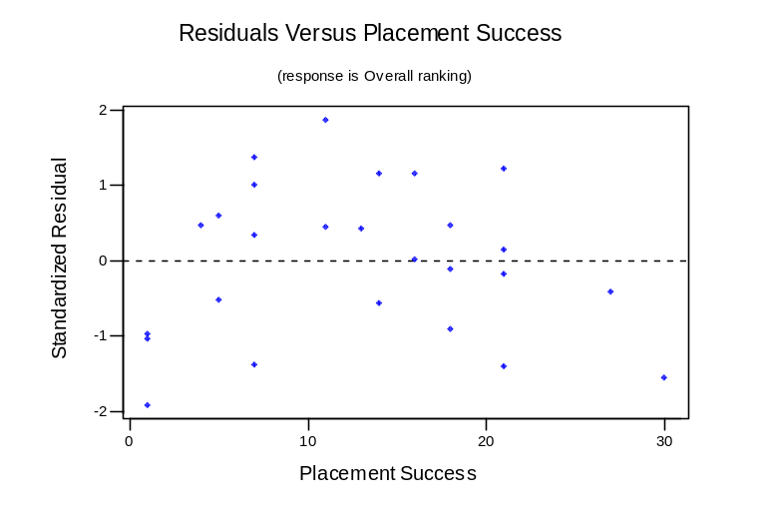

Conclusion
The U.S. News ranking of the top 25 business schools was explained by its relationship with the individual academic ranking, recruiters’ ranking, student ranking, and placement success. An estimated 99% of the variability in the overall ranking data is accounted for by the following regression equation:

Overall rank = 0.206 + 0.205 Academic rank + 0.147 Recruiters rank
+ 0.237 Student rank + 0.336 Placement success

The weight of measure in the U.S. News ranking is revealed, with approximately 40% on reputation of the school (combing the academic and recruiters’ ranking), 25% on the quality of students, and 35% on placement success.
Original attempt to model all 50 schools reported by U.S. News was not successful because the assumption of constant variance was violated. This suggests that a top 25 ranking, rather than top 50, is actually more indicative of the quality of the schools, simply because there is too much scatter in the data associated with the rest of the schools.

