The objects: Dow Jones Industrial Average Index, oil, gold, and natural gas average prices.

Primary sources of data would be [www.finance.yahoo.com](http://www.finance.yahoo.com) and [www.macrotrends.net](http://www.macrotrends.net).

The daily average data would be collected and analyzed from 2005 to 2015.

I would like to find correlation between Dow Jones Industrial Average index, oil, gold and natural gas prices.

I expect to find that oil price fluctuation causes changes in Dow Jones Industrial Average Index, gold and natural gas prices.

Raw data collected and saved in exls format: 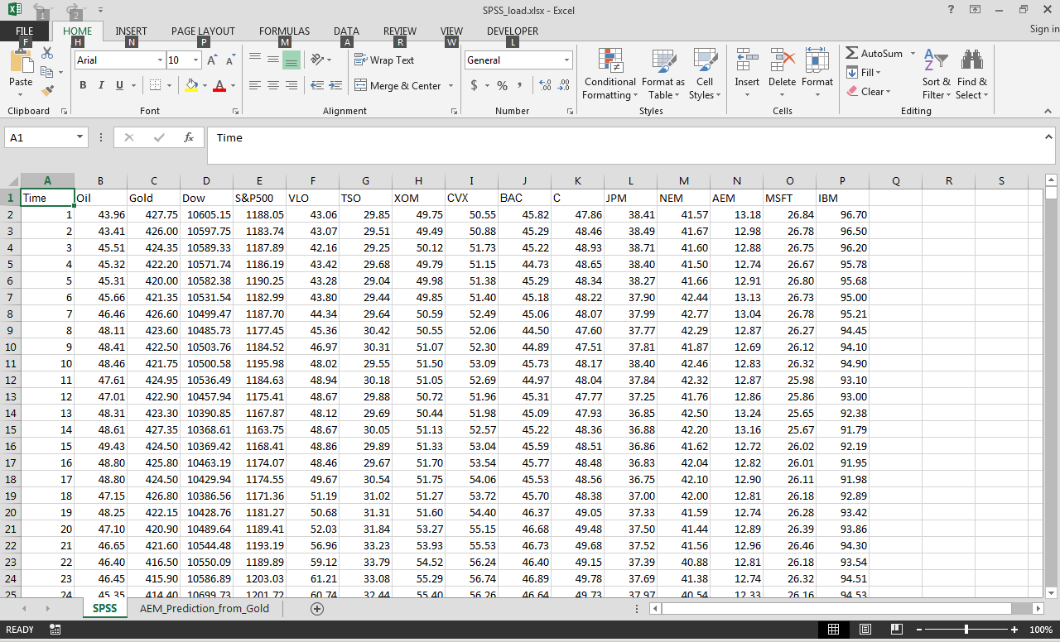

Data loaded in to SPSS:

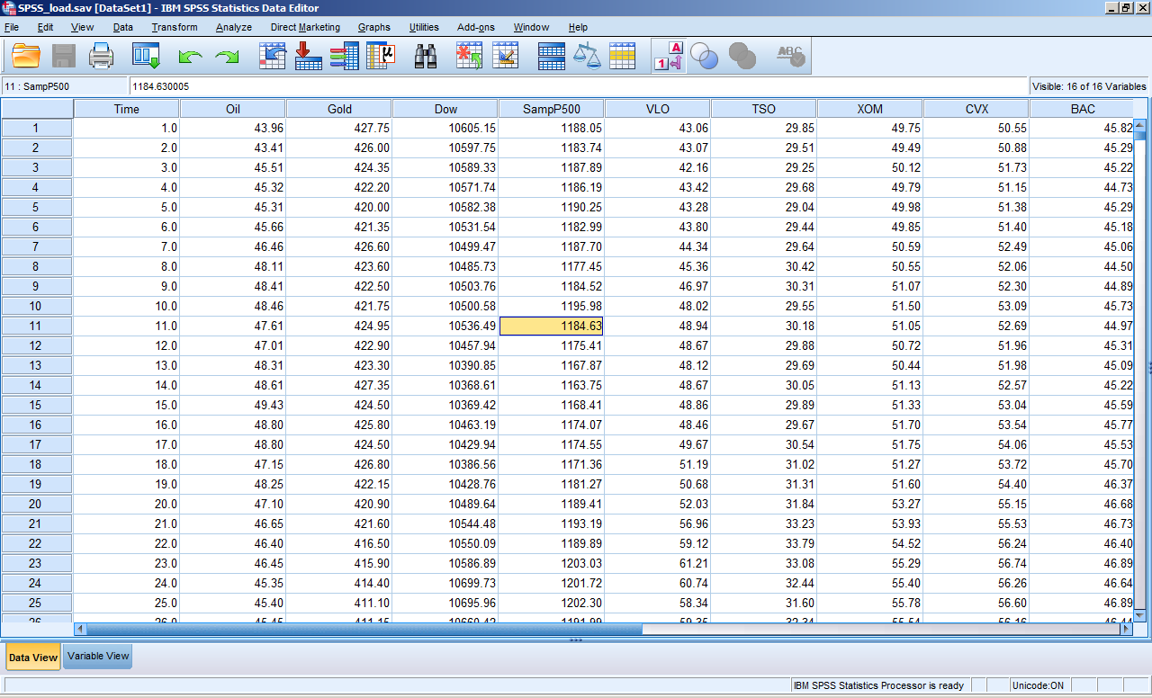

Data analysis.

Correlation between Oil Dow, Oil and Gold, Dow and Gold

Correlation -> Bivariable -> Oil Dow, Oil Gold, Dow and Gold

Regression -> Linear -> Dependent (Dow, Gold, Gold)

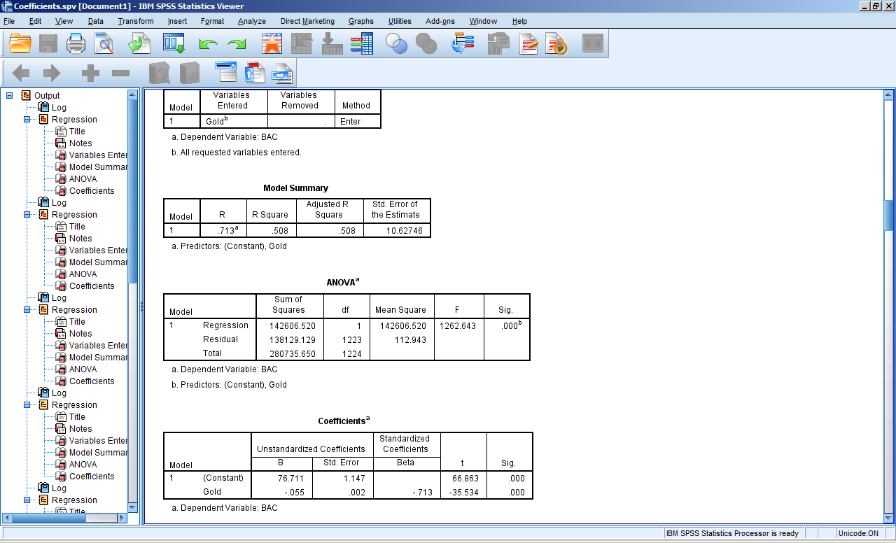

Calculated coefficients and developed formulas:

|  |  |  |  |  |  |  |
| --- | --- | --- | --- | --- | --- | --- |
| **Coefficientsa** | | | | | | |
| Model | | Unstandardized Coefficients | | Standardized Coefficients | t | Sig. |
| B | Std. Error | Beta |
| 1 | (Constant) | 8581.316 | 144.323 |  | 59.459 | .000 |
| Oil | 34.384 | 1.932 | .454 | 17.800 | .000 |
| a. Dependent Variable: Dow | | | | | | |

**Y = 34.384*x+ 8581.316**

Independent OIL

Oil Gold

|  |  |  |  |  |  |  |
| --- | --- | --- | --- | --- | --- | --- |
| **Coefficientsa** | | | | | | |
| Model | | Unstandardized Coefficients | | Standardized Coefficients | t | Sig. |
| B | Std. Error | Beta |
| 1 | (Constant) | 434.838 | 17.337 |  | 25.081 | .000 |
| Oil | 3.970 | .232 | .439 | 17.106 | .000 |
| 1. Dependent Variable: Gold | | | | | | |

Y = 3.970*x + 434.838

Dow Gold

|  |  |  |  |  |  |  |
| --- | --- | --- | --- | --- | --- | --- |
| **Coefficientsa** | | | | | | |
| Model | | Unstandardized Coefficients | | Standardized Coefficients | t | Sig. |
| B | Std. Error | Beta |
| 1 | (Constant) | 962.639 | 37.376 |  | 25.755 | .000 |
| Dow | -.022 | .003 | -.186 | -6.606 | .000 |
| a. Dependent Variable: Gold | | | | | | |

Y= -.022 * x + 962.539

Oil VS XOM

|  |  |  |  |  |  |  |
| --- | --- | --- | --- | --- | --- | --- |
| **Coefficientsa** | | | | | | |
| Model | | Unstandardized Coefficients | | Standardized Coefficients | t | Sig. |
| B | Std. Error | Beta |
| 1 | (Constant) | 49.490 | .857 |  | 57.740 | .000 |
| Oil | .317 | .011 | .619 | 27.588 | .000 |
| a. Dependent Variable: XOM | | | | | | |

Y = 49.49+ 0.317*x

Coefficients by % change in oil to xom

|  |  |  |  |  |  |  |
| --- | --- | --- | --- | --- | --- | --- |
| **Coefficientsa** | | | | | | |
| Model | | Unstandardized Coefficients | | Standardized Coefficients | t | Sig. |
| B | Std. Error | Beta |
| 1 | (Constant) | 5.119E-5 | .001 |  | .099 | .921 |
| OIL | .284 | .018 | .414 | 15.896 | .000 |
| a. Dependent Variable: XOM | | | | | | |

Y=0.00005119 + .284*x

Oil CVX

|  |  |  |  |  |  |  |
| --- | --- | --- | --- | --- | --- | --- |
| **Coefficientsa** | | | | | | |
| Model | | Unstandardized Coefficients | | Standardized Coefficients | t | Sig. |
| B | Std. Error | Beta |
| 1 | (Constant) | 41.032 | .819 |  | 50.089 | .000 |
| Oil | .428 | .011 | .745 | 39.074 | .000 |
| a. Dependent Variable: CVX | | | | | | |

**Y = 41.032 + 0.428 * x**

XOM CVX

|  |  |  |  |  |  |  |
| --- | --- | --- | --- | --- | --- | --- |
| **Coefficientsa** | | | | | | |
| Model | | Unstandardized Coefficients | | Standardized Coefficients | t | Sig. |
| B | Std. Error | Beta |
| 1 | (Constant) | -6.404 | .641 |  | -9.998 | .000 |
| XOM | 1.082 | .009 | .962 | 123.289 | .000 |
| a. Dependent Variable: CVX | | | | | | |

**Y = -6.404 + 1.082 * x**

GOLD BAC

|  |  |  |  |  |  |  |
| --- | --- | --- | --- | --- | --- | --- |
| **Coefficientsa** | | | | | | |
| Model | | Unstandardized Coefficients | | Standardized Coefficients | t | Sig. |
| B | Std. Error | Beta |
| 1 | (Constant) | 76.711 | 1.147 |  | 66.863 | .000 |
| Gold | -.055 | .002 | -.713 | -35.534 | .000 |
| a. Dependent Variable: BAC | | | | | | |

**Y = 76.711 + (-0.055) * (gold)**

GOLD C

|  |  |  |  |  |  |  |
| --- | --- | --- | --- | --- | --- | --- |
| **Coefficientsa** | | | | | | |
| Model | | Unstandardized Coefficients | | Standardized Coefficients | t | Sig. |
| B | Std. Error | Beta |
| 1 | (Constant) | 90.686 | 1.150 |  | 78.891 | .000 |
| Gold | -.080 | .002 | -.829 | -51.896 | .000 |
| a. Dependent Variable: C | | | | | | |

**Y = 90.686 + (- 0.08) * (gold)**

GOLD VLO

|  |  |  |  |  |  |  |
| --- | --- | --- | --- | --- | --- | --- |
| **Coefficientsa** | | | | | | |
| Model | | Unstandardized Coefficients | | Standardized Coefficients | t | Sig. |
| B | Std. Error | Beta |
| 1 | (Constant) | 117.662 | 1.770 |  | 66.459 | .000 |
| Gold | -.089 | .002 | -.731 | -37.437 | .000 |
| a. Dependent Variable: VLO | | | | | | |

**Y = 117.662 + (- 0.089) * (gold)**

Gold AEM

|  |  |  |  |  |  |  |
| --- | --- | --- | --- | --- | --- | --- |
| **Coefficientsa** | | | | | | |
| Model | | Unstandardized Coefficients | | Standardized Coefficients | t | Sig. |
| B | Std. Error | Beta |
| 1 | (Constant) | -20.900 | .723 |  | -28.896 | .000 |
| Gold | .085 | .001 | .929 | 88.021 | .000 |
| a. Dependent Variable: AEM | | | | | | |

**Y = -20.900 + 0.085 * (gold)**

OIL & Gold IBM

|  |  |  |  |  |  |  |
| --- | --- | --- | --- | --- | --- | --- |
| **Coefficientsa** | | | | | | |
| Model | | Unstandardized Coefficients | | Standardized Coefficients | t | Sig. |
| B | Std. Error | Beta |
| 1 | (Constant) | 43.175 | 1.127 |  | 38.306 | .000 |
| Oil | .307 | .014 | .408 | 22.507 | .000 |
| Gold | .046 | .002 | .556 | 30.668 | .000 |
| a. Dependent Variable: IBM | | | | | | |

**Y = 43.175 + 0.307 * (oil) + 0.046 * (gold)**

Gold & CVX AEM

|  |  |  |  |  |  |  |
| --- | --- | --- | --- | --- | --- | --- |
| **Coefficientsa** | | | | | | |
| Model | | Unstandardized Coefficients | | Standardized Coefficients | t | Sig. |
| B | Std. Error | Beta |
| 1 | (Constant) | -40.565 | .829 |  | -48.957 | .000 |
| Gold | .069 | .001 | .748 | 76.490 | .000 |
| CVX | .442 | .014 | .306 | 31.263 | .000 |
| a. Dependent Variable: AEM | | | | | | |

**Y = -40.565 + 0.069 * (gold) + 0.442 * (CVX)**

Gold & TSO BAC

|  |  |  |  |  |  |  |
| --- | --- | --- | --- | --- | --- | --- |
| **Coefficientsa** | | | | | | |
| Model | | Unstandardized Coefficients | | Standardized Coefficients | t | Sig. |
| B | Std. Error | Beta |
| 1 | (Constant) | 42.137 | 1.237 |  | 34.055 | .000 |
| Gold | -.029 | .001 | -.375 | -22.479 | .000 |
| TSO | .355 | .010 | .608 | 36.448 | .000 |
| a. Dependent Variable: BAC | | | | | | |

**Y = 42.137 + (-0.029) * (gold) + 0.355 * (TSO)**

Test developed formula for prediction of the price.

Gold price and mining company:

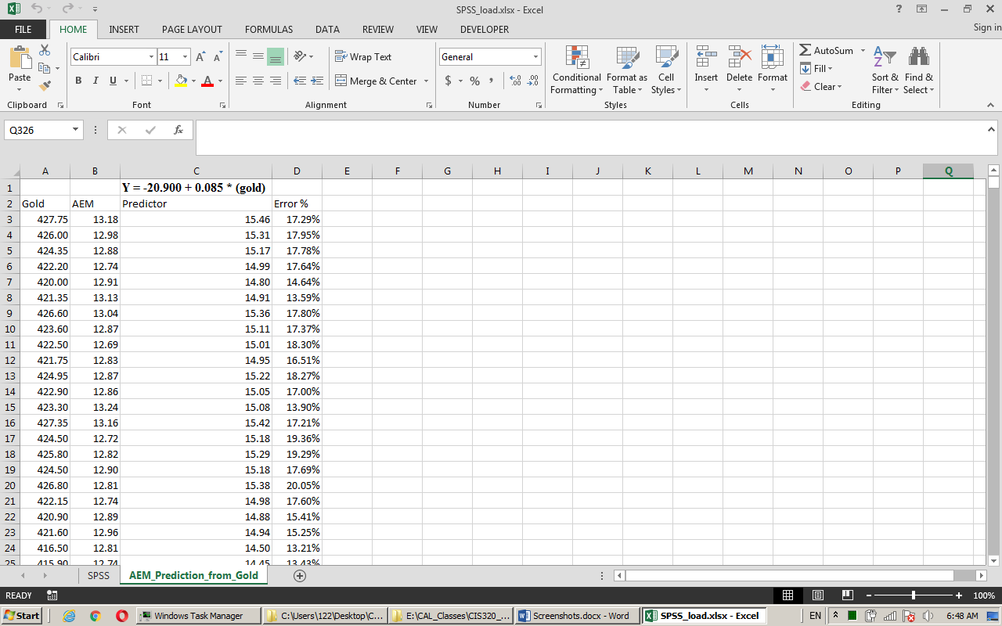

Independent (Oil, Dow) 