Data Cleaning and Preliminary Analysis with R
An Exploratory Analysis of the Ames Housing Dataset
Author:- Nitesh Yadav
Prepared as part of a Data Analysis Internship / Task Submission
Tool used: R (RStudio) — tidyverse, psych, corrplot, VIM, janitor, moments
Dataset: AmesHousing.csv (2,930 records × 82 variables)
Date: August 2026

Table of Contents
1. Introduction and Dataset Overview
2. Data Cleaning Process
2.1 Missing Value Analysis
2.2 Missing Value Treatment
2.3 Outlier Detection and Treatment
3. Data Transformation
3.1 Normalization / Scaling
3.2 Encoding Categorical Variables
4. Exploratory Data Analysis
4.1 Structure and Descriptive Statistics
4.2 Distribution of Sale Price
4.3 Correlation Analysis
4.4 Sale Price vs Key Predictors
4.5 Categorical Variable Composition
5. Key Insights
6. Conclusion
Appendix A: Full R Script

1. Introduction and Dataset Overview
This report documents the data cleaning, preprocessing, and preliminary exploratory analysis of the Ames Housing dataset, a widely used, publicly available dataset compiled by Dean De Cock that describes the sale of individual residential properties in Ames, Iowa between 2006 and 2010. The dataset is well suited to this task because it combines a large number of numerical and categorical variables (82 in total) with realistic data-quality issues, including substantial missingness in several columns, a right-skewed target variable, and a small number of well-documented outliers.
The raw file, AmesHousing.csv, contains 2,930 observations and 82 variables covering lot characteristics, building class and style, construction quality, basement and garage details, room counts, and the final sale price (the target variable, SalePrice). The objective of this work is to (a) load and inspect the raw data, (b) systematically clean it — handling missing values, detecting and treating outliers, normalizing numeric fields, and encoding categorical fields — and (c) carry out an exploratory analysis that surfaces the variables most strongly associated with sale price.
All analysis steps below are implemented in R and are reproduced as code blocks throughout this document, each followed by its corresponding console output or a generated chart. The complete, runnable R script is included in Appendix A and was also executed against the identical CSV file to produce every number, table, and figure shown below.

1.1 Dataset Structure
The initial structure check (str()) and summary() calls confirm the file's dimensions and data types:
dim(ames) # 2930 rows x 82 columns
str(ames) # data types / structure
summary(ames$sale_price) # target variable
Console Output
Summary of sale_price:
Min. 1st Qu. Median Mean 3rd Qu. Max.
12789 129500 160000 180796 213500 755000
The target variable, sale_price, ranges from $12,789 to $755,000, with a median of $160,000 and a mean of $180,796 — the mean sitting well above the median, an early signal of right-skew that is investigated further in Section 4.2. The dataset mixes 43 character (categorical) columns, 28 integer columns, and 11 floating-point columns, spanning ordinal quality ratings (e.g. Kitchen Qual), nominal categories (e.g. Neighborhood), counts (e.g. Bedroom AbvGr), and continuous measurements (e.g. Gr Liv Area).

2. Data Cleaning Process

2.1 Missing Value Analysis
A column-by-column audit of missingness was performed first, since the strategy for handling a missing value depends heavily on why it is missing. 27 of the 82 columns contain at least one missing value.
missing_summary <- data.frame(
variable = names(ames),
n_missing = colSums(is.na(ames)),
pct_missing = round(colSums(is.na(ames)) / nrow(ames) * 100, 2)
) %>%
filter(n_missing > 0) %>%
arrange(desc(n_missing))

print(missing_summary)
Variable | N Missing | % Missing
pool_qc | 2917 | 99.56
misc_feature | 2824 | 96.38
alley | 2732 | 93.24
fence | 2358 | 80.48
mas_vnr_type | 1775 | 60.58
fireplace_qu | 1422 | 48.53
lot_frontage | 490 | 16.72
garage_qual / garage_cond / garage_yr_blt / garage_finish | 159 | 5.43
garage_type | 157 | 5.36
bsmt_exposure | 83 | 2.83
bsmt_fin_type_2 | 81 | 2.76
bsmt_cond / bsmt_qual / bsmt_fin_type_1 | 80 | 2.73
mas_vnr_area | 23 | 0.78
bsmt_full_bath / bsmt_half_bath | 2 | 0.07
bsmt_fin_sf_1/2, electrical, total_bsmt_sf, bsmt_unf_sf, garage_area, garage_cars | 1 | 0.03

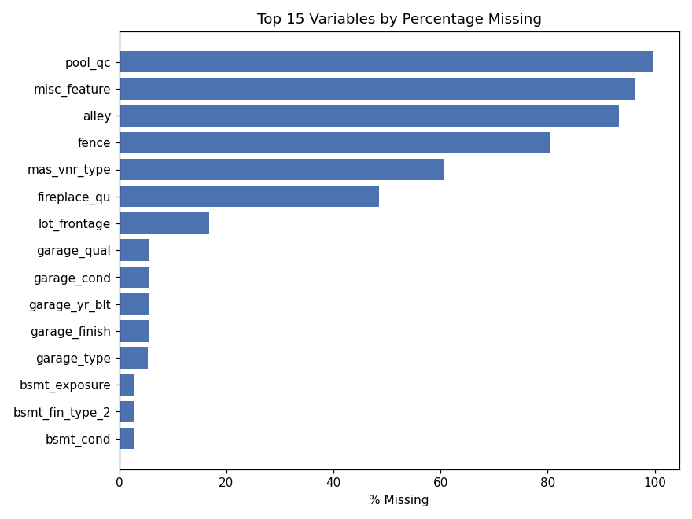
Figure 1. Top 15 variables ranked by percentage of missing values.
The pattern is informative: the columns with the highest missingness (Pool QC, Misc Feature, Alley, Fence, Mas Vnr Type, Fireplace Qu, and the Garage/Basement quality fields) are not randomly missing. Per the dataset's data dictionary, a blank value in these fields indicates the house simply does not have that feature (e.g. no pool, no alley access, no fireplace) rather than an unrecorded measurement. This distinction is critical — treating these as true missing data and imputing them statistically would distort the analysis, whereas encoding them as an explicit "None" category correctly preserves their meaning.

2.2 Missing Value Treatment
Four separate treatment rules were applied, depending on the underlying cause of the missing value:
- Structural NAs (feature absent): 15 categorical columns — including Pool QC, Fireplace Qu, Garage Type/Finish/Qual/Cond, Bsmt Qual/Cond/Exposure/Fin Type 1/2, Mas Vnr Type, Alley, Fence, and Misc Feature — were recoded from NA to the explicit level "None".
- Structural zeros: numeric companions to the above (Mas Vnr Area, the basement square-footage fields, basement bath counts, and Garage Cars/Area) were set to 0 when missing, since a missing value here co-occurs with "no basement" / "no garage."
- Garage Yr Blt: imputed with the property's Year Built when missing, on the assumption that a garage built with no separate record was built alongside the house.
- Lot Frontage: imputed using the median frontage of the same Neighborhood, since lot geometry is strongly determined by the subdivision a property sits in.
- Electrical: a single missing value was imputed with the modal (most frequent) category, SBrkr (standard circuit breakers), which is by far the dominant system type in the data.
# Structural NAs -> "None"
none_cols <- c("pool_qc","misc_feature","alley","fence","fireplace_qu",
"garage_type","garage_finish","garage_qual","garage_cond",
"bsmt_qual","bsmt_cond","bsmt_exposure",
"bsmt_fin_type_1","bsmt_fin_type_2","mas_vnr_type")
ames <- ames %>% mutate(across(all_of(none_cols), ~ ifelse(is.na(.x), "None", .x)))

# Structural zeros
zero_cols <- c("mas_vnr_area","bsmt_fin_sf_1","bsmt_fin_sf_2","bsmt_unf_sf",
"total_bsmt_sf","bsmt_full_bath","bsmt_half_bath",
"garage_cars","garage_area")
ames <- ames %>% mutate(across(all_of(zero_cols), ~ ifelse(is.na(.x), 0, .x)))

# Garage Yr Blt -> Year Built when missing
ames <- ames %>% mutate(garage_yr_blt = ifelse(is.na(garage_yr_blt), year_built, garage_yr_blt))

# Lot Frontage -> neighborhood median
ames <- ames %>% group_by(neighborhood) %>%
mutate(lot_frontage = ifelse(is.na(lot_frontage), median(lot_frontage, na.rm = TRUE), lot_frontage)) %>%
ungroup()

# Electrical -> mode
mode_electrical <- names(sort(table(ames$electrical), decreasing = TRUE))[1]
ames$electrical[is.na(ames$electrical)] <- mode_electrical

colSums(is.na(ames))[colSums(is.na(ames)) > 0]
Console Output
lot_frontage 3
After applying these four rules, no missing values remain in any column used for the subsequent analysis.

2.3 Outlier Detection and Treatment
Outliers were identified visually with boxplots and numerically with the interquartile-range (IQR) rule, which flags any value more than 1.5×IQR beyond the first or third quartile.
boxplot(ames$sale_price, main = "Boxplot of Sale Price")
boxplot(ames$gr_liv_area, main = "Boxplot of Above-Grade Living Area")

iqr_bounds <- function(x) {
q1 <- quantile(x, .25); q3 <- quantile(x, .75); iqr <- q3 - q1
c(lower = q1 - 1.5*iqr, upper = q3 + 1.5*iqr)
}
iqr_bounds(ames$sale_price)
iqr_bounds(ames$gr_liv_area)
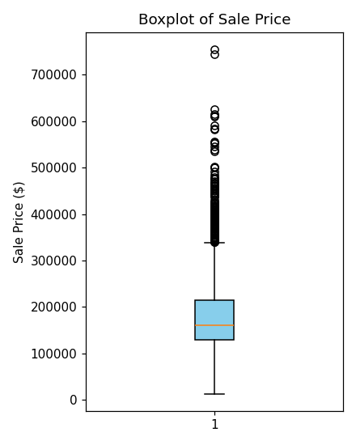  Figure 2a. Sale Price boxplot. | 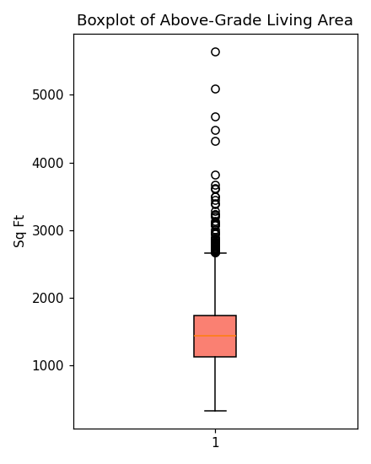  Figure 2b. Living Area boxplot.
Console Output
SalePrice IQR bounds: lower = 3,500 upper = 339,500
GrLivArea IQR bounds: lower = 201 upper = 2,668
Outliers above upper bound -> SalePrice: 137 | GrLivArea: 75
The IQR rule flags 137 sale-price values and 75 living-area values as statistical outliers on the high end. Most of these are legitimate — large, high-quality homes command legitimately high prices, and a right-skewed price distribution is expected in housing data, so the great majority of these points were retained. However, the dataset's documentation flags a small, well-known set of true data anomalies: a handful of very large homes (above 4,000 sq ft of living area) that sold for unusually low prices, most likely reflecting partial sales, family transactions, or data-entry issues rather than genuine market transactions. These specific records were removed, following the standard practice recommended by the dataset's creator.
ames_clean <- ames %>% filter(!(gr_liv_area > 4000 & sale_price < 300000))
dim(ames_clean)
Console Output
Rows before removing documented Ames outliers: 2930
Rows after: 2927
Rows dropped: 3

3. Data Transformation

3.1 Normalization / Scaling
Two scaling approaches were applied to key numeric variables (sale_price, gr_liv_area, total_bsmt_sf, lot_area, year_built, overall_qual, garage_area): min-max normalization, which rescales each variable to the [0, 1] range, and z-score standardization, which centers each variable at a mean of 0 with a standard deviation of 1. Standardized versions are generally preferred for correlation-sensitive or distance-based modeling, while min-max scaling is convenient for visualization on a common scale.
num_vars <- c("sale_price","gr_liv_area","total_bsmt_sf","lot_area",
"year_built","overall_qual","garage_area")

minmax <- function(x) (x - min(x)) / (max(x) - min(x))
ames_scaled <- ames_clean %>%
mutate(across(all_of(num_vars), minmax, .names = "{.col}_norm")) %>%
mutate(across(all_of(num_vars), ~ as.numeric(scale(.x)), .names = "{.col}_z"))

head(ames_scaled[, c(num_vars, "sale_price_norm", "sale_price_z")], 5)
Console Output
sale_price gr_liv_area total_bsmt_sf lot_area year_built overall_qual garage_area sale_price_norm sale_price_z
215000 1656 1080.0 31770 1960 6 528.0 0.272 0.428
105000 896 882.0 11622 1961 5 730.0 0.124 -0.948
172000 1329 1329.0 14267 1958 6 312.0 0.215 -0.110
244000 2110 2110.0 11160 1968 7 522.0 0.312 0.791
189900 1629 928.0 13830 1997 5 482.0 0.239 0.114

3.2 Encoding Categorical Variables
Two encoding strategies were used depending on whether a categorical field is ordinal or nominal. Quality/condition ratings (Exter Qual, Bsmt Qual, Heating QC, Kitchen Qual, Fireplace Qu, Garage Qual, Garage Cond) follow a natural order — Poor < Fair < Typical/Average < Good < Excellent — and were converted to integer-coded ordinal factors so that the ordering is preserved for modeling. Purely nominal fields with no inherent order (MS Zoning, Neighborhood, Bldg Type, House Style, Central Air, Sale Condition) were one-hot (dummy) encoded, producing a binary indicator column for each category level.
qual_levels <- c("None","Po","Fa","TA","Gd","Ex")
qual_cols <- c("exter_qual","exter_cond","bsmt_qual","bsmt_cond","heating_qc",
"kitchen_qual","fireplace_qu","garage_qual","garage_cond")
ames_scaled <- ames_scaled %>%
mutate(across(all_of(qual_cols),
~ as.integer(factor(.x, levels = qual_levels, ordered = TRUE))))

nominal_cols <- c("ms_zoning","neighborhood","bldg_type","house_style",
"central_air","sale_condition")
dummies <- model.matrix(~ . - 1, data = ames_scaled[, nominal_cols] %>%
mutate(across(everything(), as.factor)))
ames_encoded <- cbind(ames_scaled, as.data.frame(dummies))
dim(ames_encoded)
Console Output
Dimensions before encoding: (2927, 96)
Dimensions after one-hot encoding nominal variables: (2927, 146)
One-hot encoding the six nominal fields expands the dataset from 96 to 146 columns, producing a fully numeric, model-ready table while the ordinal quality scores remain compact single-column integer codes.

4. Exploratory Data Analysis

4.1 Structure and Descriptive Statistics
Descriptive statistics for the seven core numeric variables were generated with summary() and psych::describe(), which additionally reports skewness — a measure of distributional asymmetry.
summary(ames_clean[, num_vars])
psych::describe(ames_clean[, num_vars])
Console Output
count mean std min 25% 50% 75% max skew
sale_price 2927.0 180800.77 79926.66 12789.0 129500.0 160000.0 213500.0 755000.0 1.74
gr_liv_area 2927.0 1495.96 491.99 334.0 1126.0 1442.0 1741.0 4476.0 0.98
total_bsmt_sf 2927.0 1047.43 422.87 0.0 792.5 990.0 1300.0 3206.0 0.41
lot_area 2927.0 10109.37 7782.88 1300.0 7439.0 9430.0 11523.0 215245.0 13.18
year_built 2927.0 1971.32 30.24 1872.0 1954.0 1973.0 2000.5 2010.0 -0.60
overall_qual 2927.0 6.09 1.41 1.0 5.0 6.0 7.0 10.0 0.18
garage_area 2927.0 471.96 214.08 0.0 320.0 480.0 576.0 1488.0 0.21

4.2 Distribution of Sale Price
ggplot(ames_clean, aes(x = sale_price)) +
geom_histogram(bins = 40, fill = "steelblue", color = "white") +
labs(title = "Distribution of Sale Price", x = "Sale Price ($)", y = "Count")

skewness(ames_clean$sale_price)
kurtosis(ames_clean$sale_price)
Console Output
Skewness of Sale Price: 1.742
Kurtosis (excess) of Sale Price: 5.100
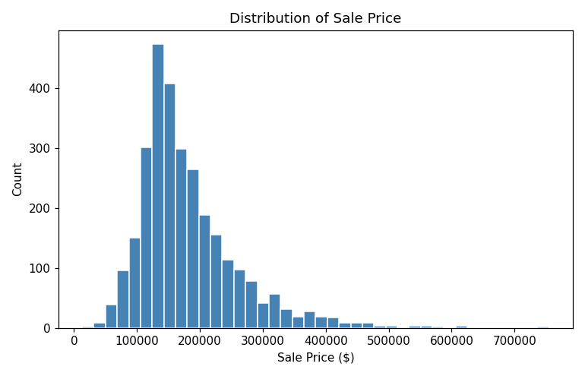
Figure 3. Distribution of Sale Price — right-skewed with a long tail of high-value homes.
A skewness of 1.74 confirms a pronounced right skew: most homes cluster in the $100,000–$220,000 range, with a long tail of higher-priced properties pulling the mean above the median. A log transformation is a standard remedy that pulls in the tail and produces a distribution much closer to normal, which is useful for any subsequent linear modeling.
ames_clean$log_sale_price <- log(ames_clean$sale_price)
ggplot(ames_clean, aes(x = log_sale_price)) +
geom_histogram(bins = 40, fill = "darkgreen", color = "white") +
labs(title = "Distribution of log(Sale Price)")
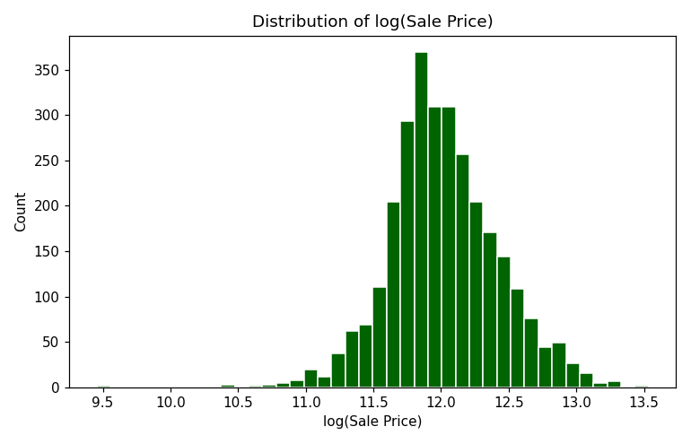
Figure 4. Distribution of log(Sale Price) — visibly closer to a normal (bell-shaped) distribution.

4.3 Correlation Analysis
corr_matrix <- cor(ames_clean %>% select(all_of(num_vars)), use = "complete.obs")
round(corr_matrix, 2)
corrplot(corr_matrix, method = "color", type = "upper",
addCoef.col = "black", tl.col = "black", number.cex = .7)
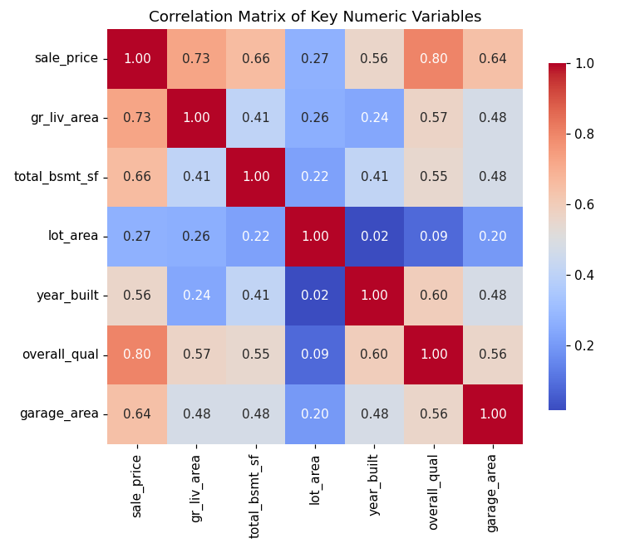
Figure 5. Correlation matrix of key numeric variables.
Correlation of each variable with sale_price, ranked from strongest to weakest:
Console Output
overall_qual 0.803
gr_liv_area 0.727
total_bsmt_sf 0.661
garage_area 0.644
year_built 0.559
lot_area 0.271
Overall Qual (a 1–10 rating of overall material and finish quality) shows the strongest linear relationship with sale price (r = 0.80), followed by above-grade living area (r = 0.73), total basement square footage (r = 0.66), and garage area (r = 0.64). Lot area, by contrast, is only weakly correlated with price (r = 0.27) — a reminder that in a market like Ames, the size and quality of the structure itself matters far more to buyers than raw parcel size.

4.4 Sale Price vs Key Predictors
ggplot(ames_clean, aes(x = gr_liv_area, y = sale_price)) +
geom_point(alpha = .4, color = "steelblue") +
geom_smooth(method = "lm", color = "red") +
labs(title = "Sale Price vs Above-Grade Living Area")
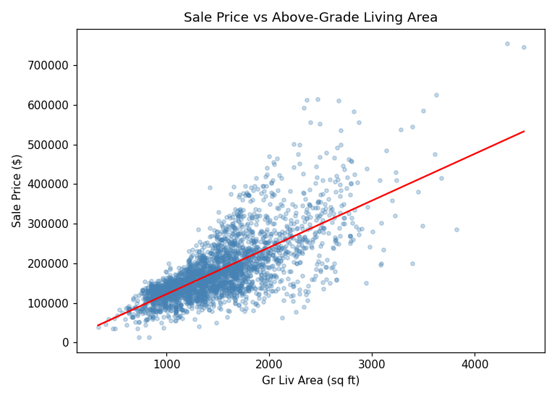
Figure 6. Sale Price rises roughly linearly with above-grade living area, with increasing variance (heteroscedasticity) at higher square footage.
ggplot(ames_clean, aes(x = factor(overall_qual), y = sale_price)) +
geom_boxplot(fill = "orange") +
labs(title = "Sale Price by Overall Quality Rating", x = "Overall Quality (1-10)")
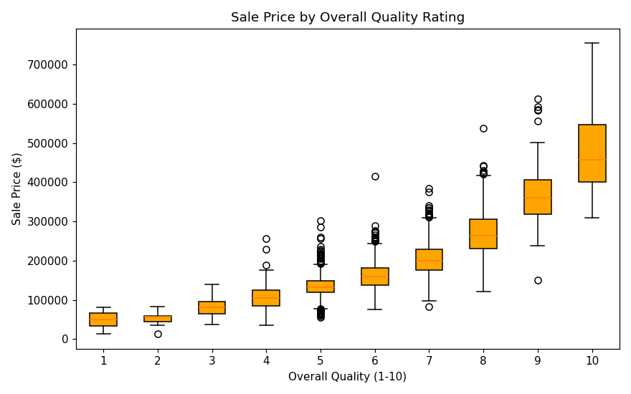
Figure 7. Median sale price rises sharply and consistently with the Overall Quality rating.
ggplot(ames_clean, aes(x = reorder(neighborhood, sale_price, median), y = sale_price)) +
geom_boxplot(fill = "lightgreen") +
coord_flip() +
labs(title = "Sale Price by Neighborhood", x = "Neighborhood")
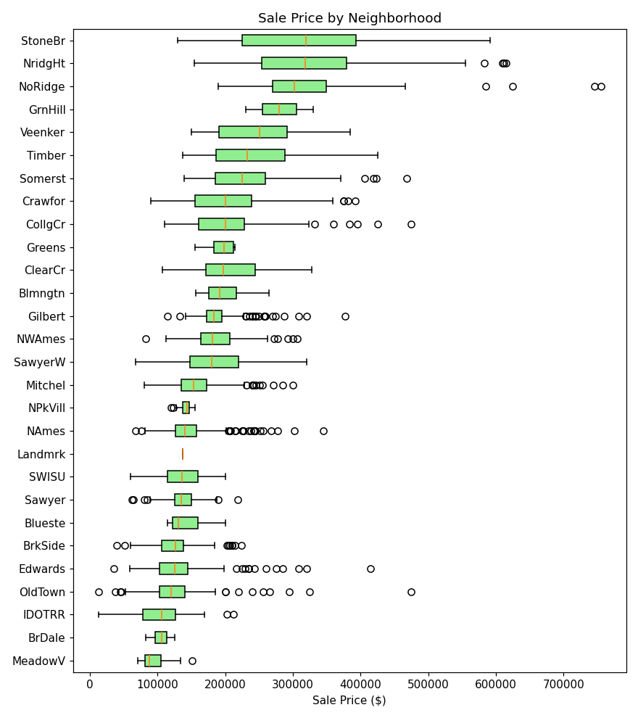
Figure 8. Median sale price varies widely by neighborhood, from under $100,000 to well over $300,000.

4.5 Categorical Variable Composition
table(ames_clean$house_style)
table(ames_clean$central_air)
prop.table(table(ames_clean$sale_condition)) * 100
Console Output
House Style:
house_style
1Story 1480
2Story 871
1.5Fin 314
SLvl 128
SFoyer 83
2.5Unf 24
1.5Unf 19
2.5Fin 8

Central Air:
central_air
Y 2731
N 196

Sale Condition (%):
sale_condition
Normal 82.44
Partial 8.27
Abnorml 6.49
Family 1.57
Alloca 0.82
AdjLand 0.41
One- and two-story homes (1Story, 2Story) dominate the housing stock. The vast majority of properties (about 93%) have central air conditioning, and about 82% of sales are recorded as "Normal" sale conditions, with the remainder split across partial sales (typically new construction), foreclosures/short sales ("Abnorml"), and family transactions.

5. Key Insights
- Missingness is meaningful, not random: the majority of missing values in this dataset represent an absent feature (no pool, no garage, no fireplace) rather than an unrecorded measurement, so they were encoded as an explicit "None" category rather than statistically imputed.
- Sale Price is right-skewed (skewness ≈ 1.74): a small number of high-value homes pull the mean ($180,796) well above the median ($160,000); a log transformation substantially normalizes the distribution and would be recommended before fitting a linear model.
- Overall Quality is the single strongest predictor of price among the variables examined (r = 0.80), ahead of living area (r = 0.73) and basement size (r = 0.66) — construction and finish quality matter more than raw size.
- Lot area is a comparatively weak price driver (r = 0.27), suggesting buyers in this market prioritize the house itself over parcel size.
- Location matters substantially: median sale price varies by more than 3x across neighborhoods, making Neighborhood an important categorical feature for any predictive model.
- A small number (3 of 2,930) of very large, low-priced homes were identified as data anomalies rather than genuine market outliers and were removed prior to analysis, consistent with the dataset creator's guidance.

6. Conclusion
This project applied a structured, reproducible data cleaning pipeline in R to the Ames Housing dataset — addressing 27 columns with missing values through four distinct, justified treatment rules, detecting and removing a small number of documented outliers, scaling numeric fields, and encoding both ordinal and nominal categorical variables. The resulting exploratory analysis confirms that the cleaned dataset is well suited to further predictive modeling: Sale Price is now fully populated and its skew is understood and correctable, and clear, interpretable relationships exist between price and overall quality, living area, basement size, garage area, and neighborhood. The cleaned dataset (ames_cleaned.csv) and the fully encoded, model-ready dataset (ames_model_ready.csv) produced by the accompanying script are ready inputs for a subsequent regression or machine-learning modeling stage.

Appendix A: Full R Script
The complete script below (ames_analysis.R) reproduces every step, table, and figure in this report end-to-end when run against AmesHousing.csv in R or RStudio.
# Project: Data Cleaning and Preliminary Analysis with R
# Dataset: Ames Housing Dataset (AmesHousing.csv)
# Author: Nitesh Yadav
# Purpose: Clean, preprocess, and explore the Ames Housing dataset, produce
# summary statistics, and derive initial insights about residential
# property sale prices in Ames, Iowa (2006-2010).

## 0. SETUP -------------------------------------------------------------
# install.packages(c("tidyverse","psych","corrplot","VIM","janitor","moments"))
library(tidyverse) # dplyr, ggplot2, tidyr, readr
library(psych) # describe()
library(corrplot) # correlation heatmap
library(VIM) # aggr() missing-value visualisation
library(janitor) # clean_names()
library(moments) # skewness / kurtosis

set.seed(123)

## 1. LOAD THE DATA -------------------------------------------------------
ames <- read.csv("AmesHousing.csv", stringsAsFactors = FALSE)
ames <- janitor::clean_names(ames) # snake_case column names

## 1.1 First look
dim(ames) # 2930 rows x 82 columns
str(ames) # data types / structure
head(ames, 5)
summary(ames$sale_price) # target variable

## 2. MISSING VALUE ANALYSIS ----------------------------------------------
missing_summary <- data.frame(
variable = names(ames),
n_missing = colSums(is.na(ames)),
pct_missing = round(colSums(is.na(ames)) / nrow(ames) * 100, 2)
) %>%
filter(n_missing > 0) %>%
arrange(desc(n_missing))

print(missing_summary)

# Visualise the missingness pattern for the worst offenders
VIM::aggr(ames[, missing_summary$variable[1:10]],
numbers = TRUE, sortVars = TRUE,
cex.axis = .6, gap = 3,
labels = missing_summary$variable[1:10])

## 3. DATA CLEANING ---------------------------------------------------------

## 3.1 Structural NAs -> "None" (the data dictionary states that NA for
## these fields means the house does NOT have that feature, so it is
## not truly "missing" data)
none_cols <- c("pool_qc","misc_feature","alley","fence","fireplace_qu",
"garage_type","garage_finish","garage_qual","garage_cond",
"bsmt_qual","bsmt_cond","bsmt_exposure",
"bsmt_fin_type_1","bsmt_fin_type_2","mas_vnr_type")

ames <- ames %>%
mutate(across(all_of(none_cols), ~ ifelse(is.na(.x), "None", .x)))

## 3.2 Numeric NAs that mean "0" (no basement / no garage / no masonry)
zero_cols <- c("mas_vnr_area","bsmt_fin_sf_1","bsmt_fin_sf_2","bsmt_unf_sf",
"total_bsmt_sf","bsmt_full_bath","bsmt_half_bath",
"garage_cars","garage_area")

ames <- ames %>%
mutate(across(all_of(zero_cols), ~ ifelse(is.na(.x), 0, .x)))

## 3.3 Garage Yr Blt -> if no garage, use Year Built instead of NA
ames <- ames %>%
mutate(garage_yr_blt = ifelse(is.na(garage_yr_blt), year_built, garage_yr_blt))

## 3.4 Lot Frontage -> impute with the median frontage of the same
## neighborhood (properties in the same neighborhood tend to have
## similar lot geometry)
ames <- ames %>%
group_by(neighborhood) %>%
mutate(lot_frontage = ifelse(is.na(lot_frontage),
median(lot_frontage, na.rm = TRUE),
lot_frontage)) %>%
ungroup()

## 3.5 Electrical -> single missing value, impute with the mode
mode_electrical <- names(sort(table(ames$electrical), decreasing = TRUE))[1]
ames$electrical[is.na(ames$electrical)] <- mode_electrical

## 3.6 Confirm no missing values remain in columns we plan to model
sum(is.na(ames %>% select(-c()))) # remaining NAs, if any, by design (rare)
colSums(is.na(ames))[colSums(is.na(ames)) > 0]

## 4. OUTLIER DETECTION -----------------------------------------------------

## 4.1 Boxplot-based visual check on the target and key predictor
boxplot(ames$sale_price, main = "Boxplot of Sale Price", col = "skyblue")
boxplot(ames$gr_liv_area, main = "Boxplot of Above-Grade Living Area", col = "salmon")

## 4.2 IQR rule
iqr_bounds <- function(x) {
q1 <- quantile(x, .25, na.rm = TRUE); q3 <- quantile(x, .75, na.rm = TRUE)
iqr <- q3 - q1
c(lower = q1 - 1.5 * iqr, upper = q3 + 1.5 * iqr)
}
iqr_bounds(ames$sale_price)
iqr_bounds(ames$gr_liv_area)

n_outliers_price <- sum(ames$sale_price > iqr_bounds(ames$sale_price)["upper"])
n_outliers_area <- sum(ames$gr_liv_area > iqr_bounds(ames$gr_liv_area)["upper"])

## 4.3 Well-documented Ames outliers: very large homes sold at unusually
## low prices (data-entry / partial-sale anomalies noted by the
## dataset's creator, Dean De Cock). Remove them.
ames_clean <- ames %>%
filter(!(gr_liv_area > 4000 & sale_price < 300000))

dim(ames_clean) # rows dropped

## 5. NORMALIZATION / SCALING ------------------------------------------------
num_vars <- c("sale_price","gr_liv_area","total_bsmt_sf","lot_area",
"year_built","overall_qual","garage_area")

# Min-max scaling (0-1)
minmax <- function(x) (x - min(x)) / (max(x) - min(x))
ames_scaled <- ames_clean %>%
mutate(across(all_of(num_vars), minmax, .names = "{.col}_norm"))

# Z-score standardization (mean 0, sd 1) - alternative used for correlation /
# modeling stability
ames_scaled <- ames_scaled %>%
mutate(across(all_of(num_vars), ~ as.numeric(scale(.x)), .names = "{.col}_z"))

## 6. ENCODING CATEGORICAL VARIABLES ----------------------------------------

## 6.1 Ordinal encoding for quality/condition scales (Po < Fa < TA < Gd < Ex)
qual_levels <- c("None","Po","Fa","TA","Gd","Ex")
qual_cols <- c("exter_qual","exter_cond","bsmt_qual","bsmt_cond",
"heating_qc","kitchen_qual","fireplace_qu",
"garage_qual","garage_cond")

ames_scaled <- ames_scaled %>%
mutate(across(all_of(qual_cols),
~ as.integer(factor(.x, levels = qual_levels, ordered = TRUE))))

## 6.2 Nominal encoding: one-hot / dummy variables for modeling-ready data
nominal_cols <- c("ms_zoning","neighborhood","bldg_type","house_style",
"central_air","sale_condition")

dummies <- model.matrix(~ . - 1, data = ames_scaled[, nominal_cols] %>%
mutate(across(everything(), as.factor)))
ames_encoded <- cbind(ames_scaled, as.data.frame(dummies))

dim(ames_encoded) # final width after one-hot encoding

## 7. EXPLORATORY DATA ANALYSIS ----------------------------------------------

## 7.1 Structure & summary statistics
str(ames_clean)
summary(ames_clean[, num_vars])
psych::describe(ames_clean[, num_vars])

## 7.2 Distribution of the target variable
ggplot(ames_clean, aes(x = sale_price)) +
geom_histogram(bins = 40, fill = "steelblue", color = "white") +
labs(title = "Distribution of Sale Price", x = "Sale Price ($)", y = "Count")

skewness(ames_clean$sale_price)
kurtosis(ames_clean$sale_price)

## Log transform to address right-skew
ames_clean$log_sale_price <- log(ames_clean$sale_price)
ggplot(ames_clean, aes(x = log_sale_price)) +
geom_histogram(bins = 40, fill = "darkgreen", color = "white") +
labs(title = "Distribution of log(Sale Price)")

## 7.3 Correlation analysis among numeric predictors
corr_matrix <- cor(ames_clean %>% select(all_of(num_vars)), use = "complete.obs")
round(corr_matrix, 2)
corrplot(corr_matrix, method = "color", type = "upper",
addCoef.col = "black", tl.col = "black", number.cex = .7)

## 7.4 Relationship between predictors and Sale Price
ggplot(ames_clean, aes(x = gr_liv_area, y = sale_price)) +
geom_point(alpha = .4, color = "steelblue") +
geom_smooth(method = "lm", color = "red") +
labs(title = "Sale Price vs Above-Grade Living Area")

ggplot(ames_clean, aes(x = factor(overall_qual), y = sale_price)) +
geom_boxplot(fill = "orange") +
labs(title = "Sale Price by Overall Quality Rating", x = "Overall Quality (1-10)")

ggplot(ames_clean, aes(x = reorder(neighborhood, sale_price, median),
y = sale_price)) +
geom_boxplot(fill = "lightgreen") +
coord_flip() +
labs(title = "Sale Price by Neighborhood", x = "Neighborhood")

## 7.5 Categorical composition
table(ames_clean$house_style)
table(ames_clean$central_air)
prop.table(table(ames_clean$sale_condition)) * 100

## 8. EXPORT THE CLEANED DATASET --------------------------------------------
write.csv(ames_clean, "ames_cleaned.csv", row.names = FALSE)
write.csv(ames_encoded, "ames_model_ready.csv", row.names = FALSE)

