Data Visualization and Insight Communication using R
Twelve Visual Stories from the Ames Housing Market
Author:- Nitesh Yadav
Week 2 Task:- Prepared as part of a Data Analysis Internship / Task Submission
Tool used: R (RStudio) — ggplot2, scales, corrplot, ggridges, tidyverse
Dataset: Ames Housing (cleaned dataset from Week 1, 2,927 records)
Date: August 2026

Table of Contents
1. Data Overview
2. Visualization Design Approach
3. The Visualizations
3.1 Distribution of Sale Price (Histogram)
3.2 Average Price by House Style (Bar Chart)
3.3 Price by Build Quality (Boxplot)
3.4 Living Area vs Price by Quality (Scatter Plot)
3.5 Price by Neighborhood (Boxplot)
3.6 Sales Seasonality (Line Chart)
3.7 Median Price by Year Sold (Line Chart)
3.8 Price by Central Air (Density Plot)
3.9 House Style Mix by Building Type (Stacked Bar)
3.10 Correlation Heatmap
3.11 Average Price by Garage Type (Bar Chart)
3.12 Price Distribution by Quality Tier (Faceted Histogram)
4. Summary of Key Insights
5. Conclusion
Appendix A: Full R Script

1. Data Overview
This report continues the analysis of the Ames Housing dataset, using the version cleaned in Week 1 (ames_cleaned.csv), which contains 2,927 residential property sales in Ames, Iowa recorded between 2006 and 2010. Missing values have already been resolved and three documented data anomalies removed, so every chart below reflects a fully clean dataset.
The visualizations in this report focus on eight variables that a non-technical reader — a homeowner, a real-estate agent, or a business stakeholder — would recognize and care about:
- Sale Price — the final sale price of the home (the central variable of interest)
- Above-Grade Living Area — total finished living space, in square feet
- Overall Quality — a 1-10 rating of the home's material and finish quality
- Neighborhood — the subdivision the home is located in
- House Style / Building Type — architectural style and structural category (single-family, duplex, townhouse, etc.)
- Year Sold / Month Sold — when the transaction closed
- Central Air — whether the home has central air conditioning
- Garage Type — how the garage is attached to (or detached from) the home
ames <- read.csv("ames_cleaned.csv", stringsAsFactors = FALSE)
dim(ames)
str(ames[, c("sale_price","gr_liv_area","overall_qual","neighborhood",
"house_style","yr_sold","mo_sold","central_air")])
Console Output
'data.frame': 2927 obs. of 8 variables:
$ sale_price : int 215000 105000 172000 244000 189900 ...
$ gr_liv_area : int 1656 896 1329 2110 1629 ...
$ overall_qual : int 6 5 6 7 5 ...
$ neighborhood : chr "NAmes" "NAmes" "NAmes" "NAmes" ...
$ house_style : chr "1Story" "1Story" "1Story" "2Story" ...
$ yr_sold : int 2010 2010 2010 2010 2010 ...
$ mo_sold : int 5 6 6 4 3 ...
$ central_air : chr "Y" "Y" "Y" "Y" ...

2. Visualization Design Approach
Every chart in this report was built in ggplot2 and follows three principles aimed at a non-technical audience: (1) each chart answers exactly one clear question, stated as a plain-English title; (2) axis labels use real units (dollars, months, years) rather than raw variable names; and (3) chart type was matched to the question — distributions use histograms/density plots, comparisons across groups use bar charts and boxplots, relationships between two numeric variables use scatter plots, and trends over time use line charts. A consistent, muted color palette and a minimal theme (theme_minimal()) were used throughout so the data — not the chart decoration — carries the message.
theme_report <- theme_minimal(base_size = 12) +
theme(plot.title = element_text(face = "bold", size = 14),
plot.subtitle = element_text(color = "grey30"),
panel.grid.minor = element_blank())
theme_set(theme_report)

3. The Visualizations

3.1 Distribution of Sale Price (Histogram)
Why this chart: a histogram is the standard way to show the shape of a single numeric variable — where most values cluster, and how spread out or skewed they are.
ggplot(ames, aes(x = sale_price)) +
geom_histogram(bins = 45, fill = "#4C72B0", color = "white") +
geom_vline(xintercept = median(ames$sale_price), linetype = "dashed", color = "red") +
scale_x_continuous(labels = dollar_format()) +
labs(title = "Most Ames Homes Sell Between $100K and $220K",
subtitle = "Distribution of Sale Price (2006-2010) — dashed line = median",
x = "Sale Price", y = "Number of Homes")
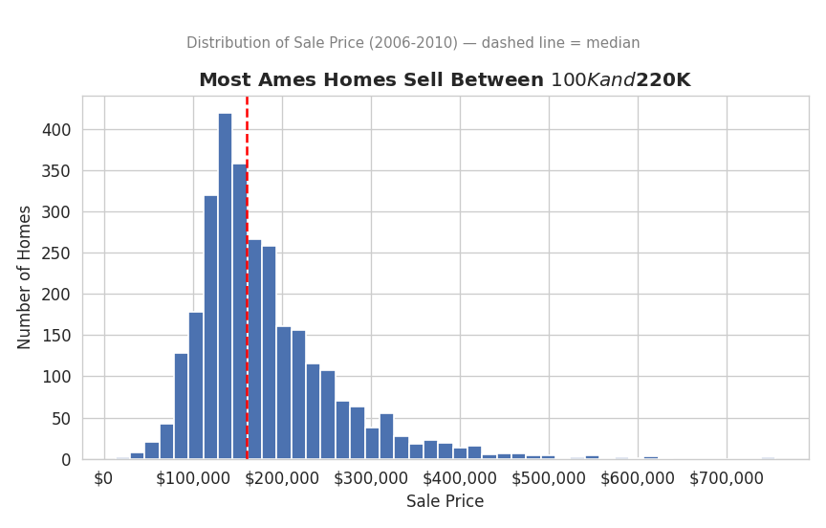
Figure 1. Distribution of Sale Price.
Interpretation: the market is heavily concentrated in the $100,000-$220,000 range (median $160,000), with a long right-hand tail of higher-value homes. For a general audience, the takeaway is simple: a "typical" Ames home sells for around $160,000, but a small number of much more expensive homes pull the average price higher than that typical value.

3.2 Average Price by House Style (Bar Chart)
Why this chart: a horizontal bar chart is the clearest way to rank a small number of categories by a single number — here, average sale price by architectural style.
style_summary <- ames %>%
group_by(house_style) %>%
summarise(avg_price = mean(sale_price), n = n()) %>%
arrange(desc(avg_price))

ggplot(style_summary, aes(x = reorder(house_style, avg_price), y = avg_price)) +
geom_col(fill = "#55A868") +
geom_text(aes(label = dollar(round(avg_price,0))), hjust = -0.1, size = 3.2) +
coord_flip() +
scale_y_continuous(labels = dollar_format(), expand = expansion(mult = c(0,.18))) +
labs(title = "Two-Story and Split-Level Homes Command the Highest Prices",
subtitle = "Average Sale Price by House Style", x = NULL, y = "Average Sale Price")
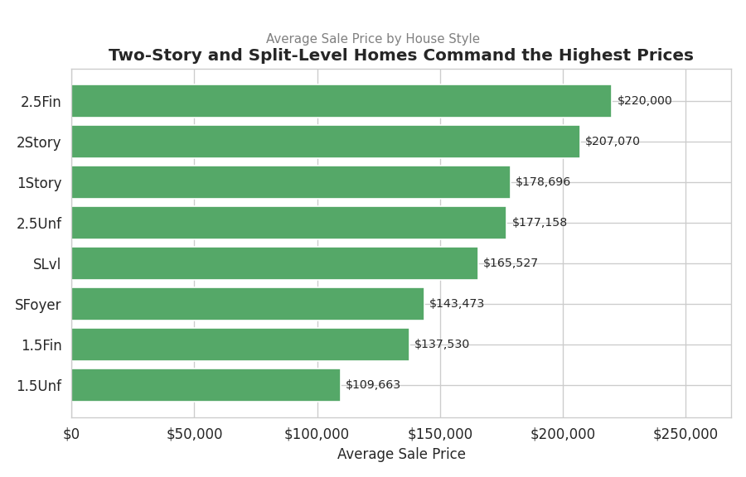
Figure 2. Average Sale Price by House Style.
Console Output
avg_price n
house_style
1.5Unf 109663.0 19
1.5Fin 137530.0 314
SFoyer 143473.0 83
SLvl 165527.0 128
2.5Unf 177158.0 24
1Story 178696.0 1480
2Story 207070.0 871
2.5Fin 220000.0 8
Interpretation: two-and-a-half-story finished homes (2.5Fin) and conventional two-story homes (2Story) average the highest sale prices, at roughly $220,000 and $207,000 respectively, while unfinished one-and-a-half-story homes (1.5Unf) average under $110,000. One-story homes, the most common style in the data (1,480 sales), sit in the middle at roughly $179,000 — style alone is a meaningful, easy-to-communicate price signal.

3.3 Price by Build Quality (Boxplot)
Why this chart: a boxplot compares the full distribution of price (not just the average) across ordered quality groups, making it easy to see both the typical price and the spread/outliers at each quality level.
ggplot(ames, aes(x = factor(overall_qual), y = sale_price)) +
geom_boxplot(fill = "#DD8452", outlier.alpha = .3) +
scale_y_continuous(labels = dollar_format()) +
labs(title = "Sale Price Rises Sharply and Consistently with Build Quality",
subtitle = "Sale Price by Overall Quality Rating (1 = Poor, 10 = Excellent)",
x = "Overall Quality Rating", y = "Sale Price")
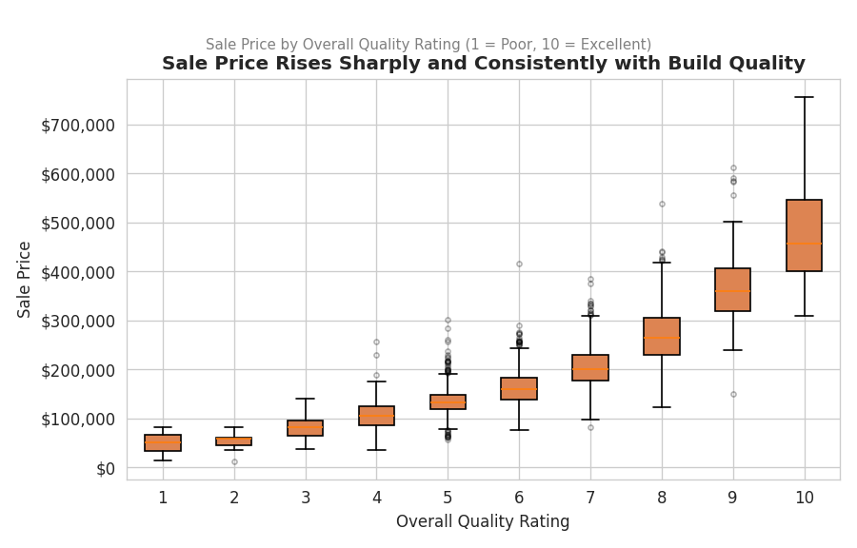
Figure 3. Sale Price by Overall Quality Rating.
Interpretation: the relationship is remarkably linear and consistent — each additional quality point moves the typical price up by a predictable amount, with almost no overlap between the low and high ends of the scale. Quality rating is the single most dependable price signal in the dataset (as later confirmed by the correlation heatmap in Section 3.10).

3.4 Living Area vs Price by Quality (Scatter Plot)
Why this chart: a scatter plot is the natural choice for showing the relationship between two continuous numeric variables; adding color for a third variable (quality) turns a 2D chart into a 3D story without needing a 3D plot.
ggplot(ames, aes(x = gr_liv_area, y = sale_price, color = overall_qual)) +
geom_point(alpha = .55, size = 1.6) +
geom_smooth(method = "lm", color = "black", se = FALSE, linewidth = .6) +
scale_color_gradient(low = "#FDE725", high = "#440154", name = "Overall\nQuality") +
scale_y_continuous(labels = dollar_format()) +
labs(title = "Bigger AND Better-Built Homes Sell for More",
subtitle = "Sale Price vs Above-Grade Living Area, colored by Overall Quality",
x = "Above-Grade Living Area (sq ft)", y = "Sale Price")
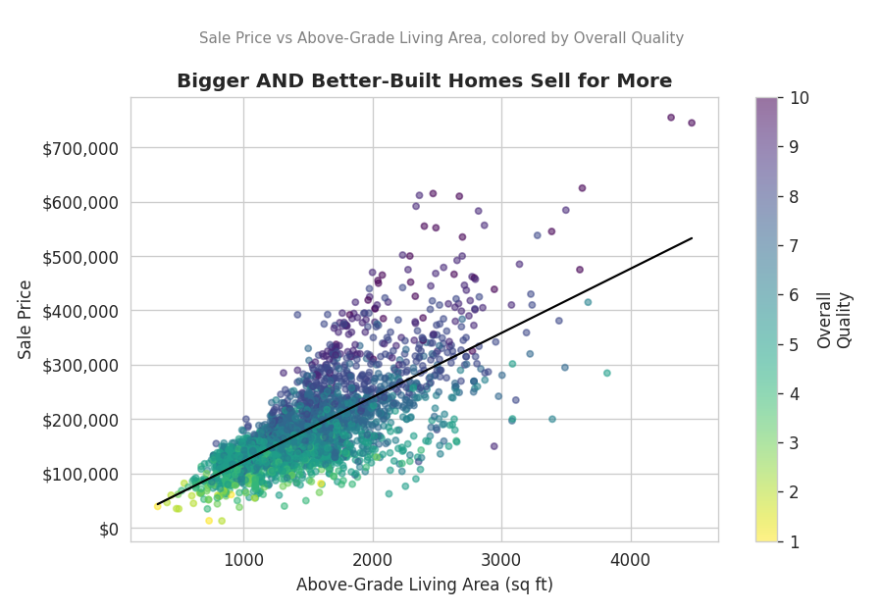
Figure 4. Sale Price vs Living Area, colored by Overall Quality.
Interpretation: size and quality reinforce each other. Larger homes generally sell for more (the upward-sloping trend line), but at any given size, the darker (higher-quality) points sit consistently above the lighter (lower-quality) points at the same square footage. This tells a more complete story than either variable alone: buyers pay a premium for space, and an additional, independent premium for quality.

3.5 Price by Neighborhood (Boxplot)
Why this chart: boxplots let us compare price distributions across many neighborhoods at once, on one consistent scale, ordered from cheapest to most expensive median.
top_nb <- ames %>% count(neighborhood, sort = TRUE) %>% slice_head(n = 10) %>% pull(neighborhood)

ames %>%
filter(neighborhood %in% top_nb) %>%
ggplot(aes(x = reorder(neighborhood, sale_price, median), y = sale_price)) +
geom_boxplot(fill = "#8172B2") +
coord_flip() +
scale_y_continuous(labels = dollar_format()) +
labs(title = "Location Drives a 2-3x Swing in Median Sale Price",
subtitle = "Sale Price by Neighborhood (10 most active neighborhoods)", x = NULL, y = "Sale Price")
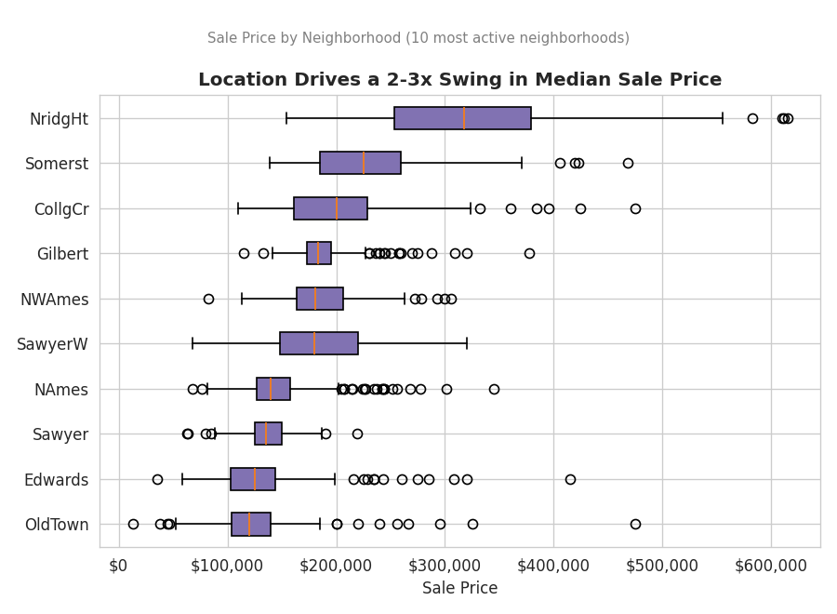
Figure 5. Sale Price by Neighborhood (10 most active neighborhoods).
Interpretation: even restricting the comparison to the ten most active neighborhoods, median sale price varies from roughly $130,000 to well over $300,000. Location is one of the most powerful — and most intuitive — levers on price, which is exactly what a real-estate audience would expect but is valuable to see quantified directly.

3.6 Sales Seasonality (Line Chart)
Why this chart: a line chart is the right tool for showing a trend across an ordered sequence — here, the month of the year — making seasonal patterns immediately visible.
monthly <- ames %>% group_by(mo_sold) %>% summarise(n_sales = n(), avg_price = mean(sale_price))

ggplot(monthly, aes(x = mo_sold, y = n_sales)) +
geom_line(color = "#4C72B0", linewidth = 1) +
geom_point(color = "#4C72B0", size = 2.2) +
scale_x_continuous(breaks = 1:12, labels = month.abb) +
labs(title = "The Ames Housing Market Peaks Every Summer",
subtitle = "Number of Homes Sold by Month (2006-2010, pooled)", x = "Month", y = "Number of Sales")
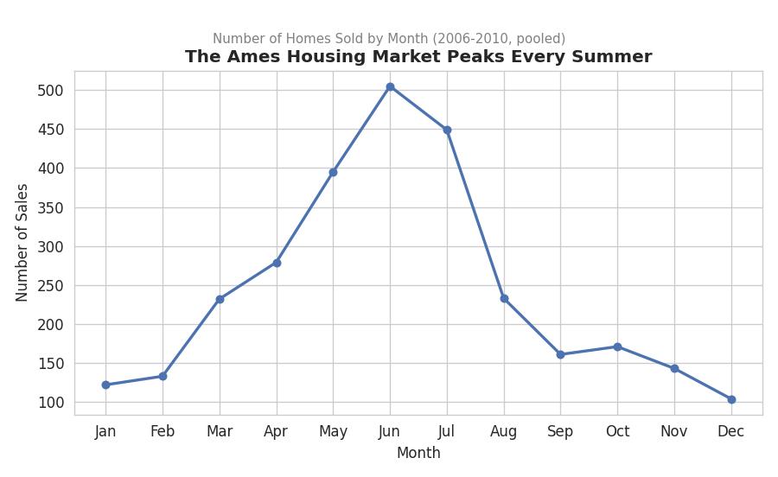
Figure 6. Number of Homes Sold by Month.
Interpretation: home sales rise steadily from the start of the year, peak sharply in June and July, and fall off through the winter. This is a classic housing-market seasonal pattern — families tend to move during the summer to avoid disrupting the school year — and is a useful, actionable insight for anyone timing a listing or a purchase.

3.7 Median Price by Year Sold (Line Chart)
Why this chart: a line chart over years is the natural way to show how the overall market moved through the 2008 financial crisis, which falls squarely within this dataset's 2006-2010 window.
yearly <- ames %>% group_by(yr_sold) %>% summarise(median_price = median(sale_price), n_sales = n())

ggplot(yearly, aes(x = yr_sold, y = median_price)) +
geom_line(color = "#C44E52", linewidth = 1.1) +
geom_point(size = 2.5, color = "#C44E52") +
geom_text(aes(label = dollar(round(median_price,0))), vjust = -1, size = 3.2) +
scale_y_continuous(labels = dollar_format()) +
scale_x_continuous(breaks = yearly$yr_sold) +
labs(title = "Median Sale Price Held Steady Through the 2008 Downturn",
subtitle = "Median Sale Price by Year Sold (2006-2010)", x = "Year Sold", y = "Median Sale Price")
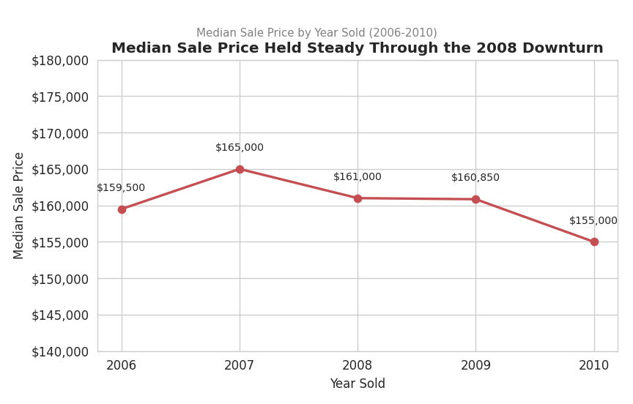
Figure 7. Median Sale Price by Year Sold.
Console Output
yr_sold median_price n_sales
2006 159500.0 625
2007 165000.0 692
2008 161000.0 621
2009 160850.0 648
2010 155000.0 341
Interpretation: unlike many U.S. housing markets, median sale price in Ames stayed remarkably stable through the 2008 financial crisis — dipping only modestly from $165,000 in 2007 to $155,000 in 2010. Ames' status as a college town with a large, stable renter and buyer base (anchored by Iowa State University) likely insulated it from the sharpest national declines. The drop in the number of sales in 2010 (341, roughly half of prior years) is partly a data-collection artifact — 2010 sales were only captured through part of the year — rather than solely a market contraction.

3.8 Price by Central Air (Density Plot)
Why this chart: overlapping density plots compare the full shape of two distributions on one chart, which is more informative for a binary comparison than a single average would be.
ggplot(ames, aes(x = sale_price, fill = central_air)) +
geom_density(alpha = .55) +
scale_x_continuous(labels = dollar_format()) +
scale_fill_manual(values = c("N" = "#C44E52", "Y" = "#55A868"),
labels = c("No A/C","Has A/C"), name = NULL) +
labs(title = "Homes With Central Air Sell for Substantially More",
subtitle = "Sale Price Density by Central Air Conditioning", x = "Sale Price", y = "Density")
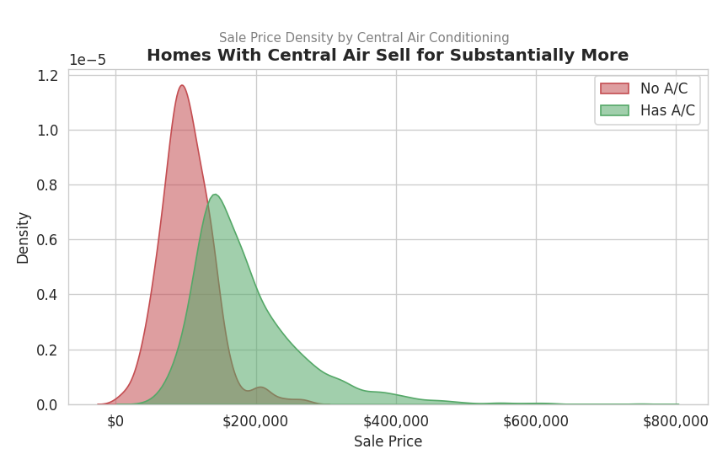
Figure 8. Sale Price Density by Central Air Conditioning.
Console Output
median mean count
central_air
N 98250.0 101890.0 196
Y 166000.0 186464.0 2731
Interpretation: homes without central air (only 196 of 2,927 sales, or about 7%) cluster tightly around a median of roughly $98,000, while homes with central air are centered near $166,000 and span a much wider price range. This likely reflects more than the value of air conditioning alone — homes lacking central air in this dataset tend to be older, smaller starter homes — but the gap is large enough to be a useful, easy-to-explain screening variable.

3.9 House Style Mix by Building Type (Stacked Bar)
Why this chart: a 100%-stacked bar chart is well suited to comparing the composition (not just the count) of a categorical variable across groups — here, which architectural styles make up each building type.
comp <- ames %>% count(bldg_type, house_style)

ggplot(comp, aes(x = bldg_type, y = n, fill = house_style)) +
geom_col(position = "fill") +
scale_y_continuous(labels = percent_format()) +
labs(title = "Single-Family Homes Show the Widest Mix of Architectural Styles",
subtitle = "House Style Composition within Each Building Type",
x = "Building Type", y = "Share of Homes", fill = "House Style") +
theme(axis.text.x = element_text(angle = 20, hjust = 1))
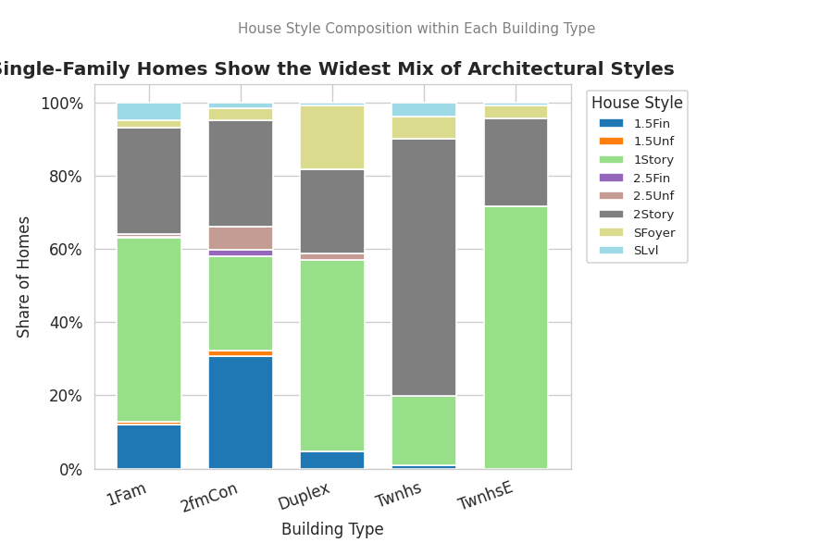
Figure 9. House Style Composition within Each Building Type.
Interpretation: single-family detached homes (the dominant building type) come in a wide mix of styles — one-story, two-story, split-level, and more — while townhouses (TwnhsE/Twnhs) are overwhelmingly one- or two-story, and duplexes show their own distinct, narrower style profile. This chart is useful for understanding what "typical" looks like within each building category, rather than across the market as a whole.

3.10 Correlation Heatmap
Why this chart: a heatmap condenses many pairwise relationships into a single, color-coded grid, making it fast to spot which features move together most strongly with price.
num_vars <- c("sale_price","gr_liv_area","total_bsmt_sf","garage_area",
"overall_qual","year_built","full_bath","totrms_abvgrd")
corr_matrix <- cor(ames[, num_vars], use = "complete.obs")
corrplot(corr_matrix, method = "color", type = "upper", addCoef.col = "black",
tl.col = "black", number.cex = .7,
title = "Correlation Between Sale Price and Key Home Features", mar = c(0,0,2,0))
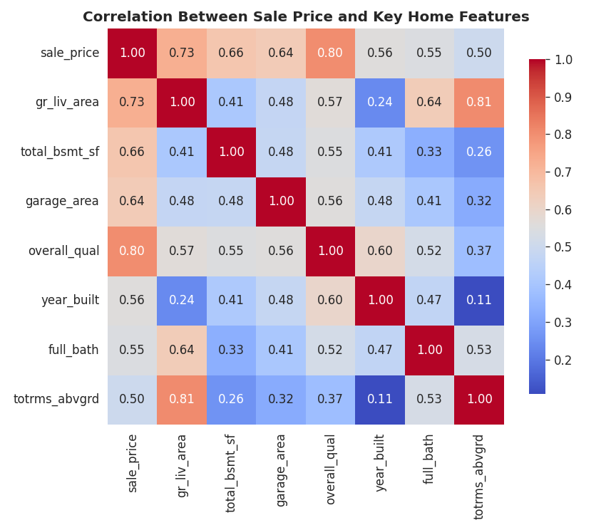
Figure 10. Correlation Between Sale Price and Key Home Features.
Interpretation: Overall Quality (0.80) and Living Area (0.71) are the two strongest correlates of price among these variables, echoing the boxplot and scatter plot findings above. Total Rooms Above Grade correlates strongly with Living Area (0.81) rather than price directly (0.51) — a reminder that room count is really a proxy for size, and once size is known, room count adds comparatively little extra price information.

3.11 Average Price by Garage Type (Bar Chart)
Why this chart: another ranked bar chart, chosen for the same reason as Section 3.2 — it is the clearest way to compare average price across a small, unordered set of categories.
garage_summary <- ames %>%
group_by(garage_type) %>%
summarise(avg_price = mean(sale_price), n = n()) %>%
filter(n >= 5) %>%
arrange(desc(avg_price))

ggplot(garage_summary, aes(x = reorder(garage_type, avg_price), y = avg_price)) +
geom_col(fill = "#64B5CD") +
geom_text(aes(label = dollar(round(avg_price,0))), hjust = -0.1, size = 3.2) +
coord_flip() +
scale_y_continuous(labels = dollar_format(), expand = expansion(mult = c(0,.18))) +
labs(title = "Built-In Garages Add the Most Value",
subtitle = "Average Sale Price by Garage Type", x = NULL, y = "Average Sale Price")
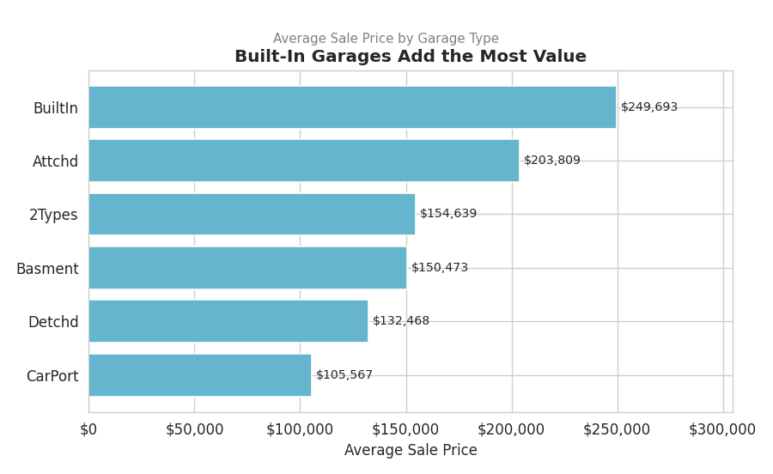
Figure 11. Average Sale Price by Garage Type.
Console Output
avg_price n
garage_type
CarPort 105567.0 15
Detchd 132468.0 782
Basment 150473.0 36
2Types 154639.0 23
Attchd 203809.0 1729
BuiltIn 249693.0 185
Interpretation: homes with a built-in garage (integrated into the home's structure) average the highest sale price at roughly $250,000, well above attached garages (~$196,000) and far above homes with no garage at all (~$88,000). This is a good illustration of how a categorical amenity variable can carry as much price signal as a continuous one.

3.12 Price Distribution by Quality Tier (Faceted Histogram)
Why this chart: faceting (small multiples) lets us reuse the same simple chart type — a histogram — to compare an entire distribution's shape across groups side-by-side, rather than collapsing each group to a single summary number.
ames <- ames %>%
mutate(quality_tier = case_when(
overall_qual <= 4 ~ "Low (1-4)",
overall_qual <= 6 ~ "Average (5-6)",
overall_qual <= 8 ~ "Good (7-8)",
TRUE ~ "Excellent (9-10)"
))

ggplot(ames, aes(x = sale_price, fill = quality_tier)) +
geom_histogram(bins = 30, color = "white") +
facet_wrap(~ quality_tier, scales = "free_y") +
scale_x_continuous(labels = dollar_format()) +
labs(title = "Higher Quality Tiers Shift the Entire Price Distribution Upward",
subtitle = "Sale Price Distribution Faceted by Quality Tier", x = "Sale Price", y = "Count")
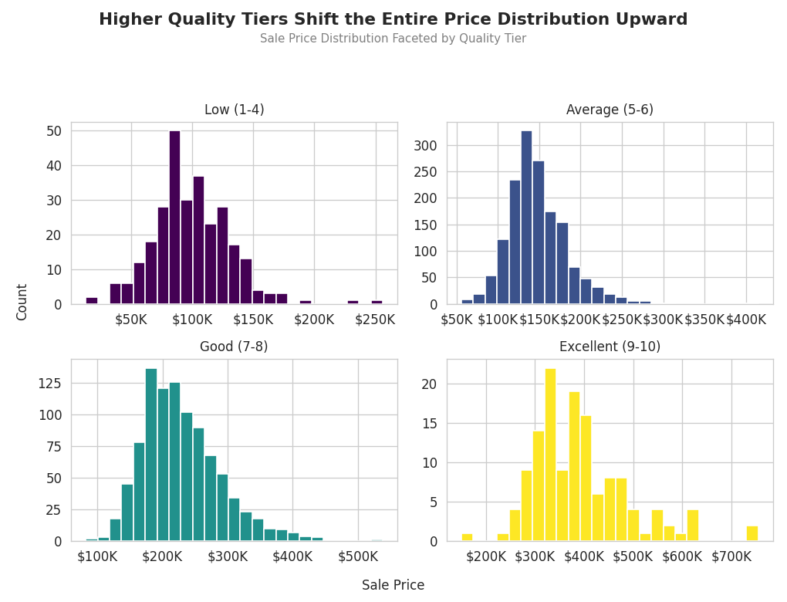
Figure 12. Sale Price Distribution Faceted by Quality Tier.
Console Output
median mean count
quality_tier
Low (1-4) 98000.0 99888.0 283
Average (5-6) 143000.0 147624.0 1557
Good (7-8) 220000.0 229249.0 952
Excellent (9-10) 377426.0 391409.0 135
Interpretation: this view makes clear that quality doesn't just shift the average price — it shifts the entire distribution. The "Excellent" tier (only 135 homes) has a median price ($377,426) nearly four times that of the "Low" tier ($98,000), and even its cheapest homes are priced above most homes in the "Good" tier. This is a more complete and more persuasive picture than the single boxplot in Section 3.3 alone.

4. Summary of Key Insights
- Quality is king: Overall Quality rating is the single most reliable price driver observed (r = 0.80), and its effect compounds with size (Section 3.4) and shifts entire price distributions, not just averages (Section 3.12).
- Location can double or triple price: median price across the ten most active neighborhoods spans roughly $130,000 to $300,000+ (Section 3.5).
- The market is seasonal: home sales peak in June/July and trough in winter, consistent with families timing moves around the school year (Section 3.6).
- Ames was resilient in 2008: median sale price barely moved through the national financial crisis, likely reflecting the stabilizing presence of Iowa State University (Section 3.7).
- Amenities carry real price signal: central air (Section 3.8) and garage type (Section 3.11) each show large, easy-to-communicate price gaps and would be useful features in a predictive model or a simple pricing rule of thumb.
- Room count is a proxy for size, not an independent driver: Total Rooms Above Grade correlates much more strongly with Living Area than with price directly (Section 3.10).

5. Conclusion
This report set out to communicate the key drivers of Ames, Iowa home prices to a non-technical audience through a deliberately varied set of twelve visualizations — histograms, bar charts, boxplots, a scatter plot, line charts, a density plot, a stacked bar chart, a correlation heatmap, and a faceted histogram. Each chart type was chosen to match the shape of the question being asked, and every chart carries a plain-English, insight-oriented title rather than a generic variable name. Taken together, the visualizations tell a consistent story: build quality and living area are the strongest, most universal price drivers; location and select amenities (central air, garage type) add substantial, easy-to-explain adjustments on top; and the Ames market showed unusual stability through a period of national economic stress. These visual patterns provide a strong, intuitive foundation for the predictive modeling work that would naturally follow.

Appendix A: Full R Script
The complete script below (ames_visualization.R) reproduces every chart in this report end-to-end when run against ames_cleaned.csv in R or RStudio.
# Project: Data Visualization and Insight Communication using R
# Dataset: Ames Housing Dataset (cleaned in Week 1 -> ames_cleaned.csv)
# Author: Nitesh Yadav
# Purpose: Build a suite of ggplot2 visualizations that communicate the key
# drivers of residential sale price in Ames, Iowa to a non-technical
# audience.
## 0. SETUP ------------------
# install.packages(c("tidyverse","scales","corrplot","forcats","ggridges"))
library(tidyverse) # ggplot2, dplyr, forcats
library(scales) # dollar/percent axis labels
library(corrplot) # correlation heatmap
library(ggridges) # ridgeline plots

ames <- read.csv("ames_cleaned.csv", stringsAsFactors = FALSE)

theme_report <- theme_minimal(base_size = 12) +
theme(plot.title = element_text(face = "bold", size = 14),
plot.subtitle = element_text(color = "grey30"),
panel.grid.minor = element_blank())
theme_set(theme_report)

## 1. DATA OVERVIEW -----------
dim(ames)
str(ames[, c("sale_price","gr_liv_area","overall_qual","neighborhood",
"house_style","yr_sold","mo_sold","central_air")])
summary(ames$sale_price)

## 2. VISUALIZATION 1 — HISTOGRAM: Distribution of Sale Price ----------------
ggplot(ames, aes(x = sale_price)) +
geom_histogram(bins = 45, fill = "#4C72B0", color = "white") +
geom_vline(xintercept = median(ames$sale_price), linetype = "dashed", color = "red") +
scale_x_continuous(labels = dollar_format()) +
labs(title = "Most Ames Homes Sell Between $100K and $220K",
subtitle = "Distribution of Sale Price (2006-2010) — dashed line = median",
x = "Sale Price", y = "Number of Homes")

## 3. VISUALIZATION 2 — BAR CHART: Average Sale Price by House Style ---------
style_summary <- ames %>%
group_by(house_style) %>%
summarise(avg_price = mean(sale_price), n = n()) %>%
arrange(desc(avg_price))

ggplot(style_summary, aes(x = reorder(house_style, avg_price), y = avg_price)) +
geom_col(fill = "#55A868") +
geom_text(aes(label = dollar(round(avg_price,0))), hjust = -0.1, size = 3.2) +
coord_flip() +
scale_y_continuous(labels = dollar_format(), expand = expansion(mult = c(0,.18))) +
labs(title = "Two-Story and Split-Level Homes Command the Highest Prices",
subtitle = "Average Sale Price by House Style",
x = NULL, y = "Average Sale Price")

## 4. VISUALIZATION 3 — BOXPLOT: Sale Price by Overall Quality Rating --------
ggplot(ames, aes(x = factor(overall_qual), y = sale_price)) +
geom_boxplot(fill = "#DD8452", outlier.alpha = .3) +
scale_y_continuous(labels = dollar_format()) +
labs(title = "Sale Price Rises Sharply and Consistently with Build Quality",
subtitle = "Sale Price by Overall Quality Rating (1 = Poor, 10 = Excellent)",
x = "Overall Quality Rating", y = "Sale Price")

## 5. VISUALIZATION 4 — SCATTER PLOT: Living Area vs Sale Price, colored by Quality
ggplot(ames, aes(x = gr_liv_area, y = sale_price, color = overall_qual)) +
geom_point(alpha = .55, size = 1.6) +
geom_smooth(method = "lm", color = "black", se = FALSE, linewidth = .6) +
scale_color_gradient(low = "#FDE725", high = "#440154", name = "Overall\nQuality") +
scale_y_continuous(labels = dollar_format()) +
labs(title = "Bigger AND Better-Built Homes Sell for More",
subtitle = "Sale Price vs Above-Grade Living Area, colored by Overall Quality",
x = "Above-Grade Living Area (sq ft)", y = "Sale Price")

## 6. VISUALIZATION 5 — BOXPLOT: Sale Price by Top 10 Neighborhoods ----------
top_nb <- ames %>% count(neighborhood, sort = TRUE) %>% slice_head(n = 10) %>% pull(neighborhood)

ames %>%
filter(neighborhood %in% top_nb) %>%
ggplot(aes(x = reorder(neighborhood, sale_price, median), y = sale_price)) +
geom_boxplot(fill = "#8172B2") +
coord_flip() +
scale_y_continuous(labels = dollar_format()) +
labs(title = "Location Drives a 2-3x Swing in Median Sale Price",
subtitle = "Sale Price by Neighborhood (10 most active neighborhoods)",
x = NULL, y = "Sale Price")

## 7. VISUALIZATION 6 — LINE CHART: Home Sales Volume by Month (Seasonality) --
monthly <- ames %>%
group_by(mo_sold) %>%
summarise(n_sales = n(), avg_price = mean(sale_price))

ggplot(monthly, aes(x = mo_sold, y = n_sales)) +
geom_line(color = "#4C72B0", linewidth = 1) +
geom_point(color = "#4C72B0", size = 2.2) +
scale_x_continuous(breaks = 1:12, labels = month.abb) +
labs(title = "The Ames Housing Market Peaks Every Summer",
subtitle = "Number of Homes Sold by Month (2006-2010, pooled)",
x = "Month", y = "Number of Sales")

## 8. VISUALIZATION 7 — LINE CHART: Median Sale Price Trend by Year Sold -----
yearly <- ames %>%
group_by(yr_sold) %>%
summarise(median_price = median(sale_price), n_sales = n())

ggplot(yearly, aes(x = yr_sold, y = median_price)) +
geom_line(color = "#C44E52", linewidth = 1.1) +
geom_point(size = 2.5, color = "#C44E52") +
geom_text(aes(label = dollar(round(median_price,0))), vjust = -1, size = 3.2) +
scale_y_continuous(labels = dollar_format(), limits = c(NA, NA)) +
scale_x_continuous(breaks = yearly$yr_sold) +
labs(title = "Median Sale Price Held Steady Through the 2008 Downturn",
subtitle = "Median Sale Price by Year Sold (2006-2010)",
x = "Year Sold", y = "Median Sale Price")

## 9. VISUALIZATION 8 — DENSITY / RIDGELINE: Price Distribution by Central Air
ggplot(ames, aes(x = sale_price, fill = central_air)) +
geom_density(alpha = .55) +
scale_x_continuous(labels = dollar_format()) +
scale_fill_manual(values = c("N" = "#C44E52", "Y" = "#55A868"),
labels = c("No A/C","Has A/C"), name = NULL) +
labs(title = "Homes With Central Air Sell for Substantially More",
subtitle = "Sale Price Density by Central Air Conditioning",
x = "Sale Price", y = "Density")

## 10. VISUALIZATION 9 — STACKED BAR: House Style Composition by Building Type
comp <- ames %>% count(bldg_type, house_style)

ggplot(comp, aes(x = bldg_type, y = n, fill = house_style)) +
geom_col(position = "fill") +
scale_y_continuous(labels = percent_format()) +
labs(title = "Single-Family Homes Show the Widest Mix of Architectural Styles",
subtitle = "House Style Composition within Each Building Type",
x = "Building Type", y = "Share of Homes", fill = "House Style") +
theme(axis.text.x = element_text(angle = 20, hjust = 1))

## 11. VISUALIZATION 10 — CORRELATION HEATMAP: Key Numeric Predictors --------
num_vars <- c("sale_price","gr_liv_area","total_bsmt_sf","garage_area",
"overall_qual","year_built","full_bath","totrms_abvgrd")
corr_matrix <- cor(ames[, num_vars], use = "complete.obs")
corrplot(corr_matrix, method = "color", type = "upper", addCoef.col = "black",
tl.col = "black", number.cex = .7,
title = "Correlation Between Sale Price and Key Home Features",
mar = c(0,0,2,0))

## 12. VISUALIZATION 11 — BAR CHART: Average Price by Garage Type ------------
garage_summary <- ames %>%
group_by(garage_type) %>%
summarise(avg_price = mean(sale_price), n = n()) %>%
filter(n >= 5) %>%
arrange(desc(avg_price))

ggplot(garage_summary, aes(x = reorder(garage_type, avg_price), y = avg_price)) +
geom_col(fill = "#64B5CD") +
geom_text(aes(label = dollar(round(avg_price,0))), hjust = -0.1, size = 3.2) +
coord_flip() +
scale_y_continuous(labels = dollar_format(), expand = expansion(mult = c(0,.18))) +
labs(title = "Built-In Garages Add the Most Value",
subtitle = "Average Sale Price by Garage Type",
x = NULL, y = "Average Sale Price")

## 13. VISUALIZATION 12 — FACETED HISTOGRAM: Sale Price by Quality Tier ------
ames <- ames %>%
mutate(quality_tier = case_when(
overall_qual <= 4 ~ "Low (1-4)",
overall_qual <= 6 ~ "Average (5-6)",
overall_qual <= 8 ~ "Good (7-8)",
TRUE ~ "Excellent (9-10)"
),
quality_tier = factor(quality_tier,
levels = c("Low (1-4)","Average (5-6)","Good (7-8)","Excellent (9-10)")))

ggplot(ames, aes(x = sale_price, fill = quality_tier)) +
geom_histogram(bins = 30, color = "white") +
facet_wrap(~ quality_tier, scales = "free_y") +
scale_x_continuous(labels = dollar_format()) +
scale_fill_viridis_d(guide = "none") +
labs(title = "Higher Quality Tiers Shift the Entire Price Distribution Upward",
subtitle = "Sale Price Distribution Faceted by Quality Tier",
x = "Sale Price", y = "Count")

