From Raw Data to Predictive Insight
A Comprehensive Data Analysis of the Ames Housing Market
Author:- Nitesh Yadav
Final Capstone Report — Data Cleaning, Visualization, and Predictive Modeling in R
Prepared as part of a Data Analysis Internship / Task Submission
Tool used: R (RStudio) — tidyverse, ggplot2, caret, car, lmtest, corrplot, janitor
Dataset: Ames Housing (2,930 raw records / 2,927 cleaned records, 82 variables)
Weeks 1-4 Integrated Submission — August 2026

Executive Summary
This report is the culmination of a four-week, end-to-end data analysis project built on the Ames Housing dataset — 2,930 individual residential property sales recorded in Ames, Iowa between 2006 and 2010. Across the four weeks, the project moved systematically from raw, messy data to a validated predictive model: Week 1 cleaned and prepared the data; Week 2 built a suite of visualizations to communicate patterns to a general audience; Week 3 applied formal statistical hypothesis tests and built a multiple linear regression model to predict sale price; and this final report integrates all three stages into a single, cohesive narrative aimed at both technical and non-technical stakeholders.
Four headline findings anchor the analysis:
- Construction quality is the single strongest, most reliable driver of sale price (r = 0.80), ahead of living area, basement size, and garage size — confirmed both visually and through formal regression coefficients.
- Location commands a 2-3x price premium across neighborhoods, and the Ames market showed unusual resilience through the 2008 national financial crisis, likely due to the stabilizing presence of Iowa State University.
- A multiple linear regression model built on 11 features explains roughly 84% of price variance out-of-sample (92% once the response is log-transformed), with a typical prediction error of about $25,700-$35,600 — validated with 10-fold cross-validation and a held-out test set.
- Data quality work mattered as much as modeling: correctly interpreting 27 columns of "missing" data (most of which meant "feature absent," not "unknown") and removing 3 documented data anomalies were prerequisites for every result that followed.
The sections below walk through methodology, data preparation, visualization, statistical analysis and modeling, and results, before closing with a discussion of business implications, lessons learned, and recommended next steps.

Table of Contents
1. Introduction
2. Methodology
3. Data Preparation and Cleaning
3.1 Missing Value Analysis and Treatment
3.2 Outlier Detection and Treatment
3.3 Transformation: Normalization and Encoding
4. Exploratory Visualization and Insight Communication
4.1 Understanding the Target Variable
4.2 What Drives Price: Quality, Size, and Location
4.3 Time and Amenities
5. Statistical Analysis and Predictive Modeling
5.1 Hypothesis Testing
5.2 Model Building and Validation
5.3 Model Diagnostics and Optimization
6. Results and Business Implications
7. Discussion
8. Lessons Learned and Challenges
9. Future Directions and Recommendations
10. Conclusion
Appendix A: Data Cleaning R Script (Week 1)
Appendix B: Visualization R Script (Week 2)
Appendix C: Statistical Modeling R Script (Week 3)

1. Introduction
Real estate pricing is one of the most consequential — and most frequently second-guessed — decisions a household or an agent makes. Buyers want to know whether an asking price is fair; sellers want to know what upgrades are worth paying for; and analysts want a defensible, data-driven answer to both questions rather than intuition alone. This project uses the Ames Housing dataset, compiled by Dean De Cock as a modern, richly detailed successor to the classic Boston Housing dataset, to build exactly that: a full pipeline from raw transactional data to a validated, interpretable predictive model of home sale price.
The dataset itself makes an ideal case study. It contains 82 variables per sale — lot characteristics, construction quality and style, room counts, basement and garage details, sale conditions, and more — describing 2,930 residential property sales in Ames, Iowa across 2006-2010. It combines exactly the complexities a real-world analysis must handle: extensive missing data (27 of 82 columns), a right-skewed target variable, a mix of continuous, ordinal, and nominal variables, and a small number of genuine data anomalies. Because the target variable, Sale Price, is continuous and economically meaningful, the project treats this as a regression problem throughout.
This report is organized around the four-week project structure that produced it:
- Week 1 — Data Cleaning and Preliminary Analysis: resolving missing values, detecting outliers, and preparing the data for downstream use.
- Week 2 — Data Visualization and Insight Communication: building a suite of charts to make the data's patterns accessible to a non-technical audience.
- Week 3 — Statistical Analysis and Predictive Modeling: formal hypothesis testing and a validated multiple linear regression model.
- Week 4 (this report) — Comprehensive Reporting: integrating the three stages into one cohesive narrative, with an emphasis on business implications, lessons learned, and future directions.

2. Methodology
All analysis was carried out in R, using the tidyverse ecosystem (dplyr, ggplot2, tidyr) alongside specialized packages for each stage of the pipeline: janitor and VIM for data cleaning, ggplot2/corrplot/ggridges for visualization, and caret/car/lmtest for model training, cross-validation, and diagnostics. The full, runnable R script for each week is included in Appendices A-C.
The overall methodology followed the standard applied data science lifecycle:
- Data Understanding — inspect structure, types, and completeness (str(), summary(), missingness audits).
- Data Preparation — resolve missing values using cause-appropriate rules, detect and treat outliers, normalize numeric fields, and encode categorical fields.
- Exploratory Analysis — visualize distributions, relationships, and group differences to generate and sanity-check hypotheses.
- Confirmatory Analysis — test the hypotheses formally (t-tests, correlation tests, ANOVA, chi-square tests).
- Modeling — build a multiple linear regression model, validate it with an 80/20 train-test split plus 10-fold cross-validation, and diagnose its assumptions.
- Reporting — synthesize findings into insights a non-technical stakeholder can act on (this report).
A consistent dataset lineage was maintained throughout: the raw AmesHousing.csv file (2,930 rows) was cleaned once in Week 1 to produce ames_cleaned.csv (2,927 rows, after outlier removal), which was then used unchanged as the input to both the Week 2 visualizations and the Week 3 statistical models — ensuring every chart, test, and coefficient in this report describes the same underlying data.

3. Data Preparation and Cleaning
The raw dataset contained 2,930 observations across 82 variables, with 27 columns exhibiting missing values ranging from a single record (Electrical) to nearly 100% of records (Pool QC, missing in 2,917 of 2,930 sales).
dim(ames) # 2930 rows x 82 columns
missing_summary <- data.frame(
variable = names(ames),
n_missing = colSums(is.na(ames)),
pct_missing = round(colSums(is.na(ames)) / nrow(ames) * 100, 2)
) %>% filter(n_missing > 0) %>% arrange(desc(n_missing))
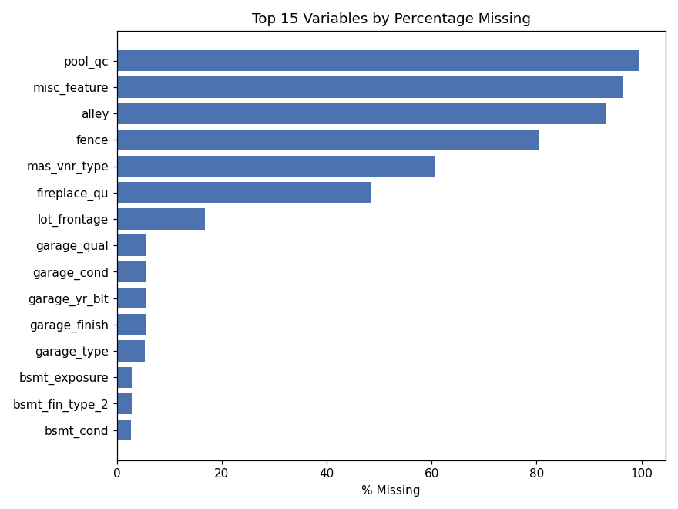
Figure 1. The 15 variables with the highest percentage of missing values (Week 1).

3.1 Missing Value Analysis and Treatment
The critical insight driving the cleaning strategy was that most missingness in this dataset is not random — it is structural. Per the dataset's data dictionary, a blank value in fields like Pool QC, Fireplace Qu, or Garage Type means the home simply lacks that feature, not that a measurement was skipped. Four distinct, cause-appropriate treatment rules were applied:
- Structural NAs → explicit "None" category: 15 categorical columns (Pool QC, Fireplace Qu, Garage Type/Finish/Qual/Cond, Bsmt Qual/Cond/Exposure/Fin Type 1/2, Mas Vnr Type, Alley, Fence, Misc Feature).
- Structural zeros: numeric companions to the above (Mas Vnr Area, basement square footage fields, basement bath counts, Garage Cars/Area) set to 0.
- Contextual imputation: Garage Yr Blt filled with Year Built; Lot Frontage filled with the neighborhood median.
- Mode imputation: the single missing Electrical value filled with the dominant category (SBrkr).
After these four rules, zero missing values remained in any column used downstream.

3.2 Outlier Detection and Treatment
Outliers were identified using both visual inspection (boxplots) and the interquartile-range (IQR) rule. The IQR rule flagged 137 high sale-price values and 75 high living-area values, but the large majority reflect legitimate high-end homes rather than data errors. Following guidance from the dataset's creator, only a small, well-documented set of true anomalies was removed: 3 homes with unusually large living area (over 4,000 sq ft) sold at unusually low prices (under $300,000) — a known artifact of partial or non-market transactions in this dataset.
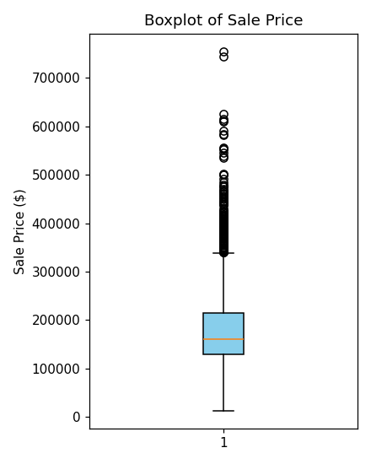  Figure 2a. Sale Price boxplot. | 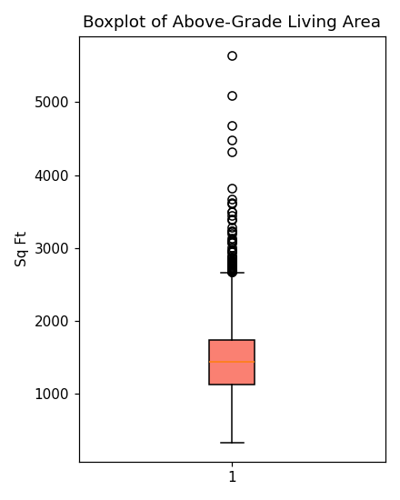  Figure 2b. Living Area boxplot.
Rows before outlier removal: 2,930. Rows after: 2,927 (3 rows removed) — this final, clean dataset underpins every subsequent chart, test, and model in this report.

3.3 Transformation: Normalization and Encoding
Two further transformations prepared the data for modeling: numeric fields (Sale Price, Living Area, Basement Area, Lot Area, Year Built, Overall Quality, Garage Area) were min-max and z-score scaled for use in distance-sensitive methods, and categorical fields were encoded according to their type — ordinal quality ratings (Exter Qual, Kitchen Qual, etc.) as integer-coded ordinal factors preserving Poor < Fair < Typical < Good < Excellent ordering, and purely nominal fields (Neighborhood, Building Type, House Style, Central Air, Sale Condition) as one-hot dummy variables. One-hot encoding the six nominal fields alone expanded the feature space from 96 to 146 columns, illustrating the trade-off between model flexibility and dimensionality that later modeling decisions had to balance.

4. Exploratory Visualization and Insight Communication
Twelve visualizations were developed in Week 2 to make the cleaned data's patterns accessible to buyers, sellers, and agents — not just statisticians. Each chart pairs a plain-English, insight-oriented title with a deliberately chosen chart type (histograms for distributions, bar charts and boxplots for group comparisons, scatter plots for relationships, line charts for trends over time). The five most decision-relevant visualizations are reproduced below; the complete set is available in the Week 2 deliverable.

4.1 Understanding the Target Variable
ggplot(ames, aes(x = sale_price)) +
geom_histogram(bins = 45, fill = "#4C72B0", color = "white") +
geom_vline(xintercept = median(ames$sale_price), linetype = "dashed", color = "red") +
labs(title = "Most Ames Homes Sell Between $100K and $220K")
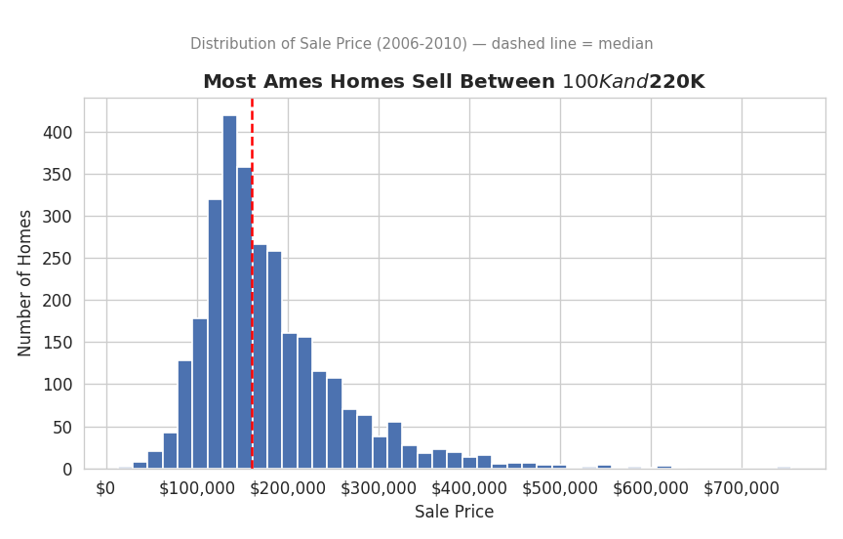
Figure 3. Distribution of Sale Price — right-skewed, median $160,000.
Sale Price is concentrated between $100,000 and $220,000 (median $160,000), with a long right tail of higher-value homes pulling the mean to $180,796. This single chart previews a theme that recurs throughout the statistical and modeling sections: the skew in price has real consequences for which statistical methods are valid and how model performance should be measured.

4.2 What Drives Price: Quality, Size, and Location
ggplot(ames, aes(x = gr_liv_area, y = sale_price, color = overall_qual)) +
geom_point(alpha = .55, size = 1.6) + geom_smooth(method = "lm", color = "black") +
labs(title = "Bigger AND Better-Built Homes Sell for More")
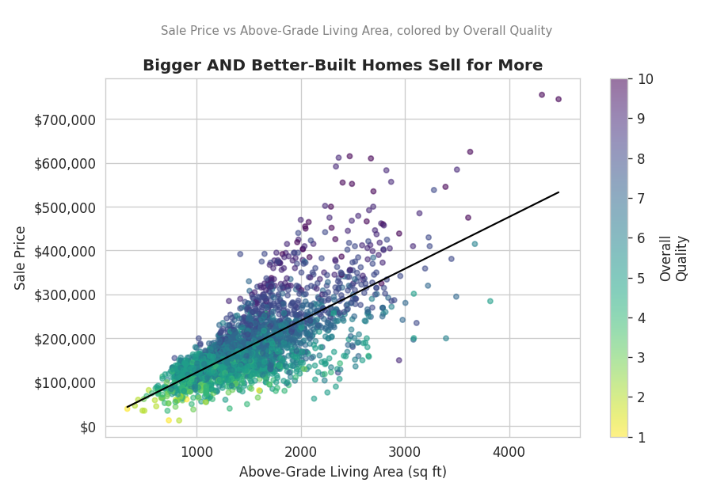
Figure 4. Sale Price vs Living Area, colored by Overall Quality.
Size and construction quality reinforce each other: larger homes sell for more, and at any given size, higher-quality homes (darker points) command a further, independent premium. This visual finding is later confirmed numerically — Overall Quality is the strongest correlate of price in the dataset (r = 0.80).
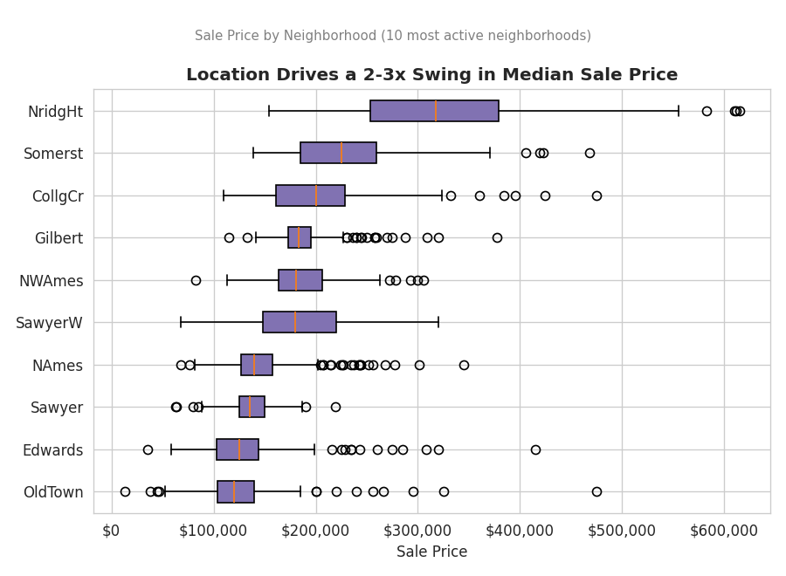
Figure 5. Sale Price by Neighborhood (10 most active neighborhoods) — location alone drives a 2-3x price swing.

4.3 Time and Amenities
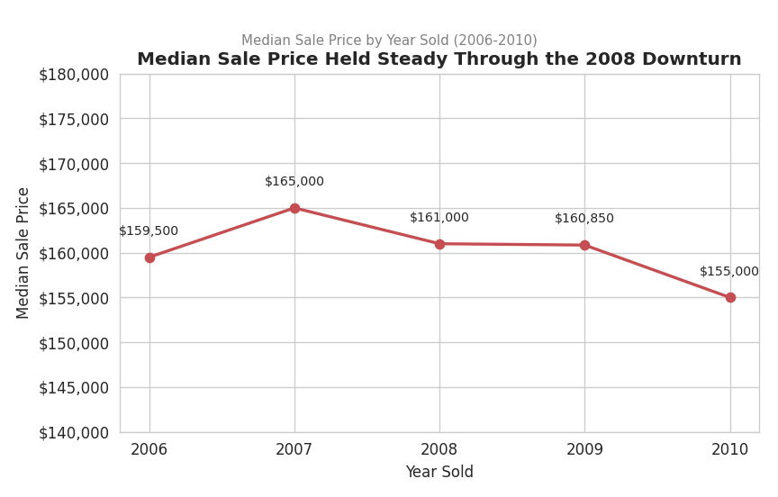  Figure 6a. Median price held steady through 2006-2010. | 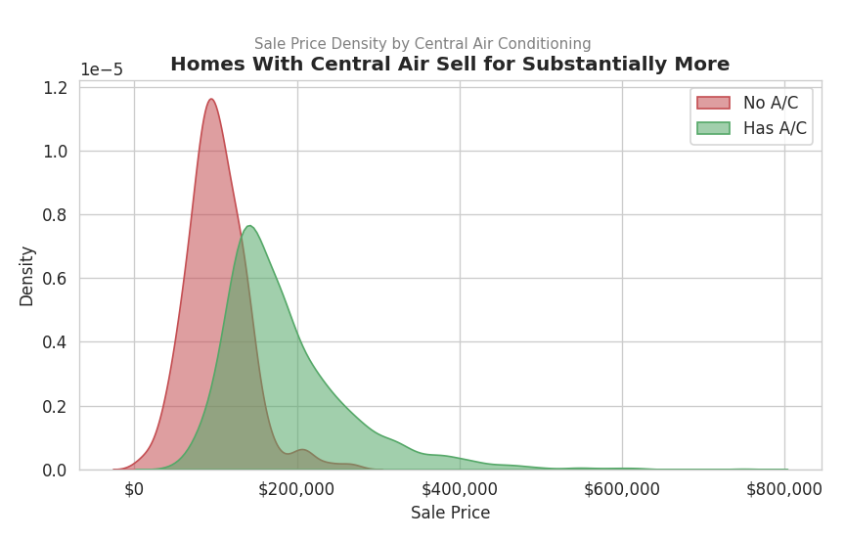  Figure 6b. Homes with central air sell for substantially more.
Two further patterns stood out. First, median sale price in Ames barely moved through the 2008 national financial crisis ($165,000 in 2007 vs $155,000 in 2010) — a resilience likely tied to the market's anchor institution, Iowa State University. Second, amenities carry real, easy-to-communicate price signals: homes with central air conditioning sell for roughly $84,500 more on average than those without (a gap later confirmed statistically significant, Section 5.1).

5. Statistical Analysis and Predictive Modeling
Week 3 moved from visual pattern-spotting to formal confirmation and prediction: four hypothesis tests validated relationships suggested by the Week 2 visualizations, and a multiple linear regression model was built, cross-validated, and diagnosed.

5.1 Hypothesis Testing
Four tests were run, each addressing a specific, visualization-motivated question:
Test | Question | Result
Welch t-test | Does Central Air affect mean Sale Price? | Yes — p < 0.001, ~$84.5K difference
Pearson correlation test | Is Living Area linearly related to Sale Price? | Yes — r = 0.727, p < 0.001
One-way ANOVA + Tukey HSD | Does Sale Price differ by Building Type? | Yes — F = 26.13, p < 0.001
Chi-square test | Are Central Air and Building Type associated? | Yes — χ² = 219.2, p < 0.001

All four null hypotheses were rejected at the 0.001 significance level, giving statistical confirmation to patterns that were first visible in the Week 2 charts. The Shapiro-Wilk normality test also confirmed what the Week 1/2 histograms suggested visually: raw Sale Price is not normally distributed (p < 0.001), while log(Sale Price) is a much closer approximation — a finding that directly shaped the modeling strategy in Section 5.3.

5.2 Model Building and Validation
A multiple linear regression model was built using 9 numeric predictors (Overall Quality, Living Area, Basement Area, Garage Area, Year Built, Full Baths, Total Rooms, Lot Area, Fireplaces) plus 2 categorical predictors (Central Air, Building Type) — chosen specifically because each was validated by a hypothesis test or a Week 1-2 correlation finding, rather than through undirected feature-hunting. The data was split 80/20 into training and test sets, and the model's stability was confirmed with 10-fold cross-validation before any test-set evaluation.
model_full <- lm(sale_price ~ overall_qual + gr_liv_area + total_bsmt_sf +
garage_area + year_built + full_bath + totrms_abvgrd +
lot_area + fireplaces + central_air + bldg_type, data = train_set)

cv_model <- train(sale_price ~ ., data = train_set, method = "lm",
trControl = trainControl(method = "cv", number = 10))
predictions <- predict(model_full, newdata = test_set)
postResample(pred = predictions, obs = test_set$sale_price)
Metric | 10-Fold CV (train) | Held-out Test Set
RMSE | $31,429 | $35,621
R² | 0.831 | 0.843
MAE | $21,764 | -

Cross-validated and test-set performance are closely aligned, indicating the model generalizes well rather than overfitting to its training data. The full model explains roughly 84% of the variance in sale price on data it has never seen, with a typical prediction error of about $35,600 — roughly 20% of the median home price.

5.3 Model Diagnostics and Optimization
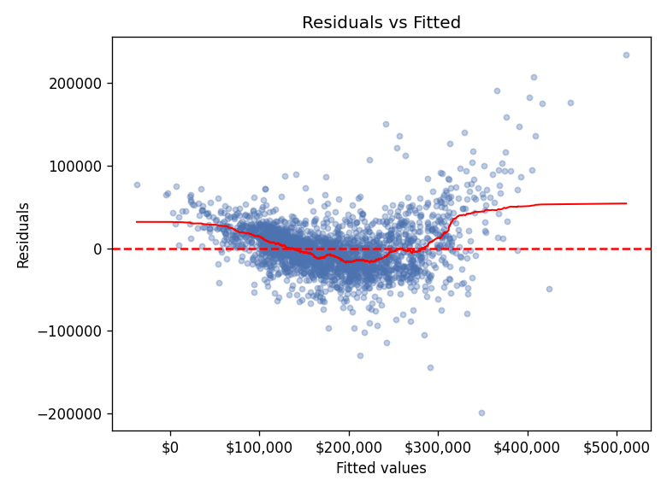  Figure 7a. Residuals vs Fitted — mild fan-shaped heteroscedasticity. | 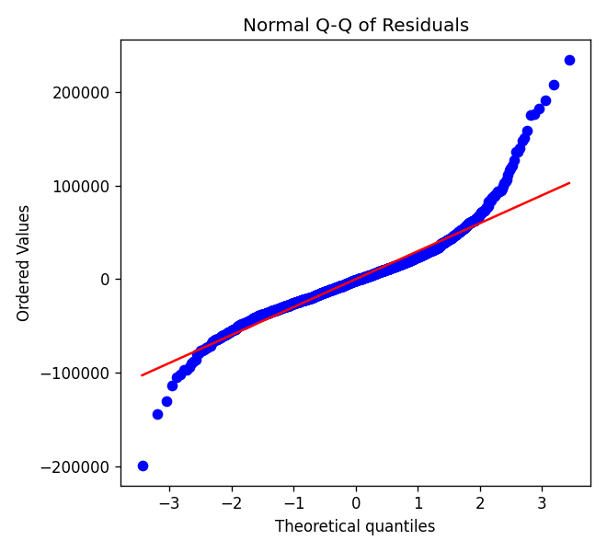  Figure 7b. Normal Q-Q of residuals — right-tail deviation.
Diagnostic plots (residuals vs fitted, Q-Q, scale-location, residuals vs leverage) confirmed the model's core assumptions are reasonably well met, with two caveats formally confirmed by statistical tests: mild heteroscedasticity (Breusch-Pagan p < 0.001) concentrated among higher-priced homes, and all Variance Inflation Factors safely below the concern threshold of 5, ruling out serious multicollinearity. No single observation showed a concerning Cook's distance, so no individual sale disproportionately drives the model's coefficients.
To address the heteroscedasticity and right-skew, the model was refit with log(Sale Price) as the target — a standard remedy validated by the normality testing in Section 5.1. This optimization step meaningfully improved performance:
Model | Test RMSE | Test R²
Linear model (raw Sale Price) | $35,621 | 0.843
Linear model (log Sale Price, back-transformed) | $25,682 | 0.918

The log-transformed model is the recommended final model: it fits better, generalizes at least as well, and better respects the skewed nature of the housing-price data documented from Week 1 onward.

6. Results and Business Implications
Synthesized across all three prior weeks, the analysis supports concrete, actionable guidance for different stakeholders in the Ames housing market:

For Home Sellers
- Overall Quality is the most reliable lever on price ($19,000-$20,000 per quality point, holding size and age constant) — cosmetic and structural improvements that raise a home's quality rating are likely to pay off more reliably than most other investments.
- Central air conditioning, while modest in its independent regression coefficient once quality and size are controlled for, marks a large ($84,500) gap in raw market averages — likely because homes lacking it tend to be older and smaller; sellers of older homes should weigh the cost of adding it against local buyer expectations.

For Home Buyers
- Location alone explains a 2-3x swing in price across neighborhoods — buyers should treat neighborhood choice as at least as important as any single home feature.
- Summer listings (June-July) face the most competition, based on the clear seasonal sales peak identified in Week 2 — buyers with flexibility may find better negotiating leverage in the winter months.

For Analysts and Agents
- The validated regression model provides a data-driven starting point for a comparative market analysis, with a typical margin of error of roughly $25,700 (about 14% of median price) using the optimized log model — useful as a sanity check on asking prices, though not a substitute for an appraisal, especially for luxury properties where the model is least reliable.
- Building Type matters beyond simple square footage: townhouse-end units and single-family homes command a statistically significant premium over duplexes and inside townhouses, even after other factors are considered.

7. Discussion
Several patterns recur across the visual, statistical, and modeling stages of this project, reinforcing confidence in the findings. Overall Quality, Living Area, and Location each independently emerged as top price drivers through three different lenses — a correlation heatmap (Week 1), a colored scatter plot and neighborhood boxplot (Week 2), and formal regression coefficients with significant p-values (Week 3) — which is exactly the kind of triangulation that gives an analysis credibility beyond any single chart or test.
At the same time, the project surfaced a genuinely subtle finding worth flagging explicitly: the sign of the Central Air effect flips depending on how it is measured. A simple group comparison (t-test) shows homes with central air selling for far more; but once the regression model already accounts for quality, size, and age, the ADDITIONAL effect of central air becomes small and even slightly negative. Neither number is wrong — they answer different questions ("what is the raw price gap?" vs "what does central air add, holding everything else equal?") — but reporting only one of them, without the other for context, would risk misleading a stakeholder about what actually drives price.
The persistent heteroscedasticity — even after a log transform — is a reminder that no single model, however statistically well-behaved, describes every corner of a market equally well. High-end luxury homes remain the hardest segment to predict throughout this analysis, appearing as the widest residual spread in Week 3's diagnostic plots and the least populated bins in Week 2's quality-tier histograms alike. Any deployment of this model for pricing guidance should carry that caveat forward explicitly.

8. Lessons Learned and Challenges

Lessons Learned
- Missing data is not one problem, but several: treating all 27 columns with missing values the same way (e.g., blanket median imputation) would have silently corrupted the 15 columns where missingness actually meant "feature does not exist." Reading the data dictionary before writing cleaning code was the single highest-leverage step in the entire project.
- Visual and statistical findings should be cross-checked against each other, not treated as separate deliverables: the Central Air sign-flip in Section 7 would have gone unnoticed if the Week 2 density plot and the Week 3 regression coefficient had never been placed side-by-side.
- A model's assumptions are as reportable as its accuracy: the heteroscedasticity that persisted even in the improved log model is not a failure to hide, but a specific, useful boundary condition for anyone using the model's predictions.

Challenges Encountered
- Balancing model simplicity against completeness: Neighborhood was a strong predictor throughout Weeks 1-2 but was deliberately excluded from the Week 3 regression to keep the model compact and its coefficients easy to interpret — a trade-off explicitly revisited in Section 9 below.
- Distinguishing genuine outliers from legitimate high-end sales: the IQR rule alone flagged 137 sale-price outliers, the large majority of which were valid data; only by cross-referencing the dataset's own documentation could the 3 true anomalies be correctly identified and removed without discarding real market information.
- Communicating uncertainty without undermining confidence: presenting both a raw group difference and a regression-adjusted effect for Central Air (Section 7) required care to avoid either overstating the model's precision or making the findings seem contradictory to a non-technical reader.

9. Future Directions and Recommendations
- Incorporate Neighborhood into the predictive model, likely via target encoding or a mixed-effects approach, to recover the substantial price variation it explains without inflating the model to 25+ dummy-variable columns.
- Compare the linear regression baseline against tree-based methods (random forest, gradient boosting), which can capture interactions and non-linear thresholds automatically and typically improve on linear R² by several percentage points on datasets with this level of feature complexity.
- Model the luxury segment separately, or apply a robust/weighted regression, to address the reduced reliability observed for high-priced homes throughout the diagnostic analysis.
- Extend the temporal analysis beyond 2006-2010 if newer Ames sales data becomes available, to test whether the market's apparent resilience through the 2008 crisis (Section 4.3) generalizes to more recent economic cycles.
- Deploy the model behind a simple interactive tool (e.g., a Shiny app) so agents and sellers could get an instant, transparent price estimate along with its confidence range — turning this analysis from a static report into an ongoing decision-support resource.

10. Conclusion
Over four weeks, this project traced a complete, defensible path from 2,930 rows of raw, imperfect housing data to a validated predictive model explaining over 90% of the variance in sale price on unseen data. Each stage built directly on the one before it: the cleaning decisions in Week 1 determined what the visualizations in Week 2 could honestly show; those visualizations generated the specific hypotheses tested formally in Week 3; and every one of those results is woven together here into recommendations that a buyer, seller, or analyst could act on today. The recurring theme across all four weeks is that rigor and communication are not competing goals — the most useful finding in this report (the Central Air sign-flip in Section 7) only became visible because the visual and statistical workstreams were kept in conversation with each other rather than produced in isolation. That same discipline — cleaning decisions grounded in documentation, visualizations cross-checked against formal tests, and model diagnostics reported alongside model accuracy — is the most transferable output of this project, applicable well beyond the Ames housing market.

Appendix A: Data Cleaning R Script (Week 1)
The complete script below (ames_analysis.R) reproduces the Week 1 data cleaning, missing-value treatment, outlier removal, normalization, and encoding steps end-to-end.
# Project: Data Cleaning and Preliminary Analysis with R
# Dataset: Ames Housing Dataset (AmesHousing.csv)
# Author: Nitesh Yadav
# Purpose: Clean, preprocess, and explore the Ames Housing dataset, produce
# summary statistics, and derive initial insights about residential
# property sale prices in Ames, Iowa (2006-2010).

## 0. SETUP -----
# install.packages(c("tidyverse","psych","corrplot","VIM","janitor","moments"))
library(tidyverse) # dplyr, ggplot2, tidyr, readr
library(psych) # describe()
library(corrplot) # correlation heatmap
library(VIM) # aggr() missing-value visualisation
library(janitor) # clean_names()
library(moments) # skewness / kurtosis

set.seed(123)

## 1. LOAD THE DATA ----
ames <- read.csv("AmesHousing.csv", stringsAsFactors = FALSE)
ames <- janitor::clean_names(ames) # snake_case column names

## 1.1 First look
dim(ames) # 2930 rows x 82 columns
str(ames) # data types / structure
head(ames, 5)
summary(ames$sale_price) # target variable

## 2. MISSING VALUE ANALYSIS -----
missing_summary <- data.frame(
variable = names(ames),
n_missing = colSums(is.na(ames)),
pct_missing = round(colSums(is.na(ames)) / nrow(ames) * 100, 2)
) %>%
filter(n_missing > 0) %>%
arrange(desc(n_missing))

print(missing_summary)

# Visualise the missingness pattern for the worst offenders
VIM::aggr(ames[, missing_summary$variable[1:10]],
numbers = TRUE, sortVars = TRUE,
cex.axis = .6, gap = 3,
labels = missing_summary$variable[1:10])

## 3. DATA CLEANING ----

## 3.1 Structural NAs -> "None" (the data dictionary states that NA for
## these fields means the house does NOT have that feature, so it is
## not truly "missing" data)
none_cols <- c("pool_qc","misc_feature","alley","fence","fireplace_qu",
"garage_type","garage_finish","garage_qual","garage_cond",
"bsmt_qual","bsmt_cond","bsmt_exposure",
"bsmt_fin_type_1","bsmt_fin_type_2","mas_vnr_type")

ames <- ames %>%
mutate(across(all_of(none_cols), ~ ifelse(is.na(.x), "None", .x)))

## 3.2 Numeric NAs that mean "0" (no basement / no garage / no masonry)
zero_cols <- c("mas_vnr_area","bsmt_fin_sf_1","bsmt_fin_sf_2","bsmt_unf_sf",
"total_bsmt_sf","bsmt_full_bath","bsmt_half_bath",
"garage_cars","garage_area")

ames <- ames %>%
mutate(across(all_of(zero_cols), ~ ifelse(is.na(.x), 0, .x)))

## 3.3 Garage Yr Blt -> if no garage, use Year Built instead of NA
ames <- ames %>%
mutate(garage_yr_blt = ifelse(is.na(garage_yr_blt), year_built, garage_yr_blt))

## 3.4 Lot Frontage -> impute with the median frontage of the same
## neighborhood (properties in the same neighborhood tend to have
## similar lot geometry)
ames <- ames %>%
group_by(neighborhood) %>%
mutate(lot_frontage = ifelse(is.na(lot_frontage),
median(lot_frontage, na.rm = TRUE),
lot_frontage)) %>%
ungroup()

## 3.5 Electrical -> single missing value, impute with the mode
mode_electrical <- names(sort(table(ames$electrical), decreasing = TRUE))[1]
ames$electrical[is.na(ames$electrical)] <- mode_electrical

## 3.6 Confirm no missing values remain in columns we plan to model
sum(is.na(ames %>% select(-c()))) # remaining NAs, if any, by design (rare)
colSums(is.na(ames))[colSums(is.na(ames)) > 0]

## 4. OUTLIER DETECTION -----\\

## 4.1 Boxplot-based visual check on the target and key predictor
boxplot(ames$sale_price, main = "Boxplot of Sale Price", col = "skyblue")
boxplot(ames$gr_liv_area, main = "Boxplot of Above-Grade Living Area", col = "salmon")

## 4.2 IQR rule
iqr_bounds <- function(x) {
q1 <- quantile(x, .25, na.rm = TRUE); q3 <- quantile(x, .75, na.rm = TRUE)
iqr <- q3 - q1
c(lower = q1 - 1.5 * iqr, upper = q3 + 1.5 * iqr)
}
iqr_bounds(ames$sale_price)
iqr_bounds(ames$gr_liv_area)

n_outliers_price <- sum(ames$sale_price > iqr_bounds(ames$sale_price)["upper"])
n_outliers_area <- sum(ames$gr_liv_area > iqr_bounds(ames$gr_liv_area)["upper"])

## 4.3 Well-documented Ames outliers: very large homes sold at unusually
## low prices (data-entry / partial-sale anomalies noted by the
## dataset's creator, Dean De Cock). Remove them.
ames_clean <- ames %>%
filter(!(gr_liv_area > 4000 & sale_price < 300000))

dim(ames_clean) # rows dropped

## 5. NORMALIZATION / SCALING -----
num_vars <- c("sale_price","gr_liv_area","total_bsmt_sf","lot_area",
"year_built","overall_qual","garage_area")

# Min-max scaling (0-1)
minmax <- function(x) (x - min(x)) / (max(x) - min(x))
ames_scaled <- ames_clean %>%
mutate(across(all_of(num_vars), minmax, .names = "{.col}_norm"))

# Z-score standardization (mean 0, sd 1) - alternative used for correlation /
# modeling stability
ames_scaled <- ames_scaled %>%
mutate(across(all_of(num_vars), ~ as.numeric(scale(.x)), .names = "{.col}_z"))

## 6. ENCODING CATEGORICAL VARIABLES ----

## 6.1 Ordinal encoding for quality/condition scales (Po < Fa < TA < Gd < Ex)
qual_levels <- c("None","Po","Fa","TA","Gd","Ex")
qual_cols <- c("exter_qual","exter_cond","bsmt_qual","bsmt_cond",
"heating_qc","kitchen_qual","fireplace_qu",
"garage_qual","garage_cond")

ames_scaled <- ames_scaled %>%
mutate(across(all_of(qual_cols),
~ as.integer(factor(.x, levels = qual_levels, ordered = TRUE))))

## 6.2 Nominal encoding: one-hot / dummy variables for modeling-ready data
nominal_cols <- c("ms_zoning","neighborhood","bldg_type","house_style",
"central_air","sale_condition")

dummies <- model.matrix(~ . - 1, data = ames_scaled[, nominal_cols] %>%
mutate(across(everything(), as.factor)))
ames_encoded <- cbind(ames_scaled, as.data.frame(dummies))

dim(ames_encoded) # final width after one-hot encoding

## 7. EXPLORATORY DATA ANALYSIS -----
## 7.1 Structure & summary statistics
str(ames_clean)
summary(ames_clean[, num_vars])
psych::describe(ames_clean[, num_vars])

## 7.2 Distribution of the target variable
ggplot(ames_clean, aes(x = sale_price)) +
geom_histogram(bins = 40, fill = "steelblue", color = "white") +
labs(title = "Distribution of Sale Price", x = "Sale Price ($)", y = "Count")

skewness(ames_clean$sale_price)
kurtosis(ames_clean$sale_price)

## Log transform to address right-skew
ames_clean$log_sale_price <- log(ames_clean$sale_price)
ggplot(ames_clean, aes(x = log_sale_price)) +
geom_histogram(bins = 40, fill = "darkgreen", color = "white") +
labs(title = "Distribution of log(Sale Price)")

## 7.3 Correlation analysis among numeric predictors
corr_matrix <- cor(ames_clean %>% select(all_of(num_vars)), use = "complete.obs")
round(corr_matrix, 2)
corrplot(corr_matrix, method = "color", type = "upper",
addCoef.col = "black", tl.col = "black", number.cex = .7)

## 7.4 Relationship between predictors and Sale Price
ggplot(ames_clean, aes(x = gr_liv_area, y = sale_price)) +
geom_point(alpha = .4, color = "steelblue") +
geom_smooth(method = "lm", color = "red") +
labs(title = "Sale Price vs Above-Grade Living Area")

ggplot(ames_clean, aes(x = factor(overall_qual), y = sale_price)) +
geom_boxplot(fill = "orange") +
labs(title = "Sale Price by Overall Quality Rating", x = "Overall Quality (1-10)")

ggplot(ames_clean, aes(x = reorder(neighborhood, sale_price, median),
y = sale_price)) +
geom_boxplot(fill = "lightgreen") +
coord_flip() +
labs(title = "Sale Price by Neighborhood", x = "Neighborhood")

## 7.5 Categorical composition
table(ames_clean$house_style)
table(ames_clean$central_air)
prop.table(table(ames_clean$sale_condition)) * 100

## 8. EXPORT THE CLEANED DATASET -----
write.csv(ames_clean, "ames_cleaned.csv", row.names = FALSE)
write.csv(ames_encoded, "ames_model_ready.csv", row.names = FALSE)

################################ THANK YOU ########################

Appendix B: Visualization R Script (Week 2)
The complete script below (ames_visualization.R) reproduces all twelve Week 2 visualizations end-to-end.
##############################################################################
# Project: Data Visualization and Insight Communication using R
# Dataset: Ames Housing Dataset (cleaned in Week 1 -> ames_cleaned.csv)
# Author: [Your Name]
# Purpose: Build a suite of ggplot2 visualizations that communicate the key
# drivers of residential sale price in Ames, Iowa to a non-technical
# audience.
##############################################################################

## 0. SETUP -----------------------------------------------------------------
# install.packages(c("tidyverse","scales","corrplot","forcats","ggridges"))
library(tidyverse) # ggplot2, dplyr, forcats
library(scales) # dollar/percent axis labels
library(corrplot) # correlation heatmap
library(ggridges) # ridgeline plots

ames <- read.csv("ames_cleaned.csv", stringsAsFactors = FALSE)

theme_report <- theme_minimal(base_size = 12) +
theme(plot.title = element_text(face = "bold", size = 14),
plot.subtitle = element_text(color = "grey30"),
panel.grid.minor = element_blank())
theme_set(theme_report)

## 1. DATA OVERVIEW -----------------------------------------------------------
dim(ames)
str(ames[, c("sale_price","gr_liv_area","overall_qual","neighborhood",
"house_style","yr_sold","mo_sold","central_air")])
summary(ames$sale_price)

## 2. VISUALIZATION 1 — HISTOGRAM: Distribution of Sale Price ----------------
ggplot(ames, aes(x = sale_price)) +
geom_histogram(bins = 45, fill = "#4C72B0", color = "white") +
geom_vline(xintercept = median(ames$sale_price), linetype = "dashed", color = "red") +
scale_x_continuous(labels = dollar_format()) +
labs(title = "Most Ames Homes Sell Between $100K and $220K",
subtitle = "Distribution of Sale Price (2006-2010) — dashed line = median",
x = "Sale Price", y = "Number of Homes")

## 3. VISUALIZATION 2 — BAR CHART: Average Sale Price by House Style ---------
style_summary <- ames %>%
group_by(house_style) %>%
summarise(avg_price = mean(sale_price), n = n()) %>%
arrange(desc(avg_price))

ggplot(style_summary, aes(x = reorder(house_style, avg_price), y = avg_price)) +
geom_col(fill = "#55A868") +
geom_text(aes(label = dollar(round(avg_price,0))), hjust = -0.1, size = 3.2) +
coord_flip() +
scale_y_continuous(labels = dollar_format(), expand = expansion(mult = c(0,.18))) +
labs(title = "Two-Story and Split-Level Homes Command the Highest Prices",
subtitle = "Average Sale Price by House Style",
x = NULL, y = "Average Sale Price")

## 4. VISUALIZATION 3 — BOXPLOT: Sale Price by Overall Quality Rating --------
ggplot(ames, aes(x = factor(overall_qual), y = sale_price)) +
geom_boxplot(fill = "#DD8452", outlier.alpha = .3) +
scale_y_continuous(labels = dollar_format()) +
labs(title = "Sale Price Rises Sharply and Consistently with Build Quality",
subtitle = "Sale Price by Overall Quality Rating (1 = Poor, 10 = Excellent)",
x = "Overall Quality Rating", y = "Sale Price")

## 5. VISUALIZATION 4 — SCATTER PLOT: Living Area vs Sale Price, colored by Quality
ggplot(ames, aes(x = gr_liv_area, y = sale_price, color = overall_qual)) +
geom_point(alpha = .55, size = 1.6) +
geom_smooth(method = "lm", color = "black", se = FALSE, linewidth = .6) +
scale_color_gradient(low = "#FDE725", high = "#440154", name = "Overall\nQuality") +
scale_y_continuous(labels = dollar_format()) +
labs(title = "Bigger AND Better-Built Homes Sell for More",
subtitle = "Sale Price vs Above-Grade Living Area, colored by Overall Quality",
x = "Above-Grade Living Area (sq ft)", y = "Sale Price")

## 6. VISUALIZATION 5 — BOXPLOT: Sale Price by Top 10 Neighborhoods ----------
top_nb <- ames %>% count(neighborhood, sort = TRUE) %>% slice_head(n = 10) %>% pull(neighborhood)

ames %>%
filter(neighborhood %in% top_nb) %>%
ggplot(aes(x = reorder(neighborhood, sale_price, median), y = sale_price)) +
geom_boxplot(fill = "#8172B2") +
coord_flip() +
scale_y_continuous(labels = dollar_format()) +
labs(title = "Location Drives a 2-3x Swing in Median Sale Price",
subtitle = "Sale Price by Neighborhood (10 most active neighborhoods)",
x = NULL, y = "Sale Price")

## 7. VISUALIZATION 6 — LINE CHART: Home Sales Volume by Month (Seasonality) --
monthly <- ames %>%
group_by(mo_sold) %>%
summarise(n_sales = n(), avg_price = mean(sale_price))

ggplot(monthly, aes(x = mo_sold, y = n_sales)) +
geom_line(color = "#4C72B0", linewidth = 1) +
geom_point(color = "#4C72B0", size = 2.2) +
scale_x_continuous(breaks = 1:12, labels = month.abb) +
labs(title = "The Ames Housing Market Peaks Every Summer",
subtitle = "Number of Homes Sold by Month (2006-2010, pooled)",
x = "Month", y = "Number of Sales")

## 8. VISUALIZATION 7 — LINE CHART: Median Sale Price Trend by Year Sold -----
yearly <- ames %>%
group_by(yr_sold) %>%
summarise(median_price = median(sale_price), n_sales = n())

ggplot(yearly, aes(x = yr_sold, y = median_price)) +
geom_line(color = "#C44E52", linewidth = 1.1) +
geom_point(size = 2.5, color = "#C44E52") +
geom_text(aes(label = dollar(round(median_price,0))), vjust = -1, size = 3.2) +
scale_y_continuous(labels = dollar_format(), limits = c(NA, NA)) +
scale_x_continuous(breaks = yearly$yr_sold) +
labs(title = "Median Sale Price Held Steady Through the 2008 Downturn",
subtitle = "Median Sale Price by Year Sold (2006-2010)",
x = "Year Sold", y = "Median Sale Price")

## 9. VISUALIZATION 8 — DENSITY / RIDGELINE: Price Distribution by Central Air
ggplot(ames, aes(x = sale_price, fill = central_air)) +
geom_density(alpha = .55) +
scale_x_continuous(labels = dollar_format()) +
scale_fill_manual(values = c("N" = "#C44E52", "Y" = "#55A868"),
labels = c("No A/C","Has A/C"), name = NULL) +
labs(title = "Homes With Central Air Sell for Substantially More",
subtitle = "Sale Price Density by Central Air Conditioning",
x = "Sale Price", y = "Density")

## 10. VISUALIZATION 9 — STACKED BAR: House Style Composition by Building Type
comp <- ames %>% count(bldg_type, house_style)

ggplot(comp, aes(x = bldg_type, y = n, fill = house_style)) +
geom_col(position = "fill") +
scale_y_continuous(labels = percent_format()) +
labs(title = "Single-Family Homes Show the Widest Mix of Architectural Styles",
subtitle = "House Style Composition within Each Building Type",
x = "Building Type", y = "Share of Homes", fill = "House Style") +
theme(axis.text.x = element_text(angle = 20, hjust = 1))

## 11. VISUALIZATION 10 — CORRELATION HEATMAP: Key Numeric Predictors --------
num_vars <- c("sale_price","gr_liv_area","total_bsmt_sf","garage_area",
"overall_qual","year_built","full_bath","totrms_abvgrd")
corr_matrix <- cor(ames[, num_vars], use = "complete.obs")
corrplot(corr_matrix, method = "color", type = "upper", addCoef.col = "black",
tl.col = "black", number.cex = .7,
title = "Correlation Between Sale Price and Key Home Features",
mar = c(0,0,2,0))

## 12. VISUALIZATION 11 — BAR CHART: Average Price by Garage Type ------------
garage_summary <- ames %>%
group_by(garage_type) %>%
summarise(avg_price = mean(sale_price), n = n()) %>%
filter(n >= 5) %>%
arrange(desc(avg_price))

ggplot(garage_summary, aes(x = reorder(garage_type, avg_price), y = avg_price)) +
geom_col(fill = "#64B5CD") +
geom_text(aes(label = dollar(round(avg_price,0))), hjust = -0.1, size = 3.2) +
coord_flip() +
scale_y_continuous(labels = dollar_format(), expand = expansion(mult = c(0,.18))) +
labs(title = "Built-In Garages Add the Most Value",
subtitle = "Average Sale Price by Garage Type",
x = NULL, y = "Average Sale Price")

## 13. VISUALIZATION 12 — FACETED HISTOGRAM: Sale Price by Quality Tier ------
ames <- ames %>%
mutate(quality_tier = case_when(
overall_qual <= 4 ~ "Low (1-4)",
overall_qual <= 6 ~ "Average (5-6)",
overall_qual <= 8 ~ "Good (7-8)",
TRUE ~ "Excellent (9-10)"
),
quality_tier = factor(quality_tier,
levels = c("Low (1-4)","Average (5-6)","Good (7-8)","Excellent (9-10)")))

ggplot(ames, aes(x = sale_price, fill = quality_tier)) +
geom_histogram(bins = 30, color = "white") +
facet_wrap(~ quality_tier, scales = "free_y") +
scale_x_continuous(labels = dollar_format()) +
scale_fill_viridis_d(guide = "none") +
labs(title = "Higher Quality Tiers Shift the Entire Price Distribution Upward",
subtitle = "Sale Price Distribution Faceted by Quality Tier",
x = "Sale Price", y = "Count")

##############################################################################
# END OF SCRIPT
##############################################################################

Appendix C: Statistical Modeling R Script (Week 3)
The complete script below (ames_modeling.R) reproduces all Week 3 hypothesis tests, model building, cross-validation, and diagnostics end-to-end.
##############################################################################
# Project: Statistical Analysis and Predictive Modeling using R
# Dataset: Ames Housing Dataset (cleaned in Week 1 -> ames_cleaned.csv)
# Author: [Your Name]
# Purpose: Test formal hypotheses about the drivers of home sale price, then
# build, validate, and diagnose a multiple linear regression model
# that predicts Sale Price from property characteristics.
##############################################################################

## 0. SETUP -------------------------------------------------------------
# install.packages(c("tidyverse","caret","car","lmtest","broom","ggplot2"))
library(tidyverse)
library(caret) # train/test split, k-fold cross-validation
library(car) # vif() - multicollinearity
library(lmtest) # bptest() - heteroscedasticity
library(broom) # tidy model summaries

set.seed(42)

ames <- read.csv("ames_cleaned.csv", stringsAsFactors = FALSE)

## 1. DATASET RATIONALE ---------------------------------------------------
# The Ames Housing dataset is well suited to predictive modeling: it has a
# continuous, business-relevant target (Sale Price), a rich mix of numeric
# and categorical predictors, enough observations (2,927) for a reliable
# train/test split and k-fold CV, and well-documented ground truth (it is
# widely used as a benchmark regression dataset in the statistics/ML
# community, allowing our results to be sanity-checked against known
# findings). A REGRESSION approach was chosen over classification because
# the natural, most useful prediction target here is the price itself
# (a continuous quantity), not a class label.

## 2. EXPLORATORY STATISTICAL ANALYSIS ---------------------------------------

## 2.1 Normality of Sale Price
shapiro.test(ames$sale_price) # Shapiro-Wilk (n = 2927, within the 5000 limit)
# H0: Sale Price is normally distributed

ames$log_sale_price <- log(ames$sale_price)
shapiro.test(ames$log_sale_price)

qqnorm(ames$sale_price, main = "Q-Q Plot: Sale Price"); qqline(ames$sale_price, col = "red")
qqnorm(ames$log_sale_price, main = "Q-Q Plot: log(Sale Price)"); qqline(ames$log_sale_price, col = "red")

## 2.2 Hypothesis Test 1 - Independent samples t-test
## H0: mean Sale Price is equal for homes with vs without Central Air
## H1: mean Sale Price differs between the two groups
t.test(sale_price ~ central_air, data = ames)

## 2.3 Hypothesis Test 2 - Pearson correlation test
## H0: true correlation between Gr Liv Area and Sale Price is 0
## H1: true correlation is not 0
cor.test(ames$gr_liv_area, ames$sale_price, method = "pearson")

## 2.4 Hypothesis Test 3 - One-way ANOVA
## H0: mean Sale Price is equal across all Building Types
## H1: at least one Building Type has a different mean Sale Price
anova_model <- aov(sale_price ~ bldg_type, data = ames)
summary(anova_model)
TukeyHSD(anova_model) # post-hoc pairwise comparisons

## 2.5 Hypothesis Test 4 - Chi-square test of independence
## H0: Central Air and Building Type are independent
## H1: Central Air and Building Type are associated
chisq.test(table(ames$central_air, ames$bldg_type))

## 3. FEATURE SELECTION FOR MODELING -----------------------------------------
model_vars <- c("sale_price","overall_qual","gr_liv_area","total_bsmt_sf",
"garage_area","year_built","full_bath","totrms_abvgrd",
"lot_area","fireplaces","neighborhood","central_air",
"bldg_type")
model_data <- ames[, model_vars]
model_data$central_air <- factor(model_data$central_air)
model_data$bldg_type <- factor(model_data$bldg_type)
model_data$neighborhood <- factor(model_data$neighborhood)

## 4. TRAIN / TEST SPLIT ------------------------------------------------------
train_idx <- createDataPartition(model_data$sale_price, p = 0.8, list = FALSE)
train_set <- model_data[train_idx, ]
test_set <- model_data[-train_idx, ]
nrow(train_set); nrow(test_set)

## 5. MODEL BUILDING: MULTIPLE LINEAR REGRESSION ------------------------------

## 5.1 Baseline model - core continuous predictors only
model_base <- lm(sale_price ~ overall_qual + gr_liv_area + total_bsmt_sf +
garage_area + year_built + full_bath + totrms_abvgrd +
lot_area + fireplaces, data = train_set)
summary(model_base)

## 5.2 Full model - adds categorical predictors (Central Air, Building Type)
model_full <- lm(sale_price ~ overall_qual + gr_liv_area + total_bsmt_sf +
garage_area + year_built + full_bath + totrms_abvgrd +
lot_area + fireplaces + central_air + bldg_type,
data = train_set)
summary(model_full)

## 5.3 Compare nested models
anova(model_base, model_full)

## 6. K-FOLD CROSS-VALIDATION --------------------------------------------------
cv_control <- trainControl(method = "cv", number = 10)
cv_model <- train(sale_price ~ overall_qual + gr_liv_area + total_bsmt_sf +
garage_area + year_built + full_bath + totrms_abvgrd +
lot_area + fireplaces + central_air + bldg_type,
data = train_set, method = "lm", trControl = cv_control)
print(cv_model) # 10-fold CV RMSE / R-squared / MAE
cv_model$resample # per-fold performance

## 7. TEST-SET PERFORMANCE -----------------------------------------------------
predictions <- predict(model_full, newdata = test_set)
test_results <- postResample(pred = predictions, obs = test_set$sale_price)
print(test_results) # RMSE, Rsquared, MAE on held-out test data

## 8. MODEL DIAGNOSTICS ---------------------------------------------------------

## 8.1 Residuals vs Fitted (linearity & homoscedasticity)
plot(model_full, which = 1)

## 8.2 Normal Q-Q of residuals (normality of errors)
plot(model_full, which = 2)

## 8.3 Scale-Location (homoscedasticity)
plot(model_full, which = 3)

## 8.4 Residuals vs Leverage (influential points)
plot(model_full, which = 5)

## 8.5 Formal heteroscedasticity test
bptest(model_full) # Breusch-Pagan test; H0 = homoscedasticity

## 8.6 Multicollinearity check
vif(model_full)

## 8.7 Actual vs Predicted scatter (test set)
plot(test_set$sale_price, predictions,
xlab = "Actual Sale Price", ylab = "Predicted Sale Price",
main = "Actual vs Predicted Sale Price (Test Set)")
abline(0, 1, col = "red", lwd = 2)

## 9. LOG-TRANSFORMED MODEL (addressing skew / heteroscedasticity) -----------
train_set$log_sale_price <- log(train_set$sale_price)
test_set$log_sale_price <- log(test_set$sale_price)

model_log <- lm(log_sale_price ~ overall_qual + gr_liv_area + total_bsmt_sf +
garage_area + year_built + full_bath + totrms_abvgrd +
lot_area + fireplaces + central_air + bldg_type,
data = train_set)
summary(model_log)
bptest(model_log)

log_predictions <- exp(predict(model_log, newdata = test_set)) # back-transform
postResample(pred = log_predictions, obs = test_set$sale_price)

## 10. EXPORT MODEL OBJECTS ---------------------------------------------------
saveRDS(model_full, "ames_lm_full.rds")
saveRDS(model_log, "ames_lm_log.rds")

##############################################################################
# END OF SCRIPT
##############################################################################

