Assignment: Student Management System with Firebase

1. Project Overview
Your task is to develop a functional mobile application that allows administrators to manage student records. The backend must be powered by Firebase, ensuring that any changes made in the app are reflected in the Firestore database.

2. Core Functional Requirements (CRUD)
Your application must implement the following four operations:
- Create: A form to add new students (e.g., Name, Student ID, Email, Course, and Age).
- Read: A dashboard or list view that fetches and displays all student records from Firebase.
- Update: The ability to select an existing student and modify their details.
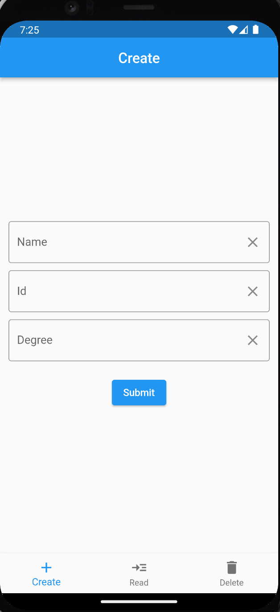
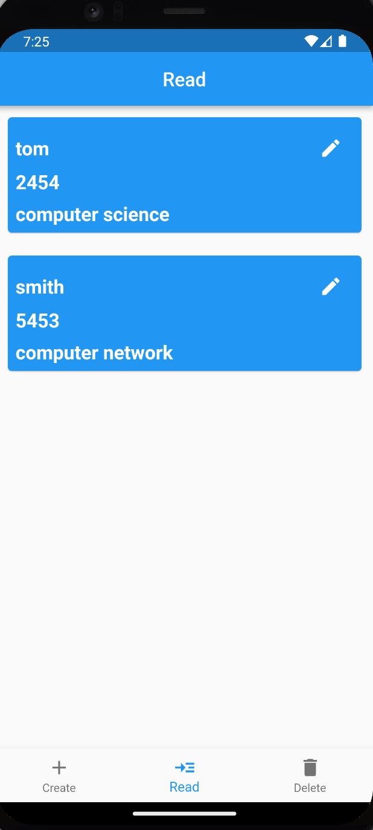
- Delete: A mechanism to remove a student record from the database.

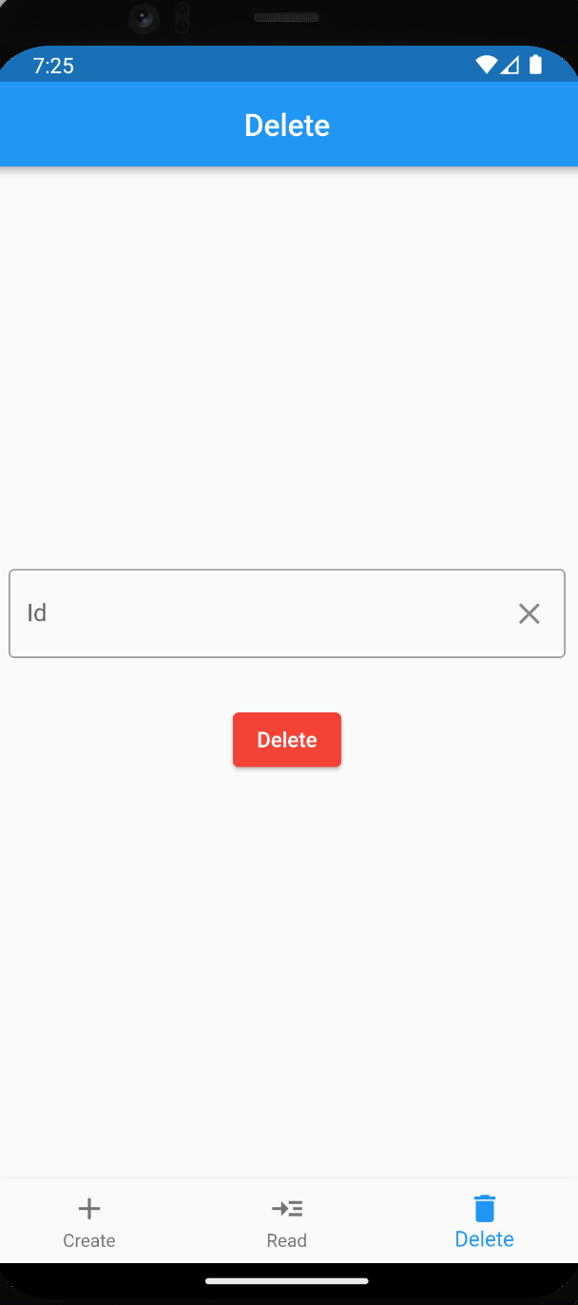
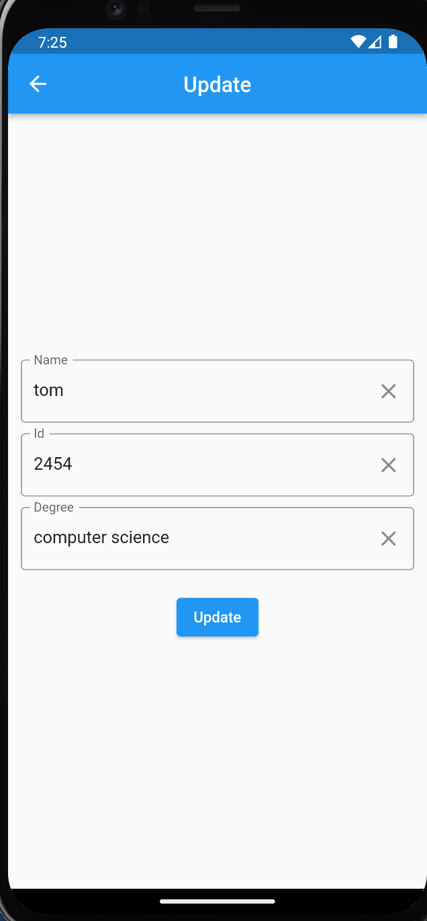

Submission Guidelines
You are required to submit a single PDF document containing the following sections:
- Application Screenshots
- Database Screenshots: A screenshot of your Firebase Console showing the stored collections/documents to prove data persistence.
- Source Code Link:
  - Upload your entire project folder to your Plymouth OneDrive.
  - Generate a shareable link (ensure permissions are set to "Anyone with the link").
  - Include this link clearly on the first page of your document.

