*Lab Practices-III Fourth Year Computer Engineering*

# Information and Cyber Security

**Assignment No.5**

|  |  |  |  |  |  |  |
| --- | --- | --- | --- | --- | --- | --- |
| W  (4) | C  (4) | D  (4) | V  (4) | T  (4) | Total  (20) | Sign/Remark |
|  |  |  |  |  |  |  |

* 1. **Title:**

**Implementation of S-DES (Data Encryption Standard)**

# Problem Definition:

Implementation of S-DES

# Prerequisite:

Basics of Computer networking and Python

# Software Requirements:

Python 3

# Hardware Requirements:

PIV, 2GB RAM, 500 GB HDD

# Learning Objectives:

Learn Data Encryption Standard Algorithm (DES)

# Outcomes:

After completion of this assignment students are able to understand the Data Encryption Standard.

# Theory Concepts:

**Data Encryption Standard (DES)**

The Data Encryption Standard (DES) is a Symmetric-key block cipher issued by the national Institute of Standards & Technology (NIST).

DES is an implementation of a Feistel Cipher. It uses 16 round Feistel structure. The block size is 64-bit. Though, key length is 64-bit, DES has an effective key length of 56 bits, since 8 of the 64 bits of the key are not used by the encryption algorithm (function as check bits only). General Structure of DES is depicted in the following illustration −

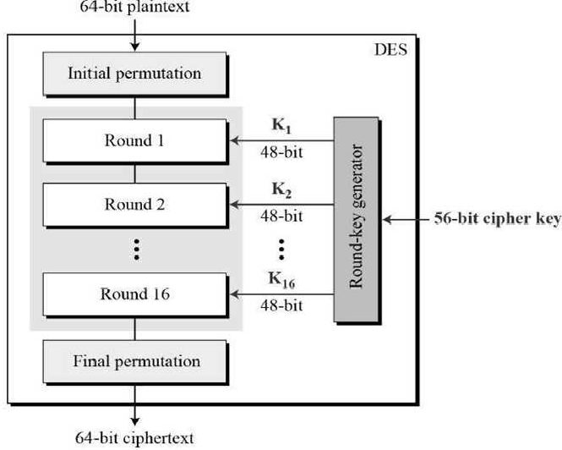

# Figure 5.1: General Structure of DES

Since DES is based on the Feistel Cipher, all that is required to specify DES is −

* + - Round function
    - Key schedule
    - Any additional processing − Initial and final permutation

# Initial and Final Permutation

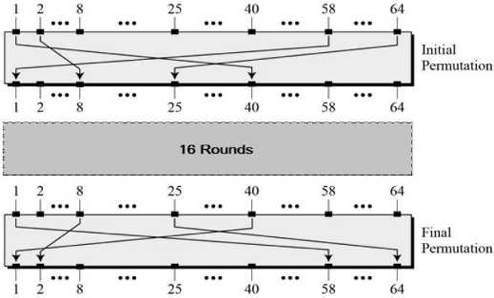The initial and final permutations are straight Permutation boxes (P-boxes) that are inverses of each other. They have no cryptography significance in DES. The initial and final permutations are shown as follows

# Figure 5.2 initial and final permutations

* + 1. **Round Function**

The heart of this cipher is the DES function, *f*. The DES function applies a 48-bit key to the rightmost 32 bits to produce a 32-bit output.

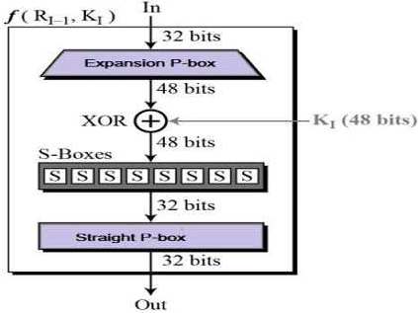

# Figure 5.3 Round Functions

* + 1. **Expansion Permutation Box**

Since right input is 32-bit and round key is a 48-bit, we first need to expand right input to 48 bits.

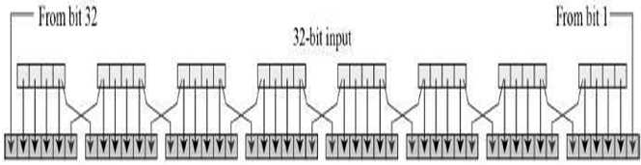

Permutation logic is graphically depicted in the following illustration:

# Figure 5.4 Permutation logic

The graphically depicted Permutation logic is generally described as table in DES specification illustrated as shown:

# Table 5.1 Permutation logic

* + 1. **XOR(Whitener)**

After the expansion permutation, DES does XOR operation on the expanded right section and the round key. The round key is used only in this operation.

# Substitution Boxes

The S-boxes carry out the real mixing (confusion). DES uses 8 S-boxes, each with a 6-bit input and

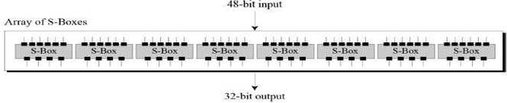

a 4-bit output. Refer the following illustration –

# Figure 5.5 S-Boxes

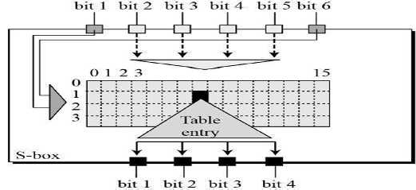The S-box rule is illustrated below –

# Figure 5.6 S-Box Rules

There are a total of eight S-box tables. The output of all eight s-boxes is then combined in to 32 bit section.

* + 1. **Straight Permutation** − The 32 bit output of S-boxes is then subjected to the straight permutation with rule shown in the following illustration:

# Table 5.2 Straight Permutation

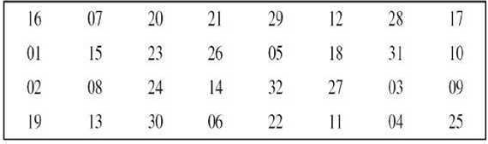

* + 1. **Key Generation**

The round-key generator creates sixteen 48-bit keys out of a 56-bit cipher key. The process of key generation is depicted in the following illustration −

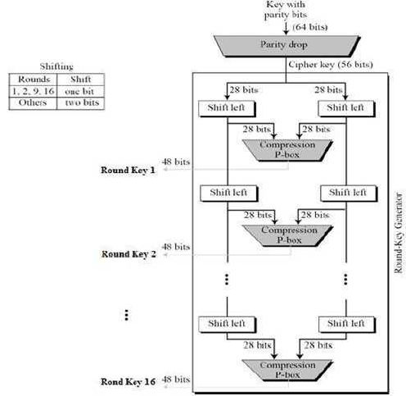

# Figure 5.7 the process of key generation

The logic for Parity drops, shifting, and Compression P-box is given in the DES description.

# DES Analysis

The DES satisfies both the desired properties of block cipher. These two properties make cipher very strong.

* + - * **Avalanche effect** − A small change in plaintext results in the very great change in the cipher text.
      * **Completeness** − Each bit of cipher text depends on many bits of plaintext.

During the last few years, cryptanalysis has found some weaknesses in DES when key selected are weak keys. These keys shall be avoided.

*Lab Practices-III Fourth Year Computer Engineering*

DES has proved to be a very well designed block cipher. There have been no significant cryptanalytic attacks on DES other than exhaustive key search.

# Oral Questions

1. Explain structure of DES
2. Explain Initial permutation steps in DES
3. Draw and explain the internal structure of single round of DES
4. Explain Double DES
5. Explain Triple DES