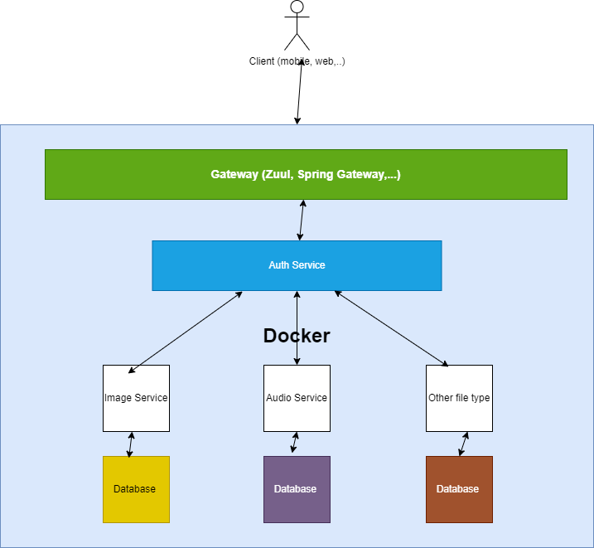

Flow: Users send request to the server to upload their files

-> Gateway service will identify type of that file and redirect the request to appropriate service to handle that request

-> (Optional) After going through gateway, Auth service will authenticate and authorize that request to check if the request is validated or not ( have permission to upload file or download, view file,…)

-> Finally, microservices will handle the logic (insert, update, …..)

Handle exception: Each microservice will have its custom exception, like images service

For example: if img has size > 5mb, images service will not insert that file and throw an exception (“File size is too large….)