# Starting point

You can use this procedure if your ‘Portal Settings’ for a Team Project has been lost.

For example:

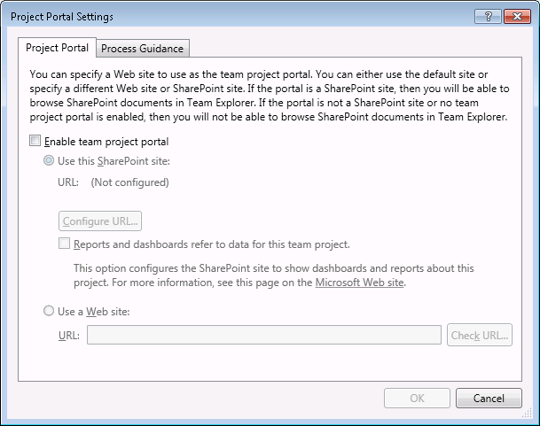

# Get a list of projects and their IDs

1. Open SSMS
2. Connect to collection database
3. Run the following query:

select project_name, project_id

from tbl_projects

where [state] = 'WellFormed' order by project_name

It should return something like this:

|  |  |
| --- | --- |
| project_name | project_id |
| Tailspin Toys | 2EB9C8A2-2243-4897-AC88-602BEF270DD5 |

Paste this into Excel

# Get a list of the sharepoint sites and ids

1. Open SSMS
2. Connect to the WSS_Content database
3. Run the following query:

SELECT

FullUrl as 'RelativePath',

Id as 'OwnedWebIdentifier'

FROM AllWebs

ORDER BY RelativePath

It should return something like this:

|  |  |
| --- | --- |
| RelativePath | OwnedWebIdentifier |
|  | B032339F-D997-4B2C-B5D0-3CB6064D2F1A |
| sites/FabrikamFiberCollection | 919B7437-B8D9-4B56-8AB5-D5B22605278F |
| sites/FabrikamFiberCollection/FabrikamFiber | 7485DD68-2C1D-4089-AD1E-7FA43D92065D |
| sites/team | 1E3082E4-6517-401A-8D5F-22DF8ED1B308 |

Paste this into somewhere else in Excel

# Construct a mapping table

Now we need to map the team projects/team project IDs to sharepoint sites.

|  |  |  |  |
| --- | --- | --- | --- |
| project_name | project_id | RelativePath | OwnedWebIdentifier |
| Tailspin Toys | 2EB9C8A2-2243-4897-AC88-602BEF270DD5 | sites/TailspinToysCollection/Tailspin Toys | 7FC7E412-F49C-488B-A023-8C1D61AE34C7 |
| FabrikamFiber | FD6FA263-B3F9-45E3-96AF-AD67E75C9FF7 | sites/FabrikamFiberCollection/FabrikamFiber | 7485DD68-2C1D-4089-AD1E-7FA43D92065D |

Now we can use this table to run the EnableProjectPortals.exe

It has the command line parameters as follows:

Usage: EnableProjectPortal.exe <tfs server url> <team project id> <sharepoint relative path> <owned web identifier>

You can use this formula in a new column to the right, in Excel:

=CONCATENATE("EnableProjectPortal.exe ""http://localhost:8080/tfs/"" """,B2,""" """,C2,""" """,D2,"""")

# Repairing connections

Once all the portal settings have been established, you should open the Team Foundation Server Administration Console and choose “Repair Connections”.

This will make sure all the SharePoint permissions and properties are set correctly.

