Air-Handwriting Recognition Using Conformer and CTC Loss

Abstract
Air-handwriting recognition has recently attracted significant attention as a touchless interaction technique for spatial computing, virtual reality (VR), augmented reality (AR), and Internet of Things (IoT) systems. However, recognizing handwriting trajectories in free space remains challenging due to unstable motion, lack of tactile feedback, writing-style variations, and temporal inconsistencies. In this study, a deep learning framework based on a Conformer encoder and Connectionist Temporal Classification (CTC) loss is proposed for Vietnamese air-handwriting recognition. The proposed framework integrates preprocessing, normalization, trajectory smoothing, data augmentation, and Random Fourier Features (RFF) to improve trajectory representation. Experimental results on the Vni_air_writing dataset demonstrate that the proposed approach achieves competitive performance with a Character Error Rate (CER) of 15.02%. The results indicate that combining convolutional operations with Transformer-based self-attention effectively captures both local stroke patterns and long-range temporal dependencies in handwriting trajectories.

Introduction
Air-writing recognition aims to infer characters or words directly from continuous human hand or finger movements in free space [1]. Based on the tracking modality used to capture hand motion, the field can be broadly categorized into three major approaches: sensor-based, radar-based, and camera-based systems.
- Sensor-based approaches [3] utilize wearable hardware—such as accelerometers, gyroscopes, inertial measurement units (IMUs), and magnetometers—to collect kinematic data (velocity and acceleration) from hand movements. Because this data is inherently sequential, most existing solutions treat it as a time-series problem and employ Recurrent Neural Networks (RNNs) [6], Long Short-Term Memory networks (LSTMs) [5], or Time Series Transformers (TSTs) [8] as primary sequence recognizers.
- Radar-based approaches [4] leverage radio wave emitter and receiver modules to capture the distance, time-of-flight, and Doppler shifts of hand movements relative to the radar origin. From this signal reflection, the coordinates of the writing finger are mapped onto a predefined 2D or 3D plane over time. These spatial sequences are typically processed using either image rendering or direct time-series modeling.
- Camera-based (vision-based) approaches [7] extract fingertip coordinates from frame sequences captured by standard webcams or depth sensors using machine learning or deep learning frameworks (such as hand pose estimators like MediaPipe). This is the exact tracking modality upon which our research is built.
In general, air-handwriting recognition faces several fundamental technical challenges:
- Lack of Tactile Feedback: Unlike writing on paper or touchscreens, air-writing does not involve a physical surface or friction. As a result, controlling finger movement becomes considerably more difficult, leading to unstable, noisy, and jittery motion trajectories.
- Co-articulation Effect: In air-writing, explicit “pen-up” and “pen-down” actions do not exist. Characters within a word are continuously connected by intermediate movements, also known as epenthetic strokes, when users move their hands from the ending position of one character to the starting position of the next. Consequently, accurately segmenting individual characters from a continuous trajectory becomes highly challenging.
- Spatiotemporal Variability: Even for the same word, trajectory size, writing speed, and handwriting style may vary significantly across different users, or even across multiple writing sessions of the same user.
These challenges require an intelligent system capable of handling noise and learning complex trajectory representations. Consequently, there is a strong demand for advanced Deep Learning approaches that can effectively address the entire pipeline, ranging from raw signal preprocessing to sequential text recognition.
To mitigate this limitation, some methods apply time-variant color gradients to the rendered trajectory pixels based on sequential timestamps; however, this mechanism breaks down when trajectories heavily overlap [2], [9]. Alternatively, other works construct a sparse 3D spatiotemporal tensor containing two spatial dimensions and one temporal dimension [10]. While this retains chronological stroke order, it results in highly sparse matrices that impose an excessively heavy computational burden.To overcome these limitations, our approach treats the input explicitly as time-series data—a sequential stream of continuous finger coordinates—and processes it using an optimized time-series deep learning architecture.
The main contributions of this work are summarized as follows:
- A complete preprocessing and normalization pipeline for trajectory refinement is proposed.
- Multiple augmentation strategies are applied to improve model robustness.
- Random Fourier Features are introduced to enhance high-frequency trajectory representation.
- A Conformer-based architecture combined with CTC Loss is developed for sequence recognition.
- The proposed framework is evaluated on Vietnamese air-handwriting datasets.

Related Work

Traditional Machine Learning Approaches
Traditional air-writing approaches generally consist of a two-stage pipeline: handcrafted feature extraction based on domain expertise, followed by classification using classical machine learning models. Commonly extracted features include fingertip motion trajectories, spatial angles, instantaneous velocity, motion direction histograms, and the frequency of directional changes.
Following feature extraction, the engineered vectors are fed into classifiers such as Hidden Markov Models (HMM), which have been extensively adopted for temporal pattern matching and isolated word decoding from continuous gesture profiles [3], [13].
The primary advantages of these traditional approaches are their ease of implementation and low computational requirements. However, their representation capability is strictly bounded, often leading to severe performance degradation when dealing with highly noisy trajectories or substantial stylistic variations across different users.

Image-based Deep Learning Approaches
In image-based approaches, handwriting motion trajectories are plotted onto a blank digital canvas to generate 2D structural images, which are then processed using Convolutional Neural Networks (CNNs) for character recognition [2].
These CNN-based models excel at automatically learning spatial hierarchy and visual feature maps directly from the rendered image paths [11], yielding higher recognition accuracy compared to traditional feature-engineering methods. However, converting raw trajectory arrays into static images inevitably discards sequential information related to writing stroke orders, travel directions, and dynamic velocity variations.

Sequence-based Deep Learning Approaches
Because air-handwriting data is inherently sequential, many studies employ sequence modeling architectures to capture the dynamic characteristics of hand movements over time.
These architectures are optimized for learning contextual information and sequential dependencies across consecutive timesteps during the writing process [12]. Consequently, sequence-based systems can more effectively distinguish characters that possess identical spatial shapes but completely different structural stroke orders by tracking the continuous coordinates explicitly.

Transformer-based Approaches
Recently, Transformer-based architecture has been widely applied to sequence processing, multivariate time-series forecasting, and computer vision tasks. Transformers utilize the self-attention mechanism to learn global dependencies between all elements in a sequence simultaneously, avoiding the step-by-step recurrence bottleneck found in RNN-based models.
In this paradigm, Time Series Transformer (TST) models are employed to process the temporal sequences of hand movement coordinates [8]. Transformers compute self-attention scores across all timesteps in parallel, allowing the model to capture long-range structural dependencies and subtle motion characteristics within lengthy air-handwriting trajectories [14]. Furthermore, because Transformers support highly parallelized training, they offer superior computational scaling when deployed on large-scale datasets. However, these models typically demand significantly larger amounts of training data and involve a higher computational overhead during inference compared to traditional approaches.

Proposed Method

Dataset
The study utilizes the open-source Vni_air_writing dataset [15], which was collected and distributed through the Kaggle platform by Trịnh Huỳnh Thịnh Khang. This dataset is one of the few large-scale datasets specifically designed for Vietnamese Air-Handwriting recognition tasks.

Dataset Characteristics
The dataset consists of 22,760 samples categorized into four main directories based on phrase length:
- 1_gram: A collection of single-word samples.
- 2_grams: A collection of two-word phrases.
- 3_grams: A collection of three-word phrases.
- n_gram: A collection of longer phrases containing four or more words.
Since the objective of this study is to focus on single-word air-handwriting recognition, only the dataset in the 1_gram directory was selected for training. Meanwhile, the datasets from the 2_grams, 3_grams, and n_gram directories were utilized for validation and testing purposes.
As a result, the training dataset used in this study consists of 15,500 single-word handwriting trajectory samples extracted from the 1_gram subset.
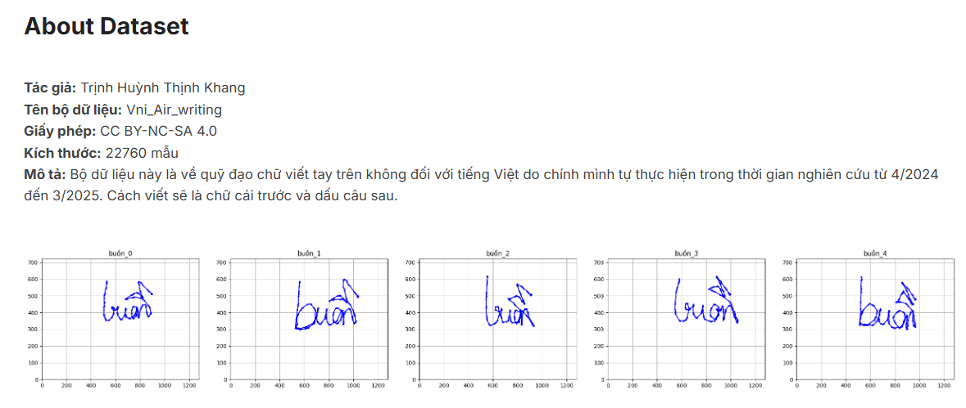
Figure 1. Overview of the dataset

Data Augmentation
Deep neural network architectures, especially Transformer-based models, contain millions of parameters and require large-scale datasets for effective convergence. Although 15,500 samples represent a relatively sufficient dataset size, real-world users may write at different angles, distances, postures, and speeds. To improve the robustness and generalization capability of the proposed framework, a comprehensive data augmentation pipeline consisting of four geometric and temporal transformations is applied.

Rotation
Objective
In real-world scenarios, handwriting trajectories rarely align perfectly along a horizontal axis due to wrist inclination, hand posture, or the relative position between the user and the camera/sensor.
Method
A random rotation is applied to the entire trajectory using a rotation angle $\theta$ sampled from a normal distribution within the range $\left[-15°,15°\right]$. The transformed coordinates are computed as:
$$\left[\begin{aligned}x^{'} \\ y^{'}\end{aligned}\right]=\left[\begin{matrix}\cos{θ} & -sin⁡θ \\ \sin{θ} & \cos{θ}\end{matrix}\right]\left[\begin{aligned}x \\ y\end{aligned}\right]$$
This transformation improves the rotation invariance capability of the model.

Stretching
Objective
This transformation simulates variations in handwriting aspect ratios. Some users tend to write tall and narrow characters, while others produce wider and flatter handwriting patterns.
Method
Independent scaling factors are applied along the horizontal and vertical axes. The scaling coefficients $s_{x}$ and $s_{y}$ are randomly sampled within the range $[0.8,1.2]$.
$$x^{'}=s_{x}⋅x \\ y^{'}=s_{y}⋅y$$
This augmentation improves the adaptability of the model to diverse handwriting styles.

Gaussian Noise Injection
Objective
Gaussian noise injection simulates:
- Sensor measurement noise.
- Natural hand trembling during free-space writing without physical support.
Method
Random Gaussian noise with mean $μ=0$ and small standard deviation $σ$ is added to each coordinate point:
$$x^{'}=x+ϵ_{x},ϵ_{x}∼N(0,σ^{2}) \\ y^{'}=y+ϵ_{y},ϵ_{y}∼N(0,σ^{2})$$
This augmentation prevents the neural network from memorizing exact coordinate values and encourages the model to learn the overall geometric structure of the handwriting trajectory.

Time Warping
Objective
Time Warping is one of the most important augmentation techniques for sequential handwriting data. During air-writing, users may write quickly on straight strokes and slow down on highly curved segments. Such local velocity variations lead to non-uniform temporal spacing between trajectory points.
Method
Time Warping performs nonlinear distortion along the temporal axis by stretching certain segments of the sequence while compressing others, without altering the original ordering of points.
This transformation improves the model’s robustness against variations in individual writing speed, also known as dynamic speed invariance.

Augmentation Summary
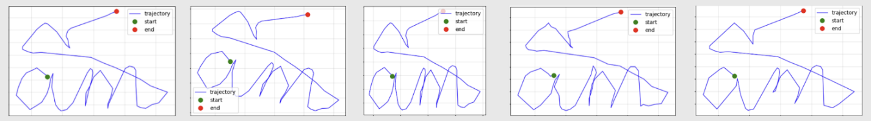
Figure 2. Illustration of data augmentation techniques
After applying flexible combinations of the above transformations, each original trajectory sample generates four additional augmented variants with different kinematic characteristics while preserving the original semantic label.
As a result, the dataset size is increased by five times, reaching a total of 77,500 samples. This significantly enlarged dataset provides a strong foundation for training the deep Conformer architecture while effectively reducing the risk of overfitting.

Preprocessing and Normalization

Preprocessing
A major characteristic of air-handwriting data is the instability of handwriting strokes caused by the absence of physical support during the writing process. Consequently, the generated trajectories are often jittery and noisy. To reduce trajectory noise and generate smoother handwriting curves, the raw samples are preprocessed using the following steps:
- A Savitzky–Golay filter is applied to remove jitter and noise from the handwriting trajectory while preserving its local geometric structure.
- The denoised trajectory is then further smoothed using spline curve interpolation. The filtered points are utilized to construct an approximate spline curve. Instead of forcing the spline to pass exactly through every point, the approximation allows the curve to pass through neighboring positions within a predefined radius. This approach produces smoother and more natural handwriting trajectories. In the implementation, the smoothing parameter is empirically set to:
$$s=2×N$$
where $N$ denotes the number of trajectory points.

Data normalization
After preprocessing, the trajectory data are normalized through the following steps:
- Shift
The trajectory is translated so that the bottom-right point becomes the origin coordinate $(0,0)$ :
$$x^{'}=x-x_{min} \\ y^{'}=y-y_{min}$$
This transformation removes the dependency on the original writing position.
- Scale
The trajectory coordinates are normalized into the range $\left[0 , 1\right]$using the scaling factor:
$$max⁡(x_{max}-x_{min}, y_{max}-y_{min})$$
The normalized coordinates are computed as:
$$x^{''}=\frac{x^{'}}{max⁡(W,H)} \\ y^{''}=\frac{y^{'}}{max⁡(W,H)}$$
where $W$and $H$denote the width and height of the trajectory.
This normalization step ensures that all handwriting samples share a consistent spatial scale regardless of writing size differences among users.
- Resampling
Since different handwriting samples contain varying sequence lengths, directly feeding raw trajectories into the neural network may negatively affect the learning process. Therefore, all trajectory samples are resampled into a fixed sequence length of 128 points.
The resampling procedure is performed as follows:
- Construct a spline interpolation curve from the input points $\left(x_{i} , y_{i} , s_{i}\right)$, where $s_{i}$denotes the accumulated curve length from $s_{1}$to $s_{i}$.
- Divide the interval $[0,1)$into 128 equally spaced points corresponding to 127 segments. The sampled positions are defined as:
$$\frac{i}{127},i∈[0,127]$$
- Let $S=\sum_{i=1}^{N}{s_{i}}$ and evaluate the spline curve at the positions $S×\frac{i}{127}$ to obtain a uniformly resampled trajectory consisting of exactly 128 points.
This resampling strategy preserves the geometric structure of the handwriting trajectory while ensuring consistent input dimensions for neural network training.
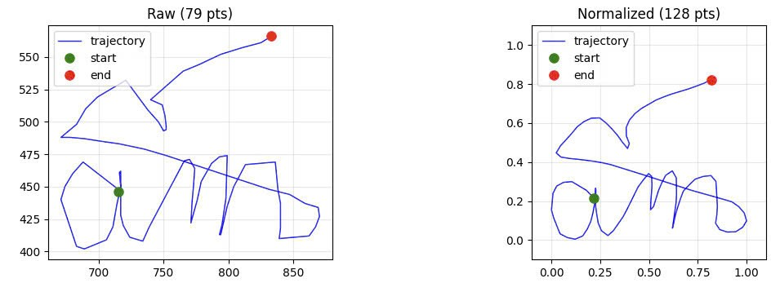
Figure 3. Illustration of data before and after preprocessing and normalization
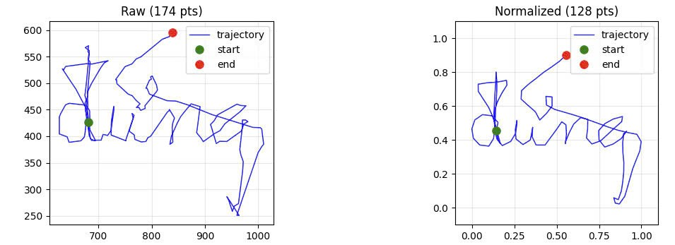
Figure 4. Illustration of data before and after preprocessing and normalization (noise-augmented version)

Feature Extraction
Given that the input data consists of two-dimensional coordinate sequences over time, the proposed framework initially extracts eight features at each timestep to comprehensively represent both the geometric and dynamic characteristics of handwriting trajectories.
- The $x$ and $y$ coordinates are the two fundamental features representing the spatial position of each point in the two-dimensional space. These features provide essential information for capturing the overall shape of the handwriting trajectory.
- The first-order derivatives along each axis, denoted as $Δx$and $Δy$, represent positional changes between consecutive timesteps. These features reflect the instantaneous writing velocity and help the model capture the dynamic behavior of the writing process.
- From the velocity vector $\left(Δx , Δy\right)$, normalized directional features are further computed, including $direction_{x}$and $direction_{y}$. These values correspond to the cosine and sine components of the motion angle, enabling the model to learn handwriting directions independently of velocity magnitude.
- In addition, second-order derivatives of the coordinate sequence are calculated to capture curvature information. After normalization, two curvature-related features, $curvature_{x}$and $curvature_{y}$, are obtained. These features describe directional changes in the trajectory and help the model recognize curves, corners, and turning patterns in handwriting strokes.

Random Fourier Features
Through extensive experimentation and literature review, it was observed that the original spatial coordinates $\left(x , y\right)$exhibit high-frequency variations during air-writing. According to the study in [16], neural networks often struggle to learn high-frequency functions due to the phenomenon known as Spectral Bias. To address this limitation, the Random Fourier Feature (RFF) method is adopted.
Random Fourier Features project the input data from the original space into a higher-dimensional feature space, where high-frequency components become easier for neural networks to learn.
Given an input vector $x∈R^{d}$, the mapping is defined as:
$$γ(x)=\left[cos⁡(Bx), sin⁡(Bx)\right]$$
where:
- $B∈R^{m×d}$is a randomly initialized matrix.
- The elements of $B$ are sampled from a Gaussian distribution:
- $B_{ij}∼N(0,σ^{2})$
- $m$ denotes the number of Fourier features.
In this study, the parameters are configured as:
$$σ^{2}=10,m=10,d=2$$
corresponding to the two-dimensional coordinate input $\left(x , y\right)$.

Final Feature Representation
Finally, the feature vector at timestep $t$is represented as:
$\left[γ(x,y),Δx,Δy,direction_{x},direction_{y},curvature_{x},curvature_{y}\right]$,
where $γ(x,y)=\left[cos⁡(B[x,y]^{T}),sin⁡(B[x,y]^{T})\right]$ and $B∈R^{10×2}$ with elements sampled from $N(0,(\sqrt{10})^{2})$.
In this representation, the original spatial coordinates are completely replaced by Fourier features to improve the model’s ability to learn high-frequency spatial variations.
The combination of positional, velocity, directional, and curvature-related features enable the model to learn a richer trajectory representation, thereby improving the performance of air-handwriting recognition.

Model Architecture
Our proposed framework utilizes a Conformer Encoder [17] to extract features from the input sequence, which consists of temporal handwriting trajectory information. Subsequently, CTC [18] is employed to decode and align the motion sequence with the output character sequence to accomplish the air-handwriting recognition task.
The overall architecture of the proposed model is illustrated in the following figure:
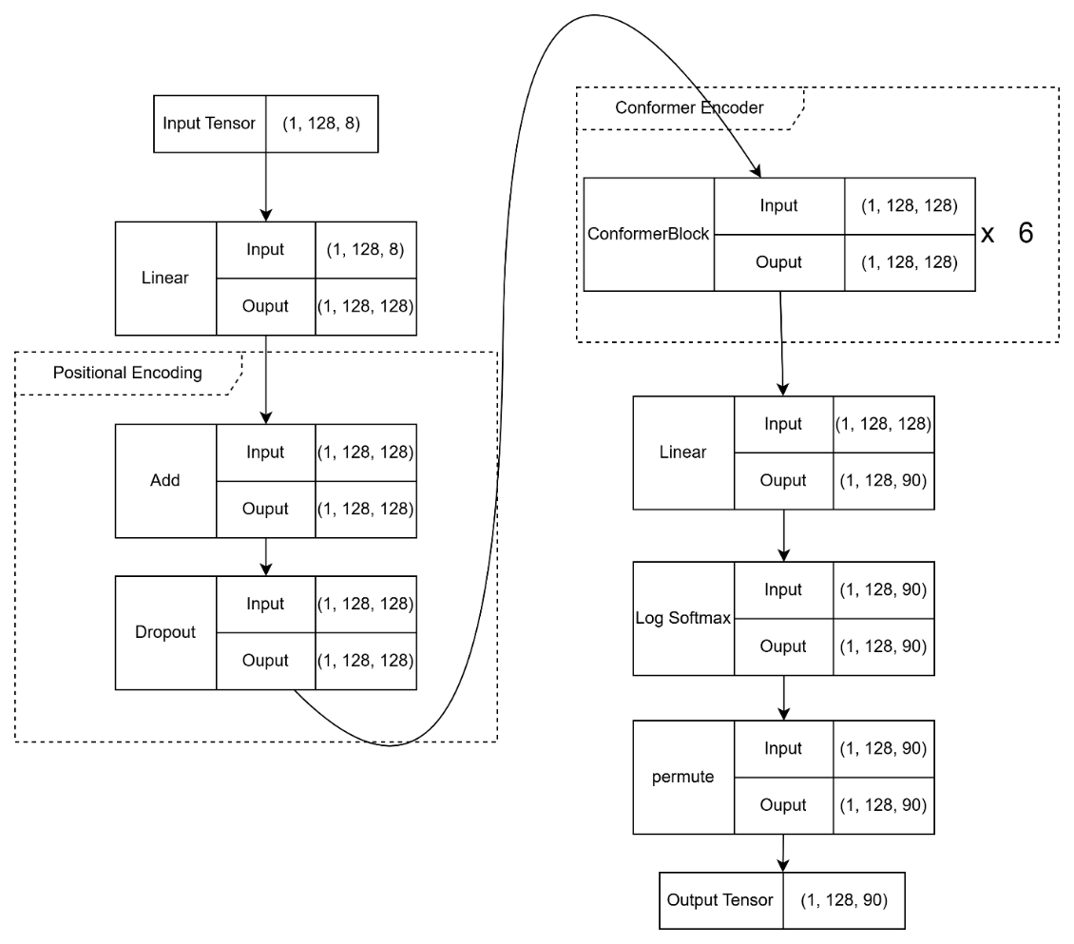
Figure 9. Overall architecture

Conformer Encoder Module
The core feature extraction pipeline adapts the Convolution-augmented Transformer (Conformer) architecture [17] originally used for speech sequence modeling. The Conformer is uniquely suited for air-writing signals because it simultaneously resolves two distinct structural nuances:
- Global Contextual Dependencies: The multi-head self-attention module captures long-range spatiotemporal correlations across the entire writing sequence, making it highly robust against individual speed variations and unexpected long pauses.
- Local Fine-Grained Kinematics: The integrated depthwise separable convolution module acts over localized temporal frames to capture fine-grained stroke dynamics, high-frequency trajectory jitters, and rapid direction changes.
Each Conformer block uses a distinctive "Macaron-style" structural layout. The sequence passes sequentially through a half-step feed-forward module, a multi-head self-attention module, a depthwise convolutional layer, and a final half-step feed-forward module, bounded altogether by residual connections and layer normalization.

CTC Loss
In the air-handwriting recognition problem, the alignment between the motion trajectory sequence (e.g., hand coordinates or spatial drawing trajectories) and the output character sequence is unknown. We only know that the order of the writing strokes corresponds to the order of the characters in the text, but we do not know exactly which segment of the trajectory corresponds to which character. This is where CTC [18] is used to automatically learn and infer the alignment.
CTC computes the loss function between a continuous temporal sequence (without explicit segmentation) and a target sequence. Specifically, it sums up the probability of all possible alignments between the input sequence and the target sequence and then calculates the loss value to update the model parameters during training.

Experimental Setup

Dataset Preparation
To prevent data leakage between the training and testing stages while ensuring a reliable evaluation of model generalization capability, the words contained in the 2_grams, 3_grams, and n_gram directories were decomposed into individual words.
After the decomposition process, a dataset containing 91 unique words was obtained, with each word consisting of 5 handwriting samples.
To evaluate the robustness and generalization ability of the proposed framework, the same data augmentation pipeline applied to the training set was also consistently applied to both the validation and test sets. The augmentation process includes four geometric and temporal transformations:
- Rotation
- Stretching
- Gaussian noise injection
- Time warping
As a result, the number of samples for each word increased fivefold, from 5 original samples to 25 augmented samples.
The entire augmented dataset was then divided using a stratified split strategy based on word categories, where:
- 20% of the samples were allocated to the validation set.
- 80% of the samples were allocated to the test set.
This experimental setup forces the system to perform inference on handwriting trajectories that were never observed during training, thereby enabling a more reliable evaluation of the model’s generalization capability and robustness.

Model Configuration
The proposed model was configured using the following parameters:
- Number of Conformer encoder layers: 6
- Number of attention heads in the Multi-Head Self-Attention module: 4
- Feed-forward hidden dimension: 512

Training Configuration
The training process was conducted using the following settings:
- Optimizer: AdamW
- Initial learning rate: 0.001
- Learning rate scheduling: The learning rate gradually warmed up during the first 10 epochs. After the warm-up stage, cosine learning rate decay scheduling was applied.
- Batch size: 128
- Number of training epochs: 50

Evaluation metrics
To evaluate the proposed framework, the Character Error Rate (CER) metric [18] is employed. CER is computed based on the Levenshtein distance between the predicted sequence and the ground-truth sequence, which represents the minimum number of insertion, deletion, and substitution operations required to transform the predicted sequence into the correct sequence.
In other words, CER measures the character-level error ratio, indicating how many character modifications are needed to convert the predicted output into the target text.
The CER metric is defined as:
$$CER=\frac{S+D+I}{N}$$
where:
- $S$(Substitution) denotes the number of incorrectly substituted characters.
- $D$(Deletion) denotes the number of missing characters.
- $I$(Insertion) denotes the number of extra inserted characters.
- $N$ denotes the total number of characters in the ground-truth sequence.
A lower CER value indicates better recognition performance and higher prediction accuracy.

Results and Discussion

Quantitative Results
The proposed framework was trained and evaluated on the test set constructed as described in Section 3.1. Four experimental configurations were investigated to evaluate the effectiveness of the Conformer architecture, Random Fourier Features (RFF), and relative positional encoding.
a. Training Process Visualization
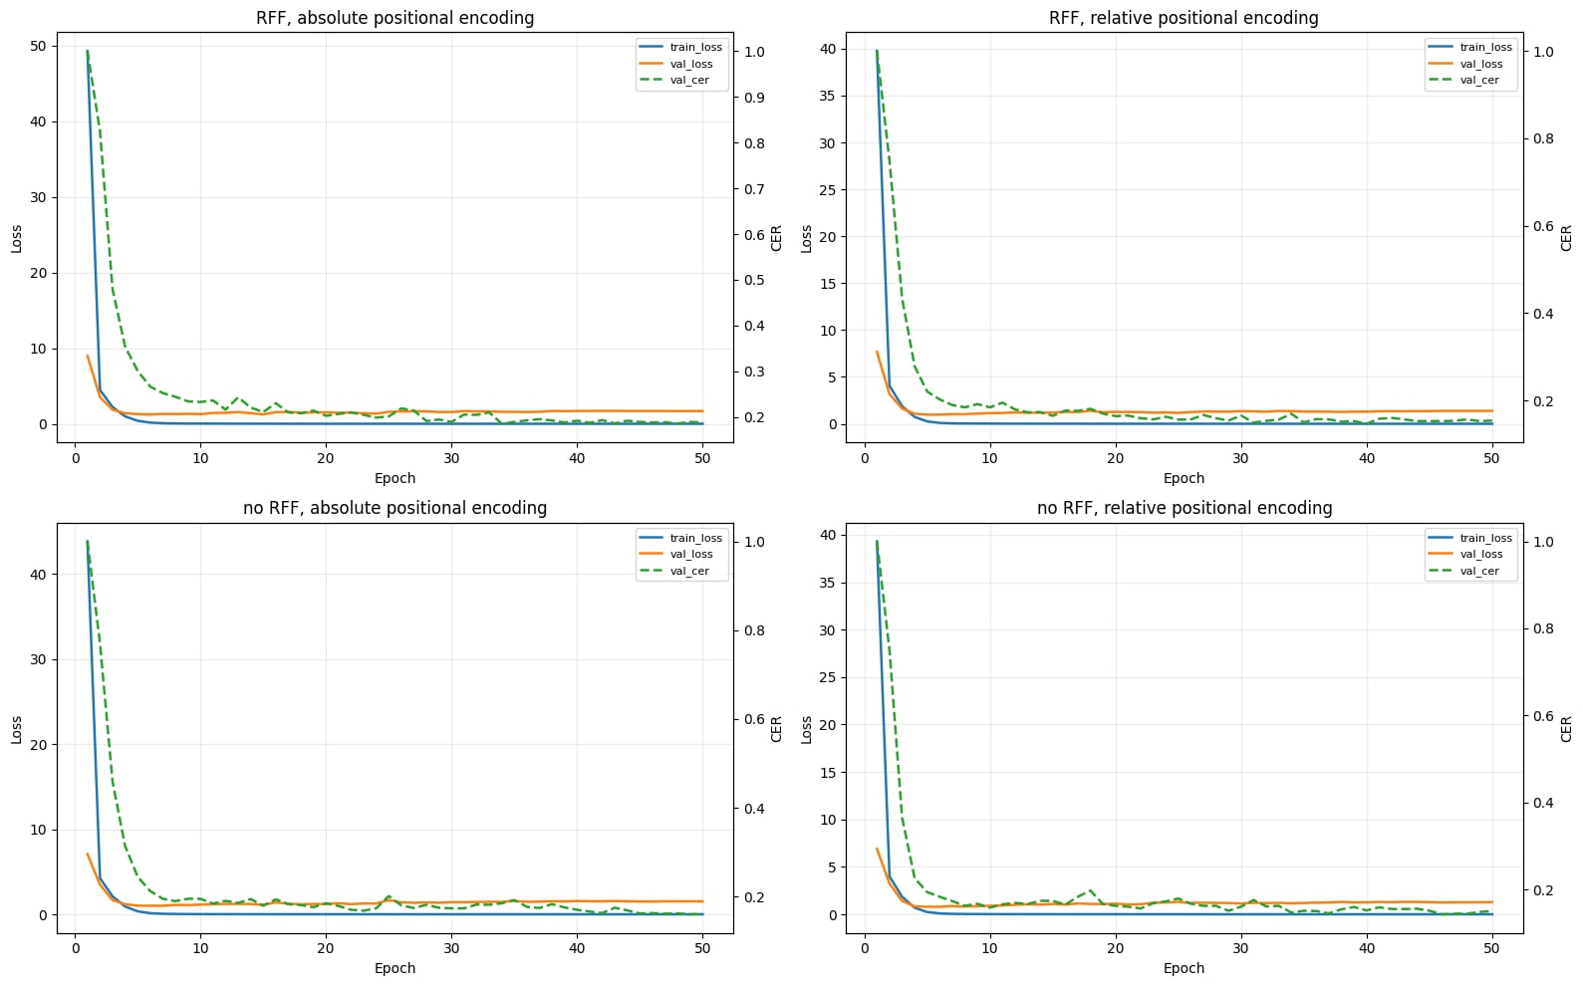
Figure 10. Loss and CER diagram during training
b. CER Metric Results
Table 1. CER results under different model configurations
Model Configuration | CER
Without Fourier feature, absolute positional encoding | 17.32%
Without Fourier feature, relative positional encoding | 15.79%
Fourier feature, absolute positional encoding | 18.43%
Fourier feature, relative positional encoding | 15.02%
From the above results, it can be observed that our Conformer model, after applying the RFF (Random Fourier Feature) extraction method, achieves significantly better performance compared to the remaining configurations. With a CER of 15.02%, the model demonstrates relatively strong prediction capability and shows potential for practical real-world applications.

Qualitative Results
During the experimentation process, the group observed that the proposed model is capable of accurately recognizing words with relatively complex handwriting trajectories. Several illustrative examples are presented below:
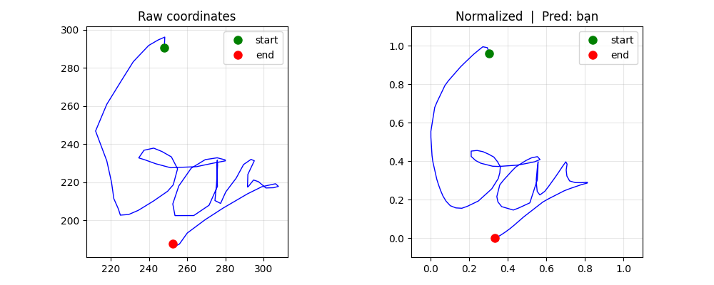
Figure 11. Example of the model correctly predicting the word “bạn”
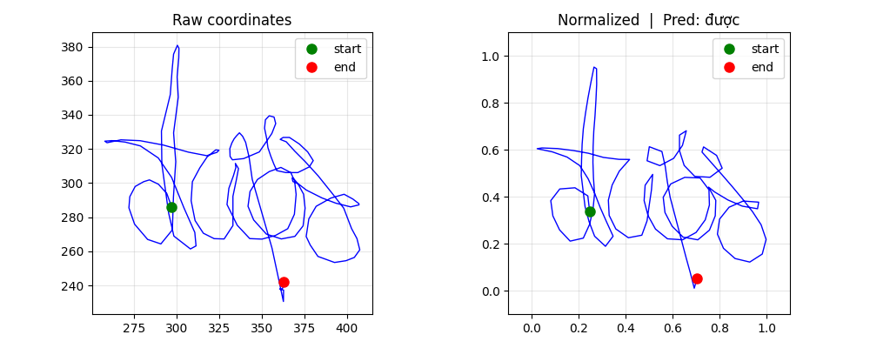
Figure 12. Example of the model correctly predicting the word “được”
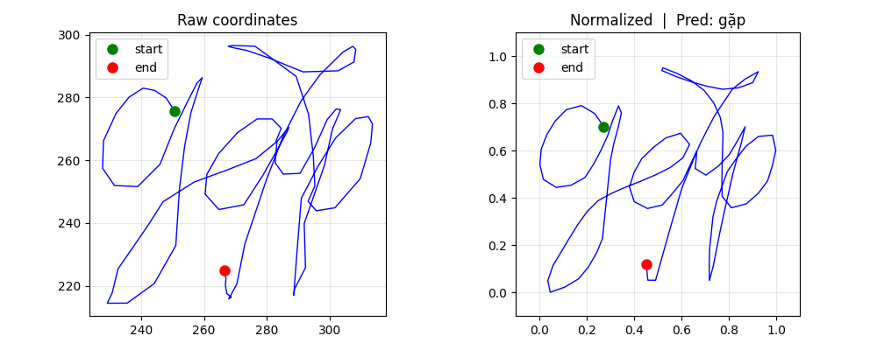
Figure 13. Example of the model correctly predicting the word “gặp”
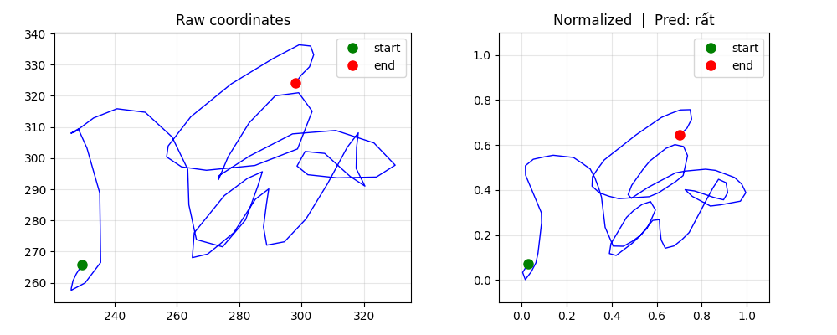
Figure 14. Example of the model correctly predicting the word “rất”
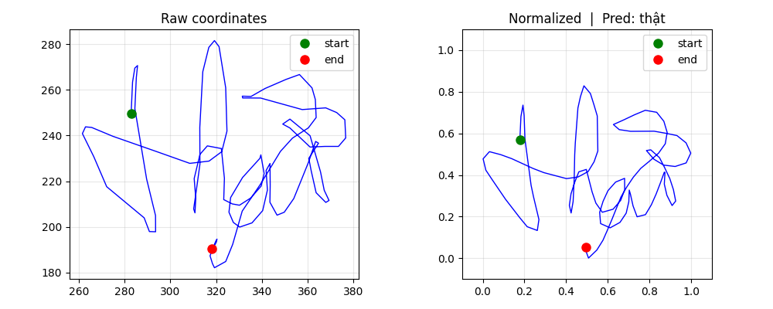
Figure 15. Example of the model correctly predicting the word “thật”
It can be observed that the above words contain relatively complex trajectories; however, the model is still able to generate accurate predictions.
Besides the promising results, the model still exhibits several limitations:
- The model has difficulty recognizing the character “i”. This character is often omitted or incorrectly recognized as “a” or “u”.
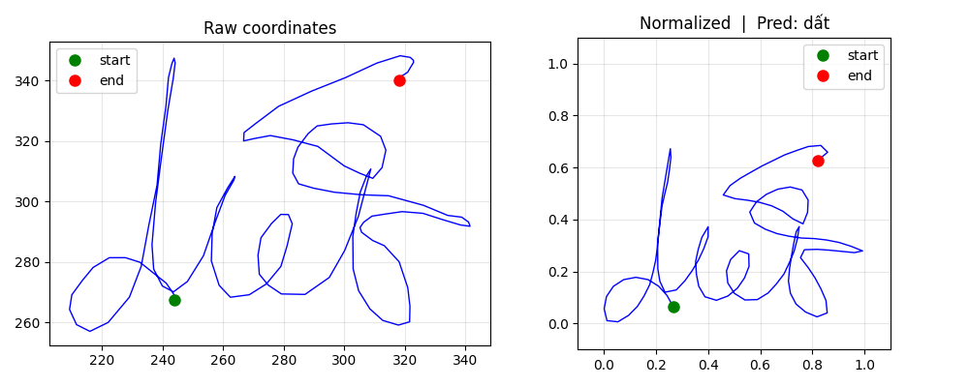
Figure 16. Example of incorrect recognition of the character “i” (“diết”)
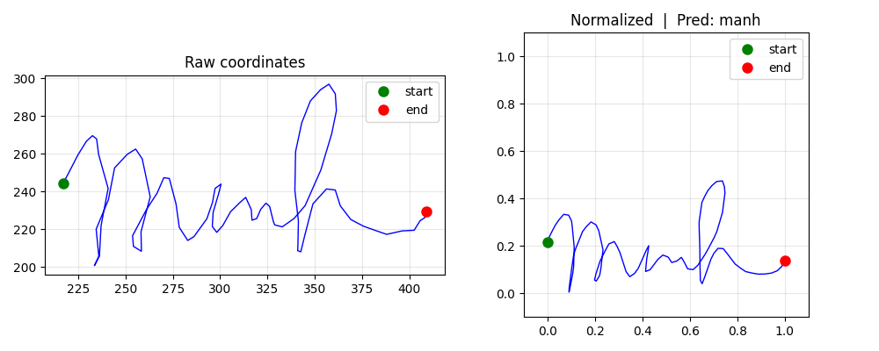
Figure 17. Example of incorrect recognition of the character “i” (“minh”)
- Due to the nature of air-handwriting, transitional strokes between characters can easily be confused with other characters, leading to incorrect predictions. For example, in the word “các” shown below, the transition stroke from the final “c” to the accent mark unintentionally creates a trajectory similar to the character “o”, causing the model to produce an incorrect prediction.
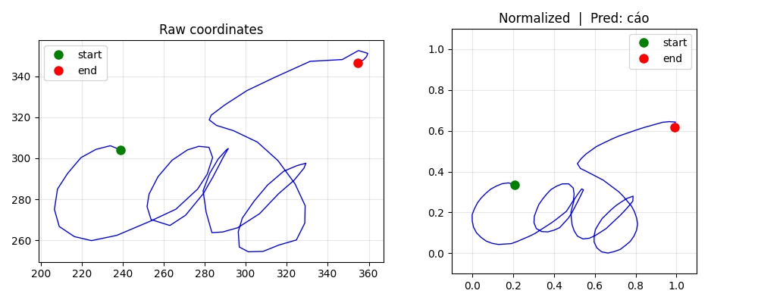
Figure 18. Illustration of transitional strokes causing loss of original trajectory information
The above limitations are mainly caused by the insufficient diversity and limited vocabulary size of the dataset, which negatively affects the generalization capability of the model. In future work, the group plans to collect additional self-recorded air-handwriting data in order to expand the dataset and further improve model performance.

Conclusion
In this report, a Conformer-based air-handwriting recognition framework combined with Connectionist Temporal Classification (CTC) loss was proposed. The problem was approached as a temporal sequence recognition task without requiring manual alignment between input trajectories and output labels.
First, the study analyzed the characteristics of air-handwriting data and constructed a complete processing pipeline including preprocessing, normalization, feature extraction, and data augmentation. Data augmentation techniques such as rotation, stretching, Gaussian noise injection, and time warping significantly improved the generalization capability of the proposed model.
From the modeling perspective, the Conformer architecture was selected due to its ability to combine convolutional operations (CNN) for extracting local features and self-attention mechanisms for capturing long-range dependencies within sequential data. Combined with the CTC loss function, the model can directly learn the mapping from input trajectory sequences to output character sequences without requiring explicit alignment steps.
Experimental results demonstrate that the proposed framework achieves strong performance on the test set, with a lower Character Error Rate (CER) compared to baseline models such as conventional LSTM and standard Transformer architectures. These results confirm the effectiveness of the Conformer architecture for temporal sequence recognition tasks such as air-handwriting recognition.
However, the proposed framework still has several limitations. First, the current system depends on fingertip position extraction using MediaPipe. Therefore, the overall performance is affected by the accuracy and stability of this module under different lighting conditions, camera viewpoints, and environmental noise. Second, the dataset size remains relatively limited (approximately 310 single words), which is insufficient for the model to fully learn linguistic patterns and the diversity of user handwriting styles. In addition, the model still encounters difficulties in cases involving unclear handwriting, unstable writing speed, or severe environmental noise.
In future work, several directions can be explored to further improve the system. First, an end-to-end framework that directly learns from raw inputs (e.g., image sequences or videos) to recognition outputs could be developed in order to eliminate the dependency on intermediate feature extraction stages. Furthermore, the dataset should be expanded both in scale and diversity, including more users and a wider range of handwriting styles. Advanced data augmentation techniques may also be incorporated to improve the model’s ability to learn more robust linguistic and motion patterns. Finally, integrating language models or leveraging pretraining techniques could further enhance recognition accuracy and prediction robustness.

References

[1] Alam, M. S., Kwon, K. C., Alam, M. A., Abbass, M. Y., Imtiaz, S. M., & Kim, N. (2020). Trajectory-based air-writing recognition using deep neural network and depth sensor. Sensors.
[2] Alam, M. S., Kwon, K. C., & Kim, N. (2019). Trajectory-based air-writing character recognition using convolutional neural network. In 2019 4th International Conference on Control, Robotics and Cybernetics (CRC)
[3] Amma, C., Georgi, M., & Schultz, T. (2012). Airwriting: A wearable handwriting recognition system. Pervasive and Mobile Computing.
[4] Arsalan, M., & Santra, A. (2019). Character recognition in air-writing based on network of radars for human-machine interface. IEEE Sensors Journal.
[5] Hochreiter, S., & Schmidhuber, J. (1997). Long short-term memory. Neural Computation.
[6] Rumelhart, D. E., Hinton, G. E., & Williams, R. J. (1986). Learning representations by back-propagating errors. Nature.
[7] Watanabe, T., Maniruzzaman, M., Hasan, M. A. M., Lee, H. S., Jang, S. W., & Shin, J. (2023). 2D camera-based air-writing recognition using hand pose estimation and hybrid deep learning model. Electronics.
[8] Zerveas, G., Jayaraman, S., Patel, D., Bhamidipaty, A., & Eickhoff, C. (2021). A transformer-based framework for multivariate time series representation learning. In Proceedings of the 27th ACM SIGKDD Conference on Knowledge Discovery & Data Mining.
[9] Chang, Y. N., et al. (2021). Chronological pixel-coloring strategies for unconstrained deep text recognition from multi-stroke character trajectories. Pattern Recognition Letters.
[10] Kim, U. H., Hwang, Y., Lee, S. K., & Kim, J. H. (2023). Writing in the Air: Unconstrained Text Recognition from Finger Movement Using Spatio-Temporal Convolution. IEEE Transactions on Artificial Intelligence.
[11] Lamaakal, I., Ouahbi, I., El Makkaoui, K., Maleh, Y., Pławiak, P., & Alblehai, F. (2024). A TinyDL model for gesture-based air handwriting Arabic numbers and simple Arabic letters recognition. IEEE Access.
[12] Ott, F., Rügamer, D., Heublein, Lucas., Hamann, T., Barth, J., Bischl, B., & Mutschler, C. (2022). Benchmarking online sequence-to-sequence and character-based handwriting recognition from IMU-enhanced pens. International Journal on Document Analysis and Recognition (IJDAR).
[13] Roy, P., Ghosh, S., & Pal, U. (2023). A CNN based framework for unistroke numeral recognition in air-writing. arXiv preprint arXiv:2303.07989.
[14] Zheng, L., Bai, J., Zhu, X., Huang, L., Shan, C., Wu, Q., & Zhang, L. (2021). Dynamic hand gesture recognition in in-vehicle environment based on FMCW radar and Transformer. Sensors.
[15] Trịnh Huỳnh Thịnh Khang (2024). Vni_Air_Writing Dataset. Kaggle. Available at: https://www.kaggle.com/datasets/trnhhunhthnhkhang/vi-air-writing.
[16] Tancik, M., Srinivasan, P. P., Mildenhall, B., Fridovich-Keil, S., Raghavan, N., Singhal, U., Ramamoorthi, R., Barron, J. T., & Ng, R. (2020). Fourier features let networks learn high frequency functions in low dimensional domains. Advances in Neural Information Processing Systems (NeurIPS).
[17] Graves, A., Fernández, S., Gomez, F., & Schmidhuber, J. (2006). Connectionist temporal classification: labelling unsegmented sequence data with recurrent neural networks. In Proceedings of the 23rd International Conference on Machine Learning (ICML).
[18] Gulati, A., Qin, J., Chiu, C. C., Parmar, N., Zhang, Y., Yu, J., Wang, W., Zhang, Z., Wu, Y., & Pang, R. (2020). Conformer: Convolution-augmented Transformer for Speech Recognition. Interspeech.

APPENDIX
- Dataset
  - Characteristics of the Vietnamese Air-writing Dataset
When working on the air-writing recognition problem, one of the biggest challenges faced by the team was the lack of available data. Worldwide, standard datasets for English and Chinese are relatively common. In Vietnam, there are also handwritten datasets collected from tablets (such as VNOn-DB), but datasets that directly record hand trajectories in the air are extremely rare.
Recognizing Vietnamese air-writing is significantly more difficult than English. The key challenge lies in the Vietnamese tonal marking system (question mark, tilde, dot, acute, and grave accents). When writing Vietnamese words in the air, users must frequently “lift the stroke” to add tonal marks, causing the hand trajectory to become discontinuous and highly variable. Therefore, the Vni_air_writing dataset used in this study is a valuable resource and is currently one of the very few datasets specifically designed for Vietnamese air-writing. The ability of the proposed model to effectively handle this complex dataset not only demonstrates the strength of the Conformer architecture but also provides a strong foundation for future research on Vietnamese language processing.
  - Organization Structure of the Dataset
The original dataset (stored in the file VNI_airwriting.zip) is systematically and well organized. In total, it contains 22,760 trajectory samples divided into four groups based on word length:
- 1_gram: Contains single-word samples. This is the largest subset with 15,500 samples and was used as the primary training dataset.
- 2_grams: Contains trajectories of two-syllable compound words.
- 3_grams: Contains trajectories of three-syllable compound words.
- n_gram: Contains trajectories of phrases with four or more syllables.
More specifically, each sample in the dataset possesses several technical characteristics that are highly suitable for time-series problems:
- Real-time trajectory recording: Instead of storing data as static 2D images (which would lose motion information), each air-writing instance is saved as a .csv file containing a sequence of fingertip coordinates (x, y) changing over time in milliseconds. This storage method preserves the full dynamic properties of handwriting, including writing speed, movement force, and hesitation points.
- Comprehensive vocabulary coverage: The single-word subset alone covers 310 of the most common Vietnamese words, encompassing a wide range of vowels, consonants, and tonal structures.
- High diversity: To prevent deep learning models from overfitting or merely “memorizing” patterns, each vocabulary word was written 50 times (corresponding to 50 .csv files). Every repetition differs in angle, speed, and writing scale, providing sufficient diversity for the system to learn actual writing patterns instead of fixed coordinate sequences.

