**CENTRO ESTADUAL DE EDUCAÇÃO TECNOLÓGICA PAULA SOUZA**

**ESCOLA TÉCNICA ESTADUAL IRMÃ AGOSTINA**

**Desenvolvimento de sistemas**

**Matheus R. Siqueira**

**Vinicius da Conceição**

**BANCO DE DADOS**

**SÃO PAULO**

**2020**

**Trabalho Exigido em Sala de Aula**

**Código:**

CREATE DATABASE SISTEMA_GESTAO_IMOBILIARIA_2019;

USE SISTEMA_GESTAO_IMOBILIARIA_2019;

CREATE TABLE TBL_ADM_IMOBILIARIA (

ID_IMOBILIARIA INT NOT NULL AUTO_INCREMENT,

ENDERECO VARCHAR(25) not NULL,

CNPJ VARCHAR(25) not NULL,

IE VARCHAR(25) not NULL,

PRIMARY KEY(ID_IMOBILIARIA)

);

CREATE TABLE TBL_PROPRIETARIO (

ID_PROPRIETARIO INT NOT NULL AUTO_INCREMENT,

TBL_ADM_IMOBILIARIA_ID_IMOBILIARIA INT NOT NULL,

ENDERECO VARCHAR(25) not NULL,

RG VARCHAR(25) not NULL,

CPD VARCHAR(25) not NULL,

PRIMARY KEY(ID_PROPRIETARIO),

CONSTRAINT TBL_PROPIEATRIO_FKINDEX1 FOREIGN KEY (TBL_ADM_IMOBILIARIA_ID_IMOBILIARIA) REFERENCES TBL_ADM_IMOBILIARIA

(ID_IMOBILIARIA)

);

CREATE TABLE TBL_IMOVEL (

ID_IMOVEL INT NOT NULL AUTO_INCREMENT,

TBL_PROPRIETARIO_ID_PROPRIETARIO INT(255) NOT NULL,

INSCRICAO_MUNICIPAL_IMOVEL VARCHAR(25) not NULL,

PRIMARY KEY(ID_IMOVEL),

CONSTRAINT TBL_IMOVEL_FKINDEX1 FOREIGN KEY (TBL_PROPRIETARIO_ID_PROPRIETARIO) REFERENCES TBL_PROPRIETARIO (ID_PROPRIETARIO)

);

CREATE TABLE TBL_CLIENTE (

ID_CLIENTE INT NOT NULL AUTO_INCREMENT,

TBL_ADM_IMOBILIARIA_ID_IMOBILIARIA INT NOT NULL,

TBL_IMOVEL_ID_IMOVEL INT NOT NULL,

NOME_CLIENTE VARCHAR(25) not NULL,

ENDERECO VARCHAR(25) not NULL,

CPF VARCHAR(25) not NULL,

PRIMARY KEY(ID_CLIENTE),

CONSTRAINT TBL_CLIENTE_FKINDEX1 FOREIGN KEY (TBL_IMOVEL_ID_IMOVEL) REFERENCES TBL_IMOVEL (ID_IMOVEL),

CONSTRAINT TBL_CLIENTE_FKINDEX2 FOREIGN KEY (TBL_ADM_IMOBILIARIA_ID_IMOBILIARIA) REFERENCES TBL_ADM_IMOBILIARIA (ID_IMOBILIARIA)

);

CREATE TABLE TBL_CONTATO (

ID_CONTATO INT PRIMARY KEY auto_increment NOT NULL,

TBL_ADM_IMOBILIARIA_ID_IMOBILIARIA INT NOT NULL,

TBL_CLIENTE_TBL_IMOVEL_ID_IMOVEL INT NOT NULL,

TBL_CLIENTE_ID_CLIENTE INT NOT NULL,

TBL_PROPRIETARIO_ID_PROPRIETARIO INT NOT NULL,

TEL1 VARCHAR(255) NOT NULL,

TEL2 VARCHAR(255) NOT NULL,

CONSTRAINT IMOBILIARA foreign key (TBL_ADM_IMOBILIARIA_ID_IMOBILIARIA) REFERENCES TBL_ADM_IMOBILIARIA(ID_IMOBILIARIA),

CONSTRAINT IMOVEL foreign key (TBL_CLIENTE_TBL_IMOVEL_ID_IMOVEL) REFERENCES TBL_IMOVEL(ID_IMOVEL),

CONSTRAINT CLIENTE foreign key (TBL_CLIENTE_ID_CLIENTE) REFERENCES TBL_CLIENTE(ID_CLIENTE),

CONSTRAINT PROPRIEATRIO foreign key (TBL_PROPRIETARIO_ID_PROPRIETARIO) REFERENCES TBL_PROPRIETARIO(ID_PROPRIETARIO)

);

INSERT INTO tbl_adm_imobiliaria (ENDERECO,CNPJ,IE) VALUES ("Luis Braz","123456789","987654321");

INSERT INTO tbl_adm_imobiliaria (ENDERECO,CNPJ,IE) VALUES ("Terezinha Machado","789123456","123789654");

INSERT INTO tbl_adm_imobiliaria (ENDERECO,CNPJ,IE) VALUES ("Machado de Assis","321456987","789564231");

INSERT INTO TBL_PROPRIETARIO (tbl_adm_imobiliaria_id_imobiliaria,ENDERECO,RG,CPD) VALUES ("1","Otavio de Carvalho","325587","445655889");

INSERT INTO TBL_PROPRIETARIO (tbl_adm_imobiliaria_id_imobiliaria,ENDERECO,RG,CPD) VALUES ("2","Carvalho de Otavio","321654987","123456887");

INSERT INTO TBL_PROPRIETARIO (tbl_adm_imobiliaria_id_imobiliaria,ENDERECO,RG,CPD) VALUES ("3","Assis Braz","123456788","456789123");

INSERT INTO TBL_IMOVEL (tbl_proprietario_ID_PROPRIETARIO,INSCRICAO_MUNICIPAL_IMOVEL) VALUES ("1","5879");

INSERT INTO TBL_IMOVEL (tbl_proprietario_ID_PROPRIETARIO,INSCRICAO_MUNICIPAL_IMOVEL) VALUES ("2","60002");

INSERT INTO TBL_IMOVEL (tbl_proprietario_ID_PROPRIETARIO,INSCRICAO_MUNICIPAL_IMOVEL) VALUES ("3","70004");

INSERT INTO TBL_CLIENTE (TBL_ADM_IMOBILIARIA_ID_IMOBILIARIA,tbl_imovel_ID_IMOVEL,NOME_CLIENTE,

ENDERECO,CPF) VALUES ("1","1","José Cleverton","Jacinto Plinio","123654777");

INSERT INTO TBL_CLIENTE (TBL_ADM_IMOBILIARIA_ID_IMOBILIARIA,tbl_imovel_ID_IMOVEL,NOME_CLIENTE,ENDERECO,CPF) VALUES ("2","2","Gabriela Silva","Kleber Peixoto","888555222");

INSERT INTO TBL_CLIENTE (TBL_ADM_IMOBILIARIA_ID_IMOBILIARIA,tbl_imovel_ID_IMOVEL,NOME_CLIENTE,ENDERECO,CPF) VALUES ("3","3","Jose Mel","Paulista","444777111");

INSERT INTO TBL_CONTATO (TBL_ADM_IMOBILIARIA_ID_IMOBILIARIA,TBL_CLIENTE_TBL_IMOVEL_ID_IMOVEL,TBL_CLIENTE_ID_CLIENTE,TBL_PROPRIETARIO_ID_PROPRIETARIO,TEL1,TEL2) VALUES ("1","1","1","1","56618855","9487712");

INSERT INTO TBL_CONTATO (TBL_ADM_IMOBILIARIA_ID_IMOBILIARIA,TBL_CLIENTE_TBL_IMOVEL_ID_IMOVEL,TBL_CLIENTE_ID_CLIENTE,TBL_PROPRIETARIO_ID_PROPRIETARIO,TEL1,TEL2) VALUES ("2","2","2","2","56625588","9487722");

INSERT INTO TBL_CONTATO (TBL_ADM_IMOBILIARIA_ID_IMOBILIARIA,TBL_CLIENTE_TBL_IMOVEL_ID_IMOVEL,TBL_CLIENTE_ID_CLIENTE,TBL_PROPRIETARIO_ID_PROPRIETARIO,TEL1,TEL2) VALUES ("3","3","3","3","56638782","9487655");

SELECT * FROM TBL_ADM_IMOBILIARIA WHERE ENDERECO Like '%lUIS BRAZ%';

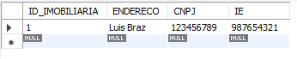

SELECT * FROM TBL_IMOVEL ORDER BY INSCRICAO_MUNICIPAL_IMOVEL;

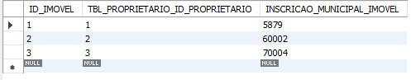

SELECT RG,CPD FROM TBL_PROPRIETARIO WHERE RG = '325587' AND CPD = '445655889';

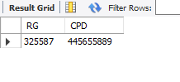

SELECT NOME_CLIENTE,CPF FROM TBL_CLIENTE WHERE NOME_CLIENTE = 'JOSÉ CLEVERTON' OR CPF = '123654777' ;

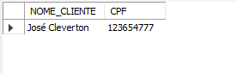

SELECT * FROM TBL_IMOVEL AS I JOIN TBL_PROPRIETARIO AS P ON I.ID_IMOVEL = P.ID_PROPRIETARIO;



SELECT * FROM TBL_CONTATO WHERE TEL1 GROUP BY TEL2;



SELECT * FROM TBL_CLIENTE ORDER BY NOME_CLIENTE DESC;

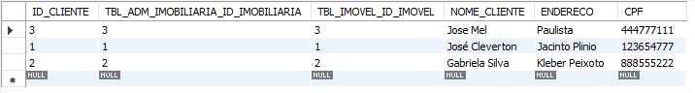

SELECT * FROM TBL_CLIENTE ORDER BY NOME_CLIENTE ASC;

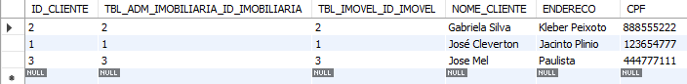

SELECT * FROM TBL_PROPRIETARIO WHERE ENDERECO LIKE 'A%';



CREATE VIEW VW_ADM_IMOBILIARIA

AS SELECT *

FROM TBL_ADM_IMOBILIARIA;

SELECT * FROM VW_ADM_IMOBILIARIA;

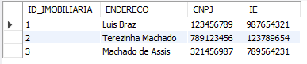

CREATE VIEW VW_IMOVEL

AS SELECT

TBL_PROPRIETARIO_ID_PROPRIETARIO,INSCRICAO_MUNICIPAL_IMOVEL

FROM TBL_IMOVEL;

SELECT * FROM VW_IMOVEL;

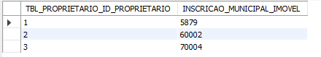

CREATE VIEW VW_CLIENTE

AS SELECT NOME_CLIENTE , CPF

FROM TBL_CLIENTE;

SELECT * FROM VW_CLIENTE;

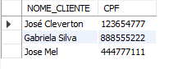

CREATE VIEW VW_CONTATO

AS SELECT TEL1

FROM TBL_CONTATO;

SELECT * FROM VW_CONTATO;

