# ConsoleOutput – Screenshots

Query-01: Show the complete product inventory with common attributes. (Print the data only for the common attributes which are there for all three product categories) ->**CRUDHelper.displayAllProducts()**  
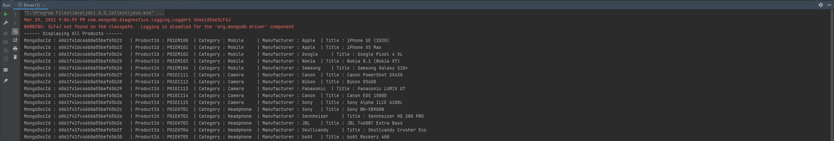

Query-02: Get the information about the first five products under the category ‘Mobiles’. -> **CRUDHelper. displayTop5Mobiles()**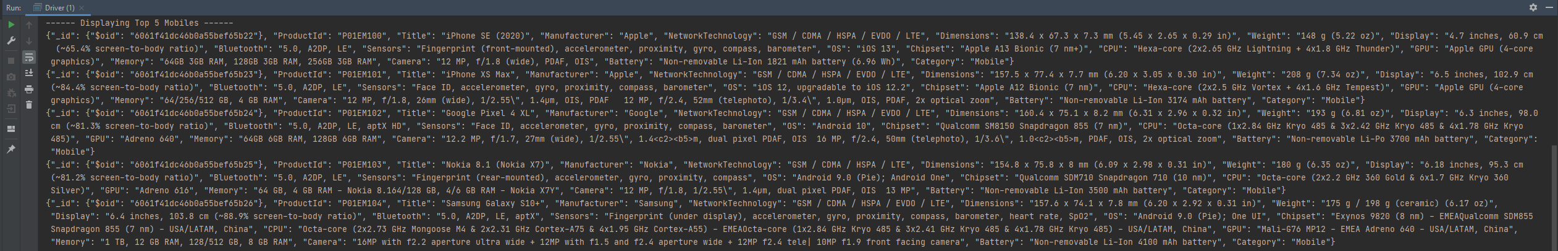

Query-03: Get the products ordered by category without their auto-generated ‘_id’ column in MongoDB. -> **CRUDHelper.displayCategoryOrderedProductsDescending()**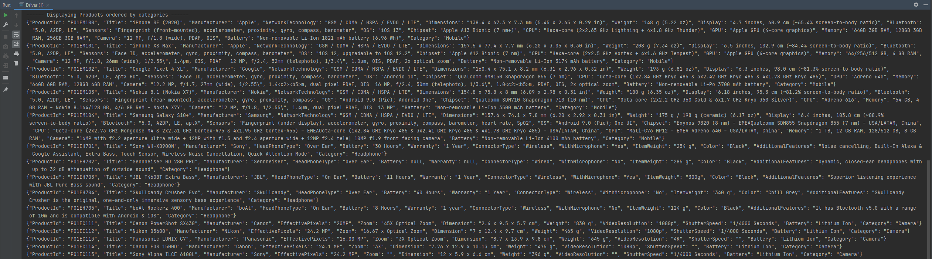

Query-04: Get the product count for every category -> **CRUDHelper.displayProductCountByCategory()**

Query-05: Get the information about all the wired headphones -> **CRUDHelper. displayWiredHeadphones()**