**DOCUMENT OF GUIDELINE FOR CONNECTING TO MEGAPAY PAYMENT GATEWAY**

Hà nội Feb-2019

# Modification history

|  |  |  |  |
| --- | --- | --- | --- |
| **Date** | **Author** | **Version** | **Content** |
| 01/12/2018 | Bùi Văn Luận | 1.0 | Create new document |
| 21/03/2019 | Nguyễn Minh Huấn | 1.1 | Modify some required/optional fields |
| 03/04/2019 | Nguyễn Minh Huấn | 1.2 | Remove the error codes which is not used |
| 05/04/2019 | Bùi Văn Luận | 1.2.1 | - Add error code OR_140, DC_122, DC_123 ,DC_124, DC_125, VA_112, VA_113  - Remove param: encodeKey |
| 16/04/2019 | Bùi Văn Luận | 1.2.2 | - Add failure error code: PG_ER2, PG_ER3, PG_ER4, PG_ER5  - Input field named “description” for mandatory in payment message |
| 18/04/2019 | Nguyễn Minh Huấn | 1.2.2 | Change userIP from optional status to mandatory status |
| 16/05/2019 | Bùi Văn Luận | 1.2.3 | - Change from **Mandatory** to option: buyerCountry, buyerCity, buyerAddr  - Add error code: OR_147 – description is invalid |
| 23/05/2019 | Bùi Văn Luận | 1.2.3 | Description Virtual Account payment method |
| 11/06/2019 | Bùi Văn Luận | 1.2.4 | Add more error code (PG_ER7 - PG_ER30) |

# Table of contents

1 Modification history 2

2 Table of contents 3

3 Test system’s information 4

3.1 Test server’s information 4

3.2 Test information 4

3.2.1 Merchant’s information 4

3.2.2 Testing card list 4

4 Payment 4

4.1 Request 4

4.2 Response 10

4.2.1 Redirect 10

4.2.2 Send notification to Merchant via API (IPN - Instant Payment Notification) 12

5 Pay by dedicated account: 14

6 Refund transaction 15

6.1 Request 15

6.2 Response 16

7 Inquiry transaction’s information 17

7.1 Request 17

7.2 Response 17

8 Appendix 19

8.1 Payment method list 19

8.2 Error code list 19

9 Payment screen 25

9.1 Payment screen 25

9.2 Select a bank 26

9.3 Input card information 26

# Test system’s information

## Test server’s information

Link:

<http://sanbox.megapay.vn:2710/pg_was/js/payment/layer/paymentClient.js>

<http://sanbox.megapay.vn:2710/pg_was/css/payment/layer/paymentClient.css>

## Test information

### Merchant’s information

* Merchant ID (merId): EPAY000001
* Checksum key (encodeKey): rf8whwaejNhJiQG2bsFubSzccfRc/iRYyGUn6SPmT6y/L7A2XABbu9y4GvCoSTOTpvJykFi6b1G0crU8et2O0Q==

### Testing card list

|  |  |  |  |  |
| --- | --- | --- | --- | --- |
| **Bank** | **Card number** | **Card holder** | **Effective /Expried date** | **OTP/CVV** |
| **BIDV** | 9704 0000 0000 0018 | NGUYEN VAN A | 03/07 | Otp |
| **BIDV** | 9704 0200 0000 0018 | NGUYEN VAN A | 03/07 |  |
| **AB Bank** | 9704250000000001 | NGUYEN HONG NHUNG | 12/08 | 123456 |
| **Visa card** | 4000 0000 0000 0002 |  | 11/22 | 123 |
| **NCB** | 9704198526191432198 | NGUYEN VAN A | 07/15 | 123456 |

# Payment

## Request

Merchant use javascript file provided by EPAY to build HTML page as the example below:

**Step 1:** Build a form base on the list of Megapay’s parameters

*Note: Form’s properties must be exactly as this: id =”megapayForm” name = “megapayForm” method = “POST”*

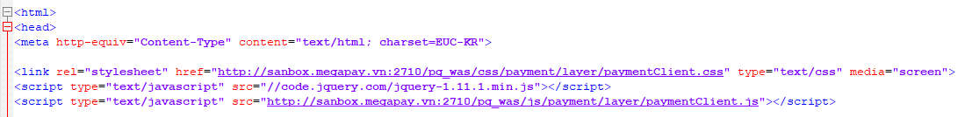

**Step 2:** Initiate payment page

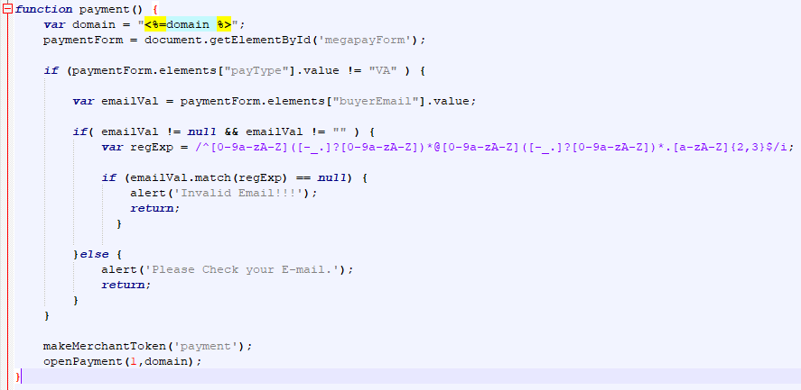

*Note: Please refer to sample code for detail*

**List of parametes:**

|  |  |  |  |
| --- | --- | --- | --- |
| **Field name** | **Description** | **Required** | **Datatype** |
| merId | Unique ID for Merchant  Sample: [String] "MEGAPAYTES" | Yes | String(10) - Fixed |
| currency | Currency of each country Only allow “VND” now | Yes | String(3) – Fixed |
| amount | Amount of money for payment  Note: amount = goodsAmount + userFee  Sample: [String] “500000” | Yes | String (12) |
| invoiceNo | Order code | Yes | String (40) |
| goodsNm | Good’s name | Yes | String(200) |
| payType | Payment method:   * **IC** : Credit card (Visa/master/JCB…) * **DC** : Domestic card (ATM) * **VA** : Virtual Account. * **NO**: Don’t select payment method **(Users will select when entering megapay’s payment page)** | Yes | String(2) |
| buyerFirstNm | Buyer’s first name   * Pay by credit card (IC): **Required** * Pay by ATM and Virtual account: Optional   Note: Including symbol “_” is not allowed | No | String(30) |
| buyerLastNm | Buyer’s last name   * Pay by credit card (IC): **Required** * Pay by ATM and Virtual account: Optional   Note: Including symbol “_” is not allowed | No | String(30) |
| buyerPhone | Buyer’s phone number | No | String(15) |
| buyerEmail | Buyer’s Email   * Pay by credit card (IC): **Required** * Pay by ATM and Virtual account: Optional | Yes | String(40) |
| buyerAddr | Buyer’s address | No | String(60) |
| buyerCity | Buyer’s city | No | String(50) |
| buyerState | Buyer’s state  This field is **mandatory** in case of the country which was sent by merchant (buyerCountry) is United State (US) or Canada (CA)   * State/District code of United State and Canada referenced by the list below: http://apps.cybersource.com/library/documentation/sbc/quickref/states_and_provinces.pdf | No | String(20) |
| buyerPostCd | Buyer’s post code  This field is mandatory in case of the country which was sent by merchant (buyerCountry) is United State (US) or Canada (CA):  When the billing country is the U.S., the 9-digit postal code must follow this format: [5 digits][dash][4 digits]  **Example** 12345-6789  When the billing country is Canada, the 6-digit postal code must follow this format: [alpha][numeric][alpha][space]  [numeric][alpha][numeric]  **Example** A1B 2C3  For the rest of the world countries, the maximum length is 10. | No | AlphaNumberic (10) |
| buyerCountry | Buyer’s country  List of country code referenced by the link below: http://apps.cybersource.com/library/documentation/sbc/quickref/countries_alpha_list.pdf | No | String(2) |
| receiverLastNm | Receiver’s last name | No | String(30) |
| receiverFirstNm | Receiver’s first name | No | String(30) |
| receiverPhone | Receiver’s phone number | No | String(15) |
| receiverAddr | Receiver’s address | No | String(100) |
| receiverCity | Receiver’s city | No | String(50) |
| receiverState | Receiver’s district | No | String(50) |
| receiverPostCd | Receiver’s post code | No | String(10) |
| receiverCountry | Receiver’s country | No | String(10) |
| callBackUrl | This url will receive the payment result from megapay (by redirecting) | Yes | String(255) |
| notiUrl | URL IPN receive the payment result from megapay (by http post) | Yes | String(255) |
| reqDomain | Merchant’s website | Yes | String(255) |
| vat | VAT tax  If there are no tax, vat = 0 | Yes | Number(12) |
| fee | Transaction fee  If there are no fee, fee = 0 | Yes | Number(12) |
| notax | Merchant’s tax number | Yes | Number(12) |
| description | Note information  Without diacritical marks (Vietnamese character) | Yes | String(100) |
| merchantToken | Merchant’s signature: it was used to authenticate merchant’s transaction.  Generated by this formula: Sha256(timeStamp + merTrxId + merId + amount + encodeKey) | Yes | String(255) |
| reqServerIP | Merchant’s server IP | No | String(15) |
| reqClientVer | Required version client | No | String(50) |
| userIP | User’s IP | Yes | String(15) |
| userSessionID | User’s ID Session | No | String(100) |
| userAgent | User’s agent | No | String (100) |
| userLanguage | User’s language. For default: “VN”  Sample: VN, EN, KR | Yes | String(2) |
| timeStamp | timeStamp  Format: yyyyMMddHHmmss | Yes | String(13) |
| domesticToken | Use for tokenization | No | String(100) |
| userId | Use for tokenization | No | String(40) |
| instmntType | Not used | No | String(2) |
| instmntMon | Not used | No | String(2) |
| merTrxId | Unique transaction ID generated by merchant (This trans ID will be used for inquiry transaction function)  Format: merId + unique number | Yes | String(50) |
| userFee | User’s fee. If there are no fee apply to customers, the user fee will be 0 | Yes | String(12) |
| goodsAmount | Good’s price, the price equal 0 for default | Yes | String(12) |
| windowColor | The color of the payment page (refer to the color table in the link below: https://html-color-codes.info/) Default “#ef5459” | Yes | String(7) |
| windowType | Merchant’s device type  0 : PC, 1: Mobile | Yes | String(2) |
| vaStartDt | Virtual account’s effective date (YYYYMMDDHHMMSS)  Sample: 20190101000000   * Pay by credit card (IC) and ATM card (DC): Optional * Pay by virtual account: Required | No | String(14) |
| vaEndDt | Virtual account’s end date (YYYYMMDDHHMMSS)  Sample: 20190201235959   * Pay by credit card (IC) and ATM card (DC): Optional * Pay by virtual account: Required | No | String(14) |
| vaCondition | Conditions to receive money when paying with Virtual Account  01 : no condition 02 : request amount >= “amount” 03 : request amount == “amount” 04 : request amount <= “amount”  Default: 03 – Always have to deposit the Virtual account with the amount of money equal to the invoice’s amount of money.   * Pay by credit card (IC) and ATM card (DC): Optional * Pay by Virtual account: Required | No | String(2) |
| mer_temp01 | Temporary field with additional requirements of Merchant | No | String |
| mer_temp02 | Temporary field with additional requirements of Merchant | No | String |

## Response

|  |  |
| --- | --- |
| Káº¿t quáº£ hÃ¬nh áº£nh cho warning icon | **Special note:** In case of payment with Virtual Account, the result is only map a virtual account number into an invoice successfully, Customers have to deposit the money into the virtual account if they want to pay (via Internet banking, Mobile banking, Bank office).  When customers deposit the money into virtual account, MegaPay will return the result of payment transaction to merchant via IPN. |

After completing the payment steps, MegaPay will return the result to merchant by 2 ways simultaneously:

### Redirect

Megapay will redirect the result to the url which was sent by merchant in the parameter named callBackUrl. No matter transaction is successful or failed, Megapay is always redirect to this call back page.

URL string for redirecting has format as below:

<http://merchant_website/sampleMerchant.do?trxId=EPAYABC111DC201902281754556976&merId=EPAYABC111&merTrxId=EPAYABC1112822019175548Jlb5Vp&resultCd=00_000&resultMsg=SUCCESS&invoiceNo=OrdNo20191175544839&amount=10000&currency=VND&goodsNm=T-1000&payType=DC&domesticToken=&merchantToken=7fa84f814b3098013be6824dec5f67161fe3ea7ededf7c23903d14020051f68f&transDt=20190228&transTm=175455&buyerFirstNm=John&buyerLastNm=Doe&timeStamp=1551351348720&instmntType=1&instmntMon=1&vaNumber=&vaName=&bankId=SML&bankName=SML&cardNo=970400xxxxxx0018>

**List of parameters:**

|  |  |  |  |
| --- | --- | --- | --- |
| **Field name** | **Description** | **Required** | **Data type** |
| trxId | Transaction code generated by MegaPay | Yes | String(30) |
| merId | Merchant ID on MegaPay system | Yes | String(10) |
| merTrxId | Transaction ID generated by Merchant | Yes | String(50) |
| resultCd | Transaction’s result (refer to error code table) | Yes | String(6) |
| invoiceNo | Order code | Yes | String(40) |
| amount | Amount of payment | Yes | String(12) |
| currency | Currency of each country | Yes | String(3) |
| goodsNm | Good’s name | No | String(200) |
| payType | Payment method information   * DC: Pay by ATM card * IC: Pay by credit card (Visa/master/JCB/,…) * V.A: Pay by Virtual Account | Yes | String(2) |
| domesticToken | Don’t use | No | String(100) |
| merchantToken | Sha256(timeStamp + merTrxId + trxId + merId + amount + encodeKey) | Yes | String(255) |
| transDt | Transaction date | Yes | String(8) |
| transTm | Transaction time | Yes | String(6) |
| buyerFirstNm | Buyer’s first name | No | String(30) |
| buyerLastNm | Buyer’s last name | No | String(30) |
| timeStamp | timeStamp | Yes | String(13) |
| instmntType | Don’t use | No | String(2) |
| instmntMon | Don’t use | No | String(2) |
| cardNo | Card no Sample: ATM: 970400xxxxxx0018  Visa/master/JCB: xxxxxxxxxxxx0002 | No | String(20) |
| bankId | Bank ID | No | String(10) |
| bankName | Bank name | No | String(200) |
| vaNumber | Virtual account number: only Virtual account payment transaction | No | String(30) |
| vaName | Virtual account name: only Virtual account payment transaction | No | String(200) |
| mer_temp01 | Temporary field with additional requirements of Merchant 1 | No | String |
| mer_temp02 | Temporary field with additional requirements of Merchant 2 | No | String |
| startDt | V.A effective date (only Virtual account transaction) | No | String(14) |
| endDt | V.A expire date (only Virtual account transaction) | No | String(14) |

### Send notification to Merchant via API (IPN - Instant Payment Notification)

When the payment transaction is successful, Megapay will return the result to merchant by Call Back link and Notify link simultaneously, these links will be sent to Megapay by Merchant in the payment request (Parameters named callBackUrl and notiUrl)

Method: POST

Data type: Json/application

|  |  |  |  |
| --- | --- | --- | --- |
| **Field name** | **Description** | **Required** | **Data type** |
| merId | Merchant ID | Yes | String(10) |
| trxId | Transaction code generated by MegaPay | Yes | String(30) |
| invoiceNo | Order code generated by Merchant |  |  |
| amount | Amount of payment | Yes | String(12) |
| bankId | Bank code | Yes | String(4) |
| status | Transaction status:  0: Paid  1: Void  2: Refund | Yes | String(1) |
| cardNo | Card no Sample: ATM: 970400xxxxxx0018  Visa/master/JCB: xxxxxxxxxxxx0002 | Yes | String(20) |
| currency | Currency | Yes | String(3) |
| instmntMon | Don’t use | No | String(2) |
| instmntType | Don’t use | No | String(2) |
| goodsNm | Good’s name | Yes | String(200) |
| buyerFirstNm | Buyer’s first name | Yes | String(30) |
| buyerLastNm | Buyer’s last name | Yes | String(30) |
| payType | Payment method information   * DC: Pay by ATM card * IC: Pay by credit card (Visa/master/JCB/,…) * VA: Pay by Virtual Account | Yes | String(2) |
| trxDt | Transaction date (yyyymmdd) | Yes | String(8) |
| trxTm | Transaction time | Yes | String(6) |
| timeStamp | Time stamp |  |  |
| merTrxId | Transaction code sent by Merchant | Yes | String(50) |
| merchantToken | Sha256(timeStamp + merTrxId + trxId + merId + amount + encodeKey) | Yes | String(255) |
| startDt | Effective date V.A (only Virtual account transaction) | No | String(14) |
| endDt | Expire date V.A (only Virtual account transaction) | No | String(14) |
| vaName | Virtual Account name (only Virtual account transaction) | No | String(50) |
| vaNumber | Virtual account number | No | String(30) |

# Pay by dedicated account:

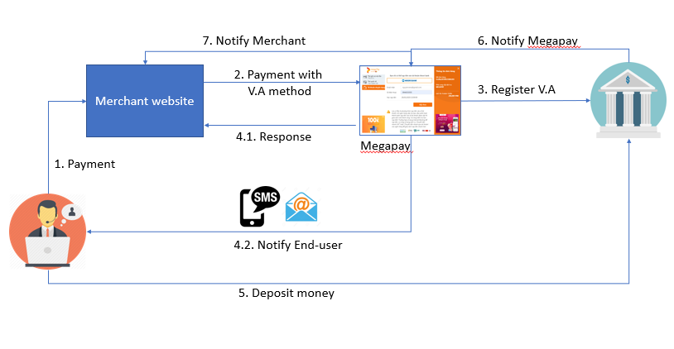

|  |  |
| --- | --- |
| **Step** | **Description** |
| 1 | Customer selects goods which are need to be paid on the Merchant’s page and click “Payment” |
| 2 | Customer chooses payment method named “Dedicated account” (pay by dedicated account) |
| 3 | Epay connects to bank to assign a dedicated account for an order code |
| 4.1 | Megapay return the result of payment made by dedicated account to merchant by redirecting to merchant’s page, merchant displays the result of payment for end-user (Main informations: Dedicated account number, Account name, Amount of money End-user have to charge, order code)   |  |  | | --- | --- | | HÃ¬nh áº£nh cÃ³ liÃªn quan | Notes: In this step, Megapay just assign a dedicated account for the order, the returned result is “Successful” it’s mean assigned successful, it’s not mean the order has paid already,  **Merchant don’t give goods or service to end-user in this step** | |
| 4.2 | Megapay also send SMS and Email to End-user simultaneously (Main info: Dedicated account number, account name, amount of money end-user have to charge, order code)  *Sending SMS and Email can be either enable or disable depend on merchant’s demand* |
| 5 | After receiving dedicated account number, amount of money need to charged in step 4, end-user perform to charge the money in the dedicated account (by the following methods: charge at bank cashier, transfer money to dedicated account) |
| 6 | When dedicated account was charged, Bank will notify for Megapay: Dedicated account has charged already, amount of money which was charged by customer |
| 7 | MegaPay get the order informations base on the assigned information between order code – dedicated account number. Megapay notify for merchant via API notify (IPN – descripted in step 4.2.2)  And now, Merchant give goods – service to end-user |

|  |  |
| --- | --- |
| HÃ¬nh áº£nh cÃ³ liÃªn quan | Note: Dedicated account number is used just 1 time; Customer don’t charge twice times in the same dedicated account to pay |

# Refund transaction

|  |  |
| --- | --- |
| Káº¿t quáº£ hÃ¬nh áº£nh cho warning icon | This function doesn’t apply for Virtual Account |

URL: <http://sanbox.megapay.vn:2710/pg_was/cancel/paymentCancel.do>

## Request

|  |  |  |  |
| --- | --- | --- | --- |
| **Field name** | **Description** | **Required** | **Data type** |
| trxId | Unique ID for transaction | Yes | String(30) |
| merId | Unique ID for Merchant | Yes | String(10) |
| merTrxId | Transaction code generated by merchant | Yes | String(50) |
| amount | Amount of money need to refund. Amount of refund must less than or equal to amount of payment.  Merchant is allowed to refund multiple times so that total amount of refund is not greater than total amount of payment. | Yes | String(12) |
| payType | Payment method:  - IC : Pay by Credit Card (Visa/master/JCB,…)  - DC : Pay by ATM  **Note: Virtual account payment method is not allowed to cancel** | Yes | String(2) |
| cancelMsg | The reason of canceling transaction | No | String(100) |
| timeStamp | timeStamp | Yes | String(13) |
| fee | Canceling transaction fee | No | String(12) |
| vat | Vat tax | No | String(12) |
| notax | No Tax Amount | No | String(12) |
| cancelServiceIp | IP of canceling server | No | String(15) |
| cancelUserId | ID of canceling user | No | String(30) |
| cancelUserIp | IP of canceling user | No | String(15) |
| cancelUserInfo | Information of canceling user | No | String(100) |
| merchantToken | Sha256(timeStamp + merTrxId + trxId + merId + amount + encodeKey) | Yes | String(255) |
| cancelPw | Merchant’s canceling password (encoded) | Yes | String(255) |

## Response

|  |  |  |  |
| --- | --- | --- | --- |
| **Field name** | **Description** | **Required** | **Data type** |
| lenght | Length of returned json string (Merchant don’t need this parameter) | Yes | String |
| payMessage | Define type of refund transaction in MegaPay system.  Refund: “CC_DCAN” | Yes |  |
| **data** | **Contain the result of refund transaction. Include data in sub json string** | | |
| trxId | Code of canceled transaction |  | String(30) |
| invoiceNo | Order code |  | String(40) |
| cancelTrxId | Code of canceling transaction (Generated by megapay) |  | String(30) |
| resultCd | Result of canceling transaction 00_000: Success Others: fail | Yes | String(6) |
| resultMsg | Message result of canceling transaction | No | String(100) |
| trxDt | Transaction date yyyymmdd | No | String(8) |
| trxTm | Transaction time  hh24miss | No | String(6) |
| description | Description | No | String(100) |
| amount | Refunded amount after canceling transaction | No | String(12) |
| merTrxId | Transaction code generated by Merchant | No | String(50) |
| merchantToken |  | No | String(255) |
| payMessage | CC_DCAN | Yes | String(7) |

**Message template**

* ***Refund success:***

{"length":"0439","payMessage":"CC_DCAN","payData":{"trxId":"EPAYABC111DC201903081126487197","invoiceNo":"OrdNo20192112832525","cancelTrxId":"EPAYABC111DC201903081128447198","resultCd":"00_000","resultMsg":"SUCCESS","trxDt":"20190308","trxTm":"112648","description":"payment","amount":"10000","merchantToken":"e42ccf1004d58e4fa4b54c227d5af8f41021f21d6959eb70812843b50bfd84af","merTrxId":"EPAYABC111832019112838wLS8LV","payMessage":"CC_DCAN"}}

* ***Refund fail:***

{"length":"0296","payMessage":"CC_DCAN","payData":{"trxId":null,"invoiceNo":null,"cancelTrxId":null,"resultCd":"CC_113","resultMsg":"Cancel Ledger duplicate registration error.","trxDt":null,"trxTm":null,"description":null,"amount":null,"merchantToken":null,"merTrxId":null,"payMessage":"CC_DCAN"}}

# Inquiry transaction’s information

## Request

API URL: <http://sanbox.megapay.vn:2710/pg_was/order/trxStatus.do>

Passed data: HTML request, Method = POST

List of parameter:

|  |  |  |  |
| --- | --- | --- | --- |
| **Field name** | **Description** | **Required** | **Data type** |
| merId | Merchant code in MegaPay system | Yes | String(10) |
| merTrxId | Transaction code of merchant, used to inquiry transaction’s information | Yes | String(50) |
| merchantToken | Check sum data: SHA256(timeStamp + merTrxId + merId + encodeKey) | Yes | String(255) |
| timeStamp | timeStamp | Yes | String(13) |

**Template of request:**

merId=EPAYABC111&merTrxId=EPAYABC111132019164952H5zcz0&merchantToken=d0c6e1ac9a18e2f9cb7b92115a0f2871fd415dc05fda0f94d0d341a68a6b039e&timeStamp=1551436017653

## Response

List of parameter:

|  |  |  |  |
| --- | --- | --- | --- |
| **Field name** | **Description** | **Required** | **Data type** |
| resultCd | **Result code of inquiry transaction. If result code is “00_000” (inquiry transaction is successful), we would have an additional data string which contains the information of transaction we are looking for.** | Yes | String(6) |
| **data** | **Information of transaction we are looking for** | | |
| trxId | Transaction code generated by MegaPay | Yes | String(30) |
| merId | Merchant ID | Yes | String(10) |
| currency | Currency type. Only support VND now | Yes | String(3) |
| amount | Amount of payment | Yes | String(12) |
| invoiceNo | Order code | Yes | String(40) |
| goodsNm | Good’s name | Yes |  |
| payType | Payment method: IC : Credit Card (Visa/master/JCB…) DC : ATM card VA : Virtual Account. | Yes | String(2) |
| buyerFirstNm | Buyer’s first name | Yes | String(30) |
| buyerLastNm | Buyer’s last name | Yes | String(30) |
| buyerPhone | Buyer’s phone | No | String(15) |
| buyerEmail | Buyer’s email | No | String(40) |
| resultCd | Result of payment transaction - 00_000: Success - Others: Fail | Yes | String(6) |
| resultMsg | Message – Corresspond to resultCd | Yes | String(200) |
| status | Transaction’s status - 0: Paid transaction - 1: Canceled transaction (Void) (Only apply for credit card Visa/Master/JCB,…) - 2: Refunded (Refund), có thể đã hoàn hết hoặc hoàn 1 phần số tiền thanh toán | Yes | String(1) |
| bankId | Bank code | Yes | String(10) |
| cardNo | Card no | Yes | String(20) |
| trxDt | Transaction date | Yes | String(8) |
| trxTm | Transaction time | Yes | String(6) |
| cancelDt | Refund date (Only refunded transaction) | No | String(8) |
| cancelTm | Refund time (Only refunded transaction) | No | String(6) |
| payMessage | Default value is “TX_CHK” | Yes | String |
| merTrxId | Transaction code generated by Merchant | Yes | String(50) |
| vaNumber | V.A number (Only Virtual account transaction) | No | String(30) |
| startDt | Effective date V.A (Only Virtual account transaction) | No | String(14) |
| endDt | Expire date V.A (Only Virtual account transaction) | No | String(14) |
| vaName | Virtual Account name (Only Virtual account transaction) | No | String(50) |
| remainAmount | Remain amount.  In case of partial refund, this amount will be the remaining amount after partial refund  In case of transaction haven’t refunded yet, the remaining amount will equal the transaction amount | Yes | String(12) |

**Json string template**

* Inquiry success:

|  |  |
| --- | --- |
| The original transactions have been refunded already | {"resultCd":"00_000","data":{"trxId":"EPAY000001DC201904100948118393","merId":"EPAY000001","currency":"VND","amount":"5000000","invoiceNo":"OrdNo20190410044956","goodsNm":"5caadc1317db115bacac4ab8","payType":"DC","buyerFirstNm":"ZYOWC","buyerLastNm":"BXBWO","buyerPhone":"0932413788","buyerEmail":"thanhluan.soft@gmail.com","resultCd":"00_000","resultMsg":"refund","status":"2","bankId":"BIDM","cardNo":"970400xxxxxx0018","trxDt":"20190410","trxTm":"094903","cancelDt":"20190410","cancelTm":"095821","payMessage":"TX_CHK","merTrxId":"MGP20190410044956","vaNumber":null,"vaName":null,"startDt":null,"endDt":null,"remainAmount":"4900000"},"resultMsg":"refund"} |
| The transaction was not found | {"resultCd":"00_000","data":{"resultMsg":"Transaction does not exist","status":"OR_140","merTrxId":"MGP201904091433114234234"},"resultMsg":"paid"} |
| The original transaction has not been refunded yet | {"resultCd":"00_000","data":{"trxId":"EPAY000001DC201904111710338511","merId":"EPAY000001","currency":"VND","amount":"19000","invoiceNo":"invoiceNo_22232","goodsNm":"goodsNm_31281","payType":"DC","buyerFirstNm":"buyerFirstNm_9494","buyerLastNm":"buyerLastNm_11927","buyerPhone":"0987898767","buyerEmail":"buyerEmail_2180@email.com","resultCd":"00_000","resultMsg":"paid","status":"0","bankId":"BIDM","cardNo":"970400xxxxxx0018","trxDt":"20190411","trxTm":"171055","cancelDt":null,"cancelTm":null,"payMessage":"TX_CHK","merTrxId":"MGP20190411121224","vaNumber":null,"vaName":null,"startDt":null,"endDt":null,"remainAmount":"19000"},"resultMsg":"paid"} |

* Inquiry fail:

{"resultCd":"OR_137","resultMsg":"Check Trx Order Error."}

# Appendix

## Payment method list

|  |  |
| --- | --- |
| **Payment method name** | **Payment method code** |
| Pay by ATM card | DC |
| Pay by credit card (Visa/master/JCB…) | IC |
| Pay by Virtual Account | VA |

## Error code list

|  |  |
| --- | --- |
| **Result code** | **Cause (English)** |
| 00_000 | Successful |
| FL_900 | Connection error. |
| FL_901 | Socket connection error. |
| FL_902 | Some error happened while processing. |
| FL_903 | Socket timeout exception. |
| OR_101 | MerID is invalid or Merchant is not registered. Contact to Customer Service Center for further information. |
| OR_102 | This Payment type doesn’t exist or currently not activated. Contact Customer Service for further information. |
| OR_103 | Currency Code was undefined. Please check your request parameter and make sure [currencyCode] is defined. |
| OR_104 | buyerCity was undefined. Please check your request parameter and make sure [buyerCity] is defined. |
| OR_105 | InvoiceNo was undefined. Please check your request parameter and make sure [invoiceNo] is defined. |
| OR_106 | Goods Name was undefined or wrong format. Please check your request parameter and make sure [goodsNm] is defined. |
| OR_107 | Buyer first name or last name was undefined. Please check your request parameter and make sure [buyerFirstNm] and [buyerLastNm] is defined. |
| OR_108 | Buyer Phone Number was undefined. Please check your request parameter and make sure [buyerPhone] is defined. |
| OR_109 | Buyer Email Address was undefined. Please check your request parameter and make sure [buyerEmail] is defined correctly. |
| OR_110 | Callback URL was undefined. Please check your request parameter and make sure [callbackUrl] is defined. |
| OR_111 | Notification URL was undefined. Please check your request parameter and make sure [notiUrl] is defined. |
| OR_112 | Payment Amount is invalid. Amount should only number and do not includes decimal. |
| OR_113 | Invalid Merchant Token. Contact Customer Service for further information. |
| OR_114 | Payment Amount has to be greater than 0. Please check your request parameter and make sure [amount] is defined. |
| OR_115 | The flag field which was used to identify if a merchant will be checked duplicate order no is null. |
| OR_116 | Invoice no is duplicated |
| OR_117 | Error encountered while doing business transaction |
| OR_118 | Error because of one of the following causes:  +) Request domain was undefined  +) Total of goods amount (GoodsAmount) and merchant fee (UserFee) is not equal amount of payment (Amount)  +) MerchantId sent by merchant is null  +) MerchantId is mismatch (Inquiry transaction function) |
| OR_120 | Merchant’s status error (Merchant is not active) |
| OR_123 | Error of merchant is not defined in the system. |
| OR_124 | Merchant’s status error (Merchant is not active) |
| OR_125 | Merchant is not registered this payment method or Cybersource settle time is not defined. |
| OR_126 | PG Type is not set. |
| OR_127 | Check Merchant’s applied limit error. |
| OR_128 | Over limit amount error. |
| OR_130 | The field used to identify merchant is online or offline is not defined. Please check your request parameter and make sure [merType] is defined |
| OR_131 | This Online Merchant type is currently not activated. |
| OR_132 | This Offline Merchant type is currently not activated. |
| OR_133 | Contract’s information is not defined. |
| OR_134 | Invalid amount |
| OR_135 | Goods Amount is not defined. Please check your request parameter and make sure [goodsAmount] is defined. |
| OR_136 | User Fee is not defined. Please check your request parameter and make sure [userFee] is defined. |
| OR_140 | Transaction does not exist |
| OR_141 | Buyer address is require |
| OR_142 | Buyer state is require when buyer country is 'us' or 'ca' |
| OR_143 | Buyer country is require |
| OR_147 | description is invalid |
| DC_101 | Error ocurred while checking information sending to or receiving from NAPAS |
| DC_102 | Transaction Id is not defined |
| DC_103 | Transaction already exist. Please make new transaction. |
| DC_104 | Invoice no is null. Please make sure that [invoiceNo] was defined already |
| DC_105 | Data is null error. |
| DC_110 | Payment type is undefined. Contact Megapay for further information. |
| DC_112 | Error occurred while inserting or updating data in the tables related to ATM transaction. |
| DC_113 | Error occurred while updating email transaction. |
| DC_114 | Error when saving data into notify transaction table. |
| DC_117 | Transaction’s information haven’t registered yet. Please check again. |
| DC_119 | Server is busy. Please kindly try again in few minutes. |
| DC_120 | Payment Success but token is not created. |
| DC_122 | Partner transaction Id is null |
| DC_123 | Partner transaction Id is invalid |
| DC_124 | Invalid amount |
| DC_125 | Invalid currency |
| IC_101 | Transaction failed. Please check card information and try again. |
| IC_102 | Transaction Id is not defined |
| IC_103 | Transaction already exist. Please make new transaction. |
| IC_104 | Invoice no is undefined (null). Please check field named [invoiceNo] again |
| IC_105 | Merchant’s card information is not defined |
| IC_107 | Error occurred while connecting to CyberSource |
| IC_110 | Paytype or merchant id is missing |
| IC_112 | Error occurred while inserting data into tables related to credit card transaction |
| IC_113 | Error occurred while updating email transaction table |
| IC_115 | Invalid MID, Merchant is not registered. Contact Megapay for further information. |
| IC_117 | Transaction’s information is not registered |
| IC_121 | Merchant is inactive |
| VA_101 | Connect to VA system is fail or transaction id is not defined |
| VA_102 | VA transaction has already existed |
| VA_103 | Merchant id information is missing |
| VA_104 | Error occurred while inserting data into VA trans table |
| VA_105 | Error occurred while inserting data into trans result table. |
| VA_106 | Error occurred while searching transaction or transaction doesn’t exist |
| VA_107 | Error occurred while inserting data into merchant notification table |
| VA_109 | Condition of receiving money is wrong (should equal to 03) |
| VA_110 | Effective date is wrong |
| VA_111 | Expire date is wrong |
| VA_112 | Transaction is invalid |
| VA_113 | Can not find Bank issuing Virtual account |
| CC_101 | Transaction id is not generated. |
| CC_102 | Invalid MID or Merchant is not registered. Contact Customer Service for further information. |
| CC_109 | Merchant in the not active status |
| CC_110 | The transaction has not been registered |
| CC_111 | Error occurred when canceling amount less than or equal 0 or canceling amount not equal transaction amount (In case of comprehensive cancelation) |
| CC_112 | The transaction need to be canceled is not found. |
| CC_113 | The transaction has been canceled fully |
| CC_114 | This payment method is currently not activated with merchant or insert notification data has been failed |
| CC_115 | Merchant’s token is invalid |
| CC_116 | Canceling amount must equal payment amount. |
| CC_117 | Amount of cancelation/refunding is invalid (Format number exception) |
| CC_118 | It has been canceled. |
| CC_119 | The amount of money you entered is larger than the payment amount or the remaining payment amount is less than 0. |
| CC_121 | Error occurred when updating transaction’s information |
| CC_122 | Error occurred when inserting partial cancelation information |
| CC_124 | Error occurred when inserting data after canceling |
| CC_125 | Transaction result registration error. |
| CC_126 | Error occurred when quering data |
| CC_127 | Partial cancelation flag or status is invalid. |
| CC_128 | Cancel message is not defined |
| CC_130 | The amount of money you want to cancel is smaller than the transaction’s payment amount. |
| CC_131 | Error occurred when inserting data into cancelation transaction table |
| CC_132 | Update transaction history error. |
| CC_133 | Bank connection error. |
| CC_135 | Cancel password is mismatched. |
| CC_136 | Canceling function is unavailable with this merchant. Please Contact to Meagepay. |
| PG_ER1 | Transaction Failed. |
| PG_ER2 | Card’s information is wrong |
| PG_ER3 | Transaction is failed - Timeout |
| PG_ER4 | Transaction is failed |
| PG_ER5 | Customer canceled transaction |
| PG_ER6 | System error, please contact to Megapay’s Admin for supporting |
| PG_ER7 | Card number is invalid |
| PG_ER8 | Publish/Expire date is invalid |
| PG_ER10 | Buyer address is wrong |
| PG_ER11 | Card has not been configured Payer Authentication yet |
| PG_ER12 | Buyer last name or first name is wrong |
| PG_ER13 | Buyer city/state is wrong |
| PG_ER16 | OTP is wrong |
| PG_ER17 | Card information has not been approved yet, please contact to issuing bank to be supported |
| PG_ER18 | Card expired or locked |
| PG_ER19 | The amount of money is not enough to make a payment |
| PG_ER20 | The amount of money of transaction is not within the allowed limit |
| PG_ER21 | Card has not been activated or signed up for online payment yet |
| PG_ER22 | Card holder name is wrong |
| PG_ER23 | Issuing bank denied the transaction |
| PG_ER25 | The transaction was denied by fraud management system |
| PG_ER26 | Data is invalid or empty |
| PG_ER28 | Issuing bank is postponing this transaction. Please try again later |
| PG_ER29 | Transaction failed because customer is in black list |
| PG_ER30 | Transaction failed – Cannot authenticate the customer |

# Payment screen

## Payment screen

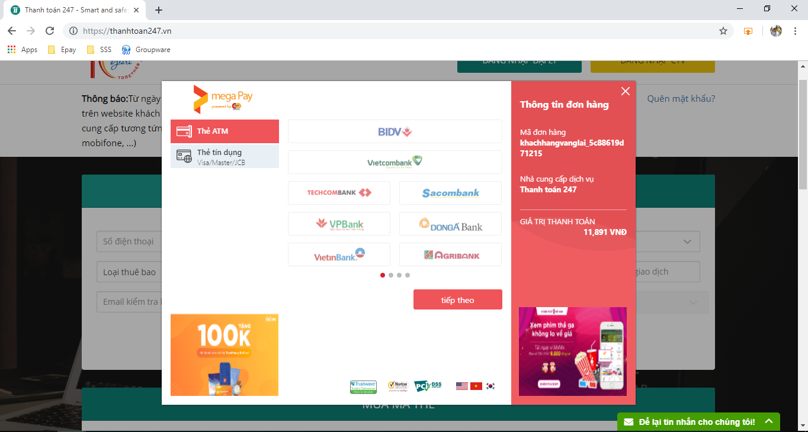

## Select a bank

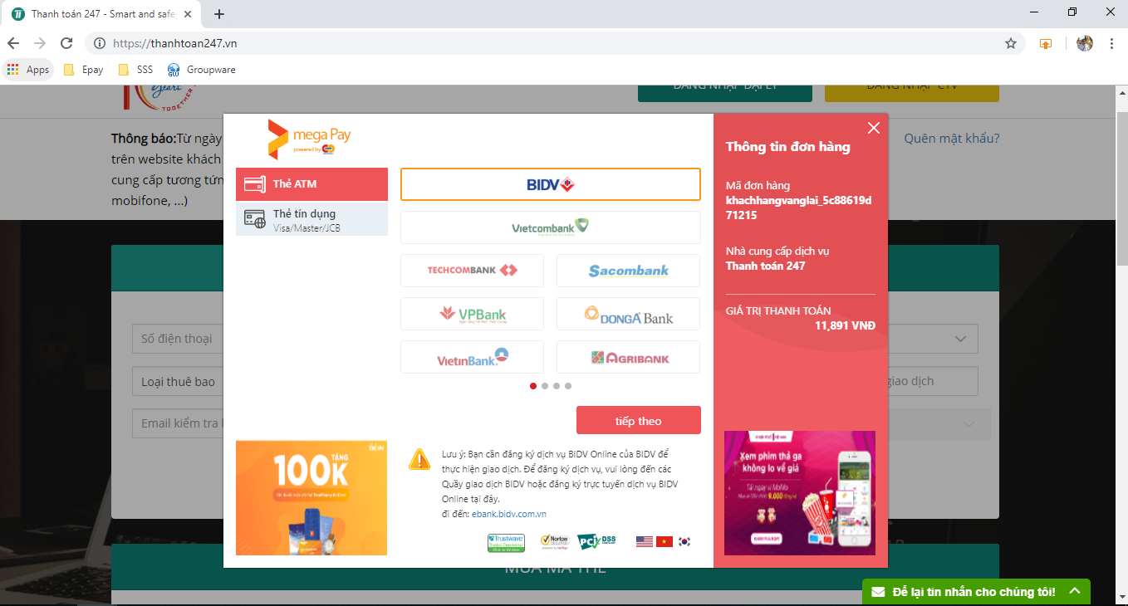

## Input card information

