

International School

Capstone Project 1
CMU-SE 450
Project Proposal
Version 1.1
Date: Sep 6th, 2026

SmartRec - Research and Development of a Multimodal AI Processing Model on Audio and Video Stream Data

Created by C1SE.15
Quyen, Nguyen Van
Khoa, Tran Huu Bach
Nam, Tran Van
Nhi, Nguyen Ngoc Yen
Minh, Tran Hong

Approved by
Mentor: Dung, Tran Thi Phuong

Proposal Review Panel Representative:

Name Signature Date

Capstone Project 1 - Mentor:

Name Signature Date

Project acronym | SmartRec
Project Title | Research and Development of a Multimodal AI Processing Model on Audio and Video Stream Data
Start Date | Aug 16th ,2026 | End Date | Dec 13th ,2026
Lead Institution | International School, Duy Tan University
Project Mentor | Dung, Tran Thi Phuong  Department: Software Development Department, MobiFone IT Center
Scrum master  / Project Leader & contact details | Quyen, Nguyen Van  Email: vanquyen102005@gmail.com  Tel: 0886506205  ID: 29219023283
Partner Organization | Duy Tan University
Project Web URL
Team members | Name | Email | Tel
29219023283 | Quyen, Nguyen Van | vanquyen102005@gmail.com | 0886506205
29211120482 | Khoa, Tran Huu Bach | tranhuubachkhoa2005@gmail.com | 0365815319
29219039167 | Nam, Tran Van | trannamqbh999@gmail.com | 0354091588
29201144438 | Nhi, Nguyen Ngoc Yen | Nhiyennguyen299@gmail.com | 0932517211
29210247142 | Minh, Tran Hong | Mt1479233@gmail.com | 0385439652
PROJECT INFORMATION
DOCUMENT APPROVALS
The following signatures are required for approval of this document.
Quyen, Nguyen Van  Student ID: 29219023283  Scrum Master | Signature | Date
Khoa, Tran Huu Bach  Student ID: 29211120482  Team Member | Signature | Date
Nam, Tran Van  Student ID: 29219039167  Team Member | Signature | Date
Nhi, Nguyen Ngoc Yen  Student ID: 29201144438  Team Member | Signature | Date
Minh, Tran Hong  Student ID: 29210247142  Team Member | Signature | Date

PROJECT PROPOSAL DOCUMENT
Document Title | Project Proposal Document
Author(s) | C1SE.15 Team
Role | Team Member, Scrum Master
Date | Sep 6th ,2026 | File name: | C1SE.15_Proposal_SmartRec_v1.1.doc

REVISION HISTORY
Version | Date | Comments | Author
1.0 | Aug 29th ,2026 | Initial Proposal Document | Van Quyen
1.1 | Sep 6th ,2026 | Complete Document | Van Quyen

TABLE OF CONTENTS
1. Project Title 5
2. Team Members 5
3. Supervisor(s) 5
4. Problem statement 5
4.1. Business Operational Bottlenecks 5
4.2. Empirical Survey 6
5. Survey & Existing Solutions 6
5.1. Solution Comparison Matrix 6
5.2. Key Innovations & Core Differentiators (SmartRec USPs) 6
6. Objectives and Scope 7
6.1. General Objective 7
6.2. Project Scope 7
6.2.1. In-Scope (12-Week MVP) 7
6.2.2. Out-of-Scope (Post-MVP) 8
7. Key Features & Requirements 8
7.1. Functional Requirements 8
7.2. Non-Functional Requirements 9
8. Constraints and Assumptions 9
8.1. Constraints 9
8.2. Assumptions 10
9. Target Users & Stakeholders 10
10. Technology Stack 11
11. Methodology and Development Plan 12
11.1. Methodology 12
11.2. Development Plan 13
11.3. Responsibilities 13
12. System Architecture Overview 14
12.1. Architectural Pattern 14
12.2. System Context Diagram 14
12.3. Logical Architecture 15
12.4. Core Workflow 15
13. Potential Risks and Mitigation Strategies 17
14. Expected Outcomes / Deliverables 19
14.1. Software Deliverables 19
14.2. Accompanying Documentation 19
14.3. Success Metrics 20
14.4. Phased Delivery Roadmap 21
15. References 21

1. Project Title
SmartRec - Research and Development of a Multimodal AI Processing Model on Audio and Video Stream Data

2. Team Members
ID Student | Name | Email | Role
29219023283 | Quyen, Nguyen Van | vanquyen102005@gmail.com | Team Leader, Fullstack dev
29211120482 | Khoa, Tran Huu Bach | tranhuubachkhoa2005@gmail.com | AI dev, Backend dev
29219039167 | Nam, Tran Van | trannamqbh999@gmail.com | Backend dev
29201144438 | Nhi, Nguyen Ngoc Yen | Nhiyennguyen299@gmail.com | Tester, Frontend dev
29210247142 | Minh, Tran Hong | Mt1479233@gmail.com | Fullstack dev

3. Supervisor(s)
- Full Name: Tran Thi Phuong Dung
- Position: Specialist
- Department: Software Development Department, MobiFone IT Center
- Academic Degree: Bachelor’s Degree
- Role: Mentor
- Email: dung.tranthiphuong@mobifone.vn
- Phone: 0799466986

4. Problem statement
4.1. Business Operational Bottlenecks
In modern corporate environments, virtual meetings (e.g., Zoom, Google Meet, MS Teams) occur continuously. However, post-meeting information processing workflows face significant operational bottlenecks:
- Human Resource Inefficiency: Employees and secretaries expend 2 to 3 hours re-listening to a 2-hour audio recording solely to manually transcribe meeting minutes.
- Operational Risks and Missed Deadlines: Manual note-taking is highly susceptible to omitting critical decisions, misallocating task ownership, or overlooking deadlines.
- Managerial Information Overload: Executive management and team leads are unable to attend all scheduled meetings and lack the time capacity to review hours of video recordings.
4.2. Empirical Survey
- An average office employee attends 62 meetings per month.
- 43% of participants admit to misinterpreting or omitting assigned tasks due to incomplete meeting minutes.
- Most foreign solutions (e.g., Otter.ai, Fireflies.ai) exhibit sub-optimal performance in processing Vietnamese speech and handling technical code-switching (e.g., deploy, fix bug, KPI, OKR).
5. Survey & Existing Solutions
5.1. Solution Comparison Matrix
Comparison Criteria | Otter.ai | Fireflies.ai | Fathom | SmartRec (Proposed)
Vietnamese Recognition & Code-Switching | Poor | Poor | Limited | Highly optimized (faster-whisper)
Summarization Context | Single generic template | Oriented towards Sales | Basic recording notes | Corporate Mode (Meeting Minutes & Action Items)
Slide Text Extraction (Video OCR) | ✗ | ✗ | ✗ | Integrated (PaddleOCR)
Interactive Timestamp Navigation | Basic | Basic | Good | Intuitive on Embedded Video Player
Security & Cost | Foreign Cloud ($10–20/mo) | Foreign Cloud ($10–19/mo) | Foreign Cloud ($19–29/mo) | On-Premise / Optimized Cost
5.2. Key Innovations & Core Differentiators (SmartRec USPs)
- Vietnamese Speech & Code-Switching Optimization: Accurately processes Vietnamese speech intermixed with English technical jargon (e.g., deploy, fix bug, KPI) via fine-tuned Automatic Speech Recognition (ASR) models.
- Summarization & Custom Report Generation (Smart Exporter): Extracts Executive Summaries and Task Matrices while enabling data mapping into enterprise-specific templates (.docx) using customizable AI prompts.
- Multimodal Processing: Synthesizes audio AI (Audio STT) and visual AI (Video OCR) to extract text, tables, and diagrams directly from presentation slides and screen shares.
- Interactive Timestamp Navigation: Clicking any summary item or task entry automatically seeks the video player to the corresponding utterance timestamp.
6. Objectives and Scope
6.1. General Objective
To develop the SmartRec web platform to automate the end-to-end post-meeting processing workflow for enterprises—ranging from meeting audio/video transcription (STT), speaker diarization, and slide/screen-share OCR, to the extraction of Executive Summaries and Task Assignment Matrices.
6.2. Project Scope
6.2.1. In-Scope (12-Week MVP)
- File Management & Ingestion: Ingestion of meeting audio/video recordings (.mp4, .mkv, .mp3) up to 2 GB in file size and 2 hours in duration.
- Asynchronous AI Processing Pipeline:
  - Audio noise suppression for conference environments using WebRTC.
  - Speaker diarization using pyannote-audio.
  - Vietnamese speech-to-text conversion with code-switching support using faster-whisper.
  - Optical Character Recognition (OCR) for extracting text, tables, and diagrams from slides/screen shares using PaddleOCR.
  - Enterprise contextual summarization: Generating Executive Summaries and Task Assignment Matrices (Task – Assignee – Deadline) via the Google Gemini 1.5 Flash API.
- User Interface & Interaction: Embedded video player featuring interactive timestamp navigation (clicking a task or text segment instantly seeks to the corresponding video timestamp).
- Review & Export Mechanisms: Allows manual verification and editing of AI-generated outputs prior to exporting to Word (.docx), PDF (.pdf), or JSON/CSV formats formatted for seamless ingestion into Trello/Jira.
6.2.2. Out-of-Scope (Post-MVP)
- Real-time stream processing and automated virtual bots for joining live meeting rooms.
- Retrieval-Augmented Generation (RAG) chatbot for conversational video Q&A (Ask-AI) and global semantic search capabilities.
- Direct API integration (Direct Sync) with Trello, Jira, and Google Calendar.
- Educational modules, including lecture processing, automated quiz generation, and flashcards.
7. Key Features & Requirements
7.1. Functional Requirements
FR Code | Module | Concise Functional Requirement Description
FR-01 | File Management & Large File Processing | User registration/login; meeting file upload (.mp4, .mp3). Automated audio compression; supports chunked uploading & audio slicing (chunking) for large files (2–4 hours); hard limit of 4 hours.
FR-02 | Audio Noise Reduction | Environmental noise suppression and microphone echo cancellation via WebRTC Audio Processing.
FR-03 | Vietnamese STT | Converts Vietnamese speech to text with timestamps; accurately recognizes technical English terminology (code-switching).
FR-04 | Speaker Diarization | Identifies and labels individual speakers within the meeting (e.g., Speaker 1, Speaker 2).
FR-05 | Video & Screen OCR | Keyframe extraction and Optical Character Recognition (OCR) to read text, numerical KPI metrics, and structural diagrams from presentation slides or screen shares.
FR-06 | Corporate Summarization | Extracts Executive Summaries (3-minute meeting summaries) and Task Assignment Matrices (Task – Assignee – Deadline).
FR-07 | Interactive Player | Clicking any task or summary entry automatically seeks the video player to the corresponding utterance timestamp.
FR-08 | Review & Edit Task | User interface enabling manual verification and editing of summaries, assignees, and deadlines prior to export.
FR-09 | Smart Custom Exporter | Automatically maps data into enterprise Word templates (.docx) via customizable AI prompts/checklists, or exports artifacts (.pdf, .json, .csv) for Trello/Jira integration.

7.2. Non-Functional Requirements
Criteria | Specific Metrics / Requirements
Processing Performance | Asynchronous queuing via Celery + Redis; processing latency for a 1-hour video does not exceed 5–7 minutes; non-blocking HTTP interface.
AI Accuracy | Word Error Rate WER < 15%; Diarization Error Rate DER < 15% on Vietnamese evaluation datasets containing English code-switching.
Security & Authorization | Secure file storage encryption; role-based data authorization for individual user accounts or internal organization scopes.
Scalability | Decoupled microservices architecture enabling independent horizontal scaling of AI Worker containers under increased processing loads.
Interface & Compatibility | Modern responsive web UI; full support for input formats (.mp4, .mkv, .mp3) and export formats (.docx, .pdf, .json, .csv).
8. Constraints and Assumptions
8.1. Constraints
Category | Technical & Business Constraints | Acceptance Criteria
Timeline | • Fixed 3-month timeframe (12 weeks).  • Implemented via Agile/Scrum spanning 6 Sprints (2 weeks/Sprint). | • 100% completion of Sprint Backlog according to schedule.  • Progress delays must be reported and replanned immediately during Sprint Retrospectives.
Tech Stack | • Core Backend: Java 17, Spring Boot 3.x.  • AI Microservice: Python 3.10, FastAPI.  • Task Queue: Celery + Redis Broker.  • AI Models: faster-whisper, pyannote-audio, PaddleOCR, Gemini 1.5 Flash API. | • Environment containerization via Docker Compose.  • Dependency version locking to prevent unauthorized external library changes.
Hardware | • GPU-equipped Server/VPS (VRAM) for AI Workers.  • Independent development and testing environments. | • Stable AI services without VRAM Out-Of-Memory (OOM) crashes during video processing.  • Pre-configured failover/recovery (backup/restart) mechanisms for each container service.
Budget | • Strictly bounded within the capstone project budget. | • Prioritize leveraging Free/Standard Tiers (Gemini API, Vercel).  • Strict Cloud VPS resource management to eliminate unexpected budget overruns.
8.2. Assumptions
- Network Infrastructure: It is assumed that users operate the application in an environment with stable Internet connectivity to facilitate video file uploads and receive API responses.
- Input Quality: Input audio/video recordings are assumed to maintain acceptable acoustic quality (i.e., devoid of severe distortion or static noise, with adequate vocal clarity).
- Third-Party Services: It is assumed that third-party dependencies—specifically the Google Gemini API and underlying open-source libraries—maintain high availability and undergo no abrupt modifications to their usage policies throughout the project lifecycle.
9. Target Users & Stakeholders
Stakeholder Group | Persona | Core Pain Point | Solution & Delivered Value (SmartRec MVP)
Enterprise Operations | Persona 1: Secretary / PM / Project Coordinator | Expends 2–3 hours re-listening to meeting recordings to manually transcribe minutes; prone to omitting tasks or misinterpreting deadlines. | Automated transcription; automated task extraction (Task – Assignee – Deadline); structured JSON/CSV export for direct import into Trello/Jira.
Management & Leadership | Persona 2: Team Lead / Manager / C-Level | Dense meeting schedules prevent attendance at all sessions; lacks time capacity to review 2-hour long video recordings. | Concise 3-minute Executive Summaries; interactive timestamp navigation to skip directly to original key statements.
10. Technology Stack
Layer | Selected Technology | Role & Functionality in SmartRec Enterprise
Frontend | ReactJS, TailwindCSS, Video.js | Single Page Application (SPA) dashboard; interactive video playback with timestamp seeking.
Core Backend | Java 17, Spring Boot 3.x | API Gateway; business logic management; JWT authentication; PostgreSQL & Word/PDF document generation.
AI Microservice | Python 3.10, FastAPI | Dedicated microservice for asynchronous ingestion and inference execution of AI models.
Task Queue | Celery + Redis | Coordinates background asynchronous worker processes for intensive video handling.
Audio AI | WebRTC, pyannote-audio, faster-whisper | Noise suppression; speaker diarization; Vietnamese Speech-to-Text (STT) transcription.
Vision AI | PaddleOCR | Optical Character Recognition for text, numerical KPIs, and structural diagrams on slides/screen shares.
NLP & LLM | Gemini 1.5 Flash API, LangChain | Contextual summarization for Executive Summaries and task extraction matrices.
Database/Storage | PostgreSQL, MinIO | PostgreSQL persists system metadata & task entries; MinIO stores raw video/audio media and slide images.
DevOps & Tooling
- Deployment: Docker & Docker Compose (environment containerization); Vercel (frontend hosting); Cloud GPU VPS (hosting AI services and background workers).
- Management & Testing: Figma (UI/UX design), GitHub (source code management), Trello/Jira (Scrum progress tracking), Postman/Swagger UI (API testing and documentation).

11. Methodology and Development Plan
11.1. Methodology
- The project adopts an Agile software development methodology utilizing the Scrum framework, constructing the SMARTREC platform through iterative Sprints. The project lifecycle is partitioned into six Sprints, with each Sprint spanning precisely two weeks to ensure continuous feedback loops and adaptive development capability. Functional software increments are evaluated at the conclusion of each Sprint to facilitate timely operational adjustments.
- The system architecture leverages a microservices model, employing Java (Spring Boot) for core backend orchestration and API management, Python (FastAPI) integrated with Celery and Redis for high-performance asynchronous AI processing, and ReactJS to build a responsive front-end interface embedded with an interactive video player.
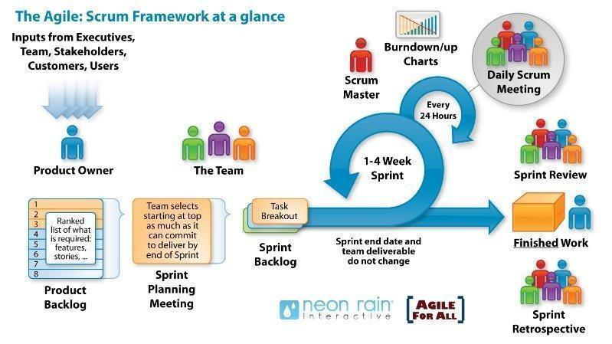
- Scrum is grounded in empirical process control mechanisms and feedback loops. By segmenting the 3-month project roadmap into manageable 2-week iterations, the development team can independently test and validate the Audio/Vision AI pipelines, Natural Language Processing (NLP) extraction workflows, and user interface components prior to full end-to-end system integration.

Imange: Scrum Model
11.2. Development Plan
No. | Task Name | Duration (Days) | Start Date | End Date | Labor Effort (Person-Hours)
1 | Project Implementation | 90 | 14/09/2026 | 12/12/2026 | 1260
1.1 | Sprint 1: Database Design & Backend Infrastructure | 8 | 14/09/2026 | 21/09/2026 | 200
1.2 | Sprint 2: Audio Preprocessing & Diarization Pipeline | 19 | 22/09/2026 | 10/10/2026 | 200
1.3 | Sprint 3: Vietnamese Speech Recognition (STT) & AI Models | 19 | 11/10/2026 | 29/10/2026 | 200
1.4 | Sprint 4: Web UI & Interactive Player (Midterm Evaluation) | 14 | 30/10/2026 | 12/11/2026 | 200
1.5 | Sprint 5: Export Module (Word/PDF) & Notification System | 15 | 13/11/2026 | 27/11/2026 | 200
1.6 | Sprint 6: Docker Compose Containerization & Deployment | 9 | 28/11/2026 | 06/12/2026 | 200
1.7 | WER/DER Evaluation, Bug Fixing & System Refinement | 6 | 07/12/2026 | 12/12/2026 | 60
2 | Final Submission | 4 | 10/12/2026 | 13/12/2026 | 40
3 | Capstone Defense | 10 | 17/12/2026 | 26/12/2026 | 50
 | Total Duration | 104 | 14/09/2026 | 26/12/2026 | 1350

11.3. Responsibilities
Name | Role
Quyen, Nguyen Van | Scrum Master
Khoa, Tran Huu Bach | Developer team
Nam, Tran Van | Developer team
Minh, Tran Hong | Developer team
Nhi, Nguyen Ngoc Yen | Developer team

12. System Architecture Overview
12.1. Architectural Pattern
The SmartRec system adopts a hybrid Event-Driven Microservices Architecture:
- Strict Separation of Concerns: The Web I/O and business logic layer (Java Spring Boot) is completely decoupled from the compute-intensive AI processing layer (Python FastAPI).
- Asynchronous Communication: Rather than making direct synchronous calls, the two service modules communicate via a Redis Message Broker and Task Queue. This mechanism guarantees non-blocking execution while processing high-volume video files.

12.2. System Context Diagram
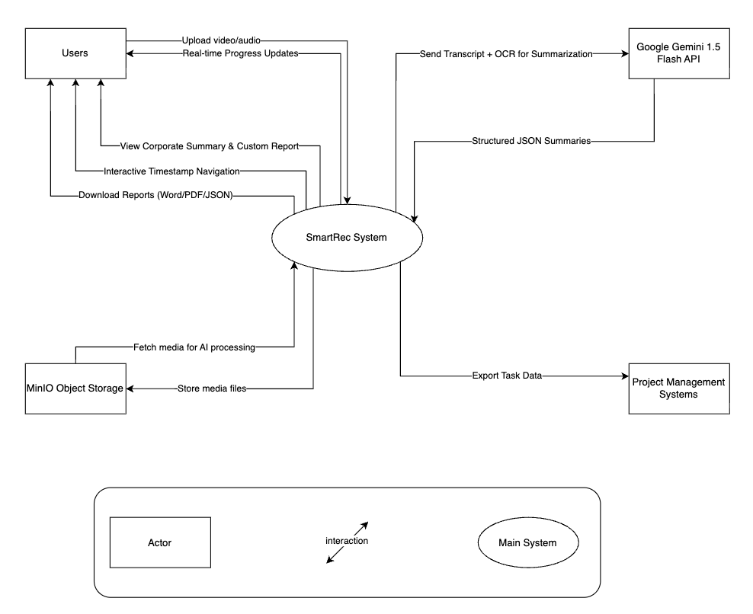

12.3. Logical Architecture
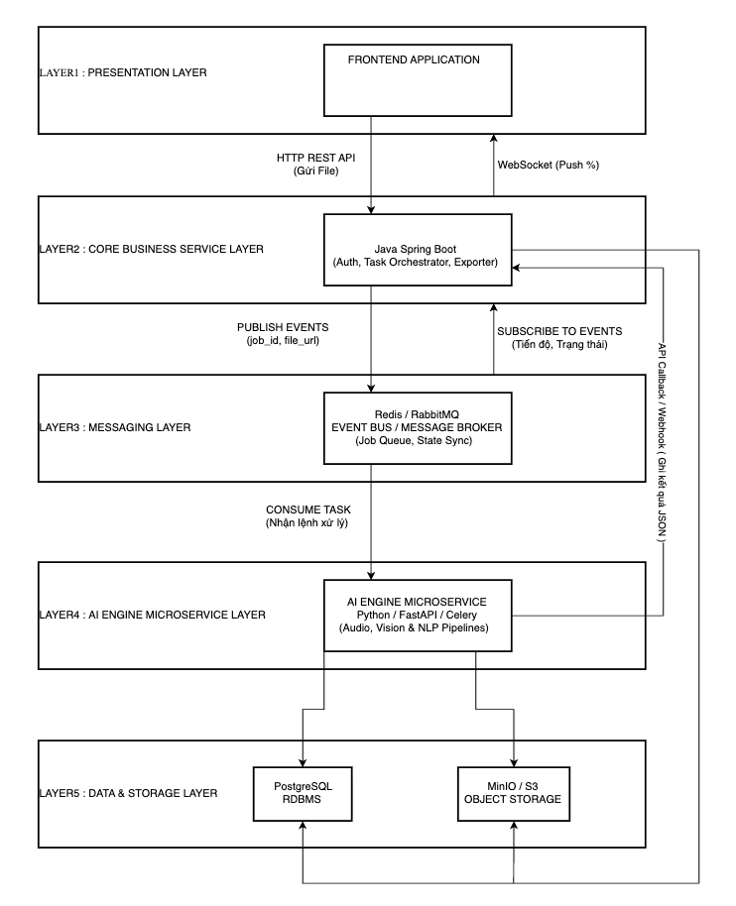
12.4. Core Workflow
The end-to-end process of transforming raw meeting audio/video recordings into structured knowledge and customized enterprise reports proceeds through six primary phases:
1. Ingestion, Validation, and Initialization (User → Spring Boot → MinIO)
- Input Validation: Upon file upload (.mp4, .mkv, .mp3), Spring Boot executes input validation: if the meeting duration exceeds 4 hours, an ERR_FILE_TOO_LARGE exception is returned to the user interface. For file sizes ranging between 2 GB and 5 GB, a multipart chunked upload protocol is automatically initialized.
- Storage and State Persistence: The raw file is ingested into MinIO Object Storage, a meeting record (status = PENDING) is initialized within PostgreSQL, and an immediate asynchronous response is returned to the client to ensure non-blocking UI responsiveness.
2. Asynchronous Task Scheduling (Spring Boot → Redis)
- Spring Boot encapsulates job parameters – including Job ID, File URL, and initialization metadata – into a message payload and pushes it directly onto the Redis Task Queue for queue-based workload distribution.
3. Preprocessing and Background AI Pipeline Execution (Redis → Python Celery Worker)
- A Celery worker dequeues the Job ID, retrieves the media payload from MinIO into the AI compute cluster, and executes parallel execution pipelines:
  - Audio Processing & Chunking: FFmpeg extracts the raw audio stream into a 16 kHz mono .mp3 file (achieving a 97% reduction in storage footprint). If the media duration exceeds 2 hours, the audio is automatically partitioned into 30–45 minute chunks for parallel inference and automated transcript stitching.
  - Audio Pipeline: Performs WebRTC-based acoustic noise suppression, speaker diarization via pyannote-audio, and Vietnamese speech-to-text conversion with technical code-switching support using faster-whisper.
  - Vision Pipeline: Extracts video keyframes and processes presentation slides or screen-share streams via PaddleOCR to capture embedded text, numerical KPI metrics, and structural diagrams.
4. Enterprise Summarization via LLMs (Python Worker → Gemini 1.5 Flash API)
- The timestamped transcript (annotated with speaker diarization labels) is contextualized with text extracted from slide OCR into a structured prompt, which is transmitted to the Google Gemini 1.5 Flash API.
- Gemini returns a structured JSON payload containing a 3-minute Executive Summary and a Task Assignment Matrix (Task – Assignee – Deadline).
5. Real-Time Progress Synchronization (Python Worker → Redis → Spring Boot → Client)
- Throughout execution, the Celery worker continuously publishes completion progress telemetry (e.g., 20%, 50%, 80%) to a designated Redis Pub/Sub channel.
- Spring Boot listens to these channel events and relays the progress data via WebSocket connections to dynamically update the dashboard progress bar on the client interface in real time.
6. Completion, Interactive Playback, and Smart Export (Python → Spring Boot → PostgreSQL → User)
- State Finalization: The Python worker posts the completed JSON payload to Spring Boot, which updates PostgreSQL and transitions the job state to status = COMPLETED.
- Interactive UI: The user dashboard unlocks an interactive video player featuring timestamp navigation (selecting any task or transcript segment seeks the video directly to the corresponding utterance timestamp) alongside a Review & Edit module for human-in-the-loop verification.
- Customized Export: Users can map structured data directly into enterprise Word templates (.docx) via Apache POI using customizable AI prompts or checklists, or export artifacts in PDF (.pdf), JSON, or CSV formats formatted for direct ingestion into Trello/Jira.
13. Potential Risks and Mitigation Strategies
No. | Risk Name & Nature | P | I | Score | Mitigation Strategy
1 | GPU/VRAM Memory Overflow:  • Large video/audio files overload VRAM during AI model inference. | 4 | 5 | 20 | • Utilize faster-whisper for optimized VRAM footprint.  • Offload summarization tasks to Gemini 1.5 Flash API to reduce GPU server load.
2 | Processing Latency for Large Files (>2 hours):  • Prolonged processing leads to HTTP request timeouts. | 4 | 4 | 16 | • Transition AI execution pipelines to background Celery Workers.  • Implement audio chunking (slicing audio into 30–45 minute segments).  • Stream real-time progress to the UI via WebSocket connections.
3 | Distributed System Integration Errors:  • Inter-service communication bottlenecks between Java (Spring Boot) and Python (FastAPI) lead to message loss or queue congestion. | 3 | 4 | 12 | • Configure Dead Letter Queues (DLQ) on Redis/RabbitMQ.  • Assign unique Job IDs for cross-service transaction log tracing.  • Standardize execution environments using Docker Compose.
4 | Sprint Schedule Delays:  • AI fine-tuning and Vietnamese accuracy optimization consume excessive time. | 3 | 4 | 12 | • Strictly adhere to the Scrum framework (2-week Sprints).  • Focus 100% on Core MVP functional scope, deferring secondary features to post-MVP iterations.
5 | Lack of Enterprise Meeting Datasets:  • Difficulty acquiring internal meeting recordings containing technical English code-switching for testing. | 3 | 3 | 9 | • Conduct simulated mock meeting sessions internally.  • Collect publicly available conference, webinar, and corporate meeting recordings.
6 | Code-Switching Recognition Errors:  • Regional accents, colloquialisms, or embedded English terms (deploy, fix bug, KPI) cause transcription errors. | 4 | 4 | 16 | • Integrate custom domain-specific vocabulary into ASR models.  • Utilize Gemini prompts to automatically normalize orthography based on context.
7 | Task & Action Item Extraction Errors:  • Unstructured or informal meeting dynamics cause AI to misidentify action items. | 3 | 4 | 12 | • Apply few-shot prompting techniques with standardized meeting templates.  • Implement a Review & Edit Task interface for human-in-the-loop verification.
8 | Data Privacy & API Cost Overruns:  • Enterprise reluctance regarding data privacy leakage; server maintenance and API costs exceed budget. | 3 | 5 | 15 | • Leverage Gemini API Free/Standard Tier.  • Encrypt stored data within MinIO/PostgreSQL.  • Roadmap local LLM deployment support (On-Premise) for subsequent development phases.

14. Expected Outcomes / Deliverables
14.1. Software Deliverables
Upon project completion (following a 12-week implementation timeline), the project team commits to delivering a fully functional Minimum Viable Product (MVP), comprising:
- SmartRec Web Application: A web platform supporting an end-to-end operational workflow: user authentication → video/audio ingestion → automated AI processing (Speech-to-Text, speaker diarization, presentation slide OCR) → standardized enterprise summary rendering → report generation.
- Interactive Video Player: An embedded video playback module featuring interactive timestamp navigation linked seamlessly across all generated artifacts (transcripts, executive summaries, and task items).
- Source Code Repository: A comprehensive source code repository spanning Frontend, Backend, and Celery/Redis asynchronous execution environments, hosted on GitHub with granular commit histories corresponding to each Sprint.
- Containerized Deployment Package: A Docker Compose orchestration package enabling complete system replication on GPU-accelerated Cloud VPS infrastructure.
14.2. Accompanying Documentation
- Project Governance & Proposal Documentation:
  - Comprehensive Final Project Summary Report.
  - Formal Project Proposal Document.
  - Project Management Plan & Sprint Execution Plan.
  - Project Governance Portfolio: Meeting Minutes & Team Collaboration Artifacts.
  - Individual Self-Reflections & 360-Degree Peer Evaluations.
- Technical Analysis & System Design Specifications:
  - Software Requirements Specification (SRS) / User Stories / Requirements Engineering Documentation.
  - System Architecture & Design Specifications: Architecture, Database Schemata, and Algorithm Design.
  - UI/UX Design Specifications & Guidelines.
  - Source Code Conventions & Technical Engineering Standards.
- Software Testing & Quality Assurance Documentation:
  - Software Test Plan (STP).
  - Test Case Suites & Evaluation Datasets.
  - Test Execution Summary Report & Defect/Bug Tracking Log.
- Scientific Publications & Technical Deliverables:
  - Condensed Technical/Scientific Manuscript (A publication-ready research paper summarizing the end-to-end system architecture and empirical evaluation).
  - Complete System Source Code & Deployment Automation Scripts.
  - Post-Defense Final Presentation Slides & Revision Record.
14.3. Success Metrics
Evaluation Criteria | Target Metric
Speech Recognition Accuracy (WER) | < 15% on Vietnamese evaluation datasets containing code-switching.
Speaker Diarization Accuracy (DER) | < 15% on multi-speaker meeting and lecture recordings.
Processing Latency | A 1-hour video is processed and yields summary results in under 5–7 minutes.
MVP Functional Completeness | 100% of functional requirements (FR-01 to FR-09) operate stably in the deployment environment.
Usability | User testing demonstrates completion of the upload → view summary → export report workflow without supplementary guidance.

14.4. Phased Delivery Roadmap
Phase | Timeline | Key Deliverables
Phase 1 | Weeks 1–4 (Month 1) | PostgreSQL database design; FastAPI + Celery/Redis backend framework; stable audio slicing, speaker diarization, and Vietnamese STT processing pipelines.
Phase 2 | Weeks 5–8 (Month 2) | Corporate Summarization & Smart Exporter modules completed; ReactJS web frontend with embedded interactive timestamp video player integrated.
Phase 3 | Weeks 9–12 (Month 3) | Word/PDF/JSON export modules; Docker Compose containerization; deployment on Vercel + Cloud GPU VPS; WER/DER metric evaluations; final project summary report completion.

15. References
[1] A. Radford et al., "Robust Speech Recognition via Large-Scale Weak Supervision," in Proc. International Conference on Machine Learning (ICML), pp. 28492–28518, 2023.
[2] H. Bredin et al., "pyannote.audio: neural building blocks for speaker diarization," in Proc. IEEE International Conference on Acoustics, Speech and Signal Processing (ICASSP), pp. 7124–7128, 2020[3] Google DeepMind, "Gemini 1.5: Unlocking multimodal understanding across millions of tokens of context," arXiv preprint arXiv:2403.05530, 2024. [4] Y. Du et al., "PP-OCR: A Practical Ultra Lightweight OCR System," arXiv preprint arXiv:2009.09941, 2020. (Nền tảng đọc văn bản trên Slide trình chiếu PaddleOCR).
[5] Otter.ai, "Otter.ai - AI Meeting Note Taker & Real-time Transcription," 2026. [Online]. Available: https://otter.ai. [Accessed: Sep. 04, 2026].
[6] Fireflies.ai, "Fireflies.ai - AI Voice Assistant & Conversation Intelligence Platform," 2026. [Online]. Available: https://fireflies.ai. [Accessed: Sep. 04, 2026].
[7] Fathom, "Fathom - Free AI Meeting Assistant," 2026. [Online]. Available: https://fathom.video. [Accessed: Sep. 04, 2026].
[8] IEEE Standard for Software and System Test Documentation, IEEE Std 829-2008, pp. 1–128, 2008.
[9] Spring Boot Documentation, "Spring Boot Framework Reference Documentation (v3.x)," 2026. [Online]. Available: https://spring.io/projects/spring-boot.
[10] FastAPI Documentation, "FastAPI Framework Documentation," 2026. [Online]. Available: https://fastapi.tiangolo.com/.
[11] K. Schwaber and J. Sutherland, "The Scrum Guide," Scrum.org, 2020. [Online]. Available: https://www.scrum.org/learning-series/what-is-scrum/.

