**Instructions for the Workshop**

The present workshop on Data Science will be a hands-on workshop with the participants expected to bring their own laptops. The following software is expected to be installed in their laptops.

1. Install R software from the following website:
   1. <https://cran.cnr.berkeley.edu/>
   2. This website has instructions for downloading and installing the software.
   3. It doesn’t matter whether you install the 32-bit or 64-bit version of the software.
   4. Alternatively, mirror websites are available at: <https://cran.r-project.org/mirrors.html>
2. We will be using R-studio, an IDE that is most preferred while working with R
   1. Please download R studio install from the following Website: <https://www.rstudio.com/products/rstudio/download/#download>
   2. Follow the instructions in the website and install the version of R-studio most suited to your machine.
3. Open R-studio. Go to *Tools 🡪 Global Options.* Check if R version is pointing to the correct R-software installed in your machine.

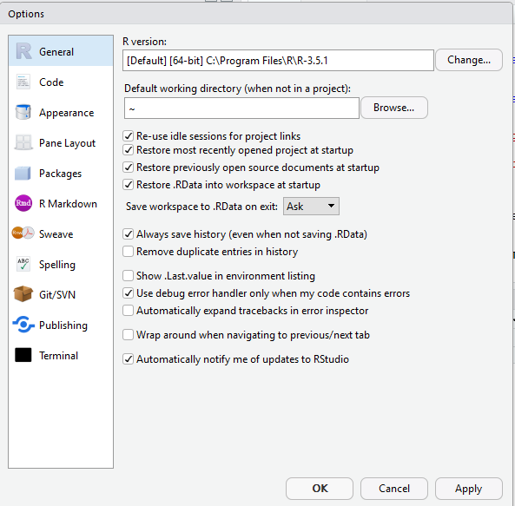

1. Download the data sets from the shared link: <https://github.com/vnrajesh/workshop>
2. We are now ready to start the workshop.