**WEEK-1**

**Installation of WEKA Tool, Weka GUI, Features of WEKA Tool.**

**Step 1:** Visit this [https://www.filehorse.com/download-weka-64](https://www.filehorse.com/download-weka-64/)/ using any web browser. Click on Free Download.



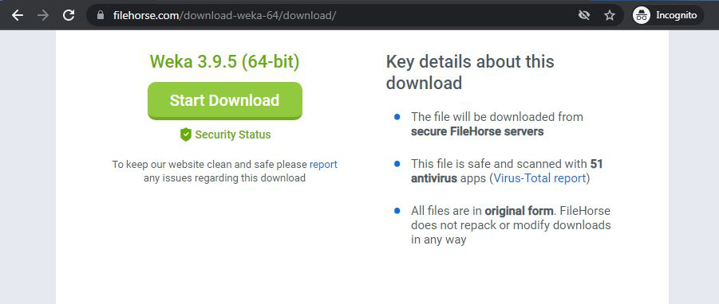**Step 2:** It will redirect to a new webpage, click on Start Download. Downloading of the executable file will start shortly. It is a big 127 MB file that will take some minutes.

**Step 3:** Now check for the executable file in downloads in your system and run it.

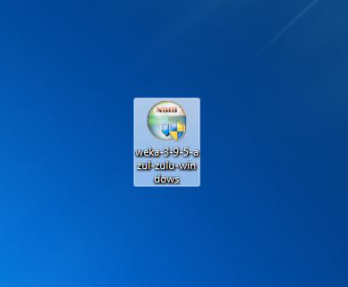

**Step 4:** It will prompt confirmation to make changes to your system. Click on Yes.

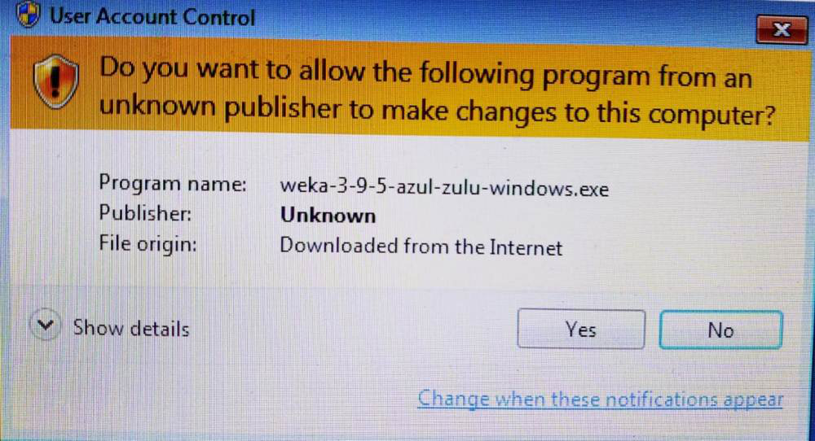

**Step 5:** Setup screen will appear, click on Next.

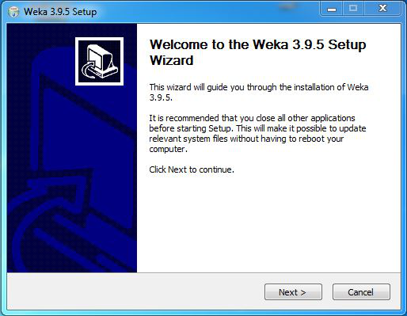

**Step 6:**The next screen will be of License Agreement, click on I Agree.

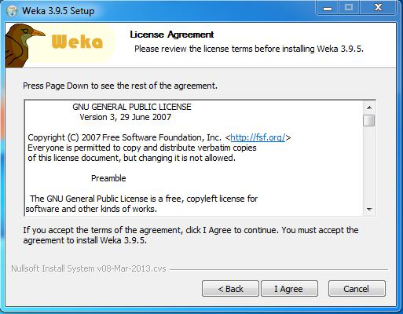

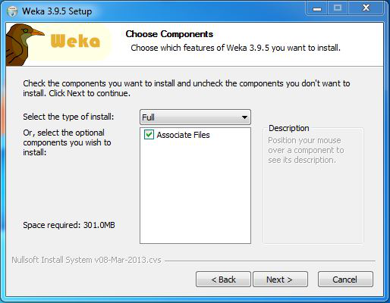**Step 7:** Next screen is of choosing components, all components are already marked so don't change anything just click on the Install button.

**Step 8:** The next screen will be of installing location so choose the drive which will have sufficient memory space for installation. It needed a memory space of 301 MB.

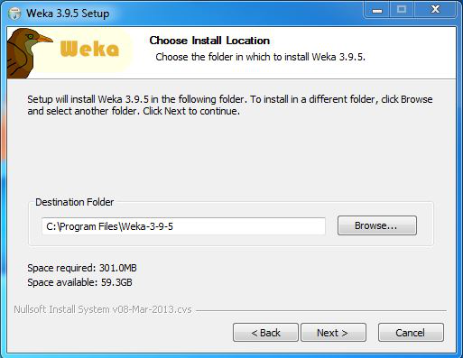

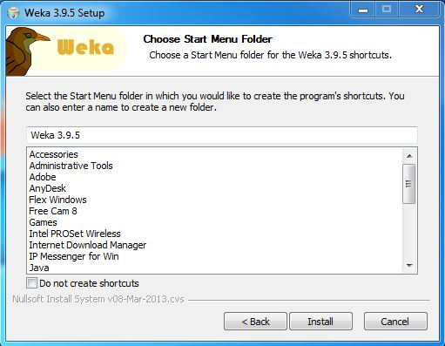**Step 9:**Next screen will be of choosing the Start menu folder so don't do anything just click on Install Button.

**Step 10:** After this installation process will start and will hardly take a minute to complete the installation.

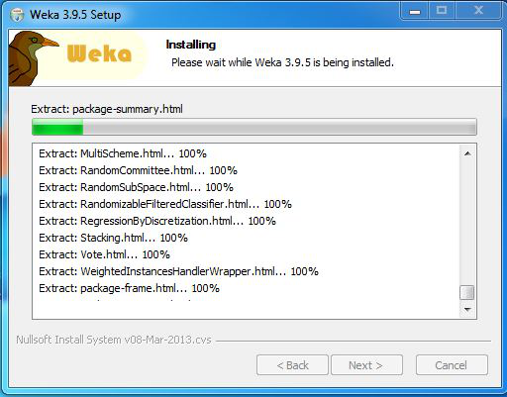

**Step 11:** Click on the Next button after the installation process is complete.

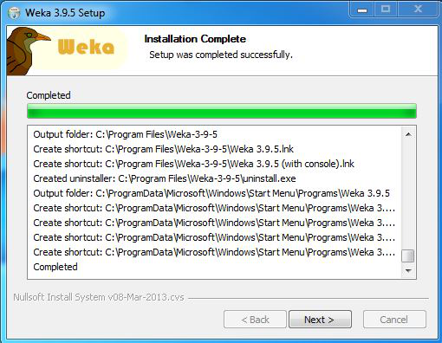

**Step 12:** Click on Finish to finish the installation process.

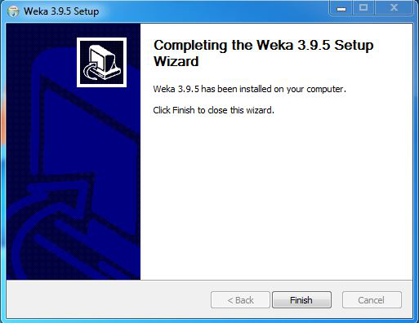

**Step 13:** Weka is successfully installed on the system and an icon is created on the desktop.

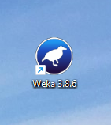

**Step 14:**Run the software and see the interface.

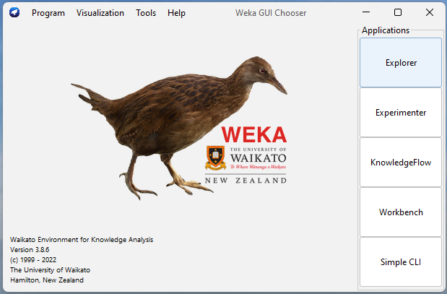

Congratulations!! At this point, you have successfully installed Weka on your windows system.

n27kmd2c