**WEEK-10**

**Demonstration of Clustering algorithm using K-means clustering algorithm.**

Procedure for applying K-means for iris.arff

**Step 1:** Load the **iris.arff** data file

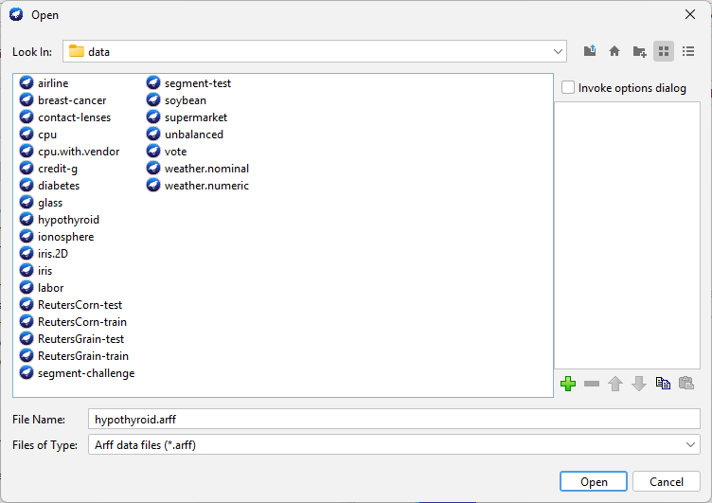

**Step 2:** Select all the attributes except ***class***

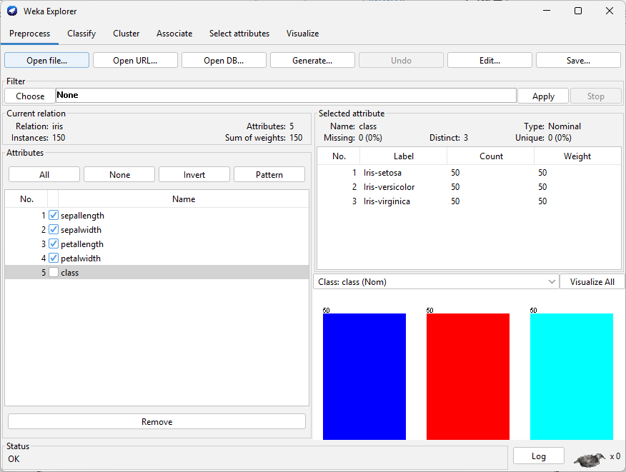

# **Step 3:** Go to **Cluster** tab

# 

Then click on choose, under the classifier, and select **SimpleKMeans**



Click on the start. **(Output for SimpleKMeans – 3 Clusters - Euclidean)**

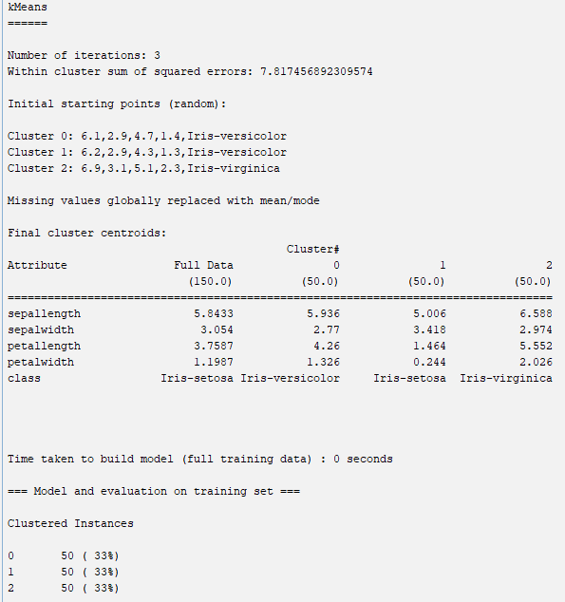

# **Step 3:** Go to **SimpleKMeans 🡪 Choose the ManhattanDistance**

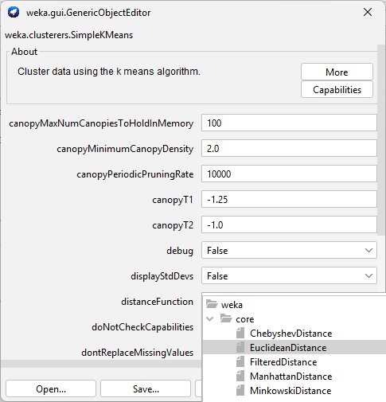

**Output for Manhattan Distance**

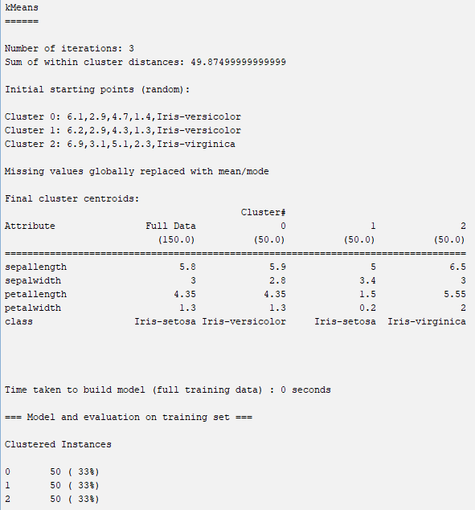

**Output for SimpleKMeans – 4 Clusters - Euclidean Distance**

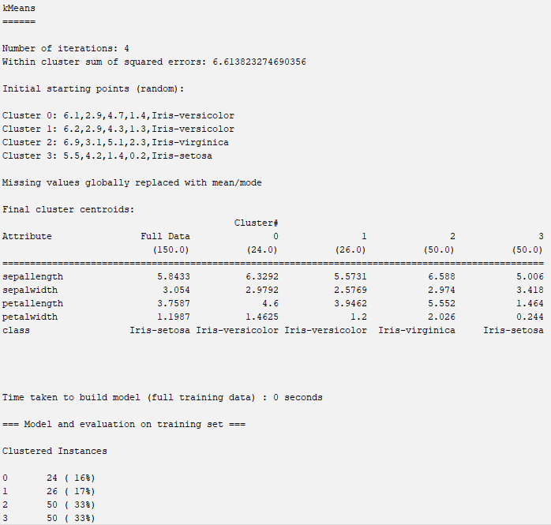

**Output for SimpleKMeans – 4 Clusters - Manhattan Distance**

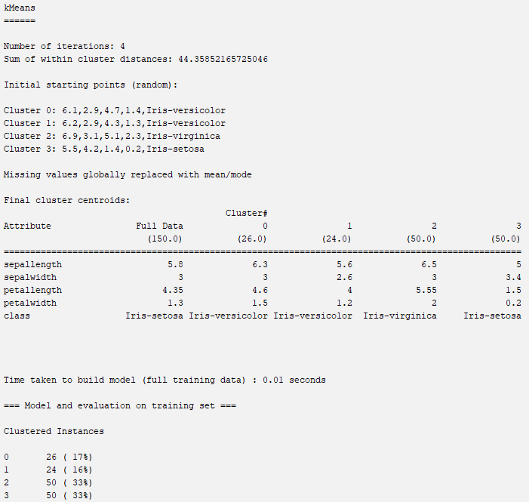

# **Step 4:** Go to **HierarchialCluster 🡪 Choose the EuclideanDistance**

**Output for HierarchialCluster – 3 Clusters - Euclidean Distance**

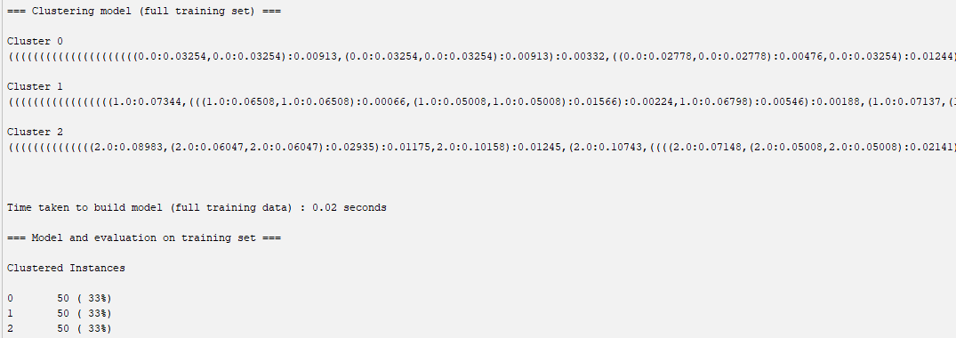

**Output for HierarchialCluster – 3 Clusters - Manhattan Distance**

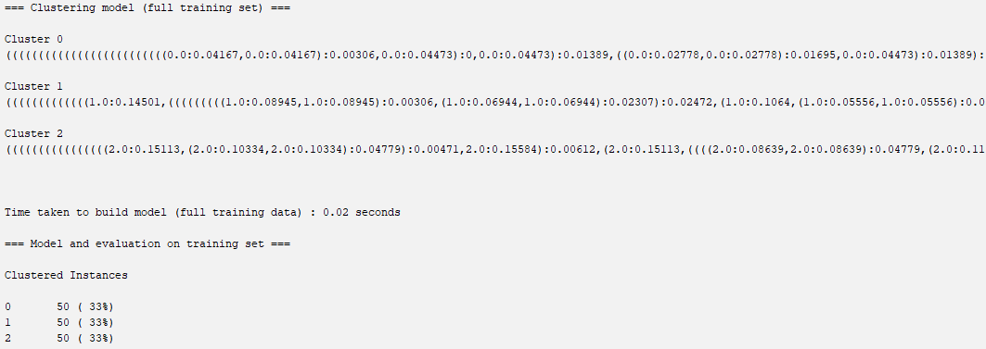

**Output for HierarchialCluster – 4 Clusters - Euclidean Distance**

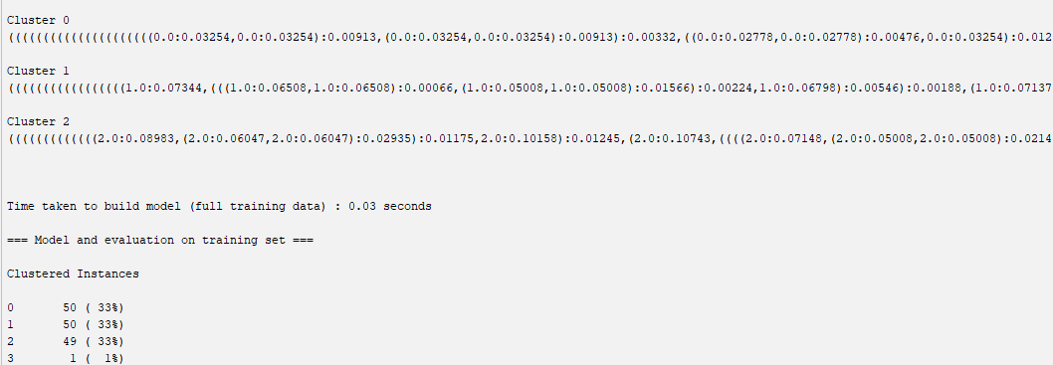

**Output for HierarchialCluster – 4 Clusters - Manhattan Distance**

