**WEEK-2**

**Creating new Arff File and CSV file using weather dataset, load the dataset and observe.**

**WEATHER.NOMINAL**

**Step 1:** List the attribute names and their types.

|  |  |
| --- | --- |
| **Name** | **Type** |
| outlook | nominal |
| temperature | nominal |
| humidity | nominal |
| windy | nominal |
| play | nominal |

**Step 2:** Number of records in each dataset

. 

**Step 3:** Identify the class attribute (if any)

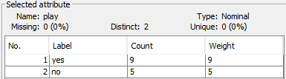

**Step 4:** Plot Histogram

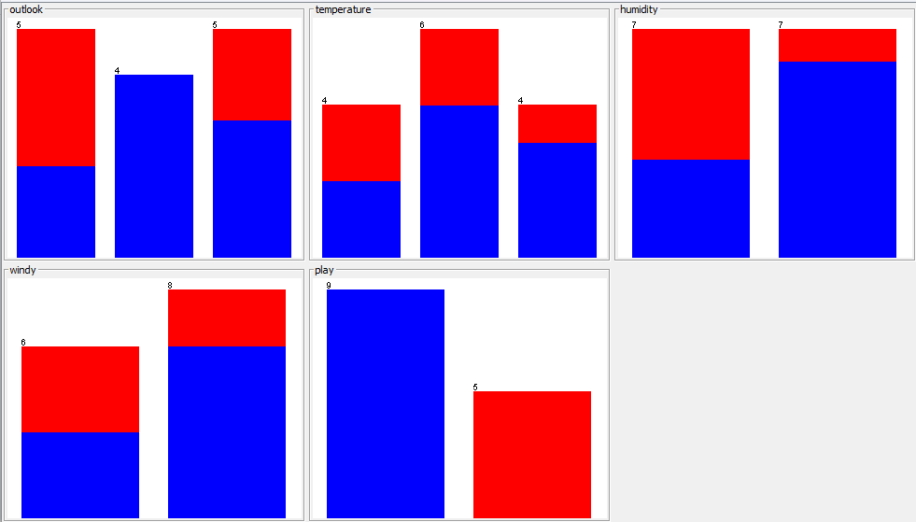

**Step 5:** Determine the number of records for each class



**Step 6:** Visualize the data in various dimensions

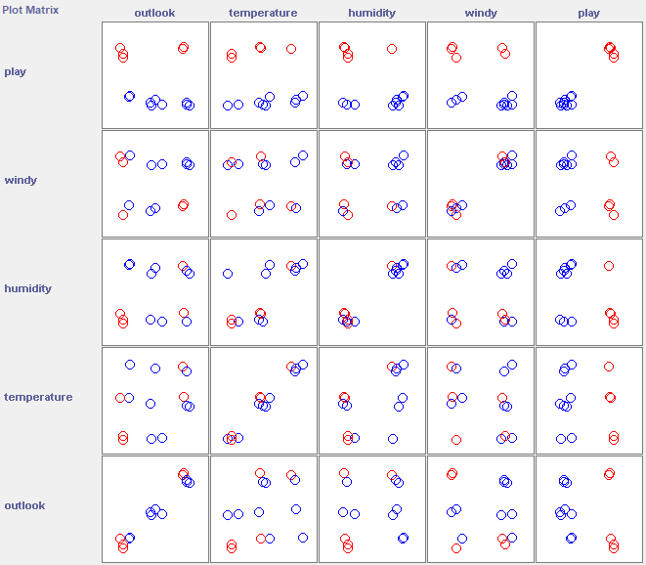

**DIABETES.NOMINAL**

**Step 1:** List the attribute names and their types.

|  |  |
| --- | --- |
| **Name** | **Type** |
| preg | numeric |
| plas | numeric |
| age | numeric |
| press | numeric |
| skin | numeric |
| insu | numeric |
| mass | numeric |
| pedi | numeric |
| age | numeric |
| class | nominal |

**Step 2:** Number of records in each dataset. 

**Step 3:** Identify the class attribute (if any)

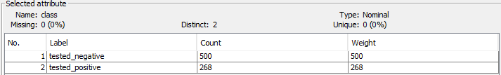

**Step 4:** Plot Histogram

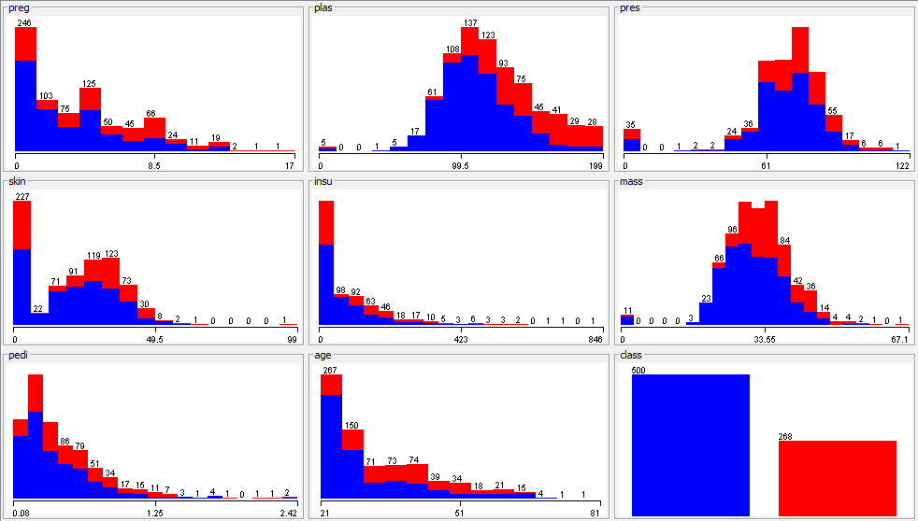

**Step 5:** Determine the number of records for each class



**Step 6:** Visualize the data in various dimensions

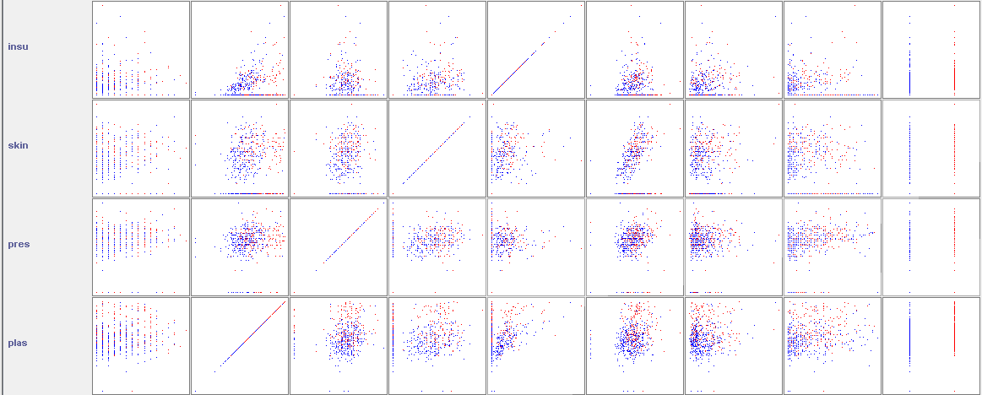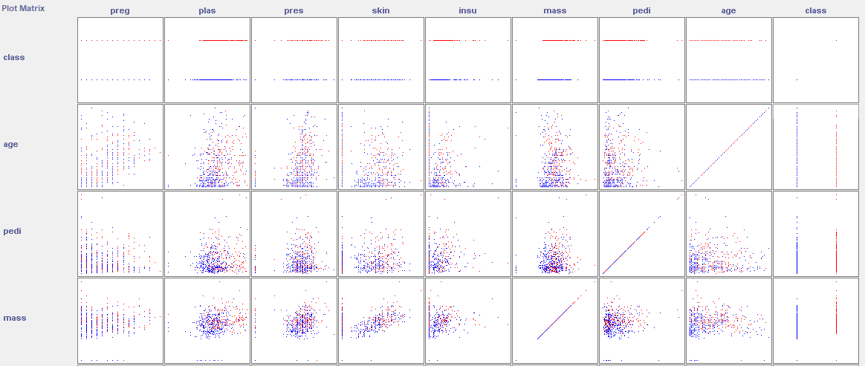

**IRIS.NOMINAL**

**Step 1:** List the attribute names and their types.

|  |  |
| --- | --- |
| **Name** | **Type** |
| Sepallenght | numeric |
| sepalwidth | numeric |
| petallength | numeric |
| petalwidth | numeric |
| class | nominal |

**Step 2:** Number of records in each dataset.



**Step 3:** Identify the class attribute (if any)

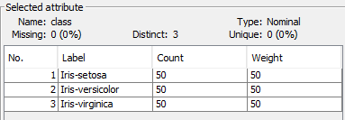

**Step 4:** Plot Histogram

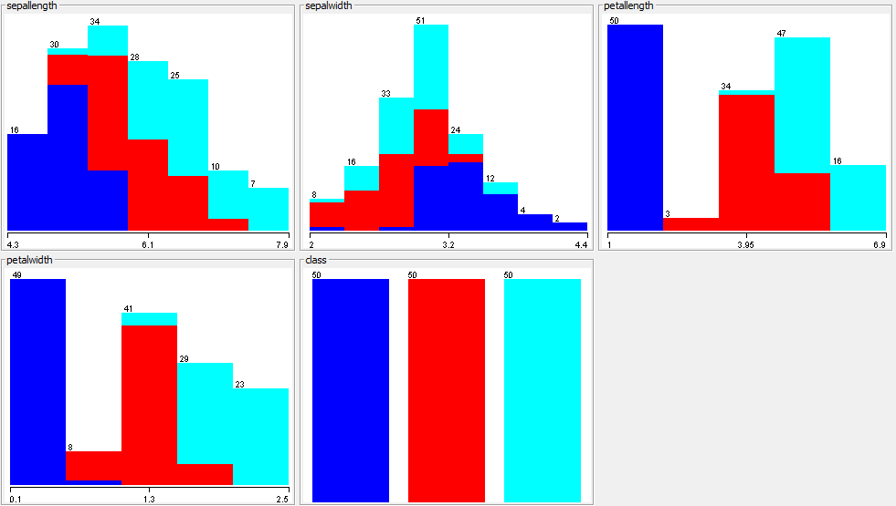

**Step 5:** Determine the number of records for each class



**Step 6:** Visualize the data in various dimensions

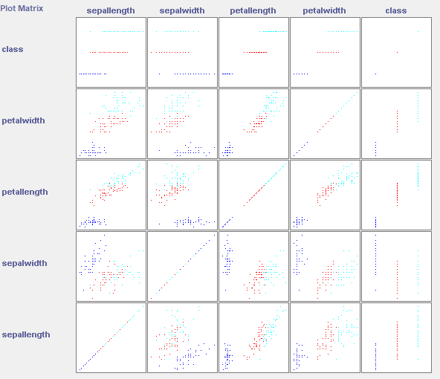

**CREDIT-G.NOMINAL**

**Step 1:** List the attribute names and their types.

|  |  |
| --- | --- |
| **Name** | **Type** |
| checking_status | nominal |
| duration | numeric |
| credit_history | nominal |
| purpose | nominal |
| credit_amount | numeric |
| savings_status | nominal |
| employment | nominal |
| instalment_commitment | numeric |
| personal_status | nominal |
| other_parties | nominal |
| residence_since | numeric |
| property_magnitude | nominal |
| age | numeric |
| other_payment_plans | nominal |
| housing | nominal |
| existing_credits | numeric |
| num_dependents | nominal |
| own_telephone | nominal |
| foreign_worker | nominal |
| class | nominal |

**Step 2:** Number of records in each dataset.



**Step 3:** Identify the class attribute (if any)

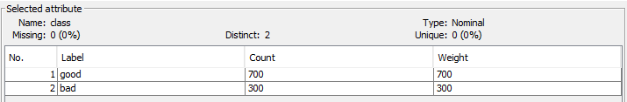

**Step 4:** Plot Histogram

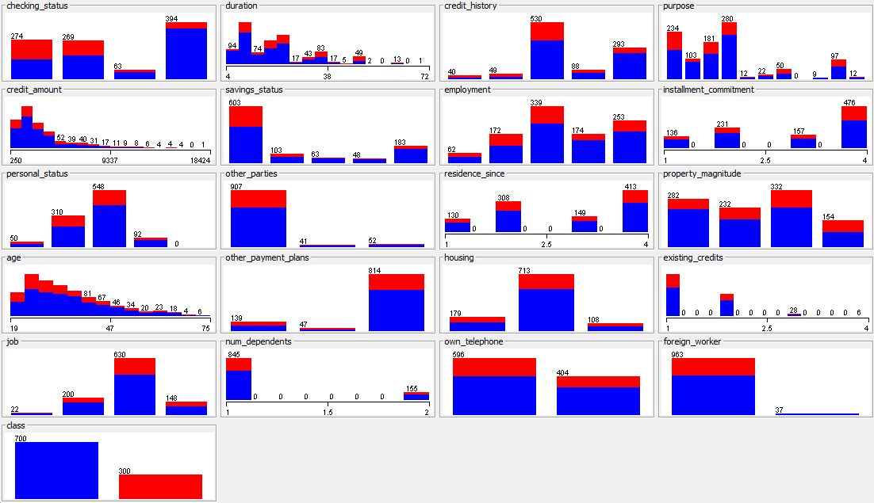

**Step 5:** Determine the number of records for each class



**Step 6:** Visualize the data in various dimensions

