**WEEK-5**

**Demonstration of Association rules using Apriori algorithm.**

Procedure for applying Apriori Algorithm for supermarket.arff

**Step 1:** Load the **supermarket.arff** data file

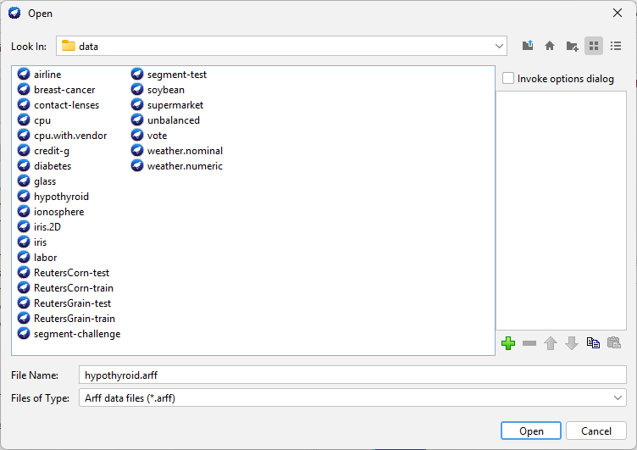

# **Step 2:** Go to **Associate** tab

# 

Then click on choose, under the associator, and select **Apriori**



Click on the start. **(Output for Apriori – numRules=10, support=0.1, metricType=confidence)**

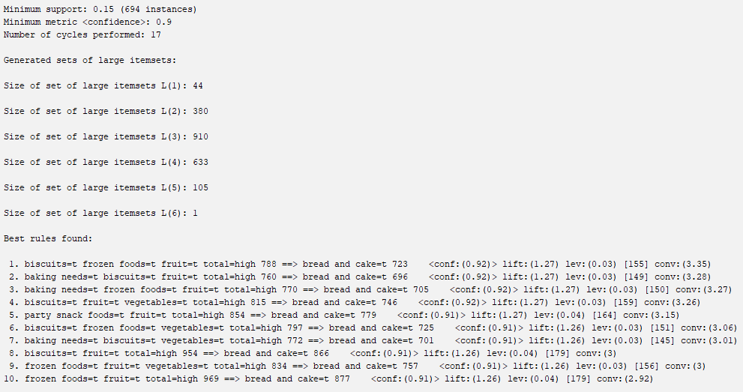

**Output for Apriori – numRules=15, support=0.5, metricType=lift**

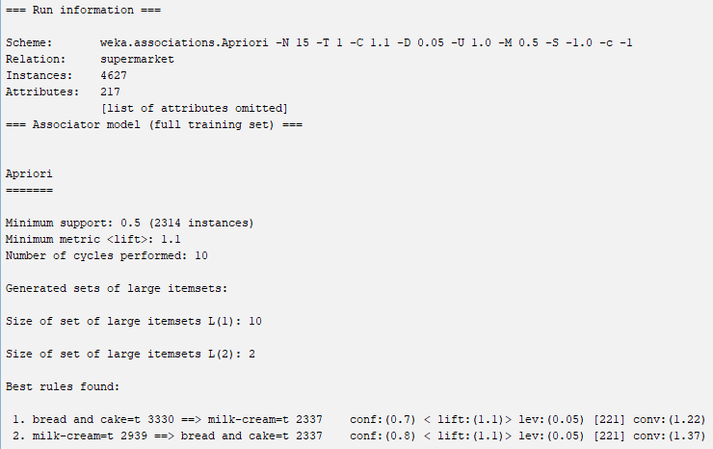

**Output for Apriori – numRules=5, support=0.4, metricType=lift**

