**WEEK-6**

**Demonstration of FP-Growth Algorithm.**

Procedure for applying FP-Growth Algorithm for supermarket.arff

**Step 1:** Load the **supermarket.arff** data file

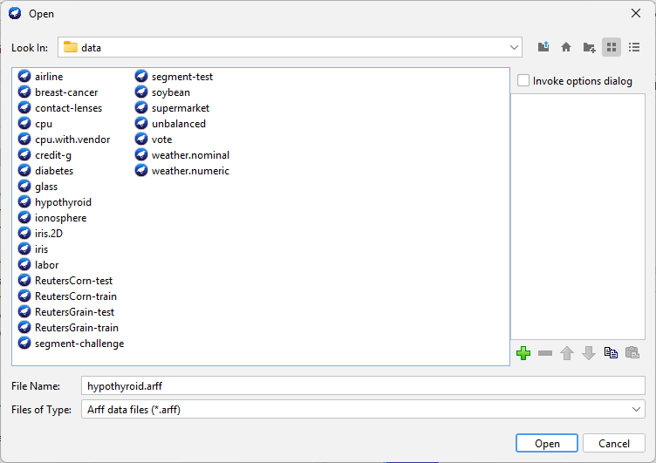

# **Step 2:** Go to **Associate** tab

# 

Then click on choose, under the associator, and select **FPGrowth**



Click on the start.

**Output for FPGrowth – numOfRulesToFind=10, support=0.1, metricType=confidence)**

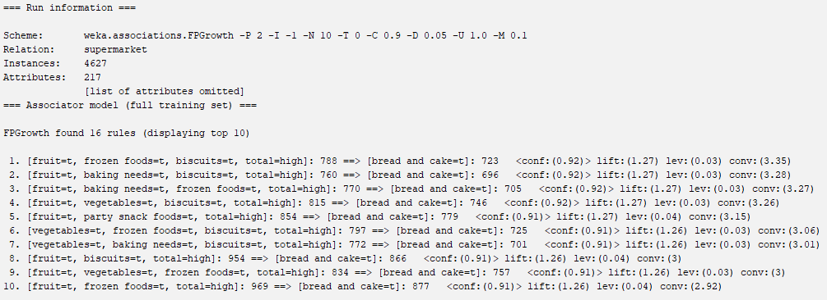

**Output for FPGrowth – numOfRulesToFind=15, support=0.5, metricType=lift**

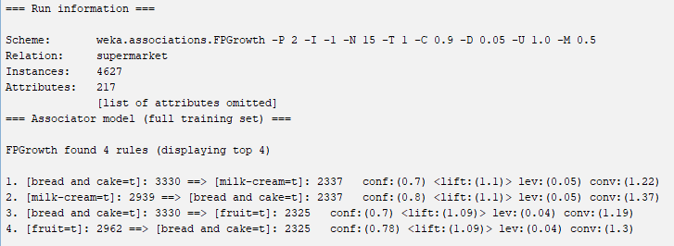

**Output for FPGrowth – numOfRulesToFind=5, support=0.4, metricType=lift**

