**WEEK-7**

**Demonstration of ID3 classification algorithm and generating rules using ID3 algorithm.**

**Step 1:** Click open file and choose the weather.nominal file.

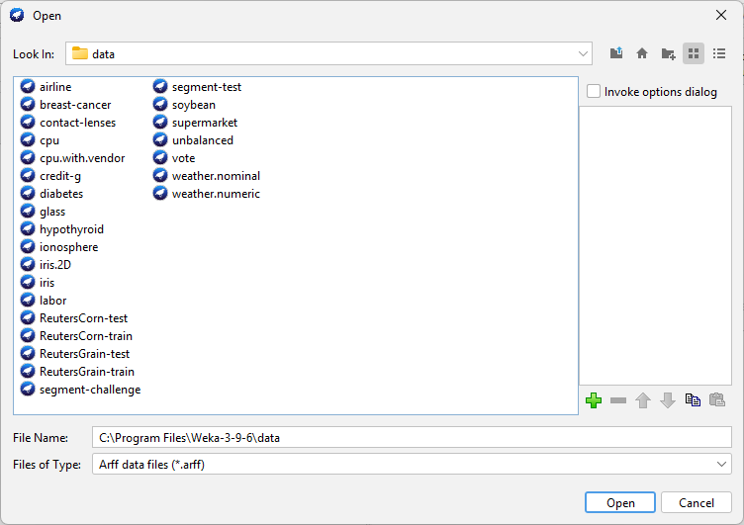

**Step 2:** Choose all attributes.

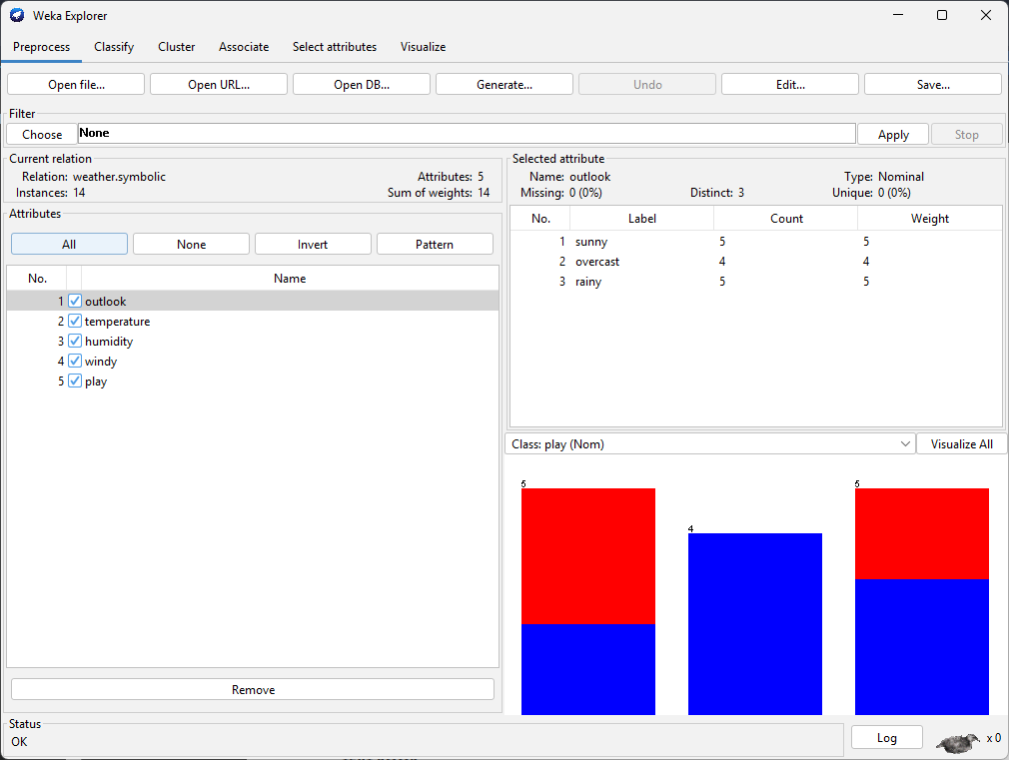

**Step 3:** Go to Classify & choose **id3**.

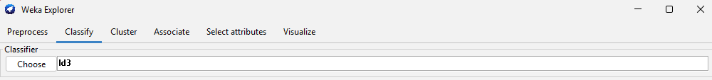

**Installing id3**

1. Go to Tools 🡪 Package Manager
2. Search simple & install SimpleEducationLearningSchemes
3. 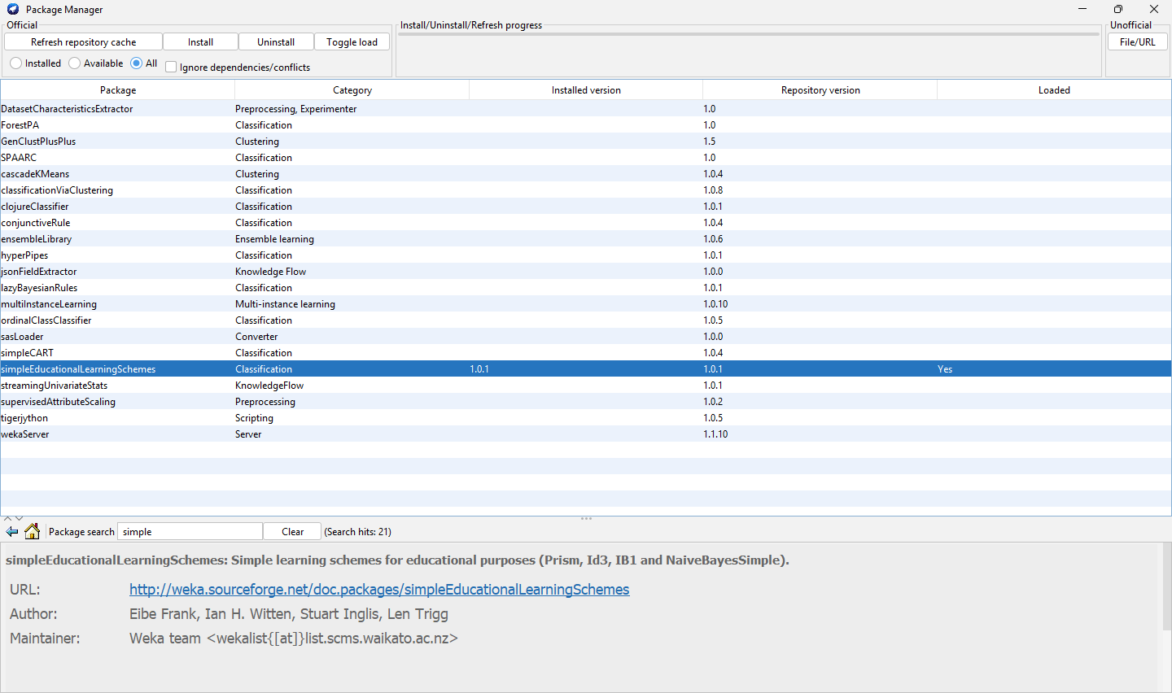

**Step 4:** Output (10-fold) (id3)

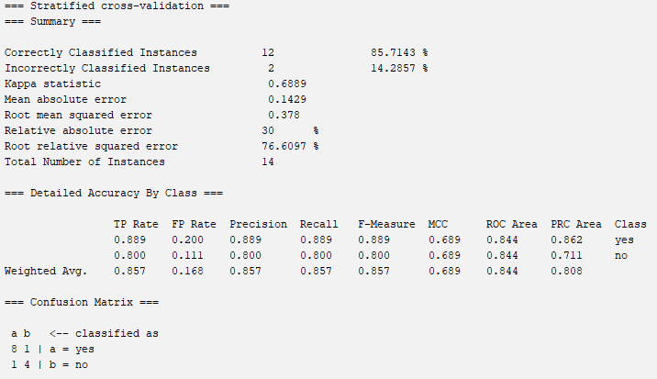

Choosing **J48 (10-fold)**

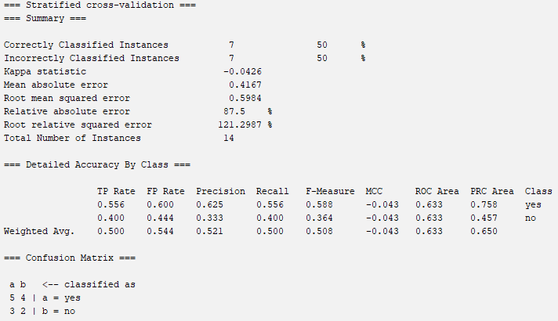

**Visualize tree**

