**WEEK-8**

**Demonstration of Classification algorithm using Bayesian approach.**

**Step 1:** Link to zoo.arff dataset (<https://github.com/renatopp/arff-datasets/blob/master/classification/zoo.arff>)

Procedure for applying Bayesian approach for zoo.arff

**Step 1:** Load the **zoo.arff** data file

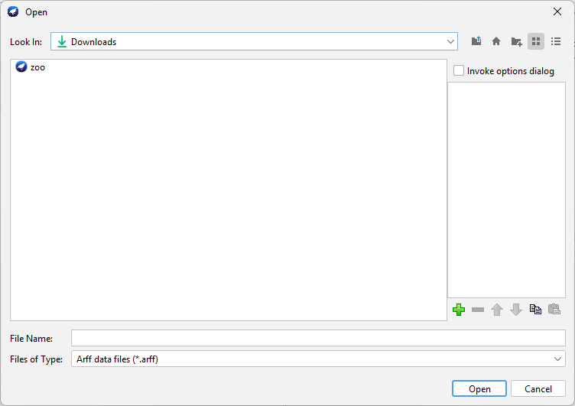

**Step 2:** Select all the attributes

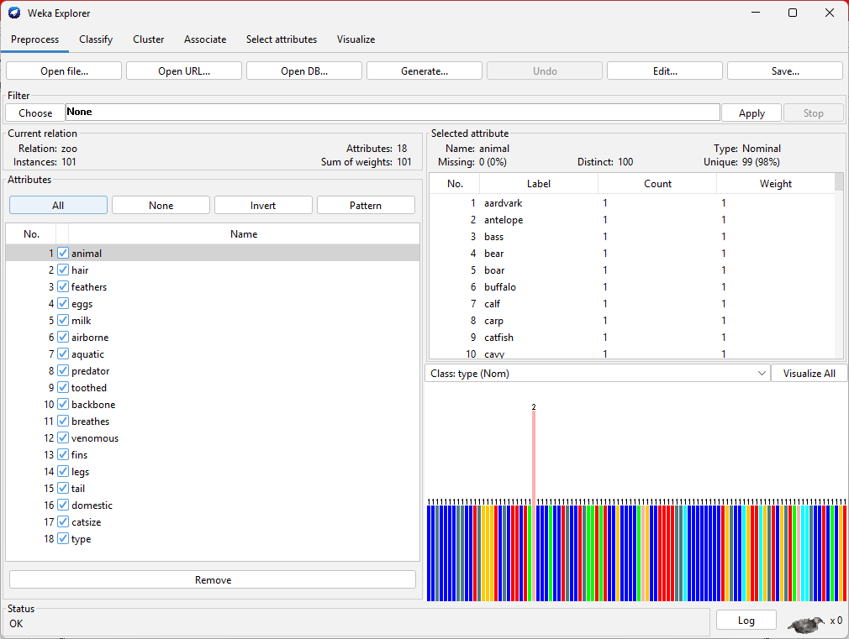

# **Step 3:** Go to classify tab

# 

# Under the test options, change the **folds to 5**

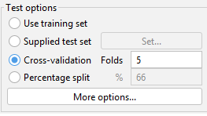

Then click on choose, under the classifier, and select **BayesNet**



Click on the start. (**Output for 5-fold)**

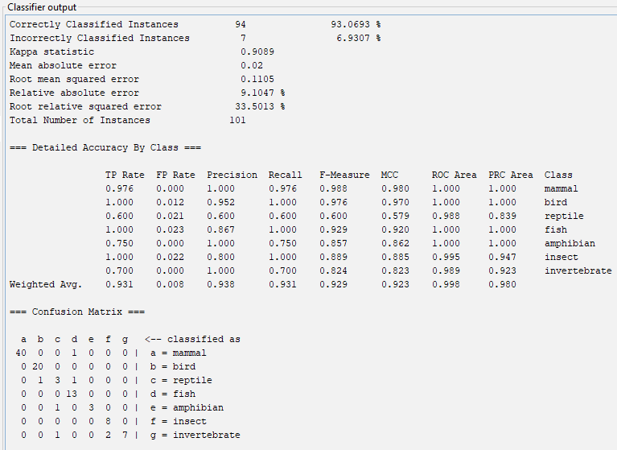

**Output for 10-fold validation**

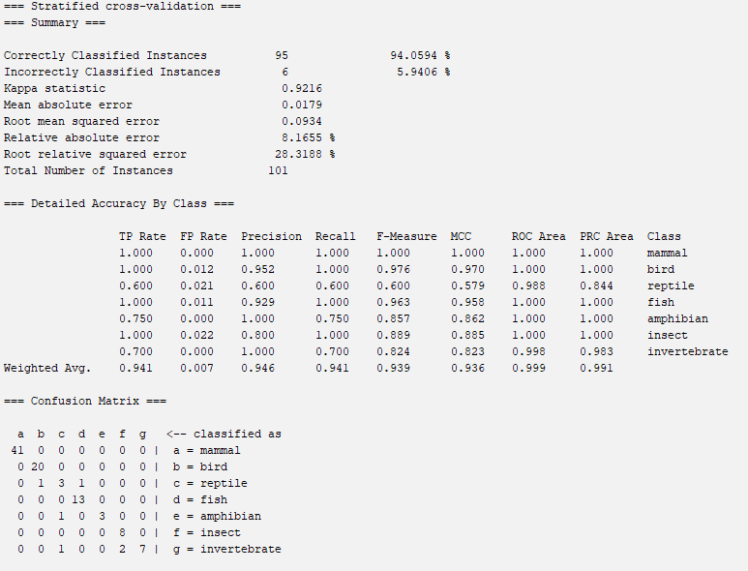

**NaiveBayes (5-fold)**

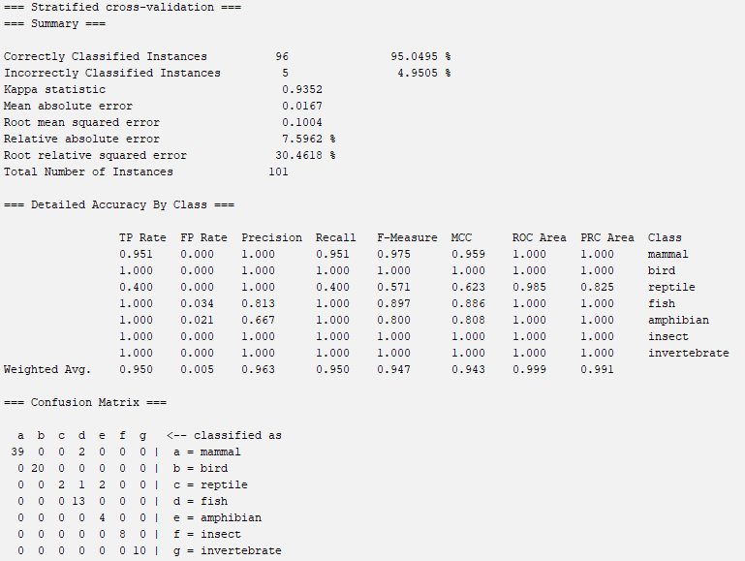

**NaiveBayes (10-fold)**

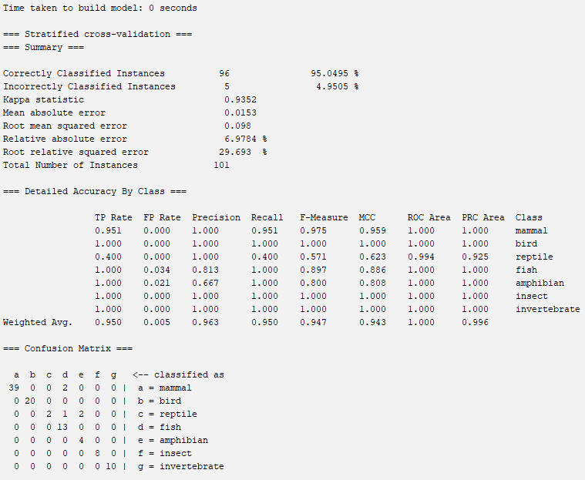

**Visualization**

|  |  |  |  |  |
| --- | --- | --- | --- | --- |
| Algo | Accuracy | Precision | Recall | F1 score |
| BayesNet (5) | 0.94 | 0.938 | 0.931 | 0.929 |
| BayesNet (10) | 0.95 | 0.946 | 0.941 | 0.939 |
| NaiveBayes (5) | 0.96 | 0.963 | 0.95 | 0.947 |
| NaiveBayes (10) | 0.96 | 0.963 | 0.95 | 0.947 |

**Applying Bayesian approach for AER_Credit_Card_Data.csv**

**Output:**

**BayesNet (5-Fold)**

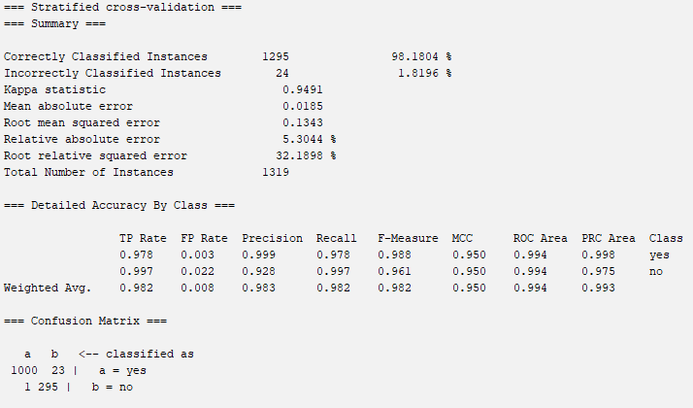

**BayesNet (10-Fold)**

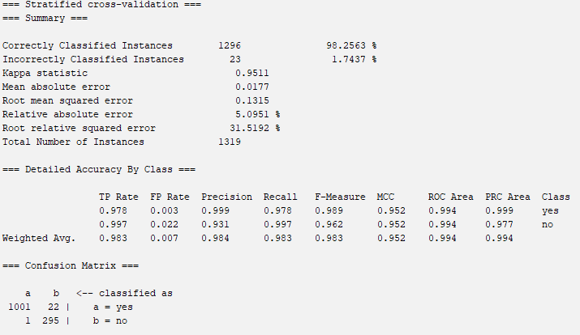

**NaiveBayes (5-Fold)**

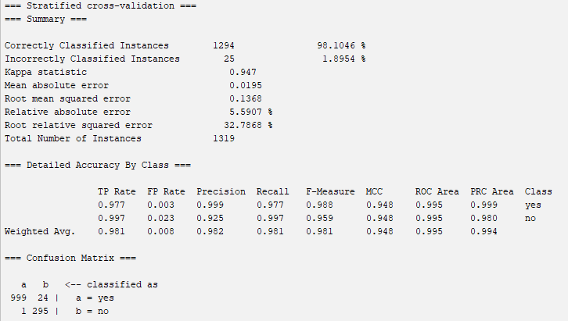

**NaiveBayes (10-Fold)**

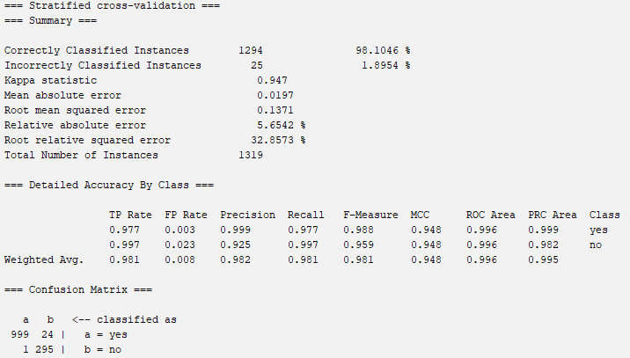

**Visualization**

|  |  |  |  |  |
| --- | --- | --- | --- | --- |
| Algo | Accuracy | Precision | Recall | F1 score |
| BayesNet (5) | 0.981 | 0.983 | 0.982 | 0.982 |
| BayesNet (10) | 0.982 | 0.984 | 0.983 | 0.983 |
| NaiveBayes (5) | 0.981 | 0.982 | 0.981 | 0.981 |
| NaiveBayes (10) | 0.981 | 0.982 | 0.981 | 0.981 |