**WEEK-9**

**Demonstration of Classification algorithm using KNN approach.**

Procedure for applying KNN approach for iris.arff

**Step 1:** Load the **iris.arff** data file

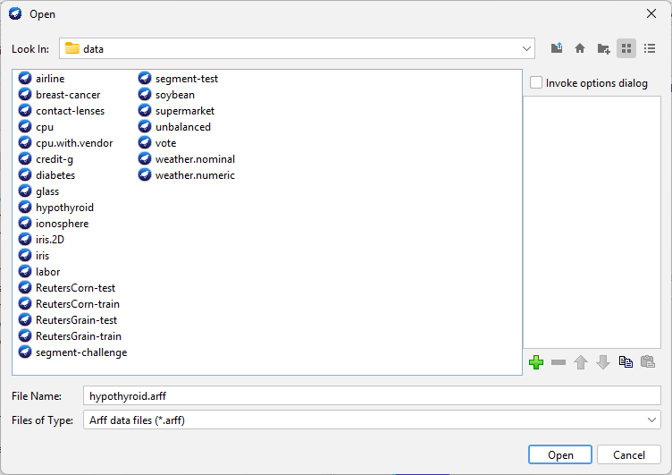

**Step 2:** Select all the attributes

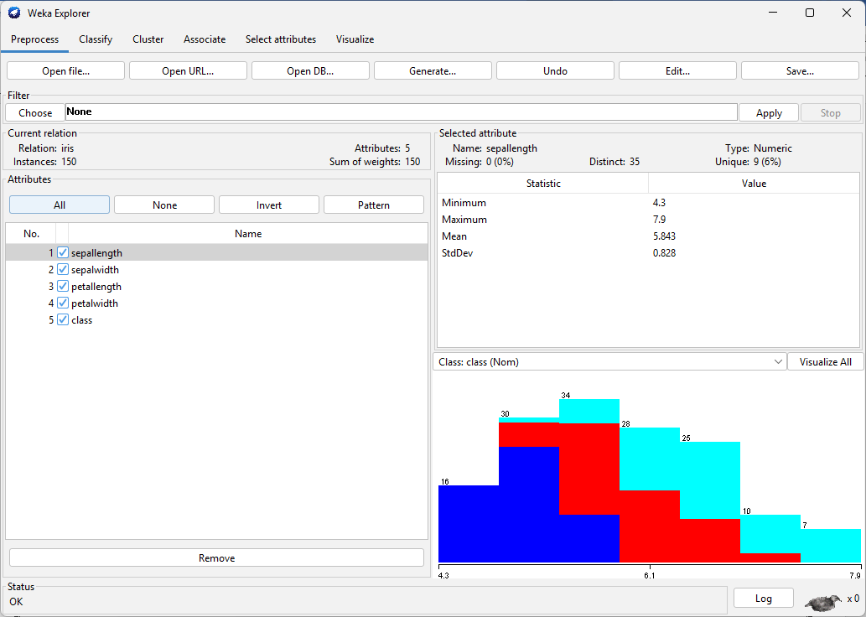

# **Step 3:** Go to classify tab

# 

Then click on choose, under the classifier, and select **IBk**



Click on the start. **(Output for Euclidean Distance)**

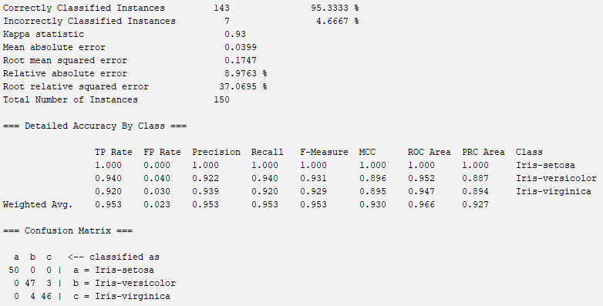

# **Step 3:** Go to **IBk 🡪 LinearNNSearch 🡪 Choose all the left over 4 distances**

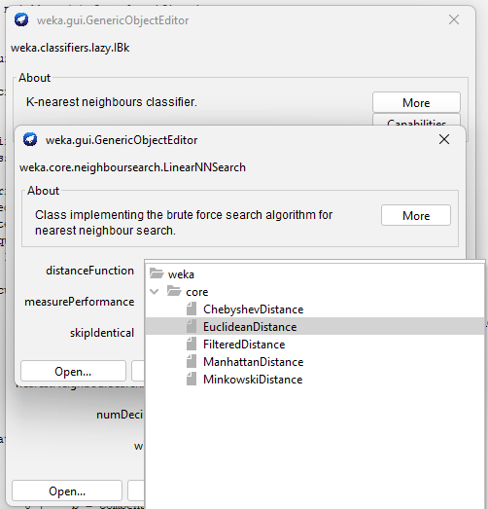

**Output for ChebyShev Distance**

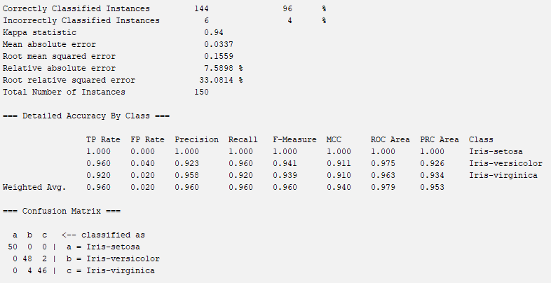

**Output for Filtered Distance**

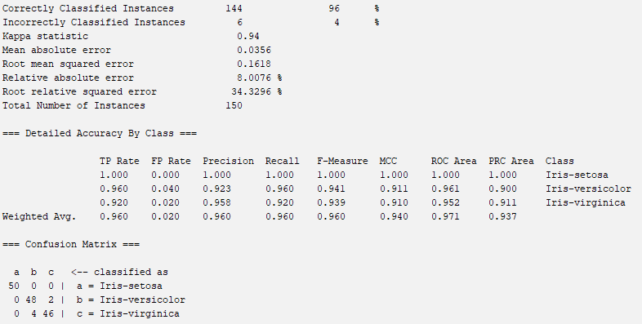

**Output for Manhattan Distance**

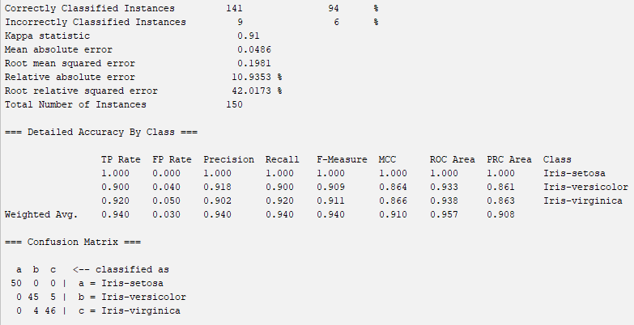

**Output for Minkowski Distance**

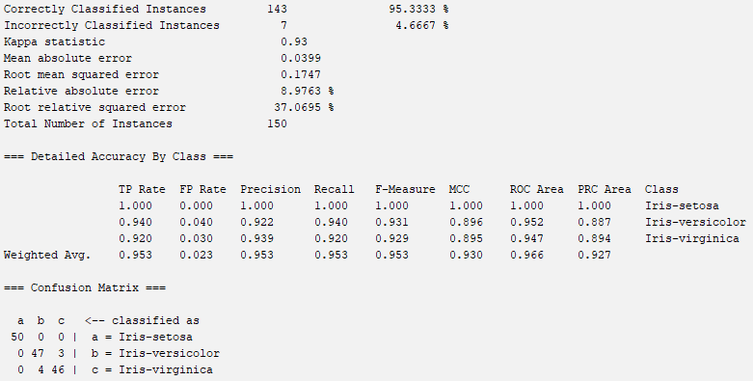

**Visualization**

|  |  |  |  |  |
| --- | --- | --- | --- | --- |
| Algo  (IBk-{distance}) | Accuracy | Precision | Recall | F1 score |
| Euclidean | 0.953 | 0.953 | 0.953 | 0.953 |
| ChebyShev | 0.960 | 0.960 | 0.960 | 0.960 |
| Filtered | 0.960 | 0.960 | 0.960 | 0.960 |
| Manhattan | 0.940 | 0.940 | 0.940 | 0.940 |
| Minkowski | 0.953 | 0.953 | 0.953 | 0.953 |