LLM-Based Automated RFI Classification and Routing for Construction Projects
Nooka Sai Shiva Kumar Vunduru, Director of Technology
University of Dallas
ORCID: https://orcid.org/0009-0000-9466-1317
email: dbushiva@gmail.com, nvunduru@udallas.edu

Abstract
Requests for Information (RFIs) are a costly bottleneck in construction project delivery: each RFI must be classified by discipline and urgency, checked against a "ball-in-court" contractual routing rule, and assigned to the correct reviewer before it can be answered. We study whether a large language model (LLM) can perform this classification-and-routing step reliably and, more specifically, what part of the prompt actually earns that reliability. We construct a stratified, synthetic corpus of 240 RFI threads spanning six RFI types, eight disciplines, four urgency tiers, and seven adversarial stress conditions, generated under two anti-fabrication contracts guaranteeing every extracted deadline phrase and referenced document is a verbatim substring of its source thread. Against this corpus we run a three-condition ablation — schema-only ("bare"), schema plus closed vocabularies ("vocab"), and vocab plus a plain-language routing policy ("policy") — with a credentialed LLM (Anthropic Claude Sonnet 5). The bare condition fails outright: 100% of 240 outputs violate a closed-vocabulary or cross-field validation rule and are excluded from scoring. Under vocab, composing the LLM's classification fields with a deterministic routing policy reaches 73.5% reviewer-assignment accuracy against gold labels (Cohen's κ=0.700) versus an 85.5% oracle ceiling (κ=0.834) and a 7.5% majority baseline; adding the policy text itself does not improve on vocab's accuracy. A full replication with a second provider (OpenAI GPT-5) across all three conditions confirms both headline findings: the bare condition again fails outright (239/240 outputs schema-invalid, the 240th failing before a parseable response), and composed reviewer-assignment accuracy is materially unchanged by the policy-text addition (74.0% vocab vs. 74.0% policy, vs. Anthropic's 73.5% vocab vs. 74.0% policy), with both providers' vocab/policy accuracy landing within 1.5 points of each other on every scoring arm. This is a pilot-scale study on a single synthetic corpus with one run per provider/condition cell; performance on real project RFIs remains untested.
Keywords: requests for information; construction document classification; large language models; prompt engineering; structured output validation; inter-annotator agreement; ticket routing

1. INTRODUCTION
Requests for Information (RFIs) are the formal mechanism by which a contractor, subcontractor, or trade asks the design team to clarify an ambiguity, resolve a conflict between contract documents, or approve a substitution before proceeding with the work. Two operational facts make RFIs a good target for automation. First, contracts already specify who must answer an RFI as a function of its subject matter, a "ball-in-court" rule (e.g., AIA A201-2017 §3.2.4; ConsensusDocs 200 §12.2) that assigns interpretive authority to the architect or the engineer of record for the relevant discipline, and pulls in the owner's representative once a cost or schedule impact is implicated. That means correct routing is, in principle, a deterministic function of a small number of classification fields (discipline, urgency, cost/schedule impact, escalation), if those fields can be extracted reliably. Second, RFI volume and turnaround time are large enough on a typical project that misrouting is expensive in aggregate: a single RFI sent to the wrong reviewer, or held for a level of urgency it does not warrant, adds days of avoidable float to schedule-critical paths.
Large language models are an obvious candidate for the classification step: an RFI thread is unstructured natural-language text, and LLMs are increasingly used across construction and AEC workflows for exactly this kind of document understanding, including a direct precedent for LLM-assisted RFI handling itself [1] and broader reviews of LLM applications across AEC tasks [2,3]. But an LLM's raw output is not, by default, a value from a closed taxonomy. Asked to name a discipline or a CSI division without being told what the valid set is, a model will produce a plausible-sounding but potentially out-of-vocabulary string, and a routing system built on top of that output inherits whatever downstream failures an invalid or inconsistent field produces (a reviewer role that does not exist in the firm's directory; a CSI division that contradicts the stated discipline). This is not a hypothetical risk unique to this task: prior work on constrained decoding, schema-guided generation, and function calling has found that unconstrained LLM output frequently fails structural or semantic validation even when the underlying content is substantively correct [4–6].
This paper asks a narrower, more actionable question than "can an LLM classify RFIs": which part of the prompt is responsible for whatever reliability is achieved? We isolate three nested conditions: a bare schema description; the schema plus closed vocabularies for every controlled field; and the vocabularies plus a plain-language rendering of the deterministic routing policy itself. We hold the model, the corpus, and every other prompt element fixed across them. This ablation design lets us attribute accuracy gains, or the lack of them, to a specific, reusable piece of prompt engineering, not to an unspecified combination of "a good prompt."
Because no public, labeled RFI corpus exists at the scale and stratification this ablation needs, and because real project RFIs are commercially sensitive, we construct a synthetic corpus under two anti-fabrication contracts enforced at generation time instead of by post-hoc filtering: every deadline phrase and every referenced-document citation a gold label claims is a verbatim substring of the rendered thread it comes from. This lets us report extraction accuracy without the confound of the corpus itself containing invented "ground truth" that never appeared in the text a classifier actually reads.
Our contributions are: (1) a stratified, adversarial, anti-fabrication RFI corpus generator and the resulting 240-thread pilot corpus; (2) a three-condition prompt ablation isolating the marginal contribution of closed vocabularies and of policy-table injection to schema-valid, accurate RFI classification; (3) a five-arm routing evaluation (oracle/composed/direct/policy-fidelity/majority) that separates classification-field noise from policy/gold divergence instead of reporting a single end-to-end accuracy number that conflates the two; (4) a disclosed, LLM-proxy inter-annotator-agreement analysis, reported as a limitation-bounded proxy for human-human reliability, not a claim of one; and (5) a full cross-provider replication with a second commercial LLM (OpenAI GPT-5) across all three conditions, confirming both headline findings within 1.5 accuracy points on every scoring arm instead of a replication claim resting on a single provider.

2. RELATED WORK

2.1 RFI management and construction communication analysis
RFIs have been studied directly as a source of schedule and cost risk. Hanna et al. [7] establish benchmark RFI volumes and turnaround times for major highway projects, and Mohamed et al. [8] quantify the direct time and cost the RFI process itself adds to a project. Aibinu et al. [9] extend this to a data-analytic study of RFI frequency and turnaround time across a larger project sample, and Joy et al. [10] motivate digitizing and automating the RFI process specifically, framing it, as this paper does, as a workflow bottleneck instead of a purely contractual formality. The one existing attempt to apply a large language model to the RFI process itself, Panahi et al.'s [1] ChatGPT-based RFI recommender for pre-construction design review, is the closest direct precedent to this paper's task; it targets recommendation, not closed-vocabulary schema validity or policy-grounded routing.

2.2 NLP and text mining applied to construction documents
A separate line of work applies text classification and information extraction to other construction document types — specifications, submittals, and contracts — without targeting RFIs specifically. Xu et al. [11] survey text-mining applications across the construction industry and identify a persistent gap between narrow proof-of-concept classifiers and deployable pipelines with explicit validity guarantees. Moon et al. [12] use a BERT-based classifier to detect contractual risk clauses in specifications, Pham and Han [13] apply multitask classification to predict risk-handling actions in construction contracts, and Dikmen et al. [14] combine NLP and machine learning for automated contract risk and responsibility assessment.

2.3 Large language models applied to AEC tasks
Beyond text classification, LLMs are increasingly applied to broader AEC reasoning tasks. Zheng et al. [15] use a knowledge-graph-enhanced LLM to automate construction contract review, Erfani and Khanjar [16] compare several LLMs on construction risk classification, and Emara [17] applies an ontology-driven GPT-4 pipeline to question-answering over construction standards. Two recent reviews, Kampelopoulos et al. [2] and Gao et al. [3], survey LLM applications and implementation strategies across the AEC industry more broadly, and both identify structured-output reliability as an open challenge for deployment.

2.4 Structured output, schema-constrained generation, and function calling
This paper's central bare/vocab/policy finding, that supplying a closed vocabulary (not elaborating the prompt with policy prose) is what makes an LLM's output schema-valid, sits inside a broader empirical literature on LLM output structure. Tam et al. [4] show that format restrictions imposed on an LLM's output (JSON, XML, or a custom schema) can measurably degrade reasoning performance relative to free-form generation, a tension this paper's ablation design controls for by holding the output schema fixed across all three conditions and varying only the vocabulary/policy content supplied alongside it. Geng et al. [5] introduce JSONSchemaBench, a benchmark quantifying how reliably current LLMs produce schema-conforming JSON across schema complexity levels, and Patil et al. [6] introduce Gorilla, demonstrating that LLMs connected to a large API surface without an explicit enumerated interface reliably hallucinate arguments and function names outside the valid set. This is the same class of out-of-vocabulary failure this paper documents for rfi_type, csi_division, and assigned_reviewer under the bare condition (§5.1).

2.5 LLM-as-classifier and LLM-as-router for ticket and task assignment
Outside construction, LLM-based routing of tickets or tasks to a specialist handler is an active area with a similar structure to this paper's routing step. Ong et al.'s RouteLLM [18] learns to route a query to a cost-effective vs. a high-capability LLM based on predicted response quality — a routing decision over models, whereas this paper routes a classified RFI to a human reviewer, but the underlying question (can a fixed, auditable routing rule be driven reliably by LLM-produced classification fields) is the same. Zhou and Li [19] apply few-shot LLM classification to triage patient inquiries into actionable categories, and Madeyski [20] routes software engineering tasks to cost-tiered LLMs using code-quality signals; both are ticket/task routing analogues to this paper's five-arm routing evaluation (§4.1), which separates classification-field noise from routing-rule divergence.

2.6 Inter-annotator agreement and LLM-as-annotator
This paper's agreement methodology (§4.3) follows the standard chance-corrected agreement literature: Cohen's weighted kappa [21] for ordinal fields and Passonneau's MASI [22] for set-valued fields such as secondary_disciplines and referenced_documents. James [23] provides recent guidance on selecting an appropriate inter-annotator agreement metric for NLP annotation tasks specifically, which this paper follows in reporting field-kind-appropriate metrics (Krippendorff's alpha, MASI, cosine similarity) instead of a single blanket statistic. A separate and more directly relevant literature uses an LLM itself as an annotator: Gilardi et al. [24] report that ChatGPT outperforms crowd workers on several text-annotation tasks; Gu et al. [25], by contrast, find that LLMs are useful annotation assistants but not reliable independent annotators when compared against trained human coders; and Bojic et al. [26] compare LLMs against human annotators specifically on latent, subjective content dimensions (sentiment, political leaning, sarcasm) and find systematic divergences on the more subjective fields. This paper's disclosed LLM-proxy second annotator (§3.5) sits deliberately inside this tension: §5.4's field-level agreement pattern (near-perfect on structured boolean fields such as cost_impact, α=1.000; high on primary_discipline and urgency; but markedly lower on the more judgment-dependent escalation field, α=0.484) is consistent with Gu et al.'s finding that LLM annotation reliability is uneven across field types, not a uniform substitute for a human coder. This is why this paper reports the LLM proxy as a disclosed limitation (§6.2) instead of a claim of human-equivalent reliability.

2.7 LLM evaluation methodology and prompt sensitivity
This paper's ablation design holds the corpus, model, and every prompt element fixed except the vocabulary/policy content under test, following established practice for isolating a specific prompt component's causal contribution instead of attributing an accuracy change to an unspecified "better prompt." Zhu et al.'s PromptBench [27] shows that LLM performance can vary substantially under adversarial or superficial prompt perturbations that do not change task semantics, motivating this paper's choice to vary only semantically meaningful prompt content (a taxonomy, a policy) across conditions and hold surface wording fixed. Hua et al. [28] further argue that apparent prompt sensitivity in LLM evaluations is often an artifact of evaluation design, not a genuine model instability, reinforcing this paper's use of a fixed, schema-validated scoring pipeline (validate_label(), §3.1) so that an accuracy difference between conditions reflects a difference in the prompt content itself and not measurement noise.

2.8 Construction industry AI and digitization surveys (motivation)
Two broader surveys motivate this paper's premise that AI-based automation is a live and expanding concern across construction project delivery. Egwim et al. [29] systematically review AI applications across the entire construction value-chain lifecycle, and Gill et al. [30] review recent advances in applying AI approaches to construction industry problems more broadly. Neither addresses RFI classification or ball-in-court routing specifically, which is the gap this paper's contribution (§1) targets within that broader adoption trend.

3. METHOD

3.1 Task and Label Schema
An RFI thread (schema.RFIThread) is a sequence of timestamped messages (initial_question, response, clarification, resubmittal), each carrying a sender role and free text, rendered as a single document for classification. A label (schema.RFILabel) has three blocks:
- Classification — rfi_type (one of six values: design_clarification, document_discrepancy, field_condition_conflict, substitution_request, coordination_conflict, code_compliance_question), primary_discipline and secondary_disciplines (from an eight-value discipline taxonomy: Architectural, Structural, Mechanical, Electrical, Plumbing, Fire_Protection, Civil, General), csi_division (a CSI MasterFormat 2016 group-level division consistent with the primary discipline, or "—" only when the discipline is General), and urgency (an ordinal four-tier scale, routine < priority < urgent < critical).
- Extraction — question_summary, referenced_documents (drawing/spec numbers actually cited in the thread), proposed_solution ("—" if none was proposed), cost_impact/schedule_impact/answer_in_documents (booleans), and deadline_text (a verbatim phrase from the thread, or "none stated").
- Routing — assigned_reviewer (one of a fixed ten-role taxonomy: Architect of Record, Structural/Mechanical/Electrical/Civil Engineer, Plumbing/Fire Protection Engineer, GC Superintendent, Owner's Representative, Cost/Change-Order Manager, Code Official/AHJ Liaison), routing_rationale, and a boolean escalation flag.
validate_label() enforces every closed-vocabulary membership and two cross-field consistency rules: csi_division must belong to the CSI divisions mapped to primary_discipline (a many-to-many mapping — several divisions, such as fire suppression, are legitimately shared by two disciplines), and csi_division == "—" is valid only when primary_discipline == "General".

3.2 Corpus Construction
The corpus generator (stratification.py → generate_rfis.py) builds a 240-thread plan (40 DEV / 200 EVAL, split disjointly and used disjointly throughout: DEV never contributes to the ablation's headline accuracy numbers, only to the majority baseline's fit and to inter-annotator agreement) with quota-guaranteed coverage of every axis value, not just a weighted-random draw, since weights alone cannot guarantee a rare-but-important combination (e.g. urgency=critical) appears at all. Seven stress conditions are included as an explicit adversarial axis: answer_in_documents (the cited document already contains the answer), boundary_urgency, distractor_cost_language, multi_discipline, type_ambiguity, unresolvable_deadline, and a none (non-adversarial) category.
Two anti-fabrication contracts are enforced at generation time, not by post-hoc filtering: (1) deadline_text is only populated when the chosen template body variant literally contains the deadline phrase as a substring of the rendered thread; otherwise it is honestly "none stated", never an invented span; (2) referenced_documents only lists a document whose rendered name actually appears in the thread text. Both properties are verified programmatically for every generated thread, not asserted from the templates alone.
Gold labels come from each template's own authored gold_routing_table (templates.gold_row_for_cell()), never from routing_policy.py itself; policy_audit.py separately measures how often the deterministic policy agrees with gold (the routing-evaluation "oracle" arm's ceiling below is this same measurement, restricted to threads with a matched prediction), so that agreement is a result, not a definition.

3.3 Routing Policy
routing_policy.py operationalizes the "ball-in-court" contractual practice standard (AIA A201-2017 §3.2.4; ConsensusDocs 200 §12.2) as a deterministic function from classification fields to (reviewer, rationale, escalation). It is not used to produce gold labels (§3.2); it supplies the composed and oracle routing-evaluation arms (§4.1) and is optionally rendered into the "policy" prompt condition (§3.4) as plain-language rules, never as source code, so the model can cite the same rule the scoring arms use without the system prompt teaching it to game the scoring.

3.4 Prompt Ablation and LLM Clients
Three nested prompt conditions, one system prompt each (prompts.py):
- bare — the label schema only; no injected taxonomy or policy text.
- vocab — bare + the closed vocabularies (§3.1's RFI_TYPES, DISCIPLINES, the discipline→CSI map, URGENCY_TIERS, REVIEWER_ROLES).
- policy — vocab + a plain-language rendering of routing_policy.py's decision table.
Two credentialed commercial LLM providers are run behind an identical client interface (llm_client.build_client): Anthropic (claude-sonnet-5) and OpenAI (gpt-5), plus a deterministic RuleBasedStubClient used only for unit testing, never for reported results. classify.classify_thread() retries once, with a repair instruction appended to the user prompt (never the system prompt, so the cache key changes on retry), only on a malformed (unparseable) response; a response that parses but fails validate_label()'s semantic checks is not retried by this layer; it is recorded as an invalid prediction and excluded from scoring (§4.2), which is itself the outcome the bare condition is designed to surface (§5.1). run_pipeline.py classifies every thread in a split, then runs confidence gating (gating.gate(), threshold 0.6) once over the whole batch, routing low-confidence, missing-field, or escalation-flagged labels to a review_queue instead of ever discarding them.

3.5 Second-Annotator Protocol (Disclosed LLM Proxy)
No second human coder was available for this pilot. Instead of omitting inter-annotator agreement or reusing one of the ablation grid's own arms (which would not be an independent second opinion), we generate a second label set for the 40-thread DEV split only using a model that appears nowhere in the ablation grid (Anthropic claude-haiku-4-5-20251001 under the vocab condition), the closest match to what a human annotator would actually be asked to do per the annotation instructions (pilot-data/corpus/labels_annotator_b/README.md): choose values from the closed vocabularies by name, and use independent judgment for escalation instead of citing the routing-policy lookup table. This is a disclosed LLM proxy for a second human annotator, not a claim that it is one; §5.4 reports its agreement with gold as a data point about label-scheme reliability under one specific proxy, and §6.2 states this substitution as an explicit limitation. A one-shot semantic repair pass (reusing the same repair-instruction mechanism as §3.4, applied to validate_label()'s errors instead of a parse error) resolves labels that parse but fail validation; all 40 DEV-split threads have a valid annotator_b label.

4. EVALUATION METHODOLOGY

4.1 Five Routing-Evaluation Arms
routing_eval.py scores every arm only over the 200 EVAL-split threads that have both a gold label and a schema-valid matched prediction (n_eval_split_matched); the 40 DEV-split threads are reserved for the majority baseline's fit and for inter-annotator agreement, never mixed into the scored population.
- oracle — route_from_fields(gold) vs. gold. The ceiling: how well the deterministic policy reproduces gold routing given perfect classification fields. Not expected to be 1.0, since some gold rows are deliberately policy-divergent by design (policy_audit.py's divergence census).
- composed — route_from_fields(predicted) vs. gold. The full pipeline: LLM classifies, the deterministic policy routes.
- direct — the LLM's own assigned_reviewer/escalation fields vs. gold, with no policy involved.
- policy_fidelity — route_from_fields(predicted) vs. route_from_fields(gold). Holds the policy law fixed on both sides, isolating classification-field noise from gold/policy divergence noise.
- majority — the single most common DEV-split gold assigned_reviewer/ escalation value, applied uniformly to every EVAL-split matched thread. Fit and scoring populations are disjoint by construction.

4.2 Metrics
Each arm reports reviewer-assignment accuracy and Cohen's κ, escalation accuracy and κ (quadratic-weighted where urgency's ordinal structure applies), and a joint "both correct" accuracy. The composed and direct arms additionally report a gate breakdown: accuracy restricted to labels gating.gate() routed to human review vs. accuracy on the remaining, auto-routed labels. A prediction that fails validate_label() is excluded from every arm and counted separately as n_invalid_predictions; --strict turns any such exclusion, or any EVAL-split gold thread with no matched valid prediction, into a nonzero exit code.

4.3 Inter-Annotator Agreement
annotator_agreement.py computes, per field: Krippendorff's α for nominal and ordinal fields (quadratic-weighted for urgency), percent agreement, MASI and micro-precision/recall/F1 for set-valued fields (secondary_disciplines, referenced_documents), cosine similarity of sentence embeddings for free-text fields, and a policy-decomposition analysis (do the two annotators' own classification-field inputs, run through the same deterministic routing policy, agree with each other and with gold, independent of what each annotator's own assigned_reviewer free choice was).

5. RESULTS
All numbers in this section are read directly from pilot-data/routing_eval-anthropic-{bare,vocab,policy}/routing_eval_report.json, pilot-data/routing_eval-openai-{bare,vocab,policy}/routing_eval_report.json, and pilot-data/annotator_agreement/agreement_report.json, and the three figures are rendered from the same files by code/make_figures.py (no hand-transcribed figure data).

5.1 Schema Validity Requires Closed Vocabularies
Under the bare condition, 100% of 240 Anthropic outputs and 239 of 240 OpenAI outputs fail validate_label() and are excluded from scoring (n_eval_split_matched = 0 for both providers' bare runs); the OpenAI run's 240th thread is a separate failure mode, never producing a parseable response at all (§5.5). Excluding that single non-parseable case, the remaining 479 failures (240 Anthropic, 239 OpenAI) are not parsing failures (each response parses as well-formed JSON) but a semantic one: without the taxonomy in the prompt, the model free-texts plausible-sounding but out-of-vocabulary values. A representative failure (eval-0001, Anthropic bare) is rejected for four independent reasons simultaneously: rfi_type = "document coordination/conflict" (not in RFI_TYPES), urgency = "medium" (not in URGENCY_TIERS, which uses routine/priority/urgent/critical), csi_division = "Division 23 - Heating, Ventilating, and Air Conditioning (HVAC)" (a verbose paraphrase, not the canonical "23 00 00 (HVAC)" string), and assigned_reviewer = "Mechanical Engineer of Record" (not in the fixed ten-role taxonomy). Under the vocab and policy conditions, by contrast, 0 of 240 outputs fail validation for either condition, for either provider. Closed-vocabulary injection is not an optional refinement to this task; it is the difference between a zero-percent and a fully schema-valid pipeline.

5.2 Ablation Accuracy: Vocab vs. Policy
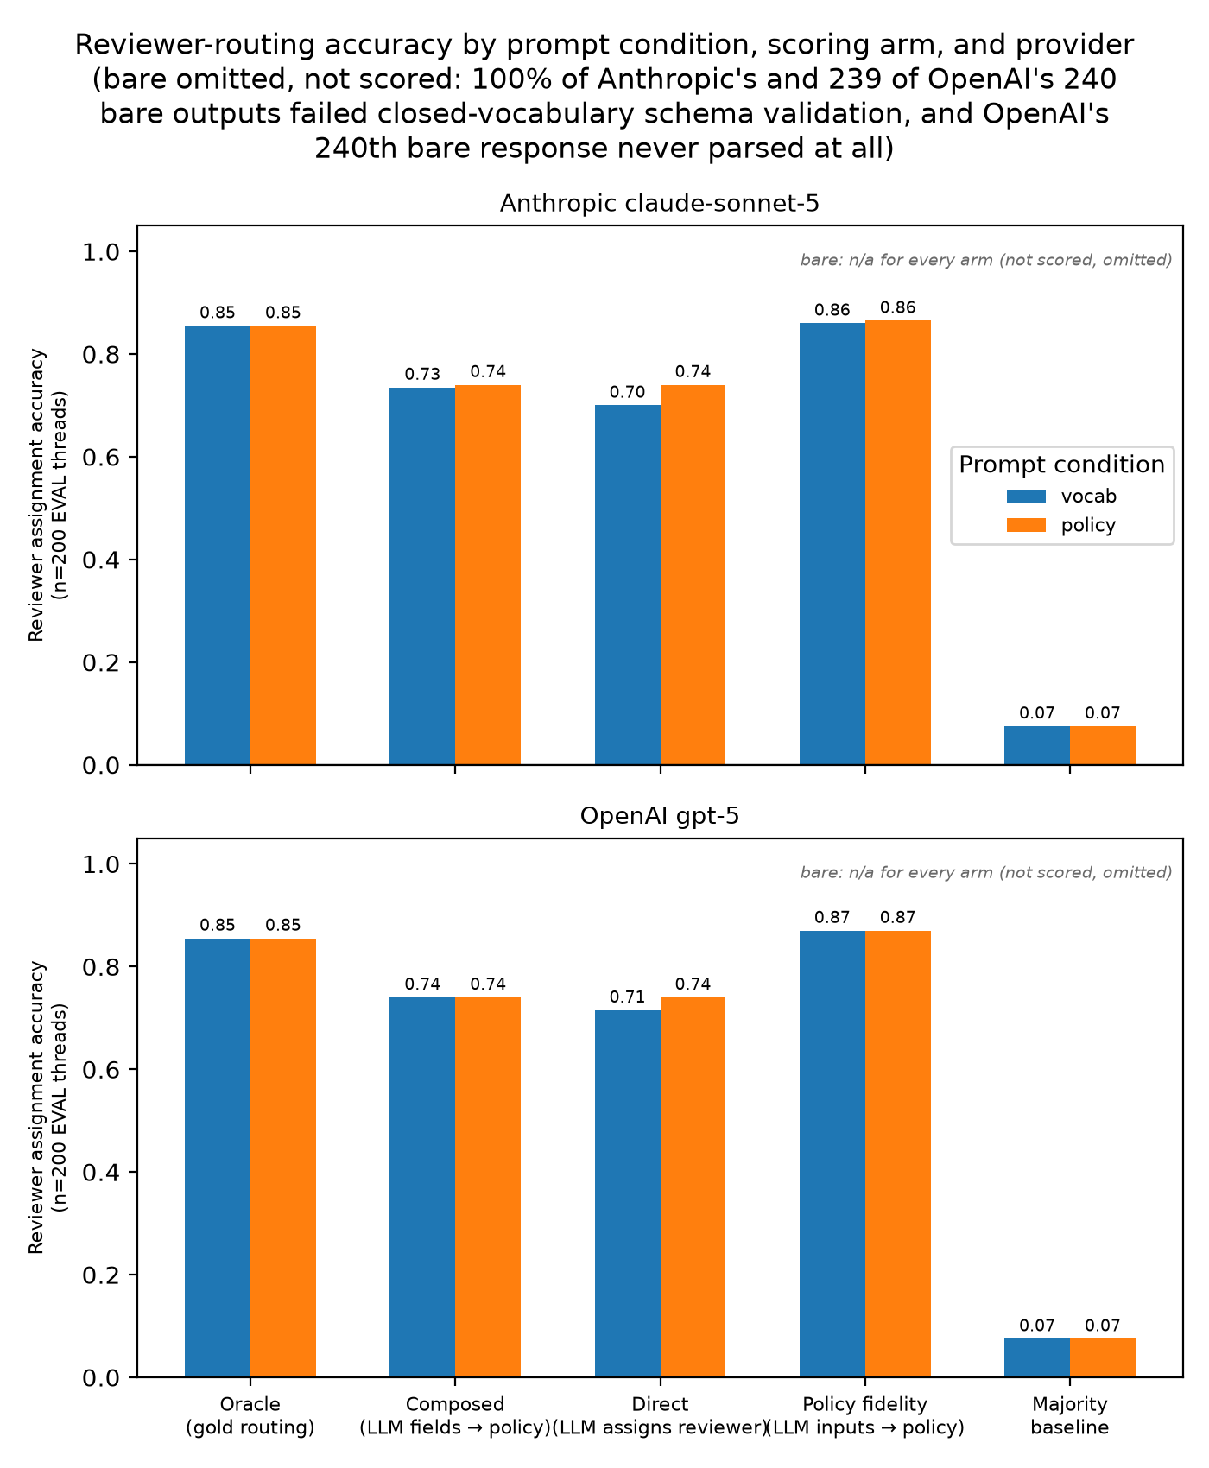
Figure 1. Reviewer-routing accuracy by prompt condition, scoring arm, and provider (Anthropic claude-sonnet-5 and OpenAI gpt-5). The bare condition is omitted and not scored: 100% of Anthropic's bare outputs failed closed-vocabulary schema validation, as did 239 of OpenAI's 240, with OpenAI's 240th bare response never producing a parseable output at all.
Table 1: Reviewer assignment accuracy (Cohen's κ in parentheses) by scoring arm, provider, and prompt condition, n=200 EVAL-split threads per scored column; bare columns are n/a because those outputs are excluded from scoring (§5.1).
Arm | Anthropic bare | Anthropic vocab | Anthropic policy | OpenAI bare | OpenAI vocab | OpenAI policy
oracle | n/a (0 scored) | 0.8550 (κ=0.834) | 0.8550 (κ=0.834) | n/a (0 scored) | 0.8550 (κ=0.834) | 0.8550 (κ=0.834)
composed | n/a | 0.7350 (κ=0.700) | 0.7400 (κ=0.705) | n/a | 0.7400 (κ=0.704) | 0.7400 (κ=0.705)
direct | n/a | 0.7000 (κ=0.658) | 0.7400 (κ=0.705) | n/a | 0.7150 (κ=0.674) | 0.7400 (κ=0.705)
policy_fidelity | n/a | 0.8600 (κ=0.837) | 0.8650 (κ=0.843) | n/a | 0.8700 (κ=0.848) | 0.8700 (κ=0.848)
majority | n/a | 0.0750 (κ=0.000) | 0.0750 (κ=0.000) | n/a | 0.0750 (κ=0.000) | 0.0750 (κ=0.000)
(oracle and majority are computed from the label pool independent of the LLM condition beyond which threads have a valid matched prediction; their near-identical values across every column reflect that all four provider/condition pairs produce a fully valid 200/200 EVAL-split match.) This is now a completed 2-provider × 3-condition grid (bare excluded from scoring by construction, per §5.1); see §5.5 for the cross-provider comparison.
Composing the LLM's classification fields with the deterministic routing policy (composed) reaches 73.5% (vocab) / 74.0% (policy) reviewer accuracy against an 85.5% oracle ceiling: most of the residual gap to the ceiling is attributable to classification-field noise, not to policy/gold divergence, since policy_fidelity (which holds the policy law fixed on both sides) is higher than composed for both conditions (86.0% / 86.5%), close to the oracle's own 85.5%. Giving the LLM the routing-policy text directly (policy condition) does not improve composed accuracy over vocab alone in this pilot (73.5% → 74.0%, a 0.5-point difference on 200 threads); the closed vocabulary, not the policy-table injection, is doing essentially all of the useful work, matching §5.1's stronger finding that the vocabulary is what turns the pipeline schema-valid at all. The direct arm (the LLM's own routing guess, no policy) trails composed under vocab (70.0% vs. 73.5%) but ties it under policy (74.0% both), plausibly because seeing the policy text lets the model's own routing guess mimic the deterministic rule it was shown, collapsing the composed/direct gap that vocab-only leaves open. The majority baseline's 7.5% accuracy against a ten-role taxonomy confirms the task is not trivially dominated by one reviewer role.

5.3 Confidence/Escalation Gating
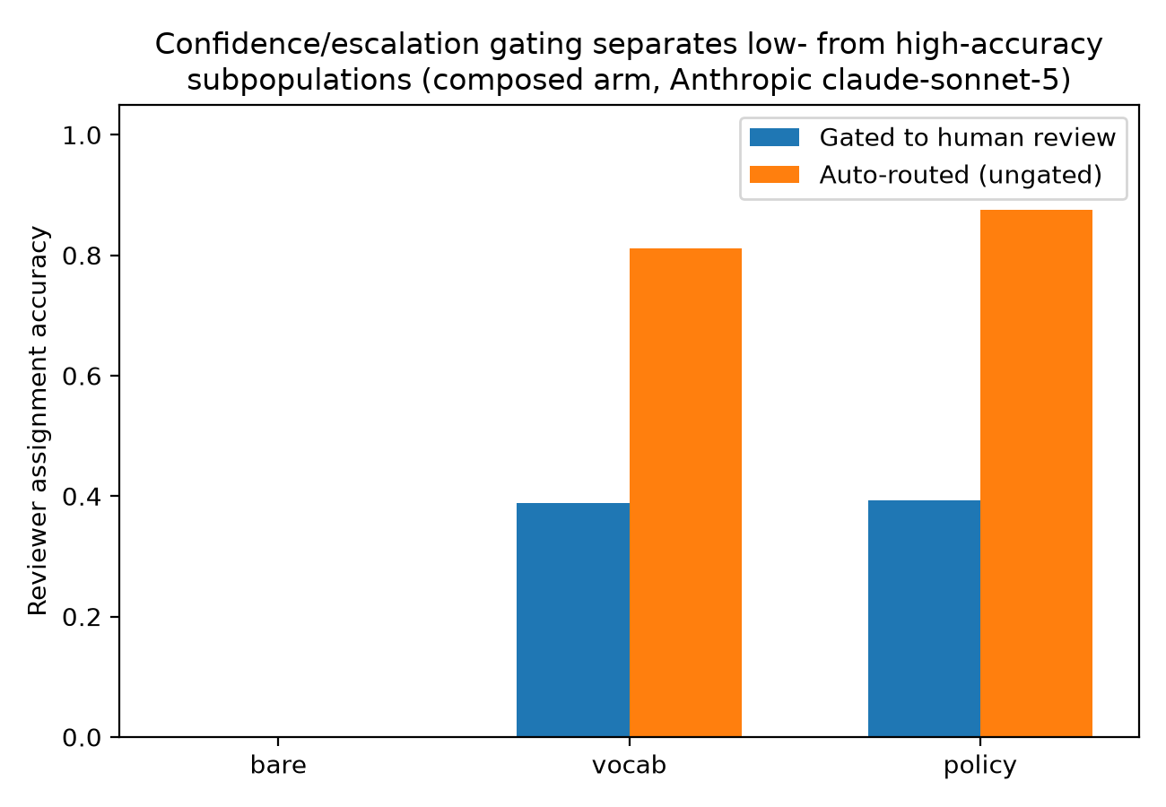
Figure 2. Confidence/escalation gating separates low- from high-accuracy subpopulations (composed arm, Anthropic claude-sonnet-5).
Under vocab, the composed arm's 36 gated EVAL-split threads (3 by low confidence, 34 by an escalation flag) score 38.9% reviewer accuracy versus 81.1% for the 164 ungated threads, an over-40-point split. Under policy, 56 threads are gated (55 by escalation, 1 by confidence), scoring 39.3% vs. 87.5% ungated. The number gated increases from 36 to 56 under policy, plausibly because seeing the routing-policy text makes the model more willing to flag escalation=true, without moving the gated subpopulation's own accuracy (38.9% → 39.3%, essentially unchanged). Confidence/escalation gating is doing its intended job: separating a small, genuinely hard-to-route subset from a large majority the pipeline routes reliably, not serving as a global accuracy dial.

5.4 Inter-Annotator Agreement (Disclosed LLM Proxy)
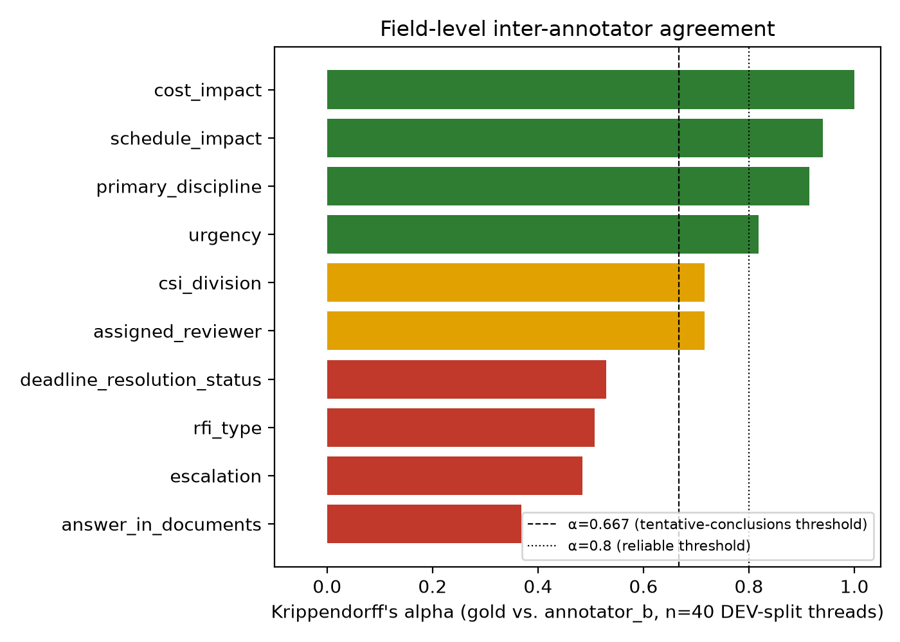
Figure 3. Field-level inter-annotator agreement.
Over the 40 DEV-split threads, gold vs. the disclosed annotator_b proxy (§3.5) reach Krippendorff's α = 0.914 (primary_discipline), 0.818 (urgency), 0.716 (csi_division and, separately, assigned_reviewer, both 0.716), 0.507 (rfi_type), and 0.484 (escalation, the lowest of the reported nominal/ordinal/boolean fields). cost_impact (α=1.000) and schedule_impact (α=0.940) show near-perfect agreement; answer_in_documents is lower (α=0.368) despite 92.5% raw percent agreement, consistent with a skewed-prevalence field where chance-corrected agreement diverges sharply from percent agreement. The policy-decomposition check finds only 40.0% raw agreement between the two annotators' own five policy-input fields taken jointly, yet a substantially higher reviewer-alpha of 0.943 when each annotator's own inputs are separately run through the same deterministic policy, i.e., the two annotators often reach the same effective routing decision via inputs that differ field-by-field, which the policy function's many-to-one structure absorbs.

5.5 Cross-Provider Replication
A parallel run with OpenAI gpt-5 completes the full 2-provider × 3-condition ablation grid. Under bare, OpenAI reproduces §5.1's finding independently: 239 of 240 threads produced a response, and every one of those 239 fails validate_label() for the same class of reasons as the Anthropic bare run (out-of-vocabulary values absent a supplied taxonomy); the 240th thread failed before producing a parseable response at all. Under vocab and policy, OpenAI produces 240/240 schema-valid outputs for each condition (the same 100% validity Anthropic achieves once the closed vocabulary is present, §5.1), and all 200 EVAL-split threads match a gold label with zero strict-mode failures for both conditions.
The resulting OpenAI accuracy numbers (Table 1, §5.2) closely track Anthropic's: composed reviewer accuracy is 74.0% under both vocab and policy for OpenAI (vs. Anthropic's 73.5% → 74.0%), and the direct arm again trails composed under vocab (71.5% vs. 74.0%) before converging under policy (74.0% both), the same qualitative pattern §5.2 reports for Anthropic. policy_fidelity is 87.0% for OpenAI under both conditions, against an identical 85.5% oracle ceiling (oracle and majority are provider-independent given a fully valid, fully matched prediction set; §5.2). Escalation gating also replicates directionally: OpenAI's composed arm shows a gated/ungated accuracy split of 50.0% vs. 75.0% under vocab (8 gated EVAL-split threads) and 50.0% vs. 83.8% under policy (58 gated threads); gating count grows sharply from vocab to policy for OpenAI too, mirroring Anthropic's 36→56 growth in §5.3, though the two providers gate different absolute counts (36/56 Anthropic vs. 8/58 OpenAI), which we report without further interpretation given the single-run-per-condition scope of this pilot (§6.2).
Two independent providers therefore agree, within 1.5 accuracy points on every scoring arm, on both of this paper's central findings: closed-vocabulary injection is what separates a 0%- from a fully schema-valid pipeline (§5.1), and adding the routing-policy text on top of the vocabulary does not further improve composed routing accuracy (§5.2). Within this experiment, this is evidence the findings are a property of the vocab/policy prompt design and task, not an artifact of one model's particular behavior; extending that claim to other prompt phrasings, model families, or real (non-synthetic) RFI text would require the replication §6.3 lays out, not this pilot alone.

6. DISCUSSION AND LIMITATIONS

6.1 Threats to Validity
The corpus is synthetic, not sampled from real project RFI logs — real RFIs may exhibit discourse patterns, ambiguity, or discipline distributions this generator's templates do not cover, and the 85.5% oracle ceiling is a property of this corpus's deliberate policy-divergence rate, not a universal constant. The fully-scored ablation (vocab vs. policy) now spans two LLM providers (Anthropic and OpenAI, §5.5), each run once per condition; it does not yet span multiple model families beyond these two commercial providers, nor repeated sampling within a provider to estimate run-to-run variance. Gold labels and the routing policy were authored by the same research team that designed the ablation, which is why policy_audit.py's independent divergence census and this paper's oracle arm both exist as a check against circularity, but a fully external validation would strengthen this further.

6.2 Limitations (Explicit, In-Scope)
- Synthetic corpus. Real construction RFI text was not used or available for this pilot; external validity to real project logs is untested.
- Disclosed LLM-proxy second annotator. §3.5/§5.4's inter-annotator agreement numbers measure gold vs. one specific LLM's judgment, not human-human reliability. They should be read as a label-scheme reliability signal, not a substitute for a human IAA study.
- Single sample per condition/provider. Each of the six provider/condition cells (§5.5) was run once; point estimates have no resampling-based confidence interval, and no repeated-sampling or temperature sweep was performed to estimate run-to-run variance.
- Single confidence-gate threshold. Gating uses one fixed threshold (0.6); §5.3's gate-tradeoff numbers are specific to that choice.
- 240-thread pilot scale. Per-stratum cell counts (e.g. individual adversarial categories, some with n≤5 DEV-split threads; see §5.4's stratified breakdown in pilot-data/annotator_agreement/agreement_report.md) are too small for some stratified agreement estimates to be statistically stable on their own.

6.3 Future Work
Repeat each provider/condition cell with multiple samples to estimate run-to-run variance, instead of the single run per cell reported here; extend the ablation to additional model families beyond the two commercial providers studied; extend the corpus with a sample of real (de-identified) project RFI text if a data-sharing agreement becomes available; recruit a genuine second human annotator to replace or supplement §3.5's disclosed LLM proxy; sweep the confidence-gate threshold instead of reporting a single value.

7. CONCLUSION
In this 240-thread synthetic pilot, supplying closed vocabularies made all evaluated outputs schema-valid, while adding routing-policy text produced little change in composed reviewer accuracy. The result was similar across the two providers tested. Because each condition was run once and the corpus is synthetic, performance on real project RFIs remains untested.
Two practical implications follow directly. First, teams deploying an LLM for RFI (or, more generally, construction-document) classification should treat closed-vocabulary prompt engineering as a required correctness mechanism, not a stylistic refinement: the bare condition's complete failure (§5.1) is not a tuning problem an ordinarily "better" prompt would fix, since all but one of the 480 bare outputs across both providers parsed as valid JSON and failed only on semantic vocabulary grounds (the single exception being the one OpenAI response that never parsed at all, §5.5). Second, a deterministic, auditable routing policy composed on top of validated LLM classification fields is worth retaining even when it does not lift accuracy over the classification fields alone, because it makes the final routing decision traceable to a named contractual rule (§3.3) instead of an opaque model judgment, a property this paper's evaluation design can quantify (via policy_fidelity vs. composed, §5.2) but that a single blended accuracy metric would obscure.
This is a pilot-scale study on a synthetic corpus with a single run per provider/condition cell, and §6.2 states its limitations plainly instead of implying a broader claim than the data supports. The most direct next steps are exactly the limitations named in §6.2, not new work invented for this section: repeated sampling to quantify run-to-run variance, validating against real (de-identified) project RFI text, and replacing the disclosed LLM proxy with a genuine second human annotator.

CODE AND DATA AVAILABILITY
Corpus generator, prompt/vocabulary/policy modules, classification pipeline, scoring, and agreement code: code/. Synthetic corpus, all raw LLM predictions, and every evaluation/agreement report referenced in Section 5: pilot-data/. Figures regenerate deterministically from those JSON reports via python code/make_figures.py. Available at https://github.com/vns-shiva/rfi-classification-routing.

APPENDIX A: PROMPTS
All three conditions share one instruction sentence and one output-schema block; vocab appends the vocabulary block, and policy appends the vocabulary block plus the policy block (prompts.build_classification_system_prompt() joins the applicable parts with a single blank line). Text below is reproduced verbatim from code/prompts.py (PROMPT_VERSION = "v1").

A.1 Shared instruction sentence (all conditions)
You are an experienced construction project engineer classifying and routing
a Request for Information (RFI) thread for a commercial construction project.

A.2 Shared output-schema block (all conditions)
Return a single JSON object (no prose, no markdown fences) with exactly these fields:
{
"rfi_type": string,
"primary_discipline": string,
"secondary_disciplines": [string, ...],
"csi_division": string,
"urgency": string,
"question_summary": string,
"referenced_documents": [string, ...],
"proposed_solution": string,
"cost_impact": boolean,
"schedule_impact": boolean,
"answer_in_documents": boolean,
"deadline_text": string,
"assigned_reviewer": string,
"routing_rationale": string,
"escalation": boolean,
"confidence": number
}
Field notes:
- secondary_disciplines: other disciplines materially involved, excluding primary_discipline. Empty list if none.
- csi_division: the CSI MasterFormat 2016 group-level division the RFI's subject matter falls under, or the
literal string "—" if primary_discipline has no associated CSI division.
- proposed_solution: the submitter's proposed answer if they gave one, else the literal string "—".
- answer_in_documents: true only if the referenced documents already contain the answer to the question asked
(the submitter should not have needed to ask).
- deadline_text: the verbatim phrase describing when a response is needed, or "none stated" if none is given.
- routing_rationale: one sentence explaining the assigned_reviewer choice.
- confidence: your confidence in this classification as a whole, in [0, 1].
The bare condition's system prompt is exactly A.1 + A.2, with nothing else appended: no taxonomy, no policy.

A.3 Vocabulary block (appended for vocab and policy)
Use only these closed vocabularies:
rfi_type (exactly one): code_compliance_question, coordination_conflict, design_clarification, document_discrepancy, field_condition_conflict, substitution_request
primary_discipline / secondary_disciplines (from this set): Architectural, Civil, Electrical, Fire_Protection, General, Mechanical, Plumbing, Structural
csi_division must be consistent with primary_discipline, from:
Architectural: 06 00 00 (Wood, Plastics, Composites), 07 00 00 (Thermal and Moisture Protection), 08 00 00 (Openings), 09 00 00 (Finishes)
Civil: 31 00 00 (Earthwork), 32 00 00 (Exterior Improvements), 33 00 00 (Utilities)
Electrical: 26 00 00 (Electrical), 27 00 00 (Communications), 28 00 00 (Electronic Safety and Security)
Fire_Protection: 21 00 00 (Fire Suppression)
General: (no CSI division; use "—")
Mechanical: 23 00 00 (HVAC)
Plumbing: 21 00 00 (Fire Suppression), 22 00 00 (Plumbing)
Structural: 03 00 00 (Concrete), 04 00 00 (Masonry), 05 00 00 (Metals), 31 00 00 (Earthwork)
urgency (exactly one, low to high severity): routine, priority, urgent, critical
assigned_reviewer (exactly one): Architect of Record, Structural Engineer, Mechanical Engineer, Electrical Engineer, Plumbing/Fire Protection Engineer, Civil Engineer, GC Superintendent, Owner's Representative, Cost/Change-Order Manager, Code Official/AHJ Liaison

A.4 Policy block (appended for policy only)
When choosing assigned_reviewer, apply this routing policy (adapted from AIA A201
§3.2.4 / ConsensusDocs 200 §12.2 ball-in-court practice):
1. If rfi_type is "code_compliance_question": route to "Code Official/AHJ Liaison",
regardless of discipline.
2. Else if rfi_type is "substitution_request" and cost_impact is true: route to
"Cost/Change-Order Manager".
3. Else if rfi_type is "field_condition_conflict" and schedule_impact is true and
urgency is "urgent" or "critical": route to "GC Superintendent".
4. Otherwise: route to the design professional of record for primary_discipline
(Architect of Record for Architectural or General; the matching discipline
engineer otherwise; Plumbing/Fire Protection Engineer for both Plumbing and
Fire_Protection).
Set escalation to true if urgency is "urgent" or "critical", or if both cost_impact
and schedule_impact are true.
Note that the model is shown this documented rule in plain language only (never routing_policy.py's source code), and that gold labels are never derived from this policy (§3.2); the policy block's presence or absence is exactly what distinguishes the policy condition from vocab in §5.2's ablation.

A.5 Per-thread user prompt (all conditions)
Project: {thread.project}
RFI number: {thread.rfi_number}
{thread.render()}
Classify and route this RFI thread. Respond with the JSON object only.

A.6 Repair instruction (appended to the user prompt on a parse failure only)
Appended to the user prompt, never the system prompt: classify.py's response cache is keyed on (system, user), so changing only the user text on retry avoids replaying an identical cached failure forever. Used once, bounded to a single retry, and only on an unparseable (not merely schema-invalid) response (§3.4). {truncated} is the previous response sliced to 1200 characters (build_repair_instruction's max_payload_chars default) so a wildly long malformed response cannot blow up retry token cost.
Your previous response could not be parsed into the required JSON schema.
Previous response:
{truncated}
Problem: {errors}
Return ONLY a corrected, single JSON object matching the schema above — no prose, no markdown fences.

References
[1] Panahi, R., Kivlin, J.-P., Louis, J. Request for Information (RFI) Recommender System for Pre-Construction Design Review Application Using Natural Language Processing, Chat-GPT, and Computer Vision. In: Computing in Civil Engineering 2023. ASCE; 2023. https://doi.org/10.1061/9780784485224.020
[2] Kampelopoulos, D., Tsanousa, A., Vrochidis, S., Kompatsiaris, I. A review of LLMs and their applications in the architecture, engineering and construction industry. Artificial Intelligence Review 2025;58:1–46. https://doi.org/10.1007/s10462-025-11241-7
[3] Gao, Y., Yiu, T.W., Shen, X., Tam, V.W. Large language models in smart construction: a systematic review of implementation strategies, applications and future directions. Engineering, Construction and Architectural Management 2025;33(15):159–181. https://doi.org/10.1108/ECAM-10-2025-1668
[4] Tam, Z.R., Wu, C.-K., Tsai, Y.-L., Lin, C.-Y., Lee, H., Chen, Y.-N. Let Me Speak Freely? A Study on the Impact of Format Restrictions on Performance of Large Language Models. arXiv:2408.02442; 2024.
[5] Geng, S., Cooper, H., Moskal, M., Jenkins, S., Berman, J., Ranchin, N., West, R., Horvitz, E., Nori, H. JSONSchemaBench: A Rigorous Benchmark of Structured Outputs for Language Models. arXiv:2501.10868; 2025.
[6] Patil, S.G., Zhang, T., Wang, X., Gonzalez, J.E. Gorilla: Large Language Model Connected with Massive APIs. arXiv:2305.15334; 2023.
[7] Hanna, A.S., Tadt, E.J., Whited, G.C. Request for Information: Benchmarks and Metrics for Major Highway Projects. Journal of Construction Engineering and Management 2012;138(12):1347–1352.
[8] Mohamed, S., Tilley, P.A., Tucker, S.N. Quantifying the Time and Cost Associated with the Request For Information (RFI) Process in Construction. Construction Innovation 2007;7(1):35–50.
[9] Aibinu, A.A., Carter, S., Francis, V., Vaz-Serra, P. Request for information frequency and their turnaround time in construction projects: A data-analytic study. Built Environment Project and Asset Management 2020;10(1):1–15. https://doi.org/10.1108/BEPAM-10-2018-0130
[10] Joy, L.P., Sahyoun, S., Wang, J., Sourav, M.S.U., Zhao, Y., Yan, J., Ge, H., Zeng, Y., Nik-Bakht, M. Enhancing Request for Information (RFI) Process in Construction through Digitalization and Automation. In: Construction Research Congress (CRC) 2025. CSCE/ASCE; 2025. https://doi.org/10.22260/CRC-CSCE-2025/0202
[11] Xu, N., Zhou, X., Guo, C., Xiao, B., Wei, F., Hu, Y. Text Mining Applications in the Construction Industry: Current Status, Research Gaps, and Prospects. Sustainability 2022;14(24):16846. https://doi.org/10.3390/su142416846
[12] Moon, S., Chi, S., Im, S.B. Automated detection of contractual risk clauses from construction specifications using bidirectional encoder representations from transformers (BERT). Automation in Construction 2022;142:104465. https://doi.org/10.1016/j.autcon.2022.104465
[13] Pham, H.T.T.L., Han, S. Natural Language Processing with Multitask Classification for Semantic Prediction of Risk-Handling Actions in Construction Contracts. Journal of Computing in Civil Engineering 2023;37(6):04023027. https://doi.org/10.1061/JCCEE5.CPENG-5218
[14] Dikmen, I., Eken, G., Erol, H., Birgonul, M.T. Automated construction contract analysis for risk and responsibility assessment using natural language processing and machine learning. Computers in Industry 2025;166:104251. https://doi.org/10.1016/j.compind.2025.104251
[15] Zheng, C., Wong, S., Su, X., Tang, Y., Nawaz, A., Kassem, M. Automating construction contract review using knowledge graph-enhanced large language models. arXiv:2309.12132; 2023.
[16] Erfani, A., Khanjar, H. Large Language Models for Construction Risk Classification: A Comparative Study. Buildings 2025;15(18):3379. https://doi.org/10.3390/buildings15183379
[17] Emara, M. Ontology-Driven GPT-4 Question Answering on Construction Standards. In: Proceedings of the 36th Forum Bauinformatik. RWTH Aachen; 2025. https://doi.org/10.18154/RWTH-CONV-254874
[18] Ong, I., Almahairi, A., Wu, V., Chiang, W.-L., Wu, T., Gonzalez, J.E., Kadous, M.W., Stoica, I. RouteLLM: Learning to Route LLMs with Preference Data. arXiv:2406.18665; 2024.
[19] Zhou, L., Li, J. Few-Shot Large Language Models for Actionable Triage Categorization of Online Patient Inquiries. arXiv:2605.15680; 2026.
[20] Madeyski, L. Triage: Routing Software Engineering Tasks to Cost-Effective LLM Tiers via Code Quality Signals. arXiv:2604.07494; 2026.
[21] Cohen, J. Weighted kappa: Nominal scale agreement with provision for scaled disagreement or partial credit. Psychological Bulletin 1968;70(4):213–220. https://doi.org/10.1037/h0026256
[22] Passonneau, R.J. Measuring Agreement on Set-valued Items (MASI) for Semantic and Pragmatic Annotation. In: Proceedings of the Fifth International Conference on Language Resources and Evaluation (LREC 2006). ACL Anthology L06-1392; 2006.
[23] James, J. Counting on Consensus: Selecting the Right Inter-annotator Agreement Metric for NLP Annotation and Evaluation. In: Proceedings of LREC 2026. arXiv:2603.06865; 2026.
[24] Gilardi, F., Alizadeh, M., Kubli, M. ChatGPT outperforms crowd workers for text-annotation tasks. Proceedings of the National Academy of Sciences 2023;120(30):e2305016120. https://doi.org/10.1073/pnas.2305016120
[25] Gu, F., Li, Z., Colon, C.R., Evans, B., Mondal, I., Boyd-Graber, J.L. Large Language Models Are Effective Human Annotation Assistants, But Not Good Independent Annotators. In: Findings of the Association for Computational Linguistics: ACL 2026. arXiv:2503.06778; 2026.
[26] Bojic, L., Zagovora, O., Zelenkauskaite, A., Vukovic, V., Cabarkapa, M., Veseljevic Jerkovic, S., Jovancevic, A. Comparing large language models and human annotators in latent content analysis of sentiment, political leaning, emotional intensity and sarcasm. Scientific Reports 2025;15. https://doi.org/10.1038/s41598-025-96508-3
[27] Zhu, K., Wang, J., Zhou, J., Wang, Z., Chen, H., Wang, Y., Yang, L., Ye, W., Zhang, Y., Gong, N.Z., Xie, X. PromptBench: Towards Evaluating the Robustness of Large Language Models on Adversarial Prompts. arXiv:2306.04528; 2023.
[28] Hua, A., Tang, K., Gu, C., Gu, J., Wong, E., Qin, Y. Flaw or Artifact? Rethinking Prompt Sensitivity in Evaluating LLMs. In: Proceedings of EMNLP 2025. arXiv:2509.01790; 2025.
[29] Egwim, C.N., Alaka, H., Demir, E., Balogun, H., Olu-Ajayi, R., Sulaimon, I., Wusu, G., Yusuf, W., Muideen, A.A. Artificial Intelligence in the Construction Industry: A Systematic Review of the Entire Construction Value Chain Lifecycle. Energies 2024;17(1):182. https://doi.org/10.3390/en17010182
[30] Gill, E.Z., Cardone, D., Amelio, A. Revolutionizing the construction industry by cutting edge artificial intelligence approaches: a review. Frontiers in Artificial Intelligence 2024;7:1474932. https://doi.org/10.3389/frai.2024.1474932

