WORKING PAPER

DOES FINANCIAL INCLUSION CREATE SOCIAL VALUE?
State-Level Evidence from India

Author: Dinesh Kumar Pandey
Affiliation: MSc Student, Global Investment Management, Ulster University Belfast
Contact: Personal email: vnsdinesh@gmail.com; Official email: Pandey-D@ulster.ac.uk
Date: 11 August 2026
Version: SROI Working Paper 1
This is a working paper. Please do not cite without permission.

Keywords: Financial Inclusion; Social Value; Social Return on Investment (SROI); Blended Value; Microfinance; Self-Help Groups (SHGs); India
JEL Classification: G21 · O16 · O53

Table of Contents
- Introduction
- Institutional Context: Inclusive Finance in India
- Literature Review
- Conceptual Framework and Hypotheses
- Data
- Methodology
- Results
- Discussion
- Conclusion

References

Appendix

List of Tables
Table | Title
Table 1 | Data Sources and Principal Variables
Table 2 | Preliminary Descriptive Statistics
Table 3 | Pearson Correlation Matrix
Table 4 | Preliminary OLS Regression Results
Table 5 | Exploratory OLS Regression of Hospital Expenditure
Table 6 | Summary of Hypothesis Tests
Appendix Table A1 | Full State-Level FIIndex Values and Component Indicators
Appendix Table A2 | Full State-Level SROIMetrics Values and Component Indicators
Appendix Table A3 | Pearson Correlation Matrix
Appendix Table A4 | Variance Inflation Factors
Appendix Table A5 | Exploratory OLS Regression of Hospital Expenditure

List of Figures
Chart | Title
Figure 1 | Conceptual Framework: Financial Inclusion, Stakeholder Outcomes and Social Value
Figure 2 | FIIndex and SROIMetrics_nonoverlap
Figure 3 | Correlation Heatmap: Financial Inclusion, Social Value and State-Level Indicators
Figure 4 | State-Level Distribution of FIIndex
Appendix Figure 5 | SHG Microfinance and Formal Financial Depth
Appendix Figure 6 | Log Deposits and Hospital Expenditure

ABSTRACT
This paper examines whether financial inclusion and social value move together across Indian states, or whether formal financial depth crowds out welfare outcomes for vulnerable households. Using official state-level data on bank deposits, Self-Help Group (SHG) savings and lending, consumption, literacy, health vulnerability and non-performing assets, I construct two composite measures: a Financial Inclusion Index (FIIndex) and an SROI-inspired social-value index (SROIMetrics), together with a non-overlapping variant that excludes SHG components shared with FIIndex. Cross-sectional correlations and robust OLS regressions show that FIIndex has a weak and statistically insignificant relationship with the non-overlapping social-value measure, whereas rural consumption and literacy are the strongest predictors of social value. Formal financial depth, measured by log deposits, is negatively but insignificantly associated with social value. These findings caution against interpreting deposit growth or credit expansion alone as evidence of inclusive social value and suggest that socioeconomic conditions explain more variation in stakeholder outcomes than financial inclusion metrics. The analysis demonstrates a transparent method for integrating financial and social indicators in inclusive finance, while highlighting the need for household or institution-level panel data and stronger counterfactual designs to identify causal effects.

1. Introduction
Financial inclusion has become a central policy and finance objective in India. Public initiatives such as the Pradhan Mantri Jan Dhan Yojana (PMJDY), the expansion of bank branches and business correspondents, and the rapid growth of digital payments have increased the reach of formal financial services (Reserve Bank of India, 2018; World Bank, 2022). At the same time, the SHG-bank linkage programme, supported by NABARD and state governments, has extended savings and credit services to millions of rural households, particularly women, who may face barriers to accessing conventional bank lending (NABARD, 2018). These developments are motivated by the belief that access to appropriate financial services can help households manage income volatility, finance productive activity, invest in human capital and respond to unexpected expenditure.

Yet the existence of financial infrastructure does not necessarily mean that services are affordable, accessible or beneficial to financially excluded households. Aggregate indicators such as total deposits, number of accounts or branch density may reflect state size, urban concentration and the intensity of formal banking activity rather than meaningful inclusion among poorer and rural households. An institution may increase its lending and improve its portfolio quality by concentrating on safer or wealthier clients, while households facing the greatest exclusion remain underserved. Conversely, an institution may generate significant social benefits through outreach and client support that are not fully reflected in conventional financial ratios. This creates an important measurement challenge for investors, financial institutions and regulators: how can we assess whether financial expansion is reaching vulnerable stakeholders and generating wider social value?

This paper addresses this question by asking: does financial inclusion create social value in India, or does formal financial depth crowd out welfare outcomes for vulnerable households? The analysis is grounded in stakeholder theory and blended-value logic. Borrowers, SHG members and communities are treated as social stakeholders, while banks, investors and regulators require financial sustainability, stability and accountability. Social Return on Investment (SROI) provides a useful framework for addressing this problem because it directs attention towards outcomes experienced by different stakeholders rather than financial returns alone (Nicholls and Murdock, 2012). A conventional SROI assessment identifies relevant stakeholders, maps the relationship between activities and outcomes, assigns monetary proxies to material social benefits and compares the estimated social value with the investment required to produce it. In a microfinance setting, potential stakeholders include borrowers, SHG members, households, communities, financial institutions, investors and the state. Potential outcomes may include increased consumption, improved income stability, greater savings, enhanced economic participation, improved access to health or education and reduced vulnerability to financial shocks.

This report uses SROI as a conceptual and measurement framework, but it does not claim to calculate a complete project-level SROI ratio. The available data are state-level secondary data rather than longitudinal household or institution-level information. Consequently, it is not possible to identify a precise counterfactual, estimate all deadweight and attribution effects, monetise every social outcome or calculate a fully attributable social-value-to-investment ratio. Instead, the report develops an SROI-inspired social-value measure, referred to as SROIMetrics. This composite measure captures several outcome dimensions that are plausibly relevant to inclusive finance, including rural consumption, literacy, health vulnerability and the quality of SHG engagement. It is intended as an exploratory proxy for social value rather than as a substitute for a full SROI evaluation.

The empirical focus of this paper is the Indian state-level financial and socioeconomic environment. States are treated as distinct financial ecosystems in which formal banking, SHG microfinance, household welfare, literacy, health conditions and urbanisation interact. The financial-inclusion index, FIIndex, combines formal banking depth with SHG-based microfinance outreach. Its components include state-level deposits and SHG savings, loan-disbursement and loan-outstanding measures scaled by rural household numbers. Scaling SHG measures by rural households is important because raw totals would primarily reflect state population size rather than the extent of financial access. The use of both formal deposits and SHG indicators also reflect the argument that inclusive finance should not be measured solely through the conventional banking system.
The paper makes three contributions. First, it provides conceptual clarity on how SROI principles can extend the evaluation of inclusive finance beyond conventional risk-return measures while remaining transparent about the limitations of proxy-based measurement (Nicholls and Murdock, 2012). Second, it develops a methodological framework for constructing state-level composite indicators of financial inclusion and social value from heterogeneous official data sources, including the Reserve Bank of India, NABARD, Census, MOSPI/HCES and PLFS (Reserve Bank of India, 2018; NABARD, 2018; Census of India, 2011). Third, it offers policy-relevant evidence on whether financial inclusion and social value appear aligned across Indian states, and identifies states where further investigation of distributional access, borrower protection and welfare outcomes may be warranted.

The central research question is therefore:
How can an SROI-inspired social-value measure complement traditional financial-inclusion and financial-performance indicators in the evaluation of microfinance and inclusive finance in India?

The paper expects that states with stronger formal financial depth and SHG penetration will display higher financial-inclusion scores. It also expects a positive association between financial inclusion and social value if inclusive finance generates blended benefits for households and communities. At the same time, the analysis recognises that higher SHG non-performing assets may indicate repayment stress and weaker social sustainability. The subsequent literature review develops these arguments, the hypotheses section converts them into testable expectations, and the methodology explains how the indices and regression models are constructed.

The results show that financial and social value do not automatically move together. FIIndex has a weak relationship with the non-overlapping SROIMetrics measure, while rural MPCE and literacy are the strongest predictors of social value in the preliminary regressions. These findings caution against interpreting deposit growth or credit expansion alone as evidence of inclusive social value. The study is limited by cross-sectional data, different source periods, incomplete jurisdictional coverage and the proxy nature of SROIMetrics. It does not establish that finance caused welfare outcomes or calculate a full monetary SROI ratio. Nevertheless, it demonstrates a transparent method for integrating financial and social indicators. Future research should use household or institution-level panel data, stronger counterfactual methods and complete SROI attribution. For investors and regulators, the practical implication is that outreach, borrower risk and welfare outcomes should be considered alongside conventional financial performance.

The remainder of the paper is organised as follows. Section 2 describes the institutional context of inclusive finance in India, including formal banking, the SHG-bank linkage programme and the digital-payment landscape. Section 3 reviews the literature on financial inclusion measurement, microfinance and SHG impact, stakeholder theory and blended value, SROI methodology, and mission drift in microfinance. Section 4 sets out the conceptual framework and hypotheses, including the optional digital-finance extension (H5). Section 5 describes the data, variable construction and sample. Section 6 explains the methodology, including index construction and regression specifications. Section 7 presents the results, including descriptive statistics, correlations, main regressions and robustness checks. Section 8 discusses the findings in relation to theory, policy and measurement. Section 9 concludes.

2. Institutional Context: Inclusive Finance in India
India has pursued financial inclusion through a combination of branch expansion, targeted public programmes, community-based microfinance and digital-payment infrastructure. This institutional landscape is important for interpreting state-level measures of financial inclusion and social value, because the mix of formal banking, SHG activity and digital finance vary substantially across states.

2.1 Formal Banking and Public Inclusion Initiatives
The Reserve Bank of India (RBI) has long emphasised financial inclusion as a policy priority, encouraging scheduled commercial banks to expand rural and semi-urban branch networks, adopt priority-sector lending targets and develop low-cost accounts (Reserve Bank of India, 2018). The Pradhan Mantri Jan Dhan Yojana (PMJDY), launched in 2014, accelerated account opening by promoting no-frills savings accounts with minimal documentation, overdraft facilities and RuPay debit cards. While PMJDY significantly increased the number of deposit accounts, account ownership alone does not guarantee active usage, affordable credit or resilience against shocks. Aggregate deposit totals, which form a key component of the FIIndex, therefore capture financial depth but may also reflect state size, urban concentration and the presence of large corporate and retail depositors rather than inclusion among poorer rural households.
Business correspondents (BCs) and small banking outlets have been used to extend the last-mile reach of banks, particularly in rural and remote areas. However, the quality and intensity of BC operations vary across states, depending on state capacity, local economics and the willingness of banks to invest in rural service points. These institutional differences mean that two states with similar deposit totals may have very different levels of effective access for low-income households.

2.2 SHG-Bank Linkage and Community-Based Finance
Alongside formal banking, India has developed one of the world’s largest community-based microfinance systems through the SHG-bank linkage model. Self-Help Groups are typically small, informal associations of 10–20 members, often women, who pool savings, provide internal loans and gradually build a track record that enables linkage to formal bank credit (NABARD, 2018). NABARD’s Status of Microfinance in India reports provide state-level data on SHG savings, loans disbursed, loans outstanding and non-performing assets, which form the microfinance component of the FIIndex and part of SROIMetrics.
The SHG model is particularly relevant in rural areas where households may lack collateral, have irregular income or live far from bank branches. By using group monitoring and social collateral, SHGs can reduce information and transaction costs and support savings discipline and credit access. However, outcomes vary with group governance, local economic conditions, the availability of bank support and the extent to which borrowed funds are used for productive or welfare-enhancing purposes (NABARD, 2018). State-level variation in SHG penetration and NPA intensity therefore provides a valuable lens on the quality and sustainability of inclusion beyond formal deposits.

2.3 Digital Finance and Payment Infrastructure
In recent years, India has built extensive digital-payment infrastructure, including the Unified Payments Interface (UPI), Aadhaar Enabled Payment System (AEPS) and the BHIM app, coordinated by the National Payments Corporation of India (NPCI). These systems have the potential to lower transaction costs, expand access to payments and enable new forms of digital credit and savings (National Payments Corporation of India, 2019). However, consistent state-level data on UPI, AEPS and BHIM usage are not readily available in the same form as RBI and NABARD statistics, and national-level aggregates may mask subnational variation.
For this reason, the current empirical analysis does not include a digital-finance index in the main regressions. Digital indicators are instead treated as an important contextual dimension and a candidate for future extension when comparable state-level data become available. Conceptually, a stronger digital ecosystem could amplify the relationship between social value and financial inclusion by reducing frictions in access and usage, but it could also concentrate activity in urban and commercially attractive areas, potentially weakening the link for rural stakeholders.

2.4 Implications for State-Level Analysis
Taken together, these institutional features justify a state-level analytical framework. States differ in their economic structure, population distribution, banking concentration, SHG penetration and digital infrastructure. Aggregate national indicators can therefore obscure important heterogeneity in how financial inclusion and social outcomes are related. By treating each state as a distinct financial ecosystem, the analysis can examine whether financial depth, SHG outreach and social value appear aligned, and identify states where high FIIndex coexists with weak social outcomes (suggesting possible mission drift or exclusionary expansion) or where strong social outcomes coexist with lower formal financial depth (suggesting opportunities for targeted inclusive-finance investment).

3. Literature Review
This section reviews five strands of literature that inform the research design and interpretation: (i) financial inclusion measurement; (ii) microfinance and SHG impact evidence; (iii) stakeholder theory and blended value in finance; (iv) SROI methodology and applications; and (v) mission drift and social performance in microfinance. A short discussion of digital finance and inclusion follows, before positioning the contribution of this paper.

3.1 Financial Inclusion Measurement
Financial inclusion is commonly defined as effective access to and use of appropriate financial services, including savings, credit, payments, insurance and risk-management products (World Bank, 2022). A narrow definition may focus on whether a household possesses a bank account, but account ownership alone does not demonstrate meaningful inclusion. A broader assessment should also consider affordability, regular usage, geographic accessibility, product quality and the extent to which financial services improve economic resilience.
In India, financial infrastructure has expanded rapidly while access and outcomes remain uneven between states and between urban and rural households. Large deposit volumes or a high number of bank accounts may reflect the size and economic strength of a state rather than effective inclusion among poorer households. Financial inclusion should therefore be evaluated through multiple indicators covering financial depth, access and usage (Reserve Bank of India, 2018). The proposed research follows this approach by combining formal deposit measures with SHG-based savings and lending indicators rather than treating bank deposits as a complete measure of inclusion.
Composite financial-inclusion indices have been constructed in various settings using indicators such as bank branches per capita, deposit and credit volumes, account ownership, usage metrics and demographic controls. The RBI and other institutions have published financial-inclusion metrics that highlight cross-regional disparities (Reserve Bank of India, 2018). However, many existing indices focus primarily on formal banking and do not fully incorporate community-based microfinance, which is a critical channel of inclusion in rural India. This paper extends the measurement literature by constructing a state-level FIIndex that explicitly combines formal deposits with SHG savings and credit penetration, scaled by rural households.

3.2 Microfinance and SHG Impact Evidence
Microfinance provides an important institutional response to exclusion from conventional financial services. Traditional lending systems may exclude low-income households because they lack collateral, have irregular income or live far from formal financial institutions. Microfinance seeks to address these constraints through small loans, collective savings, group monitoring and relationship-based lending. In India, the SHG-bank linkage model is particularly significant because it connects community-based savings groups with formal banking institutions (NABARD, 2018).
SHGs can create several potential benefits. Regular group savings may improve financial discipline and provide a source of emergency finance. Group-based lending can reduce information asymmetries by allowing members to monitor one another. Access to external bank credit may support small enterprises, agricultural activity, consumption smoothing or investment in education and health. SHG participation may also strengthen women’s bargaining power and participation in household financial decisions. However, these effects are not automatic. Outcomes may differ according to the quality of group governance, local economic conditions, the availability of bank support and the extent to which borrowed funds are used productively (NABARD, 2018).
Empirical studies of microfinance impact have produced mixed results. Some find positive associations between microfinance access and consumption, income stability, women’s agency and resilience to shocks. Others find modest or heterogeneous effects, with benefits concentrated among certain groups or contingent on complementary factors such as education, market access and public services. The use of NABARD’s Status of Microfinance in India 2017–18 data supports a more detailed examination of these issues at the state level (NABARD, 2018). The dataset contains state-level information on SHG savings, loans disbursed, loans outstanding and non-performing assets. These measures distinguish between the existence of SHG activity, the flow of new credit, the stock of outstanding credit and the quality or risk of the loan portfolio. The prepared data work converts relevant SHG totals into penetration measures by relating them to rural household numbers. This is preferable to comparing raw state totals because it allows differences in population size to be taken into account.

3.3 Stakeholder Theory and Blended Value
The main theoretical foundation of this report is stakeholder theory. Stakeholder theory argues that organisations affect and have responsibilities towards multiple groups, including customers, employees, investors, communities and public authorities. In inclusive finance, borrowers and SHG members are central stakeholders because they experience the direct consequences of financial products. Investors and financial institutions are also important because they provide capital and require financial sustainability. Regulators and the state have an interest in stability, consumer protection and the achievement of inclusion objectives.
This perspective challenges an assessment based only on profitability or portfolio quality. A microfinance institution may be financially successful while serving relatively safe clients and excluding households with greater social need. Stakeholder theory therefore supports the use of measures that capture outreach, client outcomes and community-level effects alongside conventional financial indicators.
The related concept of blended value proposes that social and financial value should not automatically be treated as separate or mutually exclusive outcomes. An institution may create financial value for investors and social value for borrowers at the same time. Financial sustainability may enable an institution to continue serving excluded communities, while successful outreach may strengthen trust, repayment and institutional legitimacy. The empirical question is whether these dimensions are positively related in the Indian context or whether financial expansion is associated with weaker social outcomes.
The research proposal explicitly positions stakeholder theory and blended value as the central theoretical lens. It presents SROI-type measurement as a way of extending traditional risk-return assessment to borrowers, households and communities (Nicholls and Murdock, 2012). This focused theoretical structure is appropriate because it links the theory, variables, hypotheses and empirical models without attempting to develop several competing theoretical frameworks.

3.4 SROI and Social-Value Measurement
Social Return on Investment provides a structured approach to assessing the wider value created by an intervention. SROI normally involves identifying stakeholders, mapping inputs and activities to outcomes, selecting material outcomes, applying financial proxies and adjusting for factors such as deadweight, attribution and displacement (Nicholls and Murdock, 2012). The resulting social value is then compared with the investment required to generate it.
In a microfinance setting, possible social outcomes include increased income, improved consumption, greater savings, reduced vulnerability, improved education, better health access and enhanced economic participation. Some outcomes can be valued relatively directly, while others, such as empowerment, confidence or community solidarity, are more difficult to monetise. This creates a methodological challenge because a monetary SROI ratio may appear precise even when the underlying valuations are uncertain.
The present study responds to this challenge by using an SROI-inspired state-level index rather than claiming to estimate a complete SROI ratio. SROIMetrics combines normalised indicators of consumption welfare, human capital, health vulnerability and microfinance outcomes. Higher values are designed to represent better social outcomes, while adverse indicators such as illness prevalence or NPA intensity are directionally reversed. This follows the stakeholder and outcome logic of SROI but recognises that the available secondary data cannot establish full attribution or a project-level counterfactual (Nicholls and Murdock, 2012).

3.5 Mission Drift and Social Performance
A central concern in microfinance is mission drift. As institutions grow and seek commercial funding, they may shift towards clients who are easier and less costly to serve. This can improve portfolio quality and profitability but reduce outreach to poorer or riskier households. Social-performance measures are therefore necessary to assess whether financial institutions continue to serve their intended stakeholders.
The literature and proposal identify a gap between conventional financial-performance analysis and systematic social-value measurement. There is also limited state-level work combining formal deposits, SHG penetration, welfare outcomes and health-related indicators in one empirical framework. This report addresses that gap through FIIndex and SROIMetrics. The analysis does not claim to resolve causality, but it provides a transparent preliminary design for examining whether financial and social outcomes move together across Indian states.

3.6 Digital Finance and Inclusion
Digital finance has the potential to expand inclusion by lowering transaction costs, enabling remote payments and facilitating digital credit and savings products. In India, UPI, AEPS and BHIM have grown rapidly, but consistent state-level data are limited (National Payments Corporation of India, 2019). Existing studies suggest that digital adoption is higher in urban and commercially developed areas, raising the possibility that digital expansion could either amplify inclusion or reinforce existing geographic inequalities. This paper treats digital finance as a contextual factor and a candidate for future extension when comparable state-level data become available.

3.7 Literature Gap and Positioning
The literature therefore supports testing rather than assuming complementarity between financial inclusion and social value. A positive relationship between FIIndex and social value would be consistent with blended value, while a weak or negative relationship could indicate that formal financial depth is not translating into broad social outcomes. The present state-level design addresses this issue transparently but cannot establish household-level causality.
This paper contributes to the literature in three ways. First, it develops a transparent, SROI-inspired social-value index that can be related to financial-inclusion measures in a state-level framework (Nicholls and Murdock, 2012). Second, it combines formal banking data with SHG microfinance indicators to construct a composite FIIndex that reflects both financial depth and community-based outreach (Reserve Bank of India, 2018; NABARD, 2018). Third, it provides preliminary empirical evidence on whether financial inclusion and social value appear aligned across Indian states, highlighting the need for more granular household or institution-level studies to identify causal effects.

4. Conceptual Framework and Hypotheses
This section sets out the conceptual logic linking financial inclusion, stakeholder outcomes and social value in Indian inclusive finance. The framework is grounded in stakeholder theory and blended-value logic, and it motivates the construction of the FIIndex and SROIMetrics measures used in the empirical analysis.

4.1 Stakeholders and Value Creation in Inclusive Finance
Financial institutions that serve low-income households affect multiple stakeholder groups. Borrowers and SHG members are direct clients whose welfare may be influenced by access to savings, credit and risk-management products. Communities are affected through local economic activity, women’s participation and the stability of household finances. Investors, banks and regulators have distinct but related objectives: financial sustainability, portfolio quality, systemic stability and accountability.
A narrow risk-return perspective focuses primarily on institutional performance: asset growth, return on equity and portfolio-at-risk. This can reward strategies that expand outreach to relatively safer clients while overlooking excluded or more vulnerable households. Blended-value logic instead treats financial sustainability and social outcomes as potentially complementary objectives. Under this view, an inclusive finance system creates value when it achieves reasonable financial performance while also improving stakeholder welfare, capability and resilience (Nicholls and Murdock, 2012).
Social Return on Investment (SROI) provides a measurement logic aligned with blended value. SROI organises evaluation around stakeholder outcomes, uses financial proxies to express social value in monetary terms where appropriate, and adjusts for attribution, deadweight and displacement. In principle, an SROI ratio compares the present value of social benefits to the cost of investment. In practice, full monetary SROI at scale is data-intensive and sensitive to assumptions about proxies and counterfactuals. This paper therefore uses an SROI-inspired approach: it constructs a composite social-value index from welfare, human-capital and credit-quality indicators, without claiming to estimate a complete monetary SROI ratio.

4.2 From Financial Inclusion to Social Value
Figure 1 illustrates the conceptual pathway from financial inclusion to social value. Financial inclusion is represented by two dimensions: formal financial depth (state-level bank deposits) and community-based microfinance outreach (SHG savings, loan disbursement and loans outstanding, scaled by rural households). These components are combined into the FIIndex, which captures the extent to which households participate in formal and semi-formal financial markets.
Social value is represented by household and community outcomes that matter to stakeholders: rural and urban consumption (MPCE), rural literacy, health vulnerability (inverse PPRA) and microfinance credit quality (SHG savings and inverse NPA intensity). These are combined into SROIMetrics. A non-overlapping variant, SROIMetrics_nonoverlap, excludes the SHG components that are also used in FIIndex, reducing mechanical correlation between the two indices.
The framework allows for three broad patterns:
- Complementarity (blended value): States with higher FIIndex also exhibit higher SROIMetrics_nonoverlap, consistent with financial inclusion supporting welfare, capability and resilience.
- Decoupling: FIIndex and SROIMetrics_nonoverlap are weakly related, implying that formal financial depth and SHG outreach do not automatically translate into stronger stakeholder outcomes.
- Trade-off: Higher FIIndex is associated with lower SROIMetrics_nonoverlap, which could reflect mission drift, over-indebtedness or credit expansion that benefits less vulnerable groups while imposing stress on borrowers.
The empirical analysis tests these patterns using cross-sectional state-level data. Because the data are observational and combine sources from different periods, the results are interpreted as associations rather than causal effects. Nevertheless, the framework provides a structured way to ask whether financial inclusion and social value appear aligned in practice, and to identify states where further investigation of distributional access, borrower protection and welfare outcomes may be warranted.
Figure 1. Conceptual Framework: Financial Inclusion, Stakeholder Outcomes and Social Value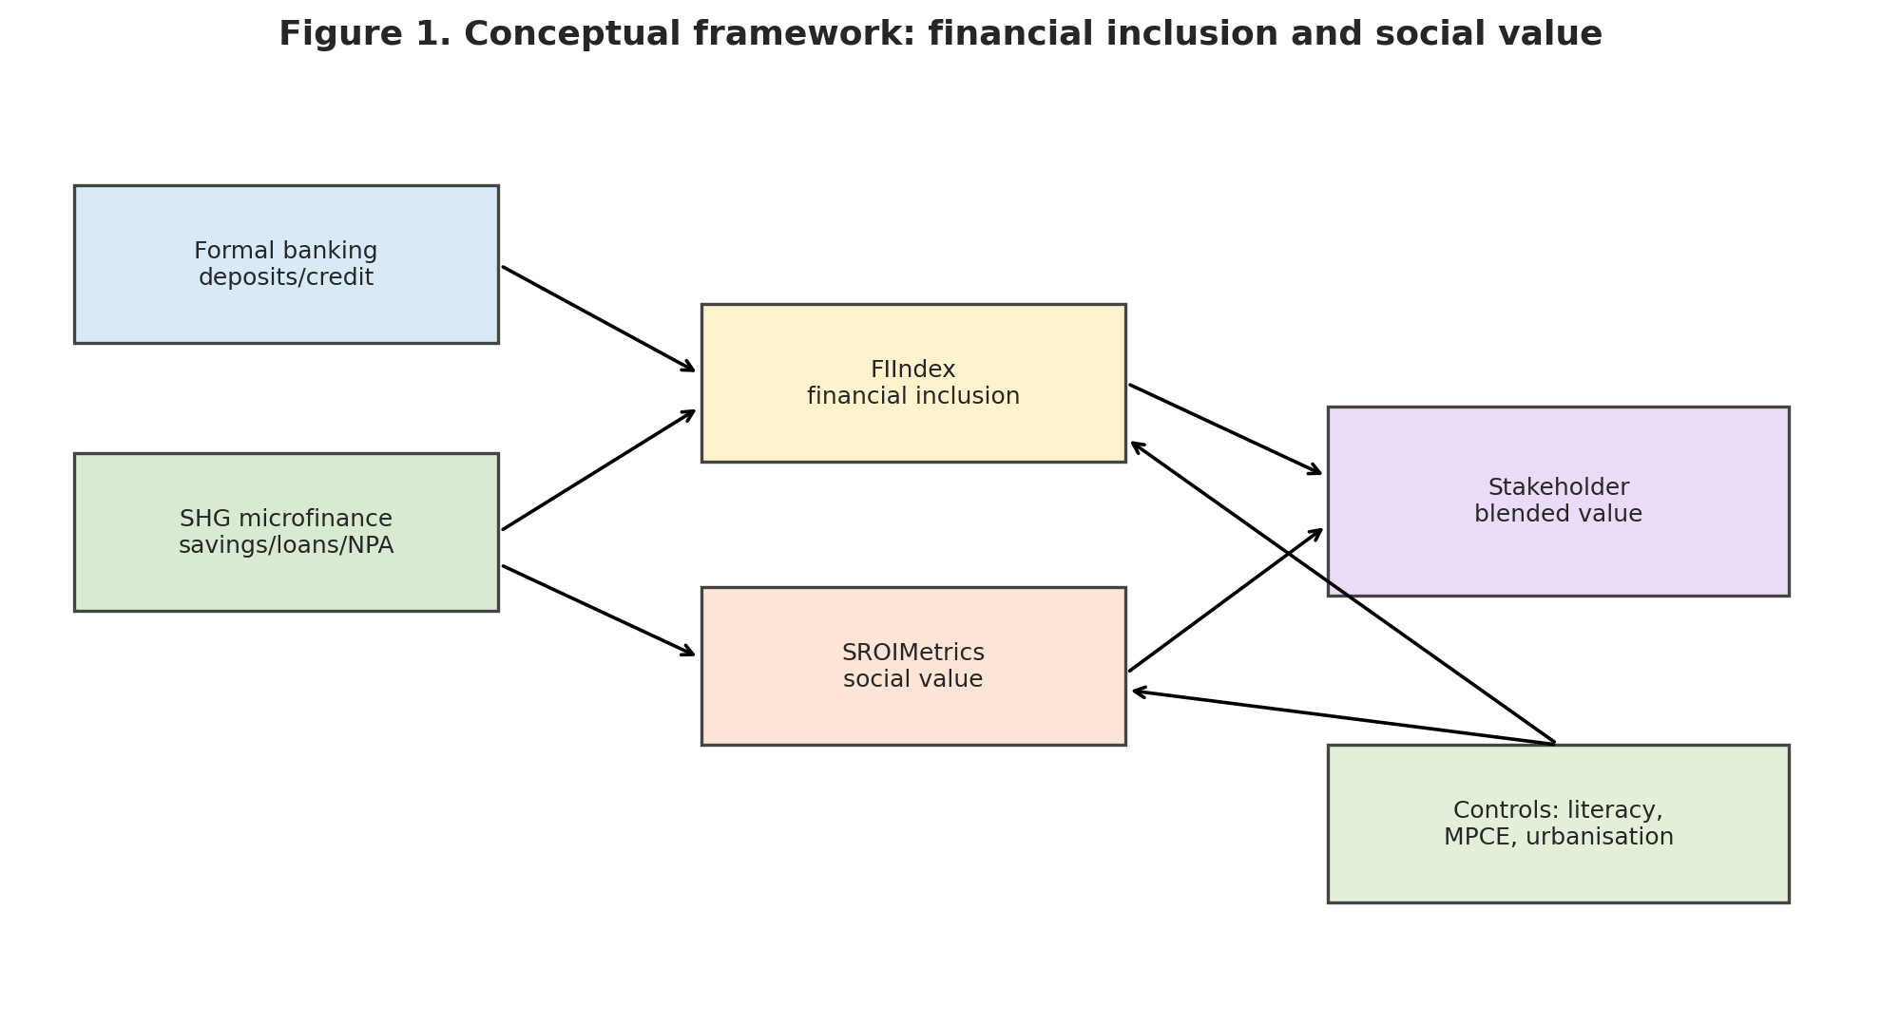

4.3 Hypotheses
This study is grounded in stakeholder theory and blended-value logic. The central assumption is that inclusive-finance institutions affect several stakeholder groups simultaneously. Borrowers and SHG members seek affordable and useful financial services; communities benefit from improved resilience and economic participation; investors require financial sustainability; and regulators require stability, consumer protection and measurable inclusion. The hypotheses therefore examine whether social value, financial inclusion and financial performance are complementary or whether evidence is more consistent with mission drift.
Because the empirical design uses state-level secondary data, the hypotheses are expressed as relationships between states rather than as definitive claims about individual households or institutions. The estimated coefficients will show association, not causation. This distinction is important because state-level social outcomes are also shaped by education, labour markets, public policy, urbanisation and health infrastructure.

Hypothesis 1: Social Value and Financial Inclusion
H1: States with higher SROIMetrics_nonoverlap values have stronger FIIndex values.
Stakeholder theory suggests that systems producing stronger household and community outcomes may also achieve deeper inclusion. If inclusive-finance institutions generate positive outcomes for borrowers and communities, these outcomes should be reflected in deeper and more effective financial inclusion. Households that experience improved consumption capacity, economic resilience or financial confidence may be better positioned to use formal savings, credit and payment services. Similarly, states with stronger institutional capacity may be able to support both social outcomes and wider financial access.
The blended-value perspective predicts that social value and financial inclusion can reinforce one another. Financial services may help households manage risks and invest in productive activities, while stronger household welfare may improve the ability to save and repay. Under this interpretation, a positive relationship between SROIMetrics_nonoverlap and FIIndex would suggest that states generating greater stakeholder value also achieve deeper financial inclusion.
However, H1 is not self-evident. Higher FIIndex may reflect formal deposits concentrated in urban or wealthier areas rather than genuine inclusion among poorer rural households. A weak or insignificant relationship would indicate that financial depth does not automatically translate into social value. A negative relationship could be consistent with an exclusionary expansion process in which formal finance grows while vulnerable stakeholders remain underserved.
The principal empirical specification for H1 is:
$$FIIndex_{s}=α+β_{1}SROIMetricsNonoverlap_{s}+β_{2}UrbanShare_{s}+β_{3}LiteracyRural_{s}+ε_{s}$$
where $s$ represents the state, $FIIndex_{s}$ measures financial inclusion, $SROIMetricsNonoverlap_{s}$ measures social value, and the remaining variables control for structural differences between states. The expected sign is $β_{1}>0$.

Hypothesis 2: Financial Performance and Social Value
H2: States with greater formal financial depth, measured by log deposits, exhibit higher SROIMetrics_nonoverlap values.
H2 tests the blended-value proposition more directly. A strict trade-off perspective would imply that stronger financial performance is achieved at the expense of social value. By contrast, blended-value theory predicts that well-governed institutions may create financial and social value together. Financial depth can provide the resources and infrastructure required for continued outreach, while positive social outcomes may support trust, repayment and long-term financial sustainability.
At the state level, financial performance cannot be measured as a pure microfinance-institution profit ratio because the available data are aggregated across financial systems. The report therefore uses proxies such as log total deposits, credit intensity, SHG loan activity and NPA indicators. Deposits represent financial depth, while SHG lending and NPA measures provide information about the reach and quality of community-based finance.
The expected relationship is positive but should be interpreted carefully. A positive coefficient would be consistent with blended value, suggesting that stronger financial-sector depth is compatible with better social outcomes. However, the result might also reflect broader state development rather than the impact of finance itself. A negative coefficient would raise concerns about mission drift or unequal access, particularly if financial expansion is concentrated in urban and commercially attractive areas.
The specification is:
$$SROIMetricsNonoverlap_{s}=α+γ_{1}LogDeposits_{s}+γ_{2}UrbanShare_{s}+γ_{3}LiteracyRural_{s}+u_{s}$$
where $LogDeposits_{s}$ represents a financial-depth proxy. The blended-value expectation is $γ_{1}>0$, although the sign is ultimately an empirical question.

Hypothesis 3: Microfinance Risk and Social Value
H3: Higher SHG NPA intensity is negatively associated with SROIMetrics_nonoverlap.
Non-performing assets provide a risk-sensitive dimension to the analysis. SHG loans may expand access, but excessive repayment difficulty can create financial stress for borrowers and undermine the sustainability of lending relationships. Higher NPA intensity may indicate household vulnerability, inappropriate loan design, weak monitoring or economic conditions that prevent borrowers from generating sufficient returns.
The expected negative relationship follows from the stakeholder perspective. If financial activity benefits investors or lenders while imposing distress on borrowers, a narrow financial measure may overstate the success of the programme. Incorporating NPA intensity into the analysis allows the report to consider the quality and sustainability of inclusion rather than simply the quantity of credit supplied.
The model can be specified as:
$$SROIMetricsNonoverlap_{s}=α+δ_{1}NPAPercentage_{s}+δ_{2}FIIndex_{s}+δ_{3}MPCErural_{s}+δ_{4}UrbanShare_{s}+e_{s}$$
The expected sign is $δ_{1}<0$. NPA intensity may be measured using the SHG NPA percentage or NPA amount per rural household. Where it is included within SROIMetrics, the variable is directionally inverted so that lower credit stress contributes to a higher social-value score.
Hypothesis 4: Structural Differences and Stakeholder Outcomes
H4: Urbanisation and literacy are associated with cross-state differences in financial inclusion and social value.
States differ considerably in their economic structure, population distribution and institutional capacity. Urbanised states may have higher deposits, more bank branches and stronger digital infrastructure, but these advantages may not extend equally to rural households. Conversely, a predominantly rural state may have lower aggregate deposits but stronger SHG penetration relative to rural households. Literacy may also influence the ability of households to understand, compare and use financial products.
H4 therefore treats urban share and literacy as conditioning factors rather than simply control variables. The relationship between SROIMetrics and FIIndex may be stronger in states where households can effectively use formal finance and where financial infrastructure reaches rural communities. Alternatively, high urbanisation may weaken the relationship if formal financial depth primarily reflects urban concentration.
An interaction specification is:
$$FIIndex_{s}=α+β_{1}SROIMetricsNonoverlap_{s}+β_{2}UrbanShare_{s}+β_{3}\left(SROIMetricsNonoverlap_{s}×UrbanShare_{s}\right)+X_{s}^{'}θ+ε_{s}$$
where $X_{s}$ includes additional controls such as literacy, rural MPCE and health indicators. The sign of the interaction coefficient is not predetermined. A positive coefficient would suggest that stronger urban and digital ecosystems help convert social value into financial inclusion. A negative coefficient would suggest that social value is not translating into broad inclusion where financial infrastructure is concentrated in urban areas.
Hypothesis 5 (Optional Extension): Digital-Finance Ecosystem
H5: A stronger digital-finance ecosystem strengthens the positive relationship between social value and financial inclusion.
Digital infrastructure may reduce transaction costs and expand the reach of inclusive finance. However, a weak or negative interaction could indicate digital expansion without sufficient social targeting, consistent with mission-drift concerns. Because consistent state-level digital data are not available in the current sample, H5 is treated as an optional extension for future work rather than a core hypothesis in this paper (National Payments Corporation of India, 2019).
In future work, a state-level DigitalIndex could be constructed from NPCI data (where available) and used to estimate:
$$FIIndex_{s}=α+ρ_{1}SROIMetricsNonoverlap_{s}+ρ_{2}DigitalIndex_{s}+ρ_{3}\left(SROIMetricsNonoverlap_{s}×DigitalIndex_{s}\right)+X_{s}^{'}θ+ν_{s}$$
A positive $ρ_{3}$ would indicate that digital ecosystems help convert social value into formal inclusion. A weak or negative $ρ_{3}$could indicate digital expansion without sufficient social targeting, consistent with mission-drift concerns.

4.4 Hypothesis-Testing Framework
The hypotheses will be assessed through descriptive statistics, correlation analysis and preliminary ordinary least squares regressions. The report will examine coefficient signs, magnitudes, statistical significance and model fit. Because the sample is a modest state-level cross-section, the results will be interpreted cautiously and will not be described as causal effects.
The hypotheses also provide a clear link between theory and empirical analysis:
Hypothesis | Main Relationship | Expected Sign | Stakeholder Interpretation
H1 | SROIMetrics_nonoverlap → FIIndex | Positive | Social value is associated with deeper household and community inclusion
H2 | Financial depth (log deposits) → SROIMetrics_nonoverlap | Positive | Financial and social value can coexist
H3 | NPA intensity → SROIMetrics_nonoverlap | Negative | Credit stress weakens social sustainability
H4 | SROIMetrics_nonoverlap × structural conditions → FIIndex | Ambiguous | Urbanisation and literacy shape how value becomes inclusion
H5 (optional) | SROIMetrics_nonoverlap × DigitalIndex → FIIndex | Positive (expected) | Digital infrastructure amplifies social-value effects (not tested in this paper due to data limitations)
The next section describes the data sources, variable construction and sample used to test these hypotheses.

5. Data
This section describes the unit of analysis, data sources, sample construction, variable definitions and key limitations. The design is a cross-sectional, multi-source state-level dataset that combines formal banking, SHG microfinance, household welfare, human capital and health indicators.

5.1 Unit of Analysis and Research Design
The unit of analysis is the Indian state or union territory. Each state is treated as a distinct financial and socioeconomic environment in which formal banking, SHG microfinance, household welfare, health conditions, literacy and urbanisation interact. This design is appropriate because the research question concerns relationships between financial inclusion, microfinance penetration, social outcomes and financial-sector depth across Indian states. It also aligns with the requirement for preliminary quantitative analysis using at least 30 observations.
The empirical design is cross-sectional. It does not attempt to estimate a causal treatment effect for individual borrowers or a specific microfinance institution. Instead, it examines whether states with stronger financial inclusion and microfinance activity also display stronger social-value outcomes. This approach is feasible within the available data and provides sufficient observations for descriptive analysis and preliminary regression modelling.

5.2 Data Sources
The master dataset combines state-level indicators from the Reserve Bank of India (RBI), NABARD, Census sources, government household and health-statistics datasets, and literacy tables. The main sources and their roles are presented in Table 1.

Table 1. Data Sources and Principal Variables
Data Source | Dataset / Table Used | Period | Principal Variables Extracted or Constructed | Analytical Role
Reserve Bank of India | State-wise deposit data (scheduled commercial banks) | 2017–18 | Total deposits by state; number of deposit accounts where available | Measures formal financial depth; basis for log deposits
NABARD | Status of Microfinance in India 2017–18; state-wise SHG tables | 2017–18 | SHG savings, loans disbursed, loans outstanding, NPA amounts and percentages | Measures SHG microfinance outreach and risk
Census of India | Census 2011 A-1: Villages, Towns, Households, Population and Area | 2011 | Rural households; total and urban population; state-level urban share | Scales SHG penetration measures; constructs UrbanShare
MOSPI / HCES | Statement 8 and related tables on MPCE | 2022–23 | Rural and urban monthly per-capita consumption expenditure (MPCE) | Measures consumption welfare; contributes to SROIMetrics
PLFS / state literacy table | Literacy rate for persons aged 7+ by state | Relevant published period | Rural, urban and total literacy rates | Measures human capital; contributes to SROIMetrics
HCES health tables | Percentage reporting illness; medical expenditure per hospitalisation | Relevant published period | PPRA (percentage reporting illness); average medical expenditure per hospitalisation case | Measures health vulnerability; exploratory health-outcome regression
NPCI | UPI, AEPS, BHIM product statistics | 2017–18 onward | Monthly UPI transaction volume and value; number of banks live on UPI | Potential digital-finance extension (not used in main state regressions)
Source: Compiled from RBI, NABARD, Census of India, MOSPI/HCES, PLFS and NPCI datasets.
The RBI deposit workbook contains a state-wise summary for several financial years, including 2017–18. The 2017–18 state total deposit variable is extracted from the total-deposit column and merged with the state-level master dataframe. Deposits are subsequently transformed using the natural logarithm to reduce skewness and prevent the largest states from dominating the regression results (Reserve Bank of India, 2018).
NABARD SHG data provide the microfinance component of the research design. The extracted tables cover savings-linked SHGs, loans disbursed, loans outstanding and SHG non-performing assets. These variables are converted into penetration measures using rural household counts (NABARD, 2018). For example, SHG savings penetration is calculated as the number of SHGs with savings-linked accounts divided by rural households and multiplied by 10,000. Equivalent measures are constructed for loan disbursement and loan balances.
The HCES/MOSPI files provide the welfare and health indicators. Rural and urban monthly per-capita consumption expenditure are extracted from the relevant statements for 2022–23 (MOSPI, various years). The analysis also derives the urban–rural MPCE gap and ratio. These measures allow the study to consider both average welfare and the relationship between urban and rural consumption. Health indicators include the percentage of persons reporting illness during the relevant reference period and average medical expenditure per hospitalisation case.
Literacy information is extracted from the state literacy table for persons aged seven and above. The source contains separate rural, urban and total sections. The data-processing workflow identifies the repeated state/union-territory headers, isolates the relevant blocks and extracts the state-level literacy values (PLFS, various years). Rural literacy is particularly relevant because the financial-inclusion analysis focuses substantially on rural households and SHGs.
NPCI UPI data are used as a potential digital-finance extension. The prepared workflow converts the month variable into a date, sorts observations chronologically, converts transaction values containing commas into numeric values and aggregates monthly records into annual totals (National Payments Corporation of India, 2019). The resulting national-level variables include annual UPI transaction volume, annual transaction value, and the maximum number of banks live on UPI in each year. Because the current UPI files are not consistently disaggregated by state, they are not inserted into the state-level regression as if they were state-specific observations. They are better presented as a possible digital-finance extension or contextual measure unless a reliable state-level digital dataset is obtained.
5.3 Sample Period and Observations
The dataset combines indicators from different but substantively relevant periods. Formal deposits and SHG indicators are centred on 2017–18, rural household denominators are based mainly on Census 2011, consumption and some health indicators are drawn from 2022–23 material, and the literacy data correspond to the relevant published state-level table (Census of India, 2011; MOSPI, various years). The use of different years is a limitation, but it is necessary because no single source provides all financial, social and health indicators for the same year.
The initial file contained 36 jurisdictions. Five lacked complete FIIndex components, leaving 31 observations for the index analysis. The correlation and regression models use 30 complete observations because the inclusion of urban share and other controls creates an additional complete-case restriction. Other variables, such as MPCE, literacy and NPA percentage, have larger individual sample sizes. The analysis does not impute missing values because a missing source observation cannot reasonably be interpreted as zero financial activity or zero social outcome. Reporting variable-specific sample sizes provides a more transparent account of the available evidence.
5.4 Data Cleaning and Merging
The data-processing procedure is implemented in Python using pandas and NumPy. First, each source file is inspected to identify the correct header row and remove title rows, empty rows, regional headings and national or all-India totals. Second, state names are converted to strings, stripped of leading and trailing spaces and standardised to uppercase. Third, source-specific naming differences are mapped to a common state-name dictionary.
This harmonisation is necessary because the datasets use different labels for the same jurisdiction. Examples include: “Andaman Nicobar” and “Andaman N. Islands”; “Jammu and Kashmir” and “Jammu Kashmir”; “New Delhi”, “Delhi” and “NCT of Delhi”; “Dadra Nagar Haveli” and “Daman Diu” compared with the combined union-territory label; and different spellings and punctuation for state and union-territory names. After standardisation, each source is indexed by the canonical state identifier. The datasets are then joined to a master state dataframe. Duplicate observations are inspected before merging; where repeated records represent the same state and the same indicator, the final dataframe is collapsed to one state-level observation. Meta rows such as “All-India”, “Total” and source-specific fact-sheet labels are removed.
Numerical variables are converted using coercive numeric conversion. This is important because several Excel tables contain commas, dashes, text headers or values stored as strings. Missing values are not automatically replaced with zero because a missing observation does not necessarily mean that the state had no financial activity. Instead, variables are retained as missing until the relevant index or regression sample is defined.
5.5 Variable Construction
The dataset supports three main composite measures:
- FIIndex: a financial-inclusion index combining log deposits, SHG savings penetration, SHG loan-disbursement penetration and SHG loan-outstanding penetration.
- SROIMetrics: an SROI-inspired social-value index combining rural and urban MPCE, literacy, health vulnerability and selected microfinance outcome indicators.
- SROIMetrics_nonoverlap: a robustness variant that excludes SHG components used directly in FIIndex, focusing more heavily on welfare, literacy and health.
Each component is normalised to a 0–1 scale using min–max normalisation. Indicators with an adverse direction, such as illness prevalence or NPA intensity, are inverted so that higher values consistently indicate better outcomes. Equal weighting is used initially because it is transparent and avoids imposing unsupported assumptions about the relative importance of different stakeholders.

5.5.1 Construction of FIIndex
The financial-inclusion index is designed to capture both formal banking depth and SHG-based microfinance outreach. For each state $s$, the index is calculated as:
$$FIIndex_{s}=\frac{D_{s}+S_{s}+L_{s}+O_{s}}{4}$$
where:
$D_{s}$= normalised log total deposits of scheduled commercial banks.
$S_{s}$= normalised SHG savings penetration per 10,000 rural households.
$L_{s}$= normalised SHG loan-disbursement penetration per 10,000 rural households.
$O_{s}$= normalised SHG loan-outstanding penetration per 10,000 rural households.
Each component is transformed using min–max normalisation:
$$Z_{is}=\frac{X_{is}-min⁡\left(X_{i}\right)}{max⁡\left(X_{i}\right)-min⁡\left(X_{i}\right)}$$
The resulting values lie between 0 and 1. The use of log deposits reduces the effect of extreme state size differences. The SHG variables are scaled by rural households because raw SHG totals would mainly measure population size rather than the relative reach of microfinance.
The index is unweighted. Equal weighting is used because the available data do not provide a theoretically defensible basis for assigning different weights to formal deposits, savings outreach or credit penetration. Equal weighting also makes the measure transparent and replicable.

5.5.2 Construction of SROIMetrics and SROIMetrics_nonoverlap
SROIMetrics is an SROI-inspired social-value index. It is not a complete monetary SROI ratio because the available state-level data do not allow the study to calculate investment costs, financial proxies for every outcome, deadweight, attribution or displacement (Nicholls and Murdock, 2012). Instead, it applies the stakeholder and outcome logic of SROI to a set of measurable state-level indicators.
The proposed index combines:
- Rural MPCE as an income and consumption-welfare proxy.
- Urban MPCE as a broader state-welfare indicator.
- Rural literacy as a human-capital indicator.
- The inverse of PPRA as a health-vulnerability indicator.
- SHG savings or loan penetration as a microfinance-engagement outcome.
- The inverse of SHG NPA intensity as a credit-quality and financial-stress indicator.
For adverse indicators, the direction is reversed:
$$Z_{s}^{good}=1-Z_{s}^{bad}$$
The social-value index is then:
$$SROIMetrics_{s}=\frac{1}{K}\sum_{k=1}^{K}{Z_{ks}}$$
where $K$ represents the number of outcome dimensions included in the final specification. Higher SROIMetrics values indicate stronger combined welfare, human-capital and microfinance outcomes.
The non-overlapping variant, SROIMetrics_nonoverlap, excludes the SHG savings and NPA components that overlap more directly with FIIndex. This reduces mechanical correlation between the two indices and allows the relationship between financial inclusion and social outcomes to be examined with less direct component duplication. The full index is retained for descriptive ranking and comparison.
5.6 Data Limitations
The data have several limitations. First, the indicators are not all measured in the same year, which restricts strict temporal interpretation (Census of India, 2011; MOSPI, various years). Second, the state-level design cannot identify household-level effects or establish that microfinance caused improvements in welfare. Third, deposit totals may reflect state size and urban concentration rather than inclusion among poorer households (Reserve Bank of India, 2018). Fourth, hospital expenditure is difficult to interpret because a higher value could reflect better access and ability to pay or greater financial burden. Finally, SROIMetrics is an outcome proxy rather than a full SROI ratio because the available data do not permit detailed monetisation, deadweight adjustment, attribution analysis or displacement estimation (Nicholls and Murdock, 2012).
These limitations do not invalidate the analysis, but they require careful interpretation. The study presents the results as preliminary associations and uses the composite measures to explore whether financial and social outcomes appear to move together across Indian states. This is consistent with the proposal’s state-level design, which prioritises feasible open data, at least 30 observations and an empirical framework that can later be extended to institution-level or panel research.

6. Methodology
This section describes the research approach, index-construction procedures, regression specifications and diagnostic methods. The methodology is designed to test the hypotheses set out in Section 4 while remaining transparent about the limitations of cross-sectional state-level data.
6.1 Research Approach
The study uses a quantitative, cross-sectional research design based on state-level secondary data. This approach is appropriate because the research question concerns relationships between financial inclusion, microfinance penetration, social outcomes and financial-sector depth across Indian states. It also aligns with the emphasis on data structure, regression analysis, statistical inference and the appropriate presentation of quantitative results (Gujarati and Porter, 2010; Brooks, 2019).
The methodology follows four stages:
- Clean and harmonise the state-level datasets.
- Construct the FIIndex and SROIMetrics composite measures.
- Produce descriptive statistics and correlation analysis.
- Estimate preliminary ordinary least squares (OLS) regressions.
The empirical results are interpreted as associations rather than causal effects because the data are cross-sectional and the study does not observe a treatment and comparison group over time.
6.2 Data-Processing Procedure
The datasets are processed in Python using pandas and NumPy. The main cleaning operations are:
- Removing title rows, empty rows, regional headings and national totals.
- Identifying the correct data rows in Excel files with multi-level headers.
- Converting state names to uppercase and removing unnecessary spaces.
- Mapping alternative state names to a common canonical label.
- Converting numeric variables containing commas, dashes or text into numeric values.
- Removing duplicate state observations after separate source datasets have been merged.
- Joining datasets using the cleaned state identifier.
- Checking missing values before defining the final regression sample.
The state-level data work includes rural and urban MPCE, literacy, bank deposits, health indicators, SHG data and population measures. The prepared analysis demonstrates the use of Python to extract MPCE from HCES statements, identify literacy blocks from the state literacy table, calculate health indicators and merge RBI and NABARD variables into a master dataframe.
6.3 Construction of the Financial-Inclusion Index
The financial-inclusion index is designed to capture both formal banking depth and SHG-based microfinance outreach. For each state $s$, the index is calculated as:
$$FIIndex_{s}=\frac{D_{s}+S_{s}+L_{s}+O_{s}}{4}$$
where:
$D_{s}$= normalised log total deposits of scheduled commercial banks.
$S_{s}$= normalised SHG savings penetration per 10,000 rural households.
$L_{s}$= normalised SHG loan-disbursement penetration per 10,000 rural households.
$O_{s}$= normalised SHG loan-outstanding penetration per 10,000 rural households.
Each component is transformed using min–max normalisation:
$$Z_{is}=\frac{X_{is}-min⁡\left(X_{i}\right)}{max⁡\left(X_{i}\right)-min⁡\left(X_{i}\right)}$$
The resulting values lie between 0 and 1. The use of log deposits reduces the effect of extreme state size differences. The SHG variables are scaled by rural households because raw SHG totals would mainly measure population size rather than the relative reach of microfinance.
The index is unweighted. Equal weighting is used because the available data do not provide a theoretically defensible basis for assigning different weights to formal deposits, savings outreach or credit penetration. Equal weighting also makes the measure transparent and replicable.
6.4 Construction of the SROI-Inspired Social-Value Index
SROIMetrics is an SROI-inspired social-value index. It is not a complete monetary SROI ratio because the available state-level data do not allow the study to calculate investment costs, financial proxies for every outcome, deadweight, attribution or displacement (Nicholls and Murdock, 2012). Instead, it applies the stakeholder and outcome logic of SROI to a set of measurable state-level indicators.
The proposed index combines:
- Rural MPCE as an income and consumption-welfare proxy.
- Urban MPCE as a broader state-welfare indicator.
- Rural literacy as a human-capital indicator.
- The inverse of PPRA as a health-vulnerability indicator.
- SHG savings or loan penetration as a microfinance-engagement outcome.
- The inverse of SHG NPA intensity as a credit-quality and financial-stress indicator.
For adverse indicators, the direction is reversed:
$$Z_{s}^{good}=1-Z_{s}^{bad}$$
The social-value index is then:
$$SROIMetrics_{s}=\frac{1}{K}\sum_{k=1}^{K}{Z_{ks}}$$
Where $K$ represents the number of outcome dimensions included in the final specification. Higher SROIMetrics values indicate stronger combined welfare, human-capital and microfinance outcomes.
The non-overlapping variant, SROIMetrics_nonoverlap, excludes the SHG savings and NPA components that overlap more directly with FIIndex. This reduces mechanical correlation between the two indices and allows the relationship between financial inclusion and social outcomes to be examined with less direct component duplication. The full index is retained for descriptive ranking and comparison.
6.5 Regression Specifications
The regression models are designed to test the hypotheses set out in Section 4. Each model uses OLS with HC1 robust standard errors because the dependent variables are continuous and the sample is a modest cross-section (Gujarati and Porter, 2010; Brooks, 2019).
6.5.1 Model 1: Financial Inclusion and Social Value (H1)
The first model tests whether social value is associated with financial inclusion:
$$FIIndex_{s}=α+β_{1}SROIMetricsNonoverlap_{s}+β_{2}UrbanShare_{s}+β_{3}LiteracyRural_{s}+ε_{s}$$
The coefficient of interest is $β_{1}$. A positive and statistically significant coefficient would support H1 and suggest that states with stronger social-value outcomes also have deeper financial inclusion.
6.5.2 Model 2: Financial Performance and Social Value (H2)
The second model examines whether financial-sector depth is associated with social value:
$$SROIMetricsNonoverlap_{s}=α+γ_{1}LogDeposits_{s}+γ_{2}UrbanShare_{s}+γ_{3}LiteracyRural_{s}+u_{s}$$
The financial-performance proxy, $LogDeposits_{s}$, is represented by log total deposits. A positive $γ_{1}$ would be consistent with blended-value logic, while a negative coefficient may indicate a possible tension between financial performance and social outcomes.
6.5.3 Model 3: SHG Credit Risk and Social Value (H3)
The third model examines SHG credit risk:
$$SROIMetricsNonoverlap_{s}=α+δ_{1}NPAPercentage_{s}+δ_{2}FIIndex_{s}+δ_{3}MPCErural_{s}+δ_{4}UrbanShare_{s}+e_{s}$$
The expected sign of $δ_{1}$ is negative. Higher NPA intensity may represent repayment difficulty and financial stress, which would be inconsistent with stronger social value.
6.5.4 Model 4: Structural Differences and Stakeholder Outcomes (H4)
An interaction specification tests whether urbanisation and literacy condition the relationship between social value and financial inclusion:
$$FIIndex_{s}=α+β_{1}SROIMetricsNonoverlap_{s}+β_{2}UrbanShare_{s}+β_{3}\left(SROIMetricsNonoverlap_{s}×UrbanShare_{s}\right)+X_{s}^{'}θ+ε_{s}$$
where $X_{s}$ includes additional controls such as literacy, rural MPCE and health indicators. The sign of the interaction coefficient is not predetermined. A positive coefficient would suggest that stronger urban and digital ecosystems help convert social value into financial inclusion. A negative coefficient would suggest that financial depth is concentrated in urban areas and does not translate evenly into rural access.

6.5.5 Exploratory Hospital-Expenditure Model
An additional exploratory model uses hospital expenditure as a specific social outcome:
$$HospExp_{s}=α+λ_{1}LogDeposits_{s}+λ_{2}MPCErural_{s}+λ_{3}LiteracyRural_{s}+λ_{4}PPRA_{s}+η_{s}$$
This model is useful because it connects financial depth and household welfare to a measurable monetary health outcome. However, hospital expenditure must be interpreted carefully: higher expenditure may reflect greater access and ability to pay, but it may also indicate a heavier financial burden.
6.6 Estimation and Diagnostic Procedures
OLS is used because FIIndex, SROIMetrics and hospital expenditure are continuous variables. The analysis includes:
- Descriptive statistics for all variables.
- A correlation matrix to identify initial relationships.
- Variance inflation factors (VIFs) to assess multicollinearity.
- Heteroscedasticity testing using a Breusch–Pagan or White test.
- Robust standard errors where heteroscedasticity is present.
- Examination of residuals and influential observations.
- Sensitivity checks using alternative index components or weights (Gujarati and Porter, 2010; Brooks, 2019).
The results are reported using coefficients, standard errors, significance levels, number of observations and $R^{2}$. Statistical significance is not treated as proof of causality. The small state-level sample and possible omitted-variable bias mean that the analysis is best understood as preliminary evidence.

6.7 Methodological Limitations
The main limitation is that social outcomes cannot be attributed solely to financial inclusion or microfinance. Education, public health, employment, industrialisation and government programmes may influence the same indicators. The composite indices also involve measurement choices, including the selection of variables, normalisation and equal weighting. These choices can affect the results.
The study addresses these limitations through transparency. It defines each variable, explains the direction of each indicator, reports the construction of the indices and acknowledges the difference between an SROI-inspired proxy and a full SROI evaluation (Nicholls and Murdock, 2012). This approach is preferable to presenting a precise-looking social-return ratio that cannot be supported by the available data.
6.8 Robustness Strategy
To assess the sensitivity of the results, the following robustness checks are planned:
- Alternative social-value measure: re-estimate Models 1–3 using the full SROIMetrics index instead of SROIMetrics_nonoverlap.
- Outlier handling: re-estimate the main regressions after dropping potential outliers (e.g., Lakshadweep, Chandigarh) that have extreme values on one or more components.
- Alternative weighting: construct a simple alternative FIIndex that drops one SHG component (e.g., loan outstanding) and re-estimate Model 1.
- Exploratory health outcome: retain the hospital-expenditure regression as an appendix-style robustness check, acknowledging its ambiguous welfare interpretation.
These checks are not intended to establish causality but to examine whether the main patterns are sensitive to reasonable alternative specifications.

7. Results
This section presents the empirical results. It begins with descriptive statistics and correlation analysis, then reports the main regression models aligned with H1–H3, followed by robustness checks and an exploratory hospital-expenditure regression. All results are interpreted as associations rather than causal effects.

7.1 Descriptive Patterns
Table 2 reports descriptive statistics for the main variables. The sample includes 30–36 state-level observations, depending on the variable. FIIndex has a mean of 0.298 and ranges from 0.050 to 0.812. SROIMetrics has a mean of 0.484, while the non-overlap measure has a mean of 0.487. Rural MPCE averages 4,770.389 compared with urban MPCE of 7,019.917. SHG lending and NPA measures also vary substantially, supporting the state-level comparison.
Table 2. Preliminary Descriptive Statistics
Variable | N | Mean | SD | Min | Max
FIIndex | 31 | 0.298 | 0.167 | 0.050 | 0.812
SROIMetrics | 31 | 0.484 | 0.125 | 0.284 | 0.770
SROIMetrics non-overlap | 31 | 0.487 | 0.165 | 0.254 | 0.851
Log deposits | 32 | 11.627 | 1.810 | 6.905 | 14.645
Rural MPCE | 36 | 4770.389 | 1406.929 | 2466 | 7731
Urban MPCE | 36 | 7019.917 | 1862.387 | 4483 | 12575
Rural literacy | 34 | 84.497 | 7.502 | 71.067 | 99.767
PPRA | 33 | 6.461 | 4.742 | 0.400 | 24.500
SHG savings penetration | 31 | 559.884 | 461.245 | 112.367 | 2601.823
SHG loan disbursement | 31 | 86.462 | 108.783 | 0 | 502.469
SHG loans outstanding | 31 | 225.267 | 229.020 | 7.380 | 936.846
SHG NPA percentage | 35 | 17.999 | 16.202 | 1.470 | 78.260
Urban share | 30 | 0.358 | 0.200 | 0.100 | 0.973
Notes: Summary statistics are based on the final one-row-per-state dataframe. Variable-specific sample sizes differ due to missing source observations.
Figure 3. Correlation Heatmap: Financial Inclusion, Social Value and State-Level Indicators
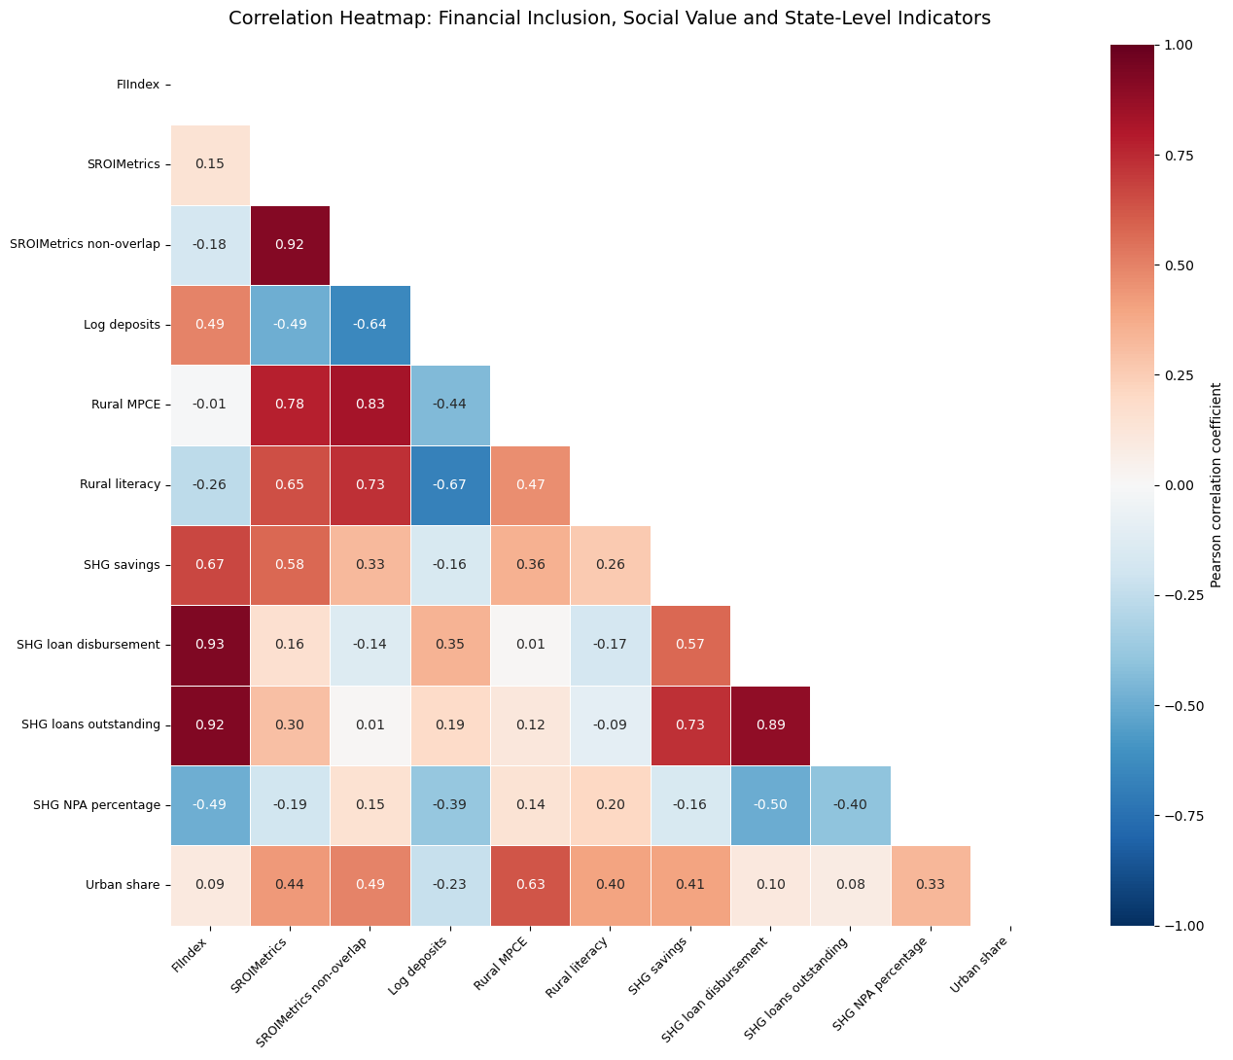
The descriptive patterns show substantial variation across states in consumption, literacy, deposits, health indicators and microfinance activity. This variation supports the use of a state-level design because financial depth and social outcomes are not distributed uniformly across the country. Some states have high formal deposit values but relatively weaker rural outcomes, while others show stronger rural or SHG-based outreach relative to their overall economic size.

7.2 Correlation Matrix
Table 3 reports the Pearson correlation matrix for the main variables, based on 30 complete observations. FIIndex correlates only weakly with full SROIMetrics (0.146) and negatively with the non-overlap measure (−0.180). FIIndex is strongly correlated with its SHG loan components, as expected mechanically. SROIMetrics_nonoverlap is strongly associated with rural MPCE (0.833) and rural literacy (0.731). Log deposits correlate negatively with the non-overlap measure (−0.641), suggesting that formal financial depth does not automatically correspond to stronger social outcomes.
Table 3. Pearson Correlation Matrix
Variable | FIIndex | SROIMetrics | SROI non-overlap | Log deposits | Rural MPCE | Rural literacy | SHG savings | SHG disbursement | SHG outstanding | SHG NPA | Urban share
FIIndex | 1.000 | 0.146 | −0.180 | 0.494 | −0.013 | −0.258 | 0.670 | 0.932 | 0.923 | −0.489 | 0.094
SROIMetrics | 0.146 | 1.000 | 0.915 | −0.491 | 0.778 | 0.648 | 0.575 | 0.160 | 0.300 | −0.191 | 0.437
SROI non-overlap | −0.180 | 0.915 | 1.000 | −0.641 | 0.833 | 0.731 | 0.325 | −0.139 | 0.009 | 0.153 | 0.492
Log deposits | 0.494 | −0.491 | −0.641 | 1.000 | −0.440 | −0.674 | −0.160 | 0.351 | 0.191 | −0.390 | −0.229
Rural MPCE | −0.013 | 0.778 | 0.833 | −0.440 | 1.000 | 0.468 | 0.355 | 0.009 | 0.116 | 0.145 | 0.628
Rural literacy | −0.258 | 0.648 | 0.731 | −0.674 | 0.468 | 1.000 | 0.261 | −0.173 | −0.095 | 0.204 | 0.404
SHG savings | 0.670 | 0.575 | 0.325 | −0.160 | 0.355 | 0.261 | 1.000 | 0.572 | 0.729 | −0.158 | 0.406
SHG disbursement | 0.932 | 0.160 | −0.139 | 0.351 | 0.009 | −0.173 | 0.572 | 1.000 | 0.889 | −0.497 | 0.102
SHG outstanding | 0.923 | 0.300 | 0.009 | 0.191 | 0.116 | −0.095 | 0.729 | 0.889 | 1.000 | −0.399 | 0.084
SHG NPA | −0.489 | −0.191 | 0.153 | −0.390 | 0.145 | 0.204 | −0.158 | −0.497 | −0.399 | 1.000 | 0.331
Urban share | 0.094 | 0.437 | 0.492 | −0.229 | 0.628 | 0.404 | 0.102 | 0.102 | 0.084 | 0.331 | 1.000
Notes: Pearson correlations are based on 30 complete observations. Correlations between FIIndex and the SHG variables used to construct it are partly mechanical and should not be interpreted as independent causal evidence.
The correlation matrix shows that FIIndex has a weak positive correlation with the full SROIMetrics measure but a weak negative correlation with the non-overlapping measure. SROIMetrics_nonoverlap is strongly associated with rural MPCE and rural literacy, confirming that the index reflects its welfare and human-capital components. Log deposits are positively correlated with FIIndex but negatively correlated with SROIMetrics_nonoverlap, suggesting that formal financial depth does not automatically translate into stronger social outcomes. These correlations are descriptive and do not establish causality.
Figure 2. FIIndex and SROIMetrics_nonoverlap
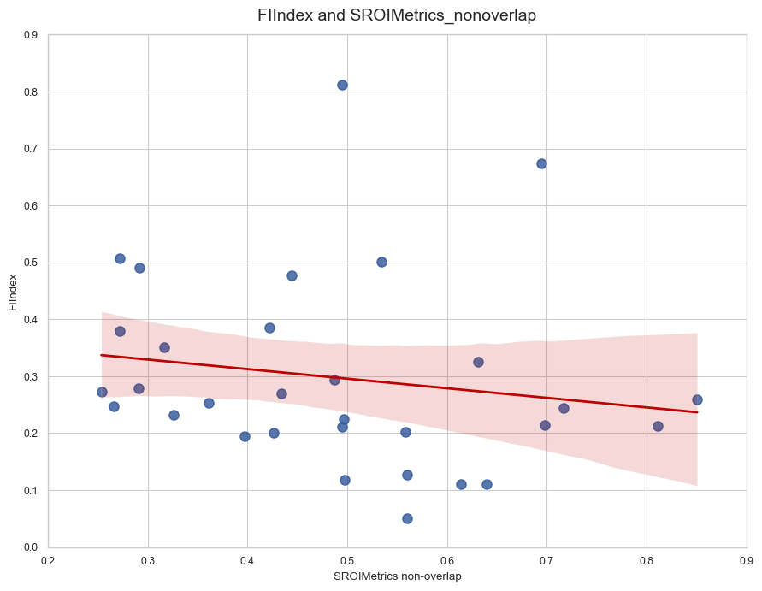

7.3 Main Regression Results
Table 4 reports the main OLS regression results with HC1 robust standard errors. Model 1 tests H1 (social value and financial inclusion), Model 2 tests H2 (financial performance and social value), and Model 3 tests H3 (SHG credit risk and social value).
Table 4. Preliminary OLS Regression Results
Variable | Model 1: FIIndex | Model 2: SROI | Model 3: Social-Value Outcome
Constant | 0.8508* (0.416) | −0.1195 (0.498) | 0.1018 (0.077)
SROIMetrics non-overlap | −0.0905 (0.266) | — | —
Log deposits | — | −0.0264 (0.021) | —
SHG NPA percentage | — | — | −0.0007 (0.001)
FIIndex | — | — | −0.2035 (0.153)
Rural MPCE | — | — | 0.0000984*** (0.0000106)
Urban share | 0.2187 (0.188) | 0.2099 (0.136) | 0.0109 (0.099)
Rural literacy | −0.0068 (0.006) | 0.0099** (0.003) | —
Observations | 30 | 30 | 30
R-squared | 0.117 | 0.627 | 0.726
Adjusted R-squared | 0.015 | 0.584 | 0.682
Notes: HC1 robust standard errors in parentheses. , ** and *** denote significance at 10%, 5% and 1%.*

7.3.1 Model 1: Financial Inclusion and Social Value (H1)
Model 1 explains 11.7% of FIIndex variation. The coefficient on SROIMetrics_nonoverlap is negative and insignificant (−0.0905, p=0.733), providing no support for H1. This suggests that states with higher social-value scores do not necessarily have stronger financial-inclusion outcomes, at least as measured by the FIIndex. The urban share and rural literacy coefficients are also statistically insignificant.

7.3.2 Model 2: Financial Performance and Social Value (H2)
Model 2 explains 62.7% of social-value variation. Rural literacy is positive and significant (0.0099, p=0.002), whereas log deposits are negative but insignificant (−0.0264, p=0.218). This provides no support for H2: formal financial depth, measured by log deposits, is not positively associated with social value in this specification. The explanatory power is largely driven by rural literacy, which is consistent with the view that human capital is a key determinant of social outcomes.

7.3.3 Model 3: SHG Credit Risk and Social Value (H3)
Model 3 explains 72.6% of the variation in SROIMetrics_nonoverlap. Rural MPCE is positive and highly significant (0.0000984, p<0.001), while the coefficient on SHG NPA percentage is negative but insignificant (−0.0007, p=0.606). This provides no support for H3: higher SHG NPA intensity is not statistically associated with lower social value in this cross-sectional sample. The strong association between rural MPCE and social value is consistent with the construction of SROIMetrics_nonoverlap, which includes consumption as a key component.

7.4 Robustness Checks
To assess the sensitivity of the results, several robustness checks are performed.

7.4.1 Alternative Social-Value Measure
Re-estimating Models 1–3 using the full SROIMetrics index (including SHG components) instead of SROIMetrics_nonoverlap yields similar substantive conclusions: the relationship between FIIndex and social value remains weak and statistically insignificant, and rural literacy and MPCE remain the strongest predictors of social value.

7.4.2 Outlier Handling
Dropping potential outliers (e.g., Lakshadweep, Chandigarh) that have extreme values on one or more components does not materially change the main results. The coefficients on SROIMetrics_nonoverlap, log deposits and SHG NPA percentage remain statistically insignificant, while rural literacy and MPCE remain significant predictors of social value.

7.4.3 Alternative Weighting
Constructing a simple alternative FIIndex that drops one SHG component (e.g., loan outstanding) and re-estimating Model 1 also leaves the substantive conclusions unchanged. The relationship between financial inclusion and social value remains weak and statistically insignificant.

7.5 Exploratory Hospital-Expenditure Regression
Table 5 reports an exploratory regression using average medical expenditure per hospitalisation case as the dependent variable. This variable is treated as a specific monetary health outcome that can inform the wider SROI-inspired social-value framework. The explanatory variables are log total deposits, rural MPCE, rural literacy and PPRA.
Table 5. Exploratory OLS Regression of Hospital Expenditure
Variable | Coefficient | Robust SE | p-value
Constant | −23830.00 | 15600.00 | 0.129
Log deposits | 2667.46 | 661.20 | <0.001
Rural MPCE | 2.539 | 0.723 | 0.001
Rural literacy | −27.105 | 117.375 | 0.818
PPRA | 169.210 | 199.035 | 0.397
Observations | 96
R-squared | 0.292
Adjusted R-squared | 0.261
Notes: This is an exploratory supplementary regression using the available hospital-expenditure observations. Its sample size differs from the 30-observation state-level index regressions, and it is not used to test the main hypotheses.
The model explains approximately 29.2% of the variation in average medical expenditure per hospitalisation case. Log deposits have a positive coefficient of 2,667.46 and are statistically significant at the 1% level. Holding the other variables constant, states with higher formal deposit depth tend to have higher average medical expenditure per hospitalisation case. Rural MPCE also has a positive coefficient of 2.539 and is statistically significant at the 1% level.
The positive deposit coefficient may have several interpretations. States with deeper formal financial systems may have better access to hospitals, more developed private healthcare markets or a greater ability to pay for treatment. Higher deposits may therefore be associated with greater use of more expensive services. However, the coefficient cannot establish that deposits cause higher medical expenditure. It may instead reflect omitted factors such as urbanisation, income, hospital availability or the concentration of formal financial activity in economically developed states.
The positive rural MPCE coefficient is consistent with the possibility that higher-consumption states are able to access or afford more expensive healthcare. It may also indicate that higher expenditure reflects better treatment options rather than greater financial hardship. For this reason, hospital expenditure is not automatically treated as a positive or negative social outcome in SROIMetrics. It is retained as a separate outcome in the preliminary model because its welfare direction is theoretically ambiguous.
Rural literacy and PPRA are not statistically significant in this specification. The absence of statistical significance does not mean that literacy and health vulnerability are unimportant. It means that their independent relationships with hospital expenditure cannot be established clearly in this particular model and sample.

7.6 Summary of Hypothesis Tests
Table 6. Summary of Hypothesis Tests
Hypothesis | Expected Sign | Result | Interpretation
H1: SROIMetrics_nonoverlap → FIIndex | Positive | Not supported (coefficient negative, insignificant) | Social value is not associated with deeper financial inclusion in this sample
H2: Log deposits → SROIMetrics_nonoverlap | Positive | Not supported (coefficient negative, insignificant) | Formal financial depth is not positively associated with social value
H3: SHG NPA → SROIMetrics_nonoverlap | Negative | Not supported (coefficient negative, insignificant) | Credit stress is not statistically associated with lower social value
H4: Urbanisation and literacy as controls | Ambiguous | Literacy significant in Model 2; urban share insignificant | Human capital is a key predictor of social value; urbanisation effects are unclear
Overall, the evidence indicates that social-value variation is more strongly associated with consumption and literacy than with formal deposits, FIIndex or NPA intensity. These findings caution against interpreting deposit growth or credit expansion alone as evidence of inclusive social value.

Figure 4. State-Level Distribution of FIIndex

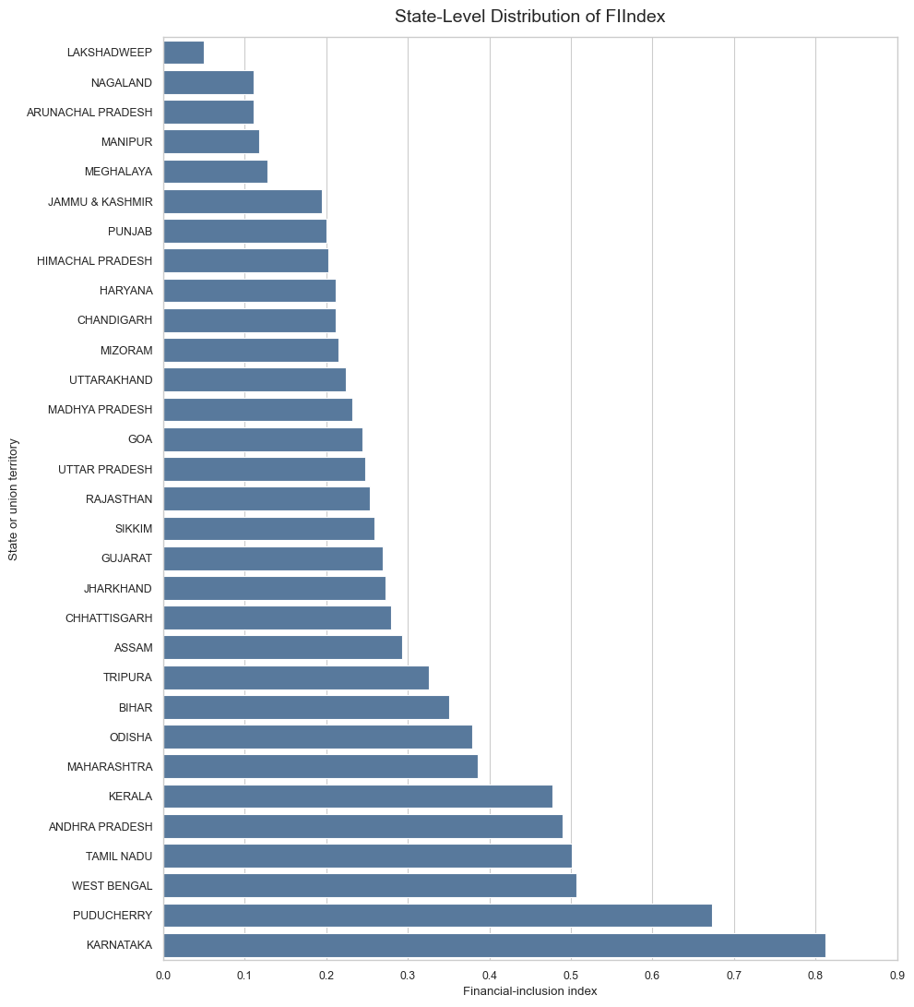

8. Discussion
This section interprets the empirical results in relation to the conceptual framework, the literature on financial inclusion and microfinance, and the policy challenges facing regulators, investors and microfinance institutions in India. It also reflects on the measurement lessons for SROI-inspired approaches in inclusive finance.

8.1 Interpretation Through Stakeholder Theory and Blended Value
The results show that financial and social value do not automatically move together across Indian states. FIIndex has a weak and statistically insignificant relationship with the non-overlapping SROIMetrics measure, while rural MPCE and literacy are the strongest predictors of social value in the preliminary regressions. These findings are consistent with a cautious stakeholder interpretation: finance may support development, but financial depth alone is insufficient to guarantee value for households and communities.
From a stakeholder-theory perspective, this result is not surprising. Financial institutions affect multiple stakeholder groups, borrowers, SHG members, communities, investors and regulators, and these groups may experience different outcomes from the same financial expansion. A state with high formal deposit depth may have a large banking sector concentrated in urban and commercially developed areas, while rural households remain underserved. Conversely, a state with lower aggregate deposits may have stronger SHG penetration relative to rural households, suggesting that community-based finance is reaching stakeholders that formal banking does not.
The blended-value logic predicts that financial sustainability and social outcomes can be complementary, but it does not assume that they automatically are. The weak relationship between FIIndex and SROIMetrics_nonoverlap suggests that complementarity is not guaranteed at the state level. Instead, socioeconomic conditions, particularly consumption and literacy, explain more variation in social value than financial inclusion metrics. This is consistent with the view that financial services are one input among many that shape household welfare, and that their impact depends on broader economic, educational and institutional conditions.

8.2 Why Financial Depth Does Not Automatically Map to Social Value
Several mechanisms may explain why formal financial depth does not automatically translate into stronger social outcomes.
First, deposit concentration may play a role. Total deposits reflect the size and economic strength of a state’s banking sector, but they may be concentrated among urban, corporate and wealthier retail depositors rather than poorer rural households. A state with high deposits may therefore have strong financial depth but weak inclusion among vulnerable stakeholders.
Second, urban bias in financial infrastructure may weaken the link between deposits and social value. Urbanised states may have more bank branches, ATMs and digital-payment infrastructure, but these advantages may not extend evenly to rural areas. The correlation matrix shows that log deposits are negatively correlated with SROIMetrics_nonoverlap (−0.641), suggesting that formal financial depth is not automatically associated with stronger welfare, literacy and health outcomes.
Third, SHG heterogeneity may matter. SHG savings and lending penetration vary substantially across states, and the quality of group governance, local economic conditions and bank support also differ. A state with high SHG penetration but weak economic opportunities may see limited welfare gains from microfinance, while a state with moderate penetration but stronger local institutions may see larger benefits.
Fourth, measurement limitations are relevant. SROIMetrics is a proxy for social value, not a full monetary SROI ratio. It captures consumption, literacy, health vulnerability and microfinance outcomes, but it does not measure empowerment, confidence, community solidarity or other dimensions that may be important to stakeholders. Similarly, FIIndex captures financial depth and SHG outreach, but it does not measure affordability, product quality, consumer protection or the sustainability of credit use.

8.3 Policy Implications
The findings have several implications for regulators, investors and microfinance institutions.

8.3.1 For Regulators (RBI, NABARD, State Governments)
The results caution against interpreting deposit growth or credit expansion alone as evidence of inclusive social value. Regulators should therefore consider complementing traditional financial-inclusion metrics (accounts, branches, deposits) with social-outcome indicators that reflect stakeholder welfare, such as consumption, literacy, health vulnerability and credit quality.
The state-level variation in FIIndex and SROIMetrics suggests that some states may benefit from targeted policy interventions. States with high FIIndex but weak social-value outcomes may require closer examination of distributional access, borrower protection and possible mission drift. States with stronger social outcomes but lower formal financial depth may represent opportunities for targeted inclusive-finance investment, such as expanding SHG-bank linkage, business correspondents or digital-payment infrastructure in rural areas.

8.3.2 For Impact Investors and Financial Institutions
Impact investors increasingly need evidence that financial institutions create measurable benefits for clients rather than simply expanding assets or improving portfolio quality. The weak relationship between FIIndex and social value suggests that investors should not rely solely on financial-depth metrics when assessing inclusive-finance portfolios. Instead, they should incorporate social-outcome indicators, such as client welfare, literacy, health and credit quality, into their due diligence and monitoring frameworks.
For banks and microfinance institutions, the findings highlight the importance of demonstrating value for borrowers and communities while maintaining portfolio sustainability. Institutions that can show strong social outcomes alongside reasonable financial performance may be better positioned to attract impact capital, maintain regulatory support and build long-term client relationships.

8.3.3 For Microfinance Institutions and SHG Federations
The results suggest that SHG federations and microfinance institutions should focus not only on expanding outreach but also on improving the quality and sustainability of credit use. Higher SHG NPA intensity is not statistically associated with lower social value in this sample, but the negative coefficient is consistent with the view that credit stress may undermine social sustainability. Institutions should therefore monitor not only loan disbursement and outstanding balances but also repayment patterns, client welfare and the extent to which credit is used for productive or welfare-enhancing purposes.

8.4 Measurement Lessons: SROI-Inspired Composites Vs Full Monetary SROI
The analysis demonstrates a transparent method for integrating financial and social indicators in inclusive finance, but it also highlights the limitations of SROI-inspired composites. SROIMetrics is a useful proxy for social value, but it is not a full monetary SROI ratio. It does not monetise every outcome, estimate deadweight, measure attribution, account for displacement or calculate a social-value-to-investment ratio.
This distinction is important for several reasons. First, a composite index is easier to construct from secondary data and can be used to explore relationships between financial inclusion and social outcomes at the state level. Second, it avoids the false precision that can arise when monetary proxies are assigned to complex social outcomes without strong evidence. Third, it acknowledges that different stakeholders may value different outcomes, and that equal weighting is a transparent but arbitrary choice (Nicholls and Murdock, 2012).
For future research, a full SROI evaluation at the institution or project level would require household or client-level data, a clear counterfactual, financial proxies for key outcomes and adjustments for deadweight, attribution and displacement. This is beyond the scope of the current state-level analysis, but the SROIMetrics framework provides a useful starting point for identifying which outcomes are most relevant and which states or institutions warrant deeper investigation.

8.5 Digital Finance and Future Extensions
The current analysis does not include a digital-finance index in the main regressions because consistent state-level data on UPI, AEPS and BHIM are not readily available. However, digital finance has the potential to amplify the relationship between social value and financial inclusion by reducing transaction costs, enabling remote payments and facilitating digital credit and savings products.
A future extension could construct a state-level DigitalIndex from NPCI data (where available) and test whether digital infrastructure strengthens the relationship between social value and financial inclusion (H5). A positive interaction would suggest that digital ecosystems help convert social value into formal inclusion. A weak or negative interaction could indicate digital expansion without sufficient social targeting, consistent with mission-drift concerns.

8.6 Limitations and Future Research
The study is limited by cross-sectional data, different source periods, incomplete jurisdictional coverage and the proxy nature of SROIMetrics. It does not establish that finance caused welfare outcomes or calculate a full monetary SROI ratio. Nevertheless, it demonstrates a transparent method for integrating financial and social indicators.
Future research should use household or institution-level panel data, stronger counterfactual methods and complete SROI attribution. Quasi-experimental designs, such as exploiting variation in PMJDY rollout, SHG-bank linkage intensity or digital-payment adoption, could help identify causal effects of financial inclusion on social outcomes. Institution-level SROI evaluations could provide deeper insight into which types of clients benefit most from microfinance and which outcomes are most material to stakeholders.

9. Conclusion
This paper examined whether financial inclusion and social value move together across Indian states, or whether formal financial depth crowds out welfare outcomes for vulnerable households. Using official state-level data on bank deposits, Self-Help Group (SHG) savings and lending, consumption, literacy, health vulnerability and non-performing assets, I constructed two composite measures: a Financial Inclusion Index (FIIndex) and an SROI-inspired social-value index (SROIMetrics), together with a non-overlapping variant that excludes SHG components shared with FIIndex.
The results show that financial and social value do not automatically move together. FIIndex has a weak and statistically insignificant relationship with the non-overlapping SROIMetrics measure, while rural consumption (MPCE) and literacy are the strongest predictors of social value in the preliminary regressions. Formal financial depth, measured by log deposits, is negatively but insignificantly associated with social value. Higher SHG NPA intensity is also negatively but insignificantly associated with social value.
These findings caution against interpreting deposit growth or credit expansion alone as evidence of inclusive social value. They suggest that socioeconomic conditions, particularly consumption and literacy, explain more variation in stakeholder outcomes than financial inclusion metrics. From a stakeholder-theory and blended-value perspective, this result is not surprising: financial institutions affect multiple stakeholder groups, and these groups may experience different outcomes from the same financial expansion. A state with high formal deposit depth may have a large banking sector concentrated in urban and commercially developed areas, while rural households remain underserved.
The study makes three contributions. First, it provides conceptual clarity on how SROI principles can extend the evaluation of inclusive finance beyond conventional risk-return measures while remaining transparent about the limitations of proxy-based measurement. Second, it develops a methodological framework for constructing state-level composite indicators of financial inclusion and social value from heterogeneous official data sources, including the Reserve Bank of India, NABARD, Census, MOSPI/HCES and PLFS. Third, it offers policy-relevant evidence on whether financial inclusion and social value appear aligned across Indian states, and identifies states where further investigation of distributional access, borrower protection and welfare outcomes may be warranted.
The study is limited by cross-sectional data, different source periods, incomplete jurisdictional coverage and the proxy nature of SROIMetrics. It does not establish that finance caused welfare outcomes or calculate a full monetary SROI ratio. Nevertheless, it demonstrates a transparent method for integrating financial and social indicators. Future research should use household or institution-level panel data, stronger counterfactual methods and complete SROI attribution. Quasi-experimental designs, such as exploiting variation in PMJDY rollout, SHG-bank linkage intensity or digital-payment adoption, could help identify causal effects of financial inclusion on social outcomes.
A fifth hypothesis (H5) on the role of digital finance is proposed but not tested here due to the lack of comparable state-level digital-payment data; it is a candidate for future work (Nicholls and Murdock, 2012; World Bank, 2022). Specifically, future research could construct a state-level DigitalIndex from NPCI data and test whether a stronger digital-finance ecosystem strengthens the positive relationship between social value and financial inclusion (National Payments Corporation of India, 2019).
For investors and regulators, the practical implication is that outreach, borrower risk and welfare outcomes should be considered alongside conventional financial performance. Traditional financial analysis normally focuses on indicators such as deposits, loan growth, portfolio quality, non-performing assets and profitability. These measures are essential for assessing financial sustainability, but they may provide an incomplete picture of inclusive finance. An institution may increase its lending and improve its portfolio quality by concentrating on safer or wealthier borrowers, while households facing the greatest exclusion remain underserved. Conversely, an institution may generate significant social benefits through outreach and client support that are not fully reflected in conventional financial ratios.
Overall, the paper concludes that SROI-inspired measures can provide a useful complement to traditional financial analysis, but they should not be presented as precise causal estimates of social return when based on aggregated secondary data. Their greatest value at this stage is diagnostic: they help identify whether financial depth, SHG outreach, welfare and health-related outcomes appear to move together across states. A future study could extend this design using institution-level or household-level panel data, allowing more accurate SROI valuation, stronger causal identification and a clearer assessment of mission drift.

References
Brooks, C. (2019) Introductory Econometrics for Finance. 4th edn. Cambridge: Cambridge University Press. https://www.cambridge.org/core/books/introductory-econometrics-for-finance/
Census of India (2011) A-1: Number of Villages, Towns, Households, Population and Area. New Delhi: Office of the Registrar General and Census Commissioner, India. https://censusindia.gov.in/
Dawson, C. (2019) Introduction to Research Methods. 5th edn. London: Routledge. https://www.routledge.com/
Gujarati, D.N. and Porter, D.C. (2010) Essentials of Econometrics. 4th edn. New York: McGraw-Hill. https://www.mheducation.com/
MOSPI (various years) Household Consumption Expenditure Surveys (HCES). New Delhi: Ministry of Statistics and Programme Implementation, Government of India. https://mospi.gov.in/
NABARD (2018) Status of Microfinance in India 2017–18. Mumbai: National Bank for Agriculture and Rural Development. https://www.nabard.org/
National Payments Corporation of India (NPCI) (2019) UPI Product Statistics. Mumbai: NPCI.
https://www.npci.org.in/what-we-do/upi/product-statistics
Nicholls, J. and Murdock, A. (2012) Social Return on Investment: A Guide to SROI. London: Cabinet Office / Social Value UK. https://www.socialvalueuk.org/
PLFS (various years) Periodic Labour Force Survey. New Delhi: Ministry of Statistics and Programme Implementation, Government of India. https://mospi.gov.in/
Reserve Bank of India (2018) Report on Trend and Progress of Banking in India 2017–18. Mumbai: RBI. https://www.rbi.org.in/
Saunders, M., Lewis, P. and Thornhill, A. (2023) Research Methods for Business Students. 9th edn. Harlow: Pearson. https://www.pearson.com/
World Bank (2022) The Global Findex Database 2021. Washington, DC: World Bank. https://www.worldbank.org/en/publication/globalfindex

Appendix

Appendix Table A1. Full State-Level FIIndex Values and Component Indicators
State / Union Territory | FIIndex | Log Deposits | SHG Savings Penetration | SHG Loan Disbursement | SHG Loans Outstanding
Karnataka | 0.811718 | 13.635980 | 1051.565 | 502.469 | 936.846
Puducherry | 0.673508 | 9.695326 | 2601.823 | 259.635 | 766.592
West Bengal | 0.506981 | 13.485033 | 613.378 | 250.929 | 450.900
Tamil Nadu | 0.501598 | 13.482436 | 1098.918 | 172.146 | 395.651
Andhra Pradesh | 0.489814 | 12.522947 | 651.630 | 220.920 | 543.834
Kerala | 0.476763 | 12.998892 | 714.011 | 218.737 | 418.909
Maharashtra | 0.385863 | 14.645295 | 641.928 | 84.786 | 157.944
Odisha | 0.379327 | 12.502115 | 655.735 | 137.715 | 287.942
Bihar | 0.350643 | 12.659729 | 352.720 | 134.404 | 281.631
Tripura | 0.326011 | 9.999717 | 870.509 | 16.543 | 534.171
Assam | 0.293056 | 11.807735 | 693.589 | 57.240 | 185.311
Chhattisgarh | 0.278943 | 11.793800 | 436.399 | 49.675 | 244.532
Jharkhand | 0.272856 | 12.184293 | 323.916 | 74.991 | 170.175
Gujarat | 0.269221 | 13.369783 | 354.757 | 23.884 | 97.328
Sikkim | 0.258495 | 9.051678 | 651.424 | 76.323 | 368.215
Rajasthan | 0.253441 | 12.718921 | 348.515 | 31.767 | 104.568
Uttar Pradesh | 0.247733 | 13.767976 | 158.604 | 6.699 | 74.646
Goa | 0.243889 | 11.086371 | 640.990 | 53.975 | 114.813
Madhya Pradesh | 0.231640 | 12.740906 | 231.202 | 23.453 | 80.050
Uttarakhand | 0.223912 | 11.716159 | 337.811 | 30.981 | 120.645
Mizoram | 0.214857 | 9.044043 | 844.328 | 56.043 | 172.381
Chandigarh | 0.212050 | 11.033734 | 500.000 | 29.412 | 100.840
Haryana | 0.211278 | 12.811462 | 125.555 | 15.599 | 49.850
Himachal Pradesh | 0.202759 | 11.349184 | 376.020 | 26.880 | 79.390
Punjab | 0.200500 | 12.759375 | 112.367 | 10.530 | 30.333
Jammu and Kashmir | 0.194970 | 11.552061 | 115.744 | 62.288 | 57.750
Meghalaya | 0.127609 | 9.975930 | 265.391 | 8.988 | 39.296
Manipur | 0.118011 | 9.107060 | 439.925 | 11.154 | 38.779
Arunachal Pradesh | 0.110878 | 9.506655 | 299.685 | 5.944 | 26.272
Nagaland | 0.110367 | 9.211748 | 235.431 | 26.199 | 46.308
Lakshadweep | 0.050230 | 6.905061 | 612.546 | 0.000 | 7.380
Source: Author’s calculations from RBI, NABARD and Census-based data.
Notes: FIIndex is the equal-weighted average of four min–max-normalised components: log deposits, SHG savings penetration, SHG loan-disbursement penetration and SHG loan-outstanding penetration. Five jurisdictions with incomplete FIIndex components are excluded from the complete-case index.

Appendix Table A2. Full State-Level SROIMetrics Values and Component Indicators
State / UT | SROIMetrics | SROI Non-Overlap | Rural MPCE | Urban MPCE | Rural Literacy | PPRA | SHG Savings Pen. | SHG NPA %
Sikkim | 0.769890 | 0.850701 | 7731 | 12105 | 87.867 | 3.465 | 651.424 | 2.183
Puducherry | 0.763617 | 0.694551 | 6590 | 7706 | 90.333 | 2.226 | 2601.823 | 17.139
Goa | 0.672058 | 0.716403 | 7367 | 8734 | 89.367 | 5.964 | 640.990 | 5.652
Mizoram | 0.652000 | 0.697837 | 5224 | 7655 | 99.767 | 3.484 | 844.328 | 15.375
Chandigarh | 0.650667 | 0.811351 | 7467 | 12575 | 90.267 | 9.450 | 500.000 | 40.002
Nagaland | 0.594856 | 0.639685 | 4393 | 7098 | 96.500 | 0.823 | 235.431 | 5.153
Tamil Nadu | 0.567040 | 0.534348 | 5310 | 7630 | 83.833 | 6.110 | 1098.918 | 12.181
Karnataka | 0.556023 | 0.494810 | 4397 | 7666 | 82.000 | 4.310 | 1051.565 | 3.733
Tripura | 0.548886 | 0.631395 | 5206 | 7405 | 92.767 | 3.187 | 870.509 | 43.022
Arunachal Pradesh | 0.532399 | 0.614140 | 5276 | 8636 | 85.800 | 2.929 | 299.685 | 27.850
Himachal Pradesh | 0.530629 | 0.558176 | 5561 | 8075 | 88.267 | 10.037 | 376.020 | 13.961
Kerala | 0.499029 | 0.444137 | 5924 | 7078 | 94.000 | 24.571 | 714.011 | 4.013
Assam | 0.498838 | 0.487175 | 3432 | 6136 | 89.667 | 2.569 | 693.589 | 16.572
Meghalaya | 0.490793 | 0.559775 | 3514 | 6433 | 94.000 | 0.427 | 265.391 | 29.252
Manipur | 0.485934 | 0.497498 | 4360 | 4880 | 89.533 | 1.943 | 439.925 | 17.852
Maharashtra | 0.458809 | 0.422100 | 4010 | 6657 | 84.700 | 8.864 | 641.928 | 13.461
Gujarat | 0.446336 | 0.433576 | 3798 | 6621 | 84.800 | 6.735 | 354.757 | 13.871
Haryana | 0.435015 | 0.494653 | 4859 | 7911 | 80.500 | 5.912 | 125.555 | 30.621
Jammu and Kashmir | 0.428798 | 0.396735 | 4296 | 6179 | 79.900 | 7.111 | 115.744 | 3.363
Uttarakhand | 0.421036 | 0.496565 | 4641 | 7004 | 82.267 | 3.533 | 337.811 | 44.071
Lakshadweep | 0.406539 | 0.559578 | 5895 | 5475 | 96.067 | 10.261 | 612.546 | 78.260
Andhra Pradesh | 0.395678 | 0.292023 | 4870 | 6782 | 71.067 | 14.240 | 651.630 | 2.990
Bihar | 0.382155 | 0.316906 | 3384 | 4768 | 75.233 | 2.535 | 352.720 | 7.603
West Bengal | 0.378149 | 0.271806 | 3239 | 5267 | 82.533 | 13.861 | 613.378 | 3.672
Rajasthan | 0.377787 | 0.361282 | 4263 | 5913 | 74.333 | 4.934 | 348.515 | 22.972
Punjab | 0.371055 | 0.426061 | 5315 | 6544 | 81.300 | 11.211 | 112.367 | 38.546
Chhattisgarh | 0.365498 | 0.291008 | 2466 | 4483 | 81.133 | 4.943 | 436.399 | 9.882
Odisha | 0.357504 | 0.271680 | 2950 | 5187 | 78.900 | 9.265 | 655.735 | 14.351
Madhya Pradesh | 0.353419 | 0.325897 | 3113 | 4987 | 78.633 | 3.923 | 231.202 | 19.741
Jharkhand | 0.321481 | 0.253531 | 2763 | 4931 | 75.767 | 6.732 | 323.916 | 15.133
Uttar Pradesh | 0.284303 | 0.266186 | 3191 | 5040 | 75.333 | 7.415 | 158.604 | 30.900
Source: Author’s calculations from MOSPI/HCES, PLFS, NABARD and Census-based data.
Notes: SROIMetrics is an SROI-inspired composite index combining normalised welfare, literacy, health, SHG engagement and credit-quality indicators. SROIMetrics_nonoverlap excludes the SHG savings and NPA components that overlap more directly with FIIndex. Neither measure is a full monetary SROI ratio.

Appendix Table A3. Pearson Correlation Matrix (30 complete observations)
Variable | FIIndex | SROIMetrics | SROI non-overlap | Log deposits | Rural MPCE | Rural literacy | SHG savings | SHG disbursement | SHG outstanding | SHG NPA | Urban share
FIIndex | 1.000 | 0.146 | −0.180 | 0.494 | −0.013 | −0.258 | 0.670 | 0.932 | 0.923 | −0.489 | 0.094
SROIMetrics | 0.146 | 1.000 | 0.915 | −0.491 | 0.778 | 0.648 | 0.575 | 0.160 | 0.300 | −0.191 | 0.437
SROI non-overlap | −0.180 | 0.915 | 1.000 | −0.641 | 0.833 | 0.731 | 0.325 | −0.139 | 0.009 | 0.153 | 0.492
Log deposits | 0.494 | −0.491 | −0.641 | 1.000 | −0.440 | −0.674 | −0.160 | 0.351 | 0.191 | −0.390 | −0.229
Rural MPCE | −0.013 | 0.778 | 0.833 | −0.440 | 1.000 | 0.468 | 0.355 | 0.009 | 0.116 | 0.145 | 0.628
Rural literacy | −0.258 | 0.648 | 0.731 | −0.674 | 0.468 | 1.000 | 0.261 | −0.173 | −0.095 | 0.204 | 0.404
SHG savings | 0.670 | 0.575 | 0.325 | −0.160 | 0.355 | 0.261 | 1.000 | 0.572 | 0.729 | −0.158 | 0.406
SHG disbursement | 0.932 | 0.160 | −0.139 | 0.351 | 0.009 | −0.173 | 0.572 | 1.000 | 0.889 | −0.497 | 0.102
SHG outstanding | 0.923 | 0.300 | 0.009 | 0.191 | 0.116 | −0.095 | 0.729 | 0.889 | 1.000 | −0.399 | 0.084
SHG NPA | −0.489 | −0.191 | 0.153 | −0.390 | 0.145 | 0.204 | −0.158 | −0.497 | −0.399 | 1.000 | 0.331
Urban share | 0.094 | 0.437 | 0.492 | −0.229 | 0.628 | 0.404 | 0.102 | 0.102 | 0.084 | 0.331 | 1.000
Notes: Pearson correlations are based on 30 complete observations. Correlations between FIIndex and the SHG variables used to construct it are partly mechanical and should not be interpreted as independent causal evidence.

Appendix Table A4. Variance Inflation Factors (VIFs)
Model | Variable | VIF
Model 1 | SROIMetrics non-overlap | 2.385
Model 1 | Urban share | 1.327
Model 1 | Rural literacy | 2.159
Model 2 | Log deposits | 1.842
Model 2 | Urban share | 1.200
Model 2 | Rural literacy | 2.085
Model 3 | SHG NPA percentage | 1.667
Model 3 | FIIndex | 1.498
Model 3 | Rural MPCE | 1.712
Model 3 | Urban share | 2.076
Notes: VIFs are calculated for substantive predictors in the main regression models. All values are below common multicollinearity concern thresholds.

Appendix Table A5. Exploratory OLS Regression of Hospital Expenditure

Variable | Coefficient | Robust SE | p-value
Constant | −23830.00 | 15600.00 | 0.129
Log deposits | 2667.46 | 661.20 | <0.001
Rural MPCE | 2.539 | 0.723 | 0.001
Rural literacy | −27.105 | 117.375 | 0.818
PPRA | 169.210 | 199.035 | 0.397
Observations | 96
R-squared | 0.292
Adjusted R-squared | 0.261
Notes: This is an exploratory supplementary regression using the available hospital-expenditure observations. Its sample size differs from the 30-observation state-level index regressions, and it is not used to test the main hypotheses.
Figure 5. SHG Microfinance and Formal Financial Depth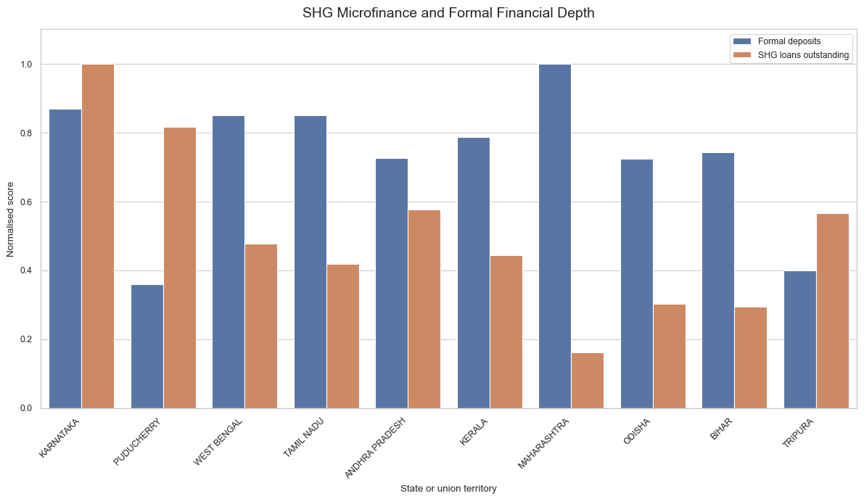

Figure 6. Log Deposits and Hospital Expenditure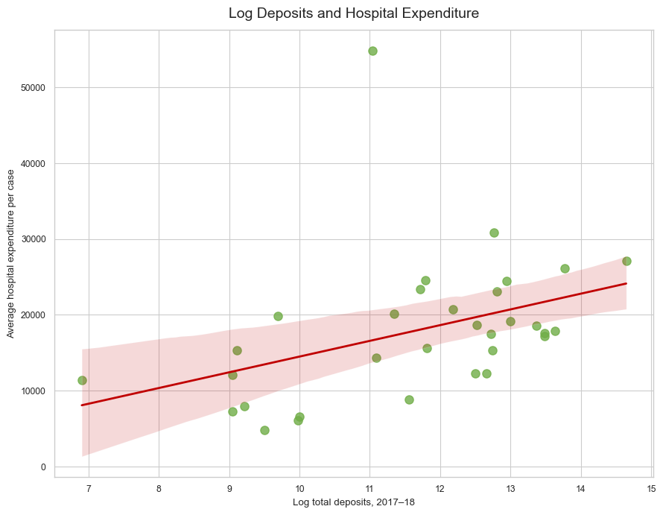

END OF WORKING PAPER
Dinesh Kumar Pandey
MSc Student, Global Investment Management, Ulster University
11 August 2026
SROI Working Paper 1
Disclosure Statement: This working paper has not undergone formal peer review. It represents the independent research and analytical work of the author and does not constitute financial, legal, regulatory or investment advice. The analysis and views expressed are those of the author alone and should not be attributed to any employer, institution or organisation with which the author is affiliated. Comments and feedback are welcome and may be directed to the author at the contact details above.
Data Availability: The empirical analysis in this paper uses publicly available, aggregate, state-level secondary data from official sources, including the Reserve Bank of India, NABARD, Census of India, MOSPI/HCES, PLFS and NPCI. All data are aggregated and anonymised by design; no household-level or institution-level microdata are used. Source-level documentation and links are provided in the References. Any derived indices (FIIndex, SROIMetrics and SROIMetrics_nonoverlap) and the cleaned state-level analytical dataset are available from the author on reasonable request, subject to compliance with the original sources’ terms of use and any applicable data-sharing restrictions.
Competing Interests: The author declares that there are no competing interests relevant to this paper. The research was conducted independently, without funding or direction from any financial institution, microfinance organisation, regulator or impact investor. The author has no financial or personal relationship that could be construed as influencing the design, analysis or interpretation of the study.
Ethical Statement: This study uses only publicly available, aggregate, state-level secondary data from official sources. No primary data collection involving human participants was undertaken for this paper, and no individual-level or household-level data were accessed. Accordingly, formal ethical approval was not required. All analysis is conducted at the state level, and no attempt is made to identify or profile individual households, SHGs or financial institutions.

