


Development of an intelligent and sustainable management module for the construction industry, based on Business Analytics

Vinícius Nascimento Silva - a62860

Dissertation submitted to the Higher School of Technology and Management of Bragança for the attainment of a Master's Degree in Information Systems.

Work supervised by:
Prof. Paulo Alexandre Vara Alves
Prof. Eduardo Cunha Campos

This dissertation does not include the criticisms and suggestions made by the Jury.

Development of an intelligent and sustainable management module for the construction industry, based on Business Analytics

Vinícius Nascimento Silva - a62860

Dissertation submitted to the Higher School of Technology and Management of Bragança for the attainment of a Master's Degree in Information Systems.

Work supervised by:
Prof. Paulo Alexandre Vara Alves
Prof. Eduardo Cunha Campos

This dissertation does not include the criticisms and suggestions made by the Jury.

Dedication
I dedicate this work to my parents, Maria Eliza and Helder.

Acknowledgments
I thank my parents Maria Eliza and Helder, my siblings Fernanda and Henrique, my friend Pablo, and my professors for their support throughout all these years.

Abstract

Small and medium-sized enterprises (SMEs) in the construction sector face ongoing challenges in terms of cost control, meeting deadlines, and resource efficiency, despite generating large volumes of data. Companies in this sector exhibit high levels of material waste and inefficiencies in decision-making, often caused by limited analytical support. This work hypothesizes that integrating Business Intelligence (BI) into a construction management system improves managers' decision-making by transforming fragmented data into useful information. The main goal is to design, implement, and validate a BI module adapted to the needs of construction SMEs, complementing a pre-existing management platform. The solution was developed using a C#/.NET backend with Entity Framework Core and MySQL, and a React/TypeScript frontend with Ant Design, following an agile Kanban methodology. The final system provides interactive dashboards focused on budget execution, global performance indicators, and project-specific analyses, allowing for the early detection of cost and schedule deviations. The results indicate that enhanced analytical support and operational transparency provide a foundation for a data-driven strategy, promoting the digital maturity and competitive positioning of SMEs in the construction industry.

Key-words: Data Analysis, Business Intelligence, Construction Management, Web Platform
Content
Introduction 1
1.1 Context and Motivation 1
1.2 Goals 3
1.3 Document Structure 4
State of the Art 5
2.1 BI and Data Analytics 5
2.2 Data Organization in the Construction Industry 6
2.3 BI Architectures and Analytical Components 7
2.4 Key Performance Indicators 8
2.5 Dashboards 9
2.6 BI Solutions for the Construction Industry 9
Methodology 14
3.1 Approach 14
3.2 Iterative Task Management 15
3.3 Planning and Validation with the Client 16
3.4 Declaration of Use of Artificial Intelligence 17
Analysis, Modeling and Architecture 18
4.1 Previously Implemented Functionality 18
4.1.1 Characterization of the Existing Platform 18
4.1.2 Existing Features 19
4.1.3 Functional Gaps in the Legacy Solution 23
4.2 Requirements Gathering and Analysis 23
4.2.1 Functional Requirements 24
4.2.2 Non-Functional Requirements 25
4.3 Modeling 26
4.3.1 Modeling of Construction Management Tools 26
4.3.2 Modeling the Parameterization Tools 28
4.3.3 Modeling Intelligent Management Tools 29
4.4 Interface Prototypes 33
4.5 Solution Architecture 36
4.5.1 Arquitetura Geral 37
4.5.2 Technologies Adopted 37
4.5.3 Backend Structure 38
4.5.4 Frontend Structure 39
4.5.5 General Structure 40
Development 47
5.1 Context 47
5.2 Tasks Before Field Tests 48
5.2.1 Review of the Report Generation Process 49
5.2.2 Review of the Attendance System 49
5.2.3 Billing System Review 50
5.2.4 Usability Review of Forms 50
5.2.5 Normalization of Migrated Data 51
5.2.6 Implementation of New Features for the Construction Management Module 51
5.2.7 Infrastructure Adjustments 52
5.3 Parallel Tasks with On-Site Testing 52
5.3.1 Inclusion of VAT Rate in the Settings Module 52
5.3.2 Adjustments to Monetary Fields in Forms 53
5.3.3 Adjustments to Filters and Duplicate Data Checking 53
5.3.4 Adjustments for Treating Borderline Cases 53
5.3.5 Continuous Improvement and Operational Stability 54
5.4 Implementation of the Intelligent and Sustainable Construction Management Module Tools 54
View of System Pages 59
6.1 Tool Groups 59
6.2 Pages of the Construction Management Module 66
6.3 Pages of the Parameterization Module 70
6.4 Pages of the Intelligent and Sustainable Construction Management Module 70
Results and Discussion 74
7.1 Validation Criteria 74
7.2 User Satisfaction Survey and Responses 75
7.3 Availability Tests 78
7.4 Limitations 79
7.5 Observations 80
Conclusions and Future Work 81

List of Tables
Table 1: Comparison of ERP solutions in construction (author's analysis) 12
Table 2: Information and description of Execução Orçamental 30
Table 3: Information and description of Indicadores Globais 31
Table 4: Information and description of Indicadores Específicos (Specific Indicators) 32

List of Figures
Figure 1: Equipamentos & Serviços - starting point 20
Figure 2: Obras - starting point 21
Figure 3: Outros Custos - starting point 22
Figure 4: Recursos Humanos - starting point 22
Figure 5: Class diagram for recording Notas de Crédito 27
Figure 6: Class diagram for recording Capítulos. 28
Figure 7: Class diagram for Parâmetros and Valores dos Parâmetros 29
Figure 8: Prototype model for Execução Orçamental 34
Figure 9: Prototype model for Indicadores Globais 35
Figure 10: Prototype model for Indicadores Específicos 36
Figure 11: Structural organization of components 41
Figura 12: Logical solution architecture 42
Figura 13: Construction Management - part 1 43
Figura 14: Construction Management - part 2 44
Figura 15: Parametrizations 45
Figura 16: Intelligent and Sustainable Construction Management 46
Figure 17: Class State definition in Execução Orçamental 55
Figure 18: Class State definition in Indicadores Globais 56
Figure 19: Class State definition in Indicadores Específicos 58
Figure 20: All groups - final version 59
Figure 21: Equipamentos & Serviços - final version 60
Figure 22: Obras - final version 61
Figure 23: Outros Custos - final version 62
Figure 24: Recursos Humanos - final version 63
Figure 25: Amortizações Fiscais - final version 64
Figure 26: Entidades - final version 64
Figure 27: Parametrizações - final version 65
Figure 28: Painéis - final version 65
Figure 29: Presenças Page 66
Figure 30: Cálculo de Vencimentos Page 67
Figure 31: Equipamento Page 67
Figure 32: Fatura Cliente Page 68
Figure 33: Leasing Viatura Form 69
Figure 34: Capítulo Page 70
Figure 35: Execução Orçamental Dashboard 71
Figure 36: Indicadores Globais Dashboard 72
Figure 37: Indicadores Específicos Dashboard 73
Figure 38: Nível máximo de satisfação 77
Figure 39: 2nd level of satisfaction 77
Figure 40: 3rd level of satisfaction 78
Figure 41: Interruption due to WSL error 79

Acronyms

ALN ALN Construções Abel Luís Nogueiro & Irmãos Lda.
API Application Programming Interface
BI Business Intelligence
BIM Building Information Modeling
DTO Data Transfer Object
ERP Enterprise Resource Planning
IoT Internet of Things
KPIs Key Performance Indicators
MVC Model View Controller
PDF Portable Document Format
REST Representational State Transfer
RSW Register Step Window
SCADA Supervisory Control and Data Acquisition
SMEs Small and Medium-sized Enterprises
VAT Value Added Tax
WSL Windows Subsystem for Linux

Chapter 1

Introduction

This chapter provides an overview of the context and motivations behind this project. Following this, the goals and structure of the document are presented.

1.1 Context and Motivation
The construction industry is characterized by high levels of operational complexity, requiring rigorous coordination of resources, deadlines, and costs. Operational inefficiencies cost the global economy trillions of dollars annually [48]. Financial control, adherence to schedules, and efficient resource allocation are critical factors for the success of construction projects [30]. These challenges are particularly relevant for small and medium-sized enterprises (SMEs), which often operate with reduced margins and are highly sensitive to budget deviations [33]. Furthermore, the sector is heavily exposed to fluctuations in the prices of raw materials and fuels [29] [44]. These variations can significantly compromise the financial predictability of buildings, reinforcing the need for information systems capable of providing up-to-date data, performance indicators, and analytical support for real-time decision-making [43].
In this context, the concept of Business Intelligence (BI) emerges as a strategic approach to support data-driven decision making [1]. The ability to monitor costs, track budget deviations, and analyze operational indicators in real time becomes particularly relevant in a sector characterized by high financial and operational variability. BI systems enable the collection, integration, and analysis of data from different operational processes, transforming them into structured information and useful knowledge for managers [5]. Integrating analytical capabilities into management systems enables the centralization of organizational information and the generation of performance indicators, analytical reports, and interactive dashboards that support monitoring project execution, identifying inefficiencies, and strategic planning [41].
In Bragança, the company ALN Construções Abel Luís Nogueiro & Irmãos Lda. (ALN) relies on effective management of human, material, and financial resources to ensure the economic viability of its buildings. Therefore, the use of IT solutions based on Enterprise Resource Planning (ERP) systems becomes essential in supporting this management [2]. Between 2023 and 2024, a collaboration between ALN ​​and the Polytechnic Institute of Bragança resulted in the development of a new web platform for managing business processes [34]. This solution is based on a system previously developed in 2013, with the goal of modernizing the infrastructure and improving data integration. However, the new platform was not launched into production because it had incomplete essential functionalities. Among these were the modules for invoice registration, attendance management, and payroll calculation, considered indispensable for the regular operation of the company.
The adoption of the new platform aims not only to replace the legacy system used by the company, but also to centralize operational data from construction projects in an integrated environment, allowing the transformation of scattered records into useful analytical information. Thus, the development of the BI module assumes a strategic role, enabling the monitoring of indicators related to costs, invoicing, productivity, budget execution, and project performance. In this way, the platform ceases to act solely as a transactional system for recording operations, and also begins to support monitoring, analysis, and decision-making processes.

1.2 Goals
Given the need to replace the existing technological platform and simultaneously complete the system with critical functionalities, a new development phase was established between 2024 and 2025. The overall goal of this work is to design, develop, and integrate new functional modules into a business management platform for the construction sector, additionally incorporating a BI module oriented towards the analysis of organizational performance and construction projects. In particular, the aim is to expand the analytical capabilities of the existing construction management system, leveraging already available operational data to support activities such as budget execution analysis.
In more granular terms, the specific goals include: (i) the development of the Construction Management Module, the Parameterization Module, and the Intelligent and Sustainable Construction Management Module, (ii) the definition of relevant performance indicators, aligned with construction project management practices, and (iii) the implementation of interactive dashboards and analytical reports that allow monitoring the execution of projects, evaluating overall performance, and supporting decision-making. Furthermore, the aim is to ensure efficient integration with existing workflows, minimizing barriers to system adoption.
The Construction Management Module is defined as the set of functionalities responsible for supporting operations associated with the execution of construction projects, including the registration and monitoring of attendance, invoices, credit notes, materials, and equipment. The Parameterization Module comprises the tools for configuring reusable parameters and business rules used by the other modules of the system. Finally, the Intelligent and Sustainable Construction Management Module corresponds to the analytical component of the platform, responsible for transforming operational data into performance indicators, analytical reports, and interactive visualizations to support decision-making.

1.3 Document Structure
The following sections of this document follow a chapter-based structure. The State of the Art will be presented in Chapter 2, where existing technological solutions in the field of construction company management are analyzed and compared. Chapter 3 presents the methodology adopted. Chapter 4 describes the modeling, pre-implementation, and architecture processes, including the functionalities to be completed or developed. Next, Chapter 5 presents the technical aspects of the solution development, the necessary changes to the database, and the alterations to the frontend and backend. Chapter 6 then provides some screenshots to contextualize what was developed. Chapter 7 discusses the results obtained and the evaluation of the developed system. Finally, Chapter 6 presents the conclusions of the work and identifies possible directions for future research and development.
Chapter 2

State of the Art

This chapter presents the state of the art related to BI, data analysis, and analytical systems applied to the construction industry. Initially, the fundamental concepts of BI and data analysis are discussed, followed by the particularities of data organization in the construction industry. Next, analytical architectures, performance indicators, and data visualization dashboards are addressed. Finally, BI solutions applied to the context of construction are analyzed, allowing for contextualization of the investigated problem and justifying the decisions adopted in the development of the proposed solution.

2.1 BI and Data Analytics
BI is defined as a comprehensive set of technologies, processes, and management practices designed to transform raw organizational data into meaningful information that supports decision-making, performance monitoring, and strategic control [21]. While traditional BI focuses on understanding past and present events through descriptive reports, the concept has evolved to include data analytics, which emphasizes predictive and prescriptive aspects to anticipate future scenarios [25]. By combining these elements, it is possible to strengthen organizations' ability to anticipate trends, reduce uncertainty, gain competitive advantages, and support evidence-based decision-making [3].
Within this framework, BI and Data Analytics have emerged as the dominant response to Big Data challenges, particularly those related to volume, velocity, variety, veracity, and value [46]. BI encompasses integrated practices and technologies for collecting and processing [6]. This enables the analysis and dissemination of information. [13]. In this way, raw data is transformed into actionable knowledge that supports strategic management [9]. It is estimated that the application of Big Data aligned with data analytics can reduce engineering and construction costs by up to 21% in the next decade [11].
The effectiveness of BI critically depends on data quality and governance, requiring rigorous standards of accuracy, completeness, and consistency throughout its lifecycle [43]. Furthermore, organizational transparency is enhanced when different departments use uniform data sources, reducing redundancies and information conflicts [2]. BI acts as the engine that extracts strategic value from a vast collection of dispersed data, being widely applied in the construction sector for purposes such as estimating costs and budgets, predicting delays, predicting resource consumption and managing productivity [31] [32].

2.2 Data Organization in the Construction Industry
Construction is recognized as a highly fragmented sector, with local organizational structures and non-linear workflows [30]. This fragmentation results in data that is dispersed throughout the lifecycle of a project, uncorrelated and often stored in heterogeneous formats, such as spreadsheets, emails and progress logs [41] [48]. In addition to this, the construction industry is characterized by slow adoption of new technologies compared to other sectors and generates design errors that contribute to around 33% of material waste [12] [19].
The organization and integration of data constitute fundamental challenges in civil construction. Among the approaches found in the literature, Building Information Modeling (BIM) stands out, which promotes the centralization of information about the life cycle of a building through integrated digital models [16] [35]. At the same time, ERP systems are widely used to consolidate operational, financial and administrative data from construction companies, functioning as central repositories for monitoring costs, resources and execution of projects [12]. Although they have different goals, both approaches contribute to the structuring and availability of data that can later feed BI systems.

2.3 BI Architectures and Analytical Components
A robust BI architecture is composed of fundamental elements that allow for the manipulation of data on a large scale. Different approaches emerge around this point to meet all needs, naturally, the architectures depend on processes to extract, transform, and load data from heterogeneous sources into the system, including digitizing documents [9]. A fundamental pillar is Data Warehouses, which act as centralized repositories optimized for historical analysis and complex queries [6] [14]. Among the main analytical techniques, data mining processes stand out, used for classification, grouping, association, and pattern prediction from large volumes of information [24]. Techniques such as Online Analytical Processing, rapid data visualization from various angles, and historical navigation or navigation through the relationships between data are also emerging [24].
In modern construction, these architectures incorporate Internet of Things (IoT) sensors and Supervisory Control and Data Acquisition (SCADA) systems for real-time data collection, integrating them with cloud platforms or edge processing to reduce latency and increase scalability [23]. In recent literature, different data sources can feed BI architectures, including ERP systems, BIM platforms, IoT sensors and document bases. The integration of these sources allows the construction of digital ecosystems capable of supporting operational and strategic analyzes throughout the life cycle of enterprises [39]. The combination of all these approaches leads to pattern discovery, predictive modeling, and the exploration of multidimensional data, which can be expressed in textual or graphical reports [5]. The results are generally presented through interactive dashboards and reports, which consolidate Key Perfomance Indicators (KPIs) and support decision-making, contributing to real cost reductions [16].

2.4 Key Performance Indicators
KPIs form the backbone of any BI system, translating raw data into standardized and actionable performance metrics [1]. These need to be specific, measurable, achievable, relevant, and time-bound [4]. In construction literature, KPIs are traditionally grouped into categories such as Cost, Schedule, Quality, and Safety [22] [29]. Recent studies broaden this scope to include sustainability, such as waste and emissions management, and supply chain resilience [26].
The quality of a KPI framework depends on its strategic alignment with the organization's goals, such as simultaneously monitoring financial results, internal processes, and learning capabilities [27]. In Industry 4.0, KPIs become dynamic, being monitored in real time to allow for immediate adjustments to planning and prevent budget overruns [10]. For complex engineering and construction projects, early identification of deviations through indicators is fundamental to mitigating risks and ensuring the timely delivery of projects [7].

2.5 Dashboards
Dashboards, or visual panels, represent the end-user interface of a BI system, consolidating critical information onto a single screen to enable quick decisions [36]. They offer a specific perspective on the project status, allowing managers to monitor budgets, deadlines, and KPIs in real time [17]. For example, tools like Power BI and Tableau allow the creation of interactive visuals that facilitate detailed analysis [8].
The effectiveness of a dashboard is linked to managing cognitive load, overly complex interfaces can lead to information overload and hinder decision-making [8] [20]. Therefore, the design should be user-centered, using intuitive visual components such as bar charts, progress indicators, and interactive functionalities such as dynamic filters and navigation between different levels of granularity [15] [18].
Currently, the integration of Artificial Intelligence and Machine Learning allows dashboards to offer not only historical views, but also prescriptive recommendations and predictive alerts of operational bottlenecks [38]. Therefore, dashboards become particularly relevant in construction management systems, as they allow for the consolidation of financial, operational, and temporal indicators in unified interfaces, facilitating the monitoring of project execution and the early identification of budget deviations and delays.

2.6 BI Solutions for the Construction Industry
The nature of civil construction projects, characterized by high complexity and variability, reduces the direct applicability of generic BI solutions. Existing market solutions support predictive models and assist in the early identification of logistical bottlenecks and schedule delays [44]. The application of BI solutions in construction has demonstrated tangible benefits in cost reduction and schedule optimization. Studies indicate that the use of data analytics can reduce project costs by 5% to 10% and shorten schedules by 10% to 20% [23].
Some solutions incorporate predictive analytics, supported by Machine Learning algorithms and Artificial Neural Networks, applied to accurately estimate the generation of construction and demolition waste, supporting sustainability strategies [40]. Other proposals have been developed for budget management, security, and real-time cost control [24] [41]. In the context of SMEs, BI solutions are fundamental to increasing digital maturity and competitiveness, allowing smaller companies to use open and internal data to tailor business proposals to the market [33]. Beyond financial management, BI has been applied to sustainability, predicting waste generation rates and optimizing energy consumption in smart buildings [28].
In the current market context, there are several IT solutions available for managing companies in the construction sector, such as ERP Primavera, ERP Cegid PHC CS and ETICADATA Obras/Projetos. All offer budget management, accounting, and project monitoring functionalities. However, these solutions were designed as independent tools and may or may not be sold separately depending on the owning company.
There are also more robust alternatives, such as SAP Business One, Microsoft Dynamics 365, Autodesk Forma, Procore and Buildertrend, which, in addition to basic features, offer real-time collaboration, BIM methodologies and advanced analytical capabilities. Although these solutions are mature, they involve high licensing costs, the need for adaptation to local realities, or the absence of specific modules.
Table 1 presents a comparison between some of the most relevant solutions, highlighting advantages and limitations. This analysis allows us to contextualize this study and identify the main shortcomings of existing software.
Table 1: Comparison of ERP solutions in construction (author's analysis)
Tool | Advantages | Limitations
ERP Primavera | It integrates accounting, construction management, and HR. Strong presence in Portugal. Suitable for SMEs. | Licensing is relatively expensive. The learning curve is slow for less experienced users.
ERP Cegid PHC CS | Contract management, project management and invoicing. User-friendly interface. | Less flexible for integration with external platforms. Average cost.
ETICADATA Obras/Projetos | Adapted to the Portuguese reality. Budgeting and construction supervision. | Limited support for advanced analytics and BI integration.
SAP Business One | Robust. Integrates finance, procurement, logistics, and construction. Scalable. | High costs. Long implementation time. Poorly suited to SMEs.
Microsoft Dynamics 365 (+ Add-ons) | Flexible. Native integration with Power BI. Strong analytical and modular capabilities. | High licensing costs. Need for customization for the construction sector.
Autodesk Forma | Real-time collaboration. BIM support. Integration of documentation and schedules. | More geared towards project management than financial management. Subscription costs.
Procore | Focus on project management. Efficient communication between teams. Cloud solution. | More popular in international markets. High cost. Poor adaptation to the Portuguese context.
Buildertrend | Designed for SMEs. Intuitive interface. Cloud access. Focus on budgets and schedules. | Limited financial capabilities. Smaller presence in Europe. Reliance on the cloud.

However, these solutions often present disadvantages, such as high costs, limited flexibility, and insufficient alignment with the operational reality of small and medium-sized enterprises. On the other hand, exploring third-party solutions made it possible to discover important visual representations such as the Gantt chart for time tracking used in Microsoft Dynamics 365, for example.
Chapter 3

Methodology

This chapter describes the methodology adopted throughout the development of the solution, focusing on work organization, task planning, and continuous integration of validation with the client. As the project corresponds to the evolution of a previously initiated platform, the methodological approach sought to balance the use of the existing structure with the incremental implementation of new functionalities. This prioritizes a logic of continuous adaptation, progressive validation, and alignment with the needs identified throughout the process.

3.1 Approach
The methodology was defined considering the particularities of the context in which the project was developed. Unlike solutions conceived entirely from scratch, this work started from a previously implemented, but still incomplete and unstable platform. As a consequence, the development was not limited to the creation of new functionalities, but also involved activities of analysis of the existing structure, correction of technical limitations, operational stabilization, and adaptation of business rules.
In this context, an iterative approach proved more suitable than a rigidly sequential process, since a significant portion of the system's needs only became clear during the use of the platform and through continuous contact with the client. Thus, development was conducted incrementally, allowing for the implementation of functionalities, validation of behaviors, correction of limitations, and incorporation of new requirements throughout the work cycle.
The adoption of an iterative approach finds support in the software engineering literature, especially in scenarios characterized by evolving requirements, frequent need for validation, and the existence of technical uncertainty associated with legacy systems [37]. In contexts of this nature, short cycles favor continuous adaptation, mitigation of integration risks, and greater alignment between technical development and operational needs.

3.2 Iterative Task Management
The work was organized in iterative cycles using Kanban and incremental development cycles [47]. This approach allowed for incremental management of efforts, prioritization of essential functionalities, and a quick response to evolving requirements [45]. To support this choice, the GitHub Projects module was adopted, which provides the main tools needed to manage tasks on a Kanban board.
The use of Kanban proved suitable due to the dynamic nature of the tasks, which required frequent priority reviews, handling of emerging corrections, and progressive integration of additional functionalities. The continuous visualization of the workflow allowed for greater transparency, control of progress, and early identification of roadblocks. Tasks were organized into columns representing the states Backlog, To Do, In Progress, and Done [37].
The Backlog contains all identified tasks that have not yet been started. It's a collection of everything that needs to be done in the future. The To Do group gathers the tasks that must be done in the current work cycle. These are the tasks that were in the Backlog and should be executed soon because they were defined as a priority in the last meeting. The In Progress label identifies all tasks that have already been started, moving them to this column indicates that work is effectively underway for that task. Finally, the Done group gathers all completed tasks and represents success in the execution of that task. In cases of interruptions to In Progress tasks, they can be returned to the To Do group, but to be completed within the current cycle or, in extreme cases, to the Backlog group. This organization made it possible to track the lifecycle of each item from definition to completion [45].
Initially, development cycles lasted fifteen days, offering longer periods for implementation and validation of functionalities. However, throughout the project, it became necessary to reduce these cycles to seven days in order to increase the frequency of monitoring and accelerate incremental validation. This shortening also provided better responsiveness to changes in business rules and promoted greater alignment between technical goals and functional requirements.

3.3 Planning and Validation with the Client
The development planning was influenced by continuous interaction with the client, whose participation played a central role in defining, prioritizing, and validating the implemented functionalities. This collaboration proved important due to the evolutionary nature of the solution, since several needs only became evident during the progressive use of the platform in a real-world context.
Frequent validation with the client allows not only the confirmation of previously identified requirements, but also the adjustment of already implemented functionalities, the review of usage flows and the incorporation of new operational needs throughout development [45]. Among the adjustments made based on this process, the following stand out: changes in search mechanisms, reorganization of interface elements, inclusion of new filters, adaptation of rules associated with attendance management and refinement of analytical indicators of the BI module.
This ongoing interaction also contributed to guiding decisions related to information visualization and the structure of analytical dashboards. The definition of global indicators, budget comparison mechanisms, and the use of graphical representations, such as bar charts and Gantt charts, resulted directly from the validation process with the client and the need to adapt the solution to the company's operational context [15] [18].
Thus, continuous interaction with the client played not only an advisory role, but also constituted an active mechanism for incremental validation of the solution. This dynamic made it possible to reduce discrepancies between expected requirements and implemented functionalities, contributing to a more consistent evolution of the platform throughout development.

3.4 Declaration of Use of Artificial Intelligence
Throughout all stages of the project, the author used the GPT-5.4 and Gemini-3.5 models for modeling review, syntactic adjustment of the text, grammar review, translation and just code review. The author declares that he reviewed and has full responsibility for the content present here.
Chapter 4

Analysis, Modeling and Architecture

This chapter presents the starting point of the solution in order to understand which parts have already been completed and what remains to be done. Following this, it presents the process of requirements analysis, functional modeling, and architectural definition of the developed solution, describing the technical and structural decisions adopted throughout the project.

4.1 Previously Implemented Functionality
This work continues the dissertation Desenvolvimento de uma Plataforma de Gestão da Construção by Oliveira [34], part of the system was already modeled and implemented. In this context, it is important to describe the existing modules, identify the limitations and explain how this basis conditioned the subsequent development.

4.1.1 Characterization of the Existing Platform
Continuing development from a pre-existing platform brought both benefits and limitations to the project. On the one hand, the existence of a prior base reduced the effort required to define the overall system structure and provided clear guidance for implementing missing functionalities. On the other hand, the fact that the solution began earlier meant inheriting structural weaknesses, a lack of validation in parts of the system, and the need to adapt the platform to the new requirements defined within this work.
Understanding the starting point proved to be a crucial step in the development process. Before moving on to new BI functionalities, it became necessary to understand the actual state of the system, assess the consistency of the existing code, and identify the components that required intervention or redesign.

4.1.2 Existing Features
In the legacy version of the platform, there were 4 main groups of functionalities organized: Equipamentos & Serviços (Equipament & Services), Obras (Buildings), Outros Custos (Other Costs), and Recursos Humanos (Human Resources). Together, they totaled 18 established tools. Terms in Portuguese should appear throughout the text because the platform was developed for the context of a Portuguese company and there was no demand for compatibility with another language. For consistency between the text and the tool's images, translated names will appear.
The Equipamentos & Serviços group comprised 2 tools: Material (Material) and Consumível/Serviço (Consumable/Service), as illustrated in Figure 1. These functionalities were responsible for managing materials and services used in the operational context of construction projects, constituting one of the main sources of data related to consumable resources in a construction project, but without associated values.

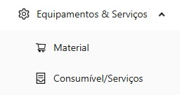Figure 1: Equipamentos & Serviços - starting point

The Obras group consisted of 8 pages: Obra (Building), Execução Orçamental (Budget Execution), Presenças (Attendance), Preço Materiais (Materials’ price), Materiais por Obra (Materials per Building), Fatura Material (Material Invoice), Pedido Cotação (Request Quotation) e Fatura Cliente (Customer Invoice), as shown in Figure 2. This group on the platform concentrated a wide range of operations directly related to the operational management of the construction projects. Initially, this distribution made sense, since both the Execução Orçamental dashboard and the Presença page were oriented based on the logic of each building. However, as the business rules matured, this organization became less consistent with the functional evolution of the platform, with some of these functionalities subsequently being repositioned in other functional contexts.

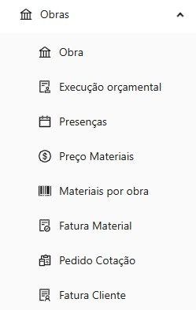Figure 2: Obras - starting point

Next, the Outros Custos group comprised 7 items: IUC (Vehicle Circulation Tax), Inspeção Periódica (Periodic Inspection), Leasing Viaturas (Car Leasing), Seguro Automóvel (Car Insurance), Seguro Trabalho (Work Insurance) and Consumíveis e Serviços (Consumables and Services), as illustrated in Figure 3. This set covered expenses associated with supporting the company's activity, although there was still room for expansion and refinement.

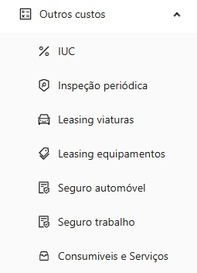Figure 3: Outros Custos - starting point

Finally, the Recursos Humanos group only had one page, Colaboradores (Collaborators), shown in Figure 4. This module had a limited level of functional coverage compared to the typical scope of human resource management in a business context, which reinforced the need for expansion to cover essential functionalities in this area, such as payroll.

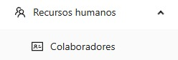Figure 4: Recursos Humanos - starting point

The existing functionalities defined the initial operational structure of the platform. This served as the basis for the continued development carried out within the scope of this work.

4.1.3 Functional Gaps in the Legacy Solution
Despite the existence of a previously implemented functional base, the platform still presented significant operational and structural limitations. Seventeen tools necessary to ensure minimum functional coverage of the identified use cases remained to be developed. This absence made it impossible to carry out a comprehensive functional validation process with the client, since the platform did not yet encompass all the operational processes that should have been supported.
In addition to the identified functional limitations, the absence of modules related to parameterization, organizational entities, tax amortizations, and analytical construction management was also noted. These gaps highlighted that the platform was still in an intermediate stage of development, making it necessary to implement additional structural functionalities before consolidating the BI indicators.

4.2 Requirements Gathering and Analysis
Requirements gathering and analysis is a fundamental step in the software development process. This process allows for the identification of the functional and operational needs of the solution. Requirements identification was conducted through meetings with the client, analysis of the legacy solution, and progressive validation of the company's operational needs. This process allowed for understanding the limitations of the previous platform, identifying functional gaps, and defining the key performance indicators necessary to support project monitoring and decision-making. The requirements gathered were organized into two main categories: functional requirements and non-functional requirements.

4.2.1 Functional Requirements
In a meeting with the client, the functional requirements for the new modules were defined, and the main performance indicators intended to support decision-making were identified. The dashboards aggregating key business information should allow managers to obtain a global view of the company's operational and financial context through a single interface.
In general terms, indicators were established related to active projects, completed projects, the client with the highest number of projects, the number of projects associated with each client, material classification, client classification, supplier classification, and classification of projects with the highest material costs. These elements became part of the Indicadores Globais (Global Indicators) tool.
Specifically regarding the construction projects, two main indicators were defined: a comparison between the planned budget and the actual recorded cost, and monitoring the time elapsed between the initial construction projects plan and the actual execution dates. Calculating these indicators required considering information related to materials, labor, taxes, and other operational costs associated with the execution of the buildings.
This need led to the creation of two complementary functionalities: Capítulo (Chapter) and Capítulos por Obra (Chapters per Building). The first, belonging to the Parâmetros (Parameters) group, is responsible for defining the chapters and their respective descriptions. The second, belonging to the Obras group, is responsible for associating the chapters with the different construction projects and for recording the corresponding temporal and budgetary information.

4.2.2 Non-Functional Requirements
From the perspective of how the system should be, the following non-functional requirements related to usability, performance, information security, and visual organization of the platform were established. These requirements aimed to ensure that the solution not only responded correctly to the intended operations but also exhibited consistent behavior appropriate to the real-world context of use.
In the usability domain, it was established that data registration forms should not include additional submission confirmation steps. This decision aims to reduce unnecessary interactions in the form completion flow, considering that the platform already has mechanisms for editing submitted data. Thus, the goal was to simplify the information entry process without compromising operational flexibility.
Still within the context of the interface, it was defined as a requirement to minimize horizontal scrolling in data tables when used on 19-inch monitors. To this end, priority was given to presenting the fields considered most relevant in each functional context, while keeping complementary information accessible through the viewing and editing flows. At lower resolutions, certain instances of horizontal scrolling remained unavoidable due to the informational density of some of the tools.
Regarding information security, it was established that only users with management profiles should have access to performance indicators and analytical functionalities. This restriction is justified by the sensitive nature of the information presented, including financial data, operational indicators, and metrics related to the performance of buildings and the company.
Finally, requirements related to the solution's performance were also defined. Although no rigid quantitative limits were established for the response time of operations, the aim was to ensure that the new platform would present interaction times equivalent to or better than those observed in the legacy solution used by the company.

4.3 Modeling
The modeling was designed for three different types of tools. The first are those related to Construction Management, where recurring records of invoices, credit notes, attendance, etc., are made. The second group to be detailed consists of tools in the Parameterization context, these allow the insertion of data and the definition of internal company rules that can be reused by the other tools in the Construction Management module. The third set to be discussed consists of tools from the Intelligent and Sustainable Construction Management module.

4.3.1 Modeling of Construction Management Tools
In Construction Management group context, the tools that were missing should follow the model of the others previously implemented. This was a way of maintaining conformity between what was already done and the new tools that would follow. Figure 5 shows the diagram for the Notas de Crédito (Credit Notes) tool. Most tools follow this structure: a building has N associated instances, and a instance has several associated items. These instances can be invoices, purchase orders, credit notes, among others, depending on the context of the page.

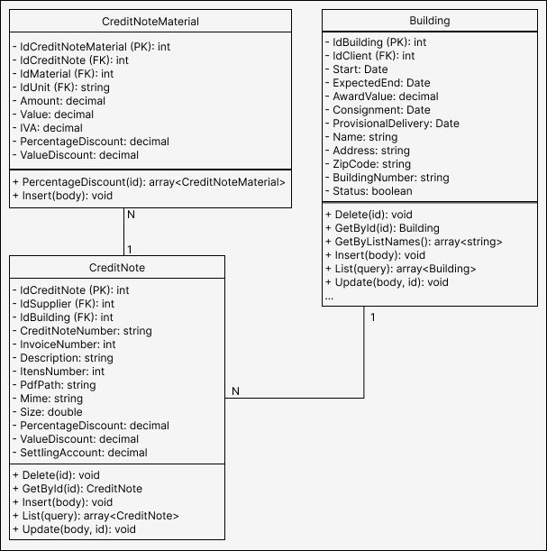Figure 5: Class diagram for recording Notas de Crédito

The advantage of always following the same standard is that it facilitates long-term maintenance by keeping all tools uniform. This also helps with training new developers [45].

4.3.2 Modeling the Parameterization Tools
Figure 6 shows the class diagram that illustrates the relationship between these concepts. As the diagram shows, a building can have several associated chapters to detail budgets and costs from start to finish.

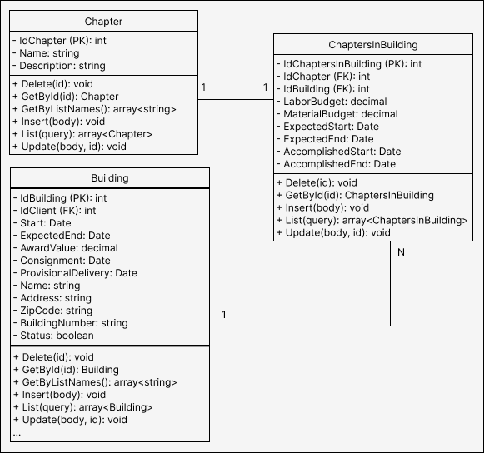Figure 6: Class diagram for recording Capítulos.

In the case of parameters and their values, they follow a dependency format where a parameter can have multiple associated values ​​as long as it is associated with an effective date, see Figure 7.

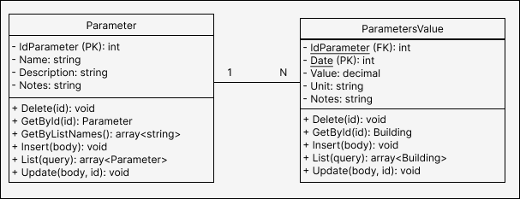Figure 7: Class diagram for Parâmetros and Valores dos Parâmetros

The system as a whole has many other tables that store information about buildings, equipments, employees, salaries, attendance, customers, suppliers, among others, all of which are better explained in Oliveira's dissertation [34]. However, the focus of this work is on performance indicators and not on explaining the complete solution. Therefore, many diagrams have been omitted.

4.3.3 Modeling Intelligent Management Tools
The platform's analytical indicators are built from operational data recorded in the system's various tools, including invoices, credit notes, labor costs, and other costs associated with the buildings. The modeling of this information was designed to support three complementary analytical perspectives. The first corresponds to the budgetary execution of a given project over a period of months and retrieves recorded execution details. The second provides a global view of the company's activity, based on consolidated indicators and comparative classifications between materials, suppliers, customers, and buildings. The third is oriented towards the individual analysis of buildings, allowing for a comparison of the executed values ​​with the budgeted values ​​over a specific time interval.
To support the Execução Orçamental functionality, an aggregating structure was defined to consolidate the main financial indicators retrieved by the system. This modeling brings together information related to labor, materials, other operating costs, taxes, and credit notes, allowing the simultaneous presentation of absolute values, financial differences, and comparative elements. Table 2 presents the main information groups used in the composition of the budget execution dashboard.

Table 2: Information and description of Execução Orçamental
Info | Description
Labor | Total direct and indirect labor costs.
Materials Invoices | Total material costs including and excluding VAT.
Other Costs | Additional operational costs, including and excluding VAT.
Credit Notes | Additional operational costs, including and excluding VAT.
Consolidated Totals | Total global costs including VAT, excluding VAT, and financial ratio.

The Indicadores Globais functionality also required the definition of structures for consolidating organizational metrics and analytical classifications. As shown in Table 3, the indicators include information related to the number of active buildings, the number of completed buildings, the client with the highest number of buildings, and the total number of buildings associated with that customer. Additionally, classification structures were modeled for materials, suppliers, customers, and buildings, enabling the construction of comparative classifications based on recorded costs. This organization allows for the creation of analytical visualizations in the form of cards, tables, and comparative graphs, facilitating the identification of relevant financial and operational patterns.

Table 3: Information and description of Indicadores Globais
Info | Description
Numerical indicators | Active buildings and completed buildings.
Biggest customer | Name and number of buildings associated with the largest customer.
Materials ranking | Materials with the highest cost recorded on the invoices.
Supplier ranking | Suppliers with higher financial volume are also related to invoices.
Customer ranking | Customers ranked according to the cost of their buildings.
Classification of buildings | Buildings classified according to the cost associated with the cost values.

To support the specific analysis of each buildings' performance, data structures were also defined to compare the planned budget with the actual costs recorded, as illustrated in Table 4. These indicators include budgeted values, executed costs, absolute differences, and percentage deviations associated with labor, materials, and other operational costs shared among the different buildings. In addition to the financial component, it also became necessary to model temporal information related to the execution schedule. Each chapter associated with the project stores planned dates and actual execution dates, allowing the construction of comparative visualizations inspired by Gantt charts and supporting the identification of delays and deviations from the initial plan.

Table 4: Information and description of Indicadores Específicos (Specific Indicators)
Info | Description
Projected Budget | Budget for labor, materials, financial leeway, and total budget.
Costs Incurred | Actual costs of labor, materials, other costs, and total cost.
Absolute Differences | Absolute differences between projected and actual values.
Percentage Deviations | Percentage deviations associated with labor costs, materials costs, and total cost.
Construction Schedule | Chapter title, planned start and end dates, actual start and end dates.
Temporal Structure | Information used to generate time-series charts and Gantt charts.

This defined information will be reused in the future to implement the code and consolidate the solution. Especially when it comes to the platform’s visual resources.

4.4 Interface Prototypes
Following the requirements analysis phase, interface prototypes were created to validate the interaction flow and visual organization of the proposed solution. Prototyping tools, such as Figma, were used to build low- and medium-fidelity prototypes.
Figure 8 shows the Execução Orçamental page template, where users can select a specific project, a date range, and obtain detailed information on actual material costs, shared costs, direct labor, indirect labor, credit notes, and totals with and without taxes. In addition, there is space reserved for three graphs: the first visually shows the proportion of construction costs over the months in bar graphs, the second compares the execution period also in bar graphs, and the third visually compares the budget with the executed value.

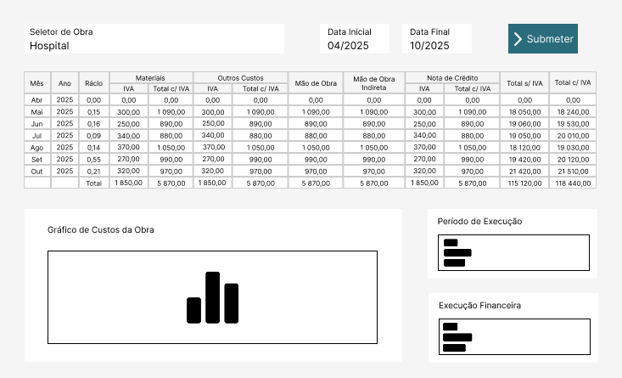Figure 8: Prototype model for Execução Orçamental

Figure 9 shows the Indicadores Globais page template, where users can select a date range and obtain information about active buildings during that period, the total number of buildings completed up to the end date, the clients with the highest number of buildings, and the total number of buildings associated with each client. In addition, the interface displays rankings of materials, suppliers, customers, and buildings based on actual cost criteria.

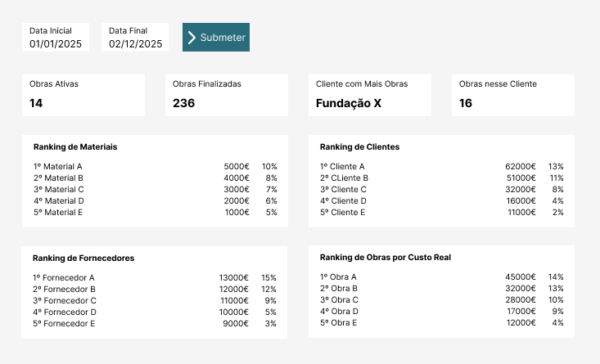Figure 9: Prototype model for Indicadores Globais

The next model, as shown in Figure 10, demonstrates that Indicadores Específicos page allows the user to choose a date range, work and a specific chapter. Thus, it is possible to understand temporal extrapolations in relation to the start and end dates of that work, as well as the labor, materials and total costs. The use of prototypes made it possible to anticipate usability problems, adjust navigation elements and ensure that the final solution was aligned with the customer's expectations. Furthermore, these representations served as a direct reference for the implementation steps.

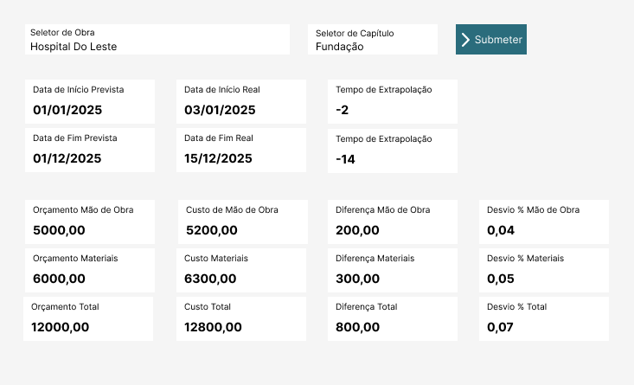Figure 10: Prototype model for Indicadores Específicos

The prototypes then explored were used to guide future implementation. However, these are not definitive versions of the implementation, adjustments may eventually become necessary.

4.5 Solution Architecture
To explain the design decisions for this segment, the overall architecture will be described, followed by the technologies, backend, and frontend structure. Finally, a recap of the overall structure adopted will be provided.

4.5.1 Arquitetura Geral
The system architecture was developed based on a three-tier client-server model, composed of the presentation layer, the business logic layer, and the data persistence layer. The presentation layer is implemented through a web application developed in React, responsible for user interaction and consumption of services provided by the Application Programming Interface (API) in a Representational State Transfer (REST) ​​model. The business logic layer consists of backend services and controllers, responsible for processing business rules and managing data flow. Finally, the persistence layer uses a MySQL relational database, with data access performed through entities and object-relational mapping mechanisms provided by Entity Framework Core. The backend follows an organization inspired by the Model-View-Controller (MVC) pattern, adapted for REST services.
The adopted architecture is based on a clear separation between presentation, business logic, and data access components, promoting greater modularity and making easier system maintenance and evolution. This organization allows for the isolation of responsibilities for each layer, reducing coupling between the frontend and backend and simplifying the implementation of new features in the future.

4.5.2 Technologies Adopted
The choice of the C# language and the .NET framework in the backend, along with Entity Framework Core and MySQL, allowed for the structuring of a robust solution for relational data management, ensuring more productive and consistent development in the manipulation of system entities. In the frontend, the use of TypeScript, React, and Ant Design contributed to a more responsive, organized, and consistent interface that meets the platform's usage needs.
This technological choice also enabled significant reuse of the legacy structure of the previous solution, originally developed in 2013, also in C#. Instead of completely replacing the existing base, an incremental modernization was chosen, preserving functional components and reducing the effort required to adapt the new system to the company's operational context. Maintaining the same language and technological ecosystem in the backend facilitated the partial reuse of previously developed code, as well as the adaptation of existing logic to a new communication structure based on REST services. The main technological breakthrough occurs in the frontend, through the adoption of modern technologies aligned with contemporary web development standards.
At the infrastructure level, a container-based approach using Docker was adopted for deploying the solution. This allowed the different system components to be encapsulated in isolated and reproducible environments. The platform is organized into multiple independent services, including the MySQL database, the backend API, the frontend application, and the Nginx server. Nginx's role is to provide unified exposure of the services. This container-based architecture makes it easier to achive a system portability, simplifies the deployment process, and ensures consistency between development and production environments. Additionally, the use of persistent volumes guarantees data preservation, even in the event of container restarts.

4.5.3 Backend Structure
Regarding the structural organization of the backend, the solution is segmented into the following components: Entity, Service, Data Transfer Object (DTO), and Controller. The Entity component supports the definition of the model classes used in the interaction with the database. The Service component concentrates the operations of read, write, update, delete requests, and business rule processing, including dynamic calculations at runtime. DTOs define the structures used for information exchange between the backend and frontend, allowing the decoupling of persisted objects from the structures exposed by the API. These objects may partially reflect the persisted entities, also including additional fields calculated dynamically and not stored directly in the database. Finally, Controllers act as an interface between internal services and requests from the frontend.

4.5.4 Frontend Structure
From a frontend perspective, the following structures apply to each page: Endpoint, Page, Table, Form, Register Step Window (RSW). The Endpoint component handles the communication interface with the backend and defines the data structures corresponding to the DTOs provided by the API. The Page component represents the main structure of the page displayed to the user, being responsible for initializing the necessary resources, managing React hooks, and coordinating the remaining visual components. The Table component is used for paginated presentation of received information, as well as for providing interaction actions such as adding, editing, and removing records, in addition to being responsible for the respective action buttons. The next component is the Form, it coordinates the base of the form for adding, editing, or viewing data. In other words, it manages the order and flow of the other windows related to data entry, as well as handling the information that will be displayed on the screen or assembling the object that will be saved in the database. Finally, the RSW component corresponds to the individual steps for filling out forms, containing text input fields, numeric values, documents, selectors, and dates. Depending on the complexity of the process, a single Form component may use multiple RSW components.

4.5.5 General Structure
The structure needs to be detailed in two ways, the component architecture and the logic. The Figure 11 presents a representation of the structural organization of the main components used in the implementation of the platform's pages.

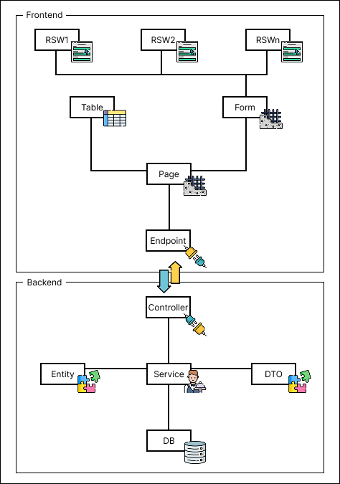Figure 11: Structural organization of components

There are also other auxiliary components intended for global navigation of the platform, definition of routes and export of common structures between different modules. However, these elements predominantly follow the structural patterns recommended by the official documentation of the .NET and React frameworks, adjusted to the specific needs of the system and, therefore, were omitted. In addition, Figure 12 presents an abstraction oriented to the logical architecture of the solution from the perspective of modular division of tools. Unlike the previous representation, focused on the structural organization of components, this view seeks to highlight the logical grouping of functionalities. Each group is responsible for fulfilling a certain role in the solution. It is worth noting that, for image standardization purposes, the modules have Portuguese names, Módulo de Gestão de Obras (Construction Management Module), Módulo Parametrizações (Parametrizations Module), and Módulo Gestão Inteligente e Sustentável da Construção (Intelligent and Sustainable Construction Management Module).

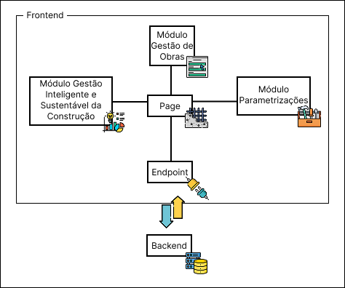Figura 12: Logical solution architecture
Each of the modules presented can be expanded to better visualize the division of tools. Figure 13 shows part 1 of the tools related to the Construction Management Module. Some of these tools also depend on each other in what is defined by them, an example of this is between the Clientes (Customers), Obra and Capítulos por Obra tool. Defining a customer is completely independent in itself, however, it only makes sense to create a project for a customer that exists and it only makes sense to define chapters for a project that exists. Therefore, there is a natural order of use in filling out the forms for each tool.

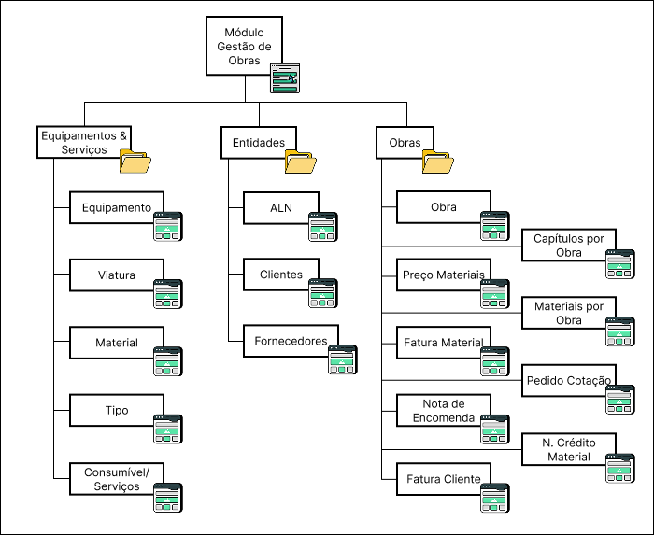Figura 13: Construction Management - part 1

Meanwhile, in Figure 14 it is possible to see the other tools that make up the Módulo Gestão de Obras. The tools were divided into part 1 and part 2 for reasons of available space but are not more or less important because of this division. It is possible to observe that some groups may need to be regrouped in the future, such as Outros Custos and Obras, as these already accumulate many functionalities.

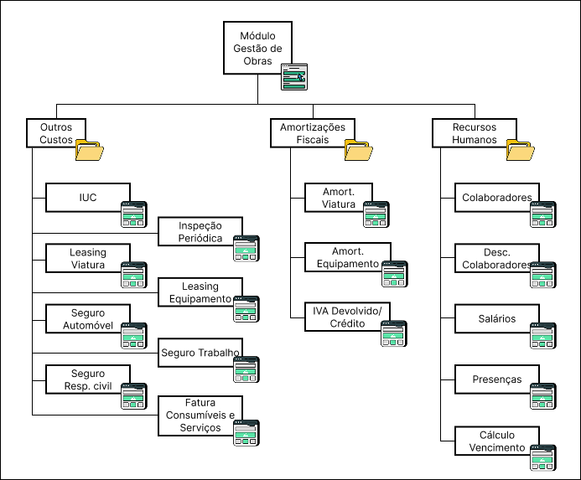Figura 14: Construction Management - part 2

The Módulo Parametrizações is the next to be explored, Figure 15. Only 3 tools are part of this subgroup. The Módulo Gestão de Obras tools depend indirectly on the definitions established in this group for faster and more uniform operations when filling out forms.

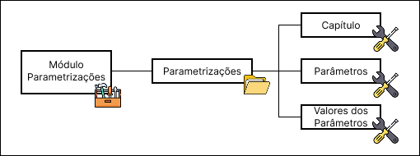Figura 15: Parametrizations

Finally, the Módulo de Gestão Inteligente e Sustentável da Construção that really attributes value to all data collection, represented in Figure 16. The three tools that make up this group represent the consolidation of BI modules in a visual way by retrieving data collected in Módulo Gestão de Obras and building graphs, tables and other performance indicators from them.

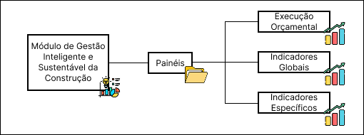Figura 16: Intelligent and Sustainable Construction Management

From this perspective, the frontend acts as a presentation and interaction layer, responsible for requesting analytical data and rendering graphic and tabular views. The backend concentrates the business logic and processing of indicators, while the relational database provides the operational data necessary to compose the metrics. This separation remains coherent between frontend and backend, favoring the modularity of the solution and simplifying the maintenance and future evolution of the platform.
Chapter 5

Development

The 96 tasks mentioned earlier were divided into 84 tasks aimed at improvements, code refactoring, and making available pages that were already modeled but not yet available, and 12 tasks related to new BI functionalities.

5.1 Context
The initial development phase focused on analyzing the existing application structure and configuring the runtime environment. This stage proved particularly relevant due to the limited technical documentation available for the previously developed solution, hindering an understanding of the adopted architecture and the application initialization process. Consequently, it was necessary to carry out an additional process of technical assessment and validation of the platform's original configuration, including clarifications with the person responsible for the previous development.
After stabilizing the development environment, a survey of functionalities not yet implemented in the new version of the platform was conducted. This analysis allowed for the identification of functional gaps and the structuring of the work into specific development tasks. In total, 19 tools pending implementation were identified.
In the Equipamentos & Serviços group, the Equipamento (Equipment), Viatura (Vehicle) and Tipo (Type) functionalities were missing. In the Obras domain, the Capítulos por Obra, Nota de Encomenda (Order Notes) and Nota de Crédito Material (Material Credit Note) tools were pending. In the Outros Custos area, the Seguro de Responsabilidade Civil (Civil Liability Insurance) functionality was identified as missing. Regarding the Recursos Humanos group, the Descendentes de Colaboradores (Descendants of Employees), Salários (Salaries) e Cálculo Vencimentos (Salary Calculation) functionalities remained unimplemented.
Additionally, entire groups without any prior implementation were identified, namely Amortizações Fiscais (Tax Amortizations), Entidades (Entities) and Parametrização (Parameterization). The Amortizações Fiscais tool included the functionalities Amortização de Viatura (Vehicle Amortization), Amortização de Equipamento (Equipment Amortization) and IVA Devolvido/Crédito (VAT Returned/Credit). The Entidades group included the functionalities ALN, Fornecedores (Suppliers) and Clientes. Finally, the Módulo Parametrização comprised the functionalities Capítulo, Parâmetros e Valores dos Parâmetros (Parameter Values).

5.2 Tasks Before Field Tests
The implementation of BI functionalities in a business context depends directly on the quality, integrity, and consistency of the data from the transactional systems that support the organization's operations. Therefore, before consolidating the analytical components of the platform, it was necessary to intervene in different structural functionalities of the management system, including operational corrections, revision of business rules, and implementation of previously non-existent tools. These interventions allowed for the stabilization of the information flows used by the platform, ensuring adequate conditions for the production of reliable indicators and for analytical support for decision-making. In this context, different technical and functional limitations were identified in the previously developed platform, requiring interventions at both the infrastructure and business logic levels of the application.

5.2.1 Review of the Report Generation Process
One of the first corrections made involved the Portable Document Format (PDF) document generation mechanism used in the attendance sheet. The originally adopted library, QuestPDF, had operational limitations and incompatibilities with the system's requirements. As a solution, it was decided to replace the library with iText7. Due to the structural differences between the two solutions, a complete reimplementation of the report generation mechanism was necessary, including a complete refactoring of the document construction logic. Adjustments were also made to the reports issued by the system, seeking to maximize the use of available space and reduce the occurrence of documents with multiple unnecessary pages.

5.2.2 Review of the Attendance System
Still within the context of attendance management, inconsistencies were identified in the handling of dates in TypeScript, particularly in the record replication mechanism. To mitigate these problems, the DayJS library was adopted, allowing for greater predictability and consistency in date manipulation. Simultaneously, it was found necessary to review some of the business rules related to the attendance system. The previously used model represented absences with the letter “F” and presences with numerical values ​​corresponding to the work schedules, but did not adequately account for situations of presence without meal allowance. As a consequence, the final calculations of allowances required additional and manual adjustments. The new model now uses three distinct representations: “N” for regular presence, “0” for absence, and “-N” for presence without meal allowance, where “N” is the numerical identifier of the building number identifier. This approach allowed for a more consistent representation of the business rules already used by the company, in addition to improving the traceability of records and dynamically computing meal allowance days without manual adjustment.

5.2.3 Billing System Review
Another relevant intervention occurred in the Fatura Obra tool, where inconsistencies were identified in the subtotal calculations due to the incorrect application of the order of operations involving taxes and discounts. Correcting these operations ensured greater accuracy in the financial values ​​presented by the system.
In addition, adjustments were made related to specific company business rules. Among these, the inclusion of the general invoice discount field stands out, which was previously non-existent despite being foreseen in the organization's administrative processes. Furthermore, visual changes were made to the interface, including reducing font size and compressing columns, with the aim of optimizing available space and minimizing the need for horizontal scrolling.

5.2.4 Usability Review of Forms
During the evaluation of existing functionalities, usability problems associated with the form completion flow were also identified. The initially adopted standard included an additional confirmation step before data submission, unnecessarily increasing the number of interactions required from the user. In response, adjustment tasks were defined for 17 of the 18 tools previously existing on the platform, with the aim of simplifying interaction flows and improving the user experience.

5.2.5 Normalization of Migrated Data
In the Inspeção Periódica tool, inconsistencies were found in the date formats resulting from the migration from the legacy system, including records stored as text in divergent formats, such as “18/07/2011” and “18-07-2011”. Considering that the new platform uses specific data types for dates, it became necessary to normalize the migrated data and adapt the records to the new persistence model.

5.2.6 Implementation of New Features for the Construction Management Module
Regarding the implementation of new features, the first fully developed pages were ALN, Fornecedores, Clientes and Cálculo de Vencimentos. This sequence was intentionally defined, allowing for a gradual progression of technical complexity, where the first three features served as structural preparation for the development of the last. During this process, interface responsiveness issues were also identified, namely the overlapping of the search bar with action buttons, prompting additional adjustments to the application's styles.
Subsequent steps focused on implementing the remaining pending functionalities, including Equipamento, Viatura, Tipo, Nota de Encomenda, Nota de Crédito Material, Seguro de Responsabilidade Civil, Amortização de Viatura, Amortização de Equipamento, IVA Devolvido/Crédito, Descendentes de Colaboradores, Salários, Parâmetros, and Valores dos Parâmetros.

5.2.7 Infrastructure Adjustments
From a hosting perspective, limitations related to the platform's production infrastructure were identified. The system was hosted in a Windows 11 Home Edition environment, where Docker did not start automatically after operating system restarts, causing temporary application unavailability until manual login was performed. As a workaround, Task Scheduler was configured to automate the authentication process, Docker initialization, and subsequent session locking. Although this approach does not eliminate restarts caused by automatic operating system updates, it significantly reduced downtime resulting from unexpected interruptions, such as power outages.

5.3 Parallel Tasks with On-Site Testing
With the completion of the preliminary structural corrections, the platform could be deployed in a production environment, allowing for the identification of new areas for improvement resulting from its use in a real-world context. This phase proved particularly important for validating operational flows and refining previously implemented functionalities.

5.3.1 Inclusion of VAT Rate in the Settings Module
Among the first adjustments made, the automatic definition of the default tax value in the forms of the platform's different tools stands out, reducing the need for manual data entry and promoting greater consistency in the records made. This also gives purpose to the Parameterization Module. In parallel, improvements were introduced to the search mechanisms, both in the main listings and in the internal forms, with the aim of optimizing the user experience and facilitating access to information.

5.3.2 Adjustments to Monetary Fields in Forms
During the use of the platform, it was also found necessary to adapt the monetary fields to support values ​​with up to four decimal places. However, the components initially adopted in the frontend used masking mechanisms incompatible with this behavior, requiring the removal of these formatting restrictions. Also at the interface level, some fields related to financial settlements were repositioned from the forms to the listing pages, since they were more relevant in the context of data query and analysis.

5.3.3 Adjustments to Filters and Duplicate Data Checking
Regarding the search and filtering mechanisms, it was found necessary to expand the query criteria provided by the system. To this end, filters by date range were added, search mechanisms were implemented to disregard special characters, and the textual criteria used in queries were broadened. In this context, additional validation for invoice numbers was also implemented, preventing duplicate records between different suppliers.

5.3.4 Adjustments for Treating Borderline Cases
In the Construction Management module, the mechanism responsible for identifying active buildings also needed revision. Although a specific status field existed, the system simultaneously used the project completion date as a validation criterion, which generated inconsistencies in situations involving the reactivation of buildings related to warranty services.
In the Nota de Crédito Material tool, problems were identified in the material selection mechanism due to the absence of necessary parameters in the DTO used by the functionality. Additionally, the quantity field now accepts decimal values, in accordance with the existing modeling in the database.

5.3.5 Continuous Improvement and Operational Stability
Beyond the interventions described, several other minor adjustments were made related to usability, validations, data consistency, and interface behavior. However, given the high volume of small refinements implemented throughout the platform's use in a real-world environment, it was decided not to exhaustively detail all the changes made. In general, these interventions contributed to increasing the system's operational stability, improving the user experience, and ensuring greater consistency of the data subsequently used by analytical and BI functionalities.

5.4 Implementation of the Intelligent and Sustainable Construction Management Module Tools
The backend returns an object according to the model defined by the State class for building the visual resources in the frontend. The first dashboard in question is the Execução Orçamental dashboard, this tool needed revision. The predefined code required adjustments and refactoring. Given a time interval for a specific project, this tool is able to retrieve key data related to material costs, labor, taxes, other costs, and organize the information month by month. Figure 17 shows a section of the code with the implementation of the class necessary to retrieve this information. The variables are grouped by the labels V1 to V6 in order to expose the main information that the tool needs to retrieve. Group V1 is related to labor costs, group V2 is linked to material costs, and group V3 contains the variables associated with shared costs. Meanwhile, group V4 represents the value of credit notes to offset costs. Group V5 represents the total accumulated costs. Group V6 represents the percentage of the company's total cost that corresponds to the specific project needed to determine other costs and indirect labor.

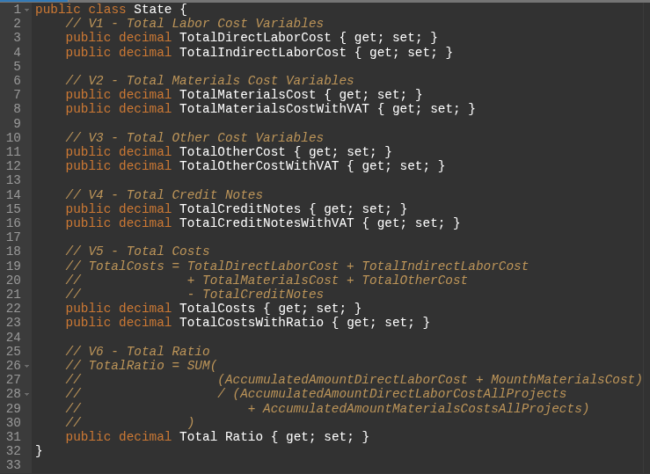Figure 17: Class State definition in Execução Orçamental

Next, the Indicadores Globais tool was fully implemented, and it should be able to retrieve global company data over a given period of time to display absolute values ​​such as active buildigs, completed buildings, the name of the customer with the most buildings, and the number of buildings associated with that customer. In addition, it is necessary to display visual classifications for the most expensive materials, most relevant customers and suppliers, and buildings with the highest costs. Figure 18 shows the definition of the code class necessary for this solution to retrieve the values, variables also grouped into groups V1 and V2. While the variable group V1 highlights the absolute value variables, group V2 represents the classification lists for materials, suppliers, customers, and buildings.

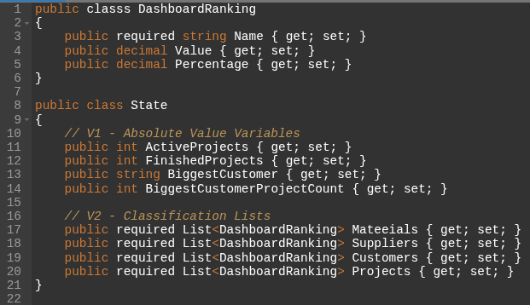Figure 18: Class State definition in Indicadores Globais

Finally, the implementation of the Specific Indicators tool was also completed, and for a given project, for all chapters if selected, it needs to be able to display a visual comparison between planned time and execution time, and a detailed graphical comparison between budget and execution cost. Figure 19 shows the main variables required in the code class declaration to retrieve the data needed to compose the dashboard. The variables were grouped from V1 to V5 for better separation of concepts. Group V1 contains variables related to recorded budgets, while V2 contains accumulated costs in invoices. Group V3 contains variables of the calculated differences between budgeted values ​​and costs, while group V4 gathers the variables of percentage deviation from the budget. Group V5 contains the schedule lists of the chapters of that project for building the Gantt chart.

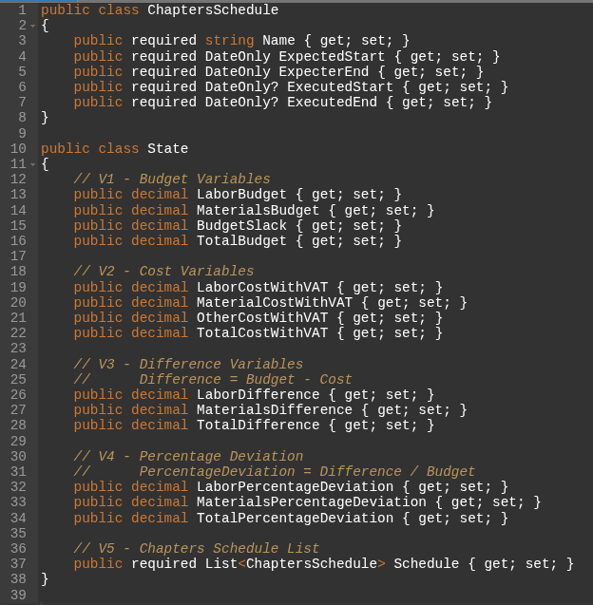Figure 19: Class State definition in Indicadores Específicos

All abstractions portrayed are a snippet of the code and just a high-level view of the implementation. They are not enough to expose all the details of the solution. Although, they are close to the concepts explored in Tables 2, 3 and 4 mentioned in subtopic 4.3.3.
Chapter 6

View of System Pages

This chapter provides an overview of the implemented tools and screens.

6.1 Tool Groups
After the implementations presented in the previous chapter, the total number of groups increased to 8, as shown in Figure 20.

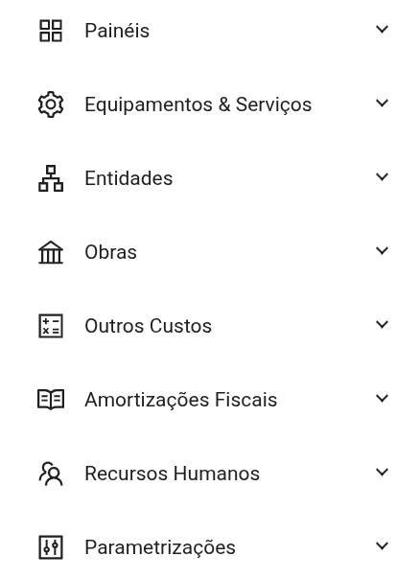Figure 20: All groups - final version

Meanwhile, Equipamentos & Serviços began to display the organization shown in Figure 21. Note that the Equipamento, Viatura and Tipo tools did not exist before, in addition to adjustments in Material and Consumível/Serviço.

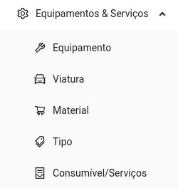Figure 21: Equipamentos & Serviços - final version

On another front, the Obras section now presents the organization shown in Figure 22. Tools that did not previously exist, such as Nota de Encomenda and Nota de Crédito Material, appears in the image as “N. Crédito Material”, have been integrated. It is also noted that the Presenças page is no longer in this group. It has been moved to Recursos Humanos, Figure 24, as it aligns better with the proposed business rule. Another change was to Execução Orçamental, which was moved to the dashboards, this will be explained in more detail later in the text in Figure 28. Other pages have also undergone adjustments.

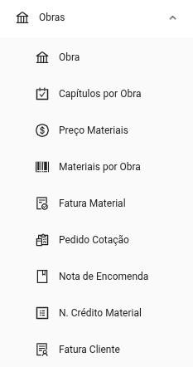Figure 22: Obras - final version

The next group is Outros Custos, as illustrated in Figures 23. It should be noted that the Serviços e Consumíveis page has been renamed to Fatura Consumíveis e Serviços, appears in the image as “Fatura Consumíveis e Ser...”, in order to improve the nominal distinction in relation to the homonymous page present in the Equipamentos & Serviços group. The Seguro Responsabilidade Civil, appears in the image as “Seguro Resp. Civil”, has also been included.

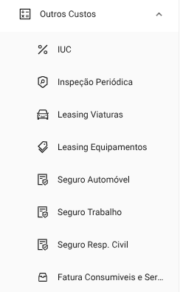Figure 23: Outros Custos - final version

Next, the Recursos Humanos group, as illustrated in Figure 24. Note that the Presenças page has been integrated into this set. The Descendentes Colaboradores, appears in the image as “Desc. Colaboradores”, Salários, and Cálculo Vencimento pages have been implemented.

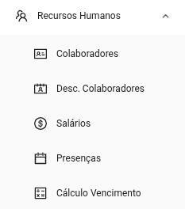Figure 24: Recursos Humanos - final version

Up to now, only the previously existing groups have been displayed. The new Amortizações Fiscais group can be seen in Figure 25. It will be useful for monitoring values ​​over time. This group includes the new tools Amortização de Viatura, appears in the image as “Amort. Viatura”, Amortização de Equipamentos, appears in the image as “Amort. Equipamentos” and IVA Devolvido/Crédito.

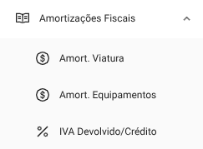Figure 25: Amortizações Fiscais - final version

The new grouping of Entidades, as shown in Figure 26. Key emphasis is placed on Clientes and Fornecedores. Without these two tools, it was not possible to manage new records, manual insertion into the database was required, which was impractical.

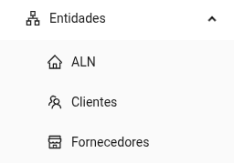Figure 26: Entidades - final version

Finally, regarding Parametrizações, as shown in Figure 27. Special mention should be made of the Capítulo tool, which is now part of this group.

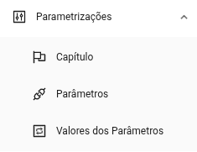Figure 27: Parametrizações - final version

The new group of Painéis contains Execução Orçamental, Indicadores Globais, and Indicadores Específicos. It's worth noting that Execução Orçamental previously belonged to the Obras group, but it was moved to this group because it makes sense to have all the BI tools in one place. This can be seen in Figure 28.

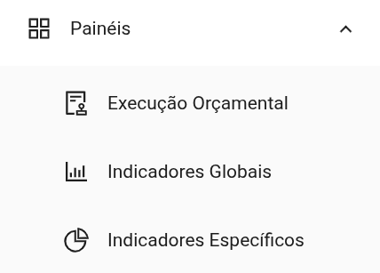Figure 28: Painéis - final version

Figures 20 to 28 are a consolidation of the logical structure that was detailed in Figures 12 to 16. The platform's navigation system followed the defined model.

6.2 Pages of the Construction Management Module
The Construction Management Module encompasses all functionalities responsible for supporting operations associated with construction execution, including the registration and monitoring of attendance, invoices, credit notes, materials, and equipment. Figure 29 shows the final version of the attendance page, this tool allows navigation through years and months, as well as replicating attendances, saving changes, and downloading the completed or empty attendance sheet. It's also worth noting that this tool fulfills another business rule by automatically determining fixed and movable holidays for Portugal, highlighted in pink, as well as optional Saturdays in light blue and Sundays in dark blue. For example, employee “Sara” was absent on 02/06/2026 and then was present on the remaining working days at construction site number 72, “Reforma”.

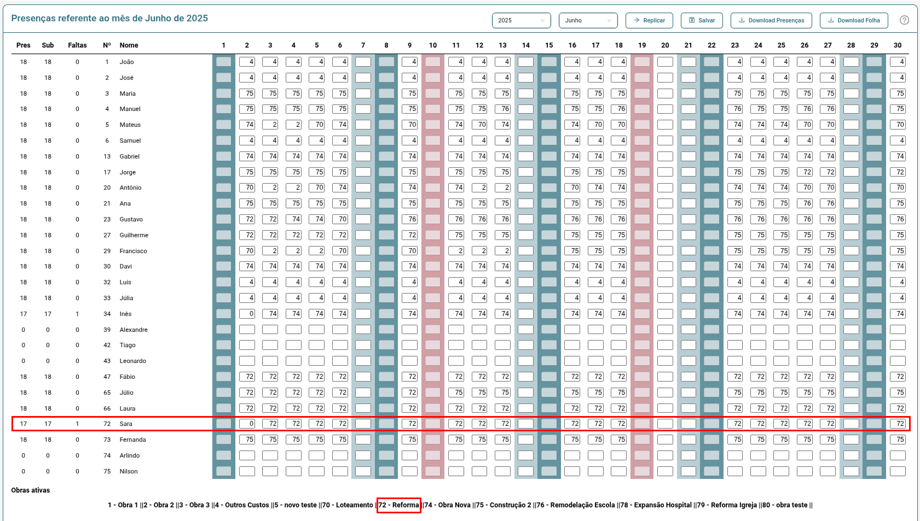Figure 29: Presenças Page

Figure 30 shows the salary calculation tool with fictitious values ​​as an example. This tool follows a style similar to the attendance sheet, but adjusted for entering values ​​and tracking amounts. When the buttons are clicked, the respective columns are automatically filled with the default values ​​as defined in the parameters. This applies to the columns Outras Remunerações, Subsídios and Duodécimos. With these weighted elements, the user can click the Calcular Vencimentos button to perform the final calculation and, finally, there is the option to export to PDF if necessary.

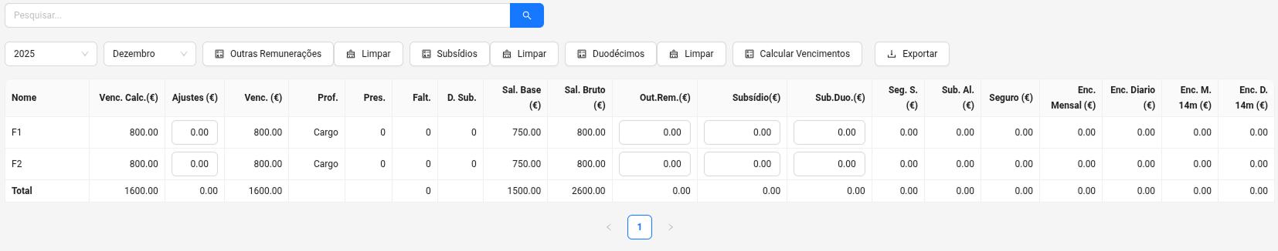Figure 30: Cálculo de Vencimentos Page

Figure 31 shows the Equipamento page listing as an example for the Construction Management Modules. The screens in general follow the same model proposed by Oliveira [34], they consist of a search bar, interactive buttons for creating, editing and deleting operations. The listed items can be individually marked for editing or viewing or selected en masse for deletion.

Figure 31: Equipamento Page

Slight interface changes may occur with the appearance of the download button for records that have attachments or for viewing only, as shown in Figure 32. The Fatura Cliente tool is represented here. It is worth emphasizing that the style of these pages follows the same defined design pattern.

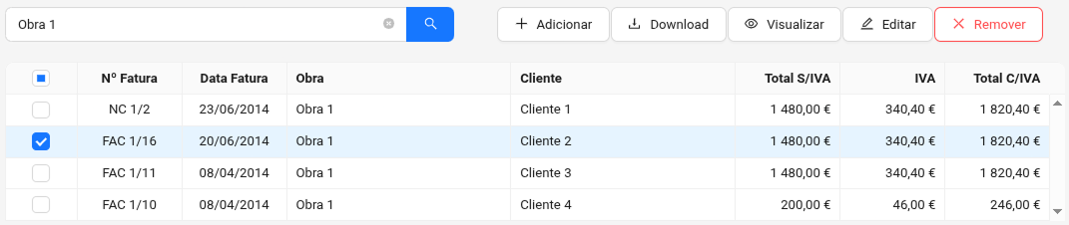Figure 32: Fatura Cliente Page

Whether adding a new item or editing, the procedure follows forms in an overlay window, see Figure 33. The fields may be pre-filled with default parameters, such as the Value Added Tax (VAT) percentage. These forms may have one to several steps as needed to insert all the necessary fields.

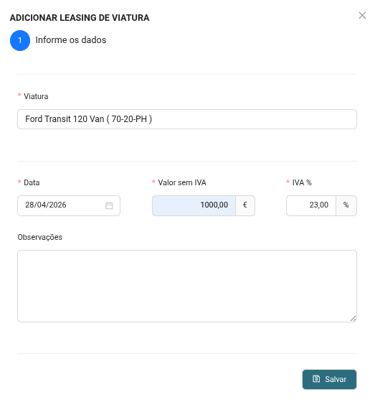Figure 33: Leasing Viatura Form

Other screens were omitted to avoid redundancy. The main factor of change is in the filling fields and, at most, a greater number of steps to complete the forms.

6.3 Pages of the Parameterization Module
The Parameterization Module comprises the tools designed for configuring reusable parameters and business rules used by the other modules of the system. The three tools in this module are Capítulo, Parâmetros, and Valores dos Parâmetros. These follow the same paginated table listing structure.
Figure 34 shows the Capítulo page. These value and chapter definitions are reused by other tools to streamline field completion or to enforce business rules that change over time. The main points of these tools are to establish the level of refinement of the tools in the Intelligent and Sustainable Construction Management Module.

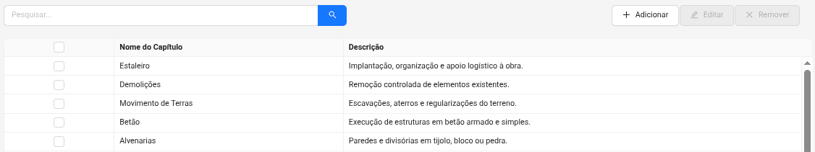Figure 34: Capítulo Page

6.4 Pages of the Intelligent and Sustainable Construction Management Module
The Intelligent and Sustainable Construction Management Module corresponds to the analytical component of the platform, responsible for transforming operational data into performance indicators, analytical reports, and interactive visualizations designed to support decision-making. The three tools in this module are Execução Orçamental, Indicadores Globais and Indicadores Específicos.
Figure 35 shows the Execução Orçamental page, where corrections were made to the calculations and the main visual change was the introduction of an option to hide graphic elements. This allows users to focus exclusively on the final values ​​and improves performance when detailed visual analysis is not required.

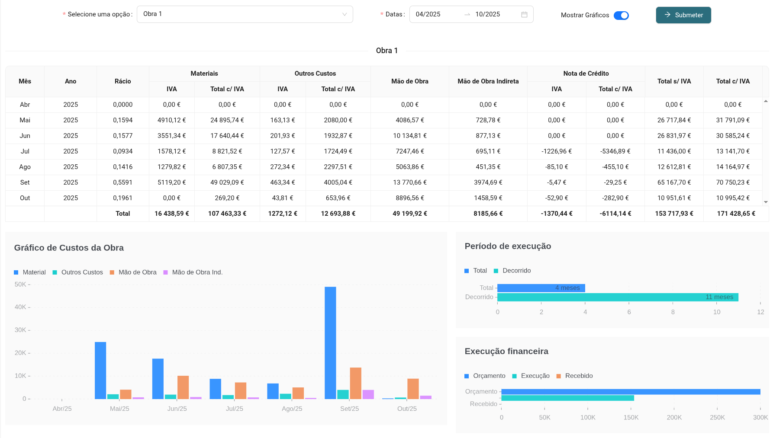Figure 35: Execução Orçamental Dashboard

For the Indicadores Globais page, the implementation followed a prototype with some improvements, see Figure 36. Client, supplier, and project names have been anonymized for legal reasons, but represent real-world application cases. Additionally, progress bars have been incorporated for better visual comparison of value magnitudes.

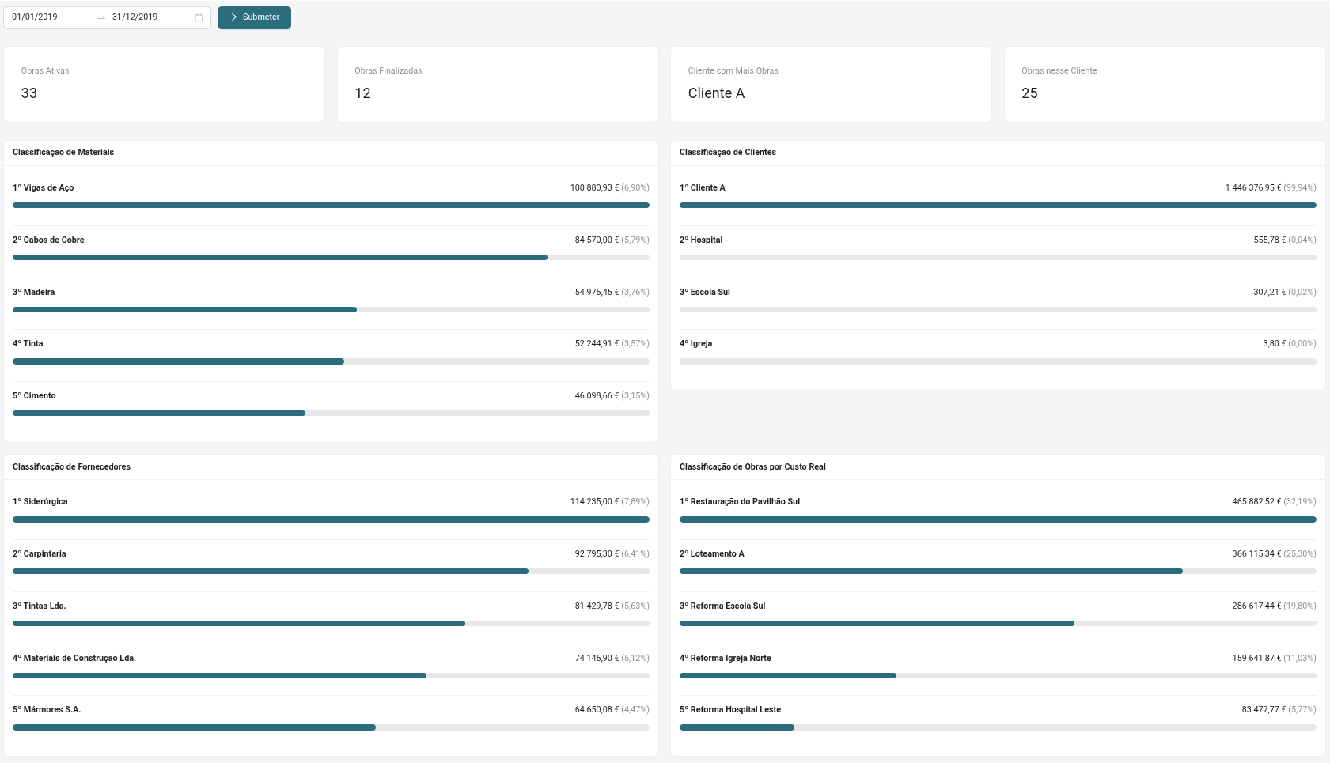Figure 36: Indicadores Globais Dashboard

The Indicadores Específicos page, see Figure 37, includes the most abrupt visual changes. The initial idea was to use information cards. However, this was a very poor and incomplete visualization for the tool. Therefore, cards were kept for the total values, but the time-based indicators were incorporated into a Gantt chart, and the remaining budgets and costs were represented in vertical bar charts. This provides greater visual distinction between the amounts.

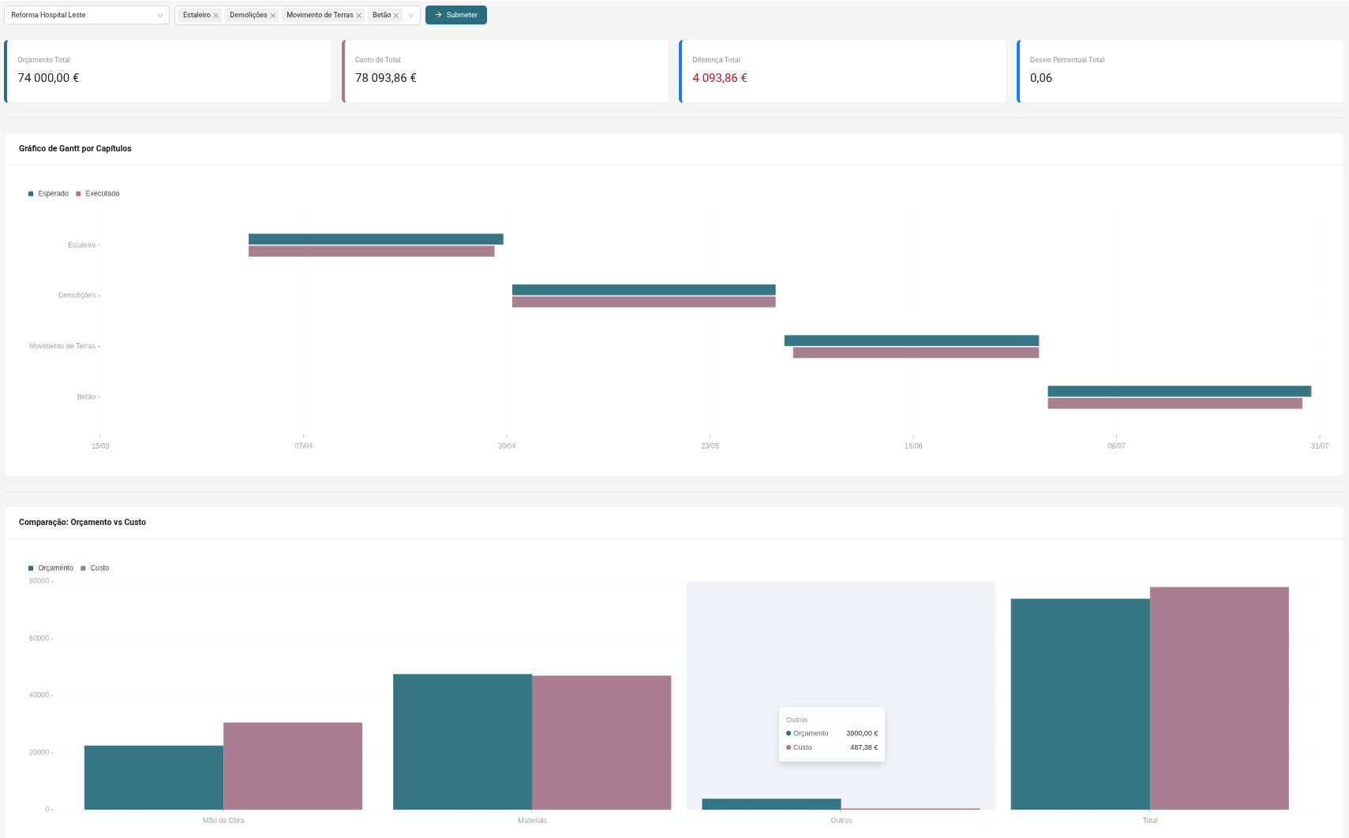Figure 37: Indicadores Específicos Dashboard

Although the concept of the prototypes function as guidance for implementation, in this case the final versions went well beyond what had been thought of in the prototypes in Figures 8, 9 and 10. It is not ideal, but it happens as the concepts of the business rules mature.
Chapter 7

Results and Discussion

This chapter is organized into 5 subchapters: validation criteria, user satisfaction survey, availability tests, limitations, and observations. Each of these presents different perspectives on the results obtained from using the platform throughout the project's development.

7.1 Validation Criteria
Product validation was performed continuously throughout the project development, occurring in two phases. In the initial phase, validations were conducted jointly with the supervising professor, through bi-weekly meetings aimed at analyzing the system's progress, discussing technical decisions, and verifying the implemented functionalities.
The process included functional testing and data consistency checks, based on predefined scenarios and manually obtained reference values. These values ​​served as a basis for validating the results presented in tables, information cards, and analytical graphs, ensuring not only the accuracy of the calculated totals but also consistency with existing operational records. Whenever discrepancies were identified, the functionalities were corrected and retested, guaranteeing convergence between the expected results and the results presented by the system. Beyond the correction of mathematical calculations, the suitability of the implemented interfaces and flows to the organization's operational needs was also evaluated.
As the solution reached an appropriate level of maturity, the client became directly involved in validating the tool, through availability tests and weekly checks of the developed functionalities. During this stage, the implemented interfaces and resources were evaluated by comparing them with the legacy system and with previously defined models, ensuring alignment with the operating modes already established in the organization.
Close collaboration with the client throughout the process allowed for the rapid identification of any inconsistencies and the clarification of doubts related to specific business rules in the areas of civil construction and administrative management, contributing to the reliability of the developed functionalities and the suitability of the system to the company's needs.

7.2 User Satisfaction Survey and Responses
To complement the platform validation, a satisfaction survey was applied to collect users' perceptions regarding their experience using the system. The survey consisted of 12 statements and 2 optional open-ended questions. For each statement, participants had to select the most appropriate level of agreement from the options: strongly disagree, disagree, neutral, agree, and strongly agree.
The 14 items were organized into four evaluation groups: usability, efficiency, functional suitability, and platform overview. The sample consisted of three users, representing all employees who will use the platform in the company's operational context.
In the usability-related group, the following statements were evaluated: “1 - Using the new system is easy.”, “2 - Navigating the platform is intuitive.”, “3 - The screens, menus, and information are presented clearly.”, “4 - The necessary information or functionalities are found quickly in the system.”, and “5 - The system responds stably and predictably during use.”.
Regarding efficiency, the following statements were considered: “6 - The current platform allows tasks to be performed objectively.”, “7 - The system reduces rework or errors during the work process.” and “8 - The system responds quickly to requests necessary for task execution.”.
In the functional adequacy group, the statements “9 - The available functionalities allow us to fulfill what they are intended to do.” and “10 - The new solution allows us to perform all the necessary tasks.” were presented, as well as the open-ended question “11 - Do you feel that the system is missing any functionality or feature that it should have?”.
Finally, the overview group included the statements “12 - The new system meets general operational expectations.” and “13 - The new system conveys a sense of completeness in relation to what is expected of it.”, in addition to the question “14 - If you could make any changes to the current system, what would you change?”.
The responses reflect the user experience with the most current version of the platform. The evaluation was conducted individually and anonymously to ensure a reliable representation of the user experience to date. Figure 38 shows that everyone fully agreed that the current platform allows them to perform all necessary tasks.

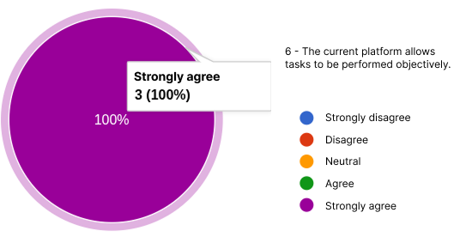Figure 38: Nível máximo de satisfação

Figure 39 shows that the majority of users fully agree with the related statements. It is noteworthy that 3 out of 5 and 2 out of 2 statements from the usability and overview groups are at this level, respectively.

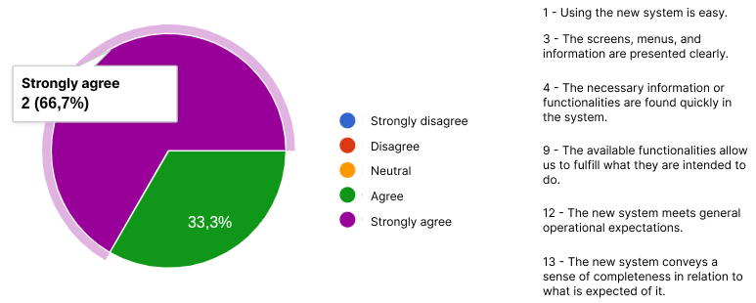Figure 39: 2nd level of satisfaction

Finally, Figure 40 presents the results regarding the overall view of the platform. In this group, a greater concentration of responses is observed in the “agree” category, rather than “strongly agree.” This behavior may be related to the natural adaptation process of users to the new platform, especially considering their prior familiarity with the system previously used by the company. This distancing was more evident in the efficiency group when comparing statement 6, already explored in Figure 38, with statements 7 and 8.

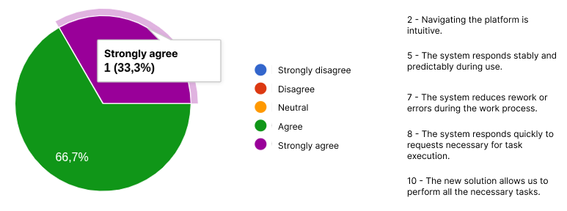Figure 40: 3rd level of satisfaction
Although the sample size is small, the satisfaction survey is important because it reflects the group of people who will use the tool daily, and it's important that it meets their expectations. Empty answers to “11 - Do you miss any functionality or feature that the system should have?” and “14 - If you could make any changes to the current system, what would you change?”.

7.3 Availability Tests
Regarding system availability tests, three instances were recorded where the server was unavailable. The first occurred due to an automatic Windows 11 update. The second case was caused by the automatic hibernation mode of Windows 11.
However, this situation could be resolved by adjusting the machine's power settings. Finally, the third case was an unexpected Docker error, an unexpected failure of the Windows Subsystem for Linux (WSL) led to the service interruption, although restarting the machine was sufficient to resolve the problem, see Figure 41.

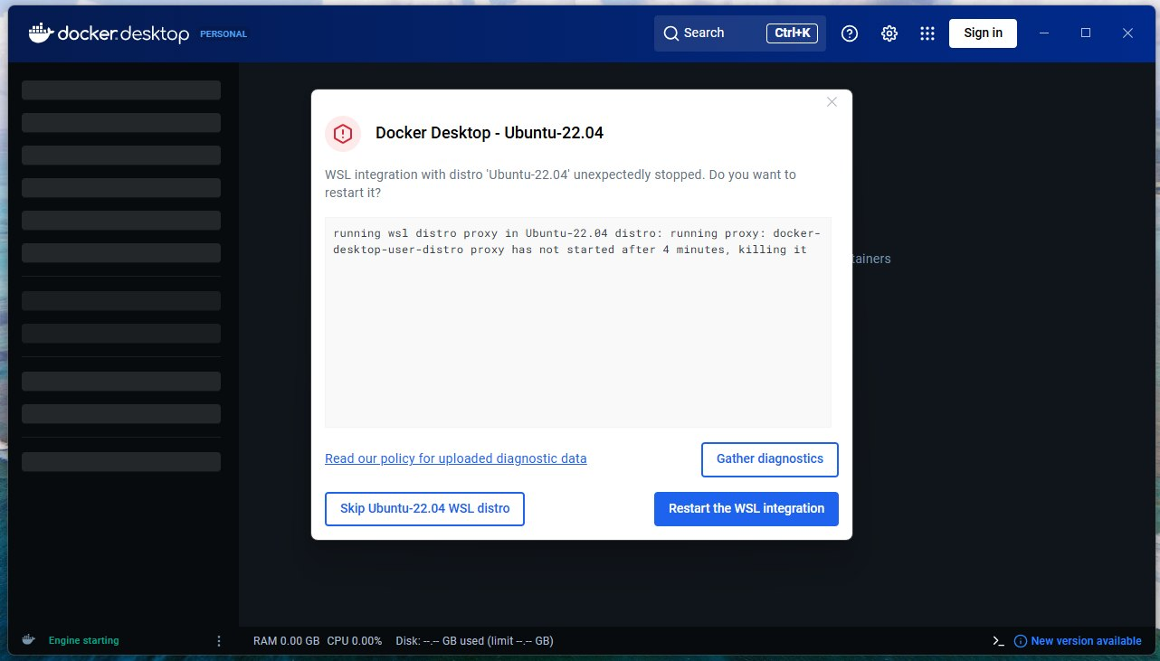Figure 41: Interruption due to WSL error

Problem situations such as automatic updates cannot be bypassed by the startup mechanisms configured in the operating system. These require human intervention.

7.4 Limitations
This study has a limitation. Validation was performed with a small number of tests in real-world situations at the client company, firstly due to a limited number of personnel available to conduct practical tests, and secondly because the old system remained in operation. The old platform is obsolete, but it has not been discarded. This scenario allows for a gradual and conservative transition to using the new tool to replace the old one, ensuring the reliability of the recorded data. However, it makes the change process slower.

7.5 Observations
The results confirm that the main goal of designing and validating a BI module integrated into an existing construction management system was achieved, expanding analytical capabilities without disrupting established workflows. In particular, the defined performance indicators and interactive dashboards effectively support the monitoring of budget execution, the evaluation of overall performance, and the specific analysis of each project. This improves transparency and allows for the early identification of cost and schedule deviations.
Chapter 8

Conclusions and Future Work

Throughout the project's development, as fixes were implemented and new versions of the system were made available to the client, a gradual reduction was observed in the number of tasks related to operational adjustments. This scenario indicates greater platform stability, and eventually, sprints became exclusively focused on the development of BI modules.
One of the main challenges identified in this initial stage was related to the fact that the tool's development largely occurred relatively remotely from the client. This situation contributed to the emergence of several rework tasks after the first system evaluations. Furthermore, it was found that some initially implemented functionalities were not as relevant to the company's operational context, suggesting that a reduced version of the tool could have been made available beforehand. However, defining the priority level of each functionality proved to be a complex process, especially during the initial development phases.
From a general project perspective, the product demonstrates a higher level of stability and is more aligned with ALN's expectations, as shown by the responses to the satisfaction survey. Fundamental pages for data entry into the database have been completed. The interactive dashboards give purpose to the collected data and add real value to the tool. The use of these dashboards allows for the retrieval of indicators and graphs from raw operational records, capable of supporting an understanding of the company's financial and operational performance. Through this approach, it becomes possible to identify the most relevant materials, suppliers, customers, and buildings over specific periods, as well as improve the monitoring of project schedules and comparative analysis between planned budgets and actual execution.
By offering an integrated and focused view of organizational data, the BI module contributes to a better understanding of resource allocation and more effective project monitoring. This approach strengthens analytical support for management and contributes to the digital transformation of SMEs in the construction sector, allowing strategic and planning decisions to be based on quantitative evidence. Additionally, the early identification of deviations and inefficiencies enables the adoption of corrective actions in the initial phases of buildings, increasing operational efficiency and the reliability of the decision-making process.
It should be noted that this project enabled side publications such as the article Data-Driven Decision Making: Business Intelligence in Construction Management [42]. This related article was submitted to the 21st Iberian Conference on Information Systems and Technologies 2026, under the themes of organizational models, information systems, architecture and construction engineering. This is because the solution is classified as a construction project management and decision support system in organizational contexts.
As future work, it is necessary to implement new functionalities related to automatic attendance registration and automatic invoice reading. Both are within the context of data entry, and since this is an administrative tool, the best way to ensure consistent output in the indicators is to have well-standardized data entry. When information digitization happens manually, human typing errors, incompleteness, or negligence arise, compromising the quality of the results.
Additionally, the platform could evolve to incorporate functionalities geared towards sustainability in the construction industry. In this context, mechanisms for monitoring and analyzing material waste stand out, allowing the identification of patterns of excessive consumption and supporting the definition of mitigation strategies. The integration of environmental indicators could also contribute to more efficient management of resources used in construction projects, promoting more sustainable practices aligned with the environmental and economic concerns of the sector.
Another possible path to improvement lies in integrating Artificial Intelligence techniques and predictive analytics applied to construction management. The use of machine learning algorithms could allow for the prediction of delays, estimates of future costs, detection of budget deviations, and early identification of operational risks. Similarly, optimization techniques could be used to support decisions related to resource allocation, team planning, materials management, and activity scheduling.
In the infrastructure context, other operating systems could be explored since the solution is running on containers. It makes no sense to continue with Windows 11 Home Edition, this system is not suitable for the server role. If it is not possible to meet the costs of a modern Windows Server, free versions of Linux servers could be explored.
Bibliography

- Afroz, Z. (2026). Business Intelligence for Service Optimization in US Education and Customer-Facing Enterprises: A Prisma Systematic Review of KPI Frameworks. American Journal of Interdisciplinary Studies, 7(1), 315–354. https://doi.org/10.63125/r2agf497
- Aggarwal, I., Anirudh, A., and Buddala, R. (2021). Literature Review: ERP Implementation in Various Industries. Innovations in Power and Advanced Computing Technologies (i-PACT), Kuala Lumpur, Malaysia, pp. 1-6. https://doi.org/10.1109/i-PACT52855.2021.9696962
- Agu, E. E., Chiekezie, N. R., Abhulimen, A. O., and Obiki-Osafiele, A. N. (2024). Building sustainable business models with predictive analytics: Case studies from various industries. International Journal of Advanced Economics, 6(8), 394–406. https://doi.org/10.51594/ijae.v6i8.1436
- Aithal, P. S., and Aithal, S. (2023). Key performance indicators (KPI) for researchers at different levels & strategies to achieve it. International Journal of Management, Technology, and Social Sciences (IJMTS), 8(3), 294-325. https://ssrn.com/abstract=4715312
- Al-Khatib, A. W., and Al-Ghanem, E. (2021). Radical innovation, incremental innovation, and competitive advantage: The moderating role of technological intensity: Evidence from the manufacturing sector in Jordan. European Business Review, 34(3), 344–369. https://doi.org/10.1108/EBR-02-2021-0041
- Al-Okaily, A., Al-Okaily, M., Teoh, A. P., and Al-Debei, M. M. (2022). An empirical study on data warehouse systems effectiveness: The case of Jordanian banks in the business intelligence era. EuroMed Journal of Business, 18(4), 489–510. https://doi.org/10.1108/EMJB-01-2022-0011
- Al-Sulaiti, A., Mansour, M., Al-Yafei, H., Aseel, S., Kucukvar, M., and Onat, N. C. (2021). Using data analytics and visualization dashboard for engineering, procurement, and construction project's performance assessment. In 2021 IEEE 8th International Conference on Industrial Engineering and Applications (ICIEA) (pp. 207-211). IEEE. https://doi.org/10.1109/ICIEA52957.2021.9436728
- Bach, B., Freeman, E., Abdul-Rahman, A., Turkay, C., Khan, S., Fan, Y., and Chen, M. (2022). Dashboard design patterns. IEEE transactions on visualization and computer graphics, 29(1), 342-352. https://doi.org/10.1109/TVCG.2022.3209448
- Bany Mohammad, A., Al-Okaily, M., Al-Majali, M., and Masa’deh, R. (2022). Business intelligence and analytics (BIA) usage in the banking industry sector: An application of the TOE framework. Journal of Open Innovation: Technology, Market, and Complexity, 8(4), Article 189. https://doi.org/10.3390/joitmc8040189
- Braglia, M., Gabbrielli, R., Marrazzini, L., and Padellini, L. (2022). Key Performance Indicators and Industry 4.0–A structured approach for monitoring the implementation of digital technologies. Procedia Computer Science, 200, 1626-1635. https://doi.org/10.1016/j.procs.2022.01.363
- Chen, C., and Lu, X. (2025). Construction Enterprise Data Platform and Big Data Analytics for Efficient Workforce Management. In 2025 IEEE International Conference on Computation, Big-Data and Engineering (ICCBE) (pp. 344-348). IEEE. https://doi.org/10.1109/ICCBE65177.2025.11255779
- Chopra, R., Sawant, L., Kodi, D., and Terkar, R. (2022). Utilization of ERP systems in manufacturing industry for productivity improvement. Materials Today: Proceedings, 62, 1238–1245. https://doi.org/10.1016/j.matpr.2022.04.529
- Contini, G., and Peruzzini, M. (2022). Sustainability and Industry 4.0: Definition of a Set of Key Performance Indicators for Manufacturing Companies. Sustainability, 14(17), 11004. https://doi.org/10.3390/su141711004
- Daissaoui, A., Boulmakoul, A., Karim, L., and Lbath, A. (2020). IoT and big data analytics for smart buildings: A survey. Journal of Ubiquitous Systems & Pervasive Networks, 13(1), 27–34. https://doi.org/10.1016/j.procs.2020.03.021
- Epperson, W., Wongsuphasawat, K., Whilden, A., Du, F., and Talbot, J. (2023). A declarative specification for authoring metrics dashboards. In 2023 IEEE Visualization in Data Science (VDS) (pp. 6-10). IEEE. https://doi.org/10.1109/VDS60365.2023.00006
- Galagali, A. A., Sandbhor, S., and Ruikar, K. (2024). A survey on enterprise resource planning and building information modeling integration: a construction 4.0 perspective. Buildings, 14(10), 3165. https://doi.org/10.3390/buildings14103165
- Ghosh, S., Mukherjee, N., and McCuen, T. (2024). Use of visual dashboards in construction projects. In T. Leathem, W. Collins, & A. Perrenoud (Eds.), Proceedings of the 60th Annual Associated Schools of Construction International Conference (EPiC Series in Built Environment, Vol. 5, pp. 486–494). https://doi.org/10.29007/wxks
- Gledson, B., Rogage, K., Thompson, A., and Ponton, H. (2024). Reporting on the development of a web-based prototype dashboard for construction design managers, achieved through design science research methodology (DSRM). Buildings, 14(2), 335. https://doi.org/10.3390/buildings14020335
- Junussova, T., Nadeem, A., Kim, J. R., Azhar, S., Khalfan, M., and Kashyap, M. (2022). Sustainable construction through resource planning systems incorporation into building information modelling. Buildings, 12(10), 1761. https://doi.org/10.3390/buildings12101761
- Ke, J., Liao, P., Li, J., and Luo, X. (2023). Effect of information load and cognitive style on cognitive load of visualized dashboards for construction-related activities. Automation in Construction, 154, 105029. https://doi.org/10.1016/j.autcon.2023.105029
- Kumar, S., and Aithal, P. S. (2023). Tech-business analytics in secondary industry sector. International Journal of Applied Engineering and Management Letters (IJAEML), 7(4), 1–94. https://dx.doi.org/10.2139/ssrn.4674849
- Kunkcu, H. A. N. D. A. N., Koç, K., Dagou, H. H., and Gurgun, A. P. (2022). Using key performance indicators in construction project literature. Proceedings of International Structural Engineering and Construction, 9(2). https://doi.org/10.14455/ISEC.2022.9(2).CON-12
- Li, F., Laili, Y., Chen, X., Lou, Y., Wang, C., Yang, H., Gao, X., and Han, H. (2023). Towards big data driven construction industry. Journal of Industrial Information Integration, 35, Article 100483. https://doi.org/10.1016/j.jii.2023.100483
- Lopes, A. B., and Boscarioli, C. (2020). Business intelligence and analytics to support management in construction: A systematic literature review. Revista Brasileira de Computação Aplicada, 13(1), 27–41. https://doi.org/10.5335/rbca.v13i1.11346
- Lutfi, A., Alsyouf, A., Almaiah, M. A., Alrawad, M., Abdo, A. A. K., Al-Khasawneh, A. L., ... and Saad, M. (2022). Factors influencing the adoption of big data analytics in the digital transformation era: Case study of Jordanian SMEs. Sustainability, 14(3), 1802. https://doi.org/10.3390/su14031802
- Marinagi, C., Reklitis, P., Trivellas, P., and Sakas, D. (2023). The impact of industry 4.0 technologies on key performance indicators for a resilient supply chain 4.0. Sustainability, 15(6), 5185. https://doi.org/10.3390/su15065185
- Mehrolhassani, M. H., Behzadi, A., and Asadipour, E. (2025). Key performance indicators in emergency department simulation: a scoping review. Scandinavian Journal of Trauma, Resuscitation and Emergency Medicine, 33(1), 15. https://doi.org/10.1186/s13049-024-01318-7
- Melo Nunes Lopes, C., Abrahão Cury, A., and Castro Mendes, J. (2024). Construction And Demolition Waste Management And Artificial Intelligence-A Systematic Review. Environmental & Social Management Journal/Revista de Gestão Social e Ambiental, 18(10). https://doi.org/10.24857/rgsa.v18n10-197
- Moradi, S., Ansari, R., and Taherkhani, R. (2022). A systematic analysis of construction performance management: Key performance indicators from 2000 to 2020. Iranian Journal of Science and Technology, Transactions of Civil Engineering, 46(1), 15-31. https://doi.org/10.1007/s40996-021-00626-7
- Nagy, O., Papp, I., and Szabó, R. Z. (2021). Construction 4.0 organisational level challenges and solutions. Sustainability, 13(21), 12321. https://doi.org/10.3390/su132112321
- Ngo, J., Hwang, B.-G., and Zhang, C. (2020). Big data and predictive analytics in the construction industry: Applications, status quo, and potential in Singapore’s construction industry. In Proceedings of the Construction Research Congress 2020 (pp. 715–724). Reston, VA: American Society of Civil Engineers. https://doi.org/10.1061/9780784482865.076
- Ochuba, N. A., Amoo, O. O., Okafor, E. S., Akinrinola, O., and Usman, F. O. (2024). Strategies for leveraging big data and analytics for business development: A comprehensive review across sectors. Computer Science & IT Research Journal, 5(3), 562–575. https://doi.org/10.51594/csitrj.v5i3.861
- Oliveira, J. F., Simões, R., and Pedrosa, I. (2021). The application of dashboards in the management of commercial proposals to public tenders: application to SMEs in the civil construction sector. In 2021 16th Iberian Conference on Information Systems and Technologies (CISTI) (pp. 1-5). IEEE. https://doi.org/10.23919/CISTI52073.2021.9476288
- Oliveira, L. H. B. (2024). Desenvolvimento de uma plataforma de gestão da construção (Master's thesis, Instituto Politecnico de Braganca (Portugal)).
- Pan, Y., and Zhang, L. (2023). Integrating BIM and AI for smart construction management: Current status and future directions. Archives of Computational Methods in Engineering, 30(2), 1081-1110. https://doi.org/10.1007/s11831-022-09830-8
- Picozzi, P., Nocco, U., Pezzillo, A., De Cosmo, A., and Cimolin, V. (2024). The Use of Business Intelligence Software to monitor key performance indicators (KPIs) for the evaluation of a computerized maintenance management system (CMMS). Electronics, 13(12), 2286. https://doi.org/10.3390/electronics13122286
- Pressman, R. S., and Maxim, B. R. (2021). Engenharia de software: uma abordagem profissional. 9ª ed. São Paulo: AMGH; 2021.
- Rahman, M. A., Alam, M. S., and Mrida, M. S. H. (2025). How interactive dashboards improve managerial decision-making in operations management. American Journal of Advanced Technology and Engineering Solutions, 1(01), 122-146. https://doi.org/10.63125/cqm5jk84
- Ram, J., Afridi, N. K., and Khan, K. A. (2019). Adoption of big data analytics in construction: Development of a conceptual model. Built Environment Project and Asset Management, 9(4), 564–579. https://doi.org/10.1108/BEPAM-05-2018-0077
- Recalcatti, S., de Carvalho, K. Q., Kern, A. P., and Nagalli, A. (2025). Machine learning in the construction industry: potential of artificial neural networks in estimating construction and demolition waste. Revista Brasileira de Ciências Ambientais, 60, e2458-e2458. https://doi.org/10.5327/Z2176-94782458
- Rodrigues, F. S., Alves, A. P., and Matos, R. (2022). Construction management supported by BIM and a business intelligence tool. Energies, 15(9), Article 3412. https://doi.org/10.3390/en15093412
- Silva, V., Alves, P., Campos, E., and Nogueiro, P. (2026). Data-Driven Decision Making: Business Intelligence in Construction Management.
- Silva, V. A. F., Martins, R., Fadel, A. S., Silva, C. L. D., Bubniak, M. J., Travagin, I. C., ... and Ramos, M. P. (2025). Business and Data Intelligence to Support the Construction Management Process in Electrical Power Utilities. Brazilian Archives of Biology and Technology, 68, e25241024. https://doi.org/10.1590/1678-4324-2025241024
- Turner, C. J., Oyekan, J., Stergioulas, L., and Griffin, D. (2020). Utilizing industry 4.0 on the construction site: Challenges and opportunities. IEEE Transactions on Industrial Informatics, 17(2), 746-756. https://doi.org/10.1109/TII.2020.3002197
- Valente, M. T. D. O. (2020). Engenharia de software moderna: Princípios e práticas para desenvolvimento de software com produtividade. Universidade Federal de Minas Gerais.
- Wattuhewa, R. M., Waidyasekara, K. G. A. S., and Dilakshan, R. (2023). Importance of utilising big data analytics in enhancing construction data management. In Proceedings of the 13th International Conference on Business & Information (ICBI 2022) (pp. 1–10). https://dx.doi.org/10.2139/ssrn.4475444
- Weflen, E., MacKenzie, C. A., and Rivero, I. V. (2022). An influence diagram approach to automating lead time estimation in Agile Kanban project management. Expert Systems with Applications, 187, 115866. https://doi.org/10.1016/j.eswa.2021.115866
- Yousif, O. S., Zakaria, R. B., Aminudin, E., Yahya, K., Mohd Sam, A. R., Singaram, L., ... and Shamsuddin, S. M. (2021). Review of big data integration in construction industry digitalization. Frontiers in Built Environment, 7, 770496. https://doi.org/10.3389/fbuil.2021.770496

Available at: https://www.microsoft.com/en-us/power-platform/products/power-bi. Accessed on: 19/05/26.
Available at: https://www.tableau.com/products/tableau. Accessed on: 05/19/26.
Available at: https://www.inovflow.pt/erp-primavera-software/. Accessed on: 05/05/2026.
Available at: https://phcsoftware.com/pt/cegid-phc-cs. Accessed on: 05/05/2026.
Available at: https://www.madeone.pt/solucoes/software/eticadata/. Accessed on: 05/05/2026.
Available at: https://www.sap.com/products/erp/business-one.html. Accessed on: 05/05/2026.
Available at: https://www.microsoft.com/en-us/dynamics-365/. Accessed on: 05/05/2026.
Available at: https://construction.autodesk.com/. Accessed on: 05/05/2026.
Available at: https://www.procore.com/en-gb. Accessed on: 05/05/2026.
Available at: https://buildertrend.com/project-management/. Accessed on: 05/05/2026.
Available at: https://www.figma.com/. Last accessed on: 05/05/2026.
Available at: https://www.cisti.eu/index.php/en/call-for-papers. Last accessed on: 19/05/2026.

