Question 1 (a).

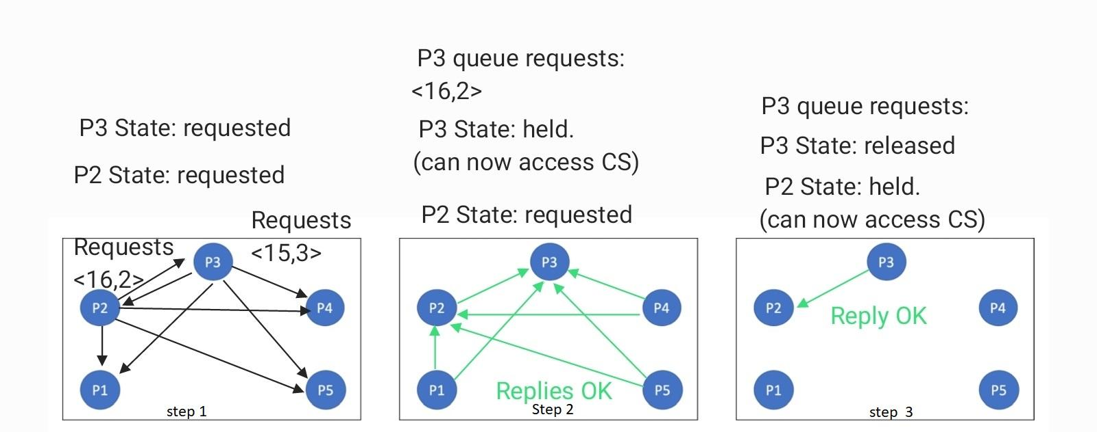

Question 1 (b). In total 16 messages consisting of 8 requests and 8 reply messages are required.

Question 1 (c). for each process’s request to be satisfied there needs to be 2\*(n-1) total messages required because of n-1 request and n-1 reply messages, where n is the number of processes. Now for “p” processes requesting access there will be 2\*(n-1)\*p messages in total. Hence for 1024 processes where p2 and p3 are two processes requesting access then there will be 2\*(1024-1)\*2 = 4092 messages.

Question 2 (a). From below we can see that Process P2 gets the token first then P3 gets the token.

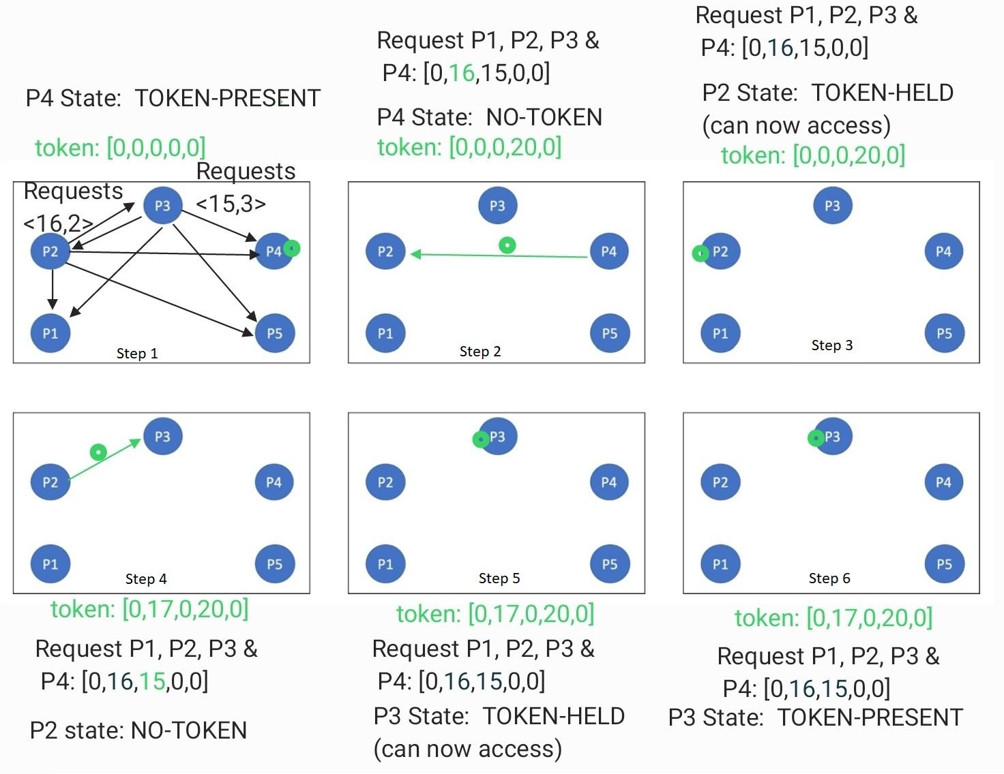

Question 2 (b). From below we can see that P3 gets the token and P2 does not get the token because the CS request time for the P2 is 16 which is lower than the token timestamp for P2 ie. 18.

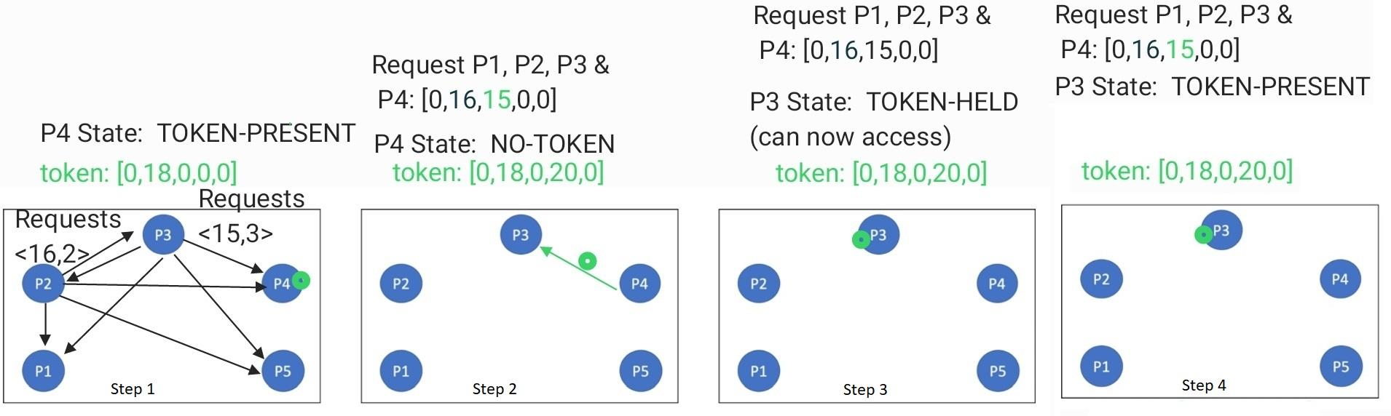

Question 3 (a).

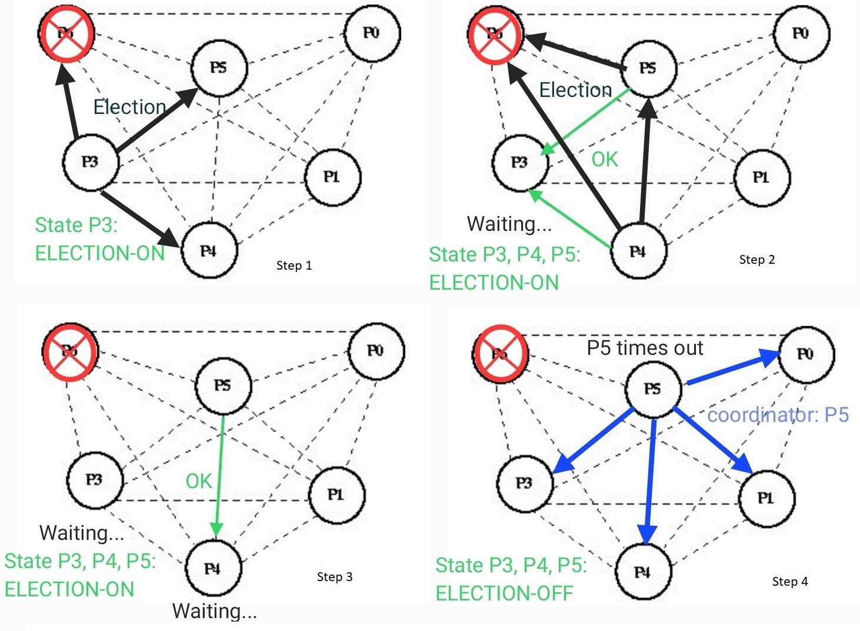

Questions 3 (b). 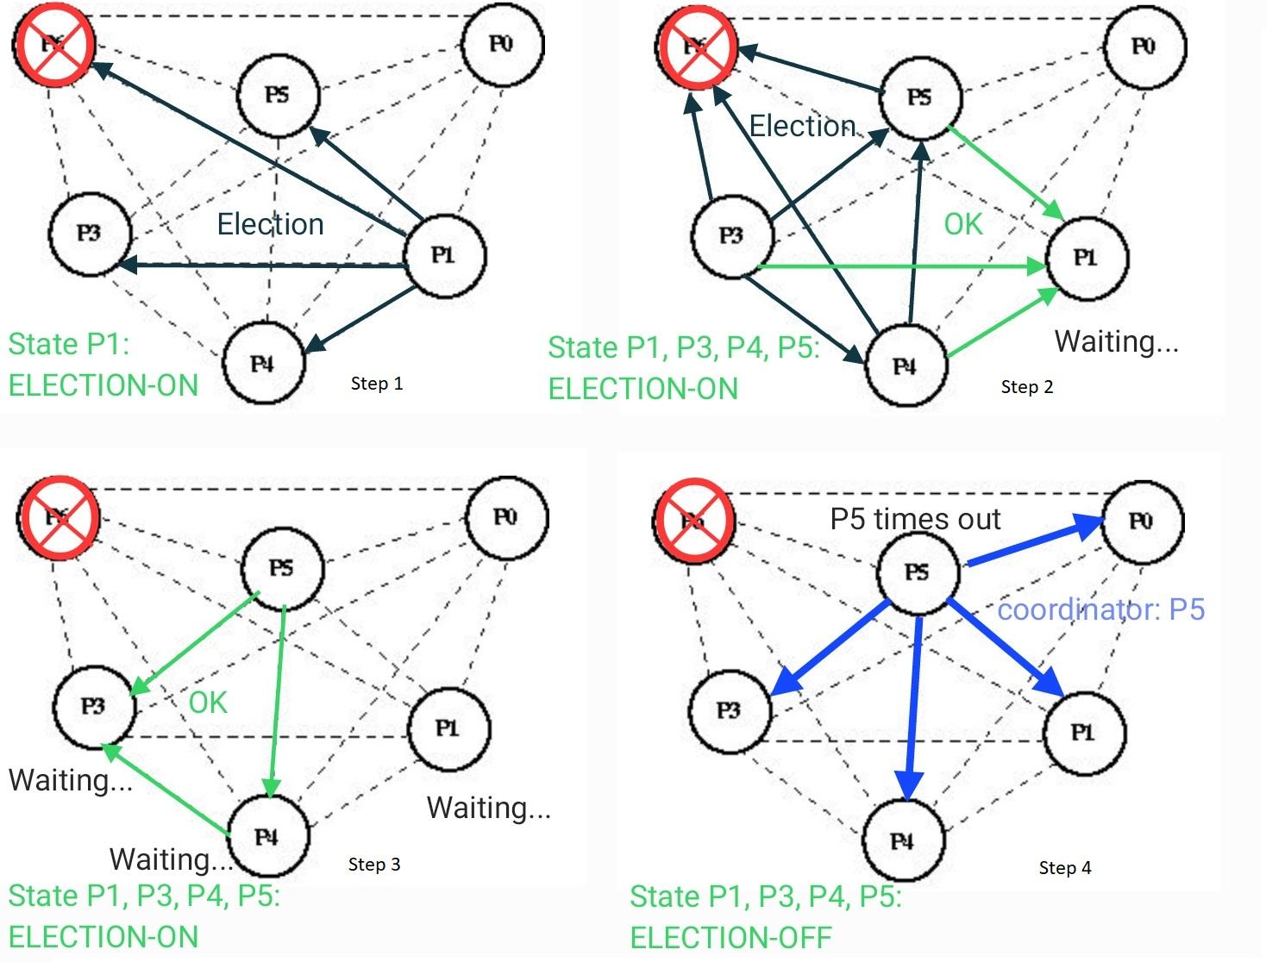

19 messages would be sent in total if Process P1 noticed that processes P6 does not respond.