Lab

0

**Software Installation and Configuration for the Virtual Internet Lab**

This document walks you through the software installation and configuration required for the virtual labs. The following instructions guide you through the installation and configuration of VMware, the GNS3 network simulation software and GNS3VM. In GNS3, routers and PCs are run on virtual machines. The virtual machines are controlled by the virtualization tool VMware.

The installation consists of

1. VMware – a hypervisor for running virtual machines (GNS3 VM runs on VMware)  
   (If you already have VMware installed, you may skip this part of the installation process.);
2. GNS3 – a tool for network configuration of virtual network devices;
3. GNS3 VM – a virtual machine that supports virtual devices in GNS3;

The software installation must be completed before commencing with Lab 1. **All software is available for free without cost.**

Software versions:

* GNS3 2.2.x and GNS3 VM 2.2.x (note both have to be same version #)
* VMware Workstation 16.y.z

System Requirements

* Windows 10 with an Internet connection
* minimum 4GB memory, 8 GB or more is recommended

Updated: December 2020

**Table of Content**

Installation and Configuration of VMware, GNS3 and GNS3VM 3

Task 1. Installation of VMware 4

Task 2. Installation of GNS3 7

Task 3. Installing GNS3 VM 9

Task 4. Configuration of GNS3 12

# Installation and Configuration of VMware, GNS3 and GNS3VM

The instructions given in each task in this lab will guide you through the installation and configuration of VMware, the GNS3 network simulation software and GNS3VM. In GNS3, routers and PCs are run on virtual machines. The virtual machines are controlled by the virtualization tool VMware.

### Task 1. Installing VMware

1. To install the VMware Workstation Pro and obtain a license key, go to the following website and log in using your ICS account[1]:

<https://elms.ics.uci.edu>

1. Login with your **ICS account**

Figure 1. Server Login for VMware

1. Select “VMware Workstation”[2]. Pick latest version for ***your*** computer. Do not select “Player”.

Figure 2. VMware Workstation

1. Select “Student” version - Free. Click “Add to Cart”.

Figure 3. VMware License Purchase

1. Click “Check Out”.

Figure 4. VMware Order

1. Order Details Screen. Note down the **Serial Number** and **Expiration Date**. Keep in a **safe place**. Click “Download”.

Figure 5. VMware Licence Key

1. Go through the installation process to install VMWare Workstation from the downloaded .exe file[3].
2. If you are prompted to “Join the WMware Customer….”, select “No” and click “Done”.
3. Once you are finished with the installation, you should see the WMware window as shown in figure below. Minimize it for now. We will first download and install GNS3 and download GNS3 VM before coming back to this window to import a Virtual Machine - GNS3 VM. If you want to stop here with downloads and installations, quit VMware. You can start it again in Task 3.

Figure 6. VMware Application Window

### Task 2. Installing GNS3

1. Go to the GNS3 website at <https://www.gns3.com/software> and select “Free Download” as shown in figure below[4].

Figure 7. GNS3 Download Website

1. Download the appropriate version for your computer as shown in Figure 8. You need to create an account to download the software. Create your own personal account.

Figure 8. Download Windows version

1. You may see this window after you click download. Close, we do not use these packages.

Figure 9. Extra GNS3 downloads

1. Once the GNS3 download is complete, double click the downloaded .exe file, and a window for GNS3 Setup will be displayed as shown in figure below. Click “Next” a few times (unless you want to change the setup of the software).

Figure 10. Setup of GNS3

1. Agree to the GNS3 License Agreement.

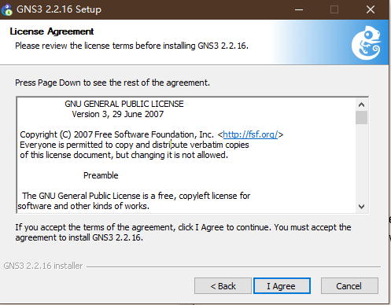

Figure 11. GNS3 License Agreement

1. When choosing components, unselect all except for GNS3 Desktop . We will install the GNS3 VM separately in Task 3. Then click next to start the installation process, Wireshark will also be installed during this process.

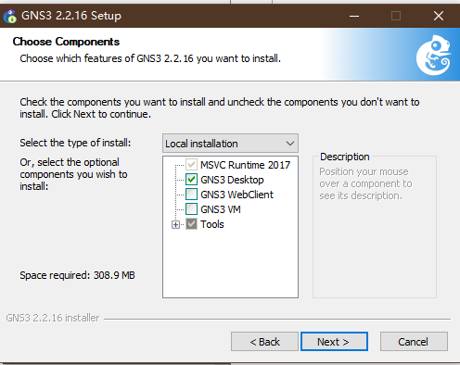

Figure 12. GNS3 choose components.

1. After the installation is done, when asked for SolarWinds toolset, you can choose yes/no, the choicewill not impact the performance of GNS3. SolarWinds is a tool that opens tabs instead of separate windows when running GNS3. Cleaner interface, easier to switch back and forth.

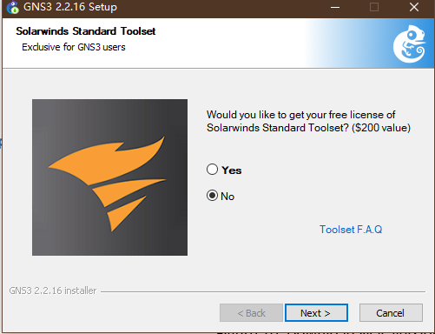

Figure 13: SolarWinds standard toolset license

1. Now the GNS3 installation is complete.

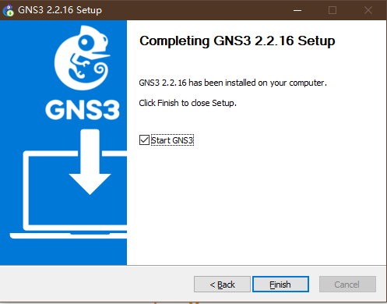

Figure 14: Completion of GNS3 installation

1. .Once the installation is complete, GNS3 starts automatically and presents the window shown in Figure 15, as well as the GNS Setup Wizard window shown in Figure 16.

* Select “Cancel” to close the Setup Wizard window in Figure 16. We will come back to that later.
* Close GNS3 by selecting “File⭢Quit” in the GNS3 application window, Figure 15.

Figure 15. GNS3 Application Window Figure 16. GNS3 Setup Wizard

### Task 3. Installing GNS3 VM

GNS3 VM is a virtual machine that accelerates the execution of routers and hosts in GNS3. The following instructions download GNS3 VM and show you how to install GNS3 VM on VMware. Since the size of GNS3 VM is > 500 MB, the download may take some time.

1. Go to the GNS3 website: <https://www.gns3.com/software>. Click on “Download VM for GNS3” in figure below[5].

Figure 17. GNS3 Website

1. You will be taken to the GNS3 VM download page as show in Figure 15. Click on download for “WMware Workstation and Fusion”. Click “Save” when asked[6].

Figure 18. Webpage for downloading GNS3 VM.

1. Once the download is complete, you should see a file “GNS3 VM.ova on your computer.
2. You will now import GNS3 VM into the VMware environment that you installed in Task 1.
3. Open the minimized VMware Workstation window from Task 1 or open/start VMware Workstation if you quit earlier and go to File -> Import to display the window shown below.
4. Click on “Open a Virtual Machine” as shown in figure below.

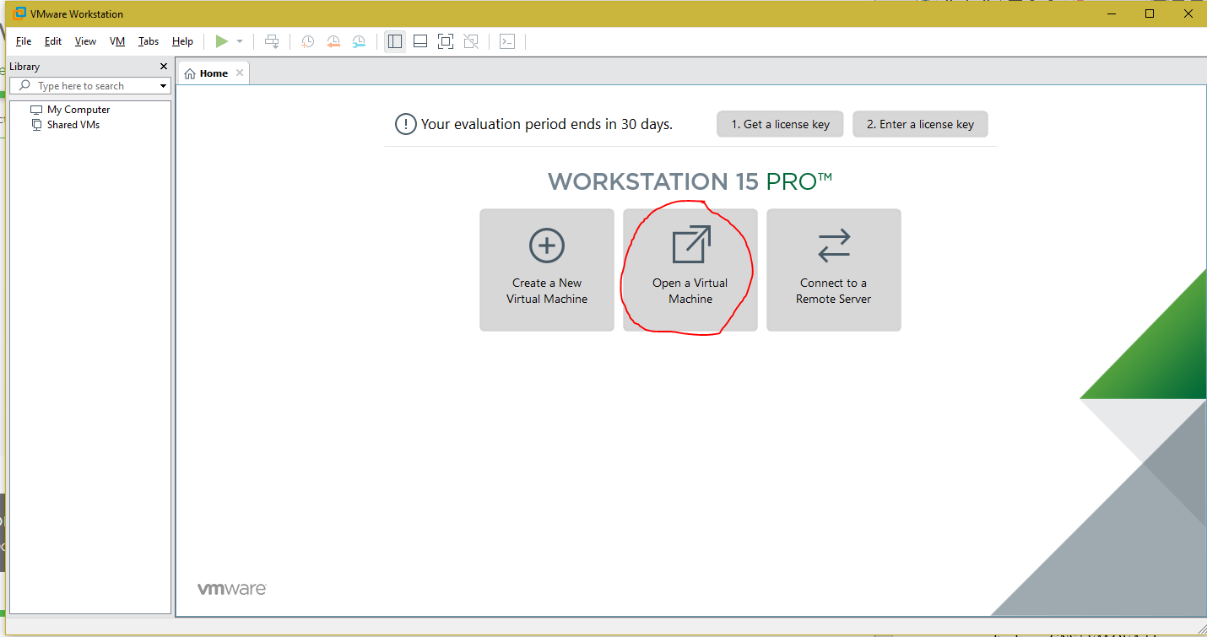

Figure 19. WMware Workstation Window

1. Browse for the “GNS3 VM.ova” file in your downloads folder.
2. Use the default settings to import the GNS3 VM. When done you will see a tab for “GNS3 VM” in the VMware Workstation window as shown in figure below. It is the console window for the GNS3 VM.

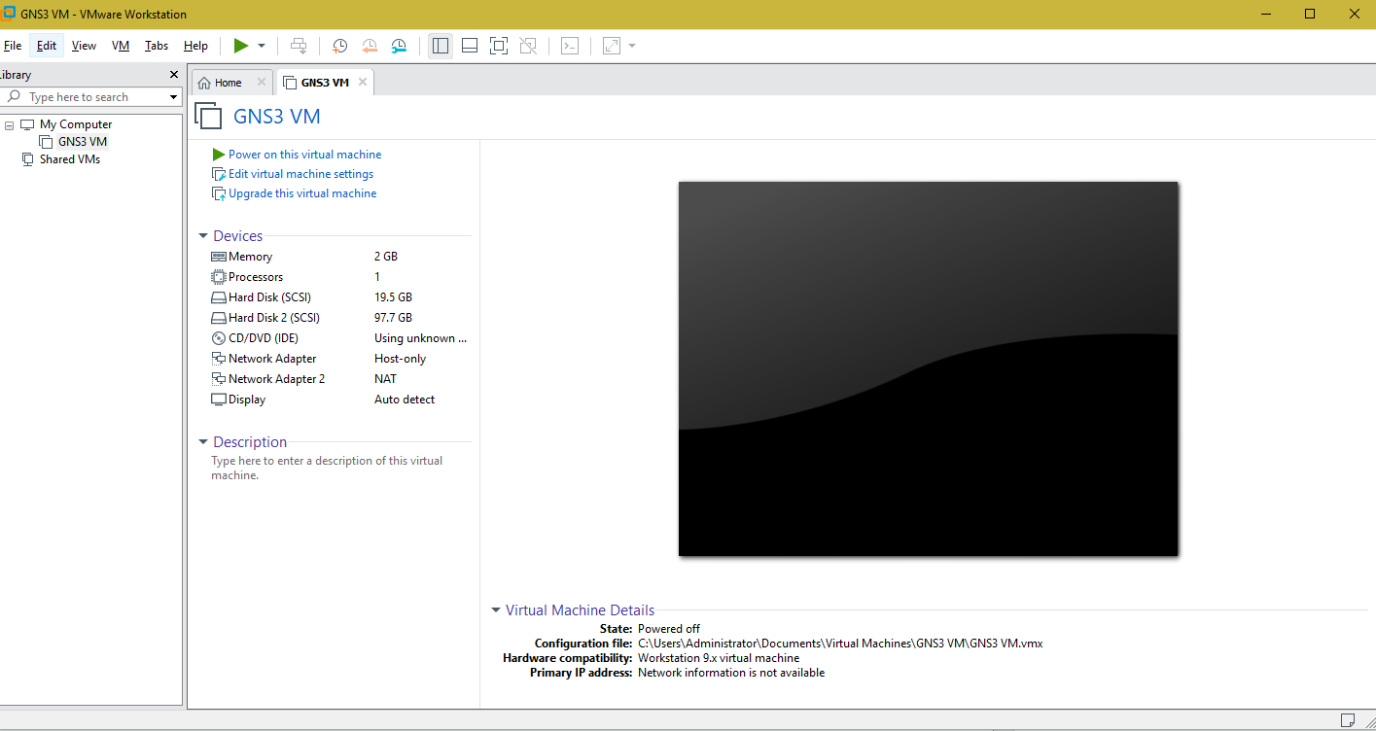

Figure 20. GNS3 VM Console Window

1. Click “Power on this virtual machine” in the tab. You can also “Power on” a VM when you are in its tab by clicking on the “green triangle” at the top of the VMware Workstation window as shown in green box in figure below. Note: if you get an error screen, as show in Figure 22, go to Step 10. If not, go to Step 11.

Figure 21. Powering on the GNS3 VM in the Console Window

1. If you see this error when trying to power up your VM, click “OK”. Then open the Administrator Command Prompt[7] on your computer, at the prompt, type the line below and restart your computer[8].

**-> bcdedit /set hypervisorlaunchtype off**

Figure 22. Error Powering On VM

1. You will see the following window in the GNS3 VM tab. Record the **IP address** of your GNS3 VM. (Shown here as IP: 192.168.154.128. Yours could be different.) Then press “enter” to select “OK”.

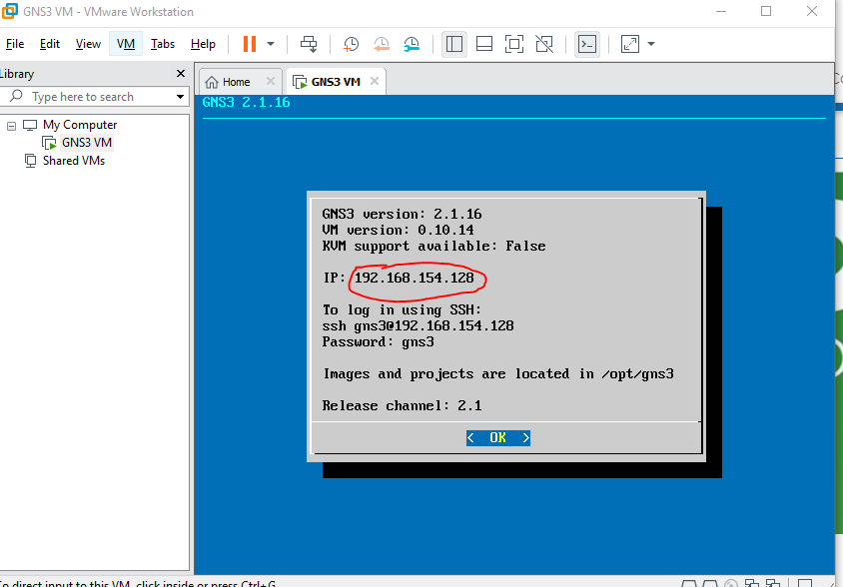

Figure 23. IP address of GNS3 VM

1. “Power off” the GNS3 VM. When in the “GNS3 VM” tab click on “red stop/pause” button, shown in green box, in figure below, and select “Off” in dropdown menu.

Figure 24. Powering off the GNS3 VM

### Task 4. Configuring GNS3

The last task of the software installation is the configuration of the GNS3 application so that it can access the installed GNS3 VM. For reasons not fully understood, the configuration is sometimes not successful even when all pieces are in place. Restarting the applications and/or the installation of the VM generally resolves the issues.

1. Start GNS3 (installed in Task 2) and select “Help⭢Setup Wizard”. Click “Next” in the Setup Wizard window with the default selection “Run applications in a virtual machine” and “Don’t show this again”.

Figure 25. Setup Wizard

1. In the window shown in igure below, for “Host binding”, select the option for the **IP address** that has the same **IP address** ***prefix*** as your GNS3 VM **IP address** (saved in Task 3), then click “Next”.

e.g. From Task 3: if saved IP address for GNS3 VM is: 192.168.154.128. The underlined portion is the ***prefix***. Then in the GNS3 Setup Wizard choose the IP address with the same prefix, e.g., 192.168.154.1 as shown in figure below.

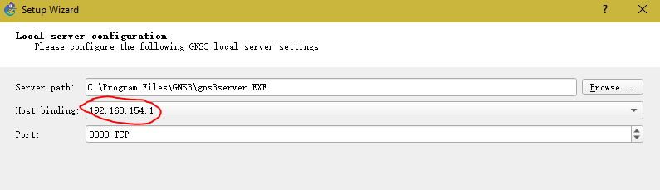

Figure 26. Setup Wizard – Host binding

1. The software will proceed with the installation. In the process, you may see an error message, which you may ignore. Eventually, you should see a window as shown in figure below, indicating that connection to the local server has succeeded. Select “Next.”

Figure 27. GNS3 Local Server Status

1. If you get the error message as shown in figure below, it means that you did not install the VMware Workstation before starting GNS3 configuration. Click OK and do/repeat Task 1.

Figure 28. Warning message during GNS3 setup

1. In the window shown below : For “Virtualization software” select “VMware” as shown. Note that GNS VM was downloaded and installed in Task 3. After a short time, you should see that “VM Name” shows “GNS3 VM” as displayed here. If you do not see a name appear, click on the “Refresh” button. Once the name “GNS3 VM” is displayed, click “Next”.

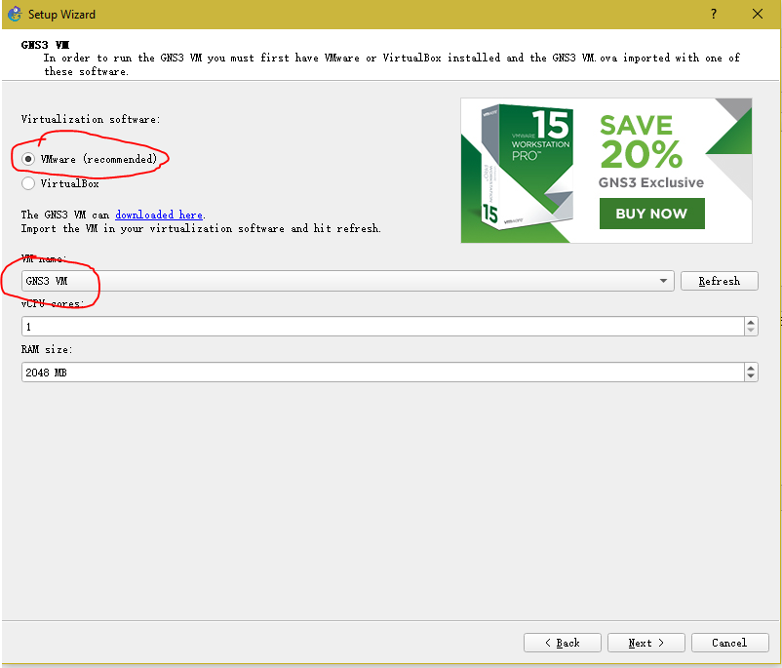

Figure 29. Configuration of GNS3 VM

1. You should now see the GNS3 simulation window as shown in figure below. Click ”Finish”.

Figure 30. GNS VM Summary Window

1. Click "Cancel" if a GNS3 “New appliance template” window should appear.

Figure 31. GNS3 New appliance template window

1. Click "Cancel" if a GNS3 “Project” screen if appears.

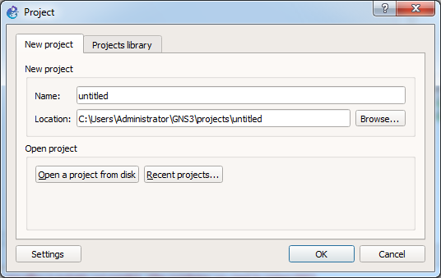

Figure 32. GNS3 Project window

1. After clicking “Finish” in Step 6 above (and cancel for Step 7 and 8 if they appear), you will see the GNS3 simulation window as shown below. In the “Servers Summary” panel should show two servers with two **green** **status indicator** lights indicating that the servers are running. Go to Step 10. If **One or both are not** **green**, it means that there is a problem in the installation/configuration of GNS3.

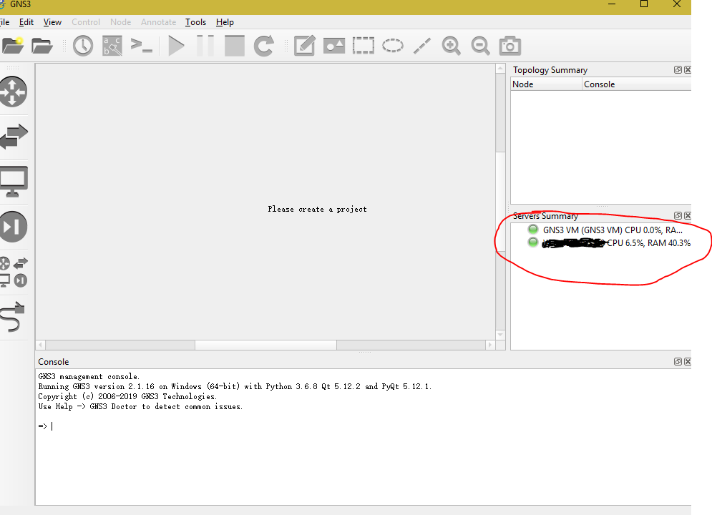

Figure 33. GNS3 Main Application window

1. You are done with installation of all the components and you can quit/stop/close all the applications and move on to Lab 1.
2. If the GNS3 VM indicator is **not green**, read the notes below to get GNS3 to start up properly. There is one quick fix. Selecting GNS3 “File -> Preferences” you will see this window:

Figure 34. GNS3 Preferences Window

1. In right column, click on GNS3 VM. You will see this window:

Figure 35. GNS VM Preferences Window

1. Check to make sure that the port is “80”. If not, set it to “80”. Also under “Action when closing GNS3 VM” the option “suspend the GNS3 VM” is originally selected, select option “stop the GNS3 VM” instead. Click OK.
2. Quit GNS3 and restart. If status light for GNS3 VM is green you are done. If not read notes below.

|  |  |
| --- | --- |
|  | **Status light of GNS3 VM does not turn green**  If the status indicator is gray or red, GNS3 cannot communicate properly with GNS3 VM. There are several potential causes.   * Close/Quit GNS3.   + WMware GNS3 VM will suspend. Power on the GNS VM and Start/Open GNS3.   + Observe if the status indicators turn **green**.   If not   * Close/Quit everything and restart your computer.   + Start/Open VMware, “Power on” the GNS VM   + Start/Open GNS3   + Observe if the status indicators turn **green**   If not   * Go back to Step 1 in Task 4 and repeat all steps from the “Setup Wizard” onwards again. Observe if the status indicators turn **green**.   If not   * Close/Quit everything.   + Start/Open VMware. Open VMware under “Edit”, there should be a “Virtual Network adapter” option, click that and then click “Change setting” in the popup window, and then click “Reset default”.   + After resetting is complete check that the “DHCP Server option” is checked in the host-only adapter.   + If not, delete GNS3 VM from VMware. Redo Task 3 (skipping the download - Step 1) and Task 4.   + Observe if the status indicators turn **green**.   If not, and/or   * You observe the following situations:   + The GNS3 VM’s screen in VMware Workstation is “black”, or   + The GNU GRUB screen in the GNS3 VM’s booting sequence   then   * + Check if Hardware Virtualization is enabled from BIOS. Please note that the steps to enable Hardware Virtualization in BIOS could vary depending on the computer manufacturer and the computer models. Sample steps are given [here](https://docs-old.fedoraproject.org/en-US/Fedora/13/html/Virtualization_Guide/sect-Virtualization-Troubleshooting-Enabling_Intel_VT_and_AMD_V_virtualization_hardware_extensions_in_BIOS.html). |

1. If you do not have an ICS account, you need to set one up. Click on this [link](https://www.ics.uci.edu/~lab/students/acct_activate.php) to start the process. You need a UCI ID and proof of registration in an ICS course.
2. You may see a different version for the downloads on your screen than shown in the figures in this document.
3. You will be asked to enter the license key during installation. Enter the key you saved.
4. You can also click on this [link](https://github.com/GNS3/gns3-gui/releases/) to get access to all the GNS3 versions. Download the GNS3-version#.dmg file. If the latest version doesn’t work then you can try with previous versions of GNS3.
5. You can also click on this [link](https://github.com/GNS3/gns3-gui/releases/) to get access to all the GNS3 versions. Note that will see file listed as GNS3.VM.VMware.Workstation.version#.zip.
6. Note that the version you download here, should match the version of GNS3 that you downloaded and installed prior. If you have an older version of GNS3 installed, you need to upgrade it to match the VM version.
7. <https://www.howtogeek.com/194041/how-to-open-the-command-prompt-as-administrator-in-windows-8.1/>
8. Note that if you try to turn Hyper-V off on your computer using the “Turn Windows features on or off” screen, you may not see Hyper-V. Follow the directions for “admin cmd prompt” as shown. That will work.