========================start of the write-up=========================

problem 1

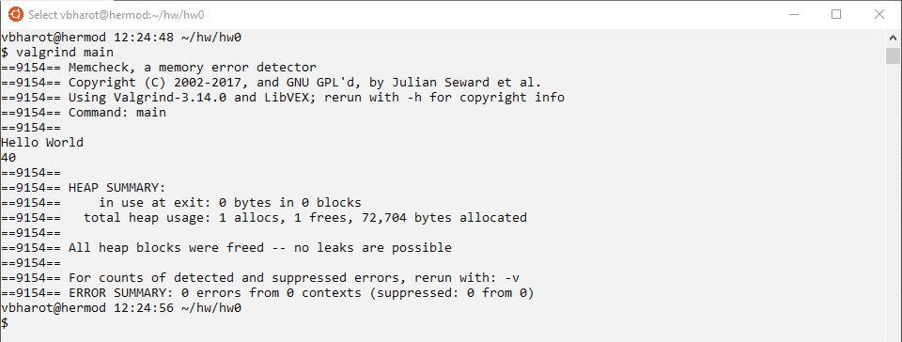

========================end of the write-up=========================