========================start of the write-up=========================

Problem 1:

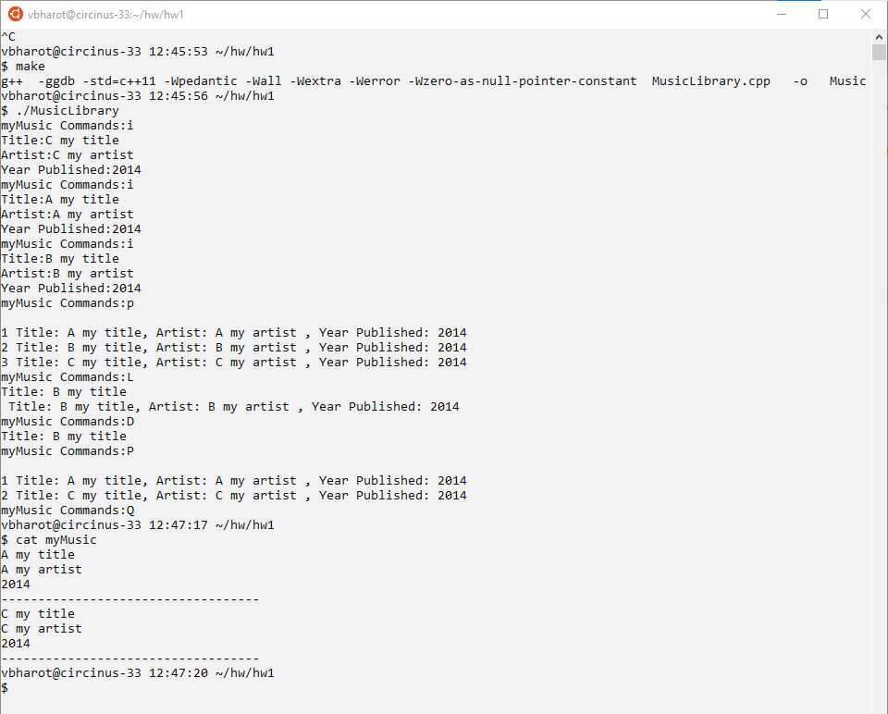

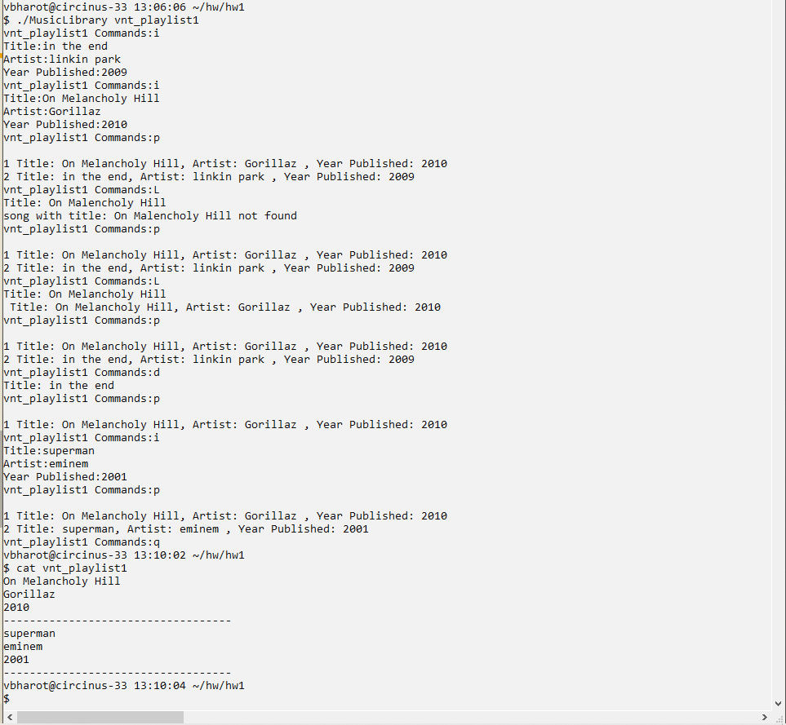

NOTE: here the first lookup is not found because of the wrong search string “On Malencholy Hill” and the second is correct “On Melancholy Hill”