***Strstr successful compilation:***

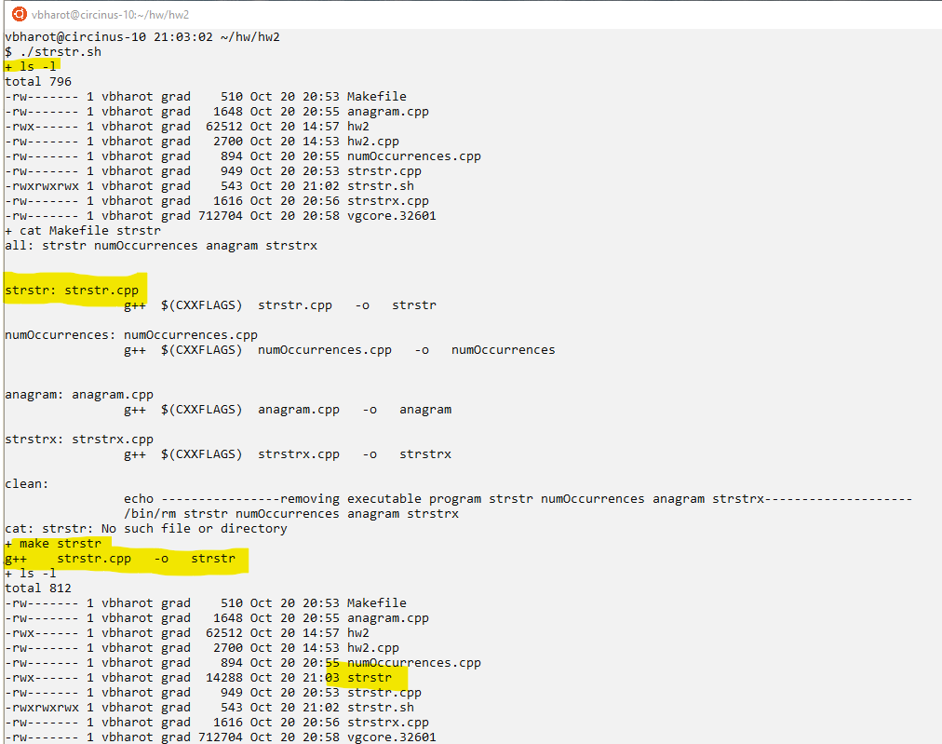

***Strstr provided example******from the assignment:***

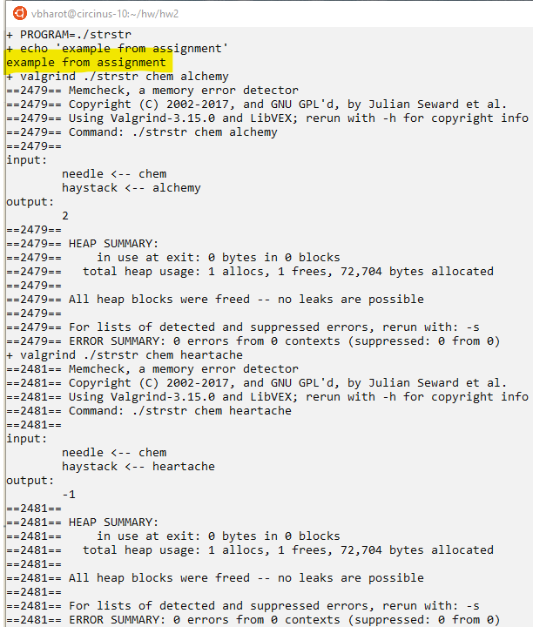

***Strstr test input:***

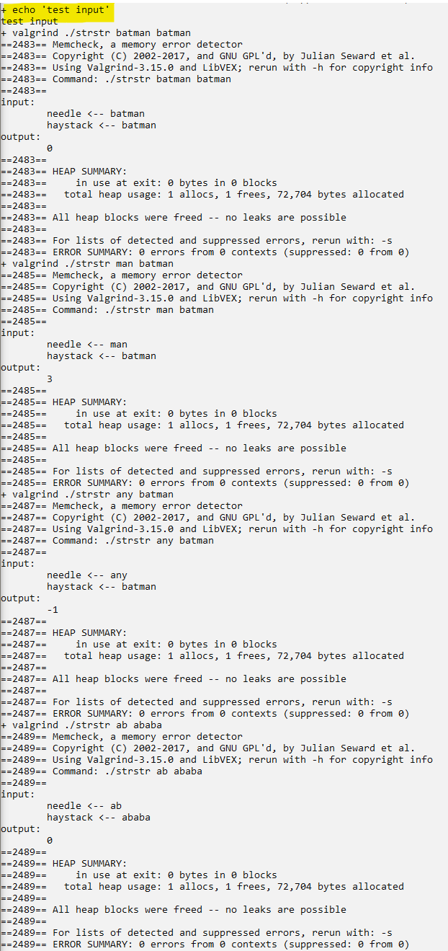

***Strstr important edge case1:***

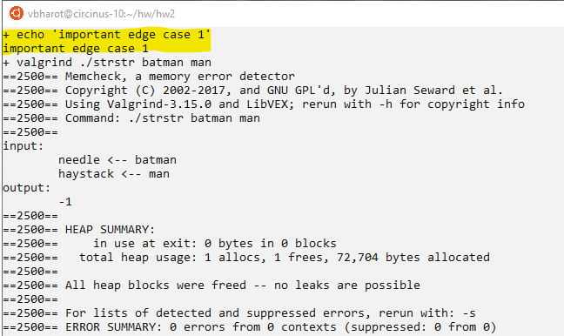

Here the edge case if that length of the haystack string is smaller than the size of the needle string

Like: needle = batman and haystack = man and expected output = -1

***Strstr important edge case2:***

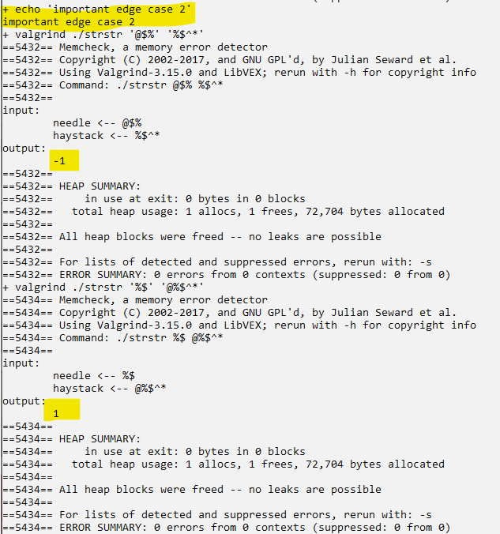

The edge case where the program should be able to deal with special characters

Like needle = @$% haystack = %$^* expected output = -1 as there is no match

And needle = %$ haystack = @%$^* expected output = 1 as there is match from index 1

***Strstr important edge case3:***

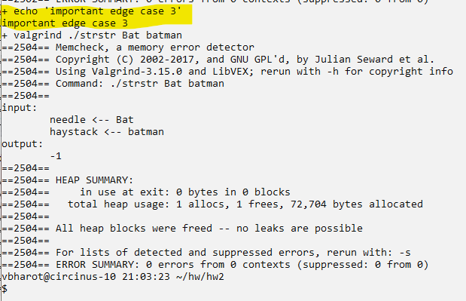

This is the case sensitive matching edge case, as there is no indication of case relaxation so this problem is case sensitive

Input: needle = Bat haystack = batman expected output = -1 cos even though bat is matched but case is different

***numOccurrences successful compilation:***

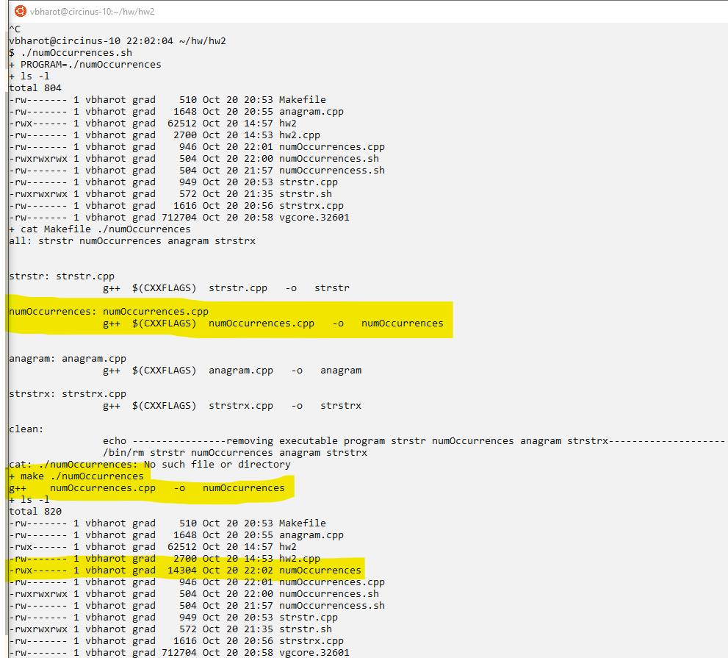

***numOccurrences example******from the assignment:***

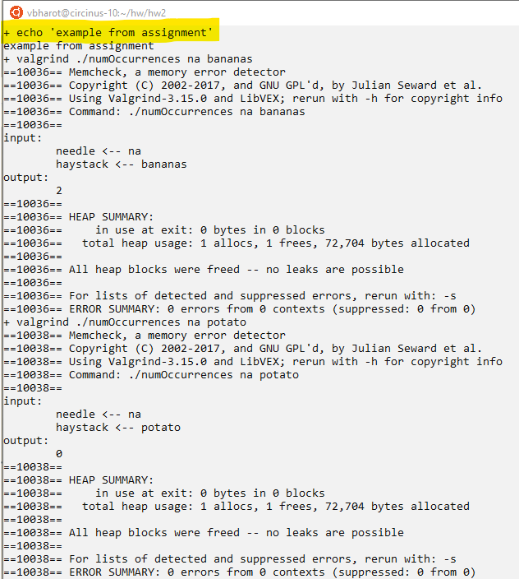

***numOccurrences test input:***

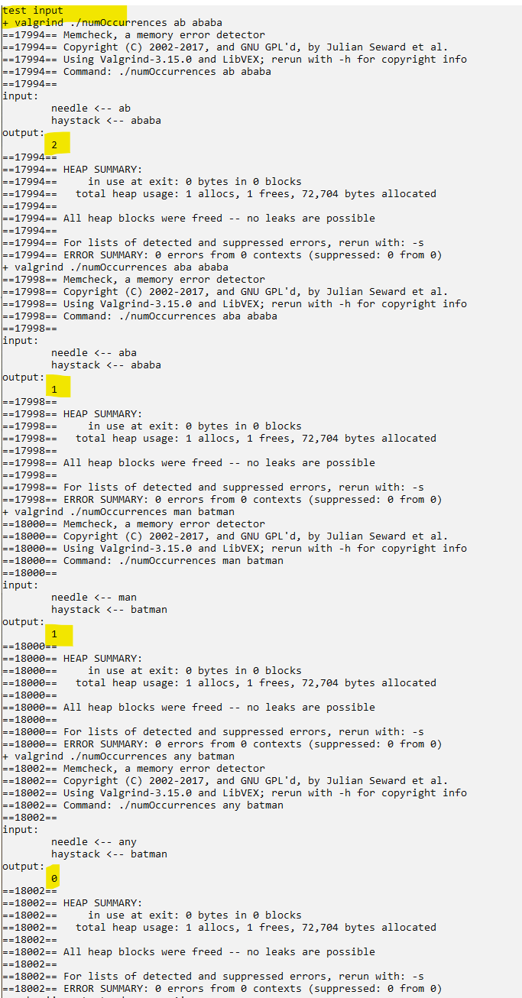

***numOccurrences important edge case 1:***

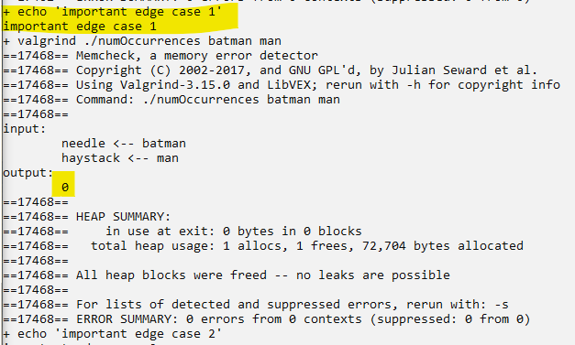

Here the edge case if that length of the haystack string is smaller than the size of the needle string

Like: needle = batman and haystack = man and expected output = 0

***numOccurrences important edge case2:***

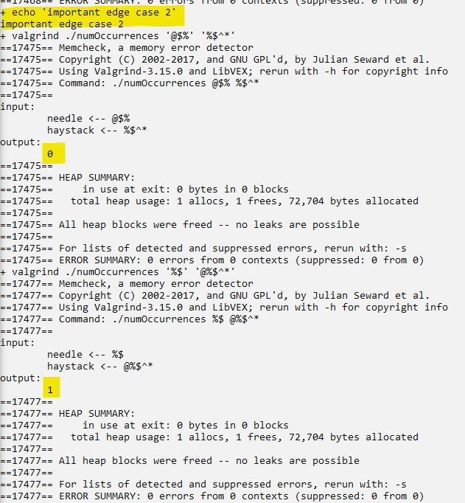

The edge case where the program should be able to deal with special characters

Like needle = @$% haystack = %$^* expected output = 0 as there is no match

And needle = %$ haystack = @%$^* expected output = 1 as there is **one** match.

***numOccurrences important edge case3:***

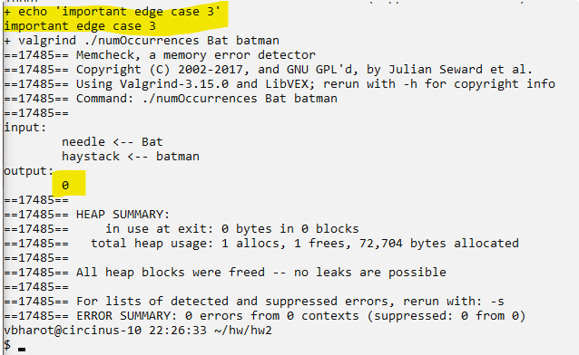

This is the case sensitive matching edge case, as there is no indication of case relaxation so this problem is case sensitive

Input: needle = Bat haystack = batman expected output = 0 cos even though bat is matched but case is different

***Anagram successful compilation:***

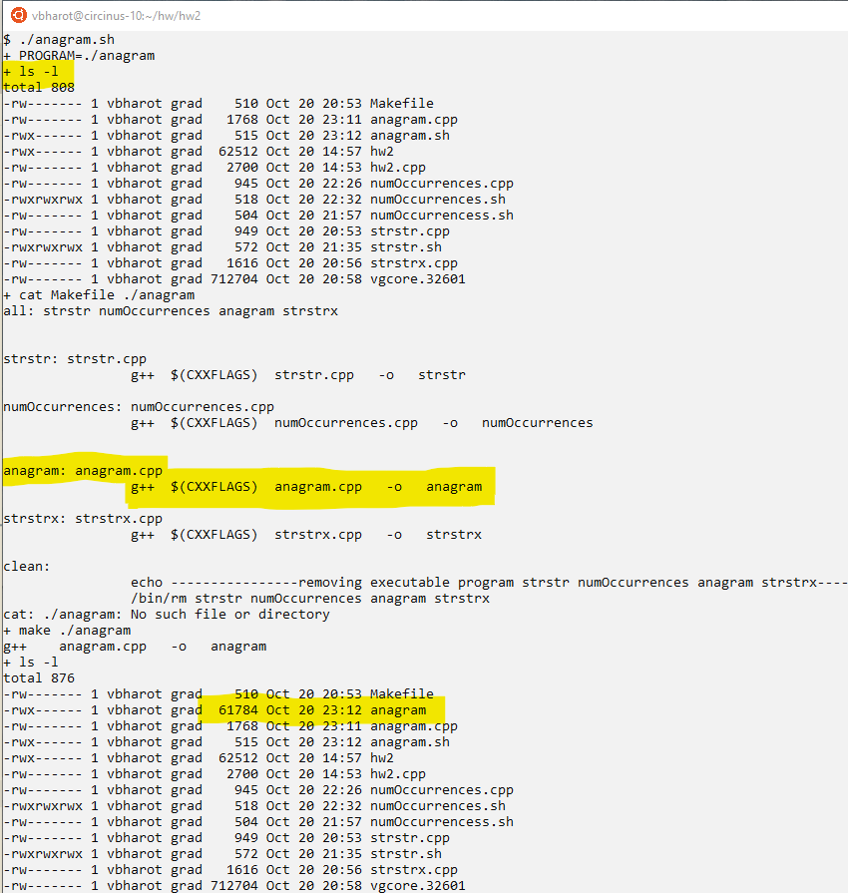

***Anagram example******from the assignment:***

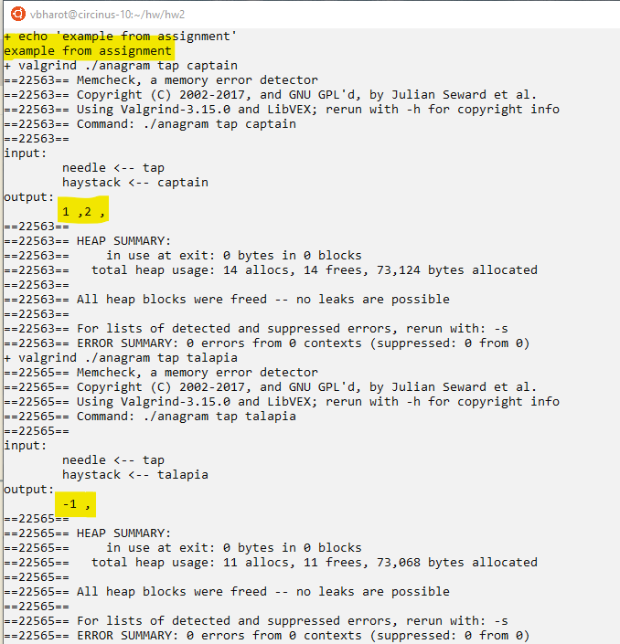

***Anagram test input:***

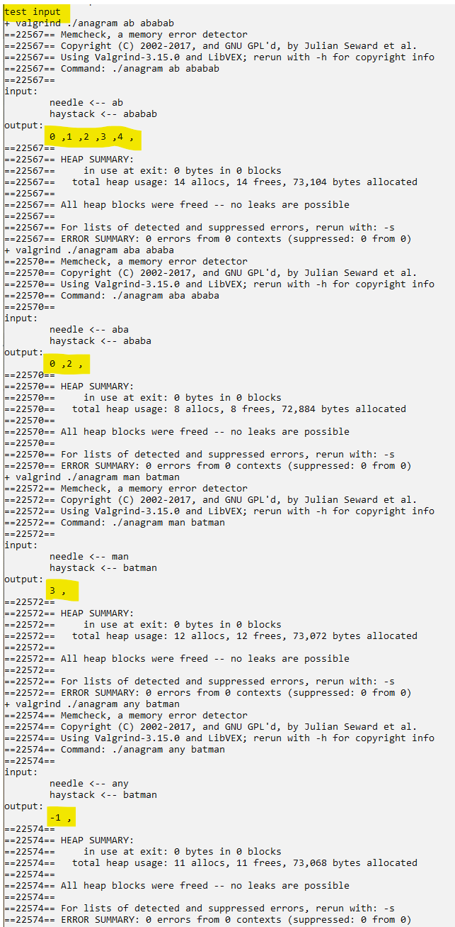

***Anagram important edge case1:***

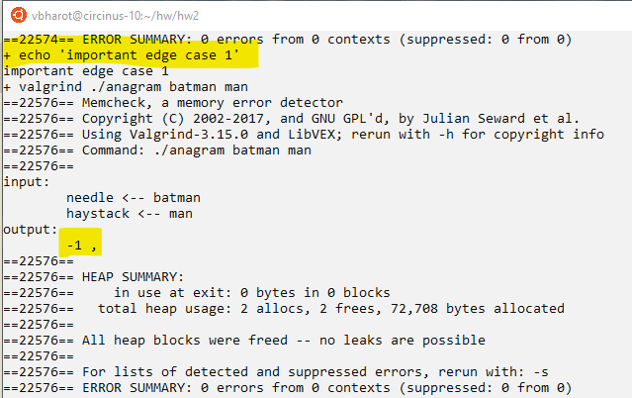

Here the edge case if that length of the haystack string is smaller than the size of the needle string

Like: needle = batman and haystack = man and expected output = -1

***Anagram important edge case2:***

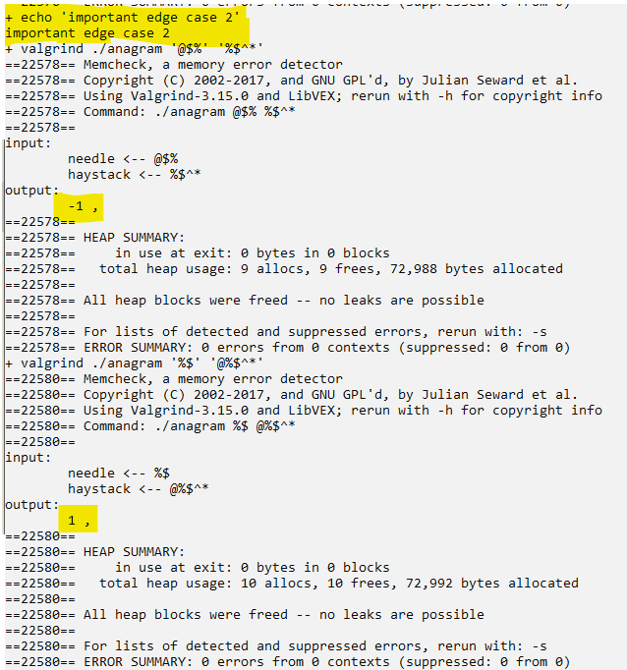

The edge case where the program should be able to deal with special characters

Like needle = @$% haystack = %$^* expected output = -1 as there is no match

And needle = %$ haystack = @%$^* expected output = 1 as there is amatch from index 1

***anagram important edge case3:***

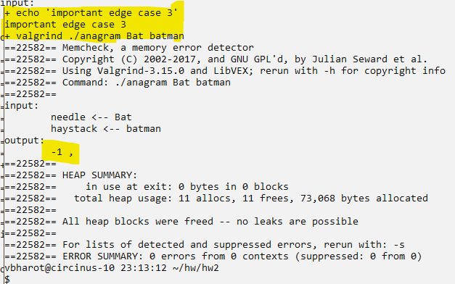

This is the case sensitive anagram matching edge case, as there is no indication of case relaxation so this problem is case sensitive

Input: needle = Bat haystack = batman expected output = -1 cos even though bat is matched but case is different

***Strstrx successful compilation:***

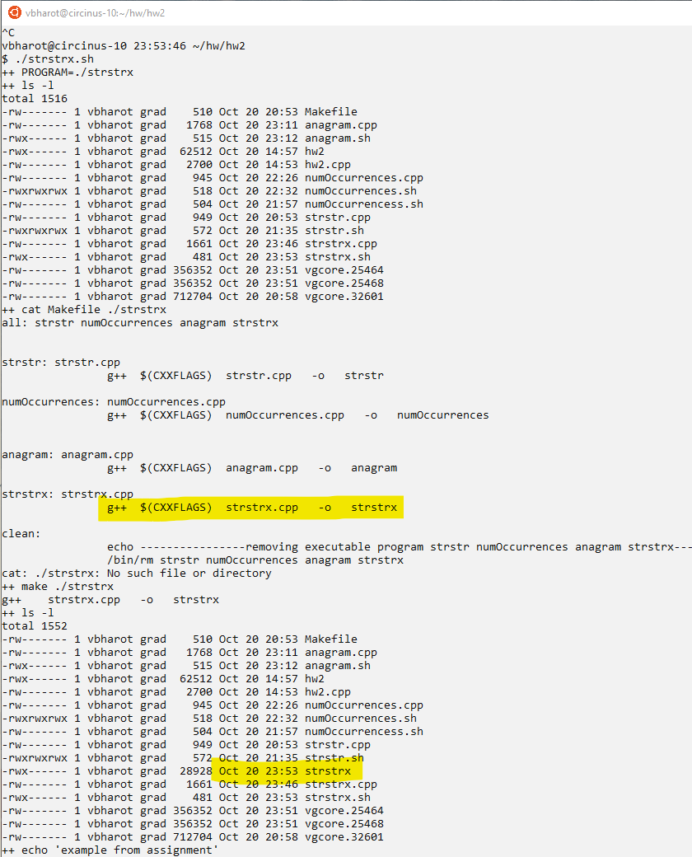

***Strstrx provided example******from the assignment:***

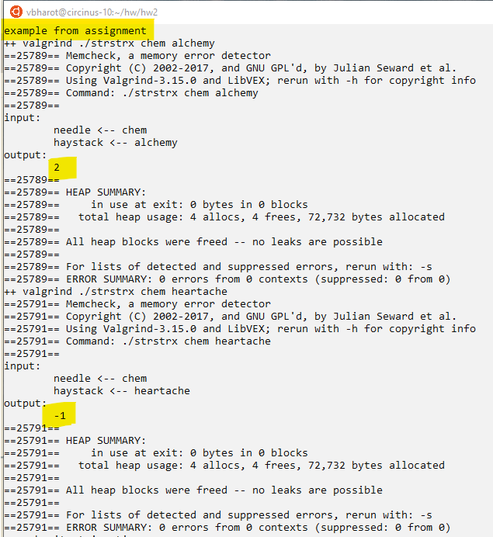

***Strstrx test input:***

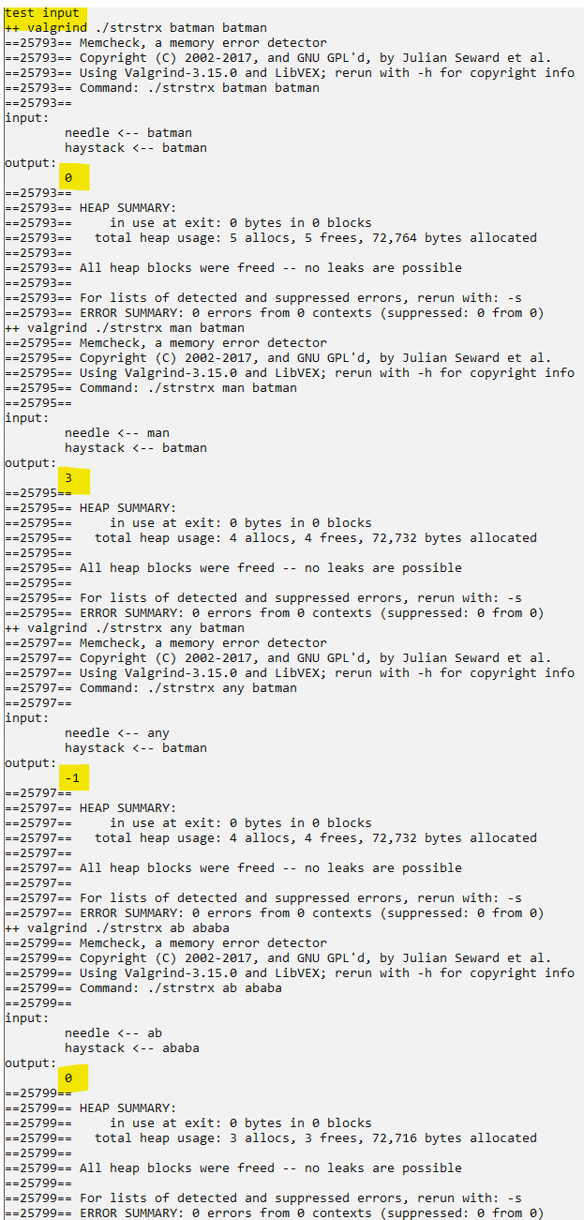

***Strstrx important edge case1:***

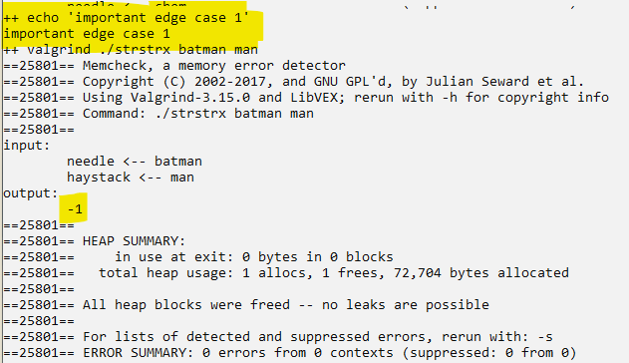

Here the edge case if that length of the haystack string is smaller than the size of the needle string

Like: needle = batman and haystack = man and expected output = -1

***Strstrx important edge case2:***

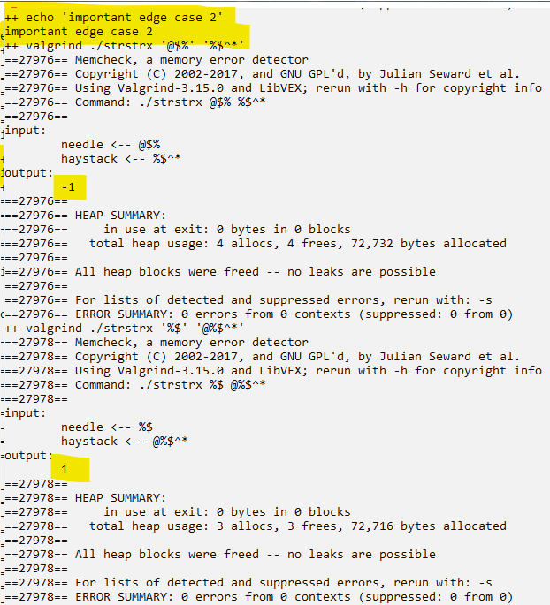

The edge case where the program should be able to deal with special characters

Like needle = @$% haystack = %$^* expected output = -1 as there is no match

And needle = %$ haystack = @%$^* expected output = 1 as there is match from index 1

***Strstrx important edge case3:***

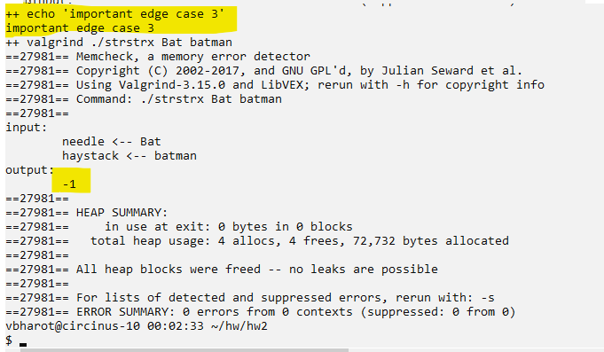

This is the case sensitive matching edge case, as there is no indication of case relaxation so this problem is case sensitive

Input: needle = Bat haystack = batman expected output = -1 cos even though bat is matched but case is different