parseC Successful compilation:

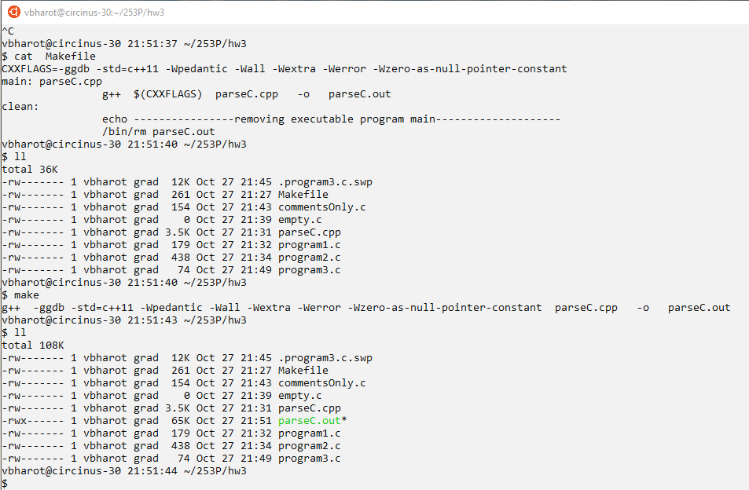

parseC Provided example from the assignment:

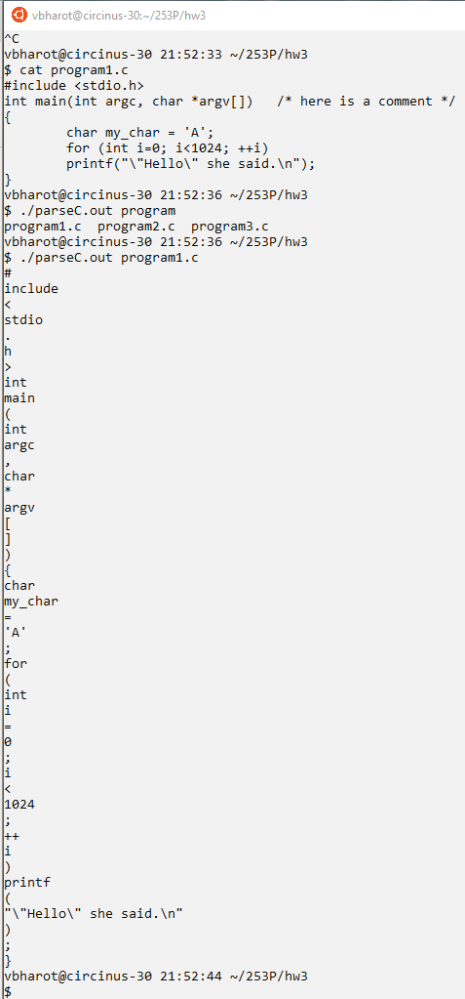

parseC Test input:

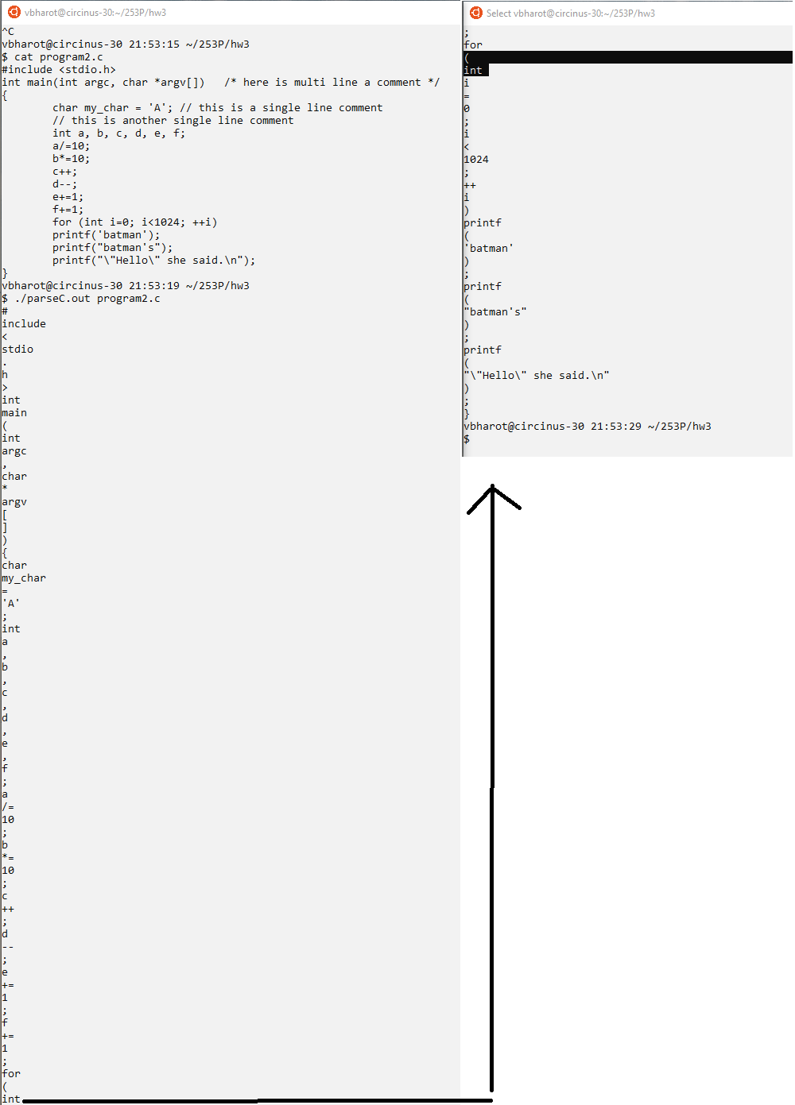

parseC Important edge case1:

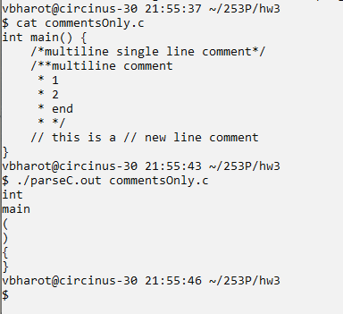

This edge case tests all the variations of the comment in c.

parseC Important edge case 2:

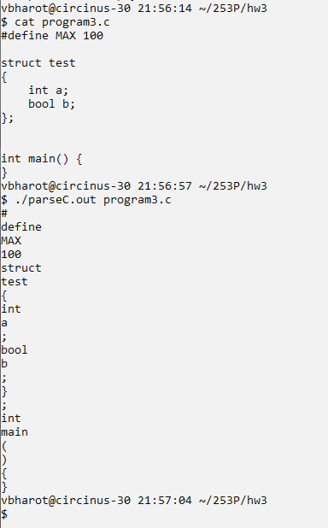

This edge case is used to test #define and struct and empty main

parseC Important edge case 3:

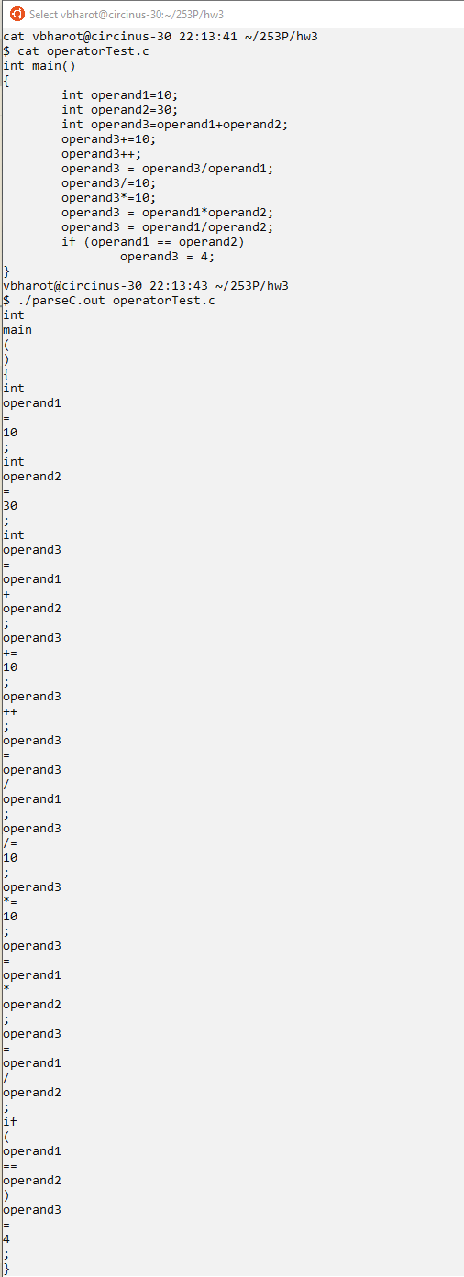

This edge case test all the variations of operator and operand combinations.

Leetcode 946 Validate Stack Sequence:

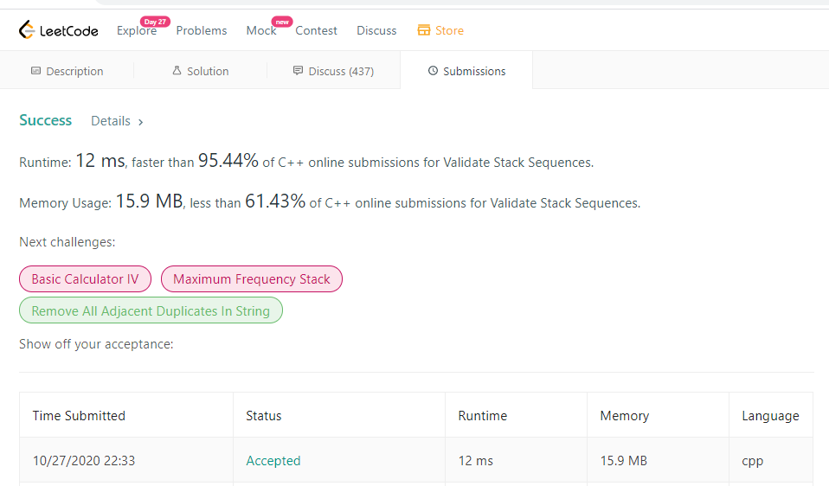

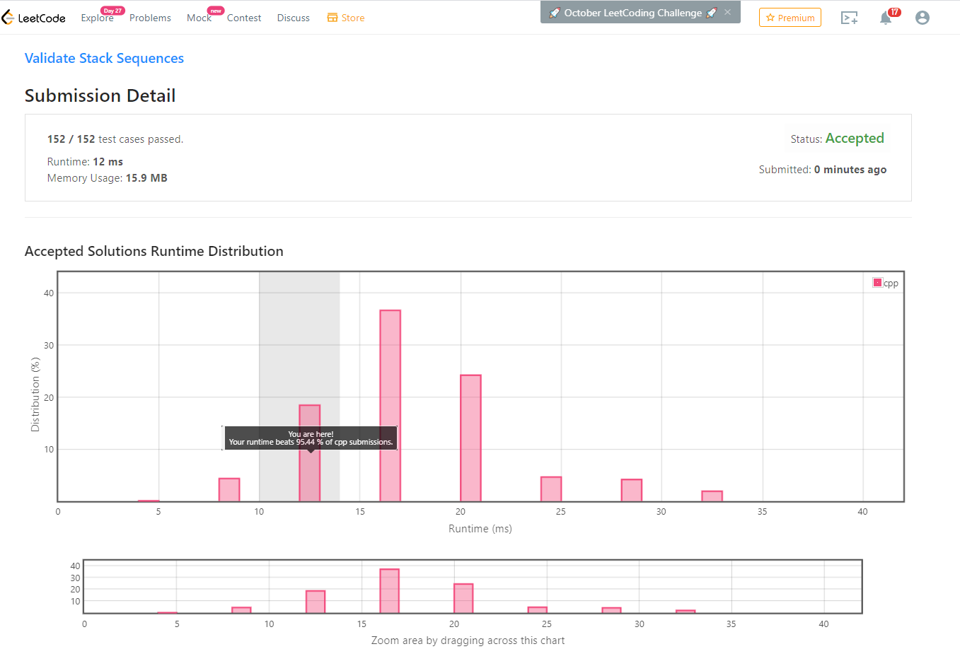

Leetcode 856 Score of Parentheses:

