AVL successful compilation:

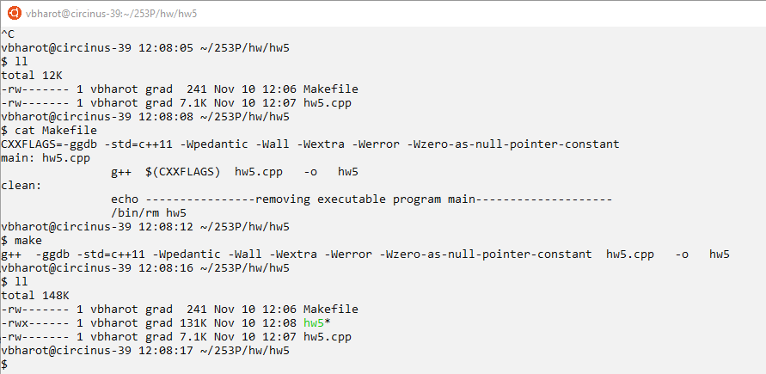

AVL provided example from the assignment:

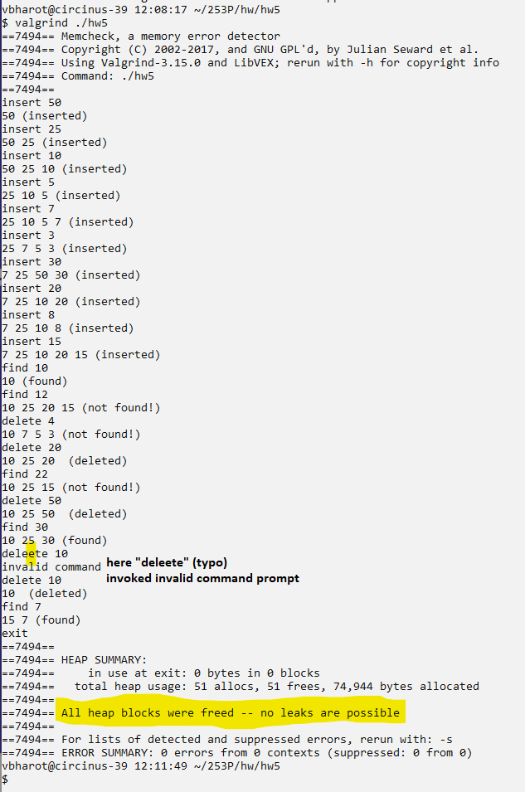

AVL Test input:

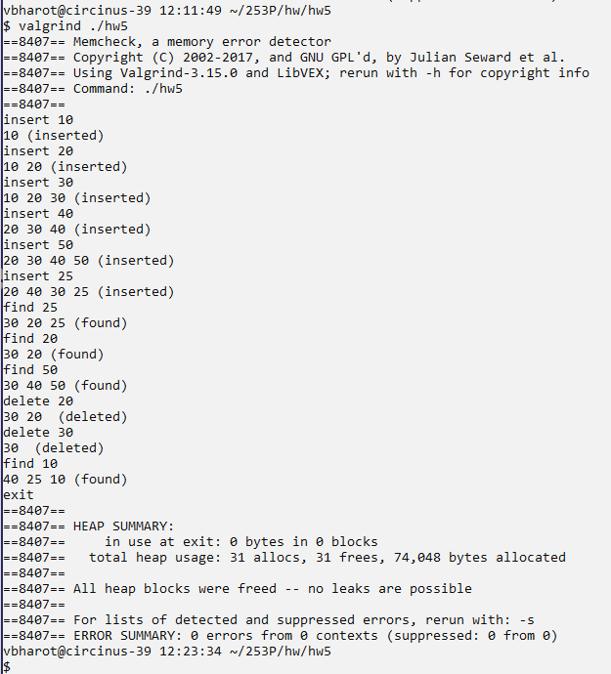

AVL edge case 1:

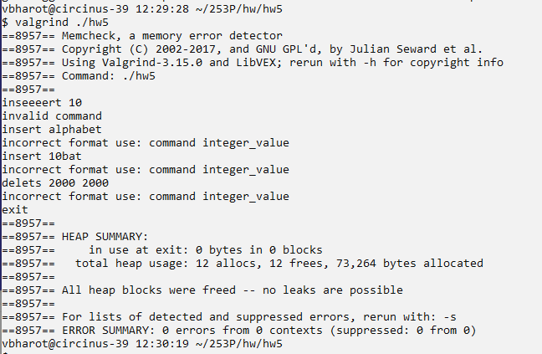

Handle invalid input command and input integer.

AVL edge case 2:

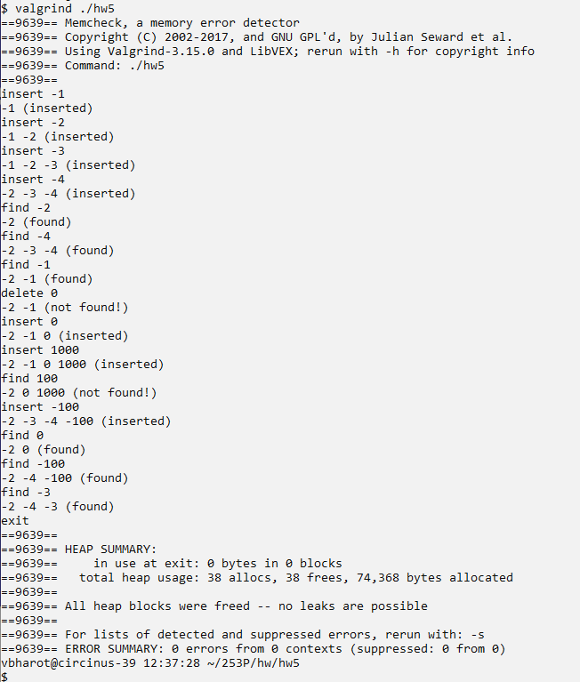

Handle negative, zero and positive integer functionality.

AVL edge case 3:

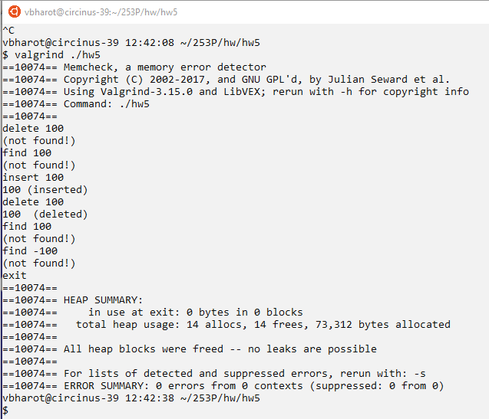

Handling delete and find on empty tree and verifying successful deletion of root node.

Maximum Binary Tree:

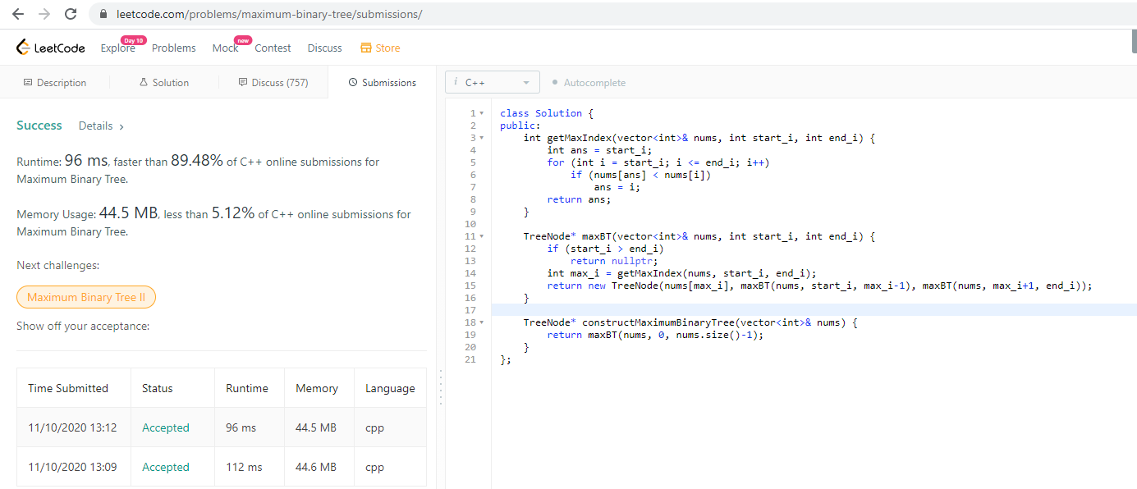

Binary Tree Pruning:

